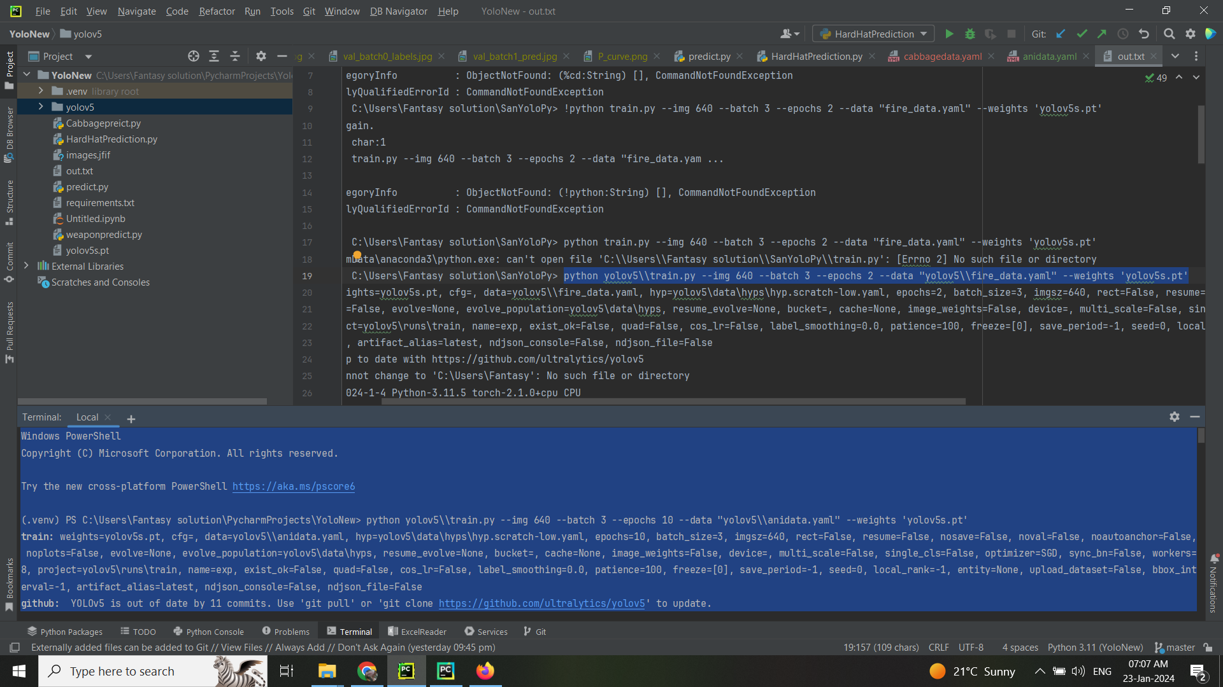
ndows PowerShell
Copyright (C) Microsoft Corporation. All rights reserved.

Try the new cross-platform PowerShell https://aka.ms/pscore6

(.venv) PS C:\Users\Fantasy solution\PycharmProjects\YoloNew> python yolov5\\train.py --img 640 --batch 3 --epochs 10 --data "yolov5\\anidata.yaml" --weights 'yolov5s.pt'
train: weights=yolov5s.pt, cfg=, data=yolov5\\anidata.yaml, hyp=yolov5\data\hyps\hyp.scratch-low.yaml, epochs=10, batch_size=3, imgsz=640, rect=False, resume=False, nosave=False, noval=False, noautoanchor=False,
noplots=False, evolve=None, evolve_population=yolov5\data\hyps, resume_evolve=None, bucket=, cache=None, image_weights=False, device=, multi_scale=False, single_cls=False, optimizer=SGD, sync_bn=False, workers=
8, project=yolov5\runs\train, name=exp, exist_ok=False, quad=False, cos_lr=False, label_smoothing=0.0, patience=100, freeze=[0], save_period=-1, seed=0, local_rank=-1, entity=None, upload_dataset=False, bbox_int
erval=-1, artifact_alias=latest, ndjson_console=False, ndjson_file=False
github: YOLOv5 is out of date by 11 commits. Use 'git pull' or 'git clone https://github.com/ultralytics/yolov5' to update.
fatal: cannot change to 'C:\Users\Fantasy': No such file or directory
YOLOv5 2024-1-4 Python-3.11.0 torch-2.1.2+cpu CPU

hyperparameters: lr0=0.01, lrf=0.01, momentum=0.937, weight_decay=0.0005, warmup_epochs=3.0, warmup_momentum=0.8, warmup_bias_lr=0.1, box=0.05, cls=0.5, cls_pw=1.0, obj=1.0, obj_pw=1.0, iou_t=0.2, anchor_t=4.0,
fl_gamma=0.0, hsv_h=0.015, hsv_s=0.7, hsv_v=0.4, degrees=0.0, translate=0.1, scale=0.5, shear=0.0, perspective=0.0, flipud=0.0, fliplr=0.5, mosaic=1.0, mixup=0.0, copy_paste=0.0
Comet: run 'pip install comet_ml' to automatically track and visualize YOLOv5 runs in Comet
TensorBoard: Start with 'tensorboard --logdir yolov5\runs\train', view at http://localhost:6006/
Overriding model.yaml nc=80 with nc=15

from n params module arguments
0 -1 1 3520 models.common.Conv [3, 32, 6, 2, 2]
1 -1 1 18560 models.common.Conv [32, 64, 3, 2]
2 -1 1 18816 models.common.C3 [64, 64, 1]
3 -1 1 73984 models.common.Conv [64, 128, 3, 2]
4 -1 2 115712 models.common.C3 [128, 128, 2]
5 -1 1 295424 models.common.Conv [128, 256, 3, 2]
6 -1 3 625152 models.common.C3 [256, 256, 3]
7 -1 1 1180672 models.common.Conv [256, 512, 3, 2]
8 -1 1 1182720 models.common.C3 [512, 512, 1]
9 -1 1 656896 models.common.SPPF [512, 512, 5]
10 -1 1 131584 models.common.Conv [512, 256, 1, 1]
11 -1 1 0 torch.nn.modules.upsampling.Upsample [None, 2, 'nearest']
12 [-1, 6] 1 0 models.common.Concat [1]
13 -1 1 361984 models.common.C3 [512, 256, 1, False]
14 -1 1 33024 models.common.Conv [256, 128, 1, 1]
15 -1 1 0 torch.nn.modules.upsampling.Upsample [None, 2, 'nearest']
16 [-1, 4] 1 0 models.common.Concat [1]
17 -1 1 90880 models.common.C3 [256, 128, 1, False]
18 -1 1 147712 models.common.Conv [128, 128, 3, 2]
19 [-1, 14] 1 0 models.common.Concat [1]
20 -1 1 296448 models.common.C3 [256, 256, 1, False]
21 -1 1 590336 models.common.Conv [256, 256, 3, 2]
22 [-1, 10] 1 0 models.common.Concat [1]
23 -1 1 1182720 models.common.C3 [512, 512, 1, False]
24 [17, 20, 23] 1 53940 models.yolo.Detect [15, [[10, 13, 16, 30, 33, 23], [30, 61, 62, 45, 59, 119], [116, 90, 156, 198, 373, 326]], [128, 256, 512]]
Model summary: 214 layers, 7060084 parameters, 7060084 gradients, 16.1 GFLOPs

Transferred 343/349 items from yolov5s.pt
optimizer: SGD(lr=0.01) with parameter groups 57 weight(decay=0.0), 60 weight(decay=0.0004921875), 60 bias
train: Scanning C:\Users\Fantasy solution\PycharmProjects\YoloNew\yolov5\animal\train\labels... 2370 images, 0 backgrounds, 0 corrupt: 100%|██████████| 2370/2370 [00:11<00:00, 201.27it/s]
train: WARNING C:\Users\Fantasy solution\PycharmProjects\YoloNew\yolov5\animal\train\images\326b9a3496142b2e_jpg.rf.6e44cb99d3f4a2696c5e28562156cf93.jpg: 1 duplicate labels removed
train: New cache created: C:\Users\Fantasy solution\PycharmProjects\YoloNew\yolov5\animal\train\labels.cache
val: Scanning C:\Users\Fantasy solution\PycharmProjects\YoloNew\yolov5\animal\valid\labels... 669 images, 0 backgrounds, 0 corrupt: 100%|██████████| 669/669 [00:10<00:00, 62.71it/s]
val: New cache created: C:\Users\Fantasy solution\PycharmProjects\YoloNew\yolov5\animal\valid\labels.cache

AutoAnchor: 2.56 anchors/target, 1.000 Best Possible Recall (BPR). Current anchors are a good fit to dataset
Plotting labels to yolov5\runs\train\exp20\labels.jpg...
Image sizes 640 train, 640 val
Using 3 dataloader workers
Logging results to yolov5\runs\train\exp20
Starting training for 10 epochs...

Epoch GPU_mem box_loss obj_loss cls_loss Instances Size
0/9 0G 0.04981 0.02336 0.05206 10 640: 100%|██████████| 790/790 [24:51<00:00, 1.89s/it]
Class Images Instances P R mAP50 mAP50-95: 100%|██████████| 112/112 [02:33<00:00, 1.37s/it]
all 669 729 0.326 0.201 0.141 0.0649

Epoch GPU_mem box_loss obj_loss cls_loss Instances Size
1/9 0G 0.0339 0.01648 0.04509 8 640: 100%|██████████| 790/790 [19:21<00:00, 1.47s/it]
Class Images Instances P R mAP50 mAP50-95: 100%|██████████| 112/112 [02:11<00:00, 1.18s/it]
all 669 729 0.363 0.261 0.225 0.123

Epoch GPU_mem box_loss obj_loss cls_loss Instances Size
2/9 0G 0.0316 0.01551 0.04048 6 640: 100%|██████████| 790/790 [18:53<00:00, 1.43s/it]
Class Images Instances P R mAP50 mAP50-95: 100%|██████████| 112/112 [02:14<00:00, 1.20s/it]
all 669 729 0.398 0.362 0.296 0.162

Epoch GPU_mem box_loss obj_loss cls_loss Instances Size
3/9 0G 0.02914 0.0157 0.0388 7 640: 100%|██████████| 790/790 [18:57<00:00, 1.44s/it]
Class Images Instances P R mAP50 mAP50-95: 100%|██████████| 112/112 [02:11<00:00, 1.17s/it]
all 669 729 0.439 0.477 0.394 0.217

Epoch GPU_mem box_loss obj_loss cls_loss Instances Size
4/9 0G 0.02752 0.01513 0.03579 8 640: 100%|██████████| 790/790 [18:55<00:00, 1.44s/it]
Class Images Instances P R mAP50 mAP50-95: 100%|██████████| 112/112 [02:11<00:00, 1.18s/it]
all 669 729 0.649 0.504 0.524 0.309

Epoch GPU_mem box_loss obj_loss cls_loss Instances Size
5/9 0G 0.02551 0.01498 0.03237 5 640: 100%|██████████| 790/790 [19:04<00:00, 1.45s/it]
Class Images Instances P R mAP50 mAP50-95: 100%|██████████| 112/112 [02:11<00:00, 1.17s/it]
all 669 729 0.58 0.554 0.575 0.342

Epoch GPU_mem box_loss obj_loss cls_loss Instances Size
6/9 0G 0.02384 0.01486 0.03138 6 640: 100%|██████████| 790/790 [18:52<00:00, 1.43s/it]
Class Images Instances P R mAP50 mAP50-95: 100%|██████████| 112/112 [02:11<00:00, 1.17s/it]
all 669 729 0.605 0.588 0.601 0.374

Epoch GPU_mem box_loss obj_loss cls_loss Instances Size
7/9 0G 0.02293 0.01451 0.02923 11 640: 100%|██████████| 790/790 [18:56<00:00, 1.44s/it]
Class Images Instances P R mAP50 mAP50-95: 100%|██████████| 112/112 [02:10<00:00, 1.17s/it]
all 669 729 0.636 0.664 0.643 0.424

Epoch GPU_mem box_loss obj_loss cls_loss Instances Size
8/9 0G 0.02116 0.01378 0.02639 8 640: 100%|██████████| 790/790 [18:55<00:00, 1.44s/it]
Class Images Instances P R mAP50 mAP50-95: 100%|██████████| 112/112 [02:11<00:00, 1.17s/it]
all 669 729 0.636 0.645 0.634 0.413

Epoch GPU_mem box_loss obj_loss cls_loss Instances Size
9/9 0G 0.01925 0.01314 0.02425 6 640: 100%|██████████| 790/790 [18:55<00:00, 1.44s/it]
Class Images Instances P R mAP50 mAP50-95: 100%|██████████| 112/112 [02:11<00:00, 1.17s/it]
all 669 729 0.693 0.677 0.692 0.476

10 epochs completed in 3.635 hours.
Optimizer stripped from yolov5\runs\train\exp20\weights\last.pt, 14.5MB
Optimizer stripped from yolov5\runs\train\exp20\weights\best.pt, 14.5MB

Validating yolov5\runs\train\exp20\weights\best.pt...
Fusing layers...
Model summary: 157 layers, 7050580 parameters, 0 gradients, 15.9 GFLOPs
Class Images Instances P R mAP50 mAP50-95: 100%|██████████| 112/112 [01:54<00:00, 1.03s/it]
all 669 729 0.693 0.678 0.692 0.476
Bear 669 63 0.863 0.667 0.818 0.617
Cheetah 669 17 0.249 0.292 0.321 0.216
Crocodile 669 42 0.691 0.929 0.813 0.436
Elephant 669 39 0.403 0.718 0.544 0.4
Fox 669 50 0.669 0.485 0.621 0.443
Giraffe 669 64 0.84 0.903 0.928 0.637
Hedgehog 669 23 0.663 0.783 0.698 0.512
Human 669 77 0.879 0.849 0.861 0.412
Leopard 669 30 0.533 0.667 0.707 0.551
Lion 669 60 0.494 0.731 0.635 0.446
Lynx 669 30 1 0 0.158 0.116
Ostrich 669 36 0.873 0.574 0.767 0.511
Rhinoceros 669 56 0.582 0.922 0.793 0.628
Tiger 669 72 0.931 0.778 0.886 0.593
Zebra 669 70 0.727 0.871 0.834 0.623
Results saved to yolov5\runs\train\exp20

