WEEK-5 E-COMMERCE

**1. Homepage (Updated UI)**

* The homepage now has a **hero section** with a promotional banner.
* **Timer Feature:** Displays an "Exclusive Deals Ends In" countdown timer.
* **Call-to-Action Button:** "Shop now" button redirects to the shop page.
* **New Arrivals Section:** Lists newly added products with a "New Arrival" or "Bestseller" label.
* Uses **Tailwind CSS** for styling and **CSS Grid/Flexbox** for layout management.

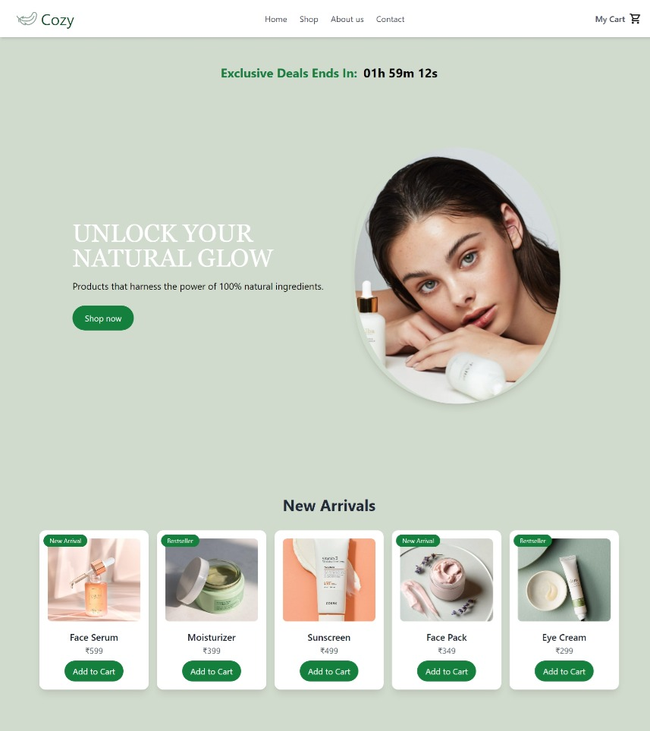

**2. Shop Page**

* Displays products in a structured grid format, including:
  + **Face Serum** - ₹599
  + **Moisturizer** - ₹399
  + **Sunscreen** - ₹499
  + **Face Pack** - ₹349
  + **Under Eye Cream** - ₹299
  + **Lip Balm** - ₹249
* Each product has an **"Add to Cart" button**, which updates the cart.

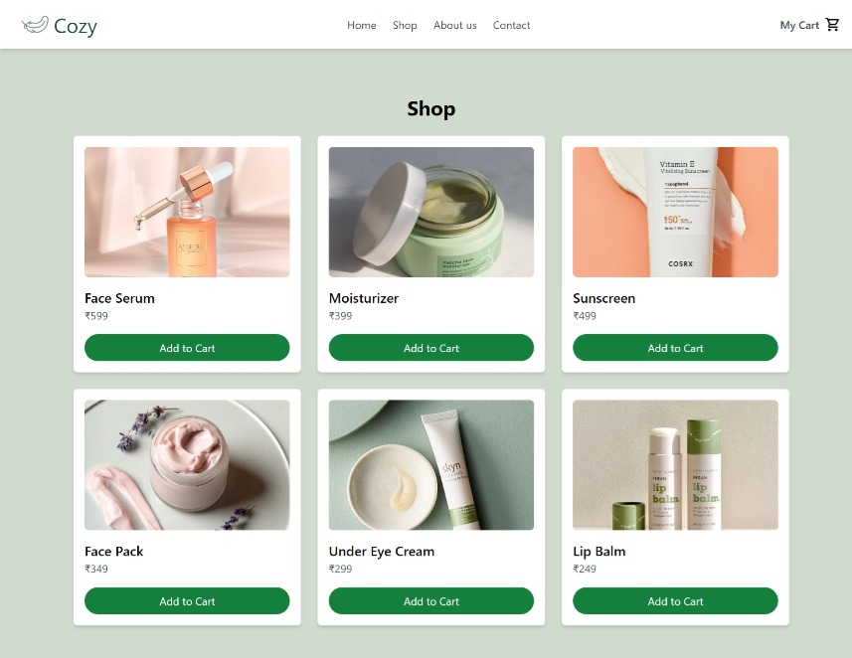

**3. Shopping Cart**

* If the cart is empty, a message **"Your cart is empty."** is displayed.
* The **total amount updates to ₹0.00** when all items are removed.
* Displays **selected products**, each with its name, price, and a **"Remove" button** for deletion.
* The **total price** updates automatically as items are added or removed

