**ActiveTracker - Fitness Routine Planner Documentation**

**Objective:** Develop a fully responsive fitness routine planner that allows users to create custom workout plans, add exercises, set durations, and track their progress. The website should feature multiple pages including Home, Create Routine, My Routines, and Progress Tracker.

Home page Structure

1. **HEADER**

* **Logo & Branding**: The logo with "ActiveTracker" branding is positioned at the top left.
* **Navigation Menu**:
  + **Home**
  + **Create Routine**
  + **My Routines**
  + **Progress Tracker**

1. **HERO SECTION**

* **Title**: "Fitness Routine Planner"
* **Subtitle**: "Achieve your Fitness Goals with Ease!"
* **Description**:

"Stay on track with your workouts by creating custom routines, tracking progress, and building a healthier lifestyle."

* **Call-to-Action Button**: "Get Started"

1. **FOOTER**

* **Branding**:
  + Logo and "ActiveTracker" text for identity.
* **Quick Links**:
  + Home
  + Create Routine
  + My Routines
  + Progress Tracker
* **Social Media Links**:
  + Instagram
  + X (Formerly Twitter)

1. **FUNCTIONALITIES**

* **Navigation Bar**: Direct access to key sections.
* **CTA Button**: "Get Started"

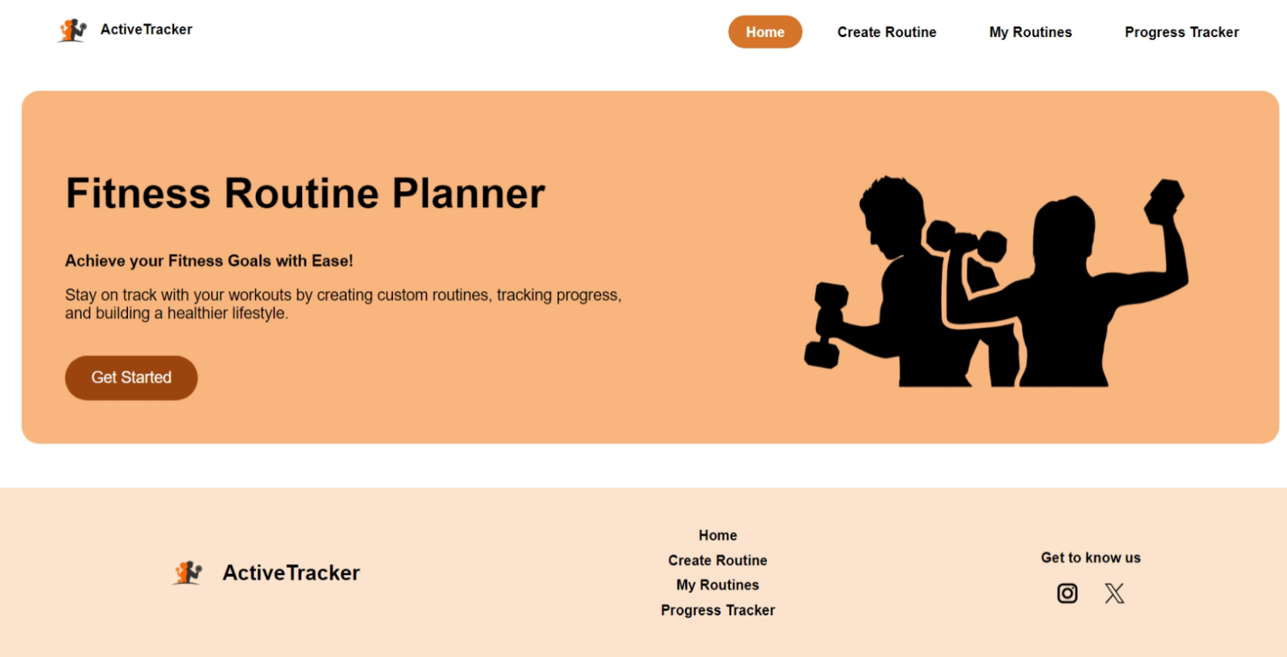

Create Routine Page Structure

1. **MAIN SECTION** - Workout Routine Creation

* **Title**: "Create Your Custom Workout Routine"
* **Input Fields**:
  + **Exercise Name**: Text input field (placeholder: "Enter exercise (e.g., Push-ups)")
  + **Duration**: Numeric input field (minutes)
  + **Rest Time**: Numeric input field (seconds)
* **Add Exercise Button**: Adds the entered exercise to the workout plan list.
* **Validation:** If any field is left empty, an error message **"Please enter the field"** is displayed

1. **WORKOUT PLAN SECTION**

* **Exercise List**: Displays added exercises in a structured format:

Example: *Push up - 5 min (Rest: 30 sec)*

* **Delete Button (Red "X")**: Allows users to remove an exercise from the list.
* **Save Routine Button**: Saves the created workout plan.
* **Alert Message:** When the user clicks "Save Routine," a pop-up alert **"Routine Saved!"** appears, confirming the action.

1. **FUNCTIONALITIES**

* **Add Exercise:** Users input an exercise name, duration, and rest time, then click "Add Exercise" to list it under "Workout Plan."
* **Remove Exercise:** Clicking the red "X" removes an exercise from the list.
* **Save Routine:** Stores the created workout routine for future tracking.

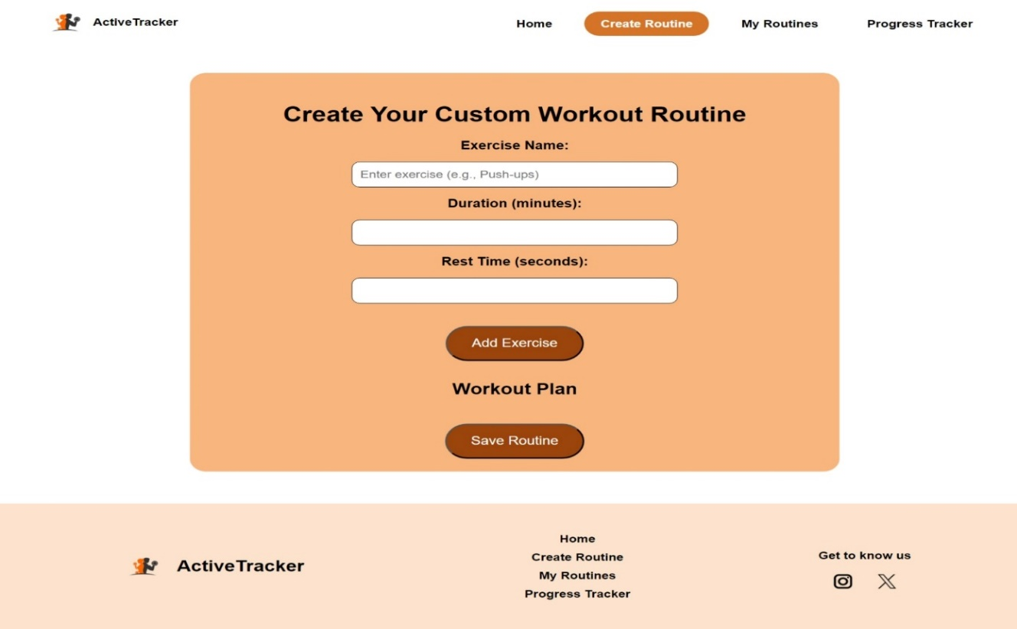

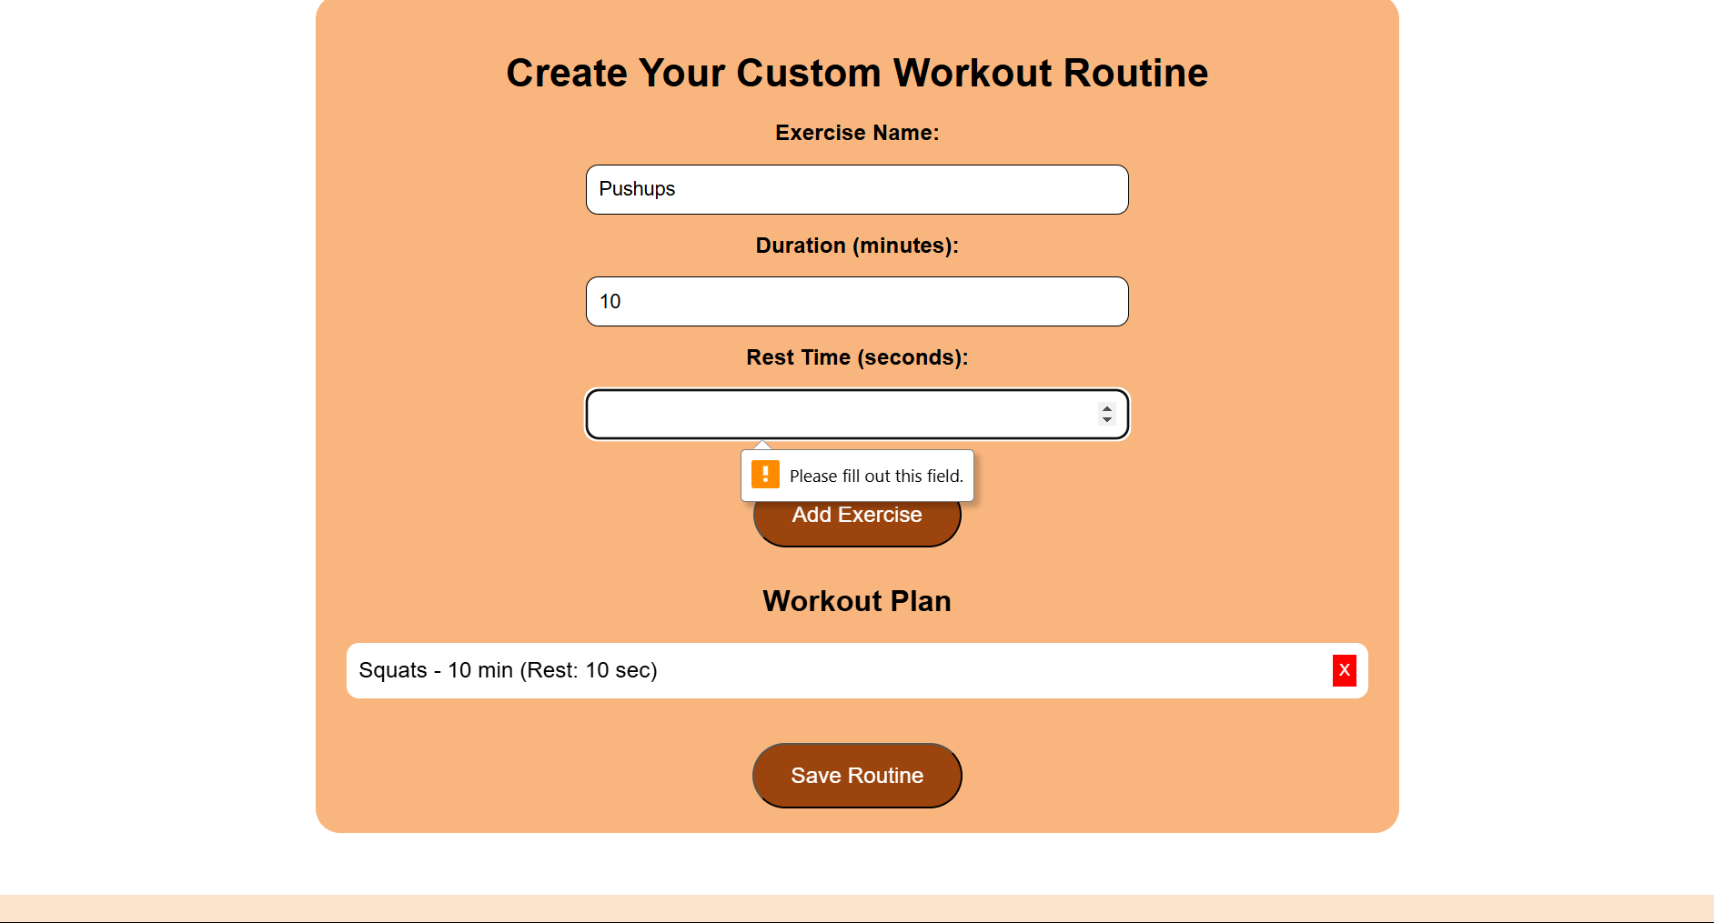

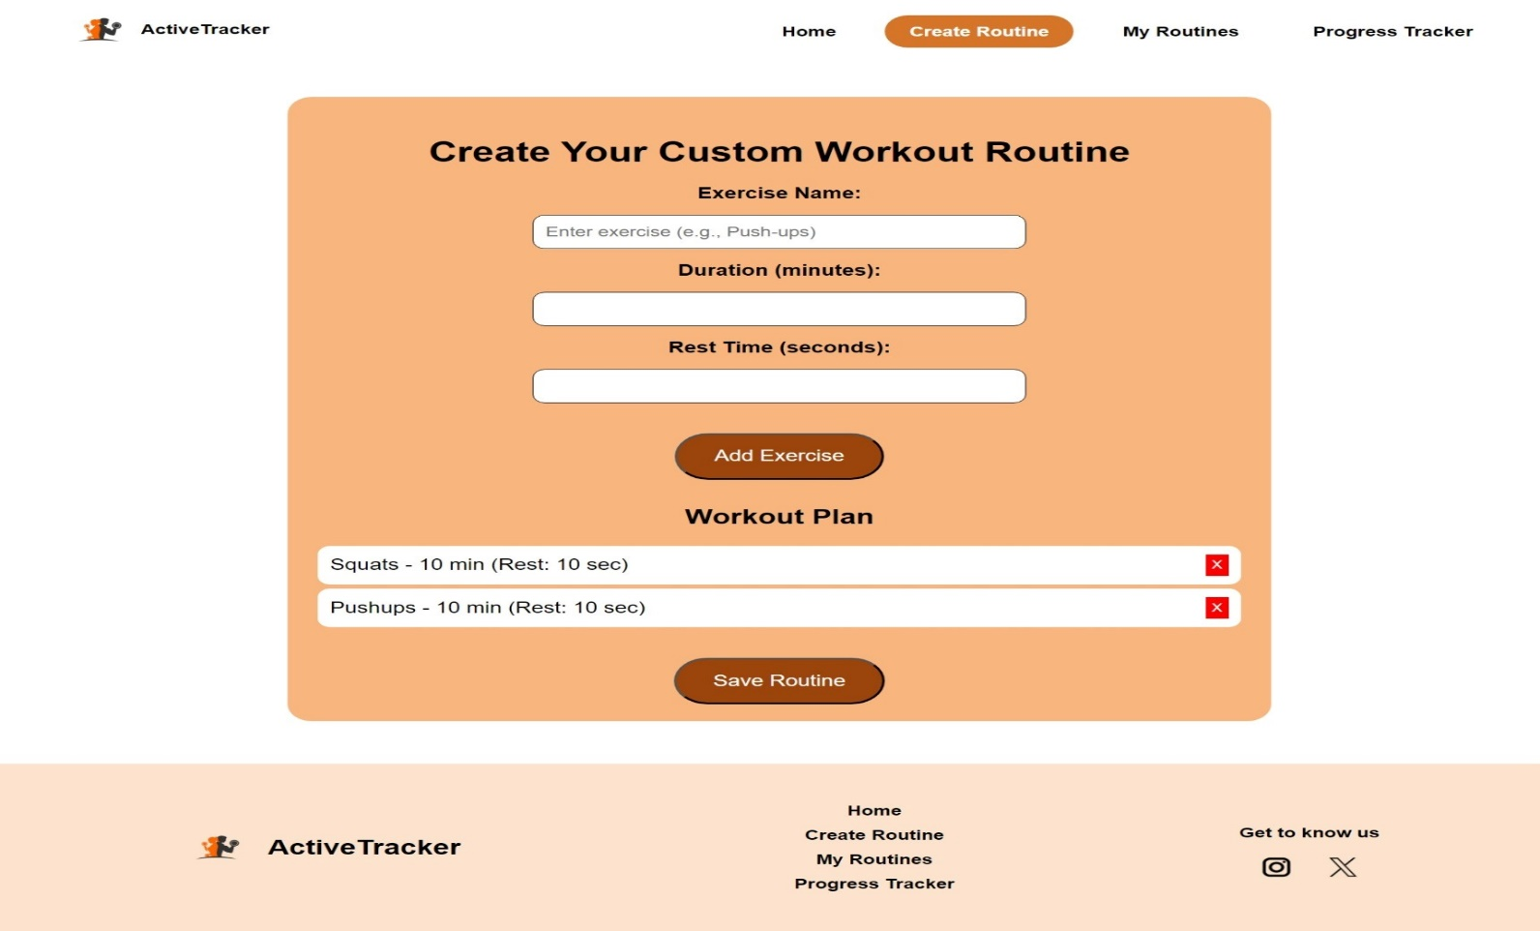

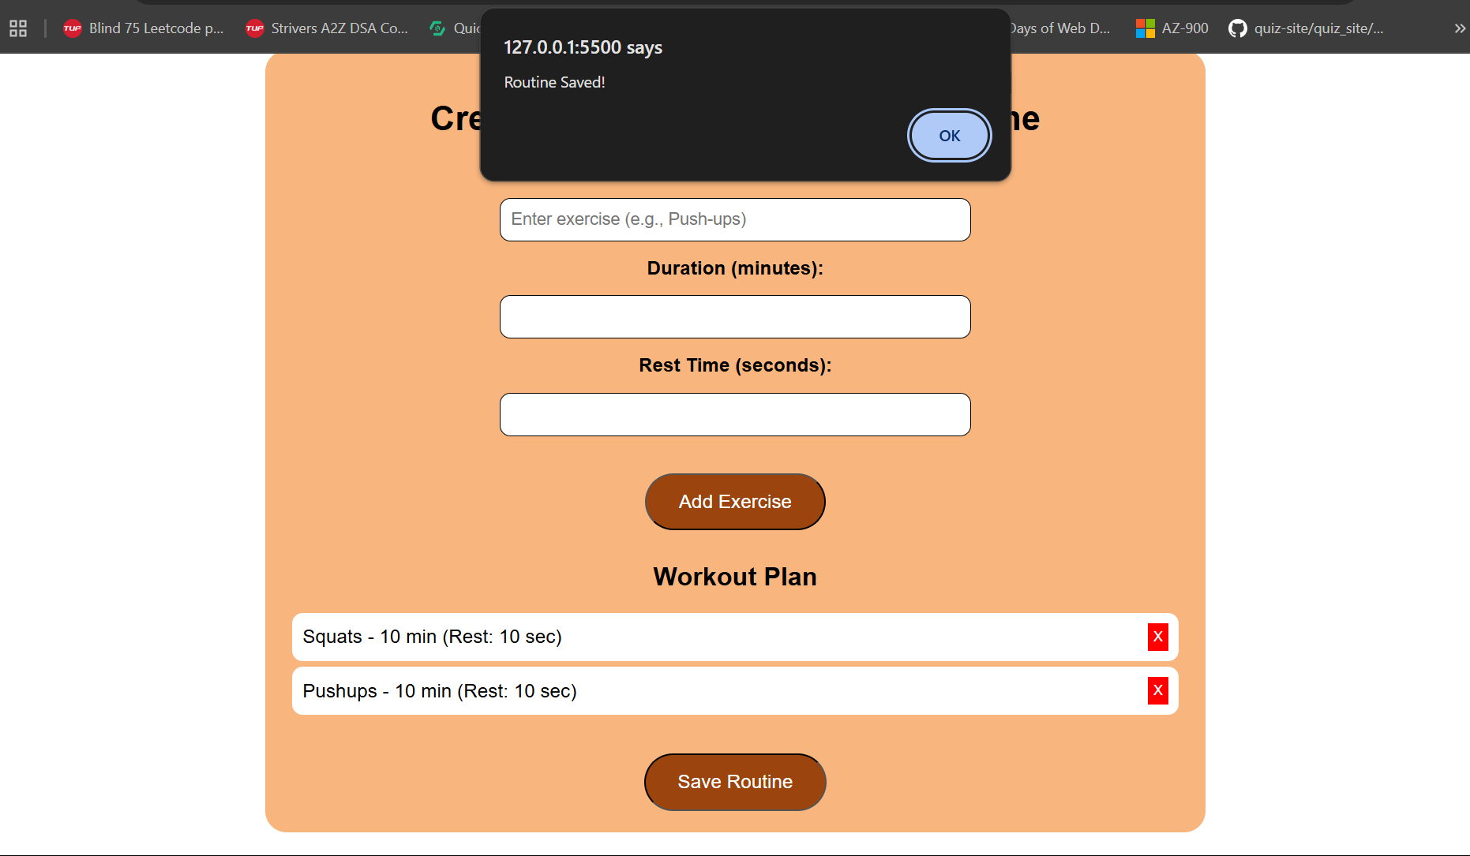

My Routines Page Structure

1. **MAIN SECTION -** Saved Workout Routines

* **Title:** "My Saved Routines"
* **Message Display:**
  + If no routines are saved: "No saved routines. Start by creating one!"
  + If routines are available, they are listed in an organized format.

1. **SAVED ROUTINES LIST**

* Each saved workout routine is displayed in a structured format;

**Example:**

Squats - 10 min (Rest: 10 sec)

Push-ups - 10 min (Rest: 10 sec)

* **Buttons for Each Exercise:**
  + Complete: Marks an exercise as completed (adds a strikethrough effect).
  + Edit: Allows the user to rename the exercise via a prompt input.
  + Delete: Removes the exercise from the list.
* **Drag-and-Drop Functionality:** Users can reorder exercises to customize their workout sequence.

1. **CLEAR ALL ROUTINES BUTTON**

* A large "Clear All Routines" button removes all saved workouts.

1. **FUNCTIONALITIES**

* **Edit Exercise:** Clicking "Edit" prompts the user to edit the exercise.
* **Delete Exercise:** Clicking "Delete" removes the selected exercise.
* **Mark as Completed:** Clicking "Complete" applies a strikethrough effect to the exercise name.
* **Undo Completion:** When an exercise is marked as completed, an "Undo" button appears to revert the status.
* **Rearrange Exercises:** Users can drag and drop exercises to change their order.

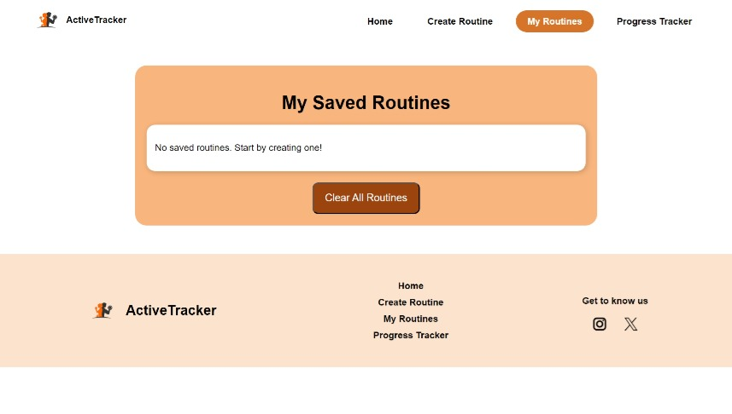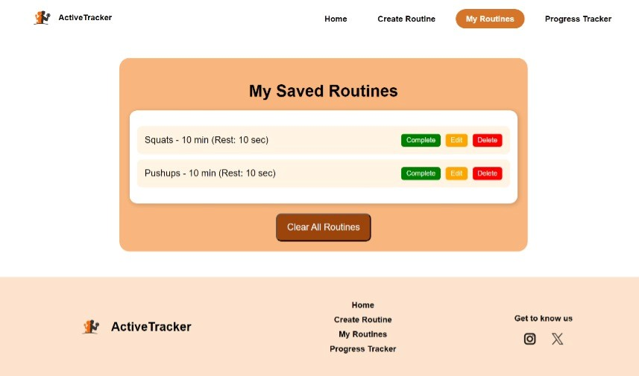

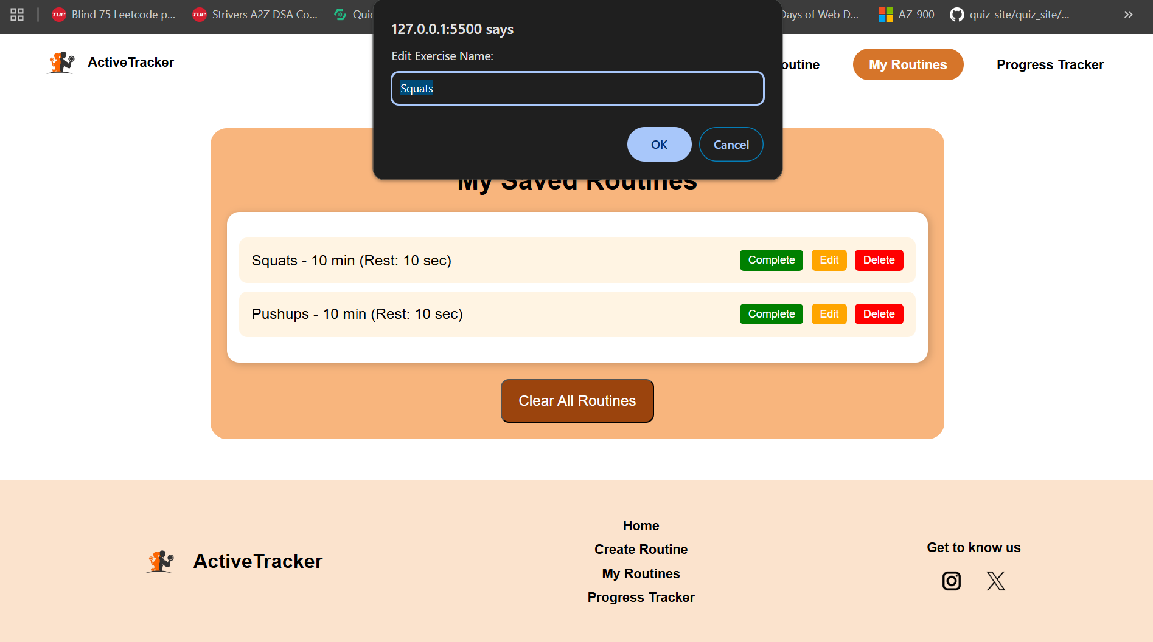

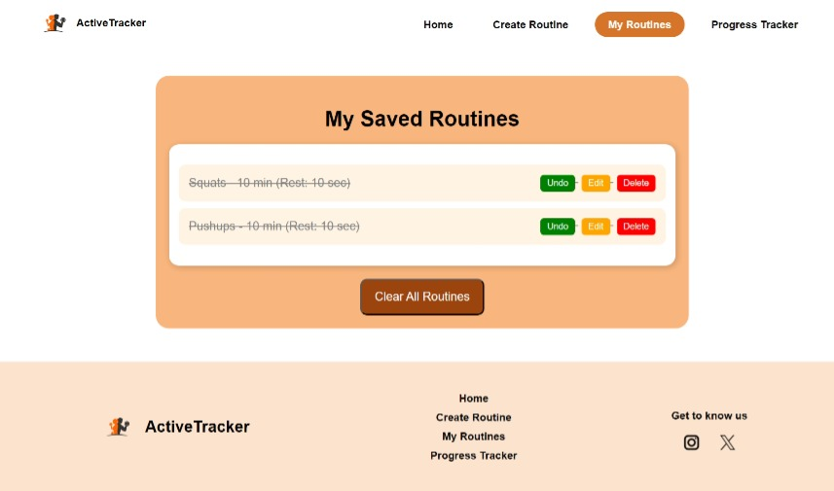

Progress Tracker Page Structure

**1. MAIN SECTION -** Workout Progress Tracking

* **Title:** "Workout Progress Tracker"
* **Workout History:**
  + Initially: Displays "No workout history available."
  + After Logging Workouts: Lists past workout entries in the format:
    - *Example:* 2025-02-23: Push-ups - 10 min
    - Each entry has a red "X" button to delete it.
* **Log Your Workout Form:**
  + **Date:** Date picker input field *(format: dd-mm-yyyy)*
  + **Exercise:** Text input field *(placeholder: "E.g., Push-ups")*
  + **Duration:** Numeric input field *(minutes)*
  + **Add Workout Button:** Adds the entered workout to history.
  + **Validation:** If any field is empty, an error message "Please enter the field" appears.

**2. VISUAL PROGRESS SECTION**

* **Charts:**
  + **Bar Chart:** Displays workout durations for different dates.
  + **Pie Chart:** Shows proportions of different exercises logged.

**3. FUNCTIONALITIES**

* **Add Workout:** Users enter the exercise details and click "Add Workout" to list it under "Workout History."
* **Remove Workout:** Clicking the red "X" deletes the selected workout from the history.
* **Visual Representation:** Updates the charts dynamically to reflect logged workouts.

