The Giant Panda

The giant panda, which only lives in China outside of captivity, has captured the hearts of people of all ages across the globe. From their furry black and white bodies to their shy and docile nature, they are considered one of the world's most loved animals.

# Intriguing Giant Panda Mysteries

While most adore their fluffy fur and round heads, which help give them their cuddly bear quality, others are fascinated by the many mysteries of the giant panda. Did you know that the giant panda may actually be a raccoon, they have an opposable pseudo thumb, and that they’re technically a [carnivore](https://en.wikipedia.org/wiki/Carnivore) even though their diet is primarily vegetarian? These things and more have baffled scientists and naturalists for hundreds of years.

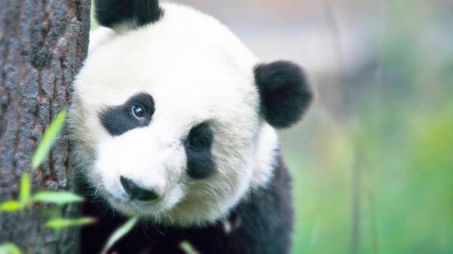

**Quick Fact** The estimated number of giant pandas in the wild varies between 1,500 and 3,000.

## Opposable Pseudo Thumb

A characteristic of the giant panda that has mystified scientists is their movable, elongated wrist bone that acts like an opposable thumb. This human-like quality that helps give them even more of a cuddly-bear appearance enables the giant panda to pick up objects and even eat sitting up.



**Quick Fact** Giant pandas have five clawed toes and one pseudo thumb.