WEB TESTING SELENIUM-CC2

KALAIVARSHAA GR

727721EUIT064

1]

package PackageCC2;

import org.openqa.selenium.By;

import org.openqa.selenium.WebDriver;

import org.openqa.selenium.chrome.ChromeDriver;

import org.openqa.selenium.chrome.ChromeOptions;

import org.testng.annotations.Test;

import io.github.bonigarcia.wdm.WebDriverManager;

public class partA {

WebDriver d;

*@Test*

public void f() throws InterruptedException {

ChromeOptions co=new ChromeOptions();

co.addArguments("--remote-allow-origins=*");

WebDriverManager.*chromedriver*().setup();

d=new ChromeDriver(co);

d.get("https://www.yatra.com/flights");

d.manage().window().maximize();

Thread.*sleep*(4000);

[d.findElement(By.*xpath*("//*[@id=\"booking_engine_flights\"]")).click](mailto:d.findElement(By.xpath("//*[@id=\"booking_engine_flights\"]")).click)();

Thread.*sleep*(2000);

[d.findElement(By.*xpath*("//*[@id=\"BE_flight_form_wrapper\"]/div[1]/div[1]/ul[1]/li[2]/a")).click](mailto:d.findElement(By.xpath("//*[@id=\"BE_flight_form_wrapper\"]/div[1]/div[1]/ul[1]/li[2]/a")).click)();

Thread.*sleep*(2000);

[d.findElement(By.*xpath*("//*[@id=\"BE_flight_origin_city\"]")).click](mailto:d.findElement(By.xpath("//*[@id=\"BE_flight_origin_city\"]")).click)();

Thread.*sleep*(2000);

[d.findElement(By.*xpath*("//*[@id=\"BE_flight_form_wrapper\"]/div[1]/div[2]/ul/li[1]/ul/li[1]/div/div/ul/div/div/div/li[3]")).click](mailto:d.findElement(By.xpath("//*[@id=\"BE_flight_form_wrapper\"]/div[1]/div[2]/ul/li[1]/ul/li[1]/div/div/ul/div/div/div/li[3]")).click)();

Thread.*sleep*(2000);

[d.findElement(By.*xpath*("//*[@id=\"BE_flight_form_wrapper\"]/div[1]/div[2]/ul/li[1]/ul/li[3]/div/div/ul/div/div/div/li[4]")).click](mailto:d.findElement(By.xpath("//*[@id=\"BE_flight_form_wrapper\"]/div[1]/div[2]/ul/li[1]/ul/li[3]/div/div/ul/div/div/div/li[4]")).click)();

Thread.*sleep*(2000);

[d.findElement(By.*xpath*("//*[@id=\"BE_flight_origin_date\"]")).click](mailto:d.findElement(By.xpath("//*[@id=\"BE_flight_origin_date\"]")).click)();

Thread.*sleep*(2000);

[d.findElement(By.*xpath*("//*[@id=\"20/04/2023\"]")).click](mailto:d.findElement(By.xpath("//*[@id=\"20/04/2023\"]")).click)();

Thread.*sleep*(2000);

[d.findElement(By.*xpath*("//*[@id=\"BE_flight_arrival_date\"]")).click](mailto:d.findElement(By.xpath("//*[@id=\"BE_flight_arrival_date\"]")).click)();

Thread.*sleep*(2000);

[d.findElement(By.*xpath*("//*[@id=\"24/04/2023\"]")).click](mailto:d.findElement(By.xpath("//*[@id=\"24/04/2023\"]")).click)();

Thread.*sleep*(2000);

[d.findElement(By.*xpath*("//*[@id=\"BE_flight_paxInfoBox\"]/i")).click](mailto:d.findElement(By.xpath("//*[@id=\"BE_flight_paxInfoBox\"]/i")).click)();

Thread.*sleep*(2000);

[d.findElement(By.*xpath*("//*[@id=\"BE_flight_passengerBox\"]/div[1]/div[1]/div/div/span[2]")).click](mailto:d.findElement(By.xpath("//*[@id=\"BE_flight_passengerBox\"]/div[1]/div[1]/div/div/span[2]")).click)();

Thread.*sleep*(2000);

[d.findElement(By.*xpath*("//*[@id=\"flight_class_select_child\"]/ul/li[3]")).click](mailto:d.findElement(By.xpath("//*[@id=\"flight_class_select_child\"]/ul/li[3]")).click)();

Thread.*sleep*(2000);

[d.findElement(By.*xpath*("//*[@id=\"BE_flight_form_wrapper\"]/div[3]/div[1]/div[1]/a/i")).click](mailto:d.findElement(By.xpath("//*[@id=\"BE_flight_form_wrapper\"]/div[3]/div[1]/div[1]/a/i")).click)();

Thread.*sleep*(2000);

[d.findElement(By.*xpath*("//*[@id=\"BE_flight_flsearch_btn\"]")).click](mailto:d.findElement(By.xpath("//*[@id=\"BE_flight_flsearch_btn\"]")).click)();

}

}

CONSOLE:

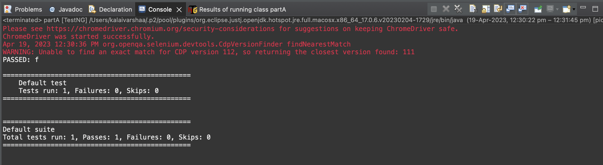

OUTPUT:

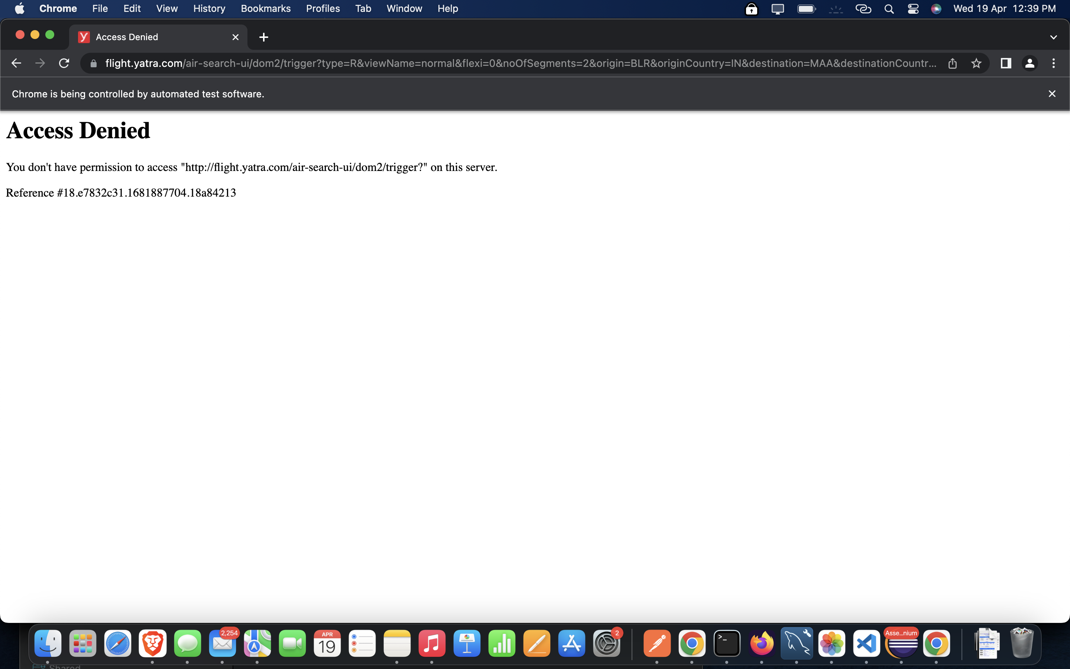

EMAILABLE:

