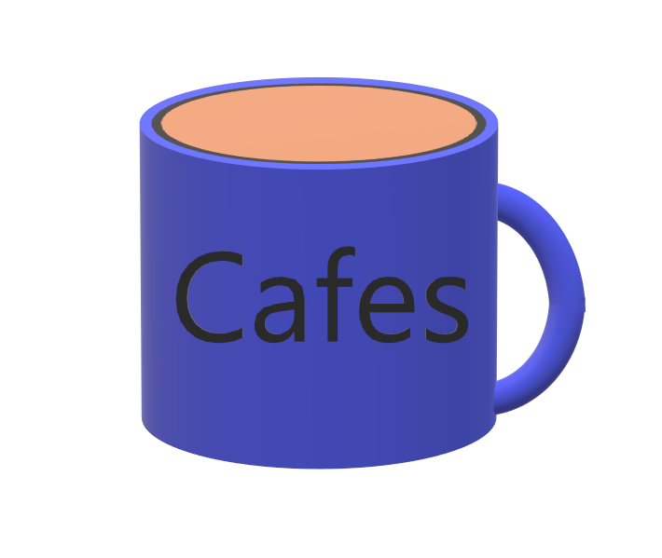

Cafes

Stymphalian

Request for Proposal  
Version 1.0

Document History

|  |  |  |  |
| --- | --- | --- | --- |
| Version | When | Who | What |
| 1.0 | 9/16/21 | Riley Doyle, Kyle LaDoux, Trevor McGeary, Jon Kopf, Hunter Leppek, Ross Prestwich | Initial Drafting |
|  |  |  |  |

Table of Contents

1. Problem description
2. Project Objectives
3. Current System(s) – if any or similar systems
4. Intended users and their interaction with the system
5. Known interactions with other systems inside/outside the client organization
6. Known constraints to development
7. Project Schedule
8. How to Submit Proposals
9. Dates
10. Glossary of terms
11. Problem description / opportunity / expression of need

The intended goal of this project is to create a fun, RPG style game based on ancient Greek mythology. Stymphalian features the character “Telephus” traveling around the island of Island of Aretias in order to gather the resources to fight the last Stymphalian birds. The player will be thrown into a combination of classic RPG style combat combined with fun minigames. Cafes believes that there is a high demand for this style of game which allows players to relive the style of games they grew up with but with some new twists.

1. Project Objectives

Cafes is searching for a team to build a single player RPG game with Greek mythological themes. The game should have items and NPC’s the player can interact with as well as different equipment.

The game should have the following features:

* Mythological creature minigame
  + Unique for each creature.
  + Made easier through quest items.
  + Stymphalian fight requires blood of a hydra
* Quests
  + Main questline as well as optional quests.
  + Multiple vectors to obtain quests.
  + Items to be received by other quests.
* Items
  + Interactable items on the map.
  + Inventory for storage of items and equipment.
  + Equipment player can equip to gain advantages
* NPC Shop
  + Spend gold to receive items and equipment.
  + Shops progressively start selling better items.
* Save / Load
  + Save the players progress at any time.
  + Load a save game from the main menu.
* Audio
  + Background music inspired by Greek themes.
  + SFX for player, enemies, NPCs, and other interactables.

Instead of a traditional retro RPG fight, each mythological creature should feel unique. Part of achieving this goal is having a memorable encounter with each creature. The minigame is a large part in the identity of every mythological creature’s encounter.

Quests are also a large driver of RPG style games. It is important that these quests have some story for the player. It should describe the mythology of the creature the player is hunting, and also tie it into the story of the game.

1. Current system(s) – if any / similar systems

Our game will be a 2D top-down RPG. There are many games that take on this format. The player must go around and level up their gear to be able to battle enemies. Many older games, like Pokémon and the original Zelda, are good examples of this type of game. Our game will be similar to Pokémon gameplay-wise with the overworld style and turned based battle scenarios.

There are also many games based on Greek Mythology: God of War being a very popular example. While our story may be based on Greek Mythology, it will not follow the myths closely, rather simply use them as a base for the player to get into their role.

1. Intended users and their basic interaction with the system

We intend our game to be played by casual RPG lovers. The Greek mythology will also attract another type of gamer. The player’s interaction includes epic battles with mythical beasts and learning about the famed Stymphalian.

Users

* Many different types of RPG players, ranging from little to no experience to highly experienced gamers.

Uses

* Keyboard and mouse to control basic player interactions.
* Saving and loading game

1. Known interactions with other systems within or outside of the client organization.

External:

Stores we can put the game on

* Steam
* Google Play
* High Score Server

Internal:

Things our code will need to interact with

* Unity Engine
* Test Code

1. Known constraints to development
   * Time required to complete the project
   * Difficulty of coding
   * The tools to develop the project
   * The money to pay the development team
2. Project Schedule

|  |  |
| --- | --- |
| Date | Description |
| September 23rd, 2021 | Post RFP |
| September 30th, 2021 | Initial draft of code should compile and run. |
| October 7th, 2021 | Have two compiled paths, one for production and the other for testing. Both must run. |
| October 23rd, 2021 | Show running code resembling a video game with a few missing features. |
| October 28th, 2021 | Coding standards due. |
| November 4th, 2021 | Brief user manual for game due. |
| November 11th, 2021 | Final product due. |
| December 2nd, 2021 | Final presentation. |

1. How to submit proposals

Proposals must be submitted in pdf format to our proposals coordinator for Cafes, Kyle LeDoux, at proposals@cafes.org. All resumes of working employees must also be submitted at this time. Any questions can be sent to Kyle via the same email address. All questions will be reproduced and distributed to all applicants.

1. Dates

All proposals are to be submitted by 5:00pm PST on October 17th, 2021. All applicants with be notified when a decision is made on October 24th, 2021 at 5pm PST.

1. Glossary of Terms

Unity – A cross-platform game engine.

NPC – Non-playable character, a character in the game that the player does not control, can include enemies or friendly characters that help the player.

Interactable - A property of a game object that gives it some relationship with other game objects.

RPG - Role Playing Game, a game where the player assumes the role of a character.