VISHWAKARMA GOVERNMENT ENGINEERING
COLLEGE
Chandkheda, Ahmedabad



COMPUTER ENGINEERING
PBL ACTIVITY
MINI SYSTEM SOFTWARE TOOLKIT
Subject: System Software
Subject Code: BE05000261
Submitted By: | Kalal Prince Bhagwanlal
Enrollment No.: | 240170107055
Semester: | 5th
Batch: | G-1
Department: | Computer Engineering
Submitted To: | Prof. Karan P. Bhatt
Academic Year: | 2026–27

CERTIFICATE
This is to certify that the Project Based Learning (PBL) report entitled "MINI SYSTEM SOFTWARE TOOLKIT: Design and Implementation of an Integrated System Software Toolkit" is a work submitted by Kalal Prince Bhagwanlal Enrollment No: 240170107055 in partial fulfillment of the requirements for the degree of Bachelor of Engineering in Computer Engineering at Vishwakarma Government Engineering College, affiliated to the University, during the academic year 2026-27.
The project work has been carried out under our supervision and guidance and meets all standard academic requirements for software engineering methodology, architectural documentation, comprehensive module-by-module test verification, and practical systems implementation.
Place: ______________________
Date: ______________________

Signature of Faculty Member: ______________________

ACKNOWLEDGEMENT
I express my deepest gratitude to our project guide, Karan P. Bhatt, Department of Computer Engineering, for his continuous encouragement, valuable suggestions, and timely feedback throughout the design, implementation, and verification of this System Software Toolkit. His guidance in systems programming and compiler construction was instrumental in structuring the five core modules and integrating them into a complete educational translation system.
I also extend my sincere thanks to the Head of Department, Vishwakarma Government Engineering College, for providing laboratory facilities and academic support, and to all faculty members of the Computer Engineering Department who taught us core subjects including System Software, Compiler Design, and Software Engineering. Finally, I thank my family members and batchmates for their constant encouragement and support.

ABSTRACT
System software constitutes the essential layer of computer software managing hardware resources and establishing an execution bridge between high-level algorithmic source code and low-level machine architecture. Within undergraduate computer engineering curricula, foundational concepts such as lexical analysis, symbol table management, three-address code generation, machine-independent code optimization, and two-pass assembly translation are traditionally studied as isolated theoretical units. Students frequently encounter difficulty conceptualizing how these modules interact as an integrated whole, primarily due to the opacity and complexity of production compilers like GCC or Clang.
This project presents the "Mini System Software Toolkit", an educational, browser-accessible and menu-driven integrated translation system designed and implemented to demonstrate the end-to-end translation of a C-subset programming language into Simplified Instructional Computer (SIC) machine architecture object programs. The toolkit integrates five core System Software modules required for the PBL activity: (1) Lexical Analyzer, performing character scanning and token classification; (2) Symbol Table, providing scope-aware identifier storage and address management; (3) Quadruple Generator, using Dijkstra's Shunting-Yard algorithm to synthesize Three-Address Code (3AC) represented as standard Quadruple tuples (Operator, Arg1, Arg2, Result); (4) Machine-Independent Code Optimizer, implementing iterative constant folding, constant propagation, algebraic simplification, and Common Subexpression Elimination (CSE); and (5) Two-Pass Assembler, performing Location Counter (LOCCTR) tracking, symbol resolution, and generating educational Header (H), Text (T), and End (E) object program records. Supporting components such as ExpressionParser, CodeGenerator, and CompilerPipeline connect these modules into the complete translation flow.
To complement the translation engine, the toolkit provides two user interfaces: a zero-dependency interactive web dashboard and a menu-driven Node.js command-line interface (CLI). The dashboard provides an interactive source code editor, multi-preset sample loaders, real-time pipeline status monitoring, token tables with filtering, symbol table inspection, three-address code and quadruple tuple views, optimization transformation logs, formatted assembly listings, and one-click object code export. The CLI provides direct menu access to the five core modules, the complete compilation pipeline, the complete test suite, and dashboard launch instructions.
The complete toolkit implementation was verified through 9 automated test suites covering the core modules, compiler integration, web dashboard, and menu-driven CLI. The cumulative verification yielded an exact result of 505 / 505 assertions passed with 0 failures.
Keywords: System Software, Lexical Analysis, Symbol Table, Three-Address Code, Quadruples, Code Optimization, Constant Folding, Two-Pass Assembler, SIC Architecture, Object Records.

TABLE OF CONTENTS
CERTIFICATE 2
ACKNOWLEDGEMENT 3
ABSTRACT 4
CHAPTER 1: INTRODUCTION 7
CHAPTER 2: SYSTEM SOFTWARE CONCEPTS USED 8
CHAPTER 3: SYSTEM REQUIREMENTS 9
CHAPTER 4: SYSTEM ARCHITECTURE 10
CHAPTER 5: MODULE DESCRIPTION 11
CHAPTER 6: IMPLEMENTATION DETAILS 12
CHAPTER 7: ALGORITHMS 13
CHAPTER 8: USER INTERFACE / WEB DASHBOARD AND MENU DRIVEN CLI 15
CHAPTER 9: TESTING AND VALIDATION 18
CHAPTER 10: SAMPLE EXECUTION AND RESULTS 19
CHAPTER 11: ADVANTAGES AND LIMITATIONS 20
CHAPTER 12: FUTURE SCOPES 21
CHAPTER 13: CONCLUSION 21
REFERENCES 21
APPENDIX A — GITHUB REPOSITORY 21
APPENDIX B — PROJECT DIRECTORY STRUCTURE 22

LIST OF FIGURES
Figure 4.1 High-Level End-to-End System Software Pipeline Architecture 11
Figure 8.1 Main Dashboard and Source Program Editor 15
Figure 8.2 Source Program Editor and Canonical Sample 15
Figure 8.3 Lexical Tokens Stream 15
Figure 8.4 Scoped Symbol Table 16
Figure 8.5 Three-Address Code and Quadruple Representation 16
Figure 8.6 Code Optimization Analysis 16
Figure 8.7 Two-Pass Assembly Listing and SYMTAB 17
Figure 8.8 Menu-Driven CLI Main Menu and Module Selection 17
Figure 8.9 CLI Automated Verification Result — 505/505 Tests Passed 17
Figure 9.1 Successful Compilation Status in the Web Dashboard 18
Figure 10.1 Canonical Sample Program Loaded in the Web Dashboard 19

LIST OF TABLES
Table 2.1 Representative SIC Machine Opcode Table (OPTAB) Specifications 9
Table 3.1 System Hardware Specifications 9
Table 3.2 Functional Requirements Specification Matrix 10
Table 6.1 Algebraic Simplification Transformation Rules 13
Table 9.1 Comprehensive Automated Test Suite Verification Results 18
Table 10.1 Canonical Pipeline Execution Step-by-Step Metrics 19
Table 10.2 Two-Pass Assembly Listing for Canonical Program 20

CHAPTER 1: INTRODUCTION
1.1 Background
Computers operate fundamentally on binary machine instructions encoded as voltage patterns and numerical opcodes. However, computer software is almost universally engineered using high-level programming languages such as C, C++, Java, or Python. High-level languages provide abstraction mechanisms, expressive syntax, and hardware independence, enabling software engineers to reason about complex algorithms without being bogged down by processor registers, instruction formats, memory addressing modes, or binary encodings. The critical system components enabling this abstraction are compilers and assemblers, collectively known as language processors or system translation software.
Understanding how high-level programmatic logic is translated step-by-step into executable machine code is one of the cornerstone disciplines of Computer Engineering. However, standard production tools such as GCC, Clang, or NASM operate as black boxes, prioritizing execution speed and compilation throughput over instructional transparency. Consequently, students studying system software often understand individual components theoretically but may not observe how tokens, symbol tables, intermediate representations, and assembly listings are combined into a final object program.
1.2 Introduction to System Software
System software comprises computer software designed to operate, control, and extend the processing capabilities of the computer hardware itself. In this project, we focus primarily on two foundational language processors: compilers and assemblers. A compiler translates source programs written in high-level programming languages into lower-level representations, performing lexical analysis, syntactic validation, intermediate code generation, and machine-independent optimization. An assembler subsequently translates symbolic assembly language mnemonics and memory labels into actual machine code and structured object programs.
1.3 Need for the Project
During classroom study of System Software and Compiler Construction, students encounter persistent challenges:
- Theoretical Abstraction vs Practical Visibility: Textbook algorithms for scanning, symbol tables, Shunting-Yard parsing, constant folding, and two-pass assembly are frequently studied on paper, leaving students disconnected from end-to-end implementations.
- Opacity of Production Compilers: Industrial compilers consist of millions of lines of code, making it difficult for students to inspect the intermediate data structures produced between different translation components.
- Lack of Integrated Tooling: Most educational tools isolate single components without providing a cohesive pipeline where the output of the compiler directly drives an assembler.
- Absence of Visual Inspection: Students lack interactive platforms where modifying a source expression immediately visualizes updated token streams, symbol addresses, quadruple tuples, optimization metric changes, and object records side-by-side.
1.4 Problem Statement
"To design, implement, and verify a modular, educational System Software Toolkit that accepts statements in a subset of the C programming language, executes a transparent integrated compilation and assembly pipeline--comprising Lexical Analysis, Symbol Table Management, Intermediate Code Generation via Quadruples, Machine-Independent Optimization, and Two-Pass Assembly targeting the Simplified Instructional Computer (SIC) architecture--and provides both an automated, verified Node.js test infrastructure and an interactive web dashboard for real-time inspection of all intermediate data structures and final object code."
1.5 Objectives & Scope
The project objectives include: (1) Developing a scope-aware Symbol Table; (2) Building a character-level Lexical Analyzer; (3) Synthesizing Quadruple Four-Tuples via Shunting-Yard parsing; (4) Implementing multi-pass Constant Folding, Propagation, Algebraic Simplification, and CSE; (5) Constructing a Leland Beck Two-Pass Assembler emitting standard Header, Text, and End records; (6) Providing a responsive zero-dependency educational web dashboard; (7) Providing a menu-driven Node.js CLI integrating the five core System Software modules; and (8) Achieving 100% test verification (505/505 passed).
The project scope focuses on educational clarity and conceptual fidelity. The input language is a defined subset of C supporting primitive variable declarations (int, float, char, double, void), variable assignments, and complex arithmetic expressions with operator precedence and nested parentheses. The target machine architecture is the classical Simplified Instructional Computer (SIC) created by Leland L. Beck.
1.6 Technologies Used
- Core Language: JavaScript (ECMAScript 2022+ / ES Modules) for functional, object-oriented execution.
- Runtime Engine: Node.js (v18+ / v20+ / v22+) for automated testing and server execution.
- Server Architecture: Native Node.js 'http', 'fs', and 'path' modules, implementing a lightweight static file server (server.js).
- Front-End Presentation: HTML5 semantic markup, Vanilla CSS3 with custom variables, and client-side JavaScript (app.js).
- Target Architecture Model: Simplified Instructional Computer (SIC) architecture specification from Leland L. Beck.
CHAPTER 2: SYSTEM SOFTWARE CONCEPTS USED
This chapter reviews the fundamental system software concepts represented in the toolkit, explaining each concept first in simple theoretical terms and then describing its exact implementation in the project.
2.1 Symbol Table
Concept: In simple terms: A symbol table is a central dictionary maintained by a compiler and assembler to record information about identifiers (variable names, constants, labels) encountered in the source code. For every symbol, the table stores attributes such as its data type, storage size in bytes, memory address or offset, line of declaration, and subsequent lines where the symbol is referenced.
Implementation: Implementation in this Project: Our toolkit implements the SymbolTable class (src/core/SymbolTable.js). The table maintains a JavaScript Map indexed by composite keys ('${scope}::${name}') to support scope awareness. Memory offsets are automatically incremented based on data type sizes (int = 4 bytes, char = 1 byte). Duplicate declarations within the same scope are detected and rejected, while undeclared references trigger descriptive errors. A polynomial rolling hash function (H = (H * 31 + charCode) % tableSize) is also provided for viva and educational hashing demonstrations.
2.2 Lexical Analysis
Concept: In simple terms: Lexical analysis (or scanning) reads the source program character-by-character, strips whitespace and comments, and groups characters into meaningful tokens (KEYWORD, IDENTIFIER, INTEGER CONSTANT, OPERATOR, DELIMITER).
Implementation: Implementation in this Project: The Lexer class (src/core/Lexer.js) performs single-pass scanning. It tracks line and column coordinates precisely, handles single-line ('//') and multi-line ('/* ... */') comments, detects string literals, recognizes multi-character operators ('==', '!=', '+=', '&&'), validates identifiers against reserved keywords, and interacts with the SymbolTable to register variable declarations.
2.3 Intermediate Code, Three Address Code & Quadruples
Concept: In simple terms: Before generating target machine instructions, compilers linearize complex expressions into Three-Address Code (3AC) where each instruction has at most one operator and three addresses. A Quadruple is a standardized four-tuple record: (Operator, Arg1, Arg2, Result).
Implementation: Implementation in this Project: The ExpressionParser extracts statements, and QuadrupleGen (src/core/QuadrupleGen.js) uses Dijkstra's Shunting-Yard algorithm to convert infix expressions to postfix, synthesizing Quadruple tuples like ('*', 'b', 'c', 't1') and human-readable 3AC strings like 't1 = b * c'.
2.4 Code Optimization
Concept: In simple terms: Code optimization transforms intermediate code to execute faster or use less memory without changing program semantics. Key machine-independent optimizations include Constant Folding (compile-time math), Constant Propagation (substituting known values), Algebraic Simplification (x + 0 = x, x * 0 = 0), and Common Subexpression Elimination (CSE).
Implementation: Implementation in this Project: The CodeOptimizer class (src/core/CodeOptimizer.js) executes iterative fixed-point optimization passes. It evaluates numeric arithmetic at compile time, propagates constants, reduces algebraic identities, and eliminates common subexpressions with commutative operator normalization ('a + b' equals 'b + a').
2.5 Two-Pass Assembly & Object Program Generation
Concept: In simple terms: A Two-Pass Assembler solves the forward reference problem by separating translation: Pass 1 calculates instruction addresses using a Location Counter (LOCCTR) and builds the Symbol Table (SYMTAB); Pass 2 resolves symbols and generates hexadecimal machine code. The object program consists of Header (H), Text (T), and End (E) records.
Implementation: Implementation in this Project: The Assembler class (src/core/Assembler.js) implements Beck's algorithm. It handles directives (START, END, WORD, BYTE, RESW), translates instructions using OPTAB (Table 2.1), and groups object code bytes into Text records (up to 30 bytes) with caret ('^') delimiters.
Table 2.1: Representative SIC Machine Opcode Table (OPTAB) Specifications
Mnemonic | Opcode (Hex) | Length | Description / RTL Action
LDA | 00 | 3 Bytes | Load Accumulator: A <- (m..m+2)
STA | 0C | 3 Bytes | Store Accumulator: m..m+2 <- (A)
ADD | 18 | 3 Bytes | Add: A <- (A) + (m..m+2)
SUB | 1C | 3 Bytes | Subtract: A <- (A) - (m..m+2)
MUL | 20 | 3 Bytes | Multiply: A <- (A) * (m..m+2)
DIV | 24 | 3 Bytes | Divide: A <- (A) / (m..m+2)
COMP | 28 | 3 Bytes | Compare: CC <- (A) : (m..m+2)
J | 3C | 3 Bytes | Unconditional Jump: PC <- m
JEQ | 30 | 3 Bytes | Jump Equal: PC <- m if CC is ==
HLT | FF | 3 Bytes | Halt Execution directive / instruction
CHAPTER 3: SYSTEM REQUIREMENTS
This chapter details the hardware, software, runtime, and functional requirements necessary to execute and verify the toolkit.
Table 3.1: System Hardware Specifications
Parameter | Minimum Specification | Recommended Specification
Processor (CPU) | Intel Core i3 / AMD Ryzen 3 (2.0 GHz) | Intel Core i5 / AMD Ryzen 5 / Apple Silicon (2.5 GHz+)
System Memory (RAM) | 4 GB DDR3 / DDR4 | 8 GB DDR4 or higher
Storage Space | 200 MB free disk space | 500 MB free space
Display Resolution | 1280 x 720 (720p HD) | 1920 x 1080 (1080p FHD) for multi-tab layout
Operating System | Windows 10/11, Ubuntu 20.04+, macOS 12+ | Windows 11 (64-bit) / Modern Linux
3.1 Software & Runtime Requirements
The software stack requires Node.js v18.0.0 or higher (tested on Node.js v20.x/v22.x) and any modern web browser (Google Chrome 100+, Mozilla Firefox 100+, Microsoft Edge 100+). All modules are authored as pure native ECMAScript Modules (ESM) with zero third-party npm runtime dependencies, ensuring completely offline execution and high portability.
3.2 Functional Requirements
Table 3.2: Functional Requirements Specification Matrix
Req ID | Functional Requirement | Target Module | Compliance Status
FR-1 | Tokenize source statements with line/col coordinates | Lexer.js | VERIFIED (51 Tests)
FR-2 | Scope-aware Symbol Table with type sizing and reference tracking | SymbolTable.js | VERIFIED (27 Tests)
FR-3 | Parse expressions and convert infix to postfix via Shunting-Yard | QuadrupleGen.js | VERIFIED (57 Tests)
FR-4 | Generate standardized 4-tuple Quadruples and linear 3AC | QuadrupleGen.js | VERIFIED (57 Tests)
FR-5 | Perform compile-time Constant Folding on numeric arithmetic | CodeOptimizer.js | VERIFIED (42 Tests)
FR-6 | Apply Algebraic Simplification rules (+0, *1, *0, etc.) | CodeOptimizer.js | VERIFIED (42 Tests)
FR-7 | Perform Common Subexpression Elimination with commutative keys | CodeOptimizer.js | VERIFIED (42 Tests)
FR-8 | Translate optimized quadruples into valid SIC assembly language | CodeGenerator.js | VERIFIED (46 Tests)
FR-9 | Execute Pass 1 and Pass 2 SIC assembly generating H, T, E records | Assembler.js | VERIFIED (58 Tests)
FR-10 | Interactive Web Dashboard with tabbed views and preset loaders | app.js / index.html | VERIFIED (75 Tests)
FR-11 | Menu-driven CLI integrating the five core System Software modules | cli.js | VERIFIED (81 Tests)
3.3 Non-Functional Requirements
- Performance: The toolkit is designed for interactive educational use and provides fast compilation for the small C-subset programs supported by the project.
- Modularity: Every compiler module is encapsulated in an isolated class with strictly defined inputs and outputs.
- Deterministic Execution: Given identical source input, compilation produces identical token streams, addresses, and object records every time.
- Error Isolation: Syntactic or lexical errors stop compilation immediately, providing exact line/column coordinates and preventing corrupt downstream outputs.
CHAPTER 4: SYSTEM ARCHITECTURE
The architecture of the Mini System Software Toolkit follows a decoupled, module-driven pipeline pattern. Figure 4.1 illustrates the complete translation flow from high-level C-subset source statements down to structured SIC object program records.
+------------------------------------------------------------------+
| SOURCE CODE |
| (C-subset program) |
+------------------------------------------------------------------+
|
v
+------------------------------------------------------------------+
| LEXICAL ANALYZER & SYMBOL TABLE |
| Tokenization, declaration tracking, scope and addresses |
+------------------------------------------------------------------+
|
v
+------------------------------------------------------------------+
| QUADRUPLE GENERATOR |
| Expression parsing, Shunting-Yard, 3AC and quadruples |
+------------------------------------------------------------------+
|
v
+------------------------------------------------------------------+
| CODE OPTIMIZER |
| Constant folding, propagation, simplification and CSE |
+------------------------------------------------------------------+
|
v
+------------------------------------------------------------------+
| TARGET CODE GENERATOR + ASSEMBLER |
| SIC assembly, symbol resolution and H / T / E records |
+------------------------------------------------------------------+
|
v
+------------------------------------------------------------------+
| OBJECT PROGRAM |
| Educational SIC object records |
+------------------------------------------------------------------+

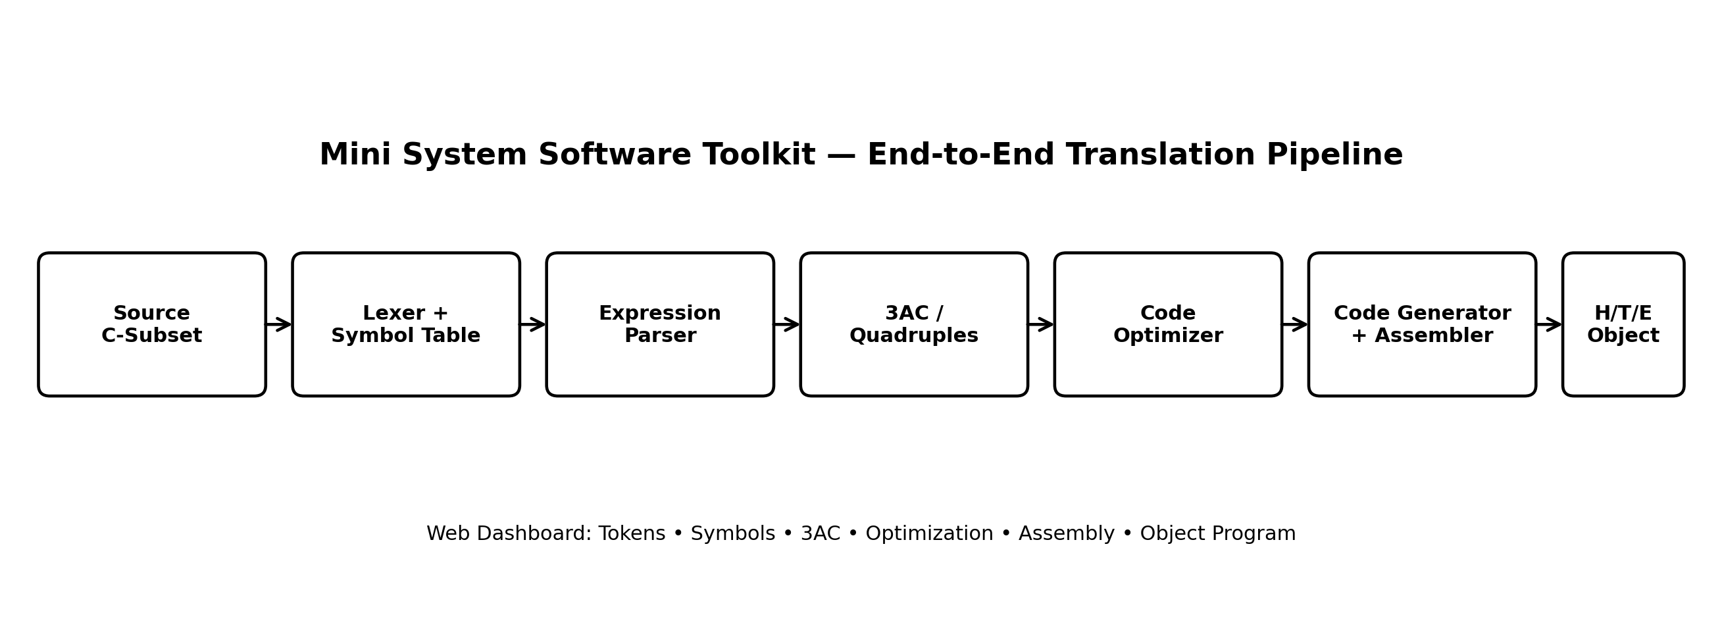
Figure 4.1 High-Level End-to-End System Software Pipeline Architecture
4.1 Component Roles & Interactivity
The architecture consists of five core System Software modules supported by additional translation and interface components. The core modules are the Lexical Analyzer, Symbol Table, Quadruple Generator, Code Optimizer, and Two-Pass Assembler. Supporting components such as the ExpressionParser, CodeGenerator, and CompilerPipeline connect these modules into a complete translation flow. The system is accessible through two interfaces: the interactive web dashboard and the menu-driven Node.js CLI.
CHAPTER 5: MODULE DESCRIPTION
This chapter describes each major module in the toolkit based directly on the actual source code.
5.1 Constants (src/utils/Constants.js)
- Purpose & Input: Defines shared language types (DATA_TYPES: int, float, char, double, void), reserved keywords, status codes, and token categories (TOKEN_TYPES).
- Processing & Output: Provides helper functions getTypeSize(type), isKeyword(word), and isValidIdentifier(name) using regex /^[a-zA-Z_][a-zA-Z0-9_]*$/.
5.2 Symbol Table (src/core/SymbolTable.js)
- Purpose & Input: Manages identifier records (SymbolEntry) across compilation. Accepts variable names, types, scopes, and declaration lines.
- Processing & Output: Uses composite keys ('${scope}::${name}') in a Map. Auto-increments memory offsets based on type sizes, tracks reference lines, and provides polynomial rolling hash demonstration.
5.3 Lexer (src/core/Lexer.js)
- Purpose & Input: Scans raw source code strings character-by-character into classified Token instances.
- Processing & Output: Strips whitespace and comments (// and /* */), classifies numeric literals, detects multi-char operators (==, !=, +=, &&), links declared identifiers to the SymbolTable, and pinpoints coordinates.
5.4 Expression Parser (src/core/ExpressionParser.js)
- Purpose & Processing: Splits token streams into statements delimited by ';', classifies statements into DECLARATION, ASSIGNMENT, or EXPRESSION, and extracts executable expressions for intermediate code generation.
5.5 Quadruple Generator (src/core/QuadrupleGen.js)
- Purpose & Processing: Converts arithmetic expressions into Quadruples (op, arg1, arg2, result) using Dijkstra's Shunting-Yard algorithm (infix to postfix) and an evaluation stack, generating linear Three-Address Code.
5.6 Code Optimizer (src/core/CodeOptimizer.js)
- Purpose & Processing: Applies iterative fixed-point optimization passes: Constant Folding, Constant Propagation, Algebraic Simplification (+0, *1, *0, etc.), and Common Subexpression Elimination with commutative operand sorting.
5.7 Code Generator (src/core/CodeGenerator.js)
- Purpose & Processing: Translates optimized quadruples into valid SIC assembly language using accumulator instructions (LDA, STA, ADD, SUB, MUL, DIV, HLT) and reserves storage via RESW and WORD.
5.8 Assembler (src/core/Assembler.js)
- Purpose & Processing: Executes Leland Beck's two-pass algorithm. Pass 1 maintains Location Counter (LOCCTR) and builds SYMTAB. Pass 2 synthesizes hexadecimal object code via OPTAB and formats Header, Text, and End records.
5.9 Compiler Pipeline (src/core/CompilerPipeline.js)
- Purpose & Processing: Master orchestrator invoking all five modules in sequence. Enforces module isolation, ensuring errors in earlier modules abort downstream processing immediately.
5.10 Web Dashboard (index.html, style.css, app.js, server.js)
- Purpose & Processing: Provides zero-dependency browser interface hosted by native Node.js HTTP server. Binds editor controls, visualizes module status, and renders tabbed views for tokens, symbols, 3AC, optimization, listing, and object code.
5.11 Menu-Driven Command-Line Interface (cli.js)
Purpose & Processing: The CLI provides a menu-driven interface required for integrating the five core System Software modules. Menu options invoke the existing Lexer, SymbolTable, QuadrupleGen, CodeOptimizer, Assembler, and CompilerPipeline implementations. Additional options execute the complete automated test suite or display instructions for launching the web dashboard. The CLI contains no duplicated compiler algorithms and uses Node.js standard facilities for interactive input.
5.12 PBL Requirement Compliance
The menu-driven CLI satisfies the PBL requirement of integrating at least five independent System Software modules through a single menu-based interface. The interface provides direct access to the Lexical Analyzer, Symbol Table, Quadruple Generator, Code Optimizer, and Two-Pass Assembler, along with an option for executing the complete translation pipeline.
CHAPTER 6: IMPLEMENTATION DETAILS
This chapter examines the internal implementation mechanisms of the toolkit. Only features that are actively implemented are documented.
6.1 Symbol Table & Lexical Scanning
The SymbolTable maintains identifier entries inside a JavaScript Map using composite keys ('${scope}::${name}'). When a variable declaration is encountered by the Lexer ('int a;'), the Lexer registers the identifier, assigning the current memory offset (e.g. 1000) and advancing the offset by the type's size (4 bytes). The Lexer maintains exact line and column coordinates, correctly skipping single-line and multi-line comments. Unrecognized characters (such as '@') are caught and reported as lexical errors.
6.2 Intermediate Code & Quadruples
Intermediate code generation employs Dijkstra's Shunting-Yard algorithm. Infix tokens are reordered into postfix notation respecting operator precedence (* and / have precedence 2; + and - have precedence 1). During postfix evaluation, an operand stack pops arguments when an operator is encountered, creating a Quadruple with a new compiler temporary variable ('t1', 't2') and pushing the temporary back onto the stack. If an assignment was present ('result = ...'), a final copy assignment quadruple ('=', tempResult, null, 'result') is appended.
6.3 Optimization Mechanics
The CodeOptimizer executes up to 5 iterative passes until no changes occur. In each pass: (1) Constant Folding checks if both operands are numeric (isNumeric()); if so, it computes the result at compile time (checking for div-by-zero); (2) Constant Propagation stores known constant values in a map and substitutes them into subsequent quadruples; (3) Algebraic Simplification checks mathematical identities (Table 6.1); and (4) Common Subexpression Elimination hashes expressions with commutative operand sorting ('+:a:b' == '+:b:a'), replacing duplicate computations with copy assignments.
Table 6.1: Algebraic Simplification Transformation Rules
Operator | Operand Pattern | Mathematical Identity | Simplified Replacement
+ | x + 0 or 0 + x | Additive Identity | quad.op = '=', quad.arg1 = x, quad.arg2 = null
- | x - 0 | Subtractive Identity | quad.op = '=', quad.arg1 = x, quad.arg2 = null
- | x - x | Self-Subtraction | quad.op = '=', quad.arg1 = '0', quad.arg2 = null
* | x * 1 or 1 * x | Multiplicative Identity | quad.op = '=', quad.arg1 = x, quad.arg2 = null
* | x * 0 or 0 * x | Zero Multiplication | quad.op = '=', quad.arg1 = '0', quad.arg2 = null
/ | x / 1 | Division by One | quad.op = '=', quad.arg1 = x, quad.arg2 = null

6.4 Two-Pass Assembly & H/T/E Record Formatting
In Pass 1, the Assembler initializes LOCCTR to the address in the START directive (default 1000H) and increments it by 3 bytes for instructions and WORD, by 3 * count for RESW, and by byte length for BYTE. Label addresses are recorded in AssemblerSymbolTable. In Pass 2, symbolic operands are looked up in SYMTAB to form 6-digit hex machine code ([Opcode 2-hex][Address 4-hex]). Text records group up to 30 bytes of object code, flushing when a RESW gap or the 30-byte limit is reached. Finally, standard Header (H^NAME^START^LEN), Text (T^ADDR^LEN^BYTES), and End (E^START) records are formatted.
CHAPTER 7: ALGORITHMS
This chapter presents the core algorithms implemented across the five core modules.
Algorithm 1 -- Symbol Table Operations
Algorithm 1: Symbol Table Insertion and Scope Lookup
Procedure INSERT(name, type, scope, size, address, lineDeclared):
1. Validate name against ^[a-zA-Z_][a-zA-Z0-9_]*$; reject if keyword.
2. key <- scope + '::' + name. If entries.has(key), return DUPLICATE_SYMBOL.
3. If size is null: size <- getTypeSize(type).
4. If address is null: address <- currentOffset, currentOffset <- currentOffset + size.
5. Create SymbolEntry and store in entries.set(key, entry); return SUCCESS.
Procedure LOOKUP(name, scope):
1. If entries.has(scope + '::' + name), return entry.
2. If scope != 'global' and entries.has('global::' + name), return global entry.
3. Return null.

Algorithm 2 -- Lexical Analysis & Token Classification
Algorithm 2: Lexical Analysis Scanning State Machine
1. Initialize i <- 0, line <- 1, col <- 1, declState <- { active: false, type: null }.
2. While i < length(source):
a. If newline: increment line, col <- 1, i <- i + 1.
b. If whitespace: increment col, i <- i + 1.
c. If '//': skip until newline; if '/*': scan until '*/'.
d. If digit [0-9]: scan number; emit INT_CONST or FLOAT_CONST.
e. If letter [a-zA-Z_]: scan identifier. If keyword, emit KEYWORD (if type, declState.active <- true).
Else: emit IDENTIFIER; if declState active, insert into SymbolTable, else lookup and add reference.
f. If delimiter (';', ',', '(', ')'): emit DELIMITER. Semicolon resets declState.
g. If an operator is recognized, emit the corresponding OPERATOR token category and advance the scanner.
h. Else: push unrecognized character error.
Algorithm 3 -- Quadruple Generation via Shunting-Yard
Algorithm 3: Shunting-Yard Infix to Postfix and Quadruple Synthesis
1. Split input into target variable and RHS expression.
2. Convert RHS infix tokens to postfix using Dijkstra's Shunting-Yard algorithm:
- Operands go directly to outputQueue.
- Operators pop higher/equal precedence operators from opStack to outputQueue, then push.
- Parentheses enforce grouping and are discarded.
3. Evaluate postfix tokens using operand stack:
- When operator encountered, pop arg2 and arg1 from stack.
- Allocate temporary variable t <- 't' + tempCounter++.
- Create Quadruple(op, arg1, arg2, t) and push t onto stack.
4. If target exists: create final assignment Quadruple('=', pop(), null, target).
Algorithm 4 -- Iterative Code Optimization
Algorithm 4: Iterative Fixed-Point Code Optimization
1. Repeat up to 5 passes while any modification occurs:
a. For each quadruple quad:
- Substitute operands from known constantValues map.
- Constant Folding: if op is arithmetic and both args numeric, compute result at compile time.
Transform quad to copy assignment quad.op <- '=', quad.arg1 <- result, quad.arg2 <- null.
- Algebraic Simplification: if identity matches (x+0, x*1, x*0, x-x), simplify to copy assignment.
- Common Subexpression Elimination: sort commutative operands; if key in expressionCache,
replace with copy assignment from earlier result; else store in cache.
Algorithm 5 -- Two-Pass Assembler
Algorithm 5: Two-Pass Assembly and Object Record Production
PASS 1: Line Parsing & LOCCTR Maintenance
1. If opcode == 'START', LOCCTR <- startAddress, insert label into SYMTAB.
2. For each line: record intermediate entry with current LOCCTR.
Advance LOCCTR by 3 for instructions and WORD; by 3*count for RESW; by length for BYTE.
If label present, insert into SYMTAB (check for duplicate).
PASS 2: Code Synthesis & Object Generation
1. Emit Header record H^NAME^START^LEN.
2. For each line: look up opcode in OPTAB and operand in SYMTAB to synthesize 6-digit hex object code.
Group object bytes into Text records (up to 30 bytes); flush on RESW gaps.
3. Emit End record E^FIRSTADDR.

CHAPTER 8: USER INTERFACE / WEB DASHBOARD AND MENU-DRIVEN CLI
The web dashboard is an interactive educational environment designed to make every module of translation inspectable and interactive.
8.1 Workspaces & Interactive Features
The interface is divided into two primary areas: (1) The Top Workspace houses the Source Code Editor (with dynamic line numbering, Ctrl+Enter compile shortcut, and configurable Program Name / Start Address) alongside the live Pipeline Status Card showing animated progress badges and metrics ribbons for Tokens, Symbols, Quads, Optimizations, and Bytes; and (2) The Bottom Workspace provides a seven-tab panel presenting granular module-by-module data structures.
8.2 Tabbed Inspection Views
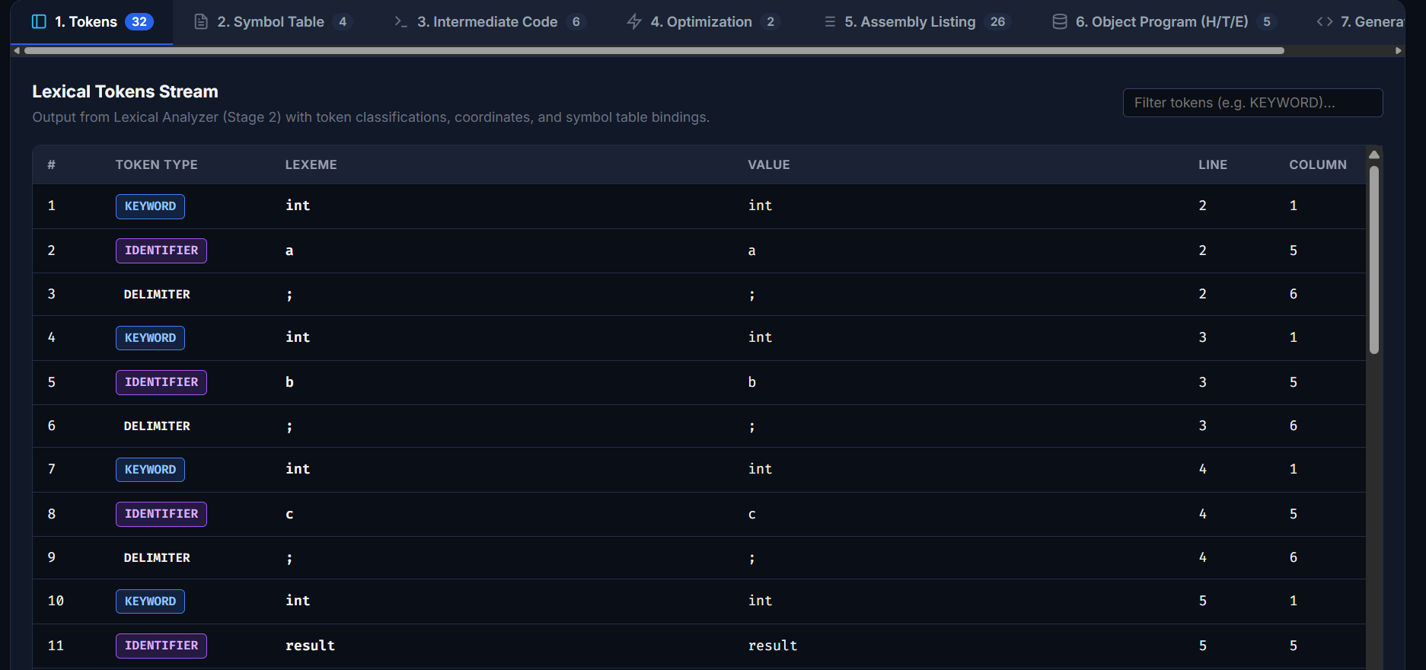
Figure 8.1 Tokens Tab
- 1. Tokens Tab: Displays complete token stream with token index, type badge, lexeme, evaluated value, line/col coordinates, and symbol table bindings, with live search filter.
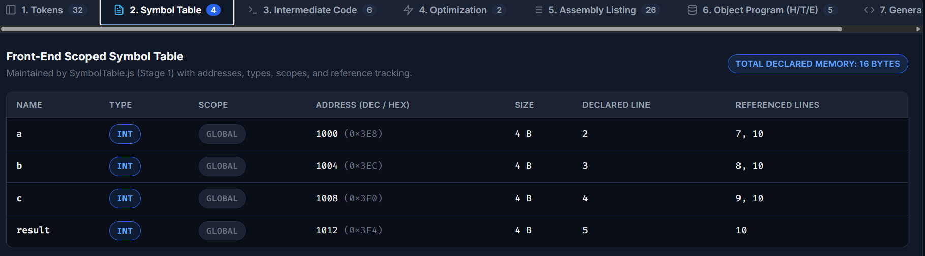
Figure 8.2 Symbol Table Tab
- 2. Symbol Table Tab: Renders symbol name, data type, scope, byte size, assigned decimal/hex address, line declared, and references.
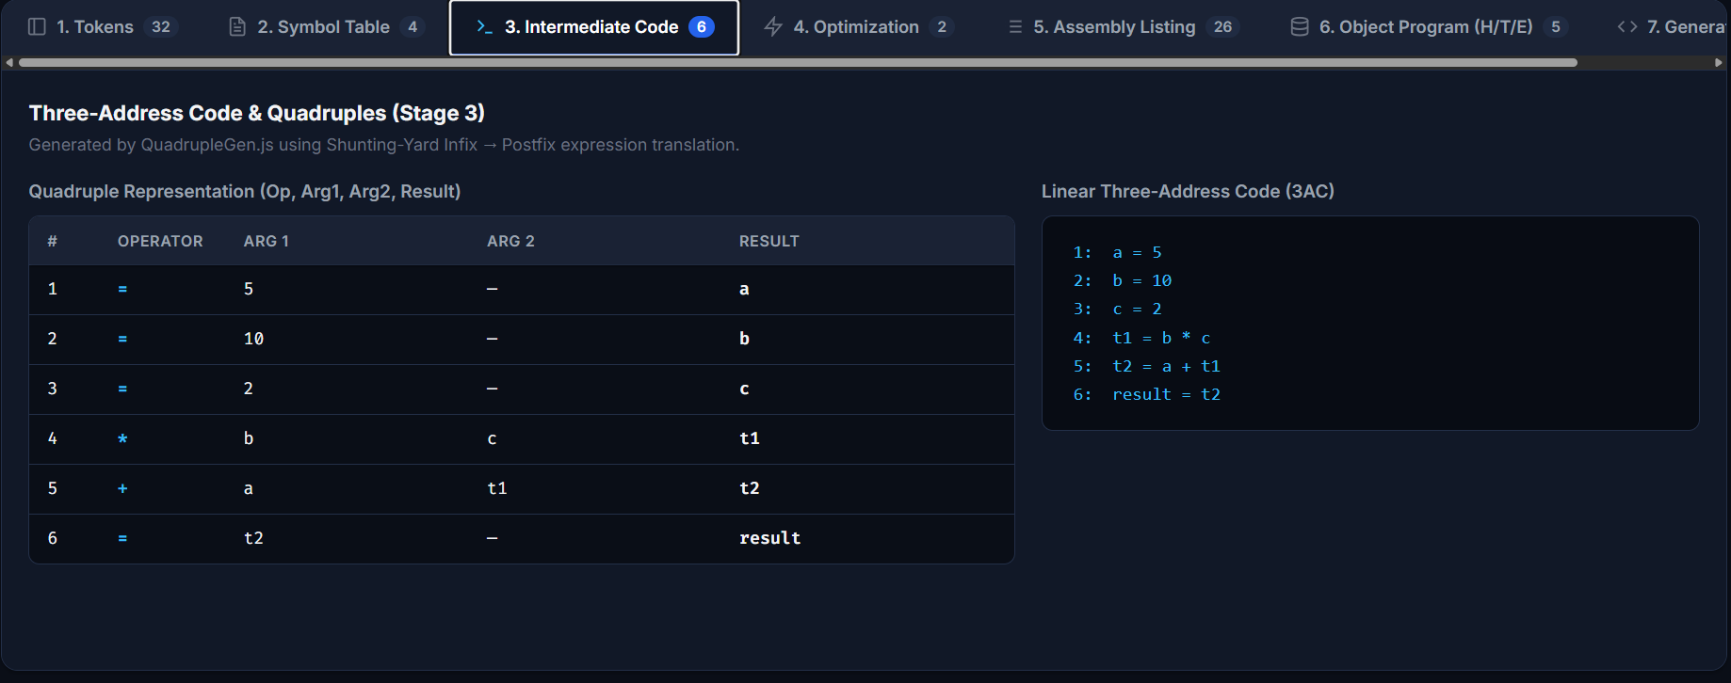
Figure 8.3 Intermediate Code Tab
- 3. Intermediate Code Tab: Presents Quadruple four-tuples table side-by-side with human-readable 3AC code panel.
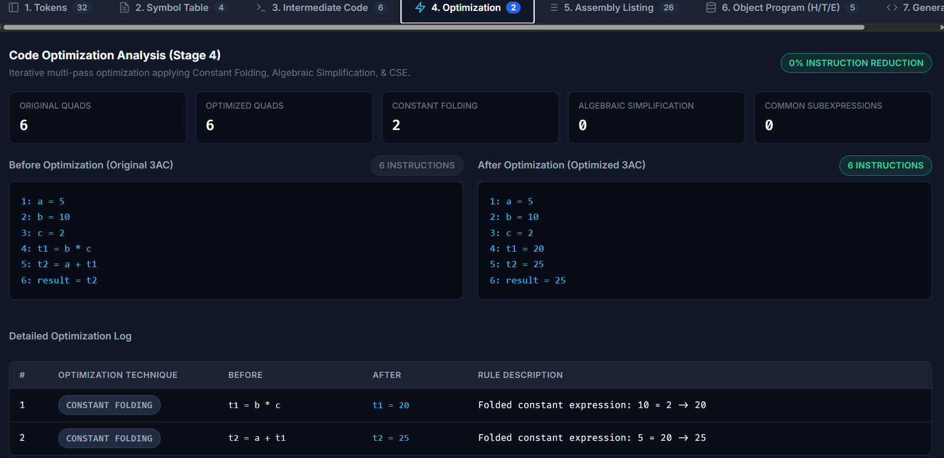
Figure 8.4 Optimization Tab
- 4. Optimization Tab: Displays optimization count metrics and transformation logs showing before-and-after 3AC statements.
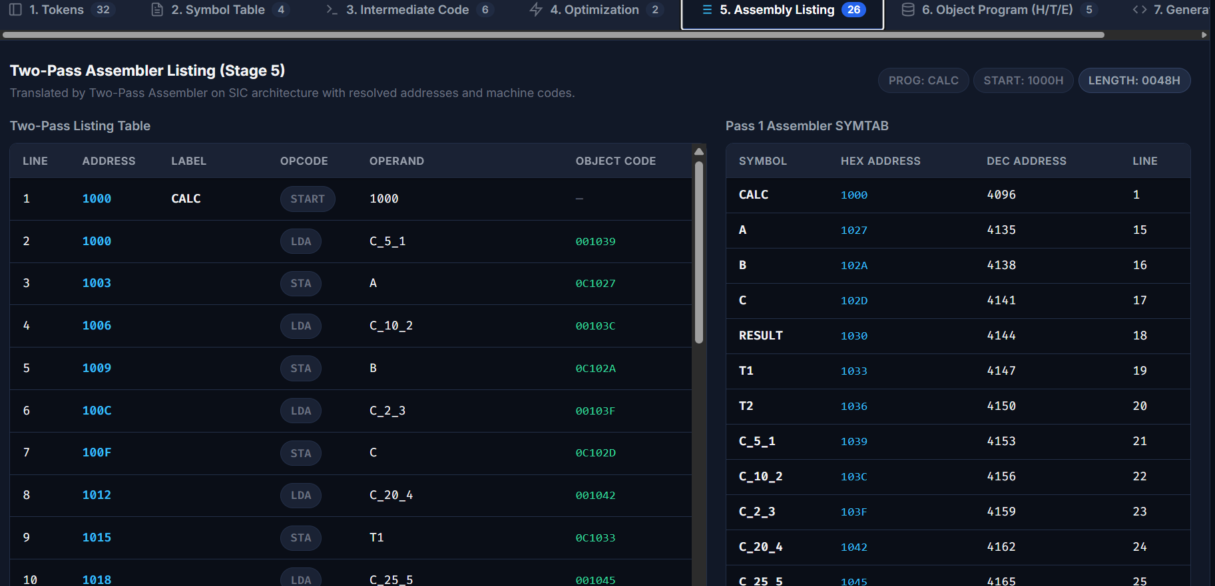
Figure 8.5 Assembly Listing Tab
- 5. Assembly Listing Tab: Shows 26-row Two-Pass Assembly listing with LOCCTR addresses, labels, opcodes, operands, and object code.
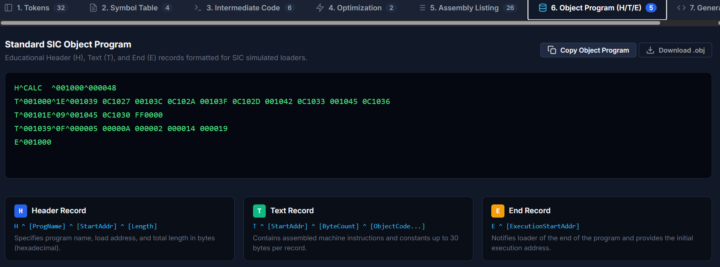
Figure 8.6 Object Program Tab
- 6. Object Program Tab: Displays formatted H, T, E records with 'Copy' and 'Download (.obj)' file export buttons.
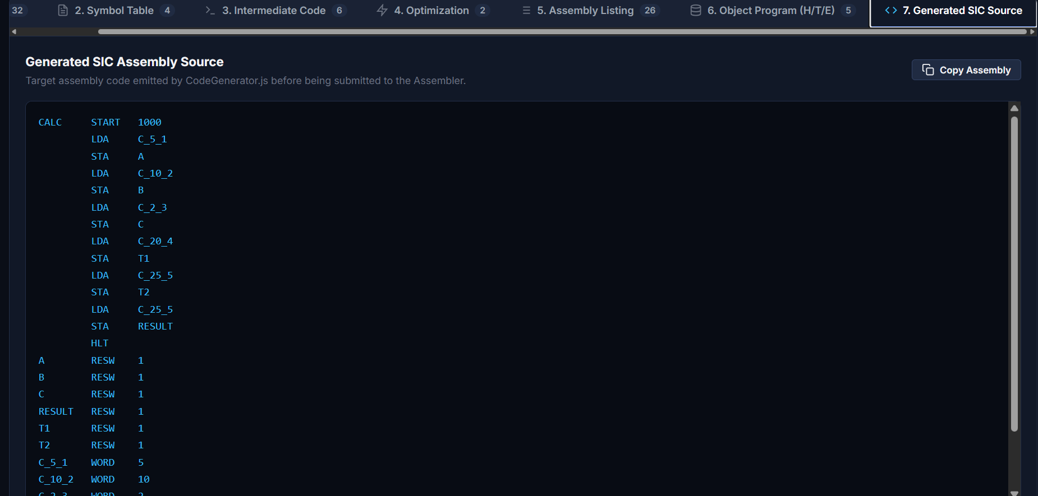
Figure 8.7 Generated Assembly Tab
- 7. Generated Assembly Tab: Shows the pure target SIC assembly language source code.
8.3 Menu-Driven Command-Line Interface
The toolkit also provides a menu-driven command-line interface (CLI) for direct access to the five core System Software modules. The CLI is intentionally kept as an interface layer: it invokes the existing implementations and does not duplicate compiler logic. It also provides access to the complete pipeline, automated verification, and web dashboard instructions.
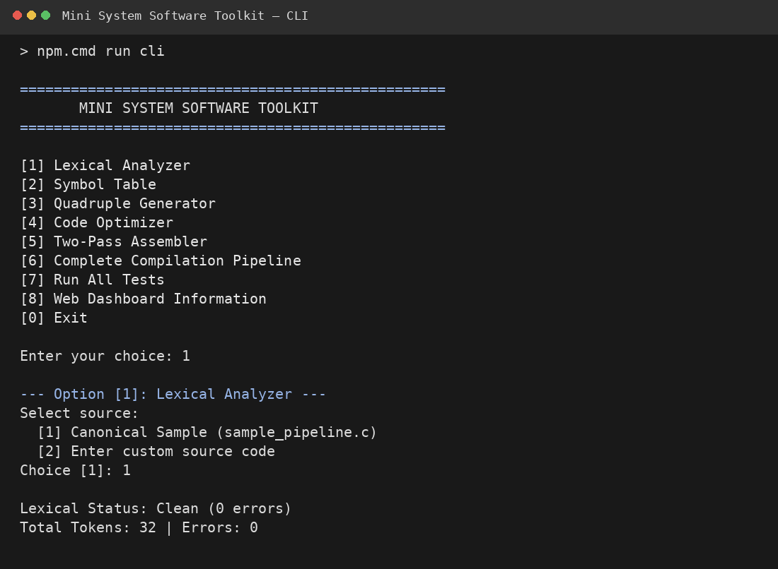
Figure 8.9 Menu-Driven CLI Main Menu and Module Selection
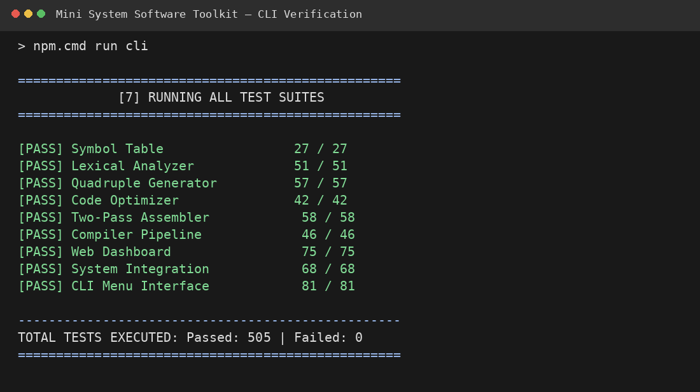
Figure 8.10 CLI Automated Verification Result — 505/505 Tests Passed
CHAPTER 9: TESTING AND VALIDATION
Testing and validation form the definitive proof of correctness for the system software implementation. The complete project was verified through 9 automated test suites comprising 505 assertions. The final result was 505 / 505 tests passed with 0 failures.
Table 9.1: Comprehensive Automated Test Suite Verification Results (505 / 505 Tests Passed)
Test Suite / Component | Target File / Component | Verified Test Scope | Assertions | Passed | Failures
Symbol Table | tests/test_symbol_table.js | Insert, lookup, scope keys, memory sizing, update, delete, hashing | 27 | 27 | 0
Lexical Analyzer | tests/test_lexer.js | Tokens, keywords, operators, delimiters, strings, comments, coords | 51 | 51 | 0
Quadruple Generator | tests/test_quadruples.js | Shunting-Yard, postfix, parentheses, syntax errors, 4-tuple synthesis | 57 | 57 | 0
Code Optimizer | tests/test_optimizer.js | Constant folding, algebraic identities, CSE, commutative sorting | 42 | 42 | 0
Two-Pass Assembler | tests/test_assembler.js | Pass 1 LOCCTR/SYMTAB, Pass 2 code synthesis, listing, H/T/E records | 58 | 58 | 0
Compiler Pipeline Verification | tests/test_pipeline.js | End-to-end integrated orchestration, data flow integrity, options handling | 46 | 46 | 0
Web Dashboard Verification | tests/test_dashboard.js | UI controller, presets, token filtering, DOM data structures, resets | 75 | 75 | 0
System Integration Verification | tests/test_integration.js | Canonical samples, sequential runs, state isolation, error propagation | 68 | 68 | 0
CLI Menu Interface | tests/test_cli.js | Menu rendering, option routing, invalid input, module execution, clean exit | 81 | 81 | 0
TOTAL VERIFIED SUITE | Entire Project Codebase | Comprehensive Automated System Software Suite | 505 | 505 | 0
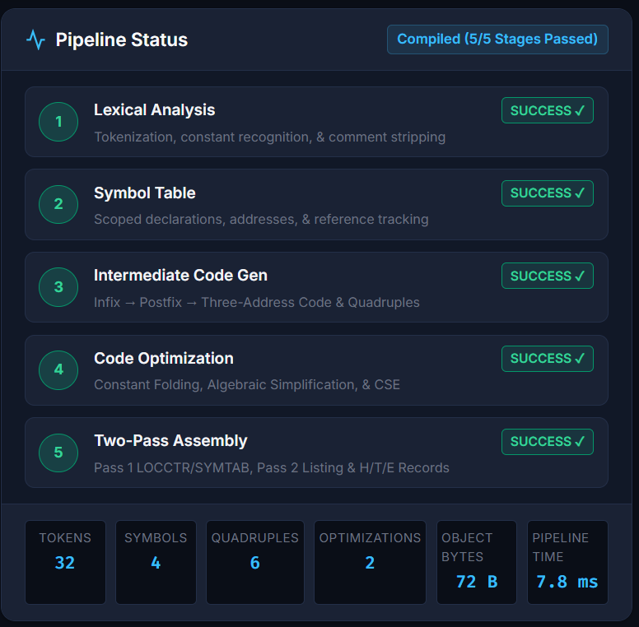
Figure 9.1 Successful Compilation Status in the Web Dashboard
9.1 Verification Highlights & Fault Isolation
Key aspects verified by the test suites include: (1) Unit correctness for all individual classes; (2) Pipeline coupling and data flow integrity; (3) Sequential compilation isolation (compiling program PROGA does not leak symbols into subsequent run PROGB); and (4) Strict error containment: lexical errors halt at Lexical Analyzer without generating intermediate code, and syntax errors halt at Quadruple Generator without producing assembly.
CHAPTER 10: SAMPLE EXECUTION AND RESULTS
This chapter traces the complete execution flow of the canonical sample program (samples/sample_pipeline.c).
Source Program: samples/sample_pipeline.c
// Sample Program for End-to-End System Software Pipeline
int a;
int b;
int c;
int result;
a = 5;
b = 10;
c = 2;
result = a + b * c;

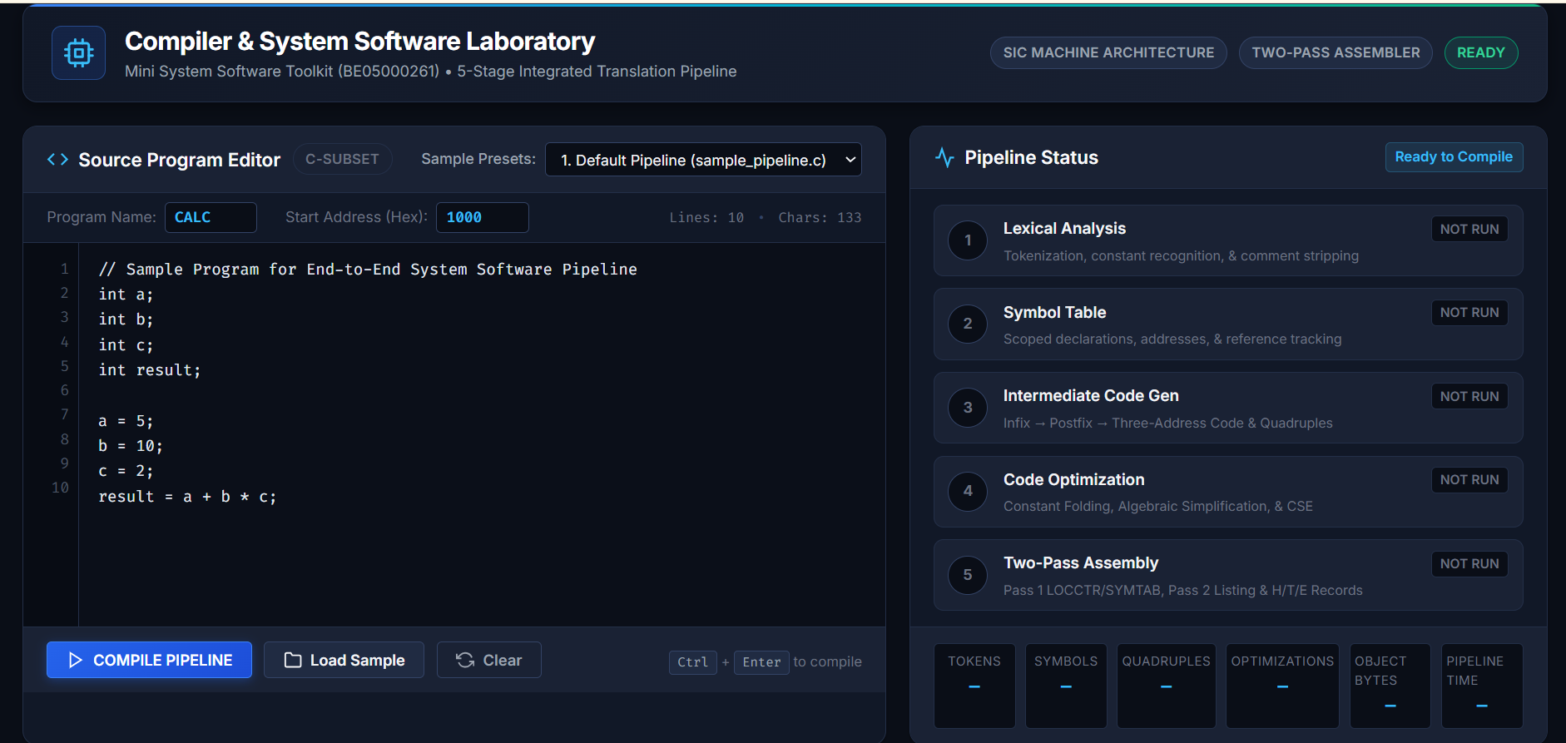
Figure 10.1 Canonical Sample Program Loaded in the Web Dashboard
Table 10.1: Canonical Pipeline Execution Step-by-Step Metrics
Pipeline Module | Processing Executed | Verified Artifact Emitted | Metric Value
Lexical Analyzer | Tokenization, keyword recognition, comment stripping | Classified Token Stream | 32 Tokens
Symbol Table | Variable registration, offset allocation | Populated Symbol Table | 4 Symbols
Quadruple Generator: Quadruple Generation | Shunting-Yard infix to postfix evaluation | Raw 4-Tuples & Linear 3AC | 6 Quadruples Emitted
Code Optimizer: Code Optimization | Constant folding compile-time arithmetic | Optimized Quadruples & 3AC | 2 Constant Foldings Logged
Target Code Generator: Code Generation | Accumulator assembly mapping & RESW/WORD | Generated SIC Assembly Text | 22 Assembly Code Lines
Two-Pass Assembler: Two-Pass Assembler | Pass 1 & Pass 2 translation & LOCCTR tracking | Complete Assembly Listing | 26 Listing Rows Generated
Two-Pass Assembler: Object Generation | Hex record formatting with caret separators | H, T, E Object Program Records | 4 Object Records Emitted

Table 10.2: Two-Pass Assembly Listing for Canonical Program
Line | Address | Opcode | Operand | Object Code
1 | 1000 | START | 1000 | —
2 | 1000 | LDA | C_5_1 | 001039
3 | 1003 | STA | A | 0C1027
4 | 1006 | LDA | C_10_2 | 00103C
5 | 1009 | STA | B | 0C102A
6 | 100C | LDA | C_2_3 | 00103F
7 | 100F | STA | C | 0C102D
8 | 1012 | LDA | C_20_4 | 001042
9 | 1015 | STA | T1 | 0C1033
10 | 1018 | LDA | C_25_5 | 001045
11 | 101B | STA | T2 | 0C1036
12 | 101E | LDA | C_25_5 | 001045
13 | 1021 | STA | RESULT | 0C1030
14 | 1024 | HLT |  | FF0000
10.1 Verified Object Program Output
Verified Generated SIC Object Program Records (H, T, E)
H^CALC ^001000^000048
T^001000^1E^001039 0C1027 00103C 0C102A 00103F 0C102D 001042 0C1033 001045 0C1036
T^00101E^09^001045 0C1030 FF0000
T^001039^0F^000005 00000A 000002 000014 000019
E^001000

10.2 Verified Error Handling Demonstrations
Example 1 (Lexical Error): Source 'int a; a = 5 @ 2;' halts immediately at 'Lexical Analysis' with diagnostic "Unrecognized character '@'" at Line 2, Column 7. Intermediate code and assembly are set to null. Example 2 (Syntax Error): Source 'int a; a = + * 2;' halts at 'Intermediate Code Generation' with diagnostic "Syntax error: Expression cannot start with '+'", halting assembly translation.
CHAPTER 11: ADVANTAGES AND LIMITATIONS
11.1 Advantages
- Complete Pipeline Visibility: Students inspect tokens, symbol tables, quadruples, optimized code, assembly listings, and object records simultaneously.
- Strict Module Decoupling: Every module is implemented as an independent ES module class with well-defined APIs.
- Zero-Dependency Portability: The toolkit uses only Node.js built-in modules and browser-native technologies, requiring no third-party runtime packages.
- Comprehensive Verification: The toolkit is supported by 505 automated assertions covering module behavior, integration, interface behavior, edge cases, and error handling.
11.2 Limitations
- Educational Subset Scope: Restricted to primitive declarations and arithmetic expressions; does not support control flow (loops, branches) or functions.
- Simplified Target Architecture: Implements an educational SIC-based target model without the extended SIC/XE addressing modes and instruction formats.
- Single Accumulator: Target code generation targets a single accumulator register (A), producing frequent LDA and STA roundtrips.
CHAPTER 12: FUTURE SCOPE
Valuable future extensions include:
- Control Flow Constructs: Extending parsing to handle if-else, while, and for loops using conditional jump quadruples.
- SIC/XE Architecture: Implementing Format 3 and 4 instructions with base-relative and PC-relative addressing.
- Multi-Register Allocation: Replacing single accumulator generation with graph-coloring register allocation.
- Modern Backend Targets: Adding alternative code generators emitting 64-bit x86-64 NASM or RISC-V assembly.
- AST & CFG Visualization: Adding interactive graphical Abstract Syntax Tree and Control Flow Graph renderers to the dashboard.
CHAPTER 13: CONCLUSION
The Mini System Software Toolkit project was successfully designed, implemented, and verified as an integrated educational system software environment. The toolkit connects five core System Software modules—Lexical Analyzer, Symbol Table, Quadruple Generator, Code Optimizer, and Two-Pass Assembler—through a transparent compilation flow. A menu-driven CLI provides direct access to these modules, while the web dashboard provides visual inspection of intermediate and final outputs.
All five core modules were implemented using modern ECMAScript standards with zero external runtime dependencies. Supporting components such as expression parsing, target code generation, and pipeline orchestration connect the modules into the complete translation flow.
The project was verified through 9 automated test suites comprising 505 assertions, achieving a 100% pass rate (505 / 505 passed, 0 failures). The final system includes both a menu-driven CLI and an interactive web dashboard, providing practical and visual access to the implemented modules.
REFERENCES
1. Beck, Leland L. System Software: An Introduction to Systems Programming. 3rd ed., Pearson Education / Addison-Wesley, 1997.
2. Aho, Alfred V., Monica S. Lam, Ravi Sethi, and Jeffrey D. Ullman. Compilers: Principles, Techniques, and Tools. 2nd ed., Pearson, 2006.
3. Dhamdhere, D. M. Systems Programming and Operating Systems. 2nd ed., Tata McGraw-Hill, 1999.
4. Muchnick, Steven S. Advanced Compiler Design and Implementation. Morgan Kaufmann Publishers, 1997.
5. ECMA International. ECMAScript 2022 Language Specification (Standard ECMA-262, 13th Edition). June 2022.
6. Node.js Documentation. Node.js v20.x LTS Documentation. Available at: https://nodejs.org/docs/
7. Dijkstra, Edsger W. "Making a Translator for ALGOL 60." ALGOL Bulletin, Supplement No. 10, 1961.
APPENDIX
APPENDIX A — GITHUB REPOSITORY
Source Code Repository: https://github.com/KalalPrince/mini-complier-toolkit.git
The GitHub repository contains the complete source code of the Mini System Software Toolkit, including the five core System Software modules, supporting translation components, menu-driven CLI, web dashboard, sample programs, and automated test suites. It provides the complete project implementation and related files for reference and verification.

APPENDIX B — PROJECT DIRECTORY STRUCTURE
System-Software-PBL/
├── package.json
├── server.js
├── index.html
├── style.css
├── app.js
├── cli.js
├── src/
│ ├── utils/
│ │ └── Constants.js
│ └── core/
│ ├── SymbolTable.js
│ ├── Lexer.js
│ ├── ExpressionParser.js
│ ├── QuadrupleGen.js
│ ├── CodeOptimizer.js
│ ├── CodeGenerator.js
│ ├── Assembler.js
│ └── CompilerPipeline.js
├── samples/
│ ├── sample_pipeline.c
│ └── sample_assembly.asm
└── tests/
├── test_symbol_table.js
├── test_lexer.js
├── test_quadruples.js
├── test_optimizer.js
├── test_assembler.js
├── test_pipeline.js
├── test_dashboard.js
├── test_integration.js
└── test_cli.js
The repository contains five core System Software modules, supporting translation components, two user interfaces (web dashboard and menu-driven CLI), sample inputs, and automated verification tests.

