Group B

EMBEDDED SYSTEMS DEVELOPMENT

Hiking Tour Assistant 1.0 User Manual

# Contents

A. Compiling and Installing the Software 1

B. Using the Smartwatch 2

C. Syncing Hiking Data from Watch to Arduino 3

D. Viewing Hiking Data on the LCD Screen 3

# Compiling and Installing the Software

To compile and install the software for the Hiking Tour Assistant on both the smartwatch and Arduino, please follow these steps:

1. **Prepare the Development Environment**: Ensure you have the Arduino IDE installed on your computer. You can download it from the official Arduino website.

2. **Connect the Devices**: Connect both the LiLyGo smartwatch and the Arduino Mega to your computer using USB cables. Figure 1 shows the location of the USB-C port on the watch.

3**. Open the Arduino IDE**: Launch the Arduino IDE on your computer.

4. **Load the Software**: Open the Hiking Tour Assistant software project in the Arduino IDE.

5. **Select the Correct Board and Port**: For the smartwatch, select the appropriate board (e.g., ESP32 Dev Module). For the Arduino Mega, select the corresponding board. Make sure to select the correct COM port for each device.

6. **Compile the Code**: Click on the 'Verify' button (checkmark icon) to compile the code for each device.

7**. Upload the Code:** After successful compilation, click on the 'Upload' button (right arrow icon) to upload the code to each device. Repeat this process for both the smartwatch and the Arduino.

8. **Disconnect the Devices**: Once the upload is complete, you can disconnect the devices from your computer.

# Using the Smartwatch

Here is how you can use the smartwatch for your hiking activities:

1**. Turning On**: Press and hold the power button on the side of the watch for 3 seconds to turn it on. The watch will display the initial program screen.

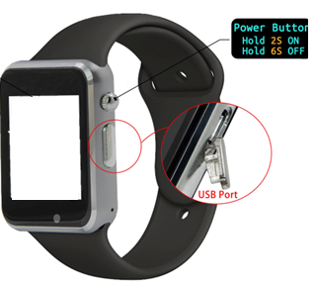

Figure 1: LiLyGo Watch general view

2. **Adjusting Settings**: On the standby view, you will see a touch-screen button for accessing settings. Tap the settings button to adjust your stride length based on your height.

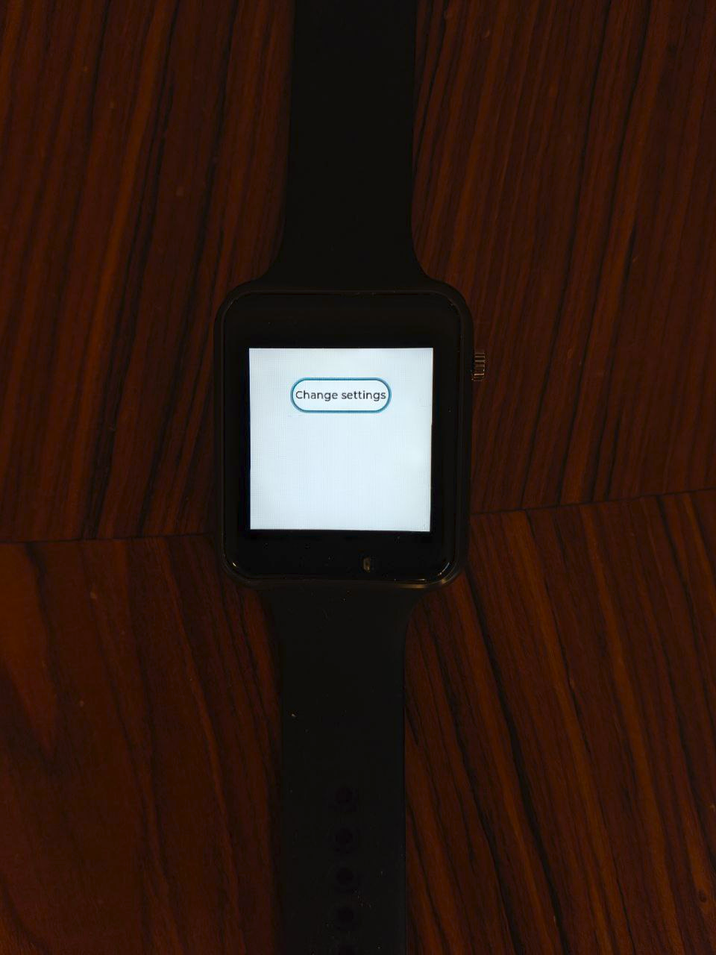 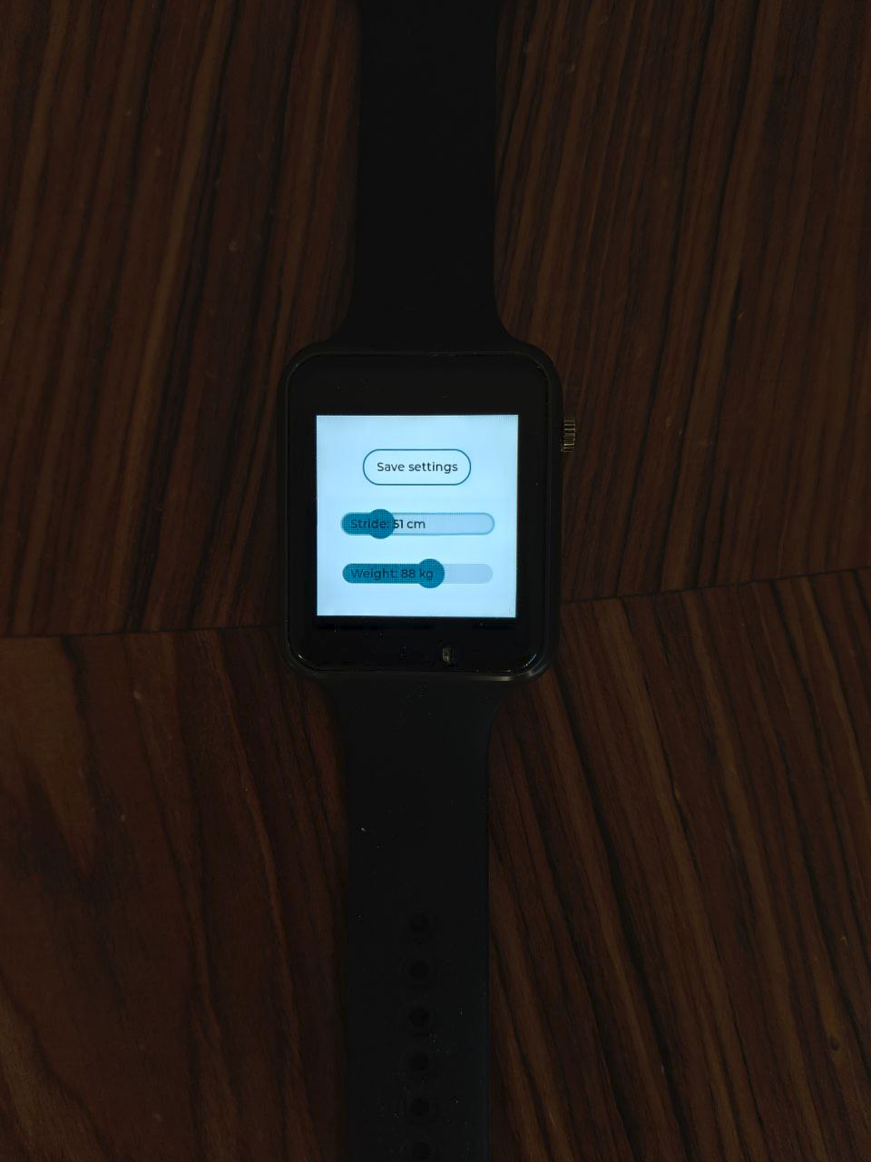

Figure 2: Standy view Figure 3: Adjusting settings

3. **Starting a Hike**: To start a hiking session, press the power button for 1 second. The watch will begin tracking your steps and calculating the distance traveled.

4. **Stopping a Hike**: To end the hiking session, press the power button for 1 second again. The watch will save the hiking data and attempt to sync with the Arduino.

5. **Viewing Hike Statistics**: During an active hiking session, the watch will display the steps count, distance traveled, and time elapsed. The display updates after each step detected by the accelerometer.

# Syncing Hiking Data from Watch to Arduino

To sync your hiking data from the smartwatch to the Arduino, follow these steps:

1. **End the Hiking Session**: Ensure that you have stopped the hiking session on the watch by pressing the power button for 1 second.

2**. Initiate Sync**: The watch will automatically attempt to sync with the Arduino via Bluetooth. If the automatic sync fails, you can manually initiate the sync from the watch settings.

3. **Successful Sync**: Once the sync is successful, the watch will notify you. The Arduino will receive the hiking data, calculate the calories burned, and store the session statistics.

# Viewing Hiking Data on the LCD Screen

To view your hiking data on the LCD screen attached to the Arduino, follow these steps:

1. **Power On the Arduino**: Connect the power cable to the Arduino to turn it on. The Arduino will start polling for incoming Bluetooth data from the watch.

2. **Receive Data**: Once the data is received and processed, the Arduino will display the session statistics on the LCD screen.

3**. Scroll Through Data**: Arduino will automatically scroll through different statistics such as steps, distance, duration, and calories burned.

Figure 4: Different views on the LCD