IT5437 — Image Processing and Machine Vision
Vidanapathirana K.D. | Index: 258839R
Assignment 1: Intensity Transformations and Neighborhood Filtering
GITHUB REPOSITORY: https://github.com/Kalana-Demintha-Vidanapathirana/258839R_IT5437_CV_Assignment_1.git
Question 1 — Intensity Transformations on the Runway Image
Key code
def gamma_transform(image_norm, gamma):
return np.power(image_norm, gamma)
def contrast_stretch(image_norm, r1=0.2, r2=0.8):
out = np.zeros_like(image_norm, dtype=np.float32)
out[image_norm < r1] = 0.0
out[(image_norm >= r1) & (image_norm <= r2)] = (image_norm[(image_norm >= r1) & (image_norm <= r2)] - r1) / (r2 - r1)
out[image_norm > r2] = 1.0
return out
Results Interpretation
Original | γ = 0.5 (brighten) | γ = 2.0 (darken) | Contrast Stretch (r₁=0.2, r₂=0.8)
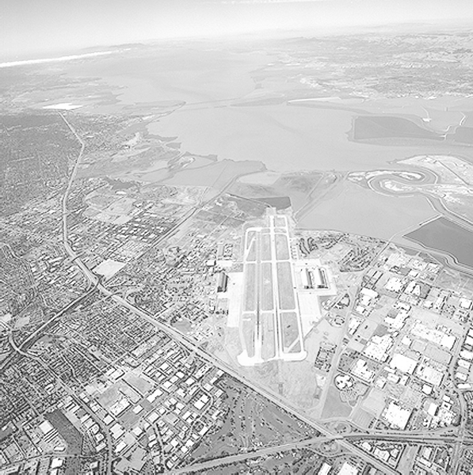 | 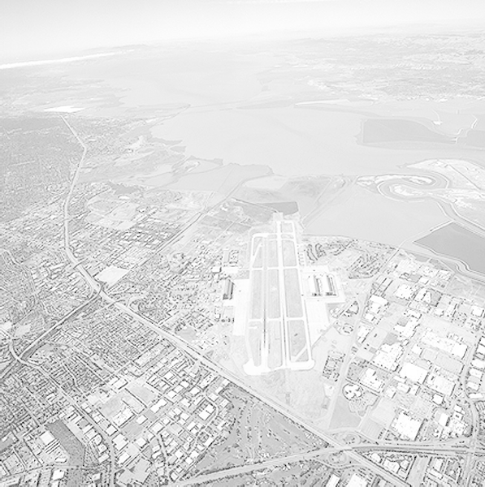 | 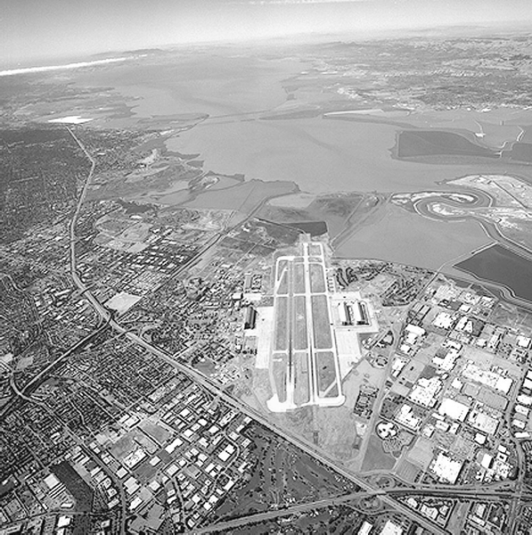 | 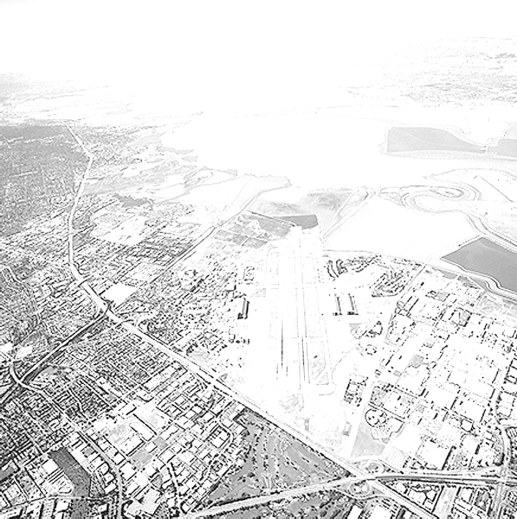

Discussion
- γ = 0.5 raises every normalised pixel toward 1 — dark areas (tarmac, shadows) brighten; the sky saturates toward white.
- γ = 2.0 pushes midtones into shadows, revealing sky texture while crushing dark runway detail.
- Contrast stretching maps the mid-band [0.2, 0.8] to the full [0, 1], maximising perceived contrast for this histogram-concentrated scene.
Question 2 — Gamma Correction in L*a*b* Colour Space
Key code
img_lab = cv2.cvtColor(img_bgr, cv2.COLOR_BGR2LAB)
L, a, b = cv2.split(img_lab)
L_norm = L.astype(np.float32) / 255.0
L_corr = np.clip(np.power(L_norm, gamma) * 255, 0, 255).astype(np.uint8)
result = cv2.cvtColor(cv2.merge([L_corr, a, b]), cv2.COLOR_LAB2BGR)
# Applied with γ = 0.8 (brightening)
Results Interpretation
Original | L* gamma-corrected (γ = 0.8)
 | 

Histograms (L channel)
Original | γ=0.5 | γ=0.8 | γ=1.2 — L* histograms
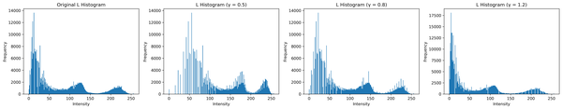

Discussion
- Correction is applied only to the L* channel, so colours (a*, b*) are preserved exactly.
- γ = 0.8 < 1 shifts the histogram rightward — pixels move to higher intensities without colour distortion.
- γ = 0.5 brightens aggressively; γ = 1.2 darkens slightly. γ = 0.8 gives the best balance for this scene.
Question 3 — Manual Histogram Equalization
Key code
def histogram_equalize(img):
hist = np.bincount(img.flatten(), minlength=256)
cdf = hist.cumsum()
cdf_min = cdf[np.nonzero(cdf)][0]
lut = np.round((cdf - cdf_min) / (img.size - cdf_min) * 255)
return np.clip(lut, 0, 255).astype(np.uint8)[img]
Result Interpretation
Original (runway) | Equalised
 | 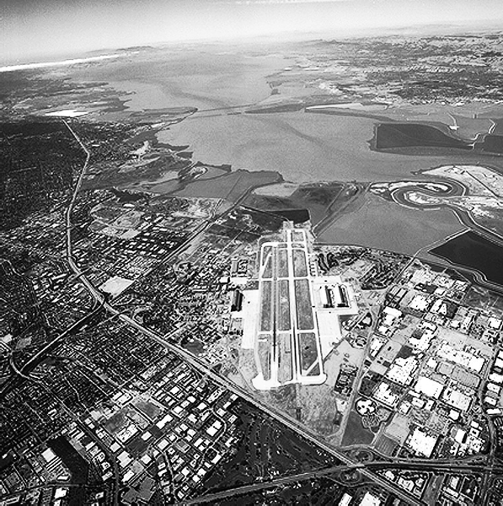

Discussion
- Equalization maps intensities via the normalized CDF, redistributing them toward a uniform distribution.
- The mapping is monotonic — relative pixel brightness is preserved; previously compressed intensity bands are spread out.
- Unlike gamma correction, no parameter tuning is required; the transform adapts fully to the image histogram.
Question 4 — Otsu Thresholding + Foreground Histogram Equalization
Key code
otsu_thresh, mask = cv2.threshold(gray, 0, 255, cv2.THRESH_BINARY + cv2.THRESH_OTSU)
if gray[mask==255].mean() > gray[mask==0].mean(): # keep darker region as foreground
mask = cv2.bitwise_not(mask)
fg = gray[mask == 255]
hist = np.bincount(fg, minlength=256); cdf = hist.cumsum()
lut = np.round((cdf - cdf[cdf>0][0]) / (fg.size - cdf[cdf>0][0]) * 255)
result[mask == 255] = np.clip(lut, 0, 255).astype(np.uint8)[gray[mask == 255]]
Otsu threshold value = 101
Results Interpretation
Grayscale | Otsu Mask | Foreground Equalized
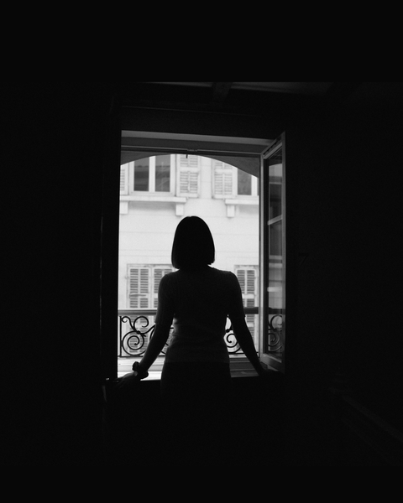 | 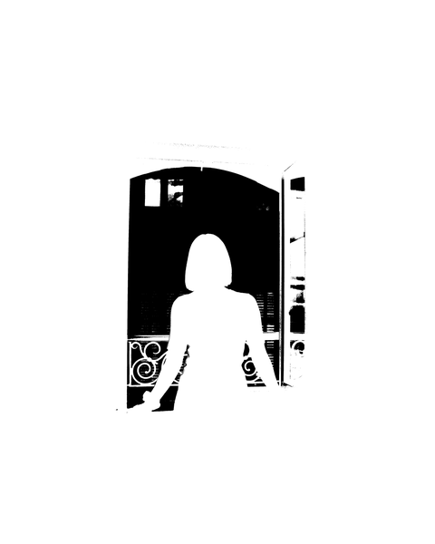 | 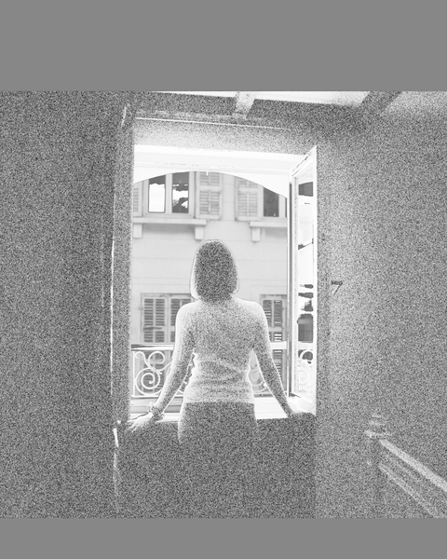

Discussion
- Otsu's method (threshold = 101) automatically separates the bright window/door from the darker woman and interior.
- Equalization applied only to the foreground reveals clothing texture and room detail without over-saturating the already bright window.
- Background pixels remain unchanged, preserving the natural contrast between interior and exterior.
Question 5 — Manual Gaussian Filtering
Key code
def gaussian_kernel(size, sigma):
ax = np.arange(-(size // 2), size // 2 + 1)
xx, yy = np.meshgrid(ax, ax)
kernel = np.exp(-(xx**2 + yy**2) / (2 * sigma**2))
return kernel / kernel.sum() # normalized — sums to 1
smoothed_manual = cv2.filter2D(img, -1, gaussian_kernel(5, 2))
smoothed_cv = cv2.GaussianBlur(img, (5, 5), sigmaX=2)
Results Interpretation
Original | Manual (5×5, σ=2) | OpenCV GaussianBlur
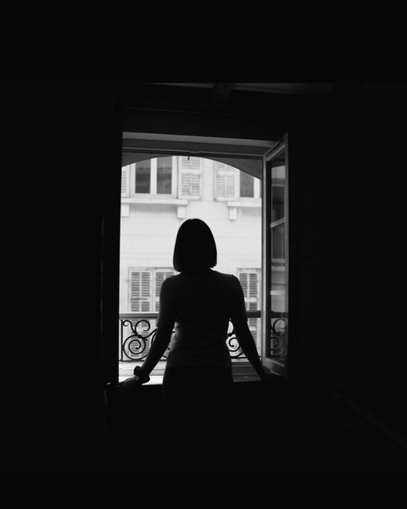 | 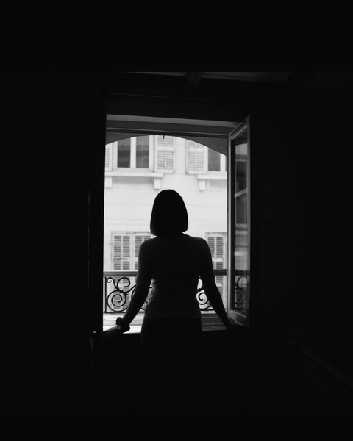 | 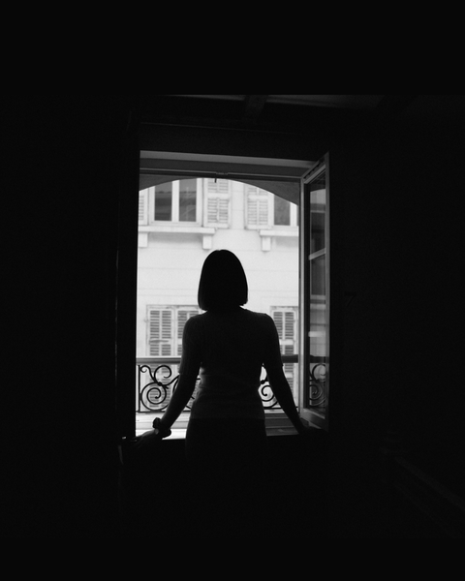

Discussion
- The normalized kernel (sum = 1) preserves mean brightness after filtering.
- Manual filter2D and OpenCV GaussianBlur produce near-identical results, confirming implementation correctness.
- Minor pixel-level differences arise from boundary handling; for σ=2 a 5×5 kernel is slightly small to capture the full Gaussian spread.

Question 6 — Derivative of Gaussian (DoG) Edge Detection
Key code
def dog_kernels(size, sigma):
ax = np.arange(-(size//2), size//2+1); xx, yy = np.meshgrid(ax, ax)
G = (1/(2*np.pi*sigma**2)) * np.exp(-(xx**2 + yy**2) / (2*sigma**2))
Gx = -(xx / sigma**2) * G; Gy = -(yy / sigma**2) * G
return Gx / np.sum(np.abs(Gx)), Gy / np.sum(np.abs(Gy))
grad_x = cv2.filter2D(img.astype(np.float32), -1, gx)
grad_y = cv2.filter2D(img.astype(np.float32), -1, gy)
grad_mag = np.sqrt(grad_x**2 + grad_y**2)
# Compared with: cv2.Sobel(img, cv2.CV_32F, 1, 0, ksize=5)
Results Interpretation
DoG Gradient Magnitude | Sobel Magnitude (ksize=5)
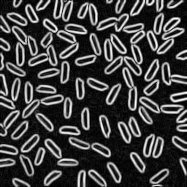 | 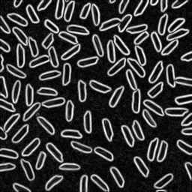

Discussion
- ∂G/∂x = −(x/σ²)·G(x,y) is odd in x and even in y, giving zero-sum rows — a mathematically valid derivative operator.
- DoG at σ=2 yields cleaner, thicker, more noise-robust edges than Sobel because Gaussian smoothing pre-suppresses noise.
- σ controls detection scale: small σ finds fine texture edges, large σ finds coarser structural boundaries (principle behind Canny and SIFT).
Question 7 — Image Zooming: Nearest-Neighbour vs. Bilinear
Key code
def resize_nearest(img, sx, sy):
for y_new in range(new_h):
for x_new in range(new_w):
out[y_new, x_new] = img[min(round(y_new/sy), h-1), min(round(x_new/sx), w-1)]
def resize_bilinear(img, sx, sy):
for y_new, x_new in ...:
y, x = y_new/sy, x_new/sx; y0, x0 = floor(y), floor(x); dy, dx = y-y0, x-x0
top = (1-dx)*img[y0,x0] + dx*img[y0,x1]
out[y_new,x_new] = (1-dy)*top + dy*((1-dx)*img[y1,x0] + dx*img[y1,x1])
def normalized_ssd(img1, img2):
return np.sum((img1.astype(float) - img2.astype(float))**2) / img1.size
Quantitative comparison — Normalised SSD vs. original
Image pair | Scale | SSD — Nearest Neighbour | SSD — Bilinear
im01 | 4× | 255.30 | 200.25
im02 | 4× | 64.63 | 48.96
im03 | 4× | 147.77 | 113.57
taylor (small) | 5× | 320.09 | 285.21
taylor (very small) | 20× | 737.81 | 654.63

Results Interpretation
NN upsample (5×) | Bilinear upsample (5×)
 | 

Discussion
- Bilinear SSD is consistently lower across all image pairs, confirming higher reconstruction fidelity.
- Nearest-neighbour preserves crisp edges but produces blocky pixel steps, especially on diagonal and curved features.
- Bilinear interpolates a convex combination of four neighbours, suppressing aliasing at the cost of slight blurring.
Question 8 — Salt-and-Pepper Noise Removal
Key code
gaussian_smoothed = cv2.GaussianBlur(img, (5, 5), sigmaX=1.0)
median_filtered = cv2.medianBlur(img, 5)
Results Interpretation
Noisy input | Gaussian (5×5, σ=1) | Median (5×5)
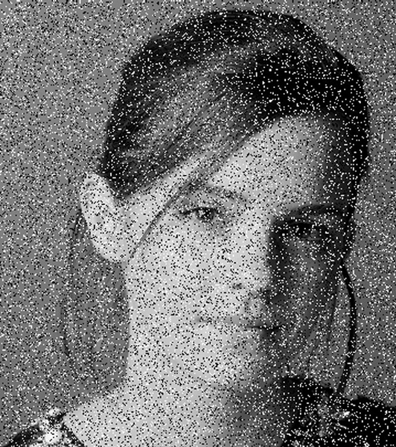 | 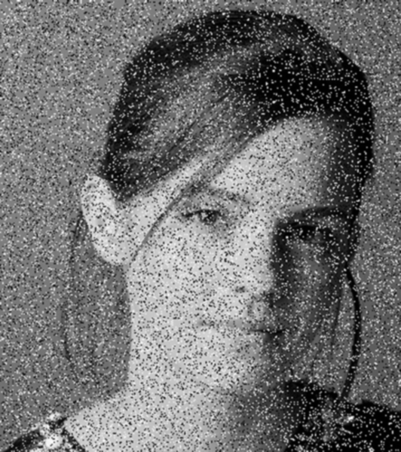 | 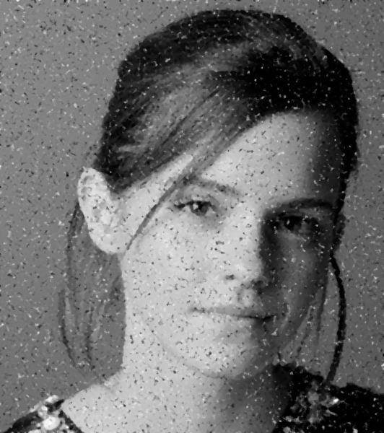

Discussion
- Salt-and-pepper noise produces isolated extreme pixels; Gaussian smoothing spreads them into blurry grey patches rather than removing them.
- Median filtering replaces each pixel with the neighbourhood median, effectively eliminating impulse noise while preserving edges.
- For impulsive noise, median filtering is clearly superior. Gaussian smoothing is better suited to additive Gaussian noise.

Question 9 — Image Sharpening (Unsharp Masking)
Key code
def unsharp_mask(img, kernel_size=(5,5), sigma=1.0, amount=1.5):
blurred = cv2.GaussianBlur(img, kernel_size, sigmaX=sigma)
sharpened = cv2.addWeighted(img, 1 + amount, blurred, -amount, 0)
return blurred, sharpened
# output = (1 + a)·f − a·(f * G) ≡ f + a·(f − blurred)

Results Interpretation
Original | Sharpened (σ=1.0, amount=1.5)
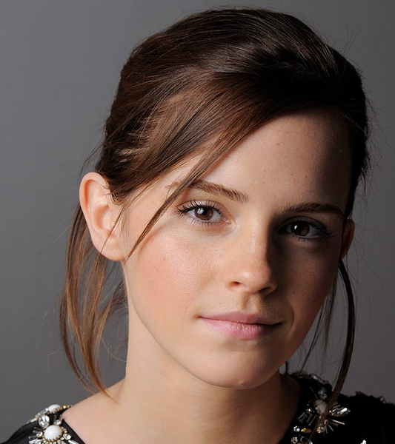 | 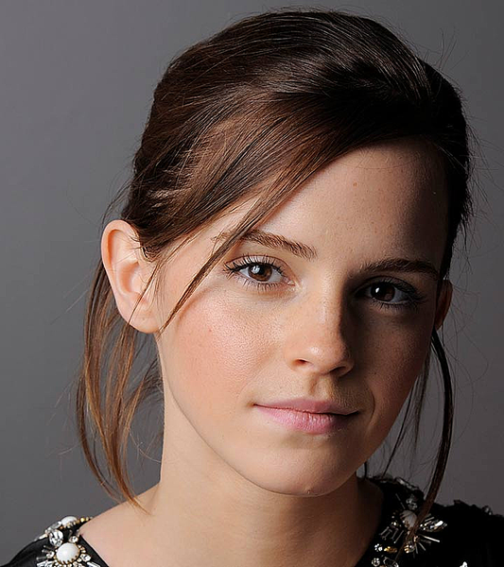

Discussion
- Unsharp masking adds a scaled high-pass signal (f − blurred) back to the original, boosting fine detail and edges.
- σ controls the scale of detail enhanced; amount=1.5 provides clear sharpening without excessive halo artefacts.
- Noise is also high-frequency and will be amplified — sharpening should be applied after denoising.
Question 10 — Bilateral Filtering (Edge-Preserving Smoothing)
Key code
def manual_bilateral_filter(img, kernel_size=5, sigma_s=3.0, sigma_r=25.0):
spatial = np.exp(-(xx**2 + yy**2) / (2 * sigma_s**2)) # geometry weight
for y, x in ...:
region = padded[y:y+ks, x:x+ks]; centre = padded[y+pad, x+pad]
range_w = np.exp(-(region - centre)**2 / (2 * sigma_r**2)) # photometric weight
output[y, x] = np.sum(spatial * range_w * region) / np.sum(spatial * range_w)
opencv_bilateral = cv2.bilateralFilter(img, d=5, sigmaColor=25.0, sigmaSpace=3.0)
Results Interpretation
Original | Gaussian (5×5) | OpenCV Bilateral | Manual Bilateral
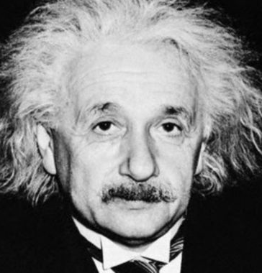 | 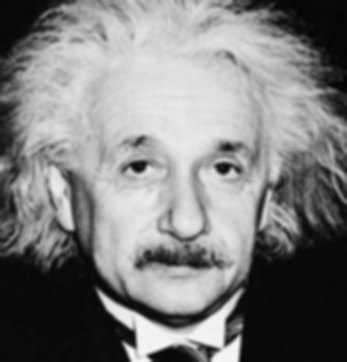 | 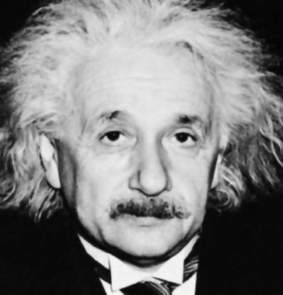 | 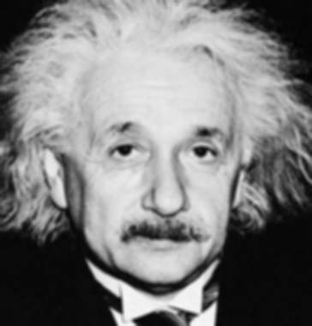

Discussion
- Bilateral filtering weights neighbours by both spatial proximity (σₛ) and intensity similarity (σᵣ), preserving edges.
- Gaussian blur smooths uniformly — edges blur. Bilateral maintains sharp edges while smoothing flat/low-contrast regions.
- Manual and OpenCV implementations produce nearly identical results, verifying correctness of the manual filter.

Question 11 — Relationship Between Spatial Filtering and Frequency Response
(a) Convolution Theorem. Spatial convolution g(x,y) = f(x,y) * h(x,y) corresponds to pointwise multiplication G(u,v) = F(u,v)·H(u,v) in the frequency domain. Applying a filter spatially is therefore equivalent to multiplying the image spectrum by the filter's transfer function H(u,v).
(b) Qualitative frequency behaviour. Averaging (box) filter — low-pass with sinc-shaped frequency response: broad main lobe, oscillating side lobes; blurs and removes high-frequency detail. Gaussian filter — low-pass with Gaussian frequency response: smooth, radially symmetric, no side lobes; gentle noise suppression without ringing. Laplacian filter — high-pass proportional to −(u²+v²); amplifies edges and fine detail at the cost of also amplifying noise.
(c) No ringing in Gaussian. An ideal low-pass filter has a sharp rectangular cutoff in the frequency domain, whose spatial impulse response is an oscillatory sinc — causing Gibbs/ringing artefacts near edges. A Gaussian is its own Fourier transform: smooth and monotonically decaying in both domains, so no side lobes exist and no ringing arises.
(d) Best filter for high-frequency noise. The Gaussian filter is most suitable: it attenuates high-frequency noise gradually as a smooth low-pass with no ringing. The Laplacian amplifies high-frequency noise. The box filter also suppresses high frequencies but its sinc transfer function introduces side-lobe artefacts.
Question 12 — Illumination Correction via Homomorphic Filtering
(a) Multiplicative model. f(x,y) = i(x,y)·r(x,y) separates illumination i (light falling on the scene) from reflectance r (surface albedo). Illumination is low-frequency (slow spatial variation — shadows, vignetting); reflectance is high-frequency (texture, edges). Uneven lighting multiplies intensity values — simple brightness adjustment cannot fully correct it.
(b) Log transform. Taking the natural log: ln f = ln i + ln r converts the multiplicative model into an additive one. Linear frequency-domain filtering can then separately attenuate ln i (low-frequency illumination) and preserve or boost ln r (high-frequency reflectance).
(c) Algorithm. log → FFT → multiply by H(u,v) = (γH − γL)(1 − exp(−c·D²/D₀²)) + γL → IFFT → exp. With γL < 1 < γH the filter attenuates low-frequency illumination and boosts high-frequency reflectance/texture.
Key code
def homomorphic_filter(img, gamma_l=0.6, gamma_h=1.8, c=1.0, d0=30):
log_img = np.log1p(img.astype(np.float32))
fft_shift = np.fft.fftshift(np.fft.fft2(log_img))
D2 = (y - crow)**2 + (x - ccol)**2 # squared distance from centre
H = (gamma_h - gamma_l) * (1 - np.exp(-c * D2 / d0**2)) + gamma_l
out = np.real(np.fft.ifft2(np.fft.ifftshift(H * fft_shift)))
return cv2.normalize(np.expm1(out), None, 0, 255, cv2.NORM_MINMAX).astype(np.uint8)
# Parameters: γ_L = 0.6, γ_H = 1.8, c = 1, D₀ = 30
Results Interpretation
Original | Homomorphic Filtered
 | 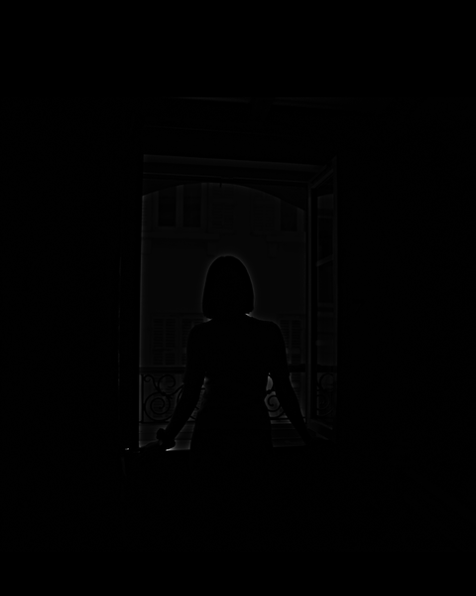

(d) Comparison with histogram equalization.
Aspect | Histogram Equalization | Homomorphic Filtering
Model assumption | None — global CDF redistribution | Multiplicative f = i · r
Domain | Spatial, pixel-wise | Log + frequency domain
Handles non-uniform light? | Poorly — global effect | Directly flattens slow illumination
Fine detail enhancement | Side effect only | Explicit high-frequency boost
Failure modes | Over-stretches noise | Halos if params too aggressive

(e) Observations on woman_window.jpg. Illumination correction: the brightness gradient between the dark interior and bright window is reduced — shadows lift, highlights come down. Contrast enhancement: reflectance detail (woman's clothing, door grain, room boundaries) becomes more visible. Artefacts: slight noise amplification in previously flat dark regions; halo-like fringes near strong edges if parameters are too aggressive. Homomorphic filtering is preferable to histogram equalization here because the dominant problem is spatially non-uniform illumination, not globally compressed contrast.

