|  |
| --- |
| Group 1 |
| Controlled Environment Monitors |
| Manufacturing Document |

# Contents

Display Unit Manufacture 2

Enclosure 2

............................................................................................................................................................ 2

Components 3

Top Cover 3

Bottom Cover 5

Battery Cover 7

Sensor Unit Manufacture 9

Enclosure 9

............................................................................................................................................................ 9

Components 10

Top Cover 10

Bottom Cover 12

Battery Cover 14

Battery Lock 16

# Display Unit Manufacture

## Enclosure

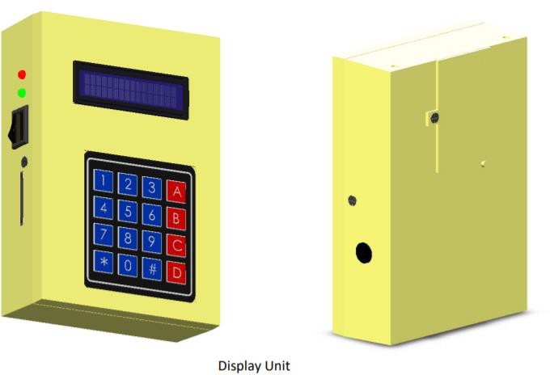

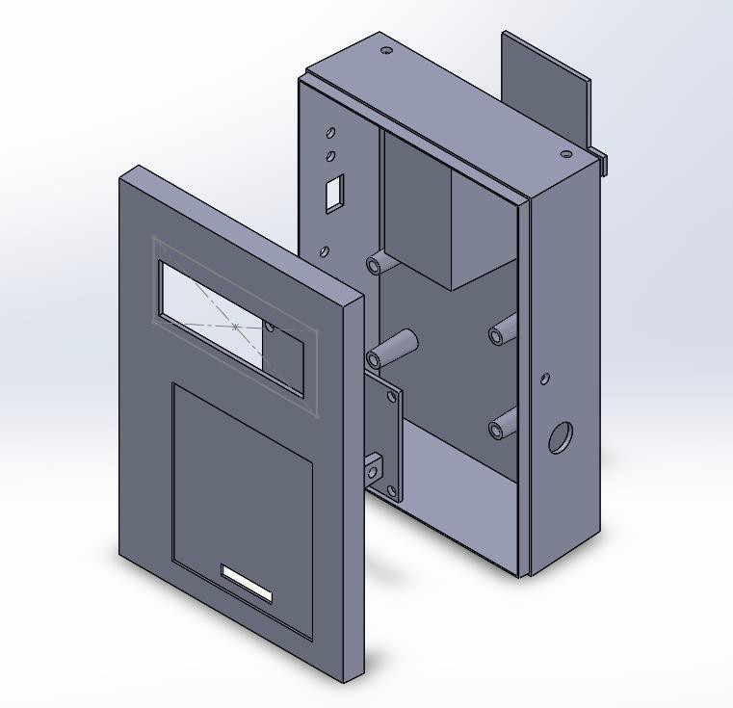

## Components

The display unit enclosure consists of 3 components that are manufactured by injection molding. All units are to be molded using hard plastic.

1. Top Cover
2. Bottom Cover
3. Battery Cover

## Top Cover

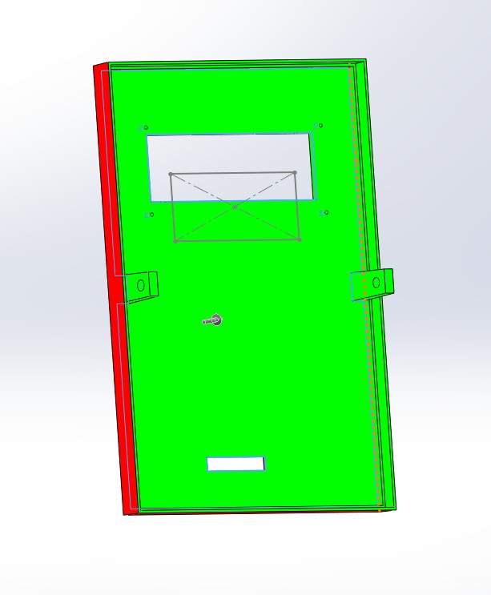*Draft Analysis*

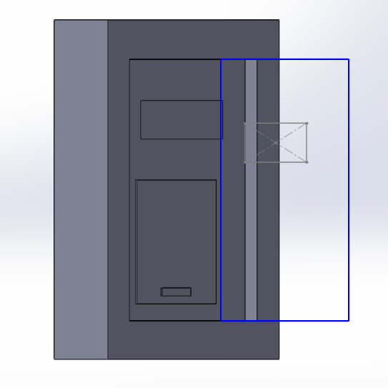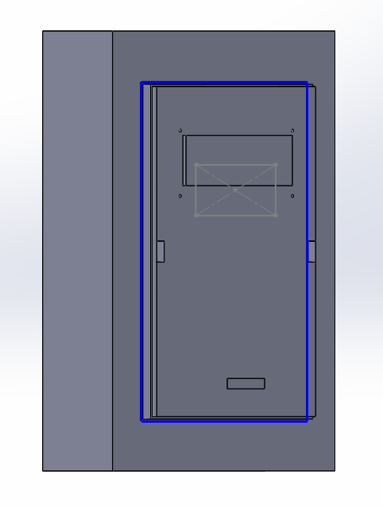*Mold Components*

Cavity Core

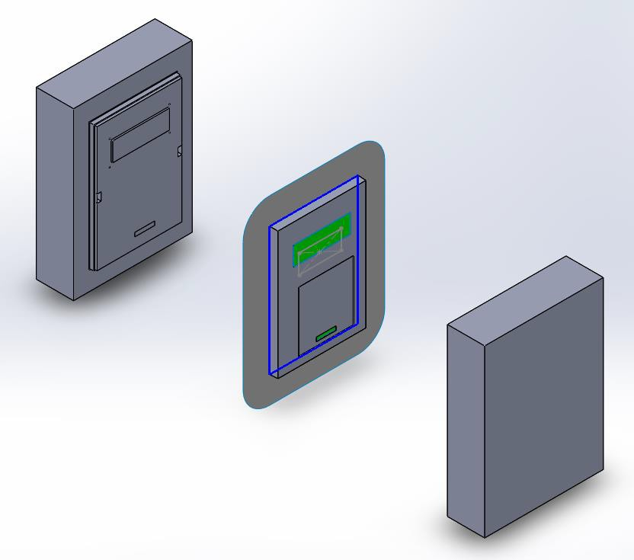

Exploded view of mold

## Bottom Cover

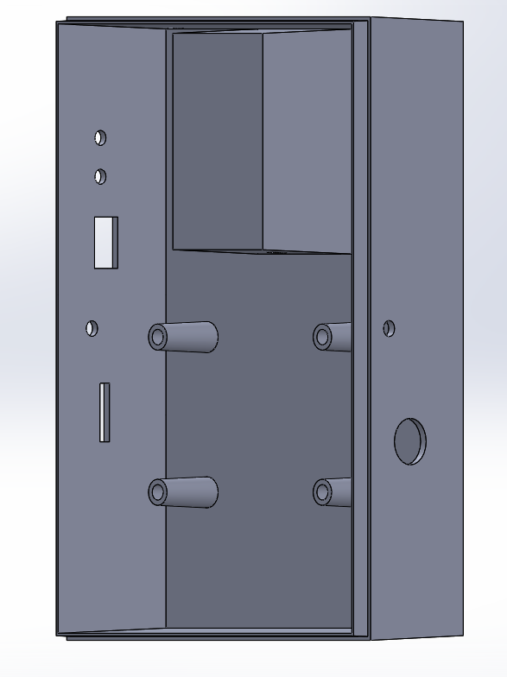

*Draft Analysis*

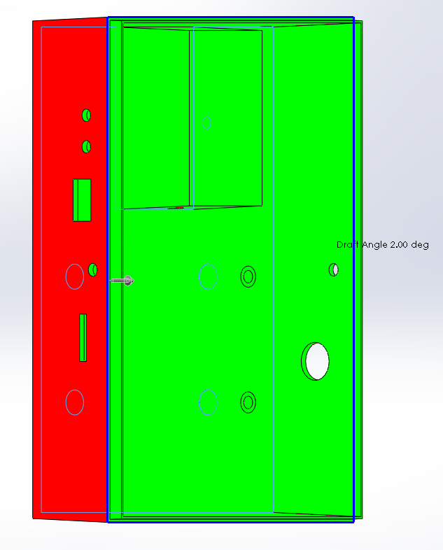

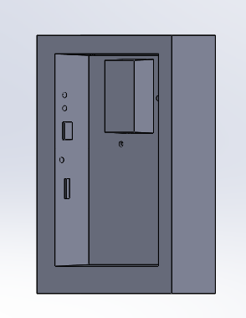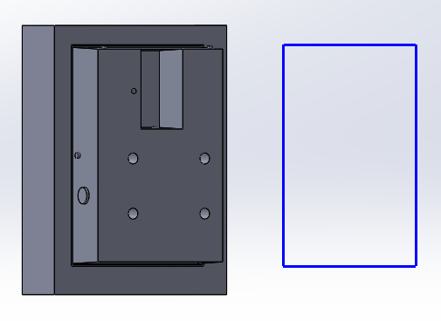*Mold Components*

Core Cavity

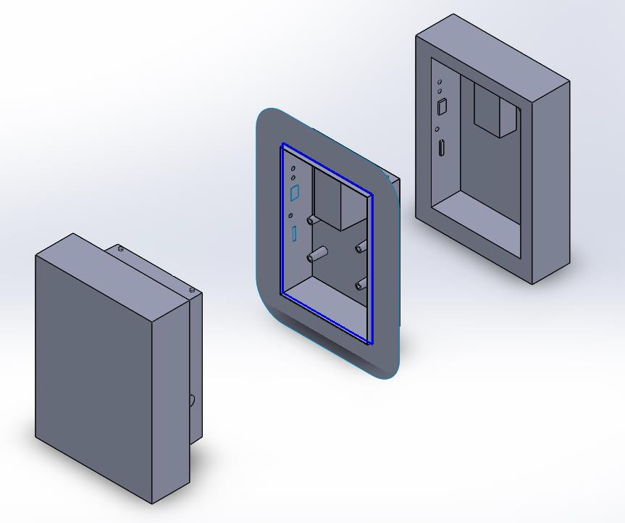

Exploded view of Mold

## Battery Cover

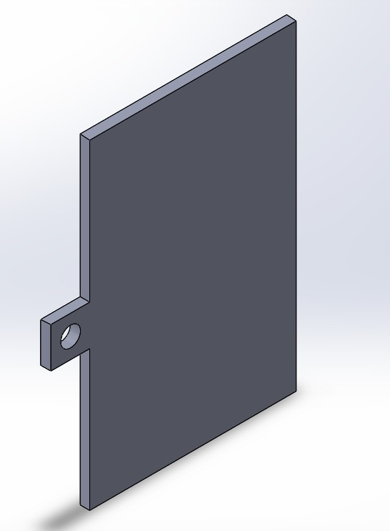

*Draft Analysis*

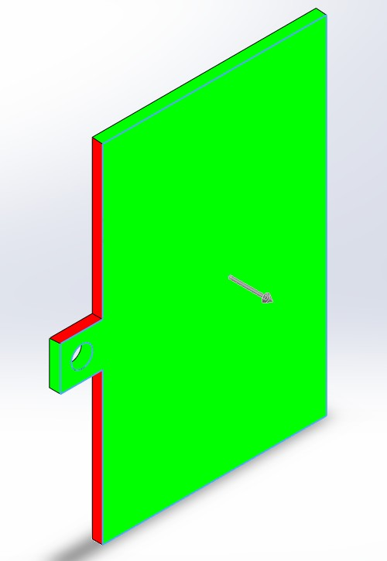

*Mold Components*

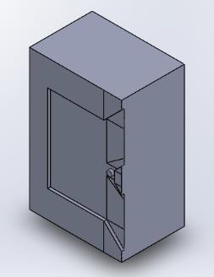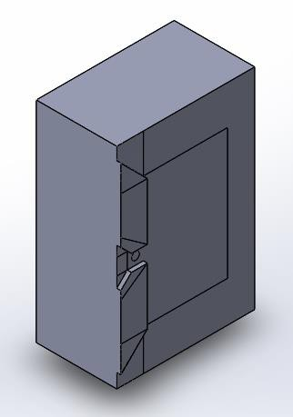

Core Cavity

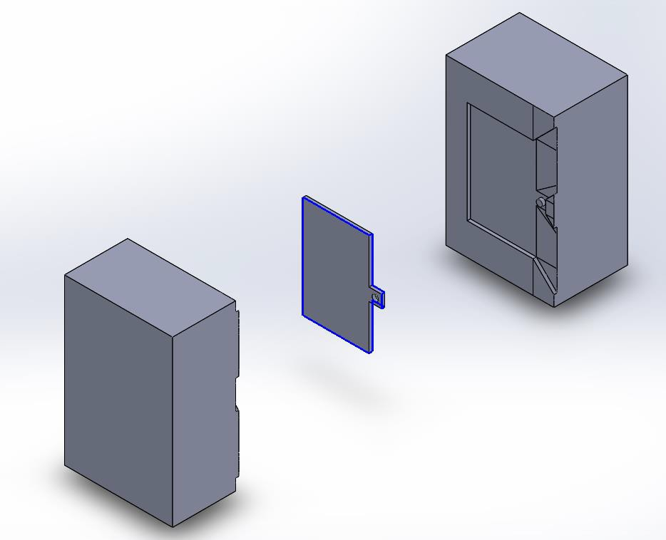

Exploded view of Mold

# Sensor Unit Manufacture

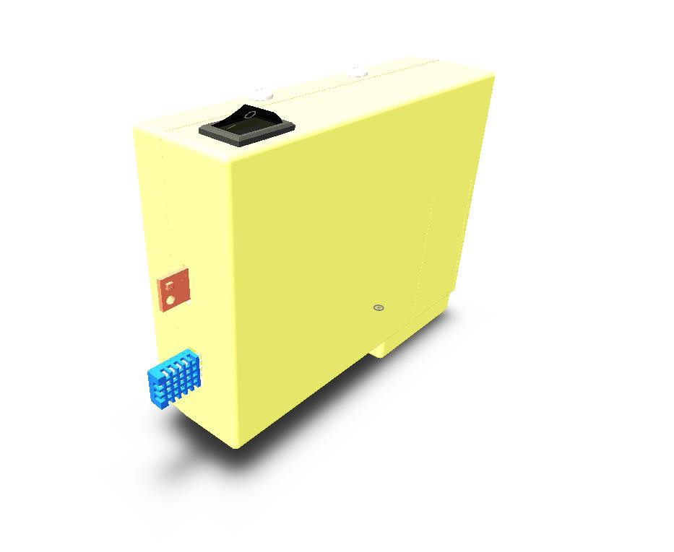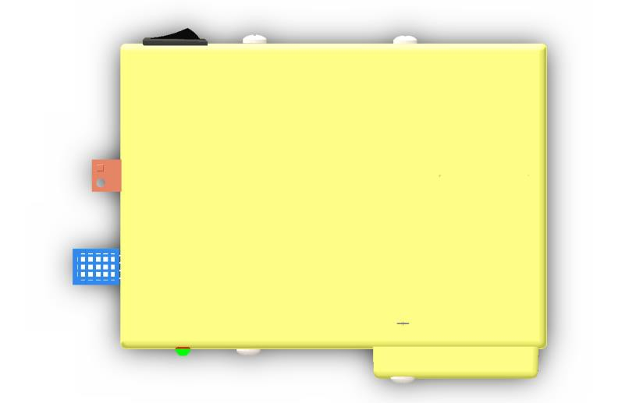

Sensor Unit

## Enclosure

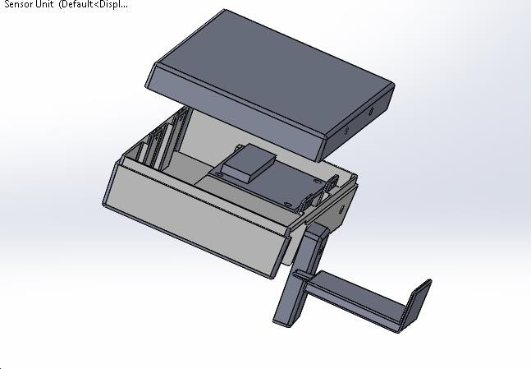

### Components

The Sensor Unit Enclosure consists of 4 components that are to be manufactured by injection molding. All units are to be molded using hard plastic

Components to be molded are:

* 1. Top Cover
  2. Bottom Cover
  3. Battery Cover
  4. Battery Lock

### Top Cover

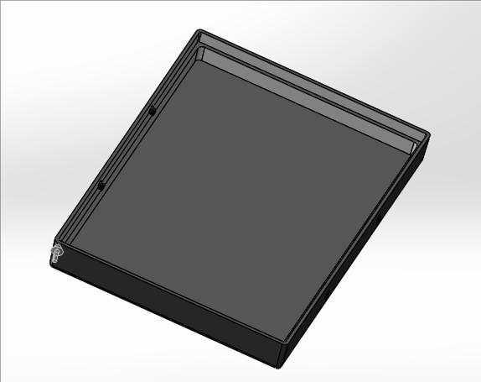

*Draft Analysis*

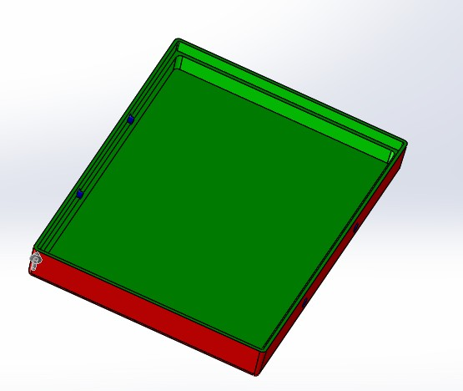

*Mold Components*

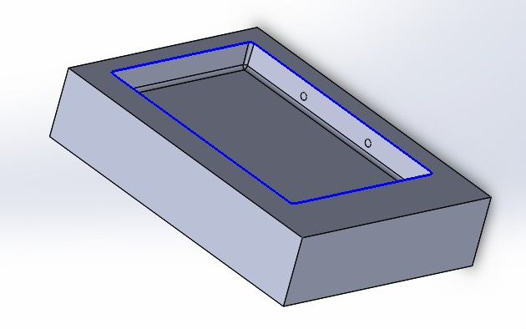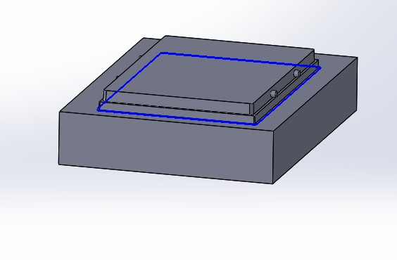

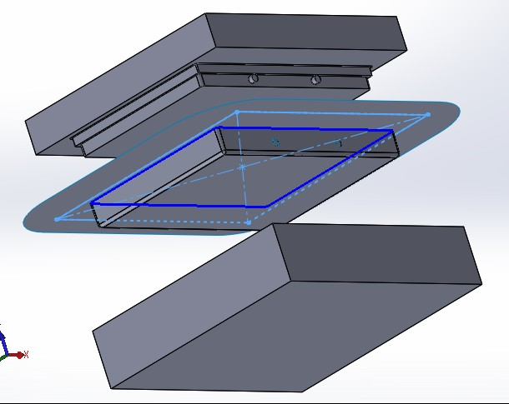

Cavity

Core



Exploded View of Mold

### Bottom Cover

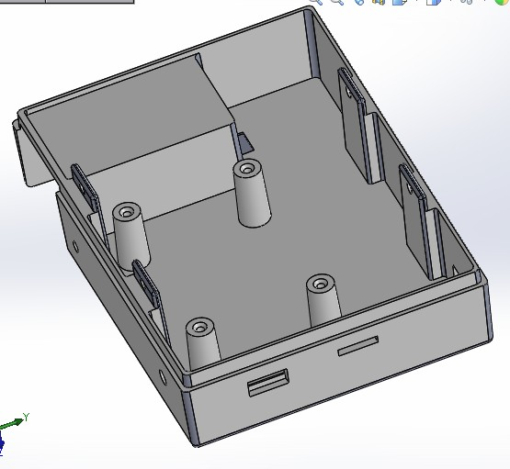

*Draft Analysis*

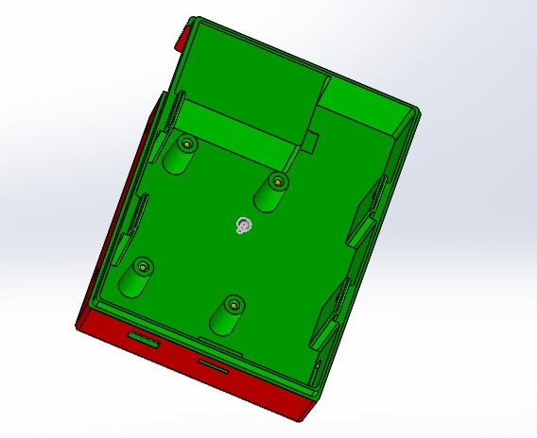

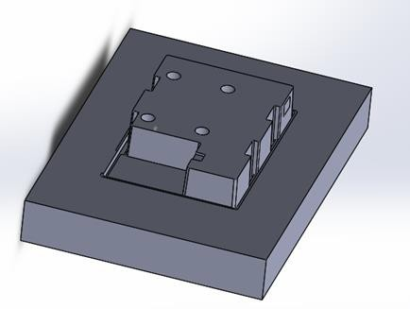*Mold Components*

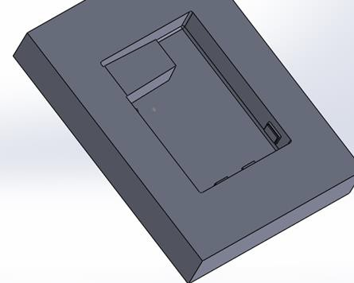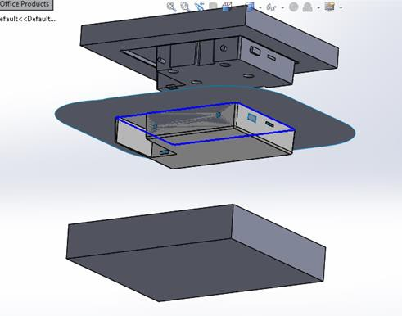

Cavity

Core



Exploded View of Mold

### Battery Cover

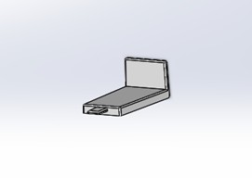

*Draft Analysis*

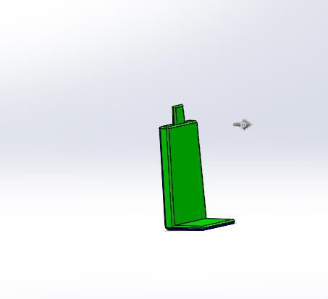

*Mold Components*

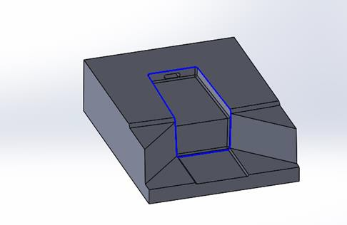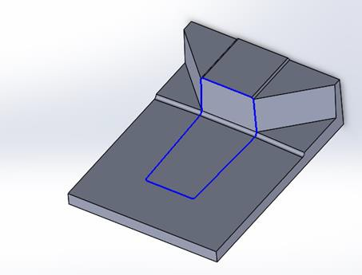

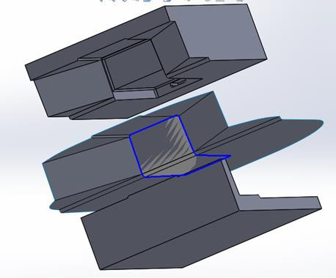

Cavity

Core



Exploded View of Mold

### Battery Lock

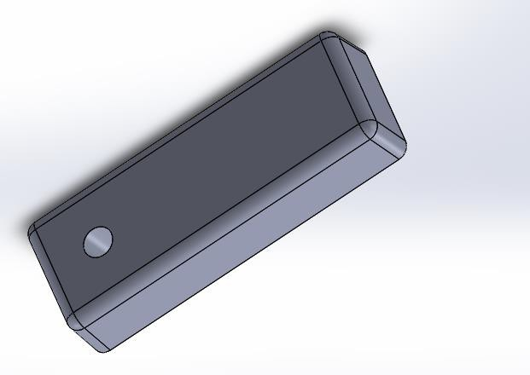

*Draft Analysis*

