# Interpreters

1. Mr. Buddhika Dassanayake (Curator – University of Wayamba)
2. Prof. J.A.K.S. Jayasinghe (Senior Professor – ENTC, University of Moratuwa)
3. Prof. Gamini Pushpakumara (Dean – Faculty of Agriculture, University of Peradeinya) (Department of Crop Sciences)
4. Dasun Tharinda (Communication Consultant)
5. AdaFruit (Suppliers – Waterproof Temperature and RH Sensor Modules)

# Summarized Input from the Interpreters

## Agricultural Side

Mr. Buddhika Dassanayake

* Temperature and relative humidity are the main factors to be controlled/monitored
* Propagators are used to keep the temperature above the outside temperature
* No standard temperatures have been published for different plants grown in propagators
* Usually the propagators are designed to main a temperature above the environment temperature (> 37 0C)
* High temperature (Around 45 0C) is an issue in the dry zone as it has high probability that the plants may be burnt
* Need two thresholds: High and low temperature thresholds to maintain the plants in the optimum range of temperature
* Propagators are designed to maintain around 100% relative humidity
* A lower threshold should be set (around 80%) to detect whether the RF goes below that
* No fertilizer is added to the plants in a propagator

Prof. Gamini Pushpakumara

* Light is also an important parameter
* No need to monitor the soil moisture level or soil temperature, because if the air humidity and temperature is sufficient, the soil conditions will also be ideal.
* Currently there are systems to control the light systems, using sensors and automatic openings.
* The type of covering depends on the plant being grown.
* The CO2 level does not need to be monitored during the time the plant is in the propagator.

## Technological Side

Prof. J A K S Jayasinghe

* With the set up used in the dry zone areas, need portability for the product
* Battery powered sensors, display unit and alarm unit
* The thresholds (RH and the temperature) needs to be set manually by the farmer
* Either 3 sensors per propagator or a sensor per propagator should be installed and as per the installation plan the temperature values and RH values should be displayed in the display
* Wireless Communication between the modules need to there
* Modular Design is required
* Waterproofed sensors/ a mechanism to easily remove and install the sensors should be there
* An Alarm and a light should be used to alert the farmer about any of the factors exceeding the thresholds
* Mechanism to record the data sampled on hourly basis for the two weeks’ time of the plant in the propagator should be present
* Better if the scalability is there even for a bigger greenhouse for monitoring and controlling system

Mr Dasun Tharinda

* Near field communication for sensors - All sensors need to communicate only with the display unit
* Far field communication / storage needed only for the central display unit

# Product Goals

## Function: What do we need?

A product to read the temperature and the humidity inside an outdoor propagator and display on a LCD screen and store the data on a SD card on an hourly basis. Further, based on two separate thresholds, an alarm should be triggered when those thresholds are exceeded.

The product comprises of three main components:

1. **Sensor Unit**: A unit with humidity, temperature and light sensor that is battery powered and transmits the data to the Display Unit
2. **Display Unit**: A battery powered unit with display, removable storage, a key pad and communicating capabilities with the sensors
3. **Alarm Unit**: A unit with a light and a buzzer that will be triggered when the temperature and/or humidity goes beyond the corresponding thresholds

## Estimated Cost

The cost of the product will be approximately 2500 including 3 sensor units, main display unit and alarming unit. The profit will be a 20% margin of this. (Selling price = LKR 3000)

## Expected Volume of production

5000 products per annum for 5 years. 100 units to be produced during the initial trial period of 6 months

# Design Specifications

Performance:

1. Sensing and displaying the temperature with an accuracy around and humidity with an accuracy and light level inside the propagator at the corresponding locations of the propagator
2. Storing the temperature, humidity and light data hourly during the day on a SD card that can be removed
3. Alarming the farmer when the temperature exceeds its threshold or humidity, or light goes below the threshold to take necessary actions.
4. Battery powered with the ability to operate a minimum of 1-day duration by one battery
5. Three Sensor units being enough to accurately represent the temperature, humidity and light level distribution of the propagator

Impact from the environment

1. The sensor units should be waterproofed
2. Anti-rusting
3. Should not interact with any chemicals used for the plants in the propagator as fertilizer
4. Should be able to operate at a moderate range of temperature from to
5. Damages from the farmers due to the negligence when using the sensors and Display Unit
6. RF communication between the Display Unit and the sensors should not be susceptible to the interference

Impact on the environment

1. Device is made of non-toxic materials
2. Micro particles occur from the wearing and tearing will not alter the controlled environmental factors inside the propagator
3. No poisonous by-products
4. Minimum wastage during the production

Lifetime

1. The Display Unit and the alarming unit should last a minimum of 2 years while the sensors are to last a minimum of 1 years.
2. The product should ideally last the duration of three cultivations of plants

Maintenance

1. The batteries should be replaced when the indicators display a charge of 5%
2. Modular components. Burned out or broken parts are easily replaceable
3. Zero Day to Day maintenance
4. It should not require a maintenance for more than 2 weeks
5. One technical person who is aware about the product will be needed to maintain the product

Production Cost

1. Maximum cost per sensing unit LKR 530: Max cost of sensing units per product LKR 1650
2. Maximum cost per Display Unit LKR 850

Package, Size and Weight

1. One package will include 3 sensor units, a Display Unit and an alarming unit

* Sensor Units: 3 x 1.5 x 2 inches 200g
* Display Unit: 5 x 6 x 3 inches 500g

1. No packaging needed post installation

**Appearance and Finish**

1. Able to input thresholds manually using the keypad
2. The temperature, humidity and light values for each sensor in a propagator should be displayed separately on the LCD screen
3. The battery level is indicated using few levels with three different colors of LEDs (eg:- Red – 2% to 20%, Green – 20% to 100%)

**Types of material**

1. Plastic
2. Acrylic
3. Wood

Reliability/ Accuracy

1. 6 sigma Standard failure rate 1 in a million

Safety

1. Surge Protection
2. Waterproofed sensor and Display Units
3. Accurate Battery Level indicator

Installation

1. Can be installed during or after the construction of the propagator
2. Can be scaled down to smaller propagators that read values using one sensor unit only
3. Extendable even to the mass scale Green House production
4. Do not require expertise knowledge for installation
5. Installation cost is free of charge
6. Less than 1-man hours to set up the product per propagator

Operations

1. Autonomous in sensing and displaying the temperature and humidity values inside the propagator
2. Saving the logs in the main frame is manual i.e. the SD card need to be removed and read manually in the computer to save the data in the main frame
3. The LCD screen will be switched off automatically after 5 min and can be switched on using a button

Reuse

1. Modular design that makes it easily removable for use elsewhere

Disposal

1. E waste centers
2. None of the components are classified as hazardous waste

Recycling

1. 80% recyclable

# Conceptual Designs

## Enclosure

Conceptual Design 01

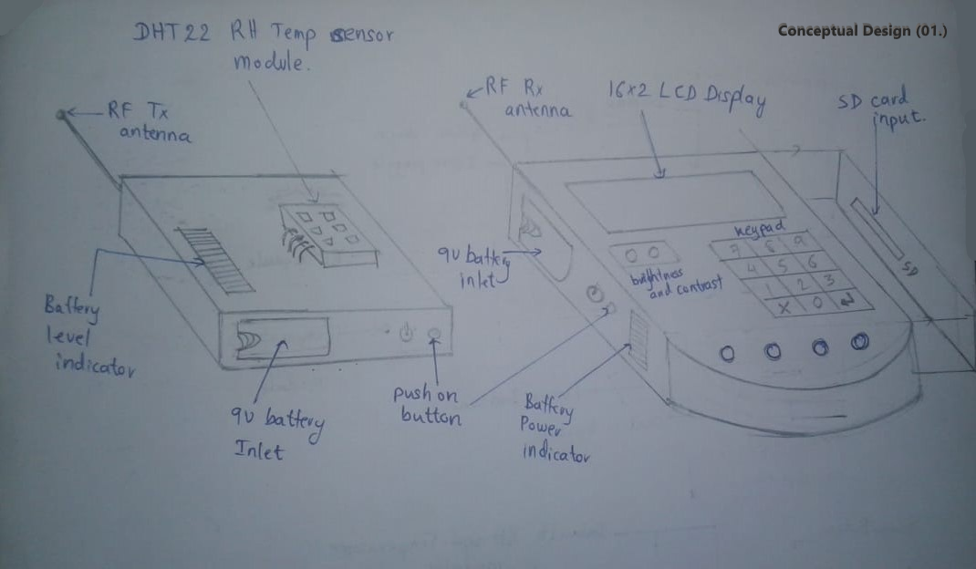

Conceptual Design 02 - Sensor Module

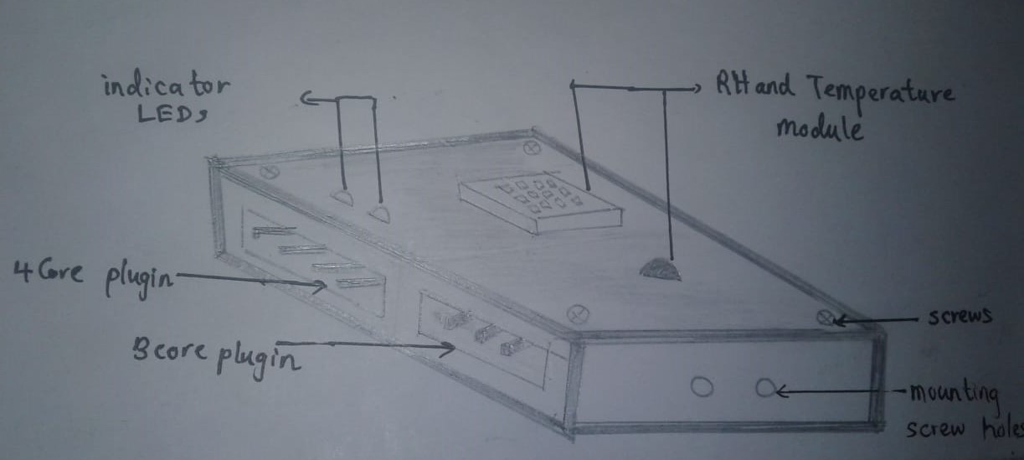

Conceptual Design 02 – Display Module

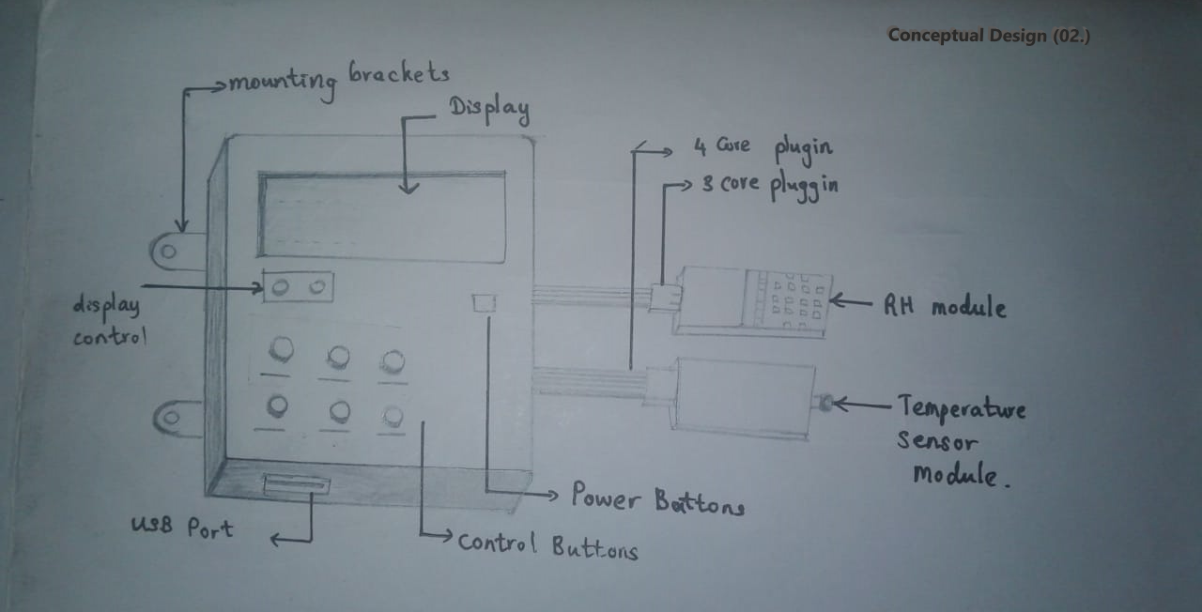

Conceptual Design 03

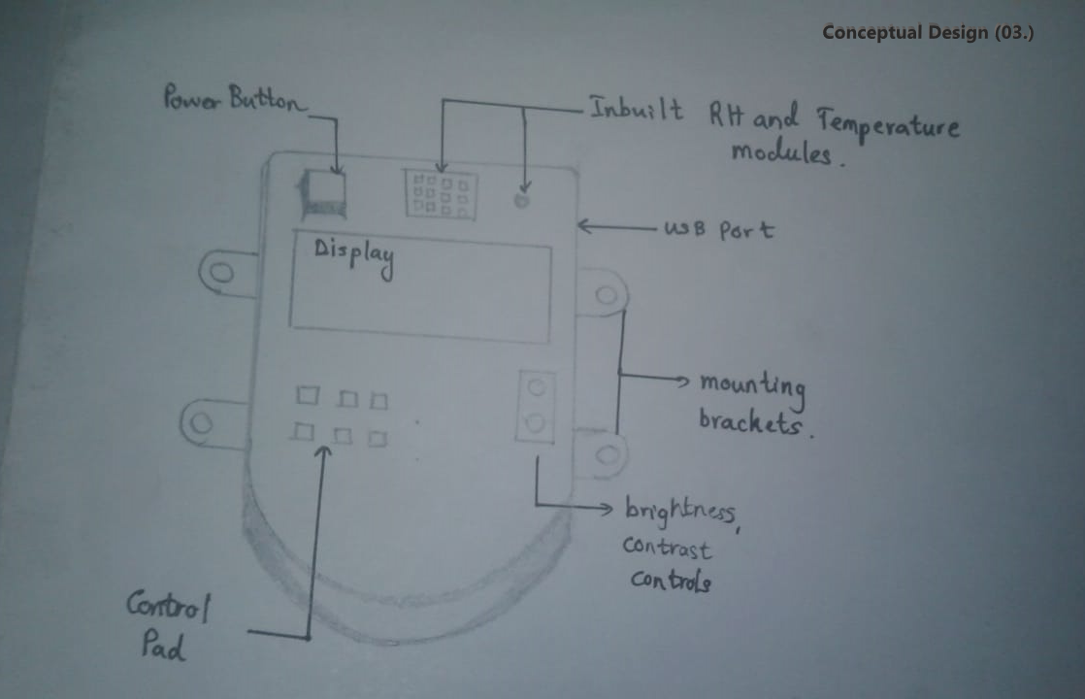

## Evaluation of the conceptual designs

|  |  |  |
| --- | --- | --- |
| **Enclosure** | **Advantages** | **Disadvantages** |
| 01 | * The sensor units and Display Units are portable (both are battery powered) * Wireless communication hence less bulky in wiring * Can input the threshold values manually using the key pad of the Display Unit * Can detect the battery charge level using the indicator * The Display Unit can be installed further from the propagator due to wireless communication * Installation and maintenance is easy | * The data can be erroneous due to certain interferences caused by other frequencies * Batteries need to be replaced on a daily basis/ more bulky and expensive batteries need to used * Communication Latency can be high * If multiple propagators are located nearby, occurrence of errors can be high due to interferences |
| 02 | * Wire Connections between the sensors, alarm and the display unit hence the latency is less * Less susceptible to the interferences * More accurate performance in temperature and humidity reading and displaying and alarming | * Bulky as more wires need to be installed * The Display Unit needs to be located very close to the propagator * External power should be given which makes the portability an issue * No SD card slot – hence the computer to store the values should be closer to the propagator * More electronic components (for example, a step-down transformer, rectifier) is needed as external power is being used * Costly installation |
| 03 | * All in one unit – Less manufacturing cost * Sensor unit, Display Unit and alarm should be installed within the propagator * Can read and store the temperature and humidity values directly from the unit on to a computer using the USB cable | * The damages that can occur due to the negligence of farmers can occur frequently * High cost to be undertaken to safeguard them against the chemicals, water and fire * No SD card slot – hence the computer to store the values should be closer to the propagator * Not a modular design – If a part is burnt the whole product needs to be replaced. * More electronic components (for example, a step-down transformer, rectifier) is needed as external power is being used |

Conclusion:

Since our product is to sense the temperature, humidity and light level in an outdoor propagator, and that the pros outweighs the cons, we choose the Conceptual Design (01.) as our design to proceed the project.

## Flow Charts

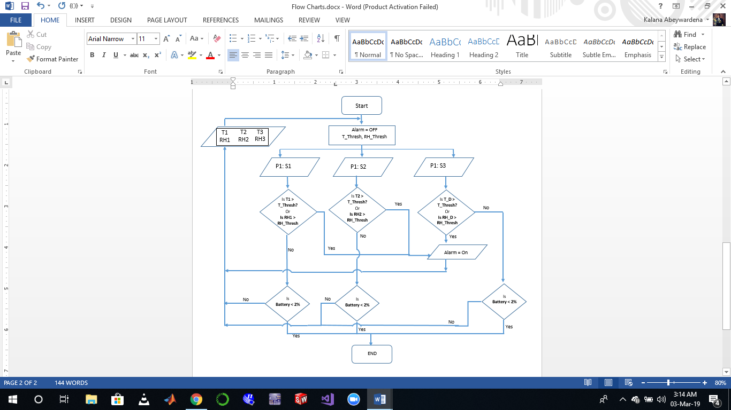**Flow Chart 01**

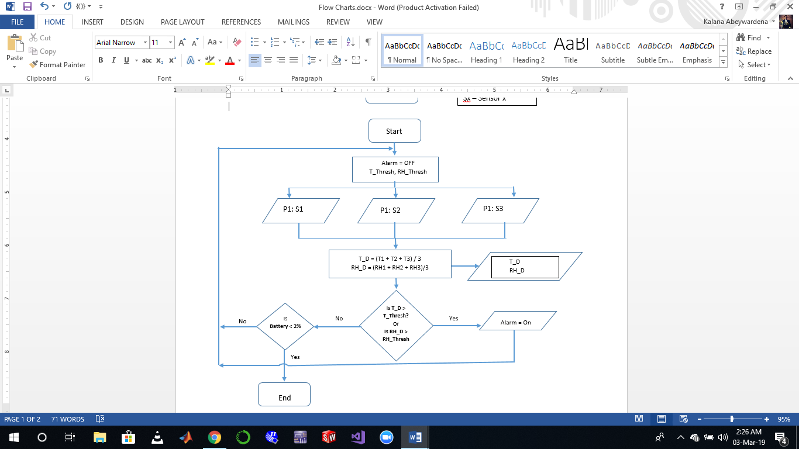**Flow Chart 02**

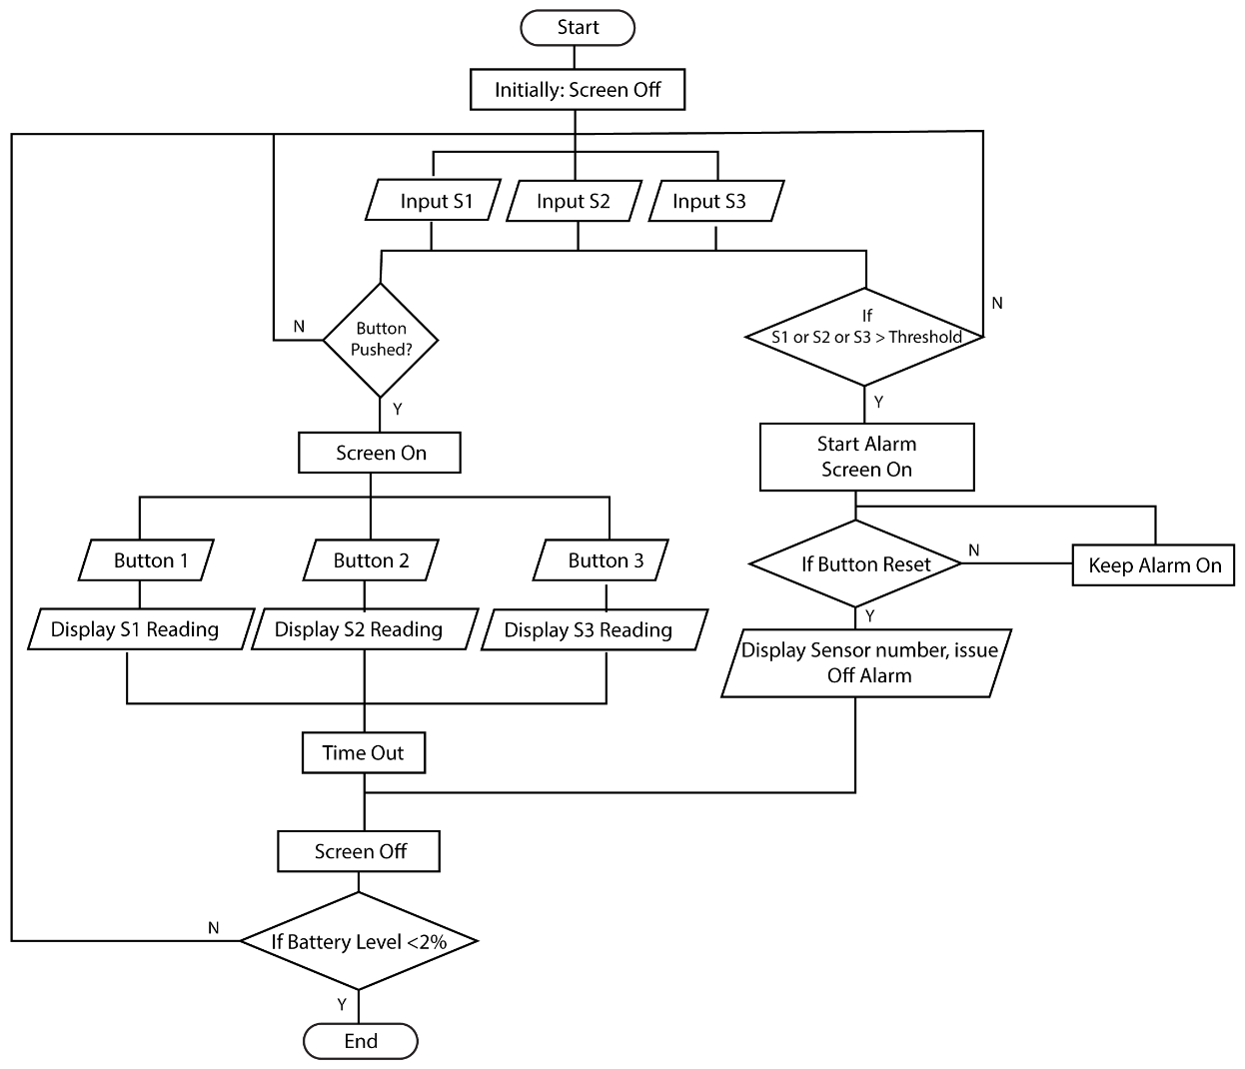**Flow Chart 3**

## Evaluation of the Flow Charts

|  |  |  |
| --- | --- | --- |
| **Flow Chart** | **Advantages** | **Disadvantages** |
| 01 | * Considers the temperature and the humidity at each point of the propagator ( from 3 sensors installed) * Better accuracy in detecting the temperature and humidity exceeding the thresholds * Display showing the temperature and humidity for each sensor in the propagator | * Logics should be evaluated for each sensor in the propagator hence computationally heavy |
| 02 | * Computationally easy * A single value represents the temperature, humidity and light level of the propagator | * The alarm get triggered when the average exceeds the threshold – For longer propagators, assuming the temperature and humidity distribution is uniform might be erroneous * 2 of the sensors are redundant – this type of algorithm can be run using one sensor * Less Accurate |
| 03 | * Computationally easy * Battery can be conserved * Can get pointwise readings for the temperature, light, and humidity * Display showing the temperature, humidity and light for each sensor. * Can use the sensors for separate propagators if they are small enough | * Have to manually push buttons to get readings from all the sensors |

Conclusion:

Based on the information gathered from the interpreter, it would be great if we can read and display the temperature and humidity at three different points in the propagator. This helps the farmer to locate the region at which the temperature has risen above the threshold and rectify it at that region. Hence the most appropriate flow chart is the Flow Chart 03.

Apart from the main functionality, the product will sample the temperature, humidity and light level values at each point hourly and store it in a SD card for further purposes.

## Circuit Block Diagrams

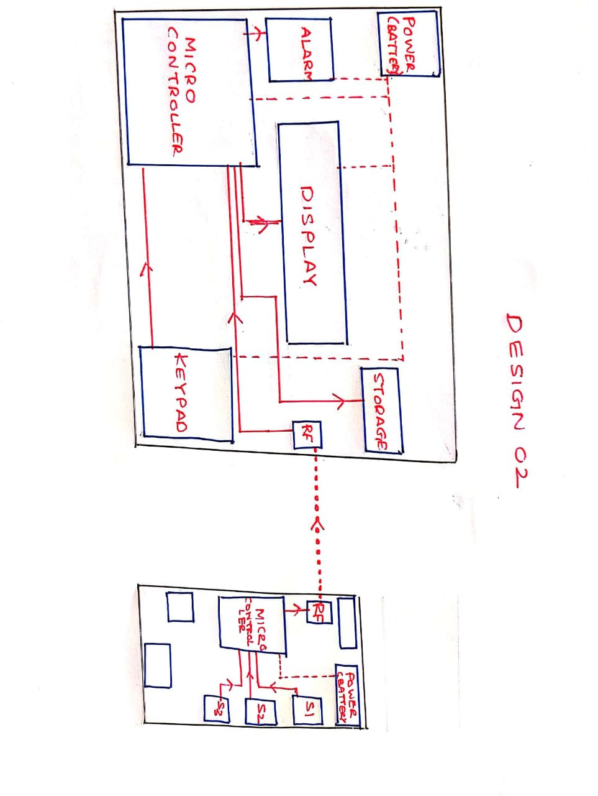Circuit Block Diagram 1

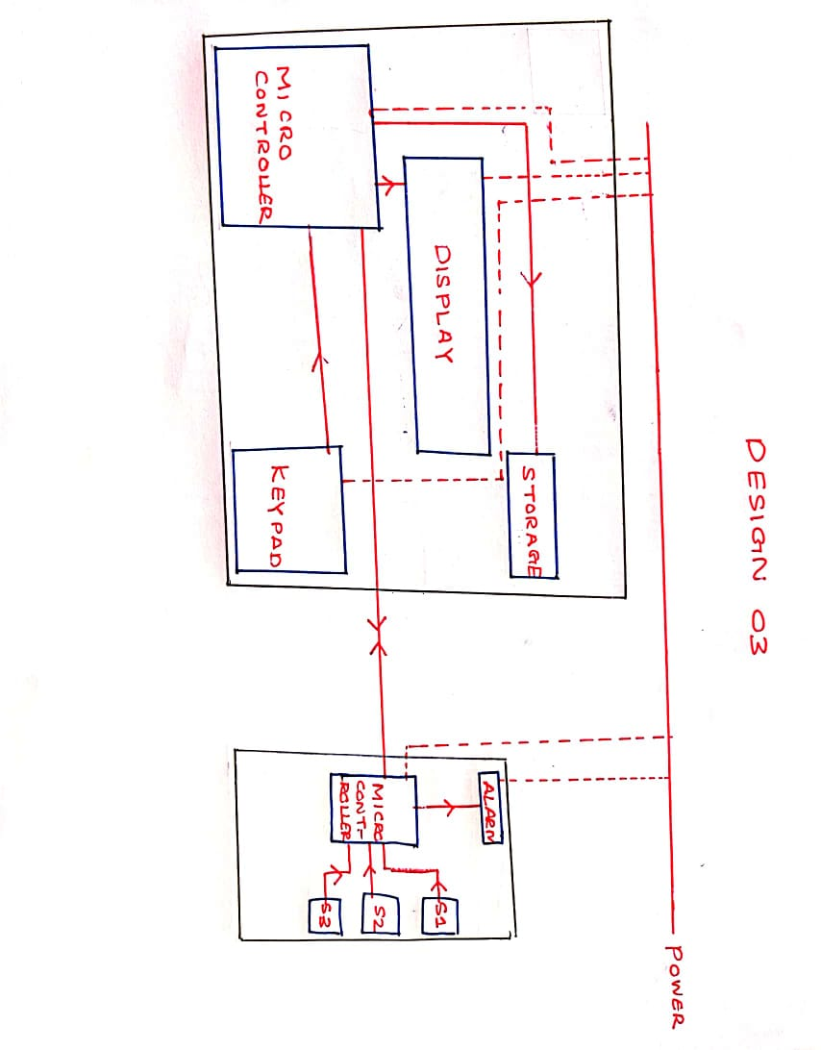Circuit Block Diagram 2

Circuit Block Diagram 3

## Evaluation of The Circuit Block Diagrams

|  |  |  |
| --- | --- | --- |
| **Circuit Black Diagram** | **Advantages** | **Disadvantages** |
| 01 | * Does not need power drawn externally. * Highly Modular due to lack of data lines between sensor and display modules. * Alarm coupled with sensor automatically indicates where the conditions have been violated. | * Battery needs to be changed occasionally * Usage of RF to communicate has risk of data loss * Alarm hidden by the propagator cover |
| 02 | * Does not need power drawn externally. * Highly Modular due to lack of data lines between sensor and display modules. * Alarm integrated into the display module. Increases modularity, simplicity and portability * Alarm externally visible to the user | * Battery needs to be changed occasionally * Usage of RF to communicate has risk of data loss |
| 03 | * Battery changes are not necessary * Alarm coupled with sensor automatically indicates where the conditions have been violated. | * Power needs to be drawn from an external source * Data and power lines reduce the modularity and portability * Lines may get damaged due to water and other weather conditions, affecting power and data transmission * Alarm hidden by the propagator cover |

Conclusion

Considering that both portability and modularity are very important considerations when designing the system, Design 2 had the best options. Therefore, considering all advantages and disadvantages, Circuit diagram Design 2 was selected for the preliminary design.

Detailed Design