|  |
| --- |
| Group 1 |
| Controlled Environment Monitors |
| Promotion Document ( June 19 ) |

# Content

1. Overview ……………………………………………………………………………………………………………. 02

2. Strategy ……………………………………………………………………………………………………………… 03

3. Business Model …………………………………………………………………………………………………... 04

4. Key features ………………………………………………………………………………………………………. 05

CEM brings a whole new experience to customers with its controlled environment monitor system. It is a whole new product under an innovative concept by team CEM. The product measures the soil moisture, humidity and temperature of a propagator/green house by sensing unit and displays it in the display unit.it furthers have a battery indicator circuit and an alarm circuit to warn when the measured values are out of threshold

See <https://github.com/ShechemKS/CEM_Design_Files> for more details.

Owner : CEM

Version: 1.0 / 20-06-2019

**Abstract:**

This product release addresses several customer requirements. Meeting the market need of an automated controlled environment monitoring system, improve the system accuracy and internal system characteristics and maintain the affordability are some. Current version of the product satisfy the basic needs of the customer with a reliable accuracy. In later versions improvements to the product will be done considering technology improvements and price-reduction.

**1.0 Strategy**

**1.1 Goals and Objectives**

Product goal of the controlled environmental monitoring system is to satisfy the customers need of an automated system to measure the important factors inside a propagator/greenhouse so that the customer does not have to measure them from time to time.

**1.2 Strategic Road Plan**

The project is the current plan for the company to reach out customers in local market and to make them realize the perks of buying this project. In futuristic versions with high accuracy and latest technology company would look into expand to the global market.

**1.3 Customer Categories**

*Farmers maintaining propagators* – farmers who maintains propagators for speed growth of their crops in the initial stage. Since their will be several propagators several sensor panels and a display unit will be needed per customer. Customer would consider buying when they realize the use of it.

*Orchid farmers* – orchid farmers use large green houses for their production and they will be needed regular care. For few greenhouses it would be hard to monitor all the time. Automated monitoring system will monitor for them and would make tasks easier.

**1.4 Competitive Strengths and Weaknesses**

Since the product is a design driven innovation, there are no competitors at the market yet but has a potential threat of competitors. The market for our product is not wide open since the customers only posses a small portion of the population. The profitability of the product is not expected in higher numbers since the customer attraction would be harder and the product should be cheap enough to the affordability level of the customers.

**2.0 Business Model**

**2.1 Value Proposition**

The product value is considered high since it is the only existing system for the task. A system would cost around Rs.5000/- at the initial stage and would vary in futuristic versions. The market competition is unavailable currently, but the value would differ if any sign of a competition occurs.

**2.2 Market Segment**

Users are farmers and owners of flower cultivation industry. Users would use the sensor panel inside the propagator humidity and temperature sensors out to the environment and soil moisture inside the soil. It would transmit data per hour basis and user interact with the display unit which is placed outside. User can assign threshold values through the keypad. The buzzer works according to the assigned threshold value. Display outputs the current values of sensors and it refreshes per hour.

## 2.3 Cost Structure

The product has initially a high cost and from time to time battery costs occur. Maintenance costs may happen in longer periods. Maintenance cost may include replacement cost of sensors and other circuit parts. In the presence of a new competitor, market price will nearly be equalized with the production price.

**2.4 Backward Compatibility**

System has a memory card slot, so customer can save all the data of the propagator/greenhouse and by using high capacity memory card they won’t be needing any replacements for quiet a long time. The data inside the chip can be used to update and maintain data bases since it can always be ejected.

**3.0 Key Features**

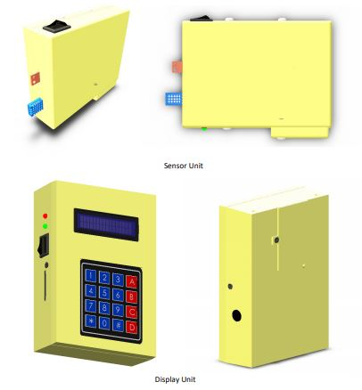

Sensor unit should be placed inside the propagator

Display unit should place outside the propagator.

**Features**

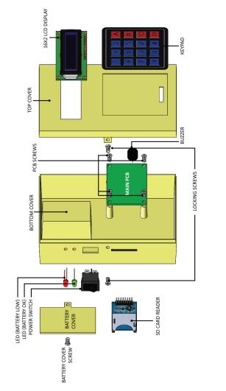 Wireless transmission between sensor unit and display.

Possibility of using micro SD cards

Battery level indicator displays the battery levels

Buzzer is loud enough to indicate the threshold exceeding status.