THOMPSON’S CALORIMETER

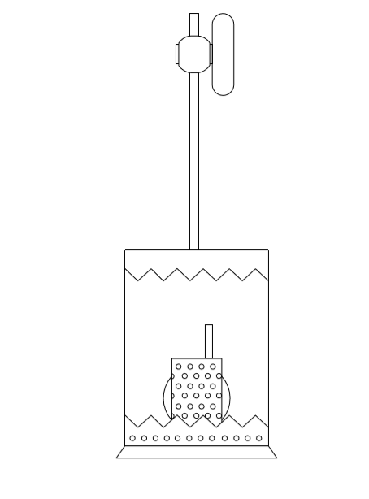

**NAME : Kayathiri M**

**INDEX NO : 160299D**

**COURSE : B.Sc. Engineering**

**GROUP : 5**

**DATE OF PER : 09.05.2018**

**DATE OF SUB :23.05.2018**

**EXPERIMENT**

Thompson’s Calorimeter.

**OBJECTIVE**

Determining the calorific value of a given solid fuel.

**INTRODUCTION**

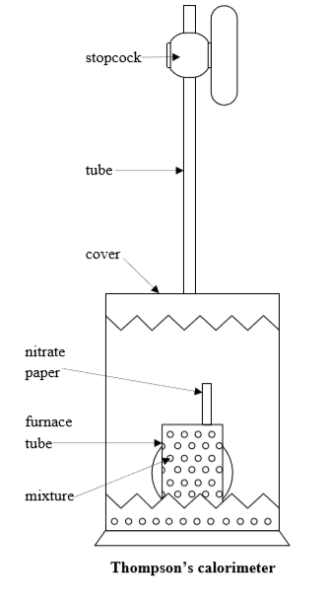The calorific value is the amount of energy produced by the complete combustion of a material or fuel. It is measured in units of energy per amount of material that is kJ/kg. It is important to know these values of materials for the application in thermodynamics such as in heat engines. In this practical we are going to find the calorific value of the coal

**MATERIALS AND APPARATUS**

* Coal powder 2 grams
* KNO3 6.5 grams
* KClO3 19.5 grams
* Nitrate paper
* Measuring cylinder with 2 litre of water
* Thompson’s calorimeter Stopwatch
* Electric thermometer
* Mortar and pestle
* Digital balance
* Furnace tube
* Metal wire

**PROCEDURE**

* Using digital balance measure and take 2g of coal, 19.5g of KCLO3, 6.5g of KNO3 and mix it and grind it for about 30 minutes to get a fine powder of the mixture using mortar and pestle which will ensure the proper burning process during practical.
* Pack the resulting compound into the furnace tube along with the nitrate paper.
* Take a 2litre of water in a measuring cylinder and take the initial temperature of the water using the thermometer.
* Ignite the nitrate paper, close it with the cover of calorimeter by using the stopcock and quickly lower it into the measuring cylinder with water as soon as possible without spilling the water and start the stop watch at the same time.
* Take the temperature readings of the thermometer for every 30 seconds.
* While recording the readings stir the water to evenly spread the heat throughout the measuring cylinder.
* The end of bubbling will indicate the maximum temperature of the water during the burning process of the mixture.
* Open the stopcock and clear the tube using the metal wire provided after all the readings up to thirty minute are taken.

**THEORY**

This practical involves basically three types of reactions. These belongs to endothermic and exothermic reactions.

**𝐶 (s) + 𝑂2 (g) → 𝐶𝑂2 (g) + 𝐻𝑒𝑎𝑡**

**2𝐾𝑁𝑂3 (s) → 2𝐾𝑁𝑂2 (s) + 𝑂2 (g) + 𝐻𝑒𝑎𝑡 (1)(exothermic)**

**2𝐾𝐶𝑙𝑂3 (s) + 𝐻𝑒𝑎𝑡 → 2𝐾𝐶𝑙𝑂2 (s) + 𝑂2 (𝑠) (2)(endothermic)**

Since we have to find the calorific value of the coal, we need complete combustion of coal. For that we need to supply adequate amount of oxygen. However, since this reaction takes place inside water we cannot supply oxygen directly. Hence we introduce the mixture of KNO3 and KClO3 to the system. According to the reactions 1 and 2, adequate amount of oxygen will be supplied to the system.

But according to reaction (1) heat will be released to the system and according to reaction (2) some heat will be absorbed from system. This heat will disturb the calculation of calorific value as we are calculating it using the heat change in the system. If the amounts of KNO3 and KClO3 are taken such a way that the heat released by reaction (1) is completely absorbed by reaction (2), the net change in

heat energy would be purely associated with the combustion of coal. So we used 6.5g of KNO3 and 19.5g of KClO3 to achieve it. The amount of O2 released in this combination is sufficient enough for the complete combustion of 2g of coal.

ASSUMPTIONS

The energy from the combustion of coal is completely absorbed by the water and the calorimeter. Further there is no impurity in the mixture and the coal is pure. Complete combustion (burning of coal) takes place.

The heat generated by the system is absorbed by the water surrounding the apparatus and the calorimeter.

**Hre = Hab**

**𝑚𝑐𝑜𝑎𝑙𝑐𝑐𝑜𝑎𝑙 = ∑𝑚𝑠∆𝛳**

**𝑚𝑐𝑜𝑎𝑙𝑐𝑐𝑜𝑎𝑙 = (𝑚𝑤𝑎𝑡𝑒𝑟𝑠𝑤𝑎𝑡𝑒𝑟 + 𝑚𝑐𝑢𝑠𝑐𝑢) ∆𝛳**

**∆𝜃 = 𝑇𝑚𝑒𝑎𝑛 − 𝑇𝑖𝑛𝑖𝑡𝑖𝑎𝑙**

**𝑇𝑚𝑒𝑎𝑛 = (𝑇𝑐𝑎𝑙 + 𝑇𝑚𝑎𝑥 )/2**

Here,

𝐻𝑟𝑒 − 𝐸𝑛𝑒𝑟𝑔𝑦 𝑟𝑒𝑙𝑒𝑎𝑠𝑒𝑑 (𝐽)

Hab−𝐸𝑛𝑒𝑟𝑔𝑦 𝑎𝑏𝑠𝑜𝑟𝑏𝑒𝑑(𝐽)

𝑚𝑐𝑜𝑎𝑙 − 𝑚𝑎𝑠𝑠 𝑜𝑓 𝑐𝑜𝑎𝑙 (𝑘𝑔)

𝑐𝑐𝑜𝑎𝑙 − 𝑐𝑎𝑙𝑜𝑟𝑖𝑓𝑖𝑐 𝑣𝑎𝑙𝑢𝑒 𝑜𝑓 𝑎 𝑐𝑜𝑎𝑙 (𝐽 𝑘𝑔−1)

𝑚𝑤𝑎𝑡𝑒𝑟 − 𝑚𝑎𝑠𝑠 𝑜𝑓 𝑤𝑎𝑡𝑒𝑟 (𝑘𝑔)

𝑠𝑤𝑎𝑡𝑒𝑟 − 𝑠𝑝𝑒𝑐𝑖𝑓𝑖𝑐 ℎ𝑒𝑎𝑡 𝑐𝑎𝑝𝑎𝑐𝑖𝑡𝑦 𝑜𝑓 𝑤𝑎𝑡𝑒𝑟 (𝐽 𝑘𝑔−1 𝐾−1)

𝑚𝐶𝑢 − 𝑚𝑎𝑠𝑠 𝑜𝑓 𝑐𝑎𝑙𝑜𝑟𝑖𝑚𝑒𝑡𝑒𝑟 (𝑘𝑔)

𝑠𝐶𝑢 − 𝑠𝑝𝑒𝑐𝑖𝑓𝑖𝑐 ℎ𝑒𝑎𝑡 𝑐𝑎𝑝𝑎𝑐𝑖𝑡𝑦 𝑜𝑓 𝑐𝑎𝑙𝑜𝑟𝑖𝑚𝑒𝑡𝑒𝑟(𝑐𝑜𝑝𝑝𝑒𝑟) (𝐽 𝑘𝑔−1 𝐾−1)

∆𝜃 − 𝑛𝑒𝑡 𝑡𝑒𝑚𝑝𝑟𝑎𝑡𝑢𝑟𝑒 𝑟𝑖𝑠𝑒 (𝐾)

ccoal is what we are trying to find, that is the calorific value of coal. Therefore,

**𝑐𝑐𝑜𝑎𝑙 = [(𝑚𝑤𝑎𝑡𝑒𝑟𝑠𝑤𝑎𝑡𝑒𝑟 + 𝑚𝐶𝑢𝑠𝐶𝑢 ) × ∆𝜃] /𝑚𝑐𝑜𝑎𝑙**

**CALCULATIONS**

* Mass of coal, 𝑚𝑐𝑜𝑎𝑙 =
* Mass of water (assuming density of water as 1 g cm-3),

𝑚𝑤𝑎𝑡𝑒𝑟 = 1 × 2000 × 10−3 𝑘𝑔

𝑚𝑤𝑎𝑡𝑒𝑟 = 2 𝑘𝑔

* Specific heat capacity of water, 𝑠𝑤𝑎𝑡𝑒𝑟 = 4200 𝐽 𝑘𝑔−1 𝐾−1
* Mass of calorimeter, 𝑚𝐶𝑢 = 442.24 𝑔 = 0.44224𝑘𝑔
* Specific heat capacity of calorimeter(copper), 𝑠𝐶𝑢 = 386 𝐽 𝑘𝑔−1 𝐾−1
* 𝑇𝑖𝑛𝑖𝑡𝑖𝑎𝑙 = 29.6℃ = 302.6 K

From graph,

𝑇𝑚𝑎𝑥 = 34.4 ℃ = 307.4 𝐾

𝑇𝑐𝑎𝑙 = 34.6 ℃ = 307.6 𝐾

* Calculation

𝑇𝑚𝑒𝑎𝑛 = (307.4 + 307.6)/ 2 𝐾

𝑇𝑚𝑒𝑎𝑛 = 307.5 𝐾

∆𝜃 = 307.5 – 302.6 𝐾

∆𝜃 = 4.9 𝐾

**𝑐𝑐𝑜𝑎𝑙 = (𝑚𝑤𝑎𝑡𝑒𝑟𝑠𝑤𝑎𝑡𝑒𝑟 + 𝑚𝐶𝑢𝑠𝐶𝑢 ) × ∆𝜃 𝑚𝑐𝑜𝑎𝑙**

𝑐𝑐𝑜𝑎𝑙 = 𝐽 𝑘𝑔−1

𝑐𝑐𝑜𝑎𝑙 = 24205448.3 𝐽 𝑘𝑔−1

𝒄𝒄𝒐𝒂𝒍 = 𝟐𝟒.**205** 𝑴𝑱 𝒌𝒈−𝟏

**RESULT**

The calorific value of the given sample of coal is, 𝒄𝒄𝒐𝒂𝒍 = 𝟐𝟒.**205** 𝑴𝑱 𝒌𝒈−𝟏

**DISCUSSION**

* Describe briefly the method used in correcting for heat loss by radiation etc. indicating the assumptions made.

Heat is released to the environment by the following ways,

Radiation: Polishing the surface of the calorimeter.

Convection: Covering the entire apparatus.

Conduction: Cover the measuring cylinder with an insulation material.

In order to correct the heat loss to environment, we initiate the experiment from a slightly lower temperature than that of the environment and end up the experiment with a slightly higher temperature than environment by the same amount. By doing this step we assume that the heat absorbed by the system during the initial stage of the experiment is equal to the heat released by the system at the end of the experiment.

* Describe the Dickinson method of correcting for radiation losses as prescribed by ASTM.

Dickinson stated that the maximum temperature is not a temperature what we are getting in the practical, it is calculated by the following equation.

𝑇𝑚𝑒𝑎𝑛 =(𝑇𝑐𝑎𝑙 + 𝑇𝑚𝑎𝑥 )/2

* How was the heat of reaction of Nitrate and Chlorate accounted for?

It is corrected by the assumption that the heat released in the exothermic reaction of KNO3 is fully absorbed by the KCLO3 for the endothermic reaction to take place. This is attained by choosing the optimum ratio of KNO3 and KCLO3 so that net heat released is zero.

* What is the expected calorific value of coal? Indicate the reasons for any discrepancy between your observed values and expected values.

The calorific value of coal is varying in different samples due to the impurities present in the samples in the range 15 MJ – 32 MJ. But 30MJ can be given as an average value. In practical we obtained as 24.663 𝑀𝐽 𝑘𝑔−1 Reasons for discrepancy between observed value & expected value; - Some amount of water spilled out due to bubbling. - Absence of complete combustion. - The heat absorbed by the measuring cylinder was ignored - Impurities in the ingredients. - There are heat losses during the practical in the modes of radiation, convection, and conduction - Measuring errors.

* What other important methods are used to obtain the calorific value of solid fuels?

Isothermal Bomb Calorimeter, Market’s Boiler, Separation & Throttling, Boy`s Calorimeter

* If you were asked to find the calorific value of a given sample of firewood, how would you do it?

Take the dry firewood and grind it well with KNO3 and KCLO3. Same steps are followed except for firewood we use Bomb calorimeter instead of Thompson’s calorimeter. Since there are more impurities and components in firewood the equations and amount of O2 needed may vary. So calculate and take suitable amount of KNO3 and KClO3 to follow the same procedure as above.