**Business analysis**

**What is business analysis?**

**Introduction:**

**Business Analysis** is the process of allowing changes in an organizational firm by finding needs, requirements and recommending effective solutions that deliver values to the stakeholders.  The solutions often include a software system development component but also can have of process development, organizational changes or strategic planning and policy developments. The person who carries out this task is called a **business analyst** or **BA**.

**The responsibilities are:**

* To file the business requests for the IT system support using correct documentation standards.
* To investigate the business systems, taking a holistic view of the situation and this may include the examining components of the organizational structures and staff development problems as well as the current processes and IT systems.
* To evaluate the process to develop the operation of a business system. Again, this will need an examination of organizational structure and staff development requirement, to make sure that they are in line with any proposed process redesign and IT system development.

**Business process analysis steps**

* Identify the process of the business. The first step to do is to find what are the processes that need development.
* Make a project team. Define a team that will support you with the analysis.
* Make a business process flowchart.
* Specify the important improvement points.

**Sample Domain chosen: Smart Mobile shopping**

**Brief introduction about the smart mobile shopping**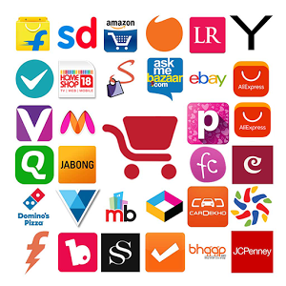

I just got a clear understanding about the value of Business Analysis and came up with an innovative idea which may help in an effective business development. I trust that this proposal will help in getting a brief understanding about my idea and its implementation. The way in which my idea will create an impact in its users is also mentioned here.

Online shopping is a method of electronic commerce which give access to directly buy goods or services from any seller through the internet using a web application or mobile app. Customers can search and find a product of interest by just visiting the website of that specific retailer directly or searching for alternative sellers using a shopping application available. Normally a simple online shopping application may display the product’s availability, ratings and the pricing at different e-retailers. As of 2016, customers can do online shopping using a range of different computers, mobile phones and devices including desktop, laptop and tablet computers.

The idea is to develop an application similar to online shopping applications that are in use nowadays and to implement them to the online users. This may help the online customers as well as e-retailers in maintaining an effective transaction than ever. Usually the users search for the product on their wish at any time. In this application there will be a specific feature to analyze the taste of the customer by reviewing his or her search history. So always the application will prefer to show some new arrivals which are related to those searches. And also there will be a feature for sending notification to the customer at the time of new arrivals and seasonal offers related to the product that they have searched more. The item they searched more will be added to their favorites and popup those arrivals at the time of login. This system will show some special features than ordinary shopping applications such as analyze user’s taste, pop up the new arrival and sending notifications related to the top most searched item. And also the user can subscribe for any of the category and enjoy the details of new arrivals time to time.

**Specific intension:** There are many online mobile shopping applications. But people face difficulties in finding the item according to their item. If they couldn’t find an item according to their wish at a time, the system could able to notify the user when that specific item come into market at any time. Then the user can decide on buying it or not. So the system should have the ability to analyze and remember the searching scenario of the user and keep updating of the details related to it and informing the user.

**Analysis:**

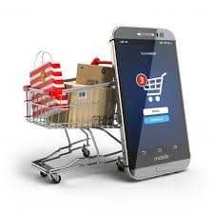Mobile shopping is somewhat famous in Srilanka. Many people use this privileged facility and having an effective transaction. There are many popular websites for online and mobile shopping in our country. Eg: MyStore.lk, Takas.lk, wow.lk etc. And big restaurants, textile shops and shopping mauls maintain their own web application to handle their transactions.

There are about 20,950,041 people in Srilanka. More than thirty percentage of people are internet users. Most of the people prefer to do mobile shopping rather than wasting time in shopping. If we implement this system, most of the people will be benefited. There are more than 18,003,447 mobile subscribers in our country. Half of them do mobile and online shopping

**Statistics:** We can introduce a free trial version among the smart phone users. After one month we can Rs.100 can be charged as a service charge. It will not cost so much to the customers. So there will be a profit. And can charge for displaying products from the owners of those product markets. As well as there will be a small charge will be deducted while doing the mobile cash transaction. SO it is profitable in many ways.

* Averagely there wil be minimum 9,000,000 users for this application.
* There are more than 1000 big companies which rely on online shopping

Above samples just show a simple estimation to understand how much this project will be profitable.

**Developments needed:**

* Analyzing the top most brands of products
* Getting the details of products which are popular among users
* Getting an appropriate pricing list of products from different shops
* Having a proper system to get the updates of pricing levels, availability of products and offers available
* System should be user friendly
* System should mainly rely on customer satisfaction
* There should be a proper maintenance
* Facility to upgrade the system

Implementation of this system will change the current online shopping markets and catch many users to this new application. This will be effective to the users and profitable to the marketers.

**Index number : 160299D**

**Name : Kayathiri M**

**Token number: 26**