### Educational Qualifications

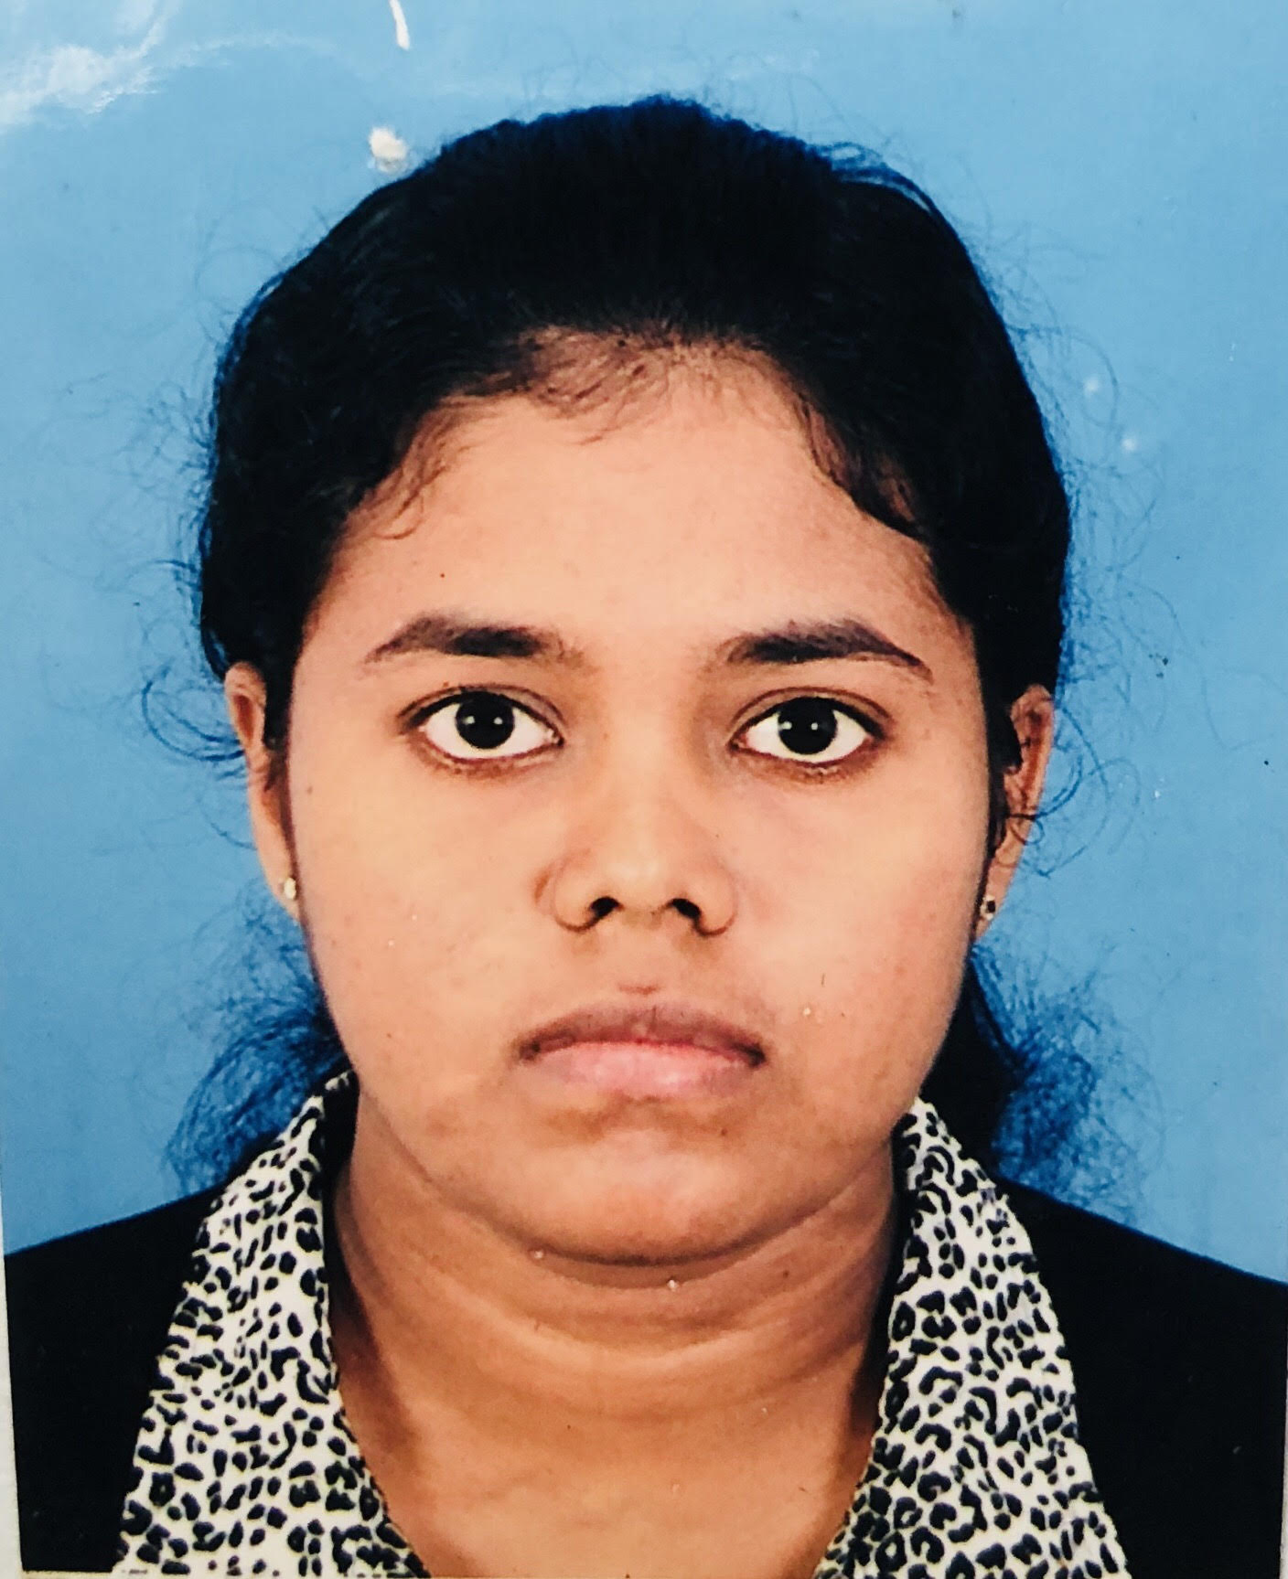

Kayathiri Mahendrakumaran

.

# **Objective**

**“I have the ability to work in challenging environments as a team worker. I consider myself an adaptable person who can be a good team player and a good leader.”**

## **Skills & Abilities**

**Languages: Tamil ●●●●● English ●●●●○ Sinhala ●●○○○**  **Programming Languages: Python ●●●●○ Java ●●●●○**

## Vitals

**T** 0770512748

**E** [kayathirim.16@cse.mrt.ac.lk](mailto:kayathirim.16@cse.mrt.ac.lk)

**Ln**Linkedin.com/in/KayathiriMahendrakumaran

#### BSc Undergraduate (2016-Present)

**Department of Computer Science and Engineering**

**University of Moratuwa**

**Current GPA-3.89**

##### **G.C.E ADVANCED LEVEL EXAMINATION V/SAIVAPRAGASA LADIES’ COLLEGE -2015**

* **All ‘A’ passes for Mathematics, Physics, Chemistry and General Information Technology, ‘B’ pass for General English and 78 out of 100 for Common General Test**
* **Island Rank : 488**
* **District Rank : 2**
* **Z-score : 2.1574**

**G.C.E ORDINARY LEVEL EXAMINATION** **V/SAIVAPRAGASA LADIES’ COLLEGE-2012** **‘A’ passes for Science, Mathematics, English, Tamil, History, Religion, Commerce and Information and Communication Technology**

### **Projects**

* **Treasure Hunt game in Java Application**

**-A java program for a game named ‘Nozama Lake’ using OOP concepts**

### **other qualifications**

* **Creative Writing**

National level -Participated-2014

* **In Dean’s list for 1st year (2017)**

### **referees**

**Mrs.P.Kamaleswary**  Principal V/Saivapragasa Ladies’ College +94242222281