

**CalculusWebS – Cloud Based Attendance Monitoring System**

http://35.244.50.5/RFIDSystem



October 4, 2019

BY Kalana Hettiarachchi

Kalanah1996@gmail.com

[**CalculusWebS**](http://35.244.50.5/RFIDSystem/webview/index.php) – Cloud Based Attendance Monitoring System

## Overview

## This device capable of scanning the Given ID cards and mark their attendance, Attended time, User Payment status basically.

## By this concatenation with these hardware modules we can scan the ID cards which are allowed or not and send the data to the Database.

## The Software Setup

Arduino IDE to program the Microcontroller

Some custom Libraries to recognize serial data from RFID reader and Print contents to the LCD Display and also to generate HTTP request the HTTP library for ESP8266. Etc.

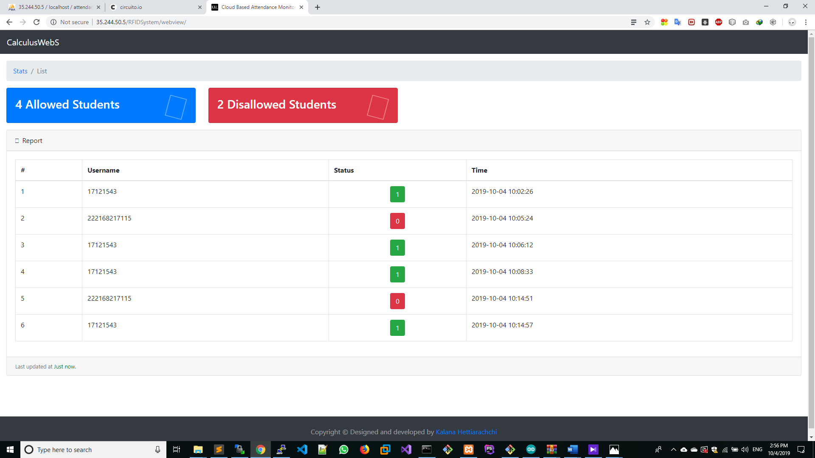A cloud VM instance (I used centOS 7 on Azure) to hold the cloud database and a Apache web server which are responsible for write to database (get.php file), Visualize collected data through a proper view (Datatables.js), Display realtime updated data to the user (AJAX) and hold the collected data (Mysql MariaDB server) (Simply the LAMP stack.)

## Hardware Setup

* A NodeMCU ESP8266
  + Node MCU is an open source IOT platform. It includes firmware which runs on the ESP8266 Wi- Fi SoC from hardware which is based on the ESP-12 module. The term "Node MCU" by default refers to the firmware rather than the dev kits.

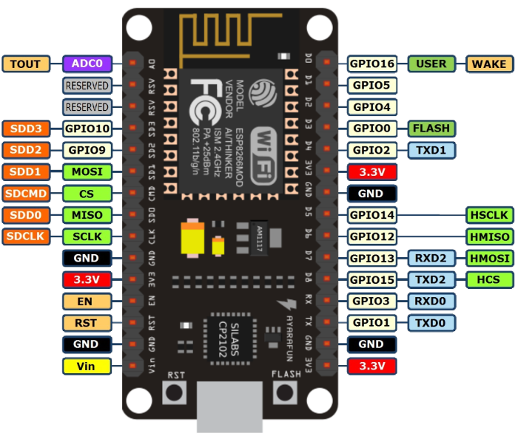

* RFID Reader
  + RFID RC522 is a low cost and easy to use module suitable for equipment and advanced application development that needs RFID applications. RFID application. RFID stands for Radio-Frequency Identification. The acronym refers to small electronic devices that consist of a small chip and an antenna

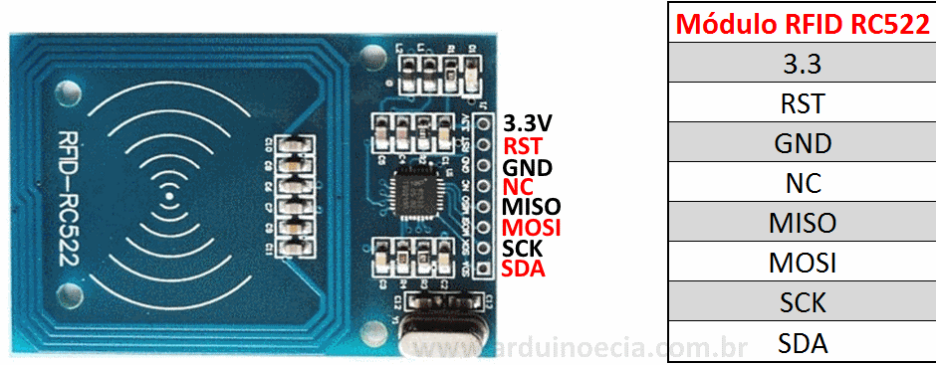

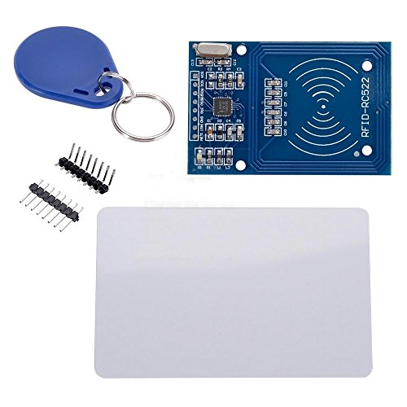

* A 16*2 LCD Display + I2C serial comm Module
* Jumper Wires
* A Buzzer
* RGB LED
* NFC Tags
* A Breadboard

## Circuit Diagram

This circuit diagram is drawn with <https://circuits.io> and since I’m not very familiar with this circuits.io I couldn’t manage to visualize the LED. Also the SDA(RFID), SCK(RFID) are connected to different Pins. 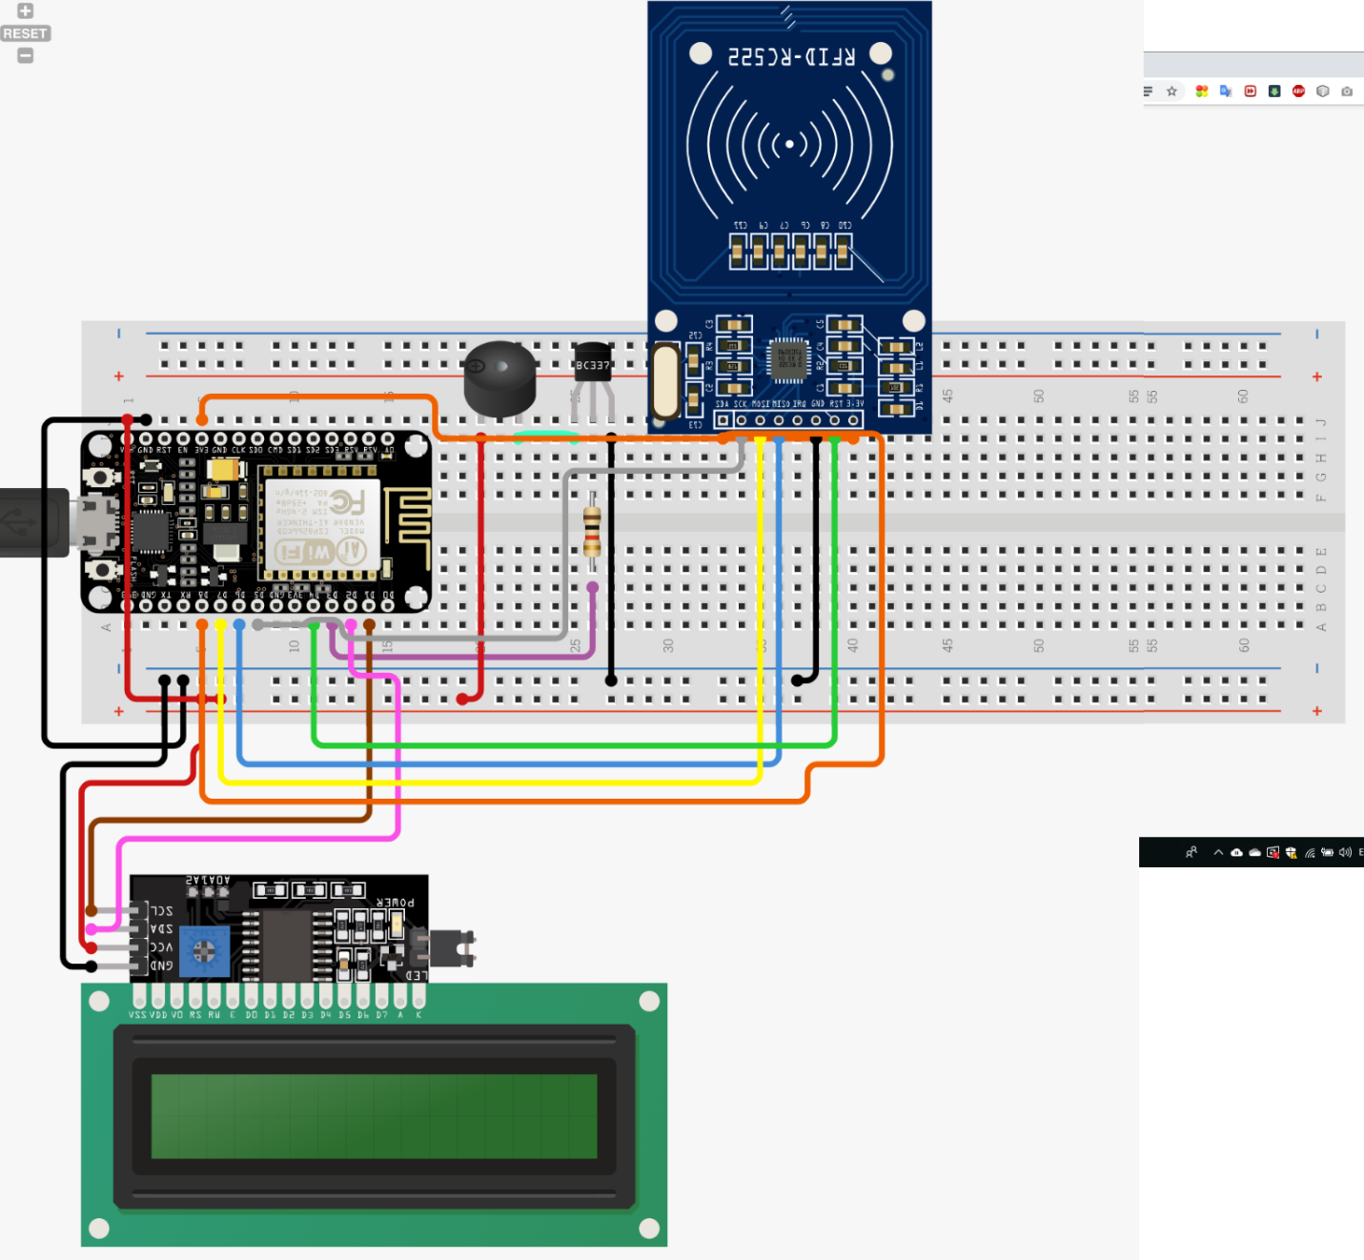

Unlike the above circuit diagram, I didn’t used neither Transistor nor a resistor for the buzzer, just connect the buzzer’s GND pin to D0 directly.

**Above Image is just for get an idea how the wiring is** and see below pin mappings, They are the exact right way according to my program.

The pins I used are as follows

* SDA(RFID) -> D4
* SCK(RFID) -> D5
* MOSI(RFID) -> D7
* MISO(RFID) -> D6
* BUZZER -> D0
* LCD SCL -> D1
* LCD SDA -> D2
* GREENLED -> D3
* REDLED -> D8

The web console for the app can be reached at <http://35.244.50.5/RFIDSystem>