CSA0415 Operating System
Smart Hospital OS Design: Engineering Report

Evaluate the Requirements of Each Computing Environment in a Smart Hospital
Item | Details
Student name | R. Kalanidhi
Register / Roll number | 1925260328
Course code and name | CSA0415 – Operating Systems
Faculty name | C. Chandravathi
Bloom’s level | K5 – Evaluate

Assignment Title: Evaluate and Justify the Operating-System Design of a Smart Hospital
(Total Marks - 50)
Nature of Assignment: Individual
Duration: 1 Week
Submission Date: 3-11-2026
Bloom’s Levels Assessed: K5 – Evaluate (every task in this assignment is at K5 level)
Mandatory Execution and GitHub Submission
• Every student must individually execute every task in this assignment, including all
“Complete the Code” programs.
• Create a GitHub repository named CSA04-<RegisterNumber>-Assignment1 and share
it with the course faculty (public, or private with the faculty added as a collaborator).
• Keep one folder for each task (for example: Task01, Task02 ... or Q1, Q2 ...), containing
the C source files, shell scripts, configuration files (Dockerfile, YAML), command outputs
and screenshots.
• Include a README.md with your name, register number, compiler and version (for
example gcc 13), the Linux distribution and version used, the exact gcc command used
to compile (for example gcc -std=c11 -Wall -Wextra -pthread), the steps to run each
program, and a short note of the result of each task.
• Commit your work progressively – at least one commit for each task. The commit history
will be checked; a single upload of all files on the last day will not be accepted.
• Submit the GitHub link below and on the cover page of your report. An assignment
submitted without a working GitHub link will not be evaluated.
GitHub Repository Link: Operating-systems-CSA0415-/CSA0415-1925260328-Assignment1 at main · Kalanidhi-ml/Operating-systems-CSA0415-

Task 1: Requirements of Each Computing Environment (4 Marks)

1.1 Ranked Requirement Table
Rank 1 = most stringent environment for that column (rank in brackets). Priority = overall criticality to patient safety.
Environment | Response time | Reliability | Throughput | Battery | Security | Priority
Bedside Monitors | [1] Hard deadline: alarm within 10 ms; jitter under 1 ms | [1] 99.999%; no crash, watchdog reset | [5] Low: about 250 samples/s per channel | [2] Battery backup 4 h+ (mains plus UPS) | [3] Authenticated, integrity-protected data | 1 (life-critical)
Handheld Tablets | [3] Soft: UI under 100 ms; sync under 2 s | [3] 99.9%; survive drops and Wi-Fi roaming | [4] Low-medium | [1] 10 h+ shift on one charge | [2] Encrypted storage, remote wipe, MDM | 3
Workstations | [4] Interactive: under 200 ms | [4] 99.5%; user-level crash tolerated | [3] Medium: concurrent users | [5] Mains powered | [2] Login, RBAC, audit trail | 4
Database Server | [2] Query under 50 ms (p99 under 200 ms) | [1] 99.99%+; zero data loss (ACID) | [2] High: thousands of transactions/s | [5] Mains plus UPS/generator | [1] Encryption at rest and in transit; full audit | 2
Imaging Server | [5] Batch: minutes per study acceptable | [2] 99.9%; job restart is acceptable | [1] Very high: GB per scan (MRI 500 MB) | [5] Mains powered | [2] PHI protection; DICOM access control | 5
Partner Link | [4] Soft: seconds, WAN latency bound | [3] 99.9%; retry and queue on failure | [3] Medium | [5] Mains powered | [1] Mutual TLS, VPN, strict isolation | 3

1.2 Safety-Critical Elements and Requirement Conflicts
- Safety-critical: bedside alarm path (sensor interrupt, deadline-bound scheduler, alarm output); database integrity of medication, allergy and dosage records; time and clock synchronisation across devices.
- Conflict 1: Determinism (bedside) vs. rich services. Adding encryption, networking and a GUI adds unbounded latency to the alarm path. Resolution: isolate the alarm task at highest priority; keep other services outside the kernel.
- Conflict 2: Battery (tablets) vs. security. Continuous encryption and VPN drain power. Resolution: hardware crypto acceleration and batched sync.
- Conflict 3: Throughput (imaging) vs. latency (database). Large DMA transfers contend for I/O bandwidth. Resolution: separate servers, separate I/O channels, priority queues.
- Conflict 4: Openness (partner link) vs. privacy (records). Resolution: gateway with a minimal-disclosure FHIR/HL7 interface, mutual TLS.

1.3 Historical OS Lessons Applied
Era | Lesson | Application in the hospital
Batch | Maximise throughput; no interaction needed | Imaging server: MRI reconstruction queued as batch jobs
Time-sharing | Fair CPU slicing gives interactive response | Workstations and database sessions: round-robin / multilevel feedback queue
Mobile | Power management, app sandboxing, intermittent connectivity | Tablets: aggressive sleep, per-app sandbox, offline-first sync
Real-time | Correctness depends on meeting deadlines; priority preemption | Bedside monitors: rate-monotonic or EDF scheduling with bounded interrupt latency

1.4 Alternative Concept & Complexity Analysis: One General-Purpose OS Everywhere
Metric | Single general-purpose OS | Specialised OS per environment
Worst-case alarm response | Unbounded: O(unbounded). Non-preemptible kernel sections, page faults, driver latency, fair-share scheduler; typical Linux/Windows worst case reaches tens to hundreds of ms under load | Bounded: O(1) interrupt-to-task latency, typically under 100 microseconds on a hard RTOS
Memory footprint (per bedside unit) | About 1 to 4 GB RAM and 10 GB+ disk, so O(size of full OS) for N devices | RTOS about 64 KB to 10 MB; saving about 99% of RAM per monitor
Administration effort | One image, but every patch touches safety devices and forces re-validation of the alarm path: effort O(N devices x patch cycles) | Patch cycles are independent per class; O(k) validation sets, k = 6 environments
Attack surface | Entire GP OS (millions of lines) on life-critical devices | Minimal trusted computing base on the monitor

Verdict: a single OS is rejected because the worst-case alarm latency cannot be bounded, which violates the hard deadline.

Task 2: Type of Operating System per Environment (3 Marks)
Environment | OS type | Justification | Example
Bedside Monitors | Hard Real-Time OS (RTOS) | Missing the 10 ms alarm deadline is a patient-safety failure; needs priority preemption, bounded interrupt latency, small footprint | QNX, FreeRTOS
Handheld Tablets | Handheld / mobile OS | Power management, touch UI, app sandboxing, wireless roaming, small storage | Android, iOS
Workstations | Desktop (time-sharing) OS | Multiple interactive applications, GUI, user accounts, peripheral support | Windows, Linux
Database Server | Clustered server OS (multi-node with fail-over) | High availability: if one node fails another takes over with shared or replicated storage | Linux + Pacemaker/Patroni cluster
Imaging Server | Multiprocessor (SMP) server OS | Parallel reconstruction needs many cores sharing one memory image; throughput-oriented batch scheduling | Linux SMP, 32 to 64 cores
Partner Link | Distributed OS services / gateway | Resources spread across organisations; naming, authentication and RPC over a WAN; location transparency for records | Linux gateway + TLS/FHIR middleware

2.1 Imaging Server: SMP vs. AMP
Criterion | Symmetric (SMP) | Asymmetric (AMP)
Structure | Every CPU runs the same OS image; shared run queue | Master CPU runs OS; slaves receive assigned tasks
Load balancing | Dynamic across all cores (high utilisation) | Static; master is a bottleneck
Fault tolerance | Any CPU can fail; others continue | Master failure halts the system
Complexity | Needs locking and cache coherence; kernel contention grows with cores | Simple kernel, little locking
Scaling | Speed-up S(n) = 1 / ((1-p) + p/n) (Amdahl); near-linear for the highly parallel reconstruction code (p about 0.95) | Limited by master throughput; saturates early

Choice: SMP for the imaging server, because reconstruction is data-parallel and needs maximum core utilisation. AMP is suitable only for embedded cases such as a dedicated DSP.

2.2 Database Server: Clustered System with Automated Fail-over
- Mechanism: nodes exchange heartbeats (every 1 s); failure is declared after about 3 missed beats; a quorum or fencing (STONITH) prevents split-brain; the standby promotes its replica and takes the virtual IP. Fail-over time is typically 5 to 30 s.
- Availability: with two nodes of availability a = 0.99 each, A = 1 - (1-a)^2 = 0.9999 (about 52 minutes of downtime per year instead of about 3.7 days).
- Modes: active-passive (simplest, safe) or active-active with synchronous replication (higher throughput, more complexity). Selected: active-passive with synchronous replication for zero data loss.

2.3 Alternative Concept & Complexity Analysis: One Large Multiprocessor Instead of a Cluster
Metric | Single large multiprocessor | Cluster of n commodity nodes
Single Point of Failure | Yes: one board, power supply or kernel panic stops everything (availability = a) | No: availability 1 - (1-a)^n
Cost | Superlinear: price grows about O(n^1.5 to n^2) with CPU count | About linear: O(n) commodity nodes
Time scaling | Amdahl limit; lock and cache-coherence contention; speed-up flattens beyond 32 to 64 cores | Near-linear for read-scaling and sharding; adds network and replication latency O(log n) coordination
Space scaling | Bounded by the maximum RAM of the machine (vertical limit) | Aggregate RAM and disk O(n); horizontal growth to new hospitals
Maintenance | Downtime for upgrades | Rolling upgrades with no outage

Verdict: the cluster is chosen; the single SMP machine is acceptable only as a single node inside the cluster.

Task 3: Operating-System Structures (4 Marks)
Structure | Reliability | Performance | Update ease | Real example
Monolithic | Low: any driver bug crashes the whole kernel | Highest: direct function calls inside the kernel | Hard: rebuild or reboot the kernel | Traditional UNIX; Linux core
Layered | Medium: bugs isolated by layer | Lower: each layer adds call overhead | Medium: replace a layer if interfaces are held | THE system; Android stack (kernel, HAL, runtime, framework, apps)
Microkernel | Highest: drivers, file system and network run as user processes; a fault restarts one server | Lower: IPC (message passing) between servers | Easy: restart or replace a server live | QNX, MINIX 3; FreeRTOS (minimal kernel, tasks and queues)
Modular | Medium: loadable modules still run in kernel mode | High: near-monolithic speed | Easy: load/unload modules without reboot | Linux loadable kernel modules
Hybrid | Medium-high: selected services in user space | High: performance-critical paths in kernel | Good | Windows NT, macOS (XNU)

3.1 Defence of Chosen Structures
- Bedside monitors: microkernel (QNX-style). A faulty sensor or display driver runs in user space with its own address space; the kernel and alarm task survive, and the driver is restarted in milliseconds. The small kernel (tens of KB) is analysable and certifiable (IEC 62304 / IEC 61508); message-passing IPC is bounded and priority-inheriting so deadlines are provable.
- Database server: modular / hybrid. Performance-critical paths (file system, network stack, scheduler, I/O) stay in the kernel for throughput; storage, file-system and crypto drivers are loadable modules updated without taking the cluster node offline (rolling patching). Isolation is less critical because the server runs a trusted, fixed workload and fail-over covers faults.

3.2 Alternative Concept & Complexity Analysis: Monolithic Kernel on Bedside Monitors
Metric | Monolithic kernel | Microkernel
Service invocation cost | System call about 0.1 to 0.3 microseconds (one mode switch, then a function call) | IPC about 1 to 5 microseconds (two mode switches plus message copy and scheduling); still far below the 10 ms deadline
Kernel memory | About 10 to 20 MB kernel plus drivers resident, all in privileged memory: O(total code) | About 100 KB kernel; drivers are separate user processes: O(minimal TCB)
Faulty driver | Wild pointer or crash corrupts kernel memory and causes a kernel panic: whole monitor fails | Process fault only; the server restarts, the alarm path is unaffected
Trusted code size | Millions of lines in kernel mode | Tens of thousands of lines

Verdict: the monolithic kernel is faster per call but has an unacceptable failure blast radius; the extra microseconds of IPC are negligible against a 10 ms budget.

Task 4: Services an Operating System Must Provide (4 Marks)
Environment | Required services | Excluded services
Bedside Monitors | Real-time scheduler, interrupt handling, timers and watchdog, sensor I/O drivers, minimal network (TCP/UDP + TLS), memory protection, alarm IPC | GUI, multi-user login, virtual memory/paging, general file system, printing, dynamic loading, shell
Handheld Tablets | Touch GUI, power management, Wi-Fi/cellular, app sandbox, encrypted storage, secure keystore, push sync | Multi-user server daemons, legacy device drivers, local database engine
Workstations | GUI, multi-process time-sharing, file system, printing, user authentication, network client, peripheral drivers | Real-time scheduling guarantees, cluster services
Database Server | Process and thread management, large buffer cache, journaling file system, fast network stack, cluster membership, backup/snapshot, audit logging | GUI, desktop applications, unnecessary daemons
Imaging Server | SMP scheduler, DMA and high-bandwidth I/O, large-file system, memory management for large buffers, job queue | GUI, interactive logins (headless), real-time guarantees
Partner Link | Network protocols, TLS/VPN, authentication and authorisation, firewall/NAT, naming, message queueing and retry | Local user interaction, unneeded file services

4.1 Services Stripped from Bedside Monitors (speed and size)
- Virtual memory and demand paging removed: page-fault latency is unbounded; use static allocation and locked memory, which gives deterministic access time.
- GUI and window system, user accounts, shell, general file system and printing removed: smaller image (about 100 KB to few MB vs. hundreds of MB), fewer interrupts, shorter boot (under 1 s).
- Dynamic module loading and background daemons removed: smaller attack surface and no timing jitter from housekeeping tasks.

4.2 Protection of Patient Records: Memory Protection and Dual Mode
- Dual-mode operation: user code runs in user mode and cannot execute privileged instructions (I/O, page-table updates, disabling interrupts); access to disks or records goes through system calls into kernel mode, where permissions are checked.
- Memory protection: each process has its own address space enforced by the MMU (base/limit or page tables with read/write/execute bits); one application cannot read another process memory or kernel memory; an illegal access raises a trap and the process is terminated.
- File-level controls: ACLs and role-based access (doctor, nurse, admin); every access is audited; encryption at rest means a stolen disk exposes nothing; the least-privilege principle limits damage from a compromised application.

4.3 Alternative Concept & Complexity Analysis: Full Desktop OS on Tablets
Metric | Full desktop OS | Handheld OS
Storage space | About 20 to 30 GB minimum install | About 4 to 8 GB system partition
Memory space | 4 GB+ minimum; many resident services | 1 to 2 GB; aggressive process lifecycle and killing of background apps
Start-up time | About 30 to 60 s cold boot | About 10 to 20 s boot; instant resume from sleep
Battery life | About 3 to 5 h: background services and non-optimised power states | About 10 to 14 h: wake-locks, doze mode, hardware-offloaded tasks
Security model | Open application model; larger attack surface | Per-app sandbox, signed apps, verified boot

Verdict: a full desktop OS fails the 10-hour shift requirement and the footprint budget; the handheld OS is selected.

Task 5: System Calls (4 Marks)

5.1 System Call Categories
Category | Purpose | Examples
Process control | Create, end, load, wait, allocate memory | fork, exec, exit, wait, brk/mmap
File management | Create, open, read, write, close, delete | open, read, write, close, unlink
Device management | Request, release, read/write devices | ioctl, read, write on device files
Information maintenance | Get/set time, attributes, system data | getpid, time, stat
Communication | Pipes, sockets, shared memory, messages | pipe, socket, send, recv, shmget
Protection | Permissions and access control | chmod, chown, umask

5.2 Execution Trace of read(fd, buf, n) (x86-64 Linux)
Step | Action
1. Library wrapper | Application calls read(); the libc wrapper loads the system call number (0 for read) in RAX and arguments fd, buf, n in RDI, RSI, RDX.
2. Trap | The wrapper executes the syscall instruction (software trap); the CPU saves the user RIP and flags and jumps to the kernel entry point (address in an MSR).
3. Mode switch | The CPU changes from user mode to kernel mode (privilege ring 3 to ring 0); the kernel stack is loaded and user registers are saved.
4. Dispatch | The kernel indexes the system call table with RAX and calls sys_read().
5. Kernel execution | Validates fd and permissions; checks that buf lies in user space; looks up the page cache; on a miss, issues a block I/O request, the process sleeps and the CPU runs another process; DMA completes and an interrupt wakes the process; data is copied to the user buffer (copy_to_user).
6. Return | The return value (bytes read or negative error code) is placed in RAX; sysret restores the user registers and mode bit; execution resumes after the syscall instruction.
7. Wrapper return | The wrapper converts a negative result to errno = -result and returns -1, otherwise returns the count to the application.

5.3 Parameter-Passing Mechanisms
- Registers: fastest, limited by the number of registers (6 arguments on Linux x86-64). Used for read/write.
- Memory block (table): parameters are stored in a block or structure in memory and its address is passed in a register; no limit on size (Linux for large structures, Solaris).
- Stack: parameters pushed on the user stack and popped by the OS; no fixed limit but needs extra validation of user pointers. Block and stack methods do not limit the number or length of parameters.

5.4 Alternative Concept & Complexity Analysis: C Library Buffering vs. Direct System Calls
Method | System calls for n bytes | Extra buffer space | Comment
Direct read() one byte at a time | n | O(1) | Worst case; every byte pays a full mode switch
Direct read() with 4096-byte block | ceil(n / 4096) | O(4096) in the application | Programmer manages the buffer
fread/fwrite with library buffer of size b | ceil(n / b) (b = BUFSIZ, typically 4096 or st_blksize) | O(b) user-space buffer (4 KB to 64 KB) | Application can request 1 byte at a time while the library batches into block-sized calls

Example: copying 1 MB byte by byte costs 1,048,576 system calls directly, but only 256 calls with a 4 KB stdio buffer (4096 times fewer) at the price of 4 KB extra memory. Trade-off: slight copy cost and buffered-data loss on a crash (mitigated by fflush/fsync).

Task 6: Cost of System Calls (4 Marks)

6.1 Why a System Call Costs More than a Function Call
Factor | Function call | System call
Control transfer | call/ret within the same privilege level; about 1 to 5 ns | Trap instruction, privilege change, stack switch; about 100 to 300 ns minimum (more with speculative-execution mitigations such as page-table isolation)
State saving | Only callee-saved registers | Full user context saved and restored
Argument checking | None | Kernel validates fd, user pointers, permissions (copy_from/to_user)
Cache/TLB effects | Warm instruction cache | Kernel code and data evict user cache lines; TLB flush or pollution
Scheduling | Never blocks | May block and trigger a context switch; I/O latency far above the trap cost

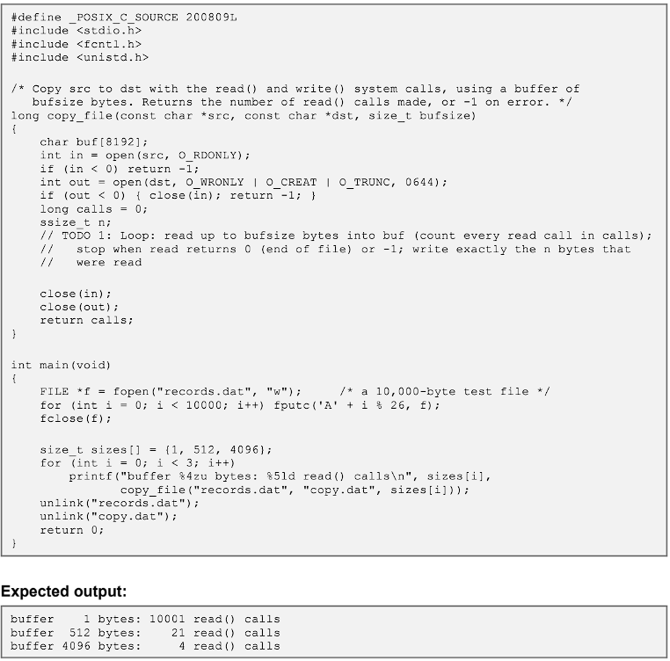

6.2 Effect of Buffer Size on File Backup
For a file of N bytes copied with buffer b, the number of calls is 2 x ceil(N/b) (one read plus one write per block) and total time T = calls x c_sys + N x c_copy. Larger b reduces the first term until it is negligible; beyond about 64 KB to 1 MB returns diminish and memory use grows.
Buffer size b | Read + write calls for N = 1 GiB | Relative to 1 KB
1 KB | 2,097,152 | 1x
4 KB | 524,288 | 4x fewer
64 KB | 32,768 | 64x fewer
1 MB | 2,048 | 1,024x fewer

6.3 Alternative Concept & Complexity Analysis: Memory-Mapped Files (mmap)
Metric | read/write with buffer b | mmap
System call count | O(N/b) | O(1): mmap, optional madvise, munmap
Kernel/user copying | One extra copy per call (kernel page cache to user buffer): O(N) bytes copied | Zero-copy: page-cache pages are mapped directly into the process; no copy for reads
Page faults | None (data copied explicitly) | About N/4096 minor faults (fewer with fault-around/readahead); each about 0.5 to 1 microsecond
Memory usage for large files | O(b) buffer only | O(N) virtual address space (demand-paged); resident memory is bounded by the page cache and can be reclaimed
Risks | Simple error codes | SIGBUS if the file is truncated; TLB pressure; poor for pure sequential streaming of huge files

Verdict: mmap suits random access to large images and shared read-only data; buffered read/write with 64 KB to 1 MB buffers is simpler and equally fast for sequential backup.

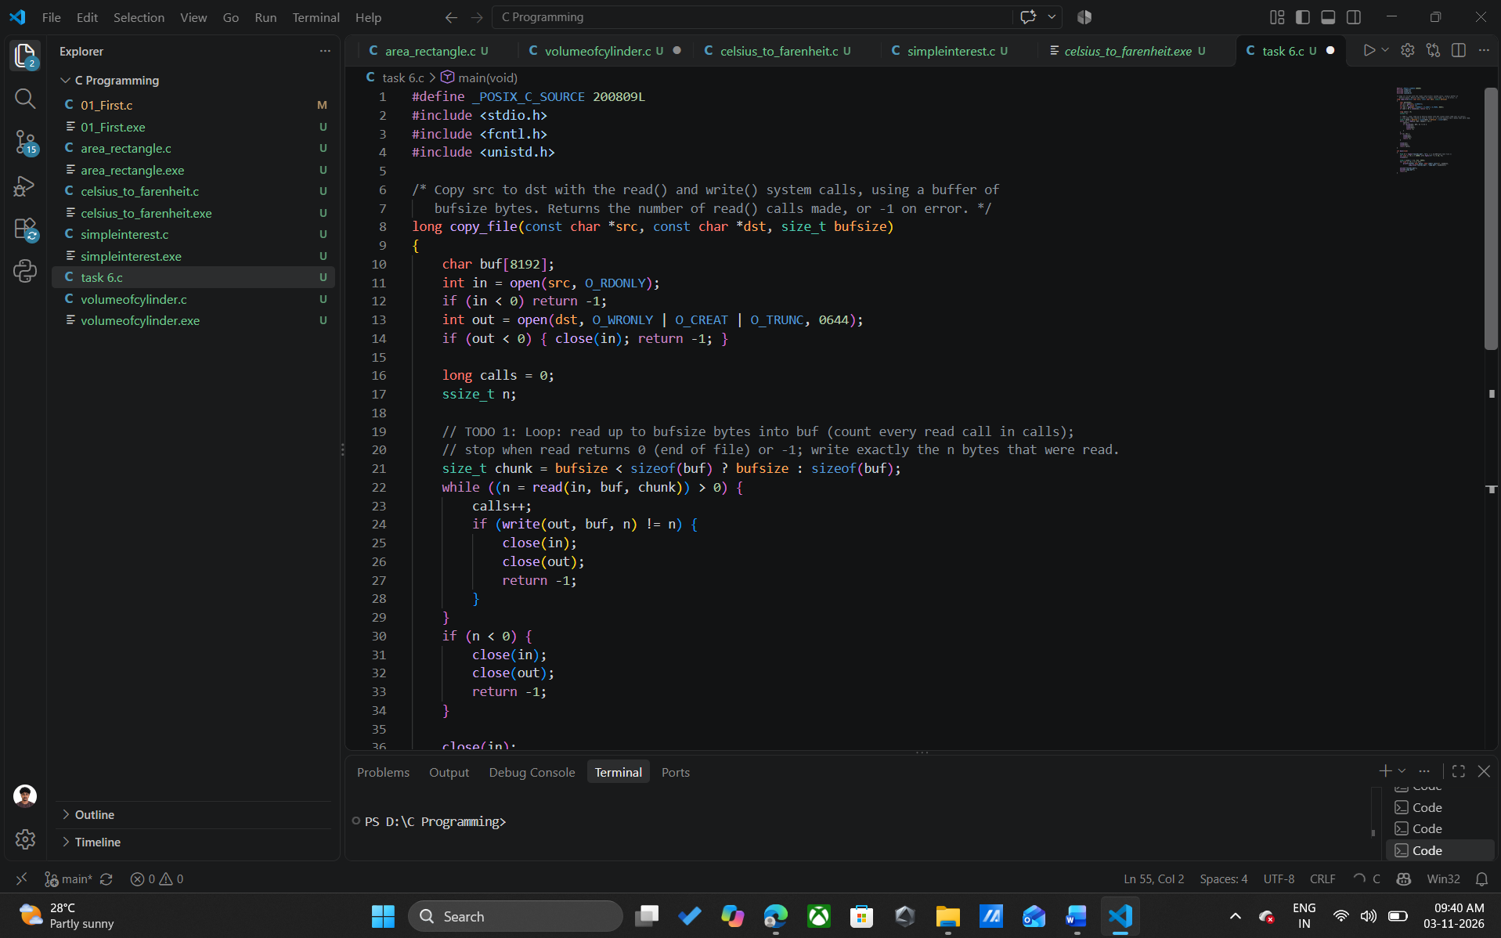

Task 7: Process Control System Calls (4 Marks)
Call | Definition
fork() | Creates a child process as a duplicate of the parent (copy-on-write address space). Returns 0 in the child, the child PID in the parent, -1 on error.
exec() | Replaces the current process image with a new program; PID unchanged; does not return on success.
wait() / waitpid() | Parent blocks until a child terminates; collects its exit status and releases the child process-table entry.
exit() | Terminates the calling process; closes files, frees memory, passes the exit code to the parent, sends SIGCHLD.

7.1 Shell Job Execution and Exit Status
The shell reads a command, calls fork(); the child calls execvp(command) (after setting redirections and pipes); the parent calls waitpid(pid, &status, 0) for a foreground job (or returns to the prompt for a background job with &). The status is decoded with the macros WIFEXITED(status) (true on normal exit) and WEXITSTATUS(status) (the low 8 bits of the exit code), which the shell exposes as $?. Example: exit(3) in the child gives WEXITSTATUS = 3.

7.2 Zombie and Orphan Processes
Type | Definition | Remediation by the OS
Zombie | Child has terminated but the parent has not yet called wait(); only its process-table entry (PID, status) remains. Many zombies exhaust the PID table. | Parent calls wait()/waitpid() or handles SIGCHLD; if the parent dies, zombies are re-parented to init and reaped.
Orphan | Parent terminates while the child still runs. | Kernel re-parents the child to init/systemd (PID 1), which calls wait() when it exits, so no zombie persists.

7.3 Why fork() + exec() Rather than One Creation Call
- Flexibility: between fork and exec the child can redirect file descriptors (dup2), build pipes, change directory, drop privileges and reset signals, without a creation call that takes dozens of parameters.
- Simplicity and orthogonality: two small primitives compose (fork alone for servers and workers, exec alone to change program).
- Efficiency: copy-on-write makes fork cheap, as pages are copied only when written.

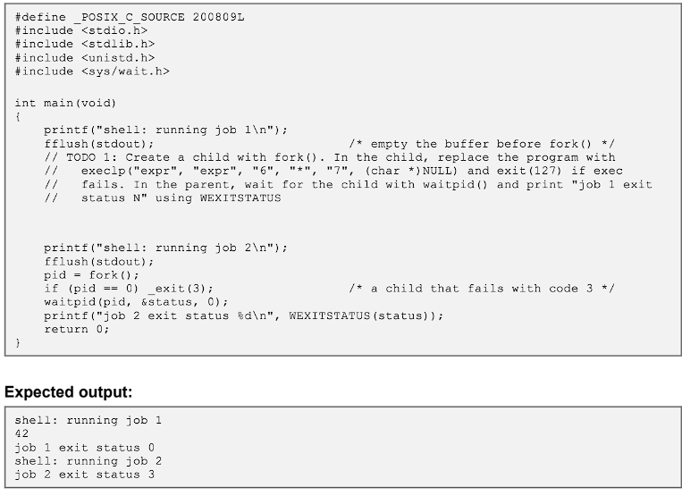

7.4 Alternative Concept & Complexity Analysis: posix_spawn() or Threads
Metric | fork() + exec() | posix_spawn() | Threads (pthread_create)
Creation time | O(size of parent page tables) to copy mappings; measured about 32 to 36 microseconds per process with a 50 MB parent | About O(1) in parent size (vfork-like); no page-table copy | Smallest: about 6 microseconds measured; no new address space
Memory sharing (COW) | COW shares pages until written; page tables and kernel structures duplicated | No duplicate of the parent image; new program loaded directly | Fully shared address space; only a stack (about 8 MB virtual) and TCB are new
Isolation | Full: separate address space and file descriptors | Full after exec | None: one fault or buffer overflow corrupts all threads
Flexibility | Any setup code between fork and exec | Limited to a declared set of file actions/attributes | Not for running a separate program

Verdict: posix_spawn is better for large parents that only launch a program; threads are best for cooperative work inside one trusted application; fork+exec is retained where isolation and setup flexibility matter (shell, per-session database workers).

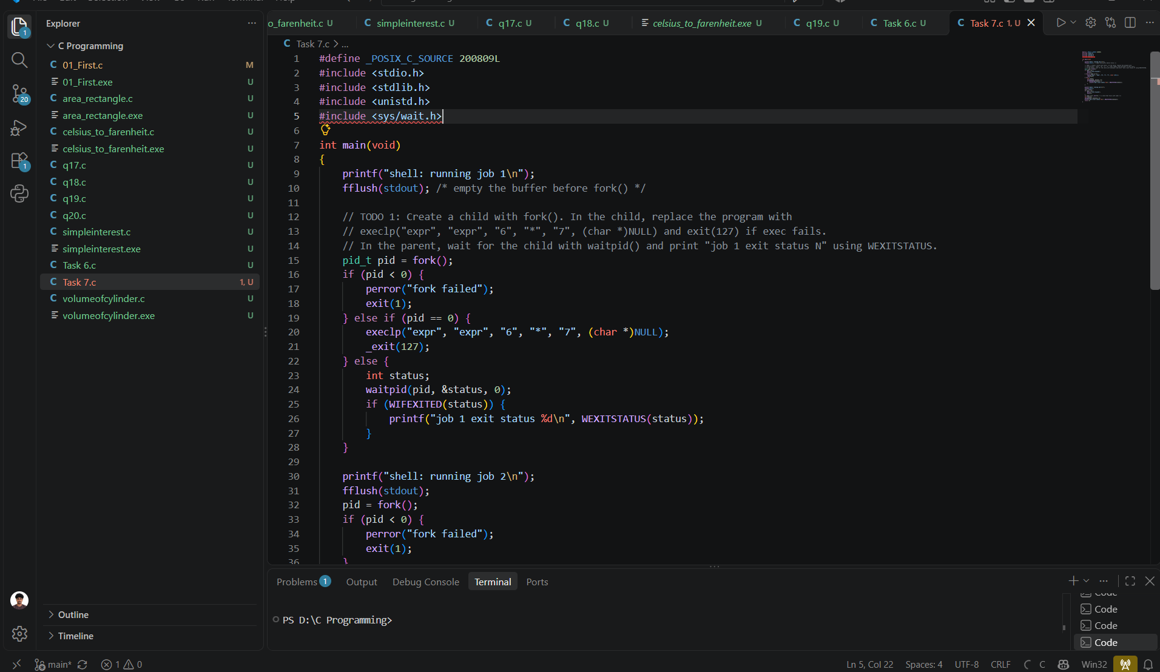

Task 8: CPU States and Protection (4 Marks)
Concept | Explanation
User / kernel mode | User mode restricts the CPU to non-privileged instructions and the process own address space; kernel mode permits all instructions and all memory.
Mode bit | A hardware bit (0 = kernel, 1 = user in the classic model) checked on every instruction; changed to kernel by interrupt, trap or system call, back to user by a return instruction.
Privileged instructions | Executable only in kernel mode: I/O instructions, interrupt enable/disable (cli/sti), load page-table base, set timer, halt. Executing one in user mode raises a protection trap.
Interrupt | Asynchronous hardware signal (device ready, timer) that saves state and jumps to a handler via the interrupt vector table.
Trap / exception | Synchronous, software-generated event: system call, divide by zero, invalid memory access, page fault.
Timer interrupt | A hardware timer interrupts periodically (for example every 1 ms) so the OS regains control from a running process, enabling preemption and preventing CPU monopolisation.

8.1 Impact if Bedside-Monitor Code Could Disable Interrupts
- Sensor-sample, timer and network interrupts would be masked: vital-sign data is lost and no alarm is raised.
- The timer interrupt would no longer preempt the process, so one faulty or infinite-loop task monopolises the CPU, and the scheduler and watchdog service never run.
- Result: a silent monitor, with an undetected arrhythmia or apnoea and patient harm. This is why cli/sti are privileged instructions; the hardware watchdog (a non-maskable interrupt) is an additional safety net that resets the device if it is not serviced.

8.2 Alternative Concept & Complexity Analysis: Polling Instead of Interrupts
Metric | Interrupt-driven | Polling at period T_p
Worst-case delay | Interrupt latency + handler: about 5 to 50 microseconds | T_p + processing time; to meet a 10 ms budget with processing the loop must run well under 10 ms
CPU time | events x handler cost; e.g. 250 events/s x 5 microseconds = 1.25 ms/s (0.125% of CPU) | Busy-wait: 100% CPU; periodic polling at 1 kHz x 2 microseconds = 0.2% but adds up to 1 ms delay
Power | CPU sleeps (wait-for-interrupt) between events: low power | CPU cannot enter deep sleep; wasted power, shorter battery backup
Scaling | O(events) | O(devices x polling rate), regardless of whether events occur

Verdict: interrupts give bounded latency with near-zero idle cost; polling is acceptable only for very high-rate devices where the interrupt rate would exceed the polling cost.

Task 9: Memory Hierarchy and I/O Systems (4 Marks)

9.1 Memory Hierarchy (typical values)
Level | Typical access time | Typical size | Volatile
Registers | under 1 ns | about 1 KB | Yes
L1 / L2 / L3 cache | 1 ns / 4 ns / 10 to 20 ns | 32 to 64 KB / 256 KB to 1 MB / 8 to 64 MB | Yes
Main memory (RAM) | about 100 ns | 8 GB to 1 TB | Yes
SSD (NVMe/SATA) | 20 to 100 microseconds | 0.5 to 8 TB | No
Hard disk | 5 to 10 ms | 1 to 20 TB | No
Network storage (SAN/NAS) | 0.5 to 10 ms | TB to PB | No

9.2 Data Placement
Data | Hot / active location | Persistent location | Reason
Monitor metrics | Circular buffer in RAM (cache-resident working set) | Periodic flush to database / local flash | Needs sub-millisecond access; old data is small and rarely read
Patient records | Database buffer pool in RAM | SSD on database nodes, replicated to network storage | Frequent random reads need low latency; durability needs replication and backup
MRI raw scans | RAM staging buffers on the imaging server during reconstruction | NVMe scratch, then network/archive storage (PACS) | Large (hundreds of MB), written once, read rarely; cost per GB dominates

9.3 Justification of DMA for the MRI Scanner
I/O method | CPU involvement | Suitability for MRI
Programmed I/O | CPU busy-waits and copies every word | Unacceptable: CPU fully occupied for the entire transfer
Interrupt-driven I/O | One interrupt and handler per word or small unit | Overhead too high for bulk data (see 9.4)
DMA | CPU programs source, destination and length; the DMA controller moves data over the bus; one interrupt at completion (or per large block) | Selected: CPU stays free for reconstruction; highest throughput

9.4 Alternative Concept & Complexity Analysis: Interrupt-Driven I/O (one interrupt per word) for a 500 MB Scan
Assume 500 MiB = 524,288,000 bytes, a 4-byte word and about 3 microseconds per interrupt (entry, handler, return).
Metric | Interrupt per word | DMA (4 KB blocks)
Interrupt count | 524,288,000 / 4 = 131,072,000: O(N/w) | 524,288,000 / 4096 = 128,000: O(N/block); only 8,000 with 64 KB descriptors
CPU time overhead | 131,072,000 x 3 microseconds = about 393 s of pure interrupt handling (over 6.5 minutes of CPU) | 128,000 x 3 microseconds = about 0.38 s
Buffer requirement | One word register plus kernel buffer; CPU copies each word to memory | Contiguous (or scatter/gather) RAM buffers, at least double buffering: 2 x block size
Overall effect | About 1,000 times more overhead; the system is livelocked by interrupts | About 1,000 times less overhead; the CPU is mostly free

Task 10: Measure and Compare (4 Marks)
Method: a C copy program (open/read/write/close loop, one read and one write per block) was run with four buffer sizes on a Linux sandbox (1 vCPU). The sandbox has no strace, so call counts are computed from the loop (exactly 2 x ceil(N/b) read/write calls; `strace -c` would also list roughly 30 start-up calls such as execve, mmap, brk). User and system CPU times were read with getrusage (the same data the `time` command reports). Single runs; absolute values vary by machine, trends are what matter.

10.1 System Call Counts and User/Kernel Time Split
Buffer size | File size | read + write calls | Real (s) | User (s) | Sys / kernel (s) | Kernel share of CPU
1 byte | 1 MiB | 2,097,152 | 0.379 | 0.092 | 0.287 | 76%
64 bytes | 64 MiB | 2,097,152 | 0.438 | 0.079 | 0.347 | 81%
4,096 bytes | 64 MiB | 32,768 | 0.065 | 0.007 | 0.026 | 79%
65,536 bytes | 64 MiB | 2,048 | 0.033 | 0.000 | 0.022 | about 100%

- Going from 1-byte to 64 KB buffers cuts calls by a factor of 65,536 per byte copied. The 1 MiB, 1-byte case costs as much time as copying 64 MiB with 64-byte blocks, which is 64 times more data.
- Time is kernel-dominated (about 75 to 80% sys) for small buffers: most CPU time is mode-switch and kernel work, not user code. With large buffers user time approaches zero and the remaining kernel time is the actual data copy, which is the unavoidable part.

10.2 Process vs. Thread Creation: 1,000 Each
A parent with 50 MB of touched memory created and reaped 1,000 children with fork() (child calls _exit immediately), then 1,000 threads with pthread_create + pthread_join (empty function). Two runs each:
Metric | 1,000 fork() processes | 1,000 pthreads
Total creation + reap time | 36.1 ms and 32.2 ms (about 32 to 36 microseconds each) | 6.6 ms and 6.1 ms (about 6 microseconds each)
Relative cost | About 5 to 6 times slower | Baseline
Memory overhead per unit (analytical) | Page tables for 50 MB (about 12,800 entries, about 100 KB) + task struct and kernel stack (about 16 KB); data pages are shared copy-on-write until written, so about 120 KB each | Stack (8 MB virtual, only touched pages resident, about 8 to 16 KB) + kernel stack and TCB (about 16 KB): about 25 to 30 KB resident each
If all 1,000 live at once (analytical) | About 120 MB kernel metadata (more as pages are written) | About 25 to 30 MB resident; about 8 GB virtual stack reservation
Isolation | Separate address spaces | Shared address space; no isolation

Creation here was sequential (create, then reap), so memory overhead is derived, not measured. Fork cost grows with the parent resident size; thread cost does not.

Task 11: Recommended and Defended OS Plan (4 Marks)

11.1 Final Plan
Environment | OS and structure | Key services | I/O method | Protection
Bedside Monitors | Hard RTOS; microkernel (QNX/FreeRTOS+MPU) | Priority-preemptive scheduler, watchdog, alarm IPC, minimal TLS | Interrupt-driven sensors; DMA for ADC streams | Dual mode, MPU/MMU isolation, signed firmware, secure boot
Handheld Tablets | Handheld OS (Android Enterprise); layered | Power management, sandbox, MDM, encrypted sync | Interrupt-driven touch and radio; DMA for storage | App sandbox, full-disk encryption, remote wipe
Workstations | Desktop OS (Windows/Linux); hybrid/modular | GUI, time-sharing, printing, SSO | Interrupt-driven peripherals; DMA for disk | User accounts, RBAC, audit, disk encryption
Database Server | Linux server in 2-node cluster; modular/hybrid | Buffer cache, journaling FS, cluster fail-over, snapshots, audit | DMA for SSD and network; interrupt coalescing | Dual mode, ACLs, TDE encryption, audit log
Imaging Server | Linux SMP; modular | SMP scheduler, large-buffer memory management, job queue | DMA with scatter/gather; NVMe | PHI access control, DICOM TLS
Partner Link | Hardened Linux gateway; distributed services | VPN/mutual TLS, FHIR/HL7 gateway, message queue with retry | Interrupt-driven NIC with DMA | Firewall, DMZ, tenant isolation, token-based authorisation

11.2 Defence, Limitations, Risks
- Defence: each environment gets the lightest OS that meets its worst requirement, so the safety-critical path is hard real-time and isolated, throughput work uses DMA and SMP, and availability is achieved by clustering.
- Limitations: six OS variants raise integration and skills cost; fail-over takes 5 to 30 s (monitors keep working locally and buffer data); synchronous replication adds write latency; the partner gateway is a high-value attack target.
- Risks and mitigations: split-brain (quorum plus fencing); firmware flaws (signed updates, staged roll-out, rollback partition); privilege abuse (least privilege, audit alerts); single-site disaster (offsite replica, tested backups).

11.3 Scalability to Three Partner Hospitals
- Architecture: per-hospital edge site with local monitors, workstations, and a local database replica; central cluster as the system of record; imaging servers scale out per site.
- Load: from one to four sites, database load grows about 4x; scale by adding cluster nodes and sharding by hospital ID (O(n) capacity, O(log n) coordination). WAN outages are handled by store-and-forward queues.
- Governance: federated identity, per-tenant encryption keys, and an audit trail for cross-site access; standard FHIR/HL7 interfaces avoid custom integration per partner.

11.4 Alternative Concept & Complexity Analysis: Everything in VMs on Two Large Physical Servers
Metric | Consolidated VMs on two servers | Planned design
10 ms monitor response | Hypervisor scheduling, vCPU preemption and noisy neighbours can add tens of ms of jitter unless CPUs are pinned and an RT hypervisor is used; shared virtual I/O adds latency | Bare-metal RTOS on the device: bounded latency under 100 microseconds
Virtualisation overhead | About 2 to 10% CPU, extra memory per guest OS, double scheduling and nested page tables | None for the safety path; moderate overhead only where used for non-critical workloads
Reliability | Failure of one host takes down 50% of all workloads; with a network or hypervisor fault, bedside functions depend on the server and the LAN. Larger blast radius, common-cause failures | Monitors work stand-alone; cluster failure domain limited to the database
Cost and admin | Fewer machines, but very large servers (superlinear cost) and one hypervisor stack to patch | More hardware types; independent update cycles

Verdict: keep monitors on bare-metal RTOS; use VMs only for non-critical workstation back-ends and test environments.

Task 12: Day-4 Design Challenge: Remote Home Monitors and Cloud Records (8 Marks)

A. Impact Analysis
Area | Affected aspect | Impact
OS types | New: embedded RTOS (home monitor), cloud/distributed OS (shared records) | Home monitors move outside the hospital controlled network and are run by non-experts; the partner link generalises to a multi-tenant cloud platform
Services | Added: secure remote update (OTA), store-and-forward buffering, device identity and attestation, power management, mobile/Wi-Fi networking. Added in cloud: replication, consensus, key management, audit, rate limiting | Home device now needs a network stack and TLS, which were previously minimal for the bedside unit; cloud adds distributed-system services
Protection mechanisms | Physical access to the device (tampering), untrusted home network, internet-exposed records, multi-tenant isolation | Dual mode and memory protection are necessary but not enough: add secure boot, hardware root of trust, mutual TLS, end-to-end encryption, zero-trust access, tenant isolation
I/O and performance | WAN latency (50 to 200 ms) and intermittent links | Alarms cannot depend on the network; telemetry becomes asynchronous

B. Evaluation of the Original Design
Aspect | Supported? | Gap
Real-time alarm on the device | Yes | The bedside RTOS and microkernel design transfers directly
Remote secure connectivity | Partly | The partner link provides mutual TLS to a few known sites, but not thousands of untrusted home devices
Device update and lifecycle | No | In-hospital devices assume IT-managed physical updates; no OTA or rollback
Scale of records | No | Two-node cluster in one site scales neither to many users nor to geographic distribution
Data consistency and privacy | Partly | Local ACID database ok; no multi-region replication, patient-consent model or per-tenant key management
Physical security | No | Devices were in controlled wards; homes are not

Conclusion: the original design supports the real-time core but not the remote, scale and trust requirements; adaptation (not a full redesign) is sufficient.

C. Adaptation / Redesign
- Home monitors: embedded RTOS (retained microkernel). Alarm and sensing run locally with the same 10 ms deadlines even when the internet is down. Added: secure boot with hardware root of trust, signed OTA updates with A/B partitions and automatic rollback, per-device certificate, minimal TLS client (MQTT/HTTPS), local flash buffer (store-and-forward), low-power sleep between samples, and tamper-evident storage.
- Edge gateway (optional, home hub or phone): aggregates devices, adds buffering and protocol translation; not on the alarm path.
- Shared cloud records: distributed system. Stateless API tier behind load balancers; replicated database across zones (Raft/quorum, strong consistency for the clinical record, eventual consistency for bulk telemetry); per-tenant encryption keys in a KMS/HSM; consensus-based leader election; immutable audit log.
- Protection: zero-trust (every request authenticated and authorised), mutual TLS device identity, OAuth2/OIDC for clinicians, consent-based role access, kernel isolation (containers or VMs with hardened kernels) for tenants, rate limiting and anomaly detection.
- Existing design retained: bedside RTOS, hospital cluster as a regional primary, SMP imaging server, workstation and tablet OS types.

D. Evidence-Based Defence and Trade-offs
Decision | Alternative | Evidence / trade-off | Outcome
Local alarm on the device RTOS | Cloud-based alarm | WAN latency 50 to 200 ms and outage risk vs. a 10 ms deadline; cloud alarm cannot be bounded | Local alarm; the cloud only receives events
Embedded RTOS microkernel at home | Linux or Android on the home monitor | Task 3 results: fault isolation, small trusted code base; Linux gives richer networking but unbounded latency and a 100x larger footprint and attack surface | RTOS retained; richer stack only on the optional gateway
Distributed cloud DB with replication | Larger single hospital cluster | Task 2 analysis: single point of failure, superlinear cost, geographic latency; replication gives availability 1 - (1-a)^n | Distributed; slightly higher write latency accepted
Strong consistency for records, eventual for telemetry | Strong everywhere | Strong consistency needs quorum round trips (higher latency, lower availability under partition); telemetry tolerates delay | Mixed model per data class
Signed OTA with rollback | Manual updates | Home devices cannot be serviced on site; unsigned or failed updates would brick safety devices | OTA with attestation
Zero-trust and per-tenant keys | Perimeter VPN only | Home networks are untrusted; one compromised credential would expose all records under a perimeter model | Zero-trust

Final position: keep the hard real-time core local and unchanged, extend trust and update services to the home, and move shared records to a replicated distributed platform. Costs: higher operational complexity, the need for continuous security patching and compliance audit, and extra write latency for strongly consistent records; benefits: safety is independent of connectivity, records remain available during node or region failure, and the design scales to additional partner hospitals and home patients.

