Before heading the foreword, we need to add students to the database using admin panel. Navigate to student profile and add student there

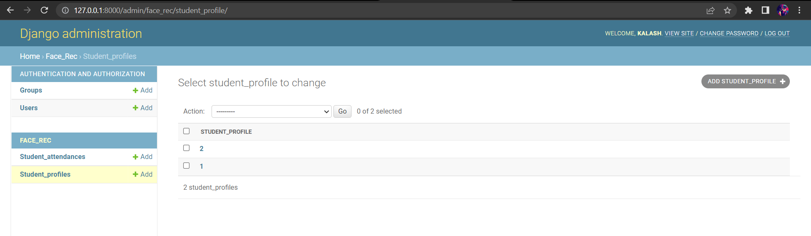

Login Page

Login using the credentials

\* Username :- Admin  
\* Password :- Admin123@

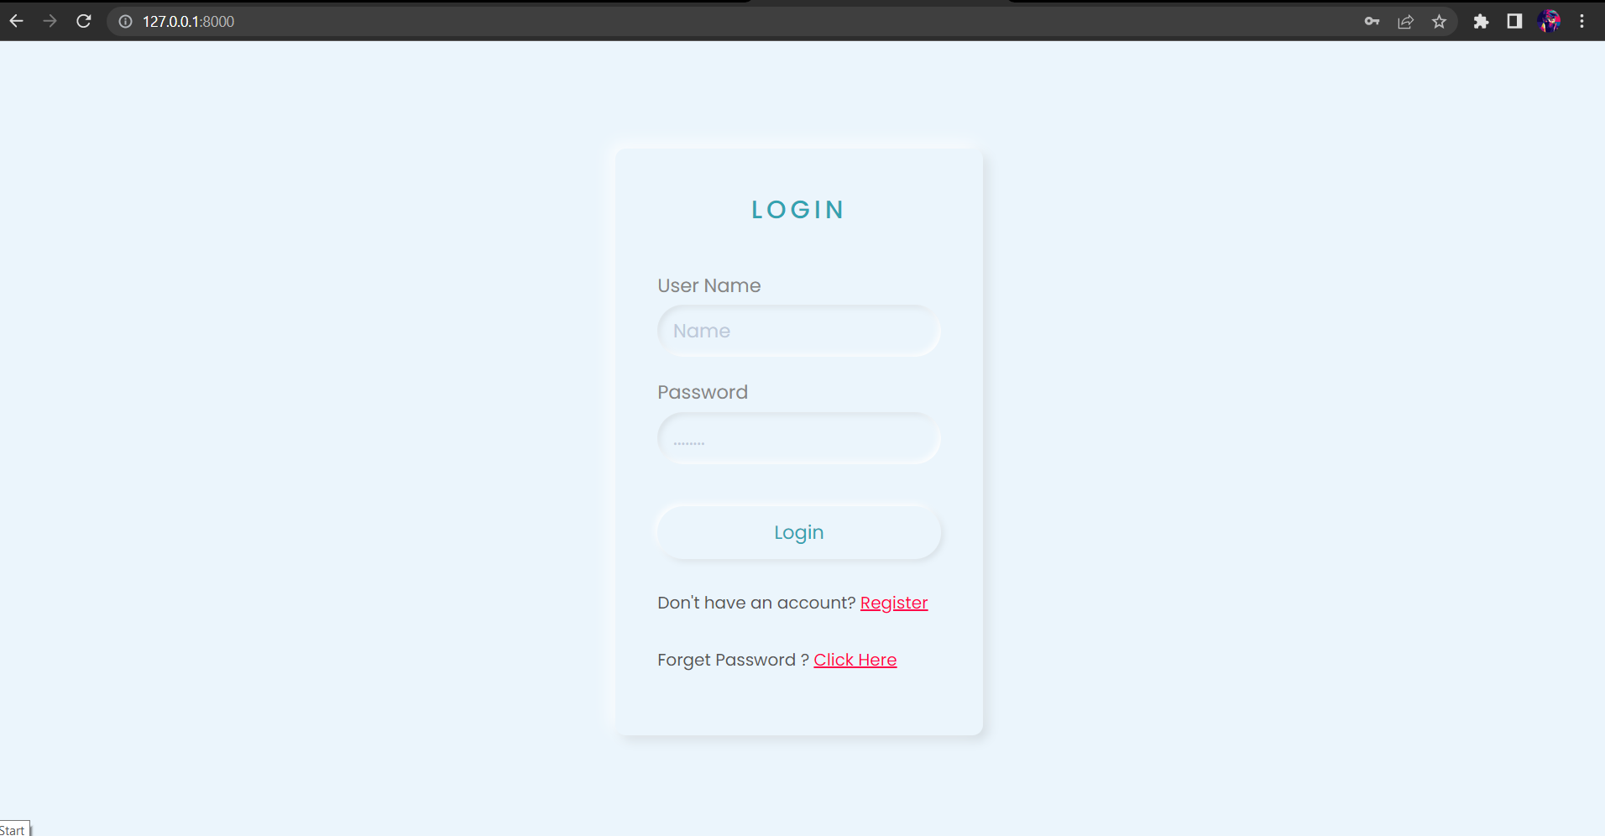

After Login Main Page

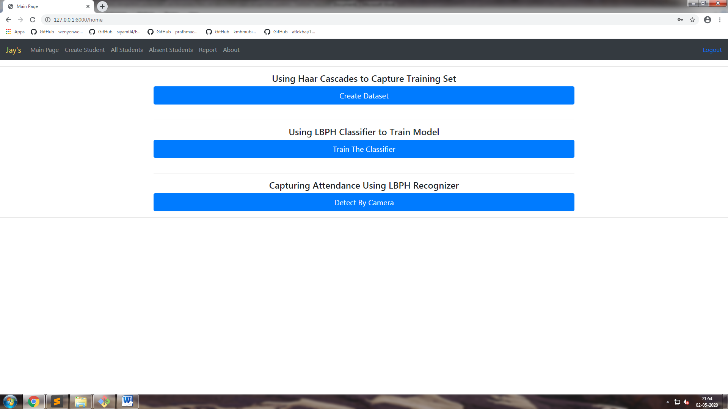

After Clicking Create Dataset

Unique id

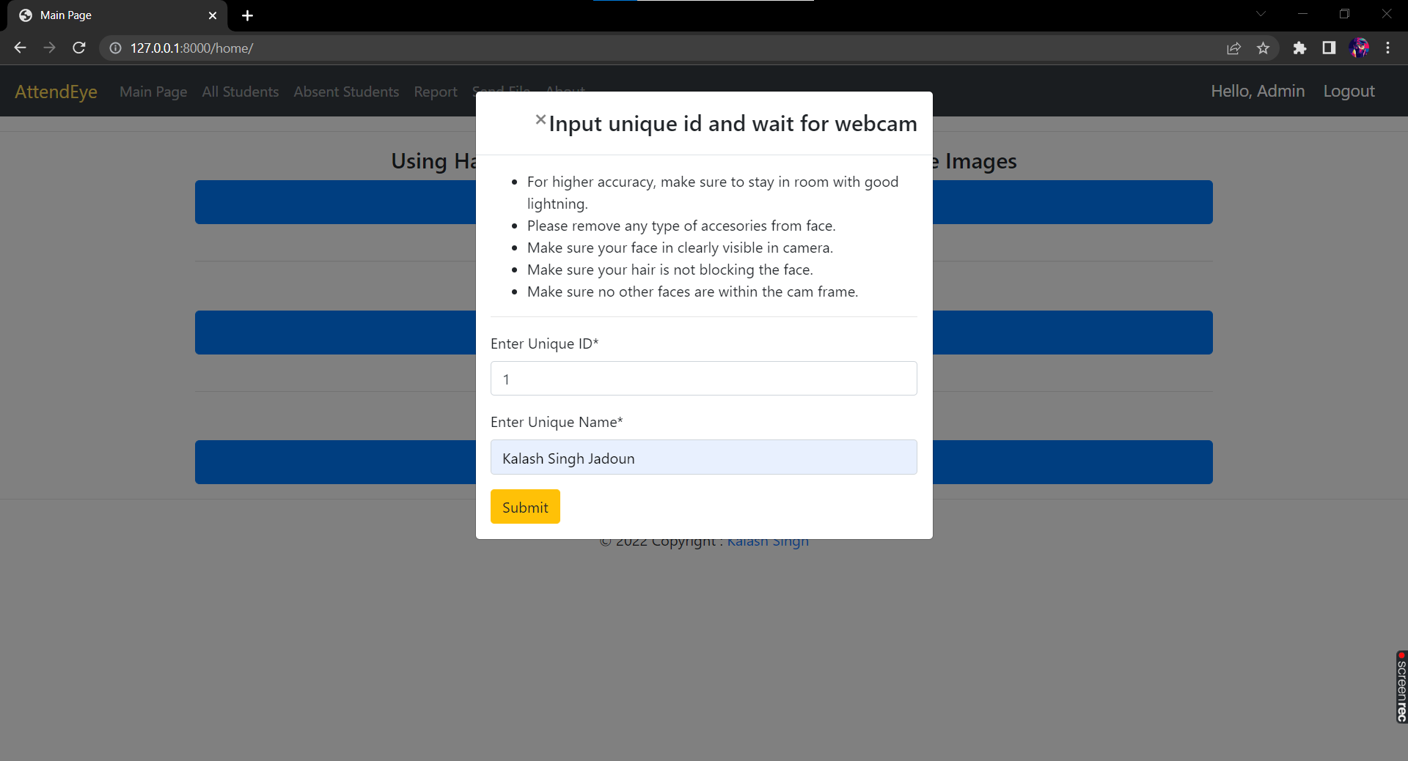

After Submitting it will Capture 60 Images For Training and after that it redirects to Dashboard

After Capturing Images Click On Train Classifier

After Clicking Detect By Camera A Frame will Open And Take attendance and Show The Profile Of The Detected User

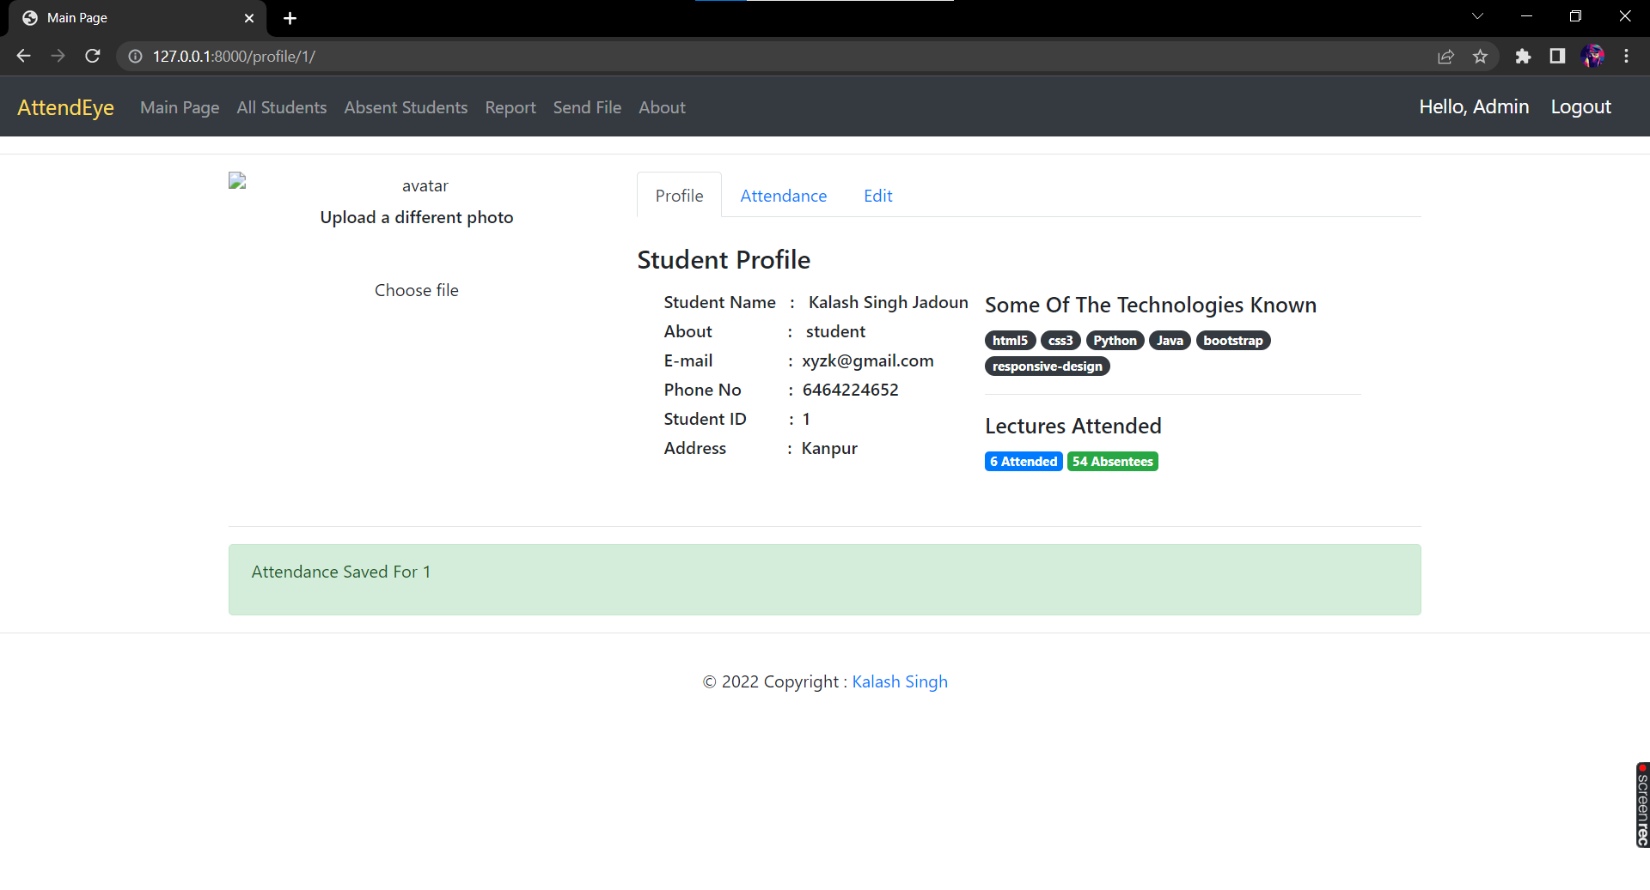

After Clicking All Students We Can see All The Students

With The Count

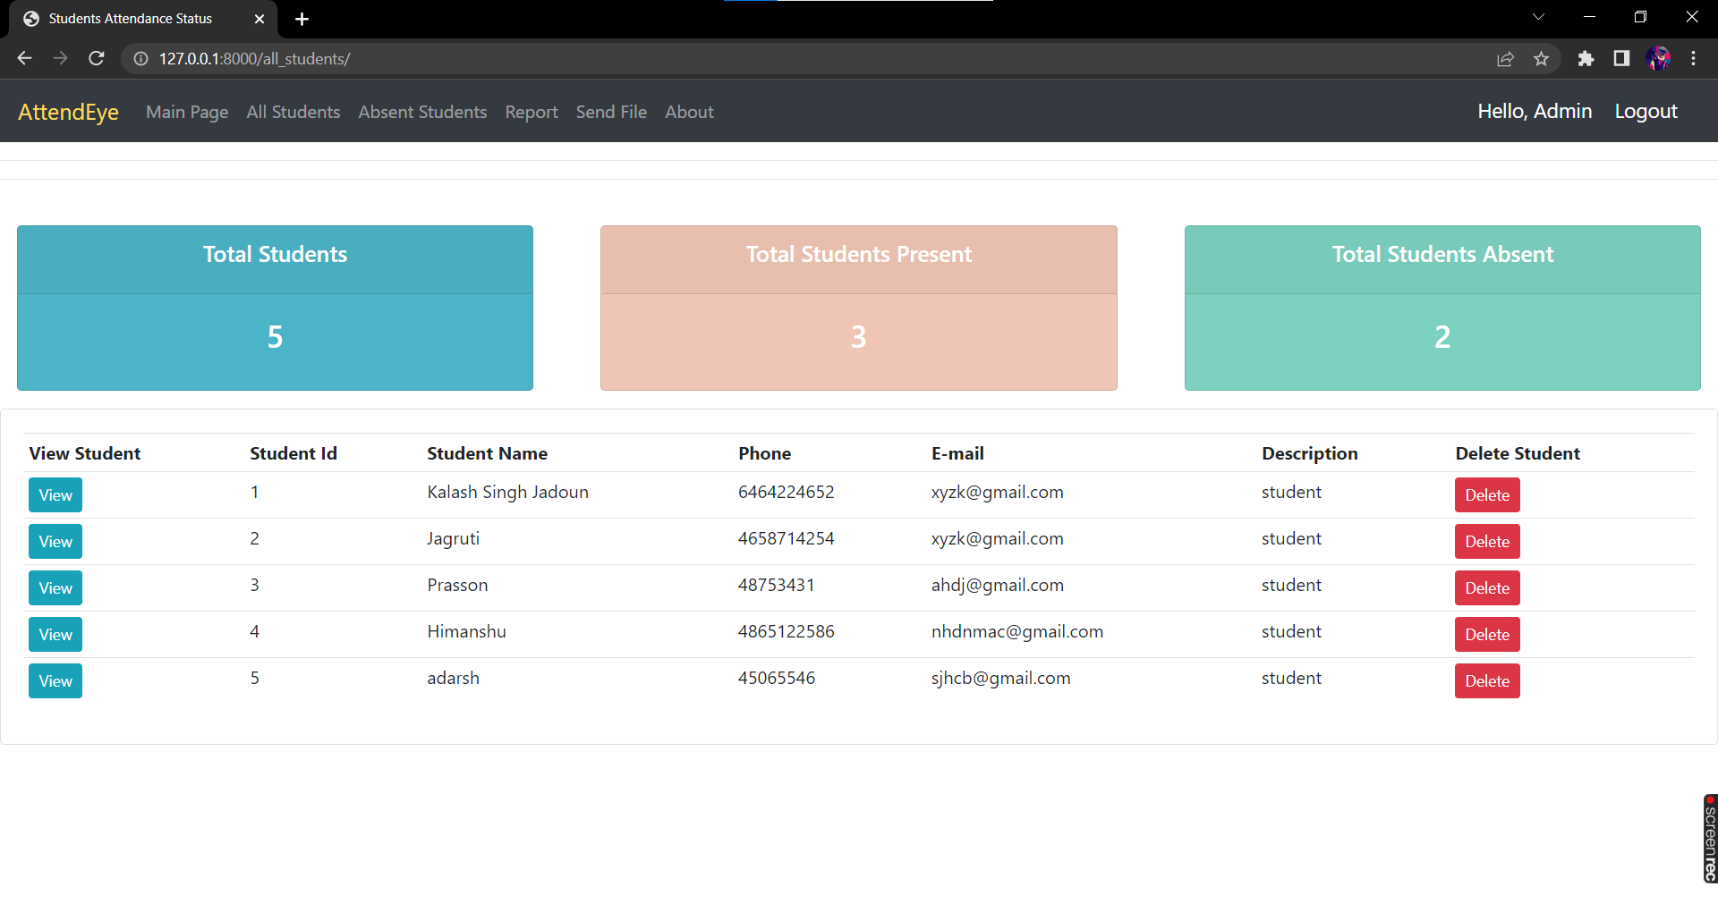

After Clicking Absent It Shows All Those Students Who Were Absent

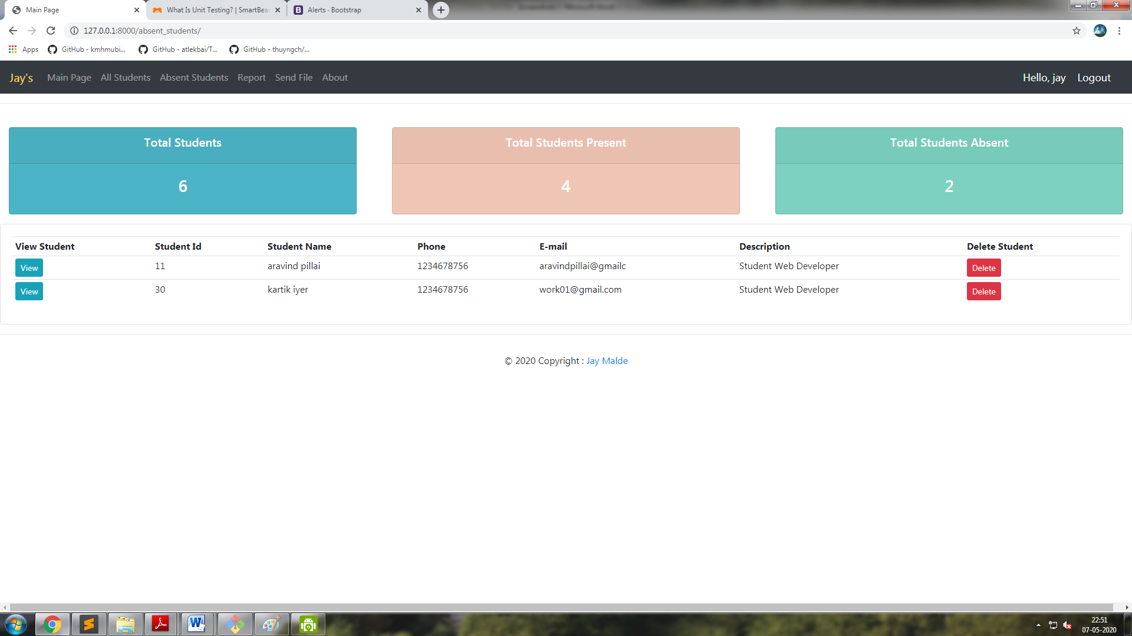

On Clicking The Report Tab It Creates A Real time Report On Students With Time Stamp

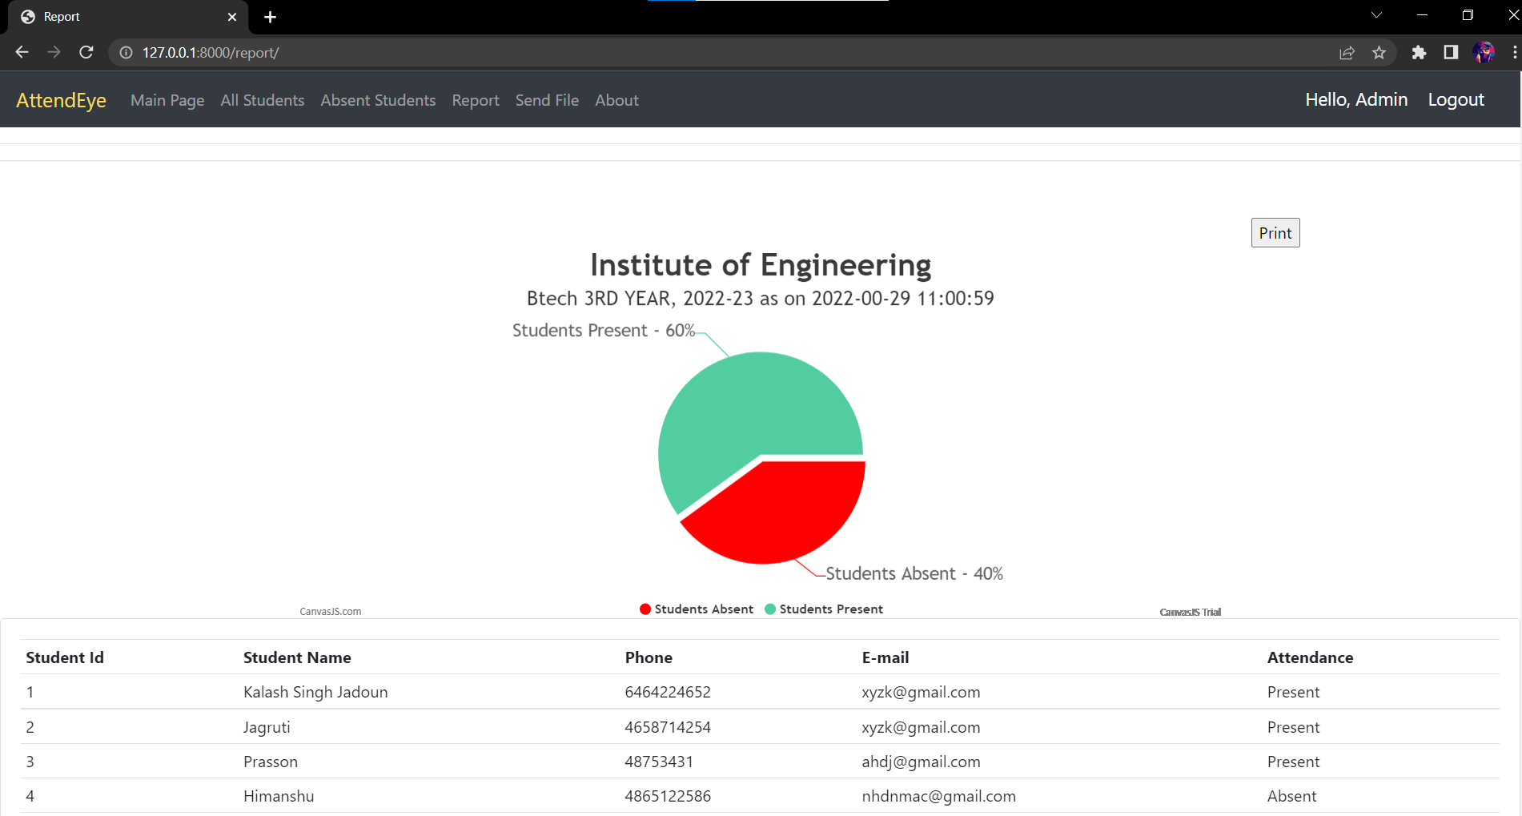

Printable Report PDF 