Design and Analysis of 8-bit Booth Multiplier (FSM-Based)

1. Objective
To design, implement, and analyze an 8-bit signed Booth multiplier using a finite state machine (FSM) based sequential architecture, and evaluate its performance in terms of latency, throughput, area, timing, and power.

2. Design Overview
The Booth multiplier is an optimized multiplication algorithm that reduces the number of addition/subtraction operations by encoding the multiplier bits. The design is implemented using a sequential approach where multiplication is performed iteratively over multiple clock cycles.

3. Architecture Description
Core Components
- Registers: Accumulator (A), Multiplier (Q), and Q-1 bit
- Control Unit: FSM controlled by ENABLE and DONE signals
- Counter: Tracks number of iterations (8 cycles)
- Datapath:
  - Conditional Addition/Subtraction (A ± M)
  - Arithmetic Right Shift of {A, Q, Q-1}

Operation Flow
- Initialization (LOAD stage)
  - A ← 0
  - Q ← Multiplier
  - Q-1 ← 0
  - Count ← 8
- Iteration (EXECUTION stage)
  - Evaluate (Q0, Q-1):
    - 01 → A = A + M
    - 10 → A = A - M
    - 00 / 11 → No operation
  - Perform arithmetic right shift
  - Decrement counter
- Completion (DONE stage)
  - Final product = {A, Q}
  - DONE signal asserted

4. Functional Verification
The design was verified using simulation testbench with multiple input combinations.
Observations
- All outputs matched expected multiplication results
- No functional errors observed
Conclusion
✔ Functional correctness successfully verified

5. Performance Analysis
5.1 Latency
- Observed Latency: 8 clock cycles
5.2 Throughput
- Throughput: 1 result per 8 clock cycles
Interpretation
- Sequential execution limits throughput
- New input cannot be processed until current operation completes

6. Area Analysis (Synthesis Results)
Resource | Usage
LUTs | 20
Registers (Flip-Flops) | 36
DSP Blocks | 0
Interpretation
- Very low hardware utilization
- Pure RTL implementation (no DSP blocks used)
- Efficient for area-constrained designs

7. Timing Analysis
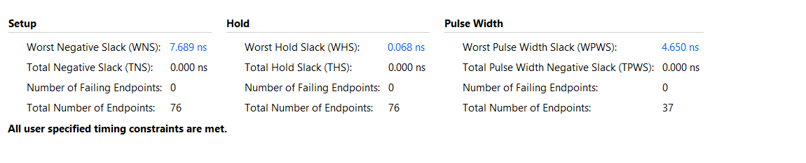Key Metrics
- Worst Negative Slack (WNS): +7.689 ns
- Worst Hold Slack (WHS): +0.068 ns
- Total Negative Slack (TNS): 0.000 ns
- Failing Endpoints: 0 (Timing Fully Met)

Derived Performance
Assuming a 10 ns clock constraint:
- Critical Path Delay ≈ 2.311 ns
- Estimated Maximum Frequency (Fmax) ≈ 432 MHz

Interpretation
- The design comfortably meets timing constraints with a large positive slack
- The combinational datapath is fast and not timing-critical
- Despite high achievable clock frequency, overall performance is limited by the sequential (FSM-based) nature of the design
- No setup or hold violations observed, indicating stable and reliable operation

8. Power Analysis
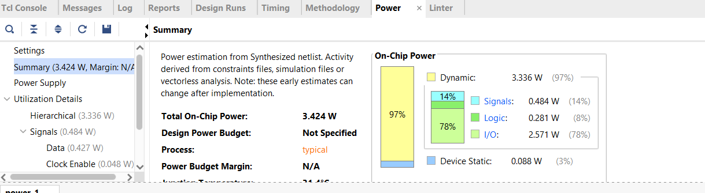Key Metrics
- Total Power: 3.424 W
Breakdown
- Logic Power: 0.281 W
- Signal Power: 0.484 W
- I/O Power: 2.571 W
- Static Power: 0.088 W

Interpretation
- Majority of power is consumed by I/O, which is tool-estimated and not fully representative of real hardware behavior
- Core logic power is very low, confirming area-efficient design
- Suitable for low-power digital logic applications

9. Waveform Analysis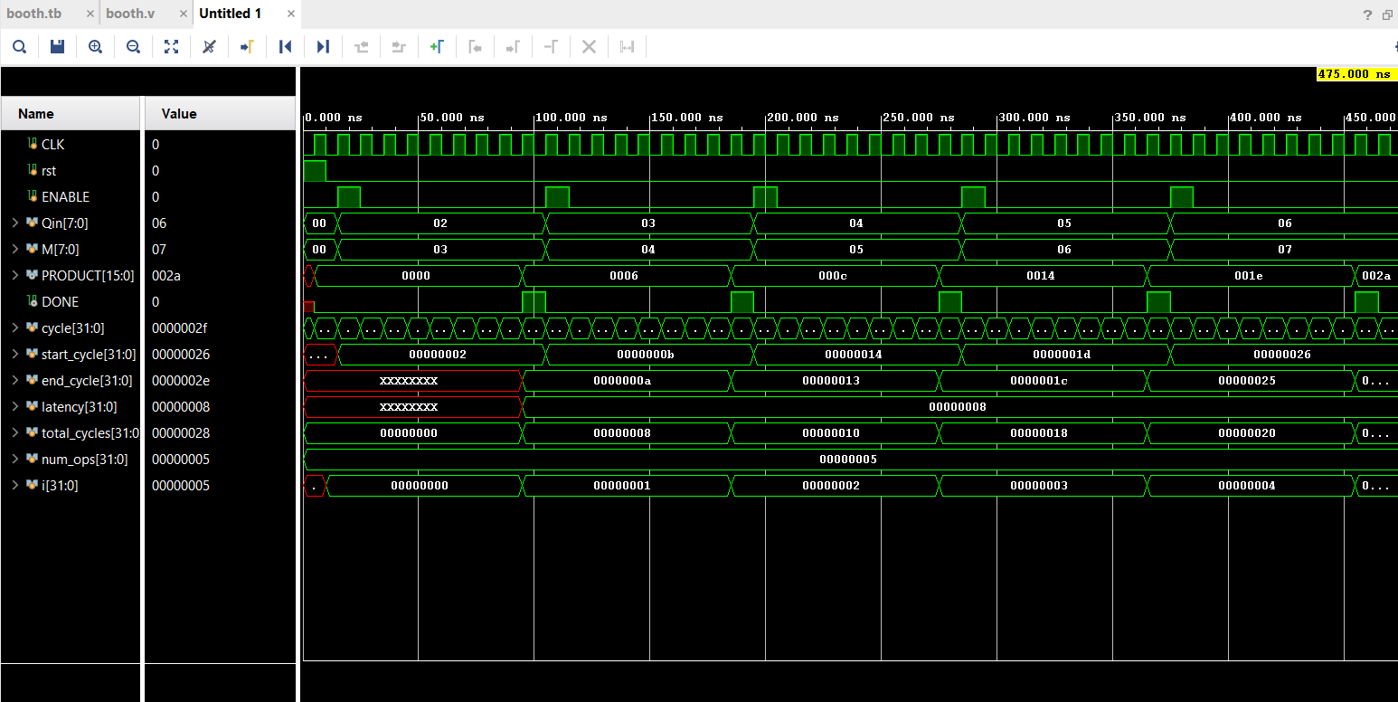
Observations
- ENABLE initiates operation
- Iterative shifting observed across cycles
- DONE asserted after 8 cycles
- Final product stabilizes correctly at completion

10. Design Characteristics
Parameter | Value
Architecture | FSM-based Sequential
Latency | 8 cycles
Throughput | Low
Area | Low
Parallelism | None

11. Key Insights
- Booth algorithm reduces arithmetic operations compared to naive multiplication
- Sequential design minimizes hardware usage
- High latency due to iterative processing
- Fast combinational logic but limited system throughput
- Suitable for area-constrained applications

12. Conclusion
The implemented Booth multiplier demonstrates an efficient tradeoff between hardware utilization and computational speed. While the design achieves low area and minimal resource usage, its sequential nature introduces higher latency and reduced throughput. This makes it well-suited for applications where hardware efficiency is prioritized over performance.

Pipelined 8×8 Wallace Tree Multiplier – Design & Analysis Report

1. Overview
This project implements an 8×8 pipelined Wallace Tree multiplier using a carry-save reduction (CSA) architecture. The design prioritizes high throughput and low combinational delay by performing parallel reduction of partial products.

2. Architecture Description
The multiplier consists of six pipeline stages:
- Stage 1 – Input Latching
Registers capture inputs (A), (B), and valid_in.
- Stage 2 – Partial Product Generation
Eight shifted partial products are generated.
- Stage 3 – First Reduction (8 → 6)
CSA-based compression using XOR (sum) and majority logic (carry).
- Stage 4 – Second Reduction (6 → 4)
Intermediate reduction of sums and carries.
- Stage 5 – Final Reduction (4 → 2)
Produces:
  - sum_final
  - carry_final
- Stage 6 – Final Addition
[
Y = sum_final + carry_final
]

3. Dataflow Characteristics
- Fully parallel datapath
- No iterative or sequential accumulation
- Fixed combinational logic per stage
- Continuous pipelined operation

4. Functional Verification
The design was verified using a custom testbench with continuous inputs.
Observations
- All outputs matched expected results
- No pipeline stalls observed
- Valid signal correctly aligned
Example outputs:
2×3 = 6
3×4 = 12
...
14×15 = 210
20×21 = 420

5. Timing Analysis
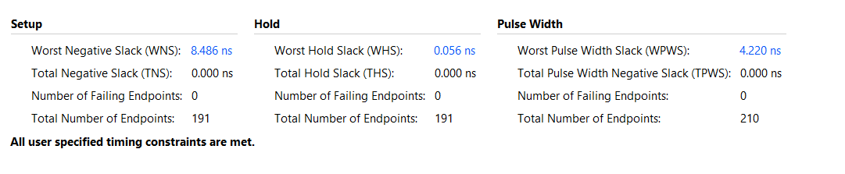Measured Values
- Worst Negative Slack (WNS): +8.486 ns
- Total Negative Slack (TNS): 0.000 ns
- Clock Period: 10 ns
- Critical Path Delay:
[
10 - 8.486 = 1.514 \text{ ns}
]
- Maximum Frequency (Fmax):
[
\approx 660 \text{ MHz}
]
Interpretation
- Positive slack confirms timing closure
- Very low delay indicates efficient parallel reduction
- High Fmax shows excellent speed performance

6. Latency and Throughput
- Pipeline Depth: 6 stages
- Measured Latency: 6 cycles
- Throughput: 1 result per cycle
Insight
After pipeline fill, the design produces continuous outputs every clock cycle, achieving maximum throughput.

7. Area Utilization
[Insert Utilization Report Screenshot Here]
Measured Resources
- LUTs: 98
- Flip-Flops: 206
- DSP Blocks: 0
Analysis
- Higher area due to:
  - Parallel CSA structure
  - Pipeline registers
- Fully logic-based (no DSP usage)

8. Power Analysis
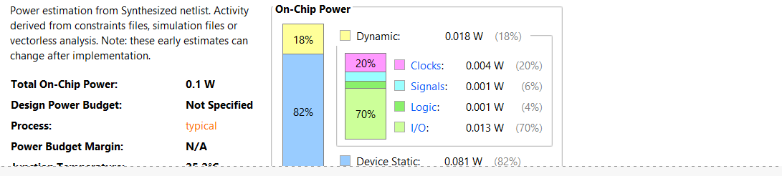Measured Values
- Total Power: 0.1 W
- Dynamic Power: 0.018 W
- Static Power: 0.081 W
Breakdown
- Clocks: 0.004 W
- Signals: 0.001 W
- Logic: 0.001 W
- I/O: 0.013 W
Observations
- Static power dominates (tool estimation effect)
- Logic power is very low
- Suitable for moderate-power designs

9. Waveform Verification

Observations
- valid_out aligns correctly with output
- No glitches observed
- Continuous output stream after latency

10. Design Trade-offs
Parameter | Wallace Multiplier
Speed | Very High
Throughput | Maximum (1 result/cycle)
Area | High
Power | Moderate
Complexity | High

11. Key Engineering Insights
- Carry-save reduction eliminates intermediate carry propagation delay
- Parallel architecture significantly improves speed
- Pipelining enables continuous data flow
- Area overhead is the trade-off for high performance

12. Conclusion
The pipelined Wallace Tree multiplier demonstrates a high-performance arithmetic design with:
- Critical Path Delay: ~1.514 ns
- Fmax: ~660 MHz
- Throughput: 1 result per cycle
It is highly suitable for:
- DSP applications
- High-speed arithmetic units
- VLSI datapath design
However, it incurs higher area usage compared to sequential multipliers, making it a performance-optimized architecture.

