**Voice FinanceAssistant**

A project submitted to

**UKA TARSADIA UNIVERSITY**

in partial fulfillment of the requirements for the degree of

**Master of Science**

in

**Information Technology**

for

**5 Years Integrated M.Sc.(IT)**

By

**Kalash Shah**

(202006100110040)

Guided by

**Dr. Sapan Naik**

**Assistant Professor**



**Babu Madhav Institute of Information Technology**

**CERTIFICATE**

This is to certify that **Kalash Shah(202006100110040)** has submitted project entitled **“Voice Finance Assistant”** as the partial fulfillment for the award of the degree of Master of Science in Information Technology for 5 Years Integrated M.Sc.(IT) in 2023 – 2024.

**Date: 31/08/2023**

**Place: Uka Tarsadia University**

**Dr. Sapan Naik Dr. Jitendra Nasriwala**

Guide Programme Coordinator

**External Examiner**

**Babu Madhav Institute of Information Technology, Uka Tarsadia University,**

**Bardoli – 394350**

**Table of Content**

|  |  |  |  |  |
| --- | --- | --- | --- | --- |
| **Chapters** | **Particulars** | | | **Page no.** |
| **1** | **Introduction** | | |  |
| 1.1 | Problem Definition | |  |
| 1.2 | Project Objective | |  |
| 1.3 | Product Scope | |  |
|  | | | | |
| **2** | **Overall Description** | | |  |
| 2.1 | Product Perspective/ Environment Description | |  |
|  | 2.1.1 | Hardware Interface/ Hardware Specification |  |
|  | 2.1.2 | Software Interface/ Software Specification |  |
|  | | | | |
| **3** | **System Specific Requirements** | | |  |
| 3.1 | Functional Requirement | |  |
| 3.2 | Non-functional Requirement | |  |
|  | | | | |
| **4** | **UML Diagrams** | | |  |
|  | 4.1 | Use case Diagram | |  |
|  | 4.2 | Activity Diagram | |  |
|  |  |  | |  |
| **5** | **System Design** | | |  |
| 5.1 | Database Design | |  |
| 5.1.1 | Database Schema |  |
| 5.1.2 | Data Dictionary |  |
|  | | | | |
| **6** | **System Implementation** | | |  |
| 6.1 | Screenshots | |  |
|  | | | | |
| **7** | **Testing** | | |  |
| 7.1 | Test Cases | |  |
|  | | | | |
| **8** | **Future Enhancement** | | |  |
|  |  | | |  |
|  | **Conclusion** | | |  |
|  |  | | |  |
|  | **Bibliography** | | |  |

***Introduction:-***

**Problem Definition: -**

In the Fast and Modern world, where everyone is fond of shortcuts, a normal Personal Finance Management Tool maybe fall out of the requirements of people. Also, when people don’t have time to understand the whole web application including its pages features. Sometimes it may become problem for elderly people to fully understand the flow and functionalities of the Personal Finance management Tool including the design and style of the web application.

**Project Objective: -**

This project aims to solve all the above listed problem with ease to understand. The project aims to enhance the user interactivity. This project includes voice assistant which can help the user with many ways like finding the page, creating budget, adding amount in budget, deducting amount from budget, open specific budget, give investment advises, greet and basic interactions with the Users in English using their voices and understanding what they want to say.

**Scope:-**

The Scope of this System will be within India only.

**Overall Description:-**

**Product Perspective/ Environment Description:-**

**Hardware Interface/ Hardware Specification:-**

* 512 MB RAM
* CPU PROCESSOR 2.3 GHZ.
* Internet Connection

**Software Interface/ Software Specification:-**

* Compatible Web Browser
* Operating System : Windows or Mac or Linux

**System Specific Requirements:-**

**- Functional Requirements:-**

|  |  |  |
| --- | --- | --- |
| RN | Description | Comments |
| FR1 | System shall provide a Form to a new user to register themselves with the system by submitting below mentioned information.  Name, contact no, ,email, password | User Registration |
| FR2 | System shall authenticate and login users into the system. | User Login |
| FR3 | Enable a registered user to manage their own profile which includes address, contact no, password etc. | Manage User Profile |
| FR4 | System shall Enable a registered user to change password if user forgets password.  System shall Send OTP through mail for user’s verification. | Forgot password and Change Password |
| FR5 | System Shall follow the voice commands of the user and perform few actions like redirecting to page, cretae budget, modify amount of budget, greet, give investment advice, etc | Voice Assistance |
| FR6 | System Shall be able to create a budget and manage it according to user. | Manage Budget |
| FR7 | System shall be able to add accounts of user like bank account, cash, etc and manage it according to user actions. (Not Directly) | Account Management |
| FR8 | System shall be able to link investment and manage them.  (Not Directly) | Investment Management |
| FR9 | System shall set financial goals of user and track them according to user actions | Goal Management |
| FR10 | System shall show the list of transactions done by the user in the past | Show Transactions |

**Non-Functional Requirement:-**

**Usability:-**

System will be user-friendly and easy to operate and functions will be easily understandable.

**Security:-**

The application will be password protected. User use the system after enters correct username and password.Password store in system after encryption.

**Maintainability:-**

The System shall be designed in a maintainable manner. It will be easy to incorporate new requirements in the individual module.

**Portability:-**

The application will be portable on different devices as well as different Operating Systems.

**Performance:-**

System will give optimum performance.

**Availability:-**

System shall be available online 24x7.

**System Design:-**

**Database Schema:-**

tbl_user { id[PK], username, email, password, number}

tbl_budget {bid[]PK, id[FK], name, amount, description, remaining, date }

FD : id -> username, email, password, number

tbl_records{ rid[PK], bid[FK], type,name, amount}

FD : bid -> id, name, amount, description, remaining, date

**Database Dictionary:-**

1. ***tbl_user:-***

|  |  |  |  |  |
| --- | --- | --- | --- | --- |
| ***Field Name*** | ***Data Type*** | ***Size*** | ***Constraints*** | ***Description*** |
| *id* | *Int* | *-* | *Primary Key* | *Unique identity of User.* |
| *username* | *Varchar* | *50* | *Not null* | *Specifies name of User.* |
| *email* | *Varchar* | *150* | *Unique, not null* | *Specifies email id of User.* |
| *password* | *Varchar* | *256* | *Not null* | *Specifies password of User.* |
| *number* | *BigInt* | *-* | *Not null, Unique* | *Specifies contact number of User.* |

1. **tbl_budget :-**

|  |  |  |  |  |
| --- | --- | --- | --- | --- |
| **Field** | **Data Type** | **Size** | **Constraints** | **Description** |
| bid | Int | - | Primary Key | Unique identifier for each budget entry |
| id | Int | - | Foreign Key | References another table's id field (related entity) |
| name | Varchar | 255 | Not null | Name of the budget |
| amount | Decimal | - | Not null | Amount allocated for the budget |
| description | Text | - |  | Description or details about the budget |
| remaining | Decimal | - | Not null | Remaining amount available in the budget after expenses |
| date | Date | - |  | Date of creation or last update of the budget entry |

1. **tbl_records**

|  |  |  |  |  |
| --- | --- | --- | --- | --- |
| **Field** | **Data Type** | **Size** | **Constraints** | **Description** |
| rid | Int | - | Primary Key | Unique identifier for each record |
| bid | Int | - | Foreign Key | References another table's id field (related entity) |
| type | Varchar | 50 | Not null | Type of the record (e.g., income or expense) |
| name | Varchar | 255 | Not null | Name or description of the record |
| amount | Decimal | - | Not null | Amount associated with the record |

1. **tbl_goals**

|  |  |  |  |  |
| --- | --- | --- | --- | --- |
| **Field** | **Data Type** | **Size** | **Constraints** | **Description** |
| gid | Int | - | Primary Key | Unique identifier for each goal |
| name | Varchar | 256 | Not null | Name of the goal |
| amount | Decimal | - | Not null | Target amount for the goal |
| description | Varchar | 500 |  | Description or details about the goal |
| achieved | Decimal | - | Not null, Default 0 | Amount achieved towards the goal (starts at 0, can increase) |
| date | Date | - |  | Date of creation or last update of the goal entry |

1. **tbl_account :**

|  |  |  |  |  |
| --- | --- | --- | --- | --- |
| **Field** | **Data Type** | **Size** | **Constraints** | **Description** |
| aid | Int | - | Primary Key | Unique identifier for each bank account |
| id | Int | - | Foreign Key | References the id field of the tbl_usertable |
| bank_name | Varchar | 100 | Not null | Name of the bank where the account is held |
| account_number | Varchar | 50 | Unique, not null | Account number assigned by the bank |
| account_type | Varchar | 50 | Not null | Type of the bank account (e.g., savings, checking) |
| balance | Decimal | - | Not null | Current balance of the bank account |

1. **tbl_investment:**

|  |  |  |  |  |
| --- | --- | --- | --- | --- |
| **Field** | **Data Type** | **Size** | **Constraints** | **Description** |
| iid | Int | - | Primary Key | Unique identifier for each investment account |
| id | Int | - | Foreign Key | References the id field of the tbl_accounts table |
| institution | Varchar | 100 | Not null | Name of the financial institution where the account is held |
| account_number | Varchar | 50 | Unique, not null | Account number assigned by the institution |
| account_type | Varchar | 50 | Not null | Type of the investment account |
| balance | Decimal | - | Not null | Current balance of the investment account |
| rate_of_interest | Decimal |  | Not Null | Current rate of interest applicable to the investment |
| Invested_amount | Decimal |  | Not Null | Amount invested in the scheme |

**Use case Diagram :-**

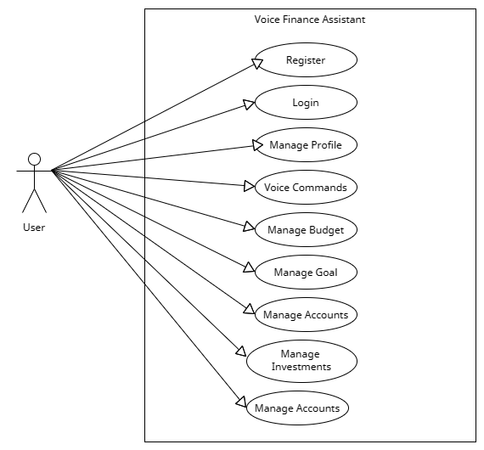

**Activity Diagram**

**Register :-**

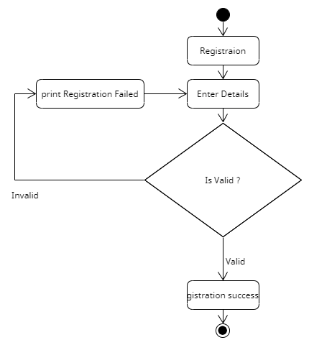

**Login :-**

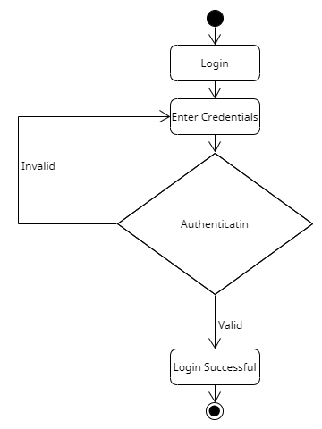

1. **Testing**

**6.1 Test cases**

**6.1.1 Test case for login**

|  |  |  |  |  |  |  |
| --- | --- | --- | --- | --- | --- | --- |
| **Test Id** | **Component** | **Description** | **Input value** | **Expected output** | **Actual output** | **Remark** |
| **1** | **Email Enter** | **Email id** | **Null** | **Field is**  **required** | **Field is Required** | **Pass** |
| **2** | **Email**  **Enter** | **Email id** | **Invalid** | **Invalid input** | **Invalid input** | **Pass** |
| **3** | **Enter Email** | **Email id** | **Valid** | **Login successful** | **Login successful** | **Pass** |
| **4** | **Password** | **Password** | **Null** | **Field is Required** | **Field is Required** | **Pass** |
| **5** | **Password** | **Password** | **Invalid** | **Invalid input** | **Invalid input** | **Pass** |
| **6** | **Password** | **Password** | **Valid** | **Login successful** | **Login successful** | **Pass** |

**6.1.2 Test case for registration**

|  |  |  |  |  |  |  |
| --- | --- | --- | --- | --- | --- | --- |
| **Test Id** | **Component** | **Description** | **Input value** | **Expected output** | **Actual output** | **Remark** |
| **1** | **Email** | **Enter email** | **Null** | **Field is Required** | **Field is Required** | **Pass** |
| **2** | **Email** | **Enter email** | **Invalid** | **Invalid input** | **Invalid input** | **Pass** |
| **3** | **Email** | **Enter email** | **Valid** | **Register successful** | **Register successful** | **Pass** |
| **4** | **Name** | **Enter name** | **Valid** | **Register successful** | **Register successful** | **Pass** |
| **5** | **Password** | **Enter password** | **Null** | **Field is Required** | **Field is Required** | **Pass** |
| **6** | **Password** | **Enter password** | **Valid** | **Register successful** | **Register successful** | **Pass** |
| **7** | **Mobile** | **Enter mobile number** | **Valid** | **Register successful** | **Register successful** | **Pass** |
| **8** | **Address** | **Enter address** | **Valid** | **Register successful** | **Register successful** | **Pass** |
| **9** | **Data of birth** | **Enter data of birth** | **Valid** | **Register successful** | **Register successful** | **Ass** |

**6.1.3 Test case for add job**

|  |  |  |  |  |  |  |
| --- | --- | --- | --- | --- | --- | --- |
| **Test id** | **Component** | **Description** | **Input value** | **Expected output** | **Actual output** | **Remark** |
| **1** | **Job role** | **Enter job role** | **Null** | **Field is Required** | **Field is Required** | **Pass** |
| **2** | **Job role** | **Enter job role** | **Valid** | **Valid** | **Valid** | **Pass** |
| **3** | **Job type** | **Enter job role** | **Null** | **Field is Required** | **Field is Required** | **Pass** |
| **4** | **Job type** | **Enter job role** | **Valid** | **Valid** | **Valid** | **Pass** |
| **5** | **Vacancy** | **Enter number of vacancy** | **Null** | **Field is Required** | **Field is Required** | **Pass** |
| **6** | **Vacancy** | **Enter number of vacancy** | **Valid** | **Valid** | **Valid** | **Pass** |
| **7** | **Salary** | **Enter salary** | **Null** | **Field is Required** | **Field is Required** | **Pass** |
| **8** | **Salary** | **Enter salary** | **Alphabet** | **Invalid input** | **Invalid input** | **Pass** |
| **9** | **Salary** | **Enter salary** | **Valid** | **Valid** | **Valid** | **Pass** |