# FONTS:

For pamposh groups main heading (this page)

* Font : Lina Serif Medium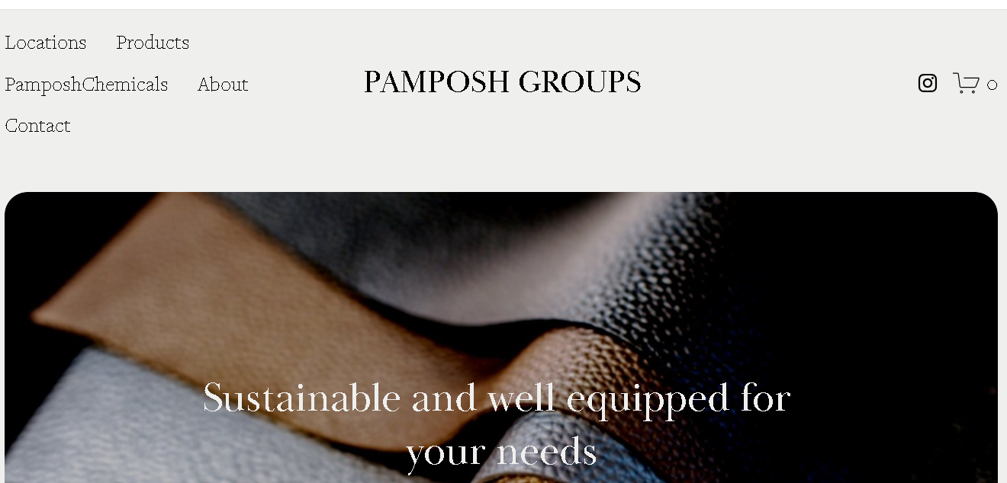

# Font : Baskerville Display PT Regular (for this)

Font : Koldby Regular (For about us) , Joanna Nova Thin (for the content under)

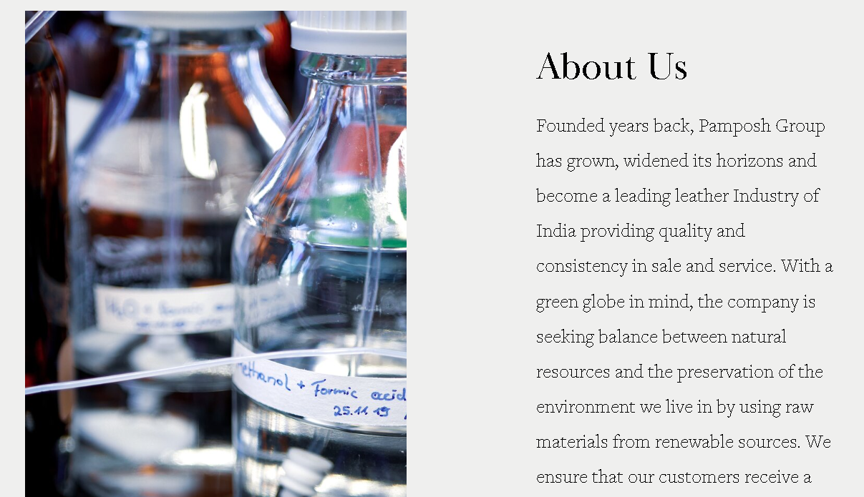

Font: Hassan Bold (for this para)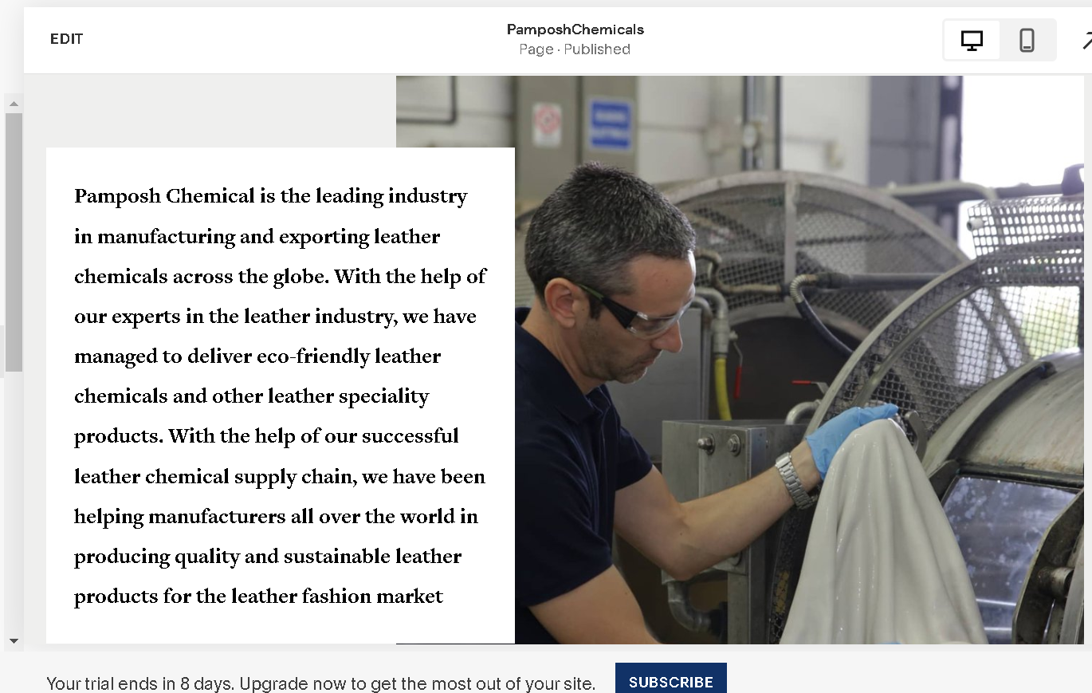

# Font: Andrade Regular (for tanning) , Sans Serif (for the para under)

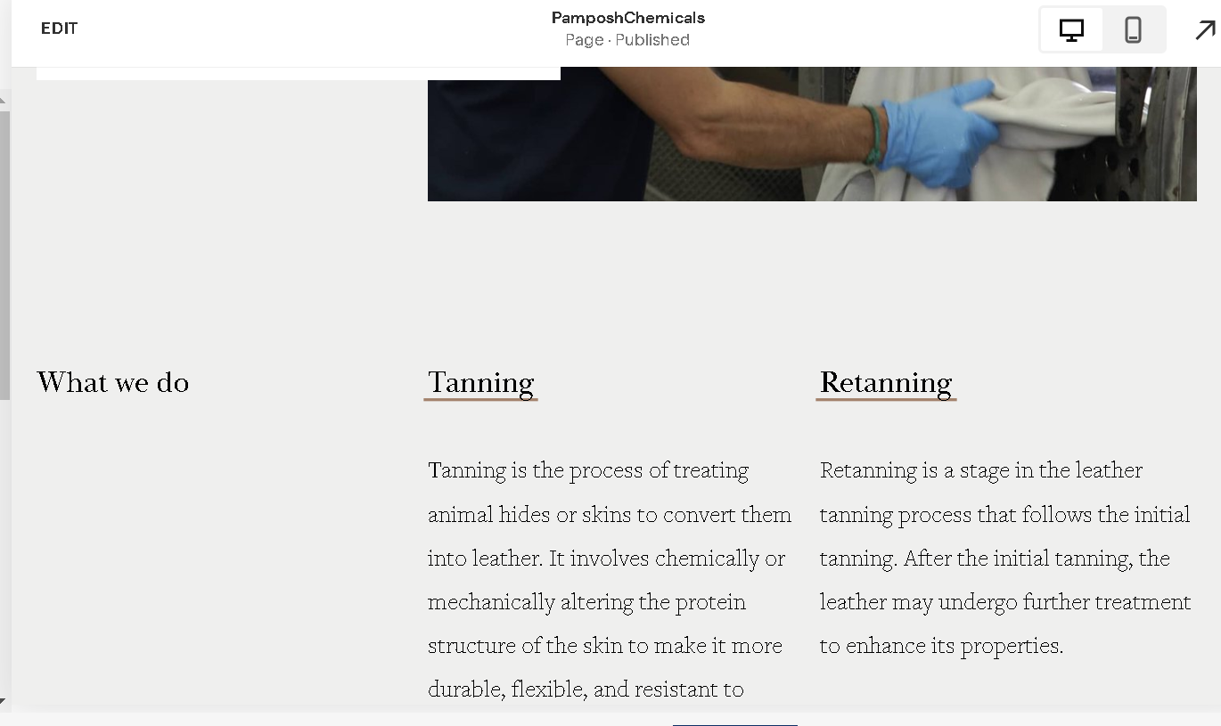

Font: Chaparral Pro Light Subhead (for this heading) 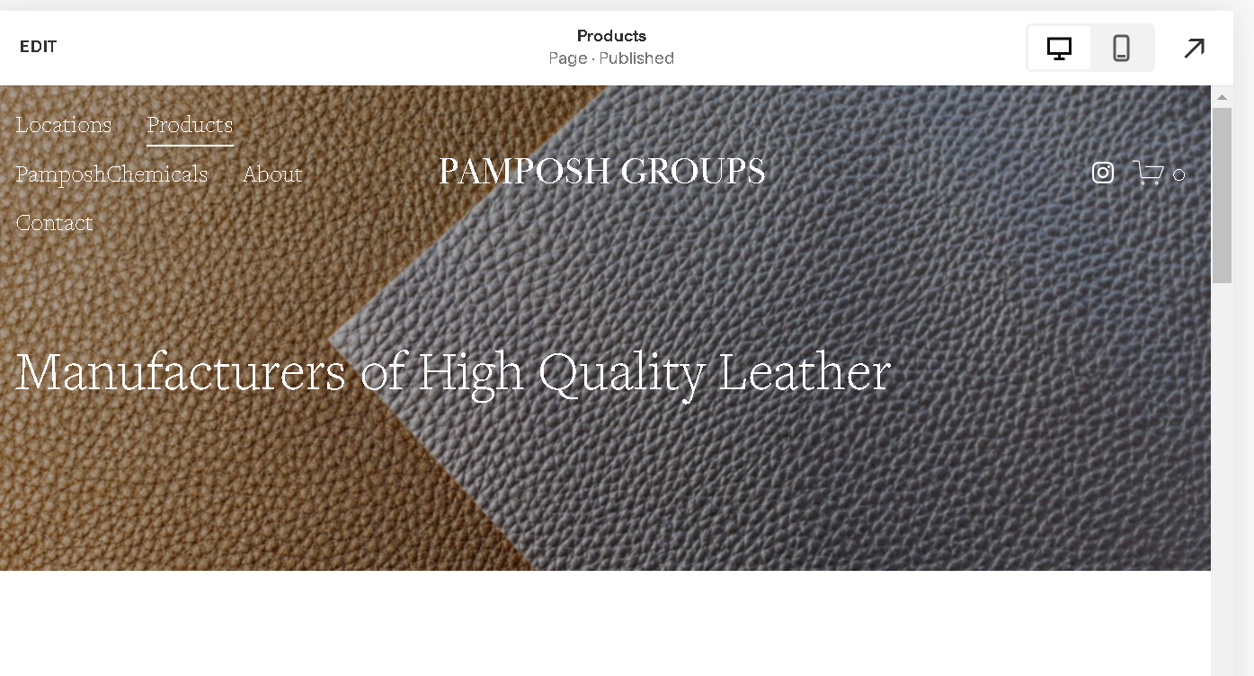

Font : **Baskerville Display PT Regular (for both heading and under) , Sans Serif (for the para under)** 