NPC – UNIT 3 ASSIGNMENT
Configure a DNS Server and Web Server Using Cisco Packet Tracer
Name: Kalashri Ajay Pawatekar
PRN: 2125UCSF1019
Objective: Configure DNS and HTTP services, then access the website using its domain name.
1. Network topology
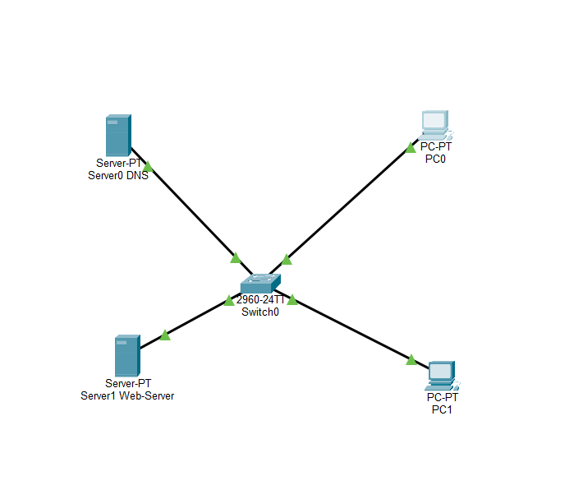

2. PC0 IP configuration
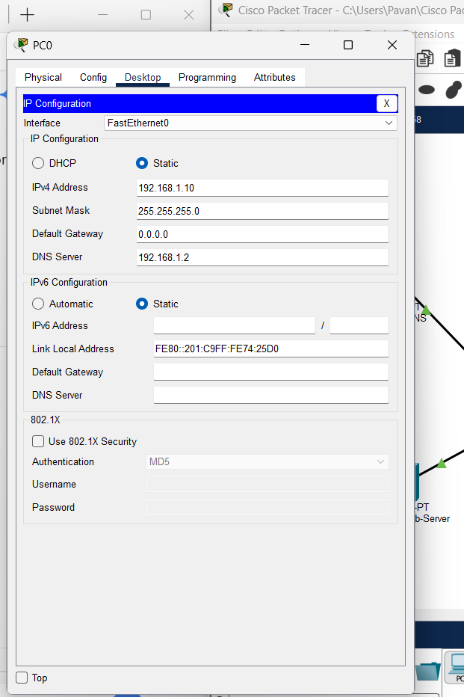

3. DNS server IP configuration
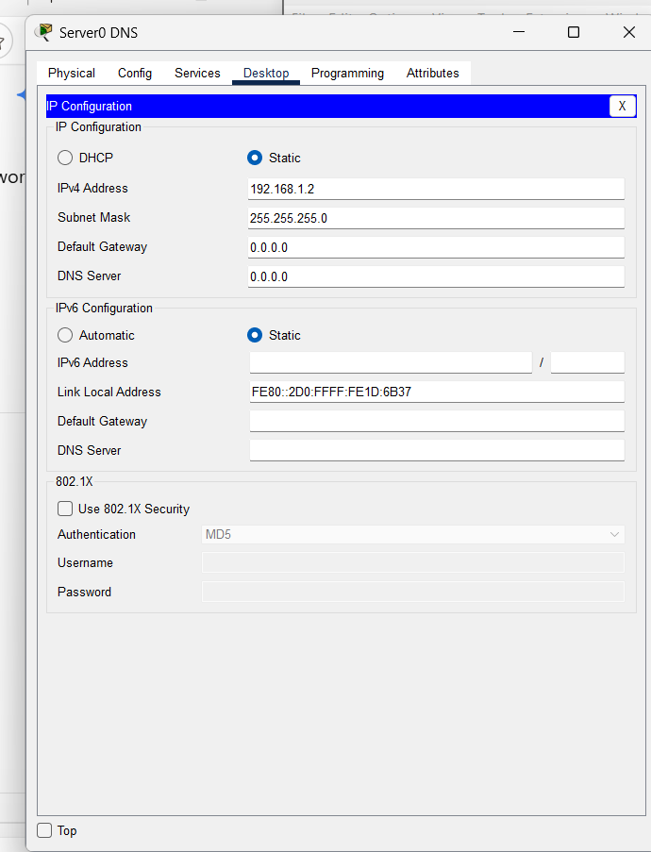

4. Web server IP configuration
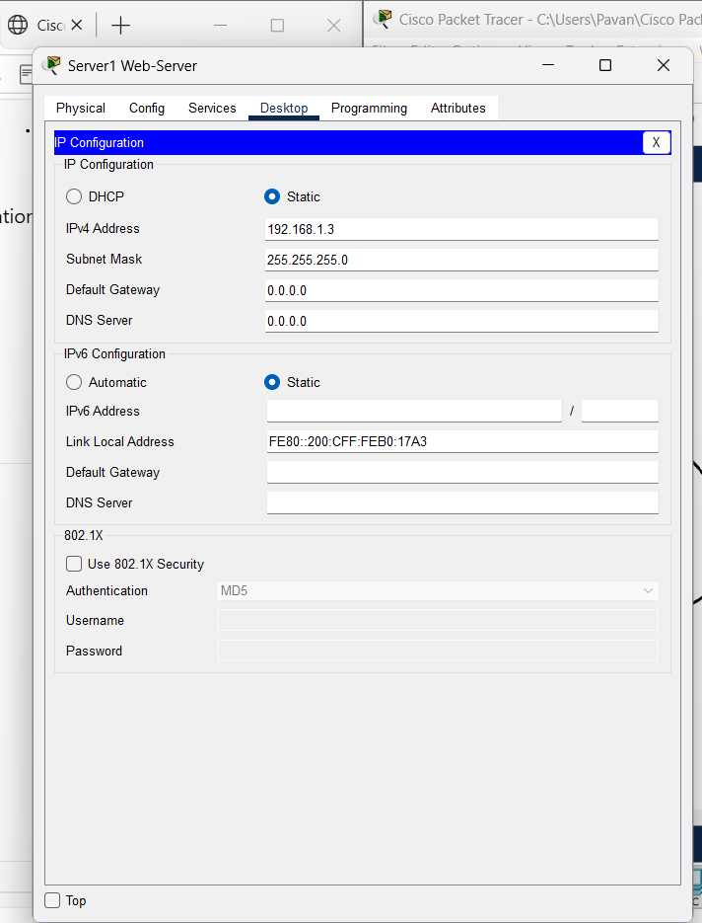

5. Website accessed using the domain name
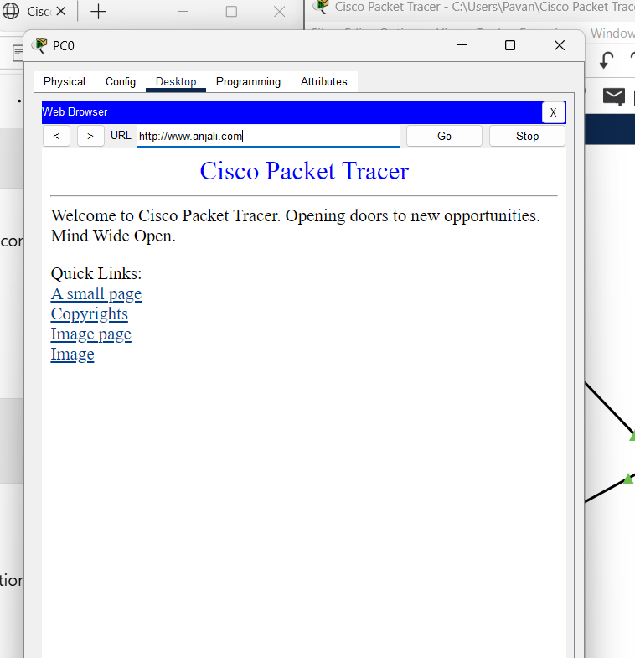
Conclusion: The network topology was created, IP addresses were configured, and the website was accessed using the domain name.

