**Banglore bio plasgens**

Reaching Homoeopathy for the Masses-These simple words highlight our belief and Zeal that drives us.

Wellness with Homoeopathy is our Goal. We see medicines not just as trade commodities, but as means to help patients regain their Health. As a Noted Manufacturer in the Homoeopathic Pharmaceutical industry, we realize our important role; we have the ethical and moral imperative to ensure good Health for patients who need it and to promote wellness among them.

Our belief and firm commitment is guided by our principles-positivity and Dynamism-which has guided us so far till now and for our future destiny.

Bangalore Bio-plasgens commenced its business in the year 1987 and is today a trusted name in the Homoeopathic Health Care industry serving the needs of Millions of Patients with high quality, affordable and innovative medicines across the country.

Wide Portfolio

Over the years, the company has significantly grown its portfolio of products across Homoeopathic Therapy. Today we have many products covering a wide spectrum of diseases Pertaining to Nutrition, Respiratory, Neurology, Gastro intestinal, Allergic conditions, Dermatology and ENT.

The company also manufactures a wide range of Generics like Homoeopathic Dilutions, Mother Tinctures, Bio-Chemic Medicines, and Specialties.

Making available Medicines when Needed.

We have a good network of field force, Stockiest, Whole sellers and retailers who connect to a vast network of practicing Homoeopathic Doctors on a daily basis to ensure that our products are available to the patients when needed across the country. We also have a Good inventory System to back the efforts of our field forces.

Homoeopathic awareness initiatives for the patients/care takers.

We have gradually developed a system of creating Homoeopathic Awareness beyond Medicines leveraging our capabilities to meet some of the Patient Needs.

* Homoeopathic Awareness Initiative
* Access to Medicines
* Better therapy experience.

**Lulu hypermarket**

Strategically located in Rajajinagar, Global Malls is in west Bengaluru, a quaint environ with tree-lined avenues steeped in culture and heritage, retaining its old world charm. It is located on 14 acres of mixed-use property behind the city railway station at Rajaji Nagar. Within the property are 356 Super luxury apartments and Duplex Penthouses, which will further enhance the mall’s premium shopping experience. Global Malls is in close proximity to the CBD and prominent junctions like Bengaluru City Railway Station, Majestic and Mysore circle. The much popular iconic destinations such as the Karnataka High Court, Race Golf Course, Vidhan Soudha and one of the largest Iskcon temples in the world are only 10 to 15 minutes away from the mall.

Global Malls is an eclectic ensemble of retail offerings spread across five storeys, spanning over 74,147 sq. m. with a total retail space of 42,779 sq. m. With 137 stores and 17 kiosks, it comes with everything that is required to imbue the desire of a discerning shopper, from branded apparels, fashion accessories, jewelry, gifts, electronic items to, food court, restaurants, coffee shops and an excellent entertainment experience that caters to both locals and tourists. Sprawling over an area of 5879 sq. m. is Lulu Hypermarket, one of the largest Hypermarkets in India. Within the mall is also Funtura - a Family Entertainment Centre, with first of its kind roller glider, tag arena, adventure coarse and trampoline, latest VR Rides, 9D theatre and bumper car, to name a few attractions. The food court of the mall will be a 1000 seater, with over 23 outlets, as well as several multi-cuisine restaurants and cafes.

The mall has a direct entry with four exclusive underpasses leading to and from the mall. This will facilitate easy movement of traffic from Majestic, towards Malleswaram, from Rajaji Nagar towards Vijayanagar. Another highlight is the ample parking space, including a separate multi-level car parking that can easily accommodate up to 1700 vehicles.

Global Malls will bring to the city not just a mall, but a destination that is a class apart!

**Sri Chamarajendra Zoological gardens**

Sri Chamarajendra Zoological Gardens, popularly known as ‘Mysuru Zoo’, is one of the oldest zoos of the country established in 1892, by His Highness, the erstwhile Ruler of Mysuru Sri Chamarajendra Wadiyar Bahadur. Mysuru Zoo holds an important place in Karnataka. In 1909 the Palace Zoo was named as Sri Chamarajendra Zoological Gardens to commemorate the illustrious founder and since then it bears the nomenclature. Mysuru Zoo has gradually grown into tourist centre, imparting wildlife values. It has got 123 years of history exhibiting wild animals in the near natural enclosures. Despite majority of the zoos have been shifted from the original place to the new places, Mysuru Zoo could modernize the zoo, without shifting the zoo. The zoo is well compacted unit, with modern animal enclosures including heritage buildings attracting tourists all over the world.

**Chamundeshwari Temple**

The Chamundeshwari Temple is a Hindu temple located on the top of Chamundi Hills about 13 km from the palace city of Mysuru in the state of Karnataka in India.[1] The temple was named after Chamundeshwari or, the fierce form of Shakti, a tutelary deity held in reverence for centuries by the Maharaja of Mysuru.

Chamundeshwari is called by the people of Karnataka as Naada Devi (ನಾಡ ದೇವಿ), which means state Goddess. It is situated at the elevation of around 3300 ft from the mean sea level.

It is believed that Goddess Durga slayed the demon king Mahishasura on the top of this hill which was ruled by him. The place was later known as Mahishooru (Place of Mahisha). The British changed it to Mysore and later Kannadized into Mysuru.

The Chamundeshwari Temple is considered as a Shakti Peetha and one among the 18 Shakti Peethas. It is known as Krouncha Pitha as the region was known in Puranic times as Krouncha Puri.

The original shrine is thought to have been built in the 12th century by the Rulers of the Hoysala Dynasty while its tower was probably built by the Rulers of the Vijayanagara Empire in the 17th century. In 1659, a staircase of one thousand steps was built leading up to the 3000-foot summit of the hill.[3] At the temple are several images of Nandi (the bull mount of Shiva). There is a huge granite Nandi on the 700th step on the hill in front of a small Shiva temple a short distance away. Believed to be sculpted in the 2nd century CE, this Nandi is over 15 feet high and 24 feet long with exquisite bells around its neck.

The temple is famous for the celebrations of festivals like Ashada Shukravara (ಆಶಾಡಾ ಶುಕ್ರವಾರ), Navaratri and Ammanavara Vardhanthi (ಅಮ್ಮನವರ ವರ್ಧಂತಿ). In the month of Ashadha, Fridays are considered particularly auspicious. Lakhs of devotees throng the temple during this occasion. Another festival celebrated during this month is Chamundi Jayanti. This day is celebrated on the anniversary of the consecration of the Utsava Moorti of the goddess by the Maharaja of Mysore. On this occasion, the goddess's idol is taken around the temple in a golden palanquin.[citation needed]

The most important festival that is celebrated here is Navaratri. Mysuru Dasara is celebrated as the state festival of Karnataka, called Nada habba (ನಾಡಾ ಹಬ್ಬಾ) in Kannada. During Navaratri, the idol is decorated in 9 different ways to depict the nine different aspects of the goddess known as Navadurgas. On the 7th day of Navaratri that is dedicated to the goddess Kalaratri, valuable jewels donated by Maharajas are brought from the District Treasury of Mysuru and are given to the temple to decorate the idol.[4]

Another temple is situated at the foothill which is in Utthanahalli called as Jwalamalini Sri Tripura Sundari Temple. This goddess is considered the sister of Chamundeshwari who helped her at the battlefield to slay the demon Raktabīja.

**Mysore Palace**

Mysore Palace, also known as Amba Vilas Palace and Mysore Aramane, is one of the most magnificent and largest palaces in India. Situated in the southern state of Karnataka, it used to be the official residence of the Wodeyar Dynasty, the rulers of Mysore from 1399 to 1950. The grand palace stands tall in the heart of Mysore city and attracts visitors from across the world. Being one of the prime attractions in India after the Taj Mahal, it certainly deserves a place in every traveler’s bucket list. So why not visit Mysore Palace this holiday season?

Before you plan your trip and book your [hotels in Mysore](https://www.fabhotels.com/hotels-in-mysore/), read this blog to know more about the palace, its history, timings, entry fee, and other interesting facts.

Mysore Palace Information:

|  |  |
| --- | --- |
| **Location** | Sayyaji Rao Road |
| **Timings** | 10:00 am to 5:30 pm; every day |
| **Entry Fee** | ₹ 70 for adults; ₹ 30 for kids above 7 years and below 12 years |
| **Still and Video Cameras** | Not allowed inside the palace |
| **Nearest Railway Station** | Mysore Junction (2 km) |
| **Also Known as** | Amba Vilas Palace, Mysuru Palace, Mysore Aramane |
| **Year of Establishment** | 1912 |
| **Commissioned by** | Maharani Kempananjammanni Devi and Maharaja Krishnaraja Wodeyar IV |
| **Architect** | Henry Irwin |
| **Architectural Style** | Indo-Saracenic |
| **Status** | A palace managed by the Government of Karnataka and the official residence of the Wadiyar Dynasty |
| **Cost of Construction** | 41.47 lakhs (in 1912) |
| **Dimensions (Main Complex)** | 245 feet (length) x 156 feet (width) x 145 feet (height of the gold plated dome from the ground) |
| **Best Time to Visit** | During Dasara celebrations |

Mysore Palace: History

Of the seven palaces that dot the cityscape of Mysore, this royal edifice is the most splendid one. The palace had its foundation laid way back in the 14th century by the Wodeyars or Wadiyars, the royal family of Mysore. It is believed that Yaduraya Wodeyar, the first ruler of the Mysore Kingdom, built a palace in *Puragiri* aka the Old Fort during his reign. This palace, which is believed to be the predecessor of the current palace, has been demolished and reconstructed multiple times over a period of six centuries.

Initially, the palace was a wooden fortress which was struck by lightning in 1638 and reconstructed under the rein of Kantirava Narasa Raja Wodeyar.  In 1793 AD, when Tipu Sultan took over the Wodeyar Dynasty, he demolished the palace and rebuilt it. In 1799, soon after the death of Tipu Sultan, the palace came under Krishnaraja Wodeyar III, who redesigned the palace as per the Hindu architectural style.

Sadly, in 1897, the palace was destroyed by fire during the wedding ceremony of Princess Jayalakshmmanni. Again, Maharani Kempananjammanni Devi and her son Maharaja Krishnaraja Wodeyar IV decided to rebuild the palace. The task of revamping the palace was commissioned to a British architect named Henry Irwin, who designed and completed this palace in 1912, at a whopping cost of over 41 lakh Indian rupees. Further expansions were done and a Public Durbar Hall wing was added to the palace under the reign of Jayachamarajendra Wadiyar during the 1930s.

Mysore Palace Architecture

Mysore Palace is built in the Indo-Saracenic style with a touch of Hindu, Mughal, Rajput, and Gothic architectural styles. The three-storied palace along with a 145 feet five-storied tower was built using fine grey granite while deep pink marble was used for the domes. The exterior of this marvelous structure is enriched with two durbar halls, several arches, canopies, columns and bay windows. There is also a sprawling green garden surrounding the palace. The interiors are opulently designed with carved doors, stained glass ceilings, glittering glazed flooring tiles, spectacular Czechoslovakian chandeliers, and works of art from all over the world. All the rooms of the palace are stunningly luxurious and quite appealing.

Above the central arch, there is a divine sculpture of Gajalakshmi – the goddess of wealth with two elephants. In addition to the three entrances, located on the eastern, southern, and western sides, the palace features several secret tunnels. There is also a group of temples at the palace, built from the 14th to the 20th century.

Mysore Palace: Today

Today, Mysore Palace is managed by the Government of Karnataka while it continues to retain its designation as the Royal Seat of the Maharajas of Mysore. The grand edifice preserves various valuable possessions of Wodeyars which includes souvenirs, jewelery, royal costumes, and paintings. Though the palace is open to the public, the erstwhile royal family still continues to live in a portion of it. There is also a museum housed within the walled complex, called the Residential Museum, which incorporates some of these living quarters.

The age-old Mysore Dasara Festival is celebrated here in its full glory. Over 6 million visitors come here annually to experience the rich history of this magnificent monument. In addition to the grandeur of the structure, the light and sound show and the illumination in the evenings are major crowd pullers.

Things to See in Mysore Palace

There is a fascinating array of things to see in and around Mysore Palace, each of which testifies to the wealth and grandeur of the Kingdom of Mysore. The top things to see in Mysore Palace include:

* The Gombe Thotti or Doll’s Pavilion, a collection of traditional dolls
* Golden Howdah, the Maharaja’s elephant seat made of 85 kilograms of gold
* Kalyana Mantap or Marriage Pavilion, an octagonal shaped hall with stained glass ceiling
* Public Durbar Hall, a large hall from where the Maharajas used to address the public
* Ambavilasa, a beautifully designed hall which was used by the Maharajas for their private audience
* Elephant Gate or Ane Bagilu, the brass gate which serves as the main entrance to the palace
* Paintings of Dasara Procession
* Portrait Gallery, a collection of valuable paintings and photographs of the Royal Family
* Casket Room containing royal collections
* Wrestling Courtyard
* Temples inside the palace

Mysore Palace Light and Sound Show

The light and sound show held in the evenings is one of the prime attractions at Mysore Palace. The entire show portrays the 600-year-old cultural heritage, history, and traditions of the Wodeyar Dynasty in a visually appealing manner.

* **Duration:** 45 minutes
* **Timings:**7.00 pm to 08.00 pm; all days except Sundays and public holidays
* **Tickets:** ₹ 70 for adults; ₹ 30 for kids above 7 years and below 12 years

Mysore Palace Illumination

Mysore Palace is lit up in the evening on Sundays and public holidays, and also during the ten days of Dasara celebrations. During weekdays, you can enjoy the illumination after the light and sound show for five minutes. The illumination is done using 97000 electric bulbs, making the palace a sight to behold.

* **Timings:**   
  Sundays, public holidays, and during Dasara – 7:00 pm to 7:45 pm  
  Weekdays – 7:40 pm to 7:45 pm
* **Tickets:** Not required

Lesser-known Facts about Mysore Palace

* The current palace was constructed over a period of 15 years.
* Mysore Palace is one of the few tourist places in India that has introduced braille guides for visually challenged tourists.
* The Golden Ambari or Palanquin which was used by kings is now used for placing Goddess Durga’s idol during the Dasara procession.

Attractions near Mysore Palace

* Dodda Gadiyaara (260 m)
* Badsha Bazaar – the silk route (800 m)
* Jaganmohan Palace Art Gallery And Auditorium (900 m)
* Devaraja Market (950 m)
* Sri Chamarajendra Zoological Gardens (1.5 km)
* Karanji Lake (2.3 km)
* Philomena church (2.1 km)
* Mysore Railway Museum (3.5 km)
* Jayalakshmi Vilas Complex Museum (4.4 km)

Mysore Palace is a visual experience – a structure that will leave you awestruck with its sheer opulence. Visit the palace, explore its many attractions, and get a glimpse into the city’s glorious past.

**Wondrela**

**Wonderla** is the largest chain of [amusement parks](https://en.wikipedia.org/wiki/Amusement_park) in [India](https://en.wikipedia.org/wiki/India). It is owned and operated by Wonderla Holidays Limited which is headquartered near [Bidadi](https://en.wikipedia.org/wiki/Bidadi), 28 kilometres (17 mi) from [Bengaluru](https://en.wikipedia.org/wiki/Bengaluru), [Karnataka](https://en.wikipedia.org/wiki/Karnataka). It operates 3 amusement parks in [Kochi](https://en.wikipedia.org/wiki/Kochi), [Bengaluru](https://en.wikipedia.org/wiki/Bengaluru), and [Hyderabad](https://en.wikipedia.org/wiki/Hyderabad).[[1]](https://en.wikipedia.org/wiki/Wonderla#cite_note-:3-1)

Wonderla is promoted by [Kochouseph Chittilappilly](https://en.wikipedia.org/wiki/Kochouseph_Chittilappilly" \o "Kochouseph Chittilappilly) and his son Arun Chittilappilly. The first amusement park project Wonderla Kochi was set up in 2000, followed by the second in Bengaluru in 2005, and finally the third in Hyderabad was commissioned in April 2016.[[2]](https://en.wikipedia.org/wiki/Wonderla#cite_note-2) Wonderla is currently planning to open its 4th amusement park in Chennai. Wonderla amusement parks offer a variety of dry rides such as roller coasters, ferris wheels, drop towers and water rides for its customers.

The park features a wide variety of attractions including 55 land and water rides, a musical [fountain](https://en.wikipedia.org/wiki/Fountain), [laser](https://en.wikipedia.org/wiki/Laser) shows, and a [virtual reality](https://en.wikipedia.org/wiki/Virtual_reality) show.[[12]](https://en.wikipedia.org/wiki/Wonderla#cite_note-:1-12) Wonderla Bangalore has a full-fledged [dance floor](https://en.wikipedia.org/wiki/Sprung_floor) with a twist, electronically controlled rain showers. Wonderla also has attractions specially designed for children, and these are gentle yet unusual like a kiddies free fall ride. It uses [solar](https://en.wikipedia.org/wiki/Solar_power)-heated water for all its pools during winter. It has [conference](https://en.wikipedia.org/wiki/Meeting) facilities for up to 1,000 persons and features five restaurants with a total seating capacity of 1,150. It has [locker rooms](https://en.wikipedia.org/wiki/Locker_room) with over 2,350 lockers and restrooms and showers.[[12]](https://en.wikipedia.org/wiki/Wonderla#cite_note-:1-12) Wonderla Bangalore has been ranked 1st in India and 7th best in Asia by [Tripadvisor](https://en.wikipedia.org/wiki/Tripadvisor" \o "Tripadvisor) for 2014, the highest for any Amusement park in India.[[13]](https://en.wikipedia.org/wiki/Wonderla#cite_note-13)

Wonderla Holidays opened its first luxury [resort](https://en.wikipedia.org/wiki/Resort), an 84-room hotel complex spread over 100,000 square feet and operational since 2012.[[14]](https://en.wikipedia.org/wiki/Wonderla#cite_note-14) The resort features includes a dedicated children's play area, other recreational and conferencing facilities.[[6]](https://en.wikipedia.org/wiki/Wonderla#cite_note-worth_the_ride-6) The resort is located next to Wonderla Bangalore.

**Electric Bunsen burner**

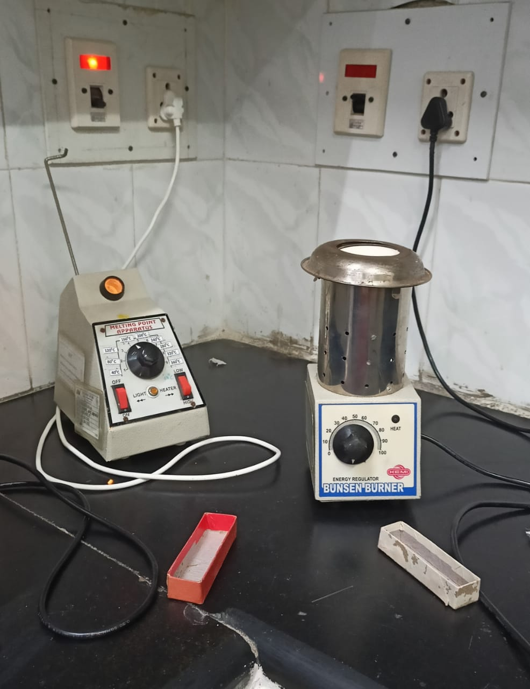

**Bunsen burner**, device for [combining](https://www.britannica.com/dictionary/combining) a flammable [gas](https://www.britannica.com/science/gas-state-of-matter) with controlled amounts of [air](https://www.britannica.com/science/air) before ignition; it produces a hotter [flame](https://www.britannica.com/science/flame) than would be possible using the ambient air and gas alone. Named for [Robert Bunsen](https://www.britannica.com/biography/Robert-Bunsen), the German chemist who introduced it in 1855 (from a design by Peter Desdega, who likely modified an earlier design by [Michael Faraday](https://www.britannica.com/biography/Michael-Faraday)), the Bunsen burner was the forerunner of the gas-stove burner and the gas [furnace](https://www.britannica.com/technology/furnace). The Bunsen burner consists of a metal tube on a base with a gas inlet at the lower end of the tube, which may have an adjusting valve; openings in the sides of the tube can be regulated by a collar to admit as much air as desired. The mixture of air and gas (optimally about 1 part gas to 3 parts air) is forced by gas pressure to the top of the tube, where it is ignited with a [match](https://www.britannica.com/science/match-tinder). It burns with a pale blue flame, the primary flame, seen as a small inner cone, and a secondary, almost colourless flame, seen as a larger, outer cone, which results when the remaining gas is completely oxidized by the surrounding air.

[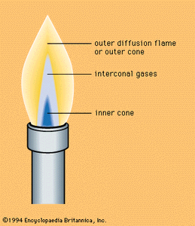](https://cdn.britannica.com/66/7466-004-5C98BBCF/Cone-Bunsen-burner-flame.jpg)

[cone of a Bunsen burner flame](https://cdn.britannica.com/66/7466-004-5C98BBCF/Cone-Bunsen-burner-flame.jpg)

The hottest part of the Bunsen flame, which is found just above the tip of the primary flame, reaches about 1,500 °C (2,700 °F). With too little air, the gas mixture will not burn completely and will form tiny [carbon](https://www.britannica.com/science/carbon-chemical-element) particles that are heated to glowing, making the flame [luminous](https://www.britannica.com/dictionary/luminous). With too much air, the flame may burn inside the burner tube; that is, it may strike back. The Meker and Fisher burners, variations of the original Bunsen burner, have metallic grids to increase the turbulence of the mixture and keep the flame at the top of the tube. The Fisher burner uses forced air. There is no secondary flame dependent on surrounding air, because these improvements introduce sufficient air for complete [combustion](https://www.britannica.com/science/combustion), and the heat of the primary flame is augmented.

Electric Bunsen, consumes approximately 350 watts, and it has numerous application in laboratory for heating test tube, crucibles, small flasks, etc. Irrespective of their shape. It also replaces gas burner. Heating element within a conically shaped refractory crucible which is enclosed in a stainless steel casing with proper insulation. The element attains the temperature range of 800° C to 900° C complete with energy regulator and cable suitable for operation on 230.V.A.C.

**Infrared moisture Balance**

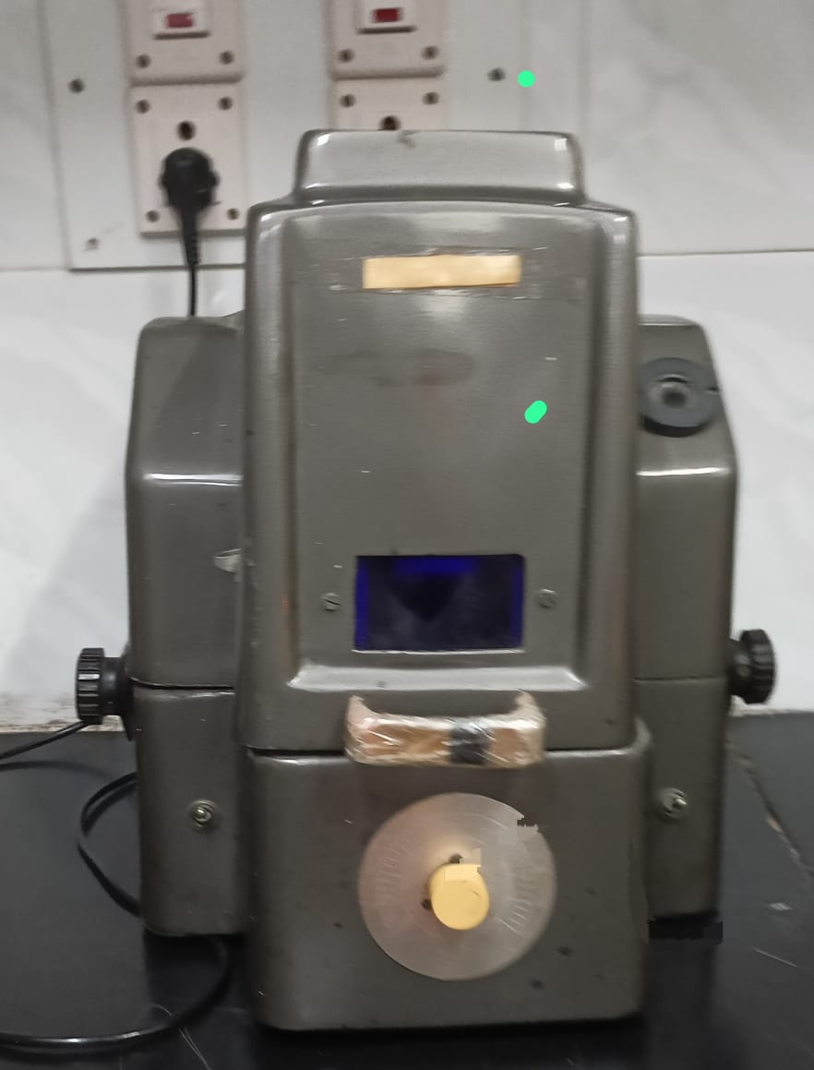

With solid state electronic Regulator. Very easy to operate with and accuracy of 0.2% by direct reading,0.1% by estimation, complete with 'L' Bend thermometer with pans cap.5 or 10 or 25 grams.

This is very reliable and sturdy instrument for an accurate determination of the moisture content of materials which do not undergo chemical change when exposed to infra red radiations. The instrument is specially useful for the substances which quickly reabsorbs moisture after drying. Observations can be taken quickly and the results obtained are accurate. The instrument can be used for reliable determination of moisture content of agricultural soil, foods, chemicals, plastics, Pharmaceuticals, construction soils and other similar materials. The instrument consist of a 250 watt infrared lamp, a sensitive torsion balance and a temp. Control, all housed in a compact cabinet made of Aluminium, having robust design. The Infra Red radiation from the lamp is used for heating the sample. The temp. is controlled by the solid state control. The sensitive torsion balance used magnetic damping to damp the vibrations of the pan. The instrument is directly calibrated in percentage of moisture between 0 to 100%.The Aluminium pans are cheap and disposable. This helps avoid loss of time which otherwise would be spent each time to clean the pans after the experiment is done. Complete with instruction manual. It is available in following Capacities to suit individual requirements.

* Capacity 5g (Approx.): For applications in pharmaceuticals, light powders, chemicals, detergent.
* Capacity 10g (Approx): For grains, rice, relatively heavy grained products etc.
* Capacity 25 g (Approx.) For Coal, Cashew nuts, Sand, Agricultural Soil etc.

OR Delux Model with auto transformer (Variac)With a superior quality variac for a long life andbetter control of temperature. Available in all the above three models

The instrument can be supplied with Digital timer with alarm. This timer gives a continuousbuzz after turning the infrared lamp off after specified time. N.B. We can also supply more Sophisticated and accurate Digital Moisture Balance.

**Digital tablet disintegration tester**

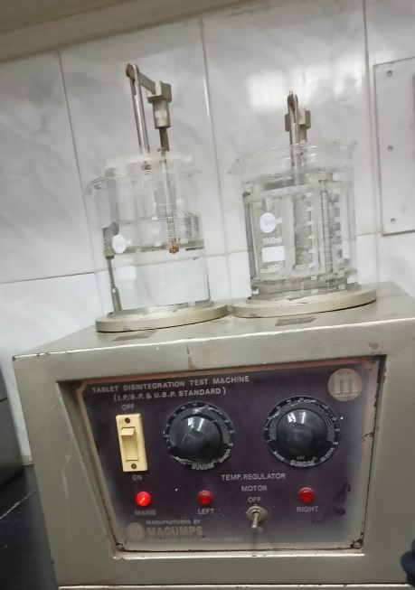

**Tablet Disintegration tester** is an instrument used to perform the disintegration test of tablets and capsules in the pharmaceutical industry as per USP/IP standards. The main purpose of this test is to check the complete disintegration of a tablet and capsule in a standard time period. If a tablet takes too much time in *disintegration* than it is considered as highly compressed and gelatin is not as per the standards for capsules. This test is done randomly for the batches manufactured and adequate action takes place accordingly.

Yatherm**Tablet Disintegration testers** are designed as per *USP/IP standards* used for accurate test results of tablets and capsule disintegration. We offer and supply smart disintegration tester with maximum efficiency and consistent results for pharmaceutical R&D department & quality assurance.

The instrument consists of two beakers capacity 1000 ml each with 6 mm thick acrylic water bath capacity 5-10 liters & ISI mark SS heater for uniform temperature in a water bath. This unit provided with two basket assemblies with separate timers and motors. The temperature of vessels and water baths is maintained with the help of the PID controller at 37°C, & the speed of the basket is maintained as per standards. This instrument can test two tablets pack simultaneously with a soft touch key panel for smooth functioning. More than 200 samples of data can be stored for 20 tests with an optional port for printing facility.

**Features**

* USP/IP Compliance
* Microprocessor-based temperature Controller
* Seven segments LED display
* 10 Soft-touch membrane type keys
* User-friendly
* Two USP baskets
* Each basket is controlled by independent Timer and Motor
* Auto parking of the basket at the top position at the end of the  test
* Temperature validation Sensor
* Printer facility
* Maintenance-free smooth drive
* Suitable for veterinary tablets

**Specifications**

|  |  |
| --- | --- |
| Model | TAB – 901 |
| Number of Baskets | 2 |
| Stroke Length | 55 mm ± 0.5 strokes / minute |
| No. of Timers | 2 Timers |
| Timer Display | 5 Digit LED Display for each Timer |
| Keyboard | Soft-touch |
| No. of Motors | 2 |
| Temperature Display | PID Controlled Digital display |
| Temperature Range | 20.0°C to 40°C |
| Temp. Control | Microprocessor-based using PT 100/ semiconductor sensor as per IP/USP |
| Accuracy | + 0.1 °C |
| Reaction Vessel | 1000 cc |
| Heater | 500 watt |
| Electrical Supply | 220 V |
| DIMENSIONS (W x H x D) | 35 cm x 21 cm x 33 cm |

**Tablet pressing machine**

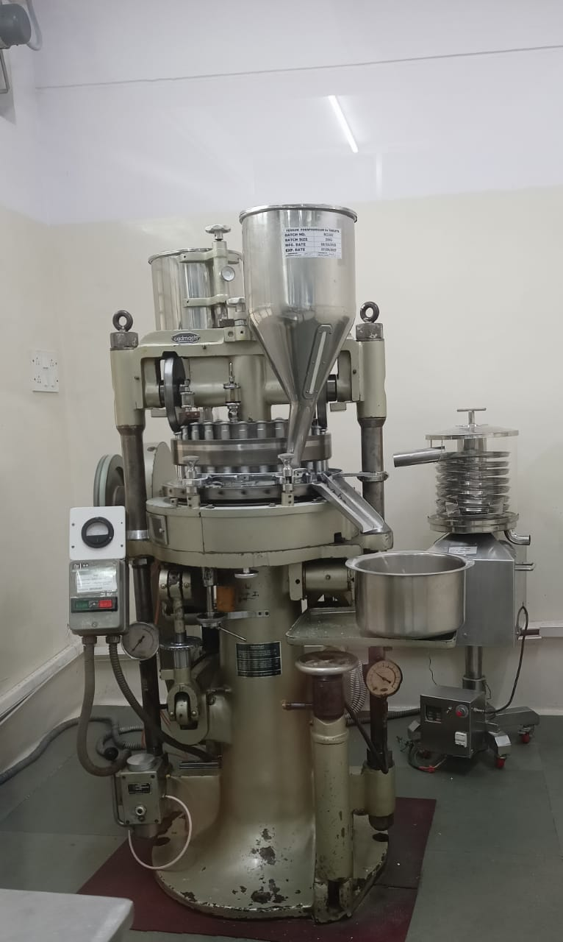

Tablet press also referred to as tableting machine, pharmaceutical tablet press, tablet compressing machine, or tablet punching machine is a mechanical device that compresses powders into tablets of uniform size, shape, and weight containing approximately the same quantity of Active Pharmaceutical Ingredient (API) and excipients. Apart from its use in the pharmaceutical industries for manufacturing [varieties of tablets](https://www.pharmapproach.com/solid-dosage-forms-tablets/), it can also be used to manufacture illicit drugs, cleaning products, and cosmetics.

All tablet press employs the same basic principle of compression. The basic unit of any tablet press is tooling consisting of two punches and a die called a station. The upper and lower punches come together in the die that contains the tablet formulation.

The development of tablet press has been a continuous process. In the past, we have hand-driven tablet press which has been modernized to electrical driven tablet press.

## **Reason for continuous development of tablet press**

* Development of newer technology in tablet production e.g. development of direct compression technology.
* Development of stringent standard of cleanliness to comply with the Current Good Manufacturing Process (CGMP).
* The introduction of automation and continuous monitory of production processes.
* Increased rate of production resulting from increased demand, multiplication of disease conditions, and exponential increase in population.

## **Types/Classification of Tablet Press**

Tablet press in current use can be classified into;

1. Single punch/single station/eccentric presses.
2. Multi-station/rotary presses.

There are numerous models of presses, manufactured by a number of companies, ranging in size, speed, and capacity.

## **Components/ functional parts of a single punch tablet press**

[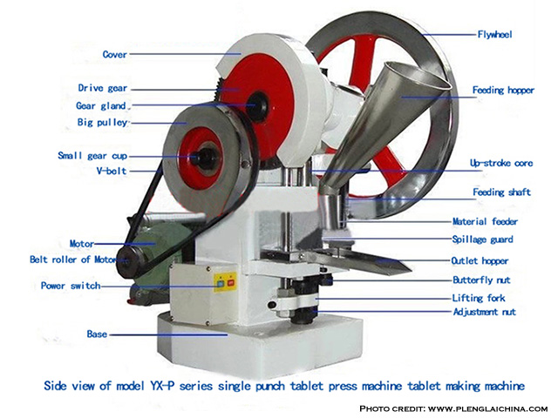](https://www.pharmapproach.com/wp-content/uploads/2016/01/tablet-press.jpg)

###### **Labeled diagram of a single punch tablet press**

* **Hopper**– This is connected to the feed shoe and it is where the granules/powder mixtures are poured into prior to tabletting or compression. The hopper can be filled manually or by using mechanical equipment during subsequent tabletting.
* **Die cavity –**The die cavity is where the powder granules are compressed into tablets. The die determines;
  1. The diameter of the tablet
  2. The size of the tablet
  3. To some extent the thickness of the tablet.
* **Punches –** This comprises upper and lower punch and they compress the powder into tablets of various shapes within the die.
* **Cam truck –**This guides the position/movement of the punches.
* **Tablet adjuster –**This is used to adjust the volume of the powder to be compressed and so determines the weight of the tablet.
* **Ejection adjuster –**This facilitates the ejection of the tablet from the die cavity after compression.

In the production of tablets using a single punch tableting machine, the upper punch compresses the powder into tablets while the lower punch ejects the tablet.

**Sealing Machine**

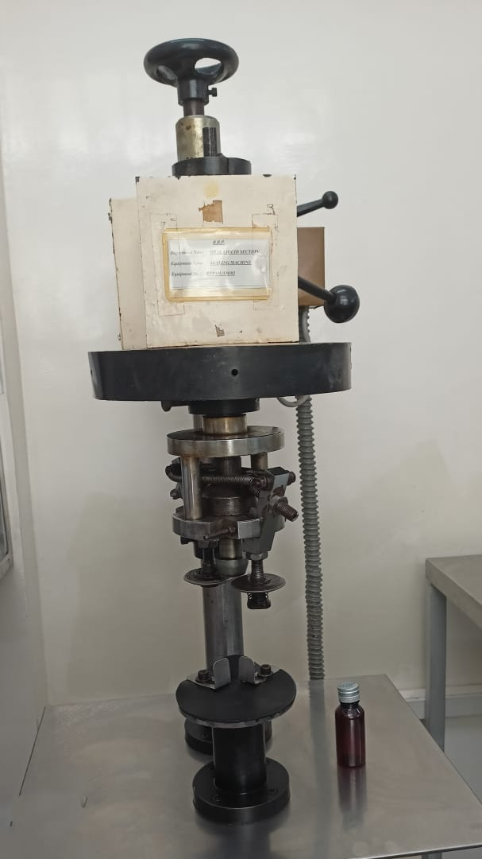

Sealing machines close and seal an individual package or provide a long continuous horizontal or vertical seal. There are many different types of sealers. Sealing machinery that combines [form, fill, and seal functions](http://www.globalspec.com/learnmore/material_handling_packaging_equipment/packaging_labeling/form_fill_seal_machines)is also available. Some sealing machines transport the plastic film horizontally, while others transport vertically.

* **Seal-only equipment** wraps or secures products, but does not form packages or fill them.
* **Manual sealing machines** aid only in the setting or holding of products.
* **Semi-automatic sealers** help with both packaging and placement, allowing a single operator to perform several activities with greater speed and accuracy.
* **Fully automatic sealing** equipment requires limited operator intervention. Typically, operators need only to replenish packaging components by loading supply hoppers or removing completed cartons.

[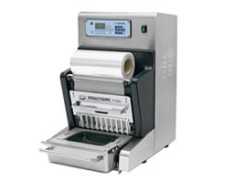](https://insights.globalspec.com/images/assets/164/1164/machine-1-fullsize.jpg)**Sealing machines close and seal an individual package or provide a long continuous horizontal or vertical seal.**(Find sealing machines by [Specification](http://www.globalspec.com/SpecSearch/SearchForm/material_handling_packaging_equipment/packaging_labeling/sealing_machines) or see the IHS [Directory](http://www.globalspec.com/search/products?page=ms#comp=4641&sqid=13125586&show=suppliers) of suppliers.)

One of the main differences between a semi-automatic and fully automatic sealing machine is that, fully automatic sealers close all of the flaps, including the leading, trailing and side flaps before taping, while semi-automatic sealers tape only the top and bottom.

Sealing machines are used to seal containers with liquids, granules, powders and sprays for consumer, bulk, and original equipment manufacturer (OEM) supply shipments. Packaging materials include aerosol containers, bags and pouches, blister packs, bottles and jars, as well as cartons and boxes. Some sealing machine suppliers provide related packaging equipment. Equipment that can be used in conjunction with sealing machines includes accumulators, batching machines, bagging machines, banders, sleevers, and box making equipment. (Click [here](https://www.youtube.com/watch?feature=player_embedded&v=NLCpAEjgy9I) for a video on the usage of tray sealing machine)

**Specifications**

Selecting a sealing machine requires an analysis of specifications, features, and applications. Fully automated sealing machines list the rate, which is usually measured in pieces per minute. Some sealing equipment is made from stainless steel for improved corrosion resistance.

* **Integral feeders** and computer interfaces that link to a control network can be found in some automated machines.
* **Aseptic or sanitary** sealing machines are easy to clean and designed in a manner that inhibits the growth or presence of pathogenic microorganisms.
* **Portable** sealing machinery is lightweight or includes wheels or casters for ease of movement.

**[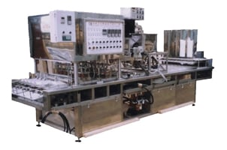](https://insights.globalspec.com/images/assets/164/1164/machine-2-fullsize.jpg)Full automated conveyor-based sealing machine. Image credit: Seal FilmApplications**

Sealing machines are used widely in the chemical, medical, and pharmaceutical industries. Sealing machines are also used to process food, beverages, cosmetics, electronics, and semiconductors.

* **End of line machines** get the package ready for shipment. This may include bundlers (also called sleeve wrappers), palletizers, pallet wrappers, and the conveyor system needed to transport the products. Additional equipment is used to apply labels or print on the box.
* **Uniform case sealers** should be used for production runs of cases of the same size. They can be physically reset between cases of boxes.
* **Random case sealers** are used when the size of each box can vary randomly, such as in order picking warehouses. The machine automatically adjusts to the size of the box as presented. Random case sealers are for lower volumes and more expensive than uniform case sealers.
* **Standup pouch filling** machines are used for products displaying on a shelf (i.e. bottled products). They use individual bags which are fed into the machine. Standup sealers can be used to fill powders, granules, or liquids into the pouch.

**Standards**

Sealing machine must adhere to certain standards to ensure proper design and safe handling. [MIL-S-4461](http://global.ihs.com/doc_detail.cfm?item_s_key=00068046&rid=GS&target=%22blank%22)discusses sealing machines using heat to create the seal and [MIL-S-22783](http://global.ihs.com/doc_detail.cfm?item_s_key=00067351&rid=GS&target=%22blank%22)is used for jaw type sealing machines.

**Single punch tablet making machine**

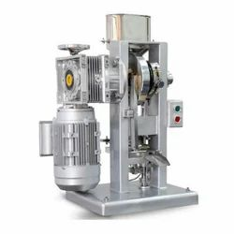

Single punch tablet press also called eccentric press or single station press is the simplest machine for [tablet manufacturing](https://www.pharmapproach.com/manufacture-of-pharmaceutical-tablets/). Single punch tablet as the name implies employ single set of station tooling that is a die and a pair of upper and lower punches.

The compaction force on the fill material is exerted by only the upper punch while the lower punch is static; such action equivalent to hammering motion and as a result, the single punch press is referred to as stamping process. The single punch tablet press produce about 60-85 tablets/min e.g. Manesty F3.

## **Components/ funtional parts of a single punch tablet press**

* **Hopper**– This is connected to the feed shoe and it is where the granules/powder mixtures are poured into prior to tableting or compression. The hopper can be filled manually or by using mechanical equipment during subsequent tableting.
* **Die cavity –**The die cavity is where the powder granules are compressed into tablet. The die determines;

1. The diameter of the tablet
2. The size of the tablet
3. To some extent the thickness of the tablet.

* **Punches –** This comprises upper and lower punch and they compress the powder into tablets of various shapes within the die.
* **Cam truck –**This guides the position/movement of the punches.
* **Tablet adjuster –**This is used to adjust the volume of the powder to be compressed and so determines the weight of the tablet.
* **Ejection adjuster –**This facilities the ejection of the tablet from the die cavity after compression.

In the production of tablets using single punch, the upper punch compresses the powder into tablets while the lower punch ejects the tablet.

## **The sequence of events involved in the formation of tablet.**

The events involved in tablet production can be divided into 3 stages;

1. Filing
2. Compression
3. Ejection

### Filing

* **Position 1 –** The upper punch is raised and lower punch drops to create a cavity in the die.
* **Position 2 –** Feed shoe moves over the die cavity and granules fall into the die cavity under the influence of gravity from the hopper.

### Compression

* **Position 3 –** Feed shoe moves out of the way and the hopper punch descends to compress the granules/powder mixture into tablets by progressive reduction of the porosity of the die content and forcing of the particles into close contact with one another.

### Ejection

* **Position 4** **–**The upper punch retracts and the lower punch moves upwards too to eject the compressed tablet. The whole events repeat over and over again unit the feed material is exhausted.

**Read Also:**[**Rotary Tablet Press (Multi-Station Tablet Press)**](https://www.pharmapproach.com/rotary-tablet-press-multi-station-tablet-press/)

## **Advantages of Single Punch Tablet Press**

* The single punch structure is rational and small.
* Easy to operate and it operates at a high utilization ratio.
* It can manufacture odd shaped products with a diameter of up to 20mm.
* It is ideal for development of tablets and small batch production.
* Single punch tablet press utilizes a high amount of pressure to reduce weight variations between tablets while maintaining a low noise level at the same time.

**Big morter and pestle**

**mortar and pestle**, ancient device for milling by pounding. The mortar is a durable bowl commonly made of stone, ceramic, or [wood](https://www.britannica.com/science/wood-plant-tissue). The pestle is a rounded grinding club often made of the same material as the mortar. Together with the [saddle quern](https://www.britannica.com/technology/saddle-quern) (a round stone rolled or rubbed on a flat stone bed), the mortar and pestle was the first means known for [grinding grain](https://www.britannica.com/technology/cereal-processing); the grain was placed in a shallow depression in a stone, the mortar, and pounded with a rodlike stone, the pestle. Smaller refined versions of the mortar and pestle have continued to find use in kitchens for preparing pastes and other finely ground elements of [cuisine](https://www.britannica.com/dictionary/cuisine), in [pharmacy](https://www.britannica.com/science/pharmacy) for preparing medicines, and in chemical laboratories.