**4-Week Online Summer Training Program on “Programming Skills for Engineering”** ASSIGNMENT NO.1

Kalash tyagi

B.tech CSE 3rd year

19013009

Bpsmv Haryana

kalashtyagi98@gmail.com

**Ques-1** Variable names - The Python interpreter

has strict rules for variable names.

Which of the following are legal python names?

If the name is not legal, state the reason.

and - invalid(keywords can’t use as variable).

and_1 - valid(underscore is allowed)

var - valid

var1- valid

1var- invalid(no. Is not allowed at beginning)

My-name- invalid(hyphen not allowed in between)

Your name- invalid(space is not allowed)

COLOR- valid.

**Ques-2** Write down the type of the values stored in each of the variables below. Pay special attention to punctuation: values are not always the type they seem!

a = False

b = 3.7

c = ‘Alex’

d = 7

e = ‘True’

f = 17

g = “17”

h = True

i = ‘3.14159’

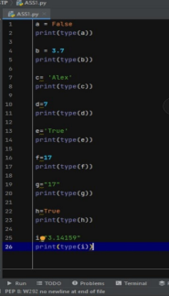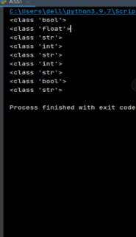

**Ques-3** Given the following variables:

look = ’Look at me!’

now = ’ NOW’

What are the values of the following expressions? Try to guess on your own before using your interpreter (but feel free to use your interpreter once you get stuck).

look[:4]

look[-1]

look*2

look[:-1] + now + look[-1]

now[1]

now[4]

look*2 + look[:-1] + now + look[-1].

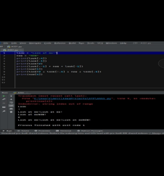**Ques-4 What will be output of this program:**

**A= input('Enter word ')**

**print("Original String:",a)**

**# using list slicing**

**# convert string to list**

**# pick only even index chars**

**X=list(A)**

**For i in X[0:2]:**

**Print(i)**

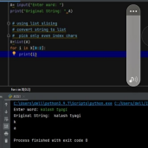

**Ques-5 Display numbers divisible by 5 from a given list: X= [10, 20, 33, 46, 55].**

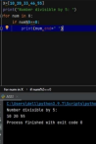

**Ques-6 Write a program to create a new string made of the middle three characters of an input string.**

**A= "JhonDipPeta"**

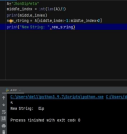

**Ques-7 Reverse a given list in Python**

**X= [100,200,300,500,900]. Which command is used to reverse the list in python?**

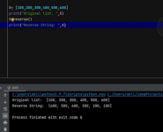

**Ques-8 Given a list of numbers i.e**

**A= [1,2,3,4,5,6,7]**

**Write a program to turn every item of a list into its square.** 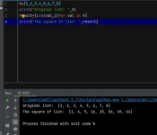

**Ques-9 Write Python code to swap two tuples.**

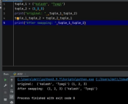

**Ques-10 Write Python code to Counts the number of occurrences of item 50 from a given tuple: a=(20,30,50,30,50,80,50)**

