**4-Week Online Summer Training Program on “Programming Skills for Engineering”**

**ASSIGNMENT NO.2**

**Kalash tyagi**

**B.tech cse 5th sem.**

**19013009**

**BPSMV**

[**kalashtyagi98@gmail.com**](mailto:kalashtyagi98@gmail.com)

1. (a) Write a program that uses a while loop (not a for loop) to read through a

string and print the characters of the string one-by-one on separate lines.

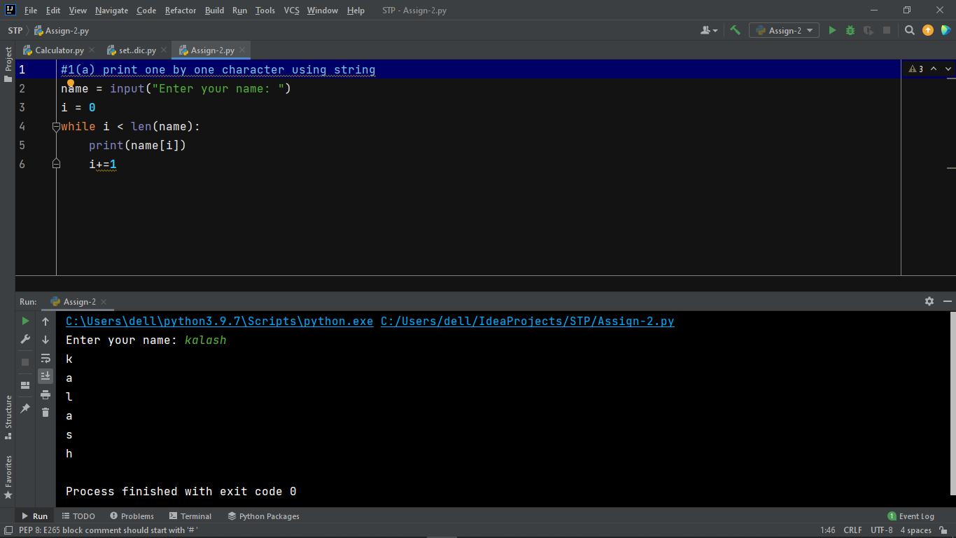

(b) Modify the program above to print out every second character of the string.

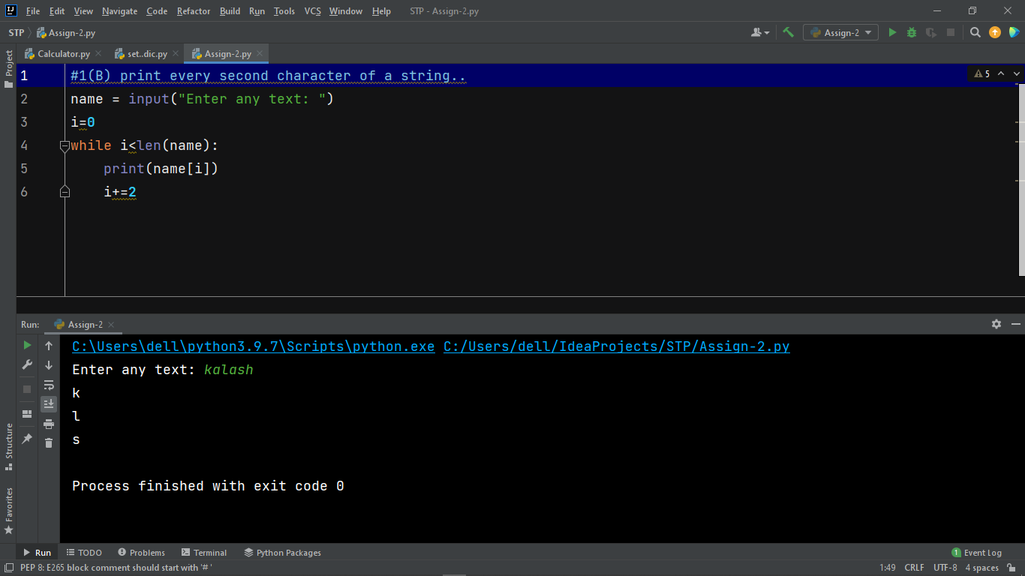

2. Create a list and perform the following methods

1) insert () 2) remove() 3) append() 4) len() 5) pop() 6) clear()

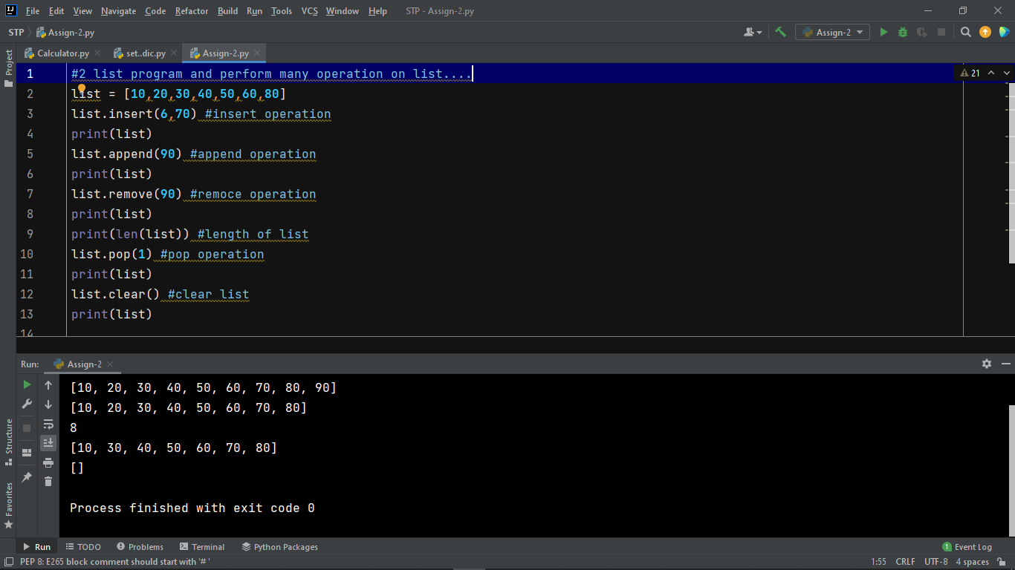

3. Write a python program to find factorial of a given number using functions.

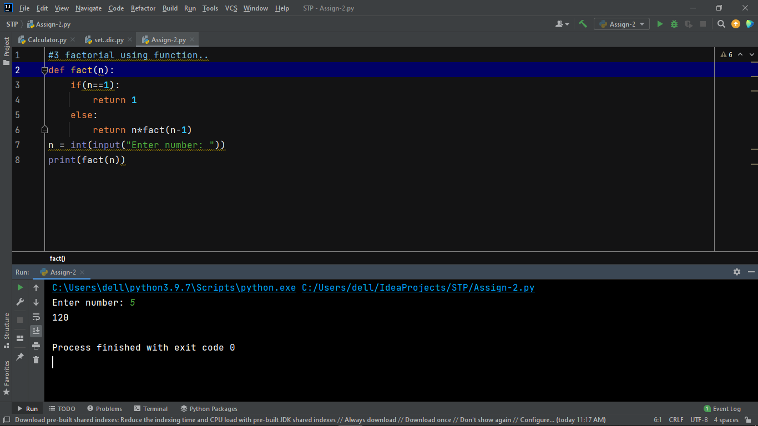

4. Write a program that asks the user to enter a length in centimeters. If the user

enters a negative length, the program should tell the user that the entry is invalid.

Otherwise, the program should convert the length to inches and print out the result.

There are 2.54 centimeters in an inch.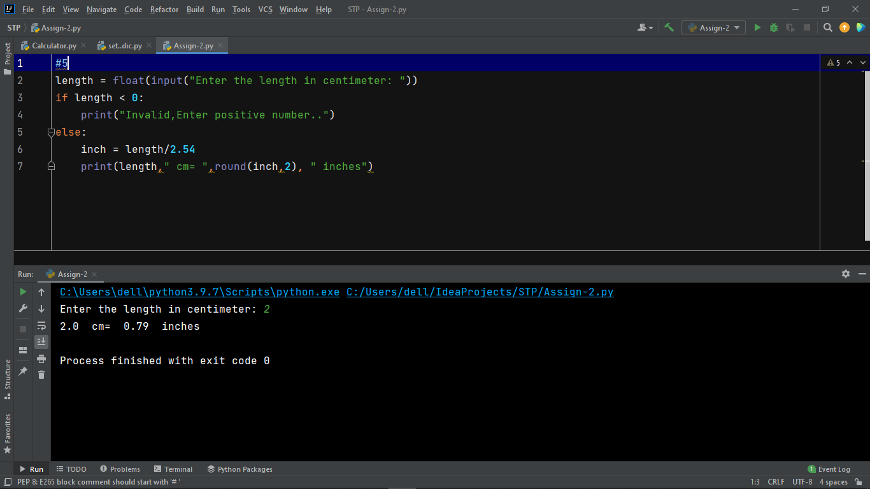

5. Ask the user for a temperature. Then ask them what units, Celsius or Fahrenheit,

the temperature is in. Your program should convert the temperature to the other

unit. The conversions are F = 9/5C + 32 and C = 5/9 (F-32).

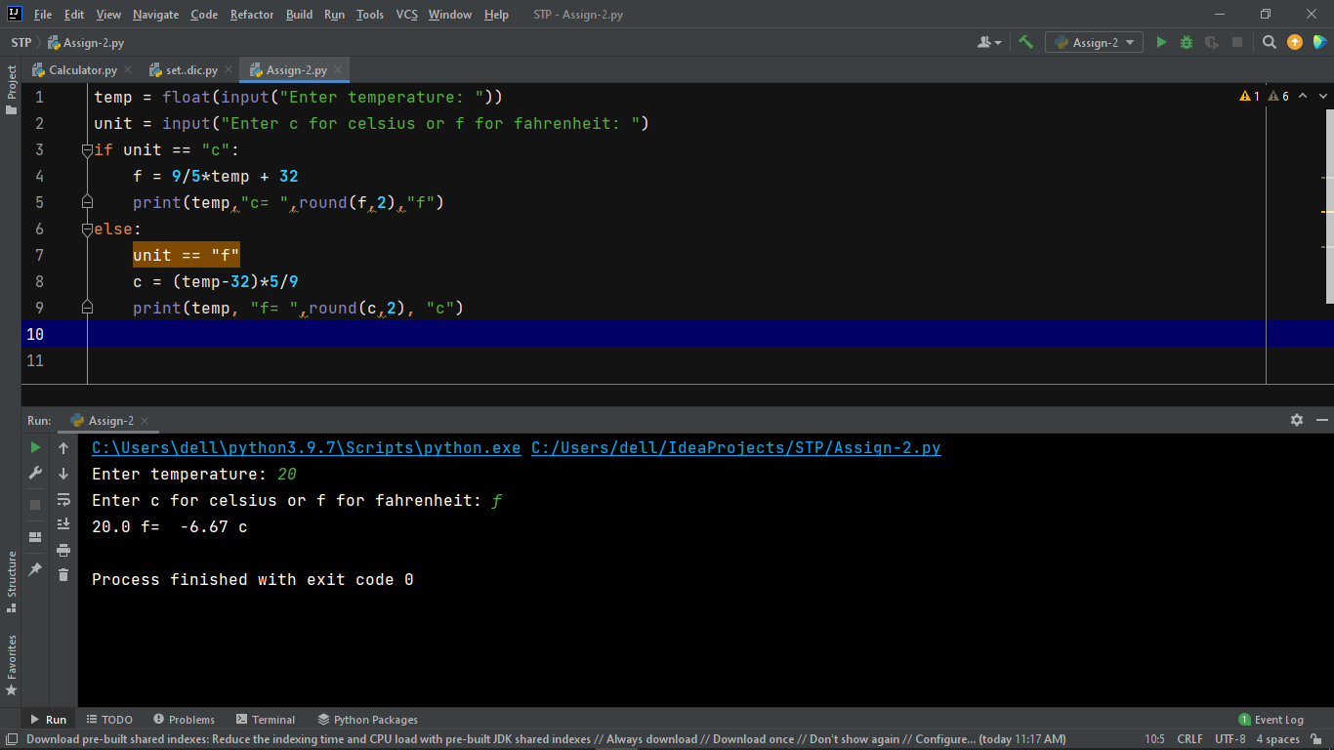

6. Write a program that generates and prints 50 random integers, each between 3

and 6.

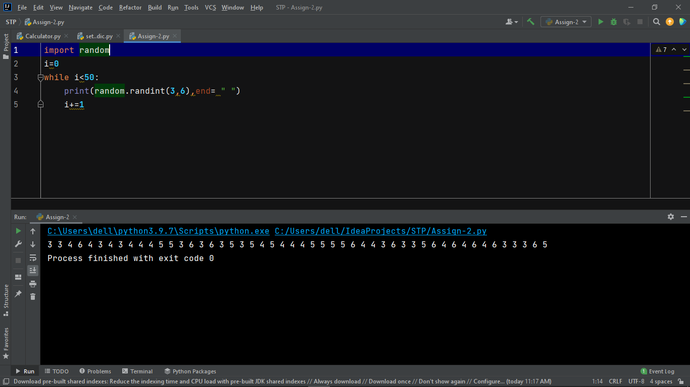

7. Create a tuple and perform the following methods

1) Add items 2) len() 3) check for item in tuple 4)Access items

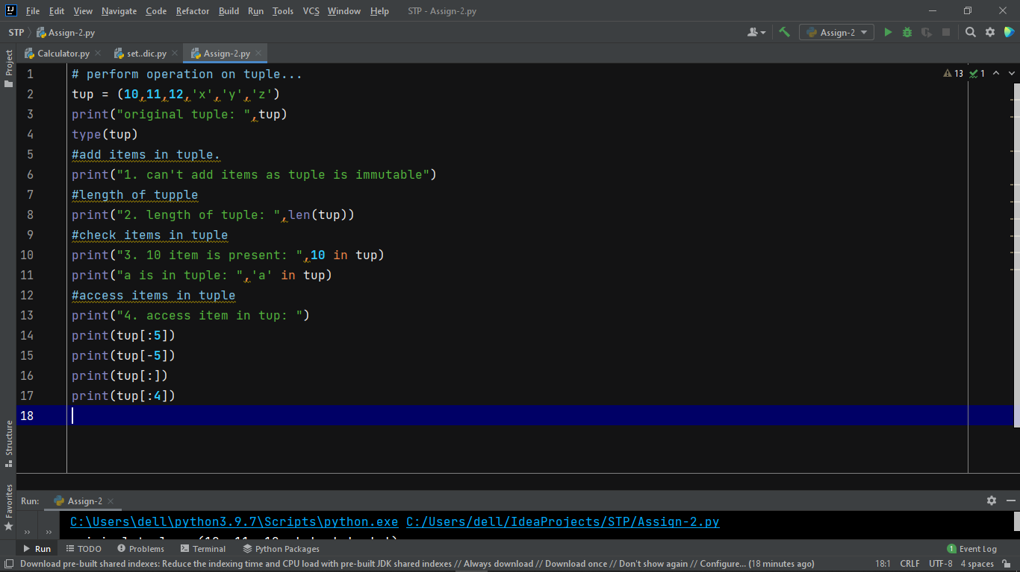

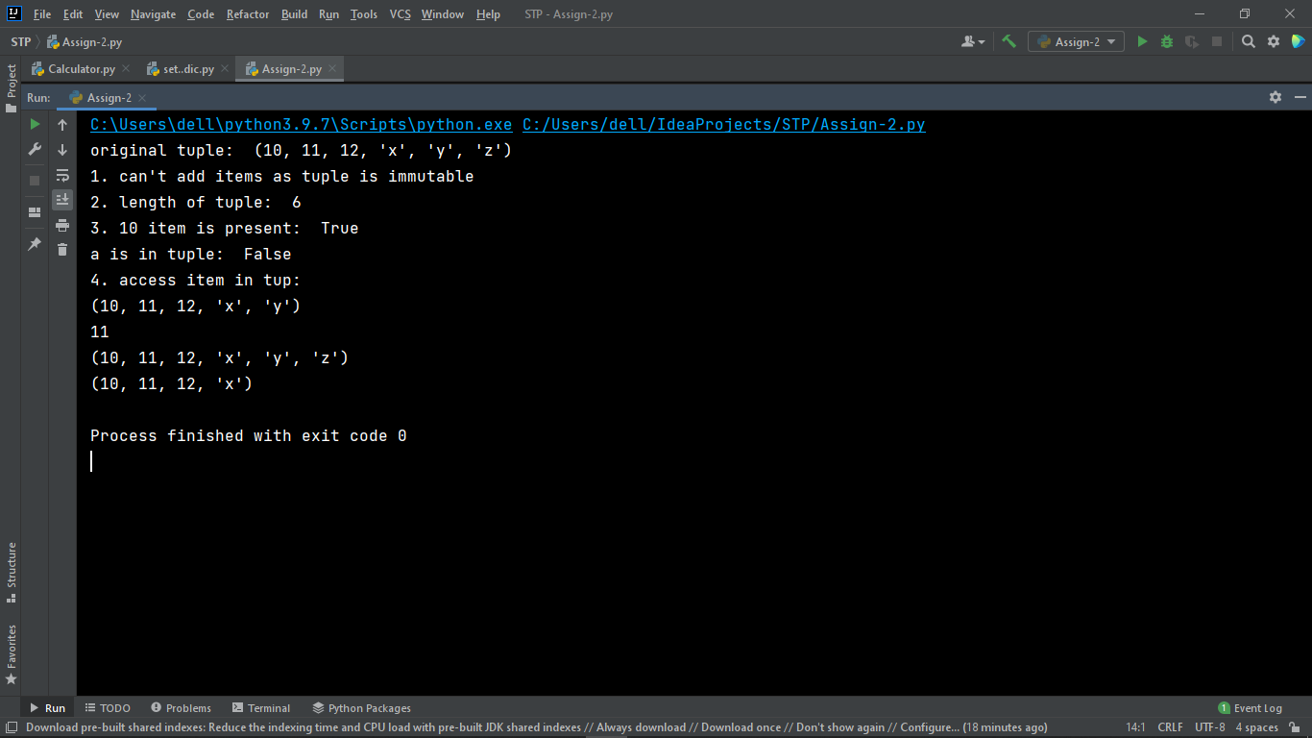

8. Create a dictionary and apply the following methods

1) Print the dictionary items 2) access items 3)use get() 4)change values 5) use

len()

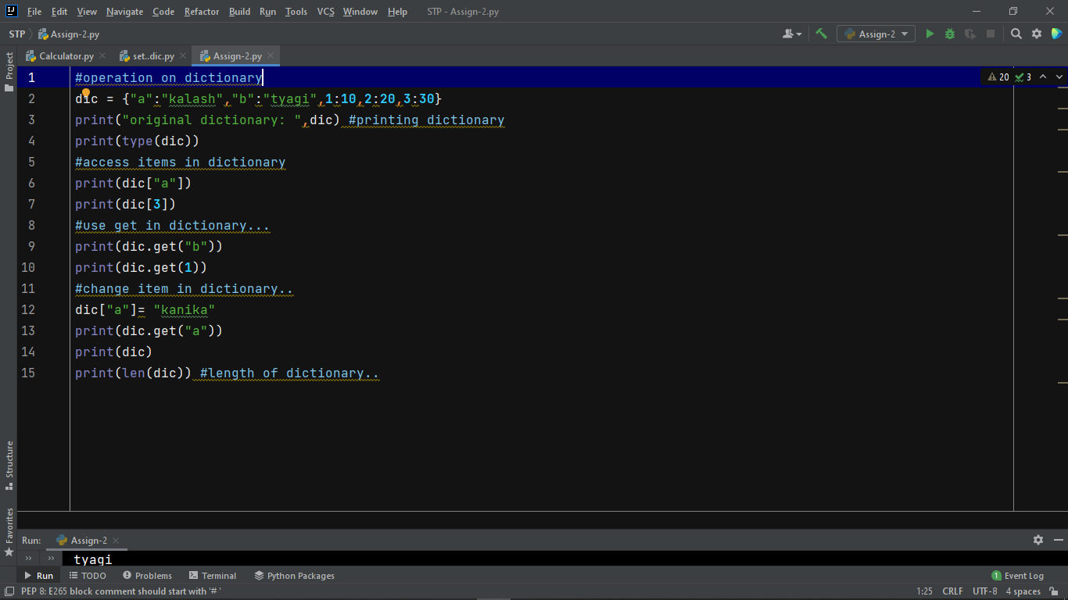

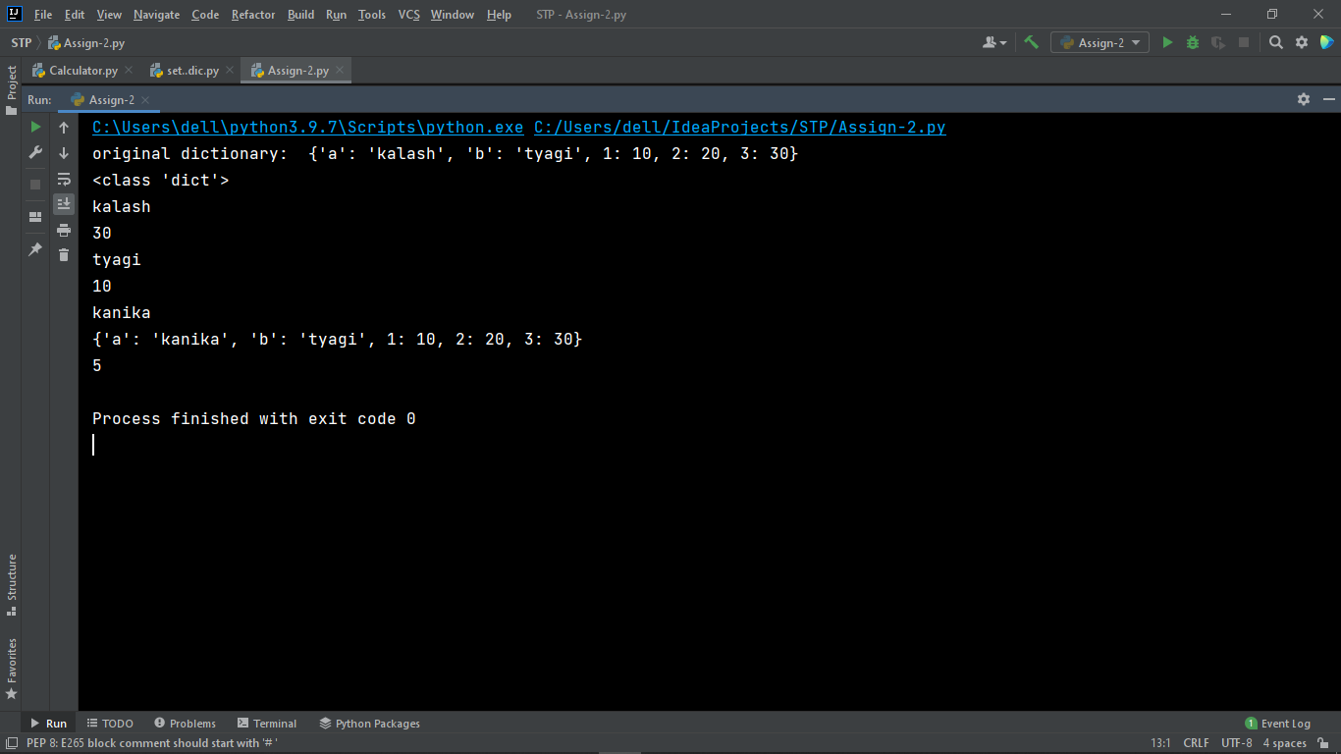

9. Write a python program to construct the following pattern using nested for loop:

*

**

***

****

*****

*****

****

***

**

*

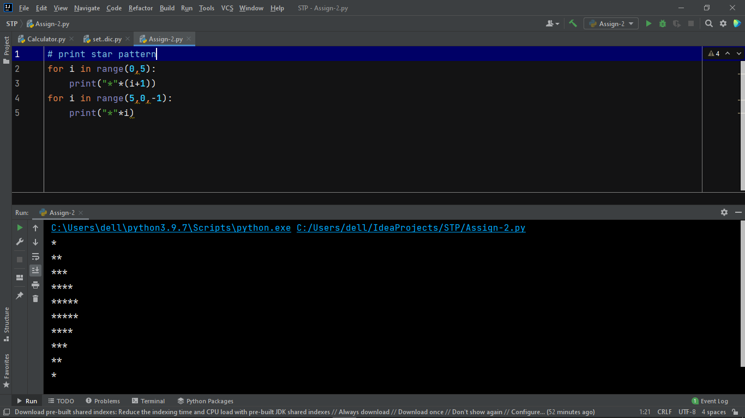

10. Write a python program to convert temperature to and from Celsius to

Fahrenheit.

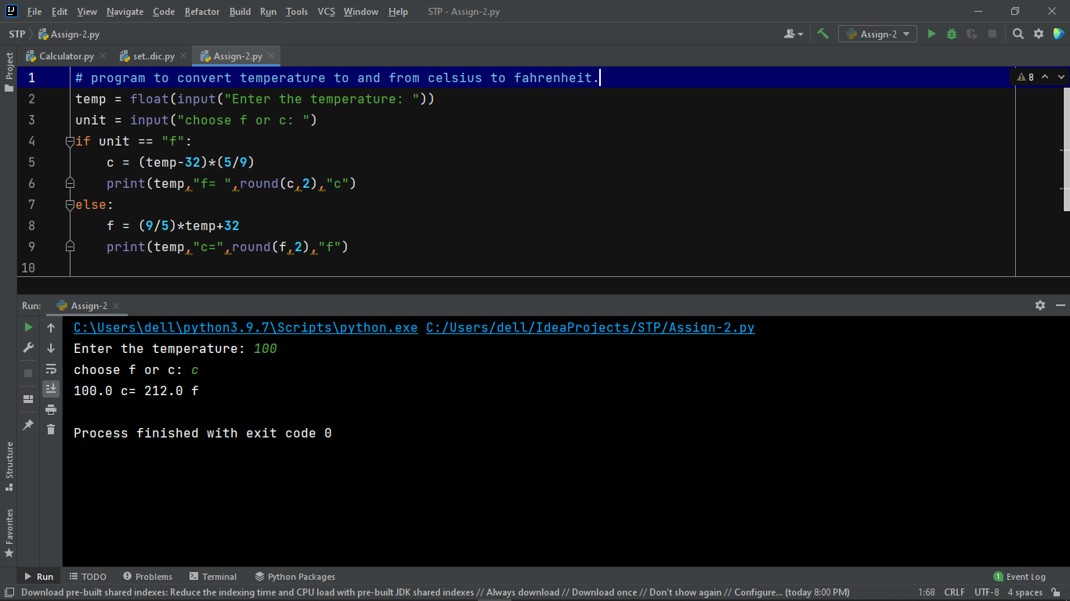

11. Write a python program to that accepts length of three sides of a triangle as

inputs. The program should indicate whether or not the triangle is a right angled

triangle (use Pythagorean theorem):

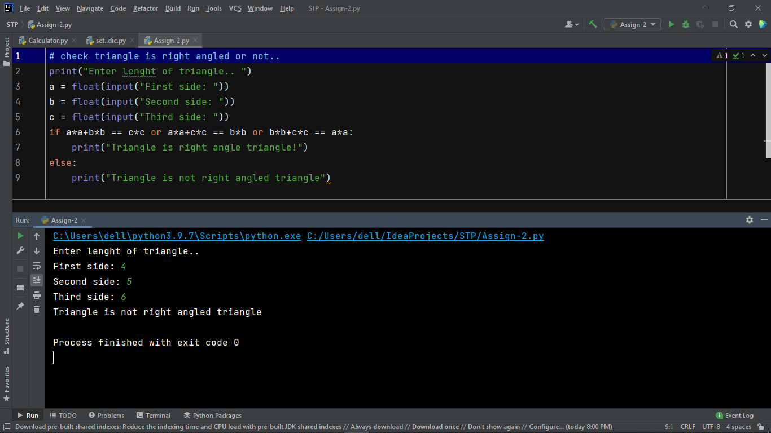

12. Write a program using a while loop that asks the user for a number, and prints a

countdown from that number to zero.

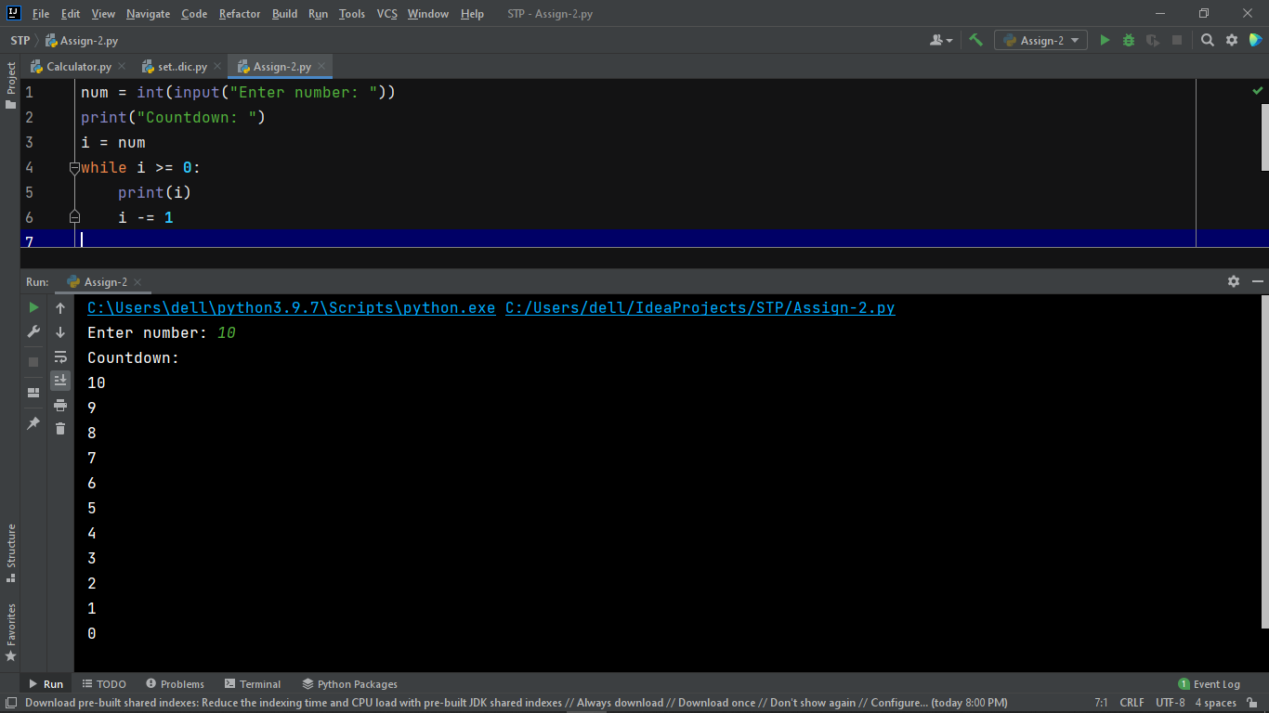

13. Write a program that uses a for loop to print the numbers 100, 98, 96, . . . , 4, 2.

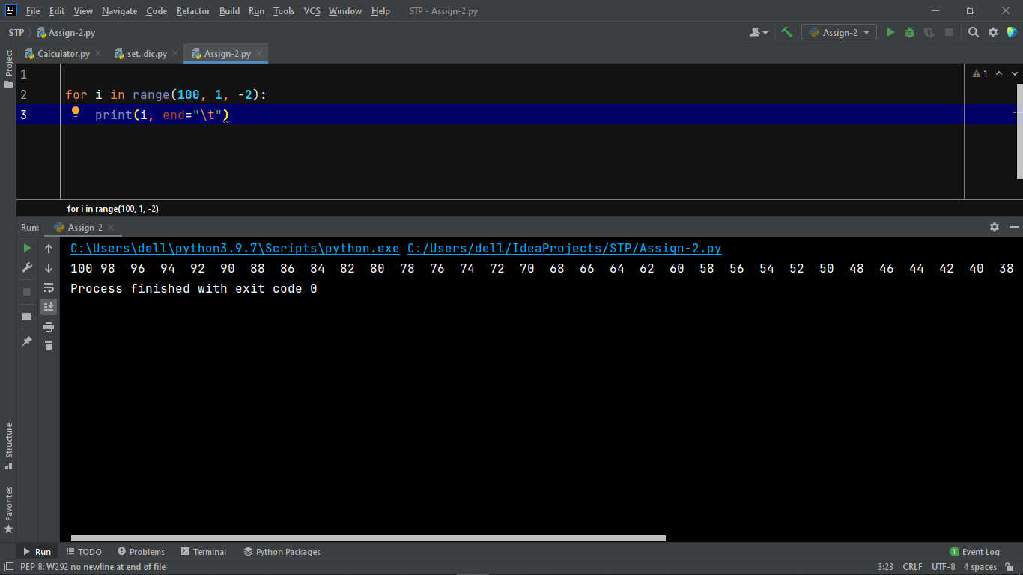

14. Write a function called factors that takes an integer and returns a list of its

factors.

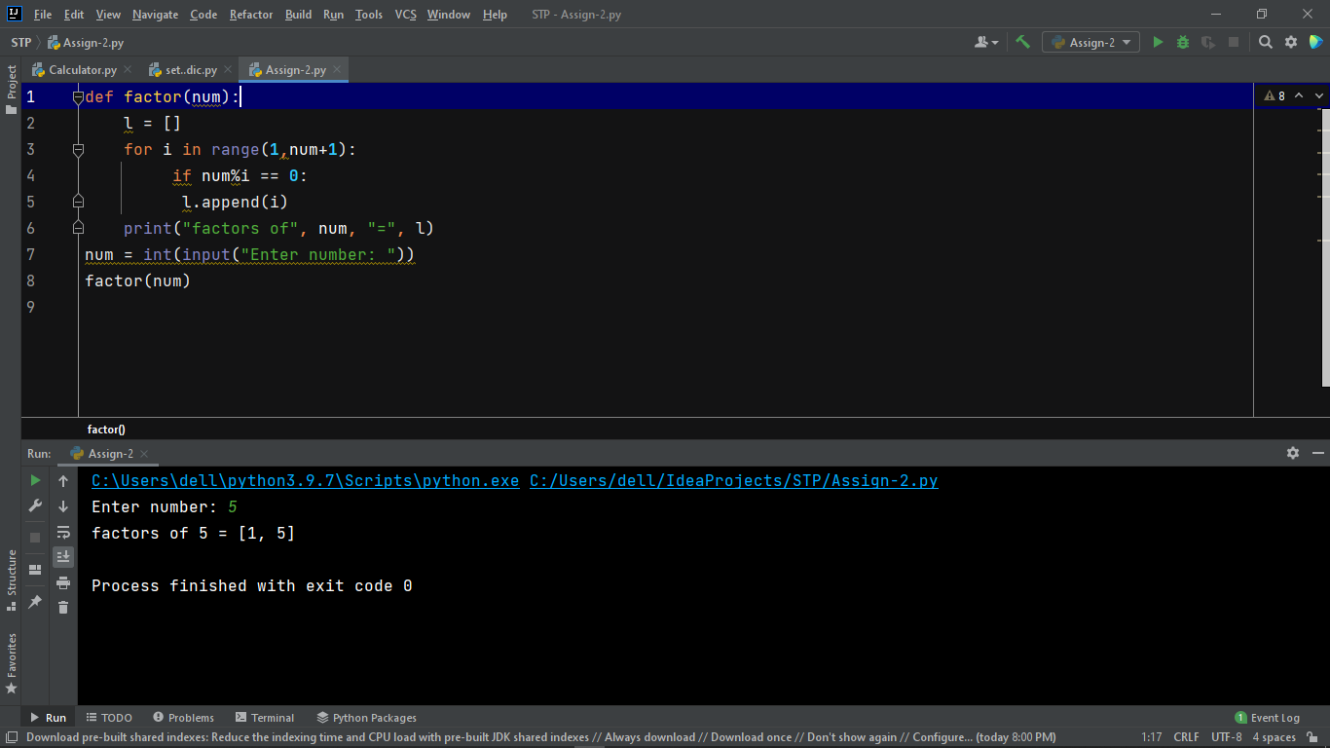

15. Write a function called change_case that given a string, returns a string with

each upper case letter replaced by a lower case letter and vice-versa.

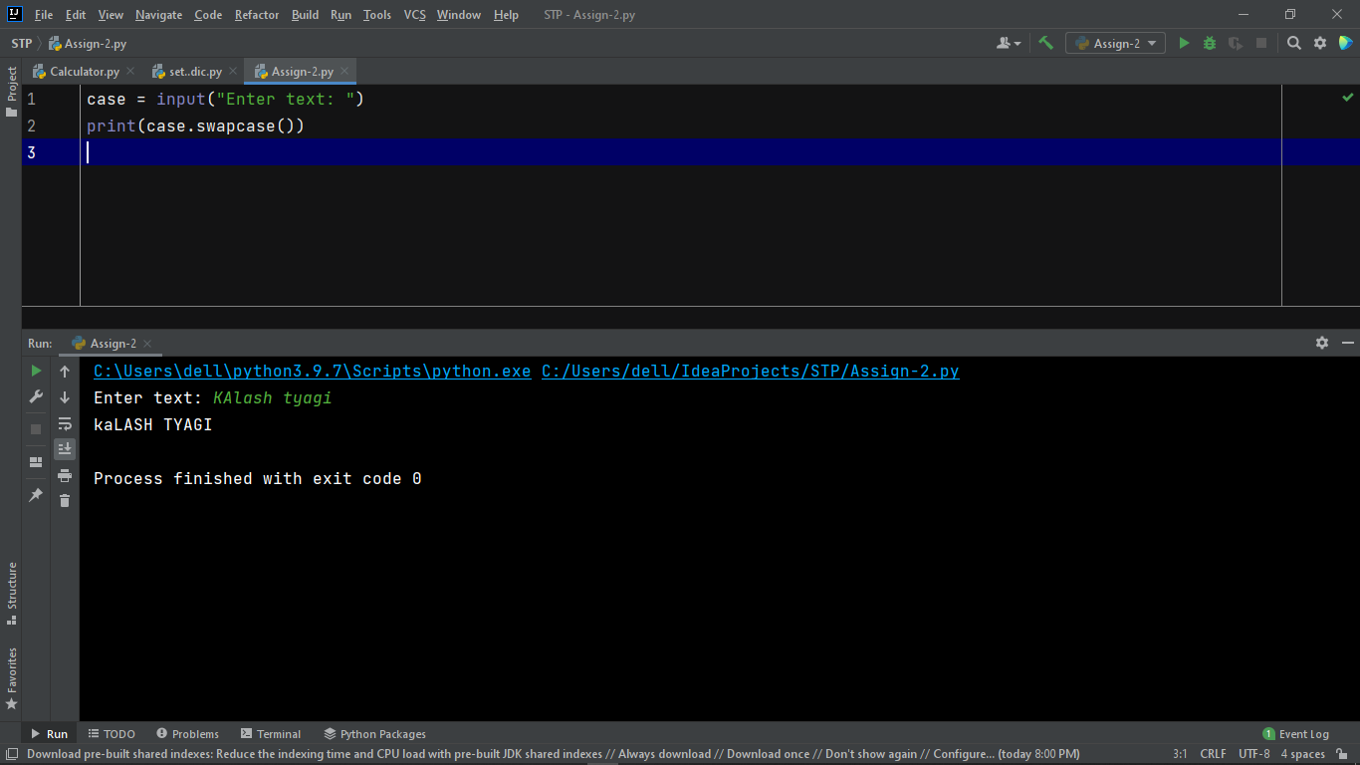

16. Write a program that has a list of ten words, some of which have repeated letters

and some which don’t. Write a program that picks a random word from the list that

does not have any repeated letters.

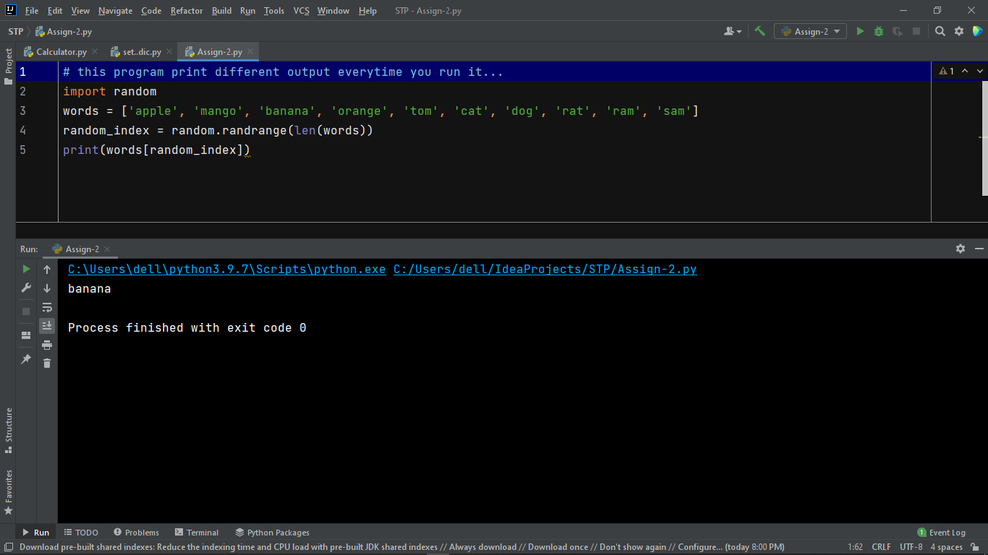

17. Ask the user to enter a temperature in Celsius. The program should print a

message based on the temperature:

• If the temperature is less than -273.15, print that the temperature is invalid

because it is below absolute zero.

• If it is exactly -273.15, print that the temperature is absolute 0.

• If the temperature is between -273.15 and 0, print that the temperature is below

freezing.

• If it is 0, print that the temperature is at the freezing point.

• If it is between 0 and 100, print that the temperature is in the normal range.

• If it is 100, print that the temperature is at the boiling point.

• If it is above 100, print that the temperature is above the boiling point.

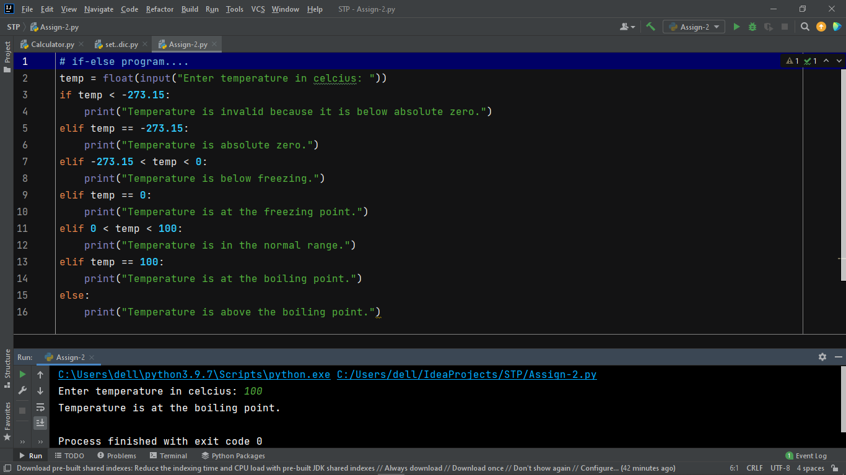

18. Write a program that prints a giant letter A like the one below. Allow the user

to specify how large the letter should be.

*

* *

* * * * *

* *

