Simple Task Manager
1.0

Software Requirements Specification

12.08.2015

Team Recommen

Team members

Cvetelina Koleva, Petya Hristova, Kaloian Mateev, Elizabeth Dimitrova, Ismail Ismail.
Table of Contents

Document Approval i
1. Introduction 1
1.1 Purpose 1
1.3 Definitions, Acronyms, and Abbreviations 1
1.4 References 1
1.5 Overview 2
The remainder of this document includes three chapters. In the second one is described what functions the application will provide in the first release and what improvements will be in the second release. What kind of users will use the STM and system interaction with other systems. 2
2. General Description 2
2.1 Product Perspective 2
2.2 Product Functions 2
2.3 User Characteristics 2
2.4 General Constraints 3
The Internet connection is a constraint for the site. Since the site fetches data from the database over the internet, it is crucial that there is an Internet connection for the site to function. 3
Тhe quality of the web browser is also important for the system to work correctly. 3
2.5 Assumptions and Dependencies 3
3. Specific Requirement 3
3.1 External User Interface Requirements 3
3.2 Functional Requirements 10
3.5 Non-Functional Requirements 14
3.5.1 Performance 14
3.5.2 Reliability 14
3.5.3 Availability 14
3.5.4 Security 15
3.5.5 Maintainability 15
3.5.6 Portability 15
3.6 Inverse Requirements 15
3.7 Design Constraints 16
3.8 Logical Database Requirements 16
3.9 Other Requirements 16
5. Change Management Process 16
6. Appendix

1. Introduction
This section gives a scope description and overview of everything included in this SRS document. Also, the purpose for this document is described and a list of abbreviations and definitions is provided.

Purpose
The purpose of this document is to describe the requirements for the Simple Task Manager (STM) software. This document will explain the system’s functionality, interface and interaction with other external applications. Also in this document will be able to understand what is impl emented. This document is primarily intended to reference for developing the first version of the system for the development team and to test analysis for the test team.

  - Scope

Simple Task Manager is free web site who helps people to organize their time. Users can record their tasks online and check it when they need it from their laptop, tablet or smart phone.
Users can delete the tasks one by one by the time they are finished with it or they can delete all the tasks.

To interact with the system device used by the user should have internet connection.
All system information is maintained in a database, which is located on a web-server.

1.3 Definitions, Acronyms, and Abbreviations
STM | Simple Task Manager
User | Someone who interact with the STM web site.
Database | An organized collection of data.
Web-server | An information technology that processes requests via HTTP .
.

1.4 References

There are no references.

1.5 Overview

The remainder of this document includes three chapters. In the second one is described what functions the application will provide in the first release and what improvements will be in the second release. What kind of users will use the STM and system interaction with other systems.
In third chapter is provide the requirements specification in detailed terms and a description of the different system interfaces. Different specification techniques are used in order to specify the requirements more precisely for different audiences.

In the last chapter is explained how the team create this document.

2. General Description
This chapter give us overview of the system. Will be introduce the basic functionality of the Simple Task Manager, how it interacts with other systems and the constraints and assumptions for the system.

2.1 Product Perspective
Simple Task Manager will be a web site. To interact whit it user should have a simple browser on his device and internet connection.
To store the data from the user account will be used database. It won’t have restriction for the number of created tasks. All of the database communication will go over the internet.

2.2 Product Functions
With Simple Task Manager users will be able to organize their time . In STM 1.0 users can add and remove finished task or all of them. To set time and date for each task.
In future 1.1 users will be able to set place, end date and time and priority for each task . Also in 1.1 user can sort all the tasks by day , place and priority.
In the next release existing user will be able to change his password and edit his entire profile – adding an avatar, change user name and mail. Furthermore, the user will be able to choose wallpaper for backend from existing gallery in the site or they can add several.
In case of forgotten password the system also will generate a new one.

2.3 User Characteristics
There is only one type of user that interact whit the system .
It will not be necessary for user to have special education to use STM.

2.4 General Constraints

The Internet connection is a constraint for the site. Since the site fetches data from the database over the internet, it is crucial that there is an Internet connection for the site to function.

Тhe quality of the web browser is also important for the system to work correctly.

2.5 Assumptions and Dependencies
This subsection of the SRS should list each of the factors that affect the requirements stated in the SRS. These factors are not design constraints on the software but are, rather, any changes to them that can affect the requirements in the SRS. For example, an assumption might be that a specific operating system will be available on the hardware designated for the software product. If, in fact, the operating system is not available, the SRS would then have to change accordingly.

3. Specific Requirement
This section contains all of the functional and quality requirements of the system. It gives a detailed description of the system and all its features.

3.1 External User Interface Requirements
The following section provides the prototypes of all basic user interfaces.

When the user accesses our Simple Task Manager the following main page should be opened with a Sign in form on it.

Screenshot 1 – Main page
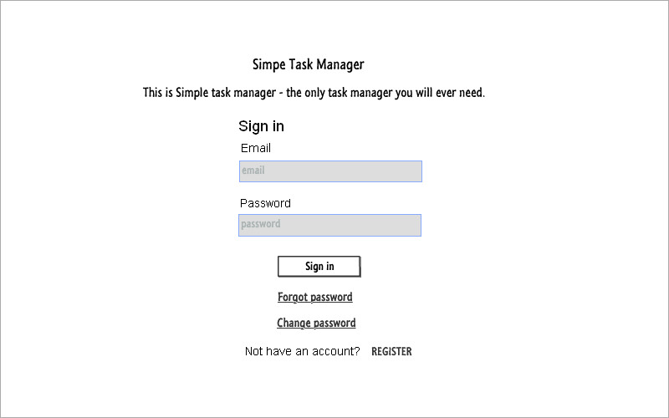

If the user has already an account in our Task manager he should be able to see his Personal Task’s page after signing in with his email and password in the Sign in form.

Screenshot 2 –Personal Task Page

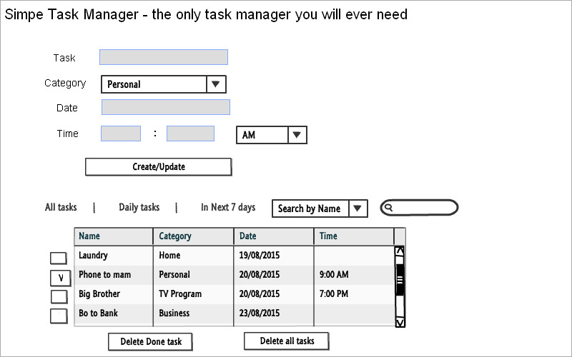

If the user has an account in our application, but he forgot his password he should be able to receive a new password through going on “Forgot password” link. The following Forgot password window will open:

Screenshot 3 – Forgot Password
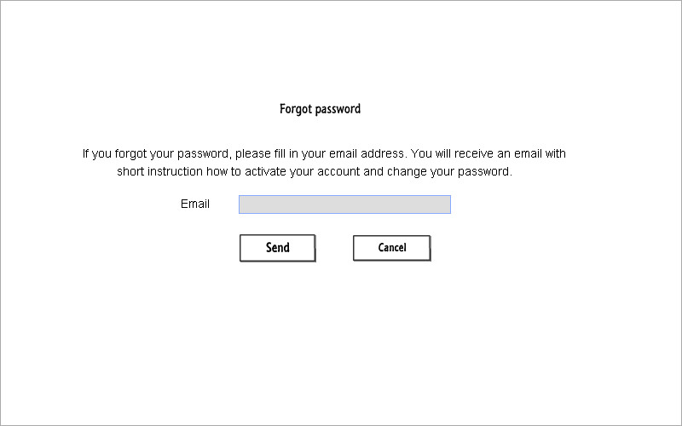

If the user clicks on the “Cancel” button, “Forgot password” window will close and the user will be transferred to the main page.

If the user clicks on the “Send” button and the “Send” process is successful, then over the “Forgot password” window the following notification message “The email is successfully sent. Please open your mail account to read it” will appear with a ‘Close’ option. When the user clicks on “Close” option of the message, the “Forgot password” window will close and the user will be transferred to the main page.

If the user clicks on Send button, he will receive an email in his mail account with subject: “<Simple Task Manager> Forgot Password” and content:

Screenshot 4 – The email for Forgot password
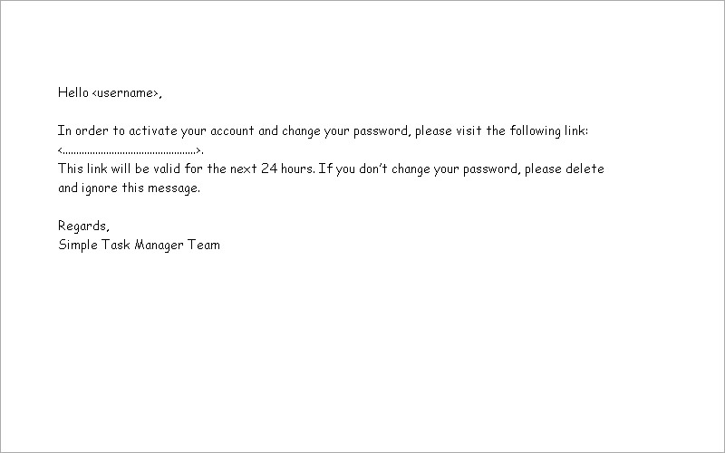

When the user opens the email and clicks for the first time over the link in it, the following Change password window (first version) should be opened:

Screenshot 5 – Change password (version 1)
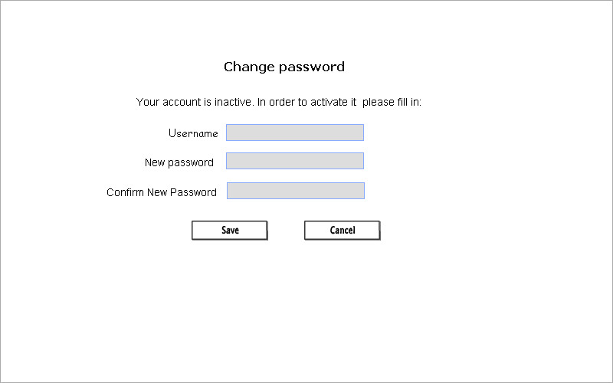

If the user clicks on the “Cancel” button, “Change password” window will close and the user will be transferred to the main page.

If the user clicks on the “Save” button and the “Save” process is successful, then over the “Change password” window the following notification message “Your password is successfully changed” will appear with a ‘Close’ option. When the user clicks on “Close” option of the message, the “Change password” window will close and the user will be transferred to the main page.

If the user has an account in our application, but he wants to change his password, he should be able to do it through going on “Change password” link. The following Change password window (second version) will open:

Screenshot 6 – Change password (version 2)
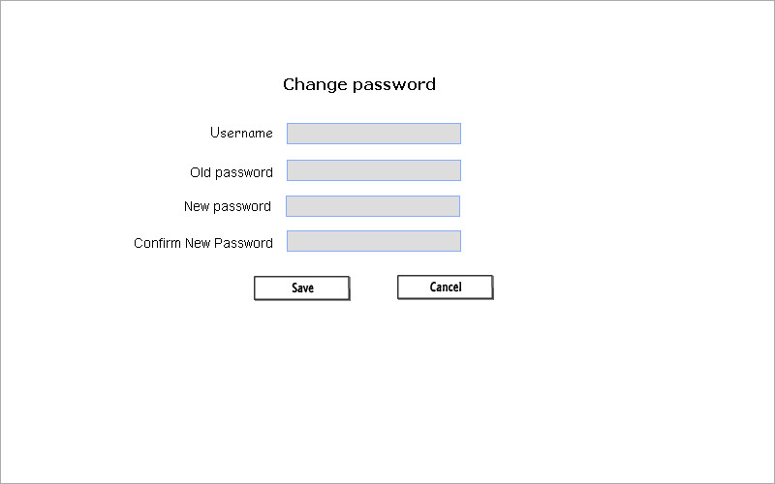

If the user doesn’t have an account in the Simple Task Manager, he should be able to register through filling in the following Registration form:

Screenshot 7 – Registration Form
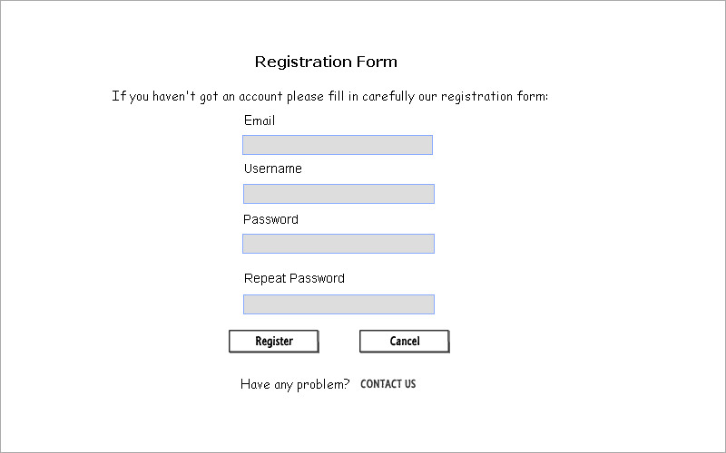

If the registration is successful, then the user should be transferred to his Personal Task’s page, which at the beginning is empty.

Screenshot 8 – Empty Personal Task Page

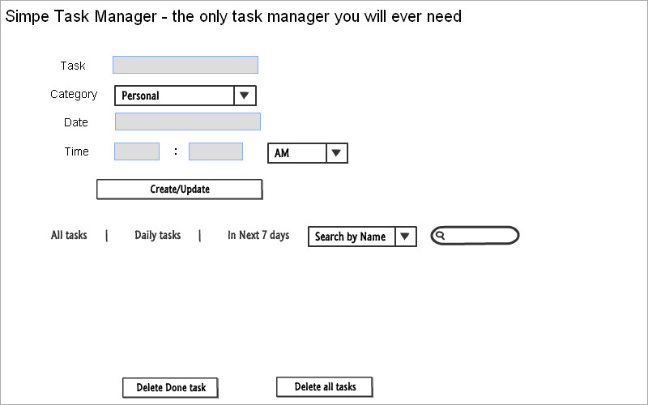

If the user has any problem he should be able to contact us through the following Contact form:

Screenshot 9 – Contact form
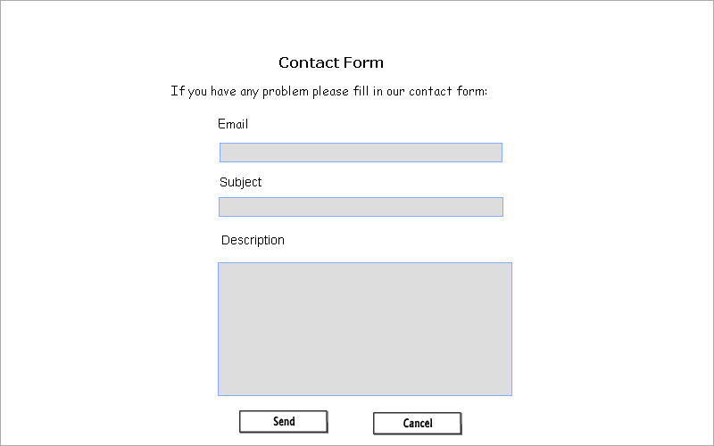

3.2 Functional Requirements
This section includes the requirements that specify all the fundamental actions of our Simple Task Manager application.

3.2.1. Login functionality

Use Case Name | 01. Log in
Ref | ----
Description | How a user logs into the Simple Task Manager
Pre-condition | The user has a registration in the Simple Task Manager and he is on the Log in form
Basic Flow Actions for success Log in the Simple Task Manager | 1. The username and the password are required fields in the Login form and application requests the user to fill in them.  2. The User enters correctly his username and password.  3. After our application validates them as an existing combination of username and password, then the User is logged successfully in our Simple Task Manager.
Alternative Flow for Log in failure when not all the mandatory fields are filled in | 1. If on Step 2 the user doesn’t fill in his password or username then the login fails.  A descriptive error message appears with the reason for the login failure and the application urges the user to fill in the empty required field via positioning the cursor inside it.  If the both required fields are empty then the cursor is positioned inside the first empty required field, which in our Login form is the “Username” field.
Alternative Steps Flow for Login failure when the username is invalid | If on Step 2 the user fills in invalid username, then the login fails. A descriptive error message appears with the reason for the login failure and application urges the user to update his username via positioning the cursor inside the username field as the content of the field is not deleted.
Alternative Flow for Login failure when the password is wrong | If on Step 2 the user fills in invalid password, the login fails.  A descriptive error message appears with the reason for the login failure and the application urges the user to re-enter his password again via positioning the cursor inside the password field as the content of the field is deleted.  If the user re-enters again invalid password then the application advices the user to go on Forgot password option, because if he enters three times consecutively incorrect password then his account will lock and he has to go on Contact form.
Post-condition | If the Log in process passes successfully then the User is transferred to his Personal Task page.  Otherwise if the Log in process fails then the User is on the Log in form and he is not allowed accessing his personal Task page.

3.2.2. Registration form

Use Case Name | 02. Registration
Ref | ----
Description | How a user create an account(registration) in the Simple Task Manager
Pre-condition | The user doesn’t have a registration in the Simple Task Manager. In order to create an account he has to go on Register option and to fill in correctly our Registration form.
Success Basic Flow | 1. The User enters correctly all account details – enter his username, an existing email address, a password, and then confirms properly his password.  2. Accept the Term and Condition how to use our Simple Task Manager.  3. The User clicks the “Submit” button.  4. After the user going on Submit button, the application makes here consecutively the following list of verifications:  - if all the mandatory fields are filled in  - if the entered username is not busy  - if the entered email address is in a valid email format  - if the email address is not available in our database  - if the password is in a valid password format  - if the password is properly confirmed  - if the checkbox “Accept our Term and Condition” is ticked.  5. If all verifications pass successfully the Registration is successful and the user accesses his personal Task page.
Alternative Flow for Registration failure when not all the mandatory fields are fill in | If on Step 1 the user doesn’t fill in all mandatory fields, then the Registration fails.  A descriptive error message appears with the reason for the registration failure and the application urges the user to fill in the empty required field via positioning the cursor inside it.  If more than one required fields are empty then the cursor is positioned inside the first empty required field, which in our Registration form is the “Email” field.
Alternative Flow for Registration failure when the username is busy | If on Step 1 the user fills in a username, which is busy, then the Registration fails.  A descriptive error message appears with the reason for the Registration failure and application urges the user to update his username via positioning the cursor inside the username field as the content of the field is not deleted.
Alternative Flow for Registration Failure when the email address is already available | 1. If on Step 1 the user fills in an email address, which is already available in our database, then the Registration fails.  A descriptive error message appears: “There is already a registration with this email. Please make sure that your address is correct”. The user has two options here – to update his email address or try to remember his password and then log into the Simple Task Manager.  1a. If the user entered invalid email address he can change it and continue with his registration.  1b. If the user email address is correct – the User has here two options – to remember his password or go on Forgot password option.
Alternative Flow for Registration Failure when the entered email address is in invalid email format* (the email restrictions are listed below this use case) | If on Step 1 the user fills in an email address in invalid format, the Registration fails.  A descriptive error message appears with the reason for the Registration failure and the application urges the user to enter a valid email address.
Alternative Flow for Login failure when the password is in invalid password format* (the password restrictions are listed below this use case) | If on Step 1 the user fills in a password in invalid format, the Registration fails.  A descriptive error message appears with the reason for the Registration failure and the application urges the user to enter a new password in the correct password format.
Alternative Flow for Login failure when the password is not properly confirmed | If on Step 1 the User fills in a password in “Confirm password” field which differs from the password in the “Password” field, then the Registration fails.  A descriptive error message appears with the reason for Registration failure. The application urges the user to repeat his password again via positioning the cursor inside the “Confirm password” field as the content of the “Confirm password” field is deleted.
Alternative Flow for Login failure when the User is not accepted our Term and Condition | If on Step 1 the User is not accepted our Term and Condition how to use our application, then the Registration fails.  The following error message appears “Please accept our Term and Condition for using the Simple Task Manager”.
Post-condition | If the Registration process passes successfully then  1. the User is transferred to his Personal Task Page, where he can start to create, update, delete his daily tasks.  2. the User’s data, entered from the Registration Form, are stored in the App Database (this can be check by a tester, who has access to the Simple Task Manager database).  3. the User has an account, which can be used for logging in the Simple Task manager from the Log in page.  If the registration process fails then the user is on the Registration form and the application urges him to update his account details accurately.

*There are some restrictions for the User’s email address and his password. And the registration fails if the entered email address, respectively the password, doesn’t satisfy them.

The password restrictions are:
- Password length is between 6 and 10 characters;
- Cannot contain empty symbols;
- Cannot start with specific symbols, e.g. it always has to start with a letter or digit;
- Must contain at least one uppercase letter, at least one lowercase letter and at least one numeric character

If one password satisfies all these constraints, it’s accepted as valid. Otherwise it’s invalid.
If our application determines one password as invalid, then this password is removed from the field, where it was entered, and the application urges the user to re-enter it again via positioning the cursor inside this field.

The email restrictions are:
- The email address is with length at least 6 characters;
- The email must contain exactly one time the symbol “@”
- Only Latin letters are acceptable (A-Z, a-z)
- The digits are allowed
- The dot character ‘.’ is allowed, but it cannot be first or last symbol in the local part or in the domain part, also the presence of two or more times consecutively is not allowed (e.g. John..Doe@example.com is invalid email format).

If one email address satisfies all these constraints, it’s accepted as valid. Otherwise it’s invalid.
If our application determines one email address as invalid, then the application urges the user to update it again via positioning the cursor inside this field as the content of the email field is not deleted.

The table with examples for valid and invalid email addresses and these examples cover the most commonly used email addresses. So we have to support them.

Valid email address | Explanation
email@domain.com | Standard email address
firstname.lastname@domain.com | Presence of dot in local part of the email address is acceptable as valid
Firstname_lastname@domain.com | Presence of underscore in the local part of the email address is acceptable as valid
Firstname-lastname@domain.com | Presence of dash in local part of the email address is acceptable as valid
1234567890@domain.com | Digits in the local part of the email address are acceptable as valid
email@domain-one.com | Dash in domain part of the email address is acceptable as valid
email@subdomain.domain.com | Email contain dot with sub-domain
email@123.123.123.123 | Domain of valid IP address is also acceptable as valid
email@domain.co.jp | Dot in Top Level Domain name is also considered as valid (use co.jp as example here)

Invalid email address | Explanation
Exampe | Missing sign @ and domain
@domain.com | Missing local part of the email address
email.domain.com | Missing @
first@last@domain.com | Two signs @ (more than one is not allowed)
first@domain | Missing top level domain (such as .org, .com, etc.)
.email@domain.com  email.@domain.com  first..last@domain.com | Dot as first or last character in the local and domain part is not allowed, also is not allowed the presence of two or more dots consecutively

3.5 Non-Functional Requirements

3.5.1 Performance
The system must be interactive and the delays involved must be less . The response time must be less than 2 seconds. In case of popping error messages and saving tasks there is delay much below 2 seconds, In case of sorting tasks and evaluation there are no delays and the operation is performed in less than 2 seconds for opening ,sorting > 95% of the files. Also when connecting to the server the delay is based editing on the distance of the 2 systems and the configuration between them so there is high probability that there will be or not a successful connection in less than 10 seconds for sake of good communication.

3.5.2 Reliability
As the system provide the right tools for discussion, problem solving it must be made sure that the system is reliable in its operations and for securing the sensitive details.

3.5.3 Availability

If the internet service gets disrupted while sending information to the server, the information can be send again for verification.

3.5.4 Security
-Information transmission should be securely transmitted to server without any changes in information.
- Anti-web robot check should be passed before user authentication.
- To access the account user should enter valid username and password.
- The text in password field should be invisible. After registration the user should confirmed on mail send by the system.
- Every time when the user try to log in from different device the system should send a warning mail for that action.

3.5.5 Maintainability
If the system crash it automatically should be repaired.

3.5.6 Portability

The web app should be opened from all existing web browsers across all existing devices.

3.6 Inverse Requirements
The web application’s disallowed behaviour consists of the following constraints:

- The application shouldn’t crash, which means that it shouldn’t be using a lot of memory to load, it shouldn’t be too slow and there shouldn’t be any bugs in the code, which will affect the execution of the application.
- The application shouldn’t be prone to known hacking attacks, such as SQL injections or any sort of malicious attack on the application itself, the server on which it is running or the user’s information in the database.
- There shouldn’t be any advertisements popping up in the application, but due to design constraints we will have this issue, until the official release of the application.
- The application shouldn’t consume have a huge size pages, which will affect the loading time of the website.
- The application shouldn’t have any bugs regarding its functionality such as log in the profile page of the user.
- There shouldn’t be any error messages when the user tries to register or log in or create, save or delete tasks.
- The user’s information shouldn’t appear in the URL as GET variables.

3.7 Design Constraints
Due to lack of funds for high quality paid server, our option was to use a free server in which we hosted our web application. The server has an advertising system, which is attached to the website therefore sometimes advertisements pop up when the user is using the website. The website is also using Javascript and jQuery for the profile.php for creating tasks. Our application cannot work properly after login if the Javascript is disabled, but that is why we have put noscript tag to alert the user to run on the Javascript. The reason why we use so much Javascript is because we have to create the tasks somehow and we create the html by Javascript. In addition there is no support of date input on some browsers and there is no support time.

The application must run on a hosting service in order to be used. In addition It should use a database, preferably MySQL, because it is easy to use in conjunction with php.
The disk usage shouldn’t be very big for the simple design of the application - less than 10MB. The bandwidth that our host provides is 100GB so that is the limit for the speed of our application.

3.8 Logical Database Requirements
Will a database be used? If so, what logical requirements exist for data formats, storage capabilities, data retention, data integrity, etc.

3.9 Other Requirements
Catchall section for any additional requirements.

4. Unit tests with jUnit and Selenium

We have made automation tests for repeated actions such as login and register and creating tasks. One part of the team coded the jUnit test and the other used Selenium in the browser. In the jUnit we have made tests for valid login, validRegister and some regression tests such as failed creating tasks.

5. Change Management Process
Every member of the developer or test team is going to have permission to change the file of SRS when project scope or requirements change. We are going to use repository on GitHub to update the documentation.

Release
The requirements are divided based on technical knowledge and priority. The first release will be based on the requirements that are implemented an build up the core functionality of the application. The second release, which should be final will contain the full functionality and met requirements.

6. Appendix

Internet sources
http://www.w3schools.com/html/html_form_input_types.asp
http://stackoverflow.com/questions/121203/how-to-detect-if-javascript-is-disabled
http://stackoverflow.com/questions/8655937/github-what-is-the-difference-between-readme-and-readme-md

https://en.wikipedia.org/wiki/README
https://en.wikipedia.org/wiki/Software_requirements_specification

Screenshots of the wireframe of the web application.

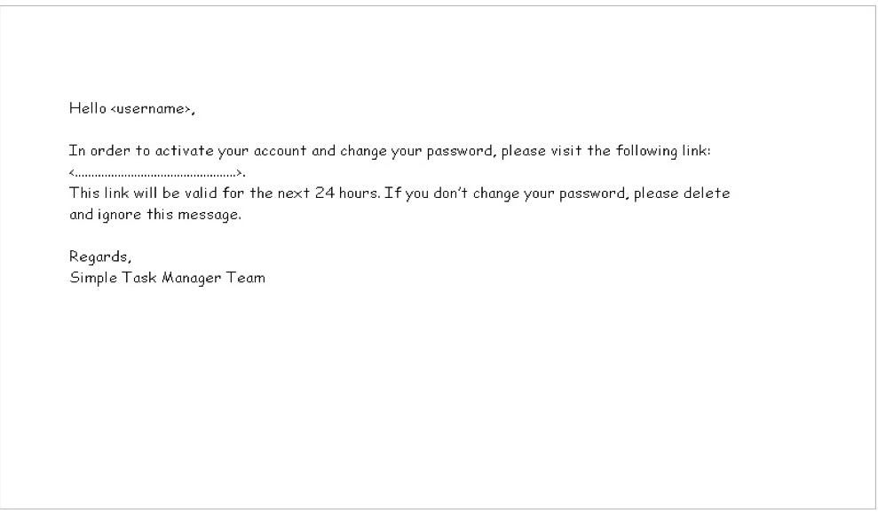
intro

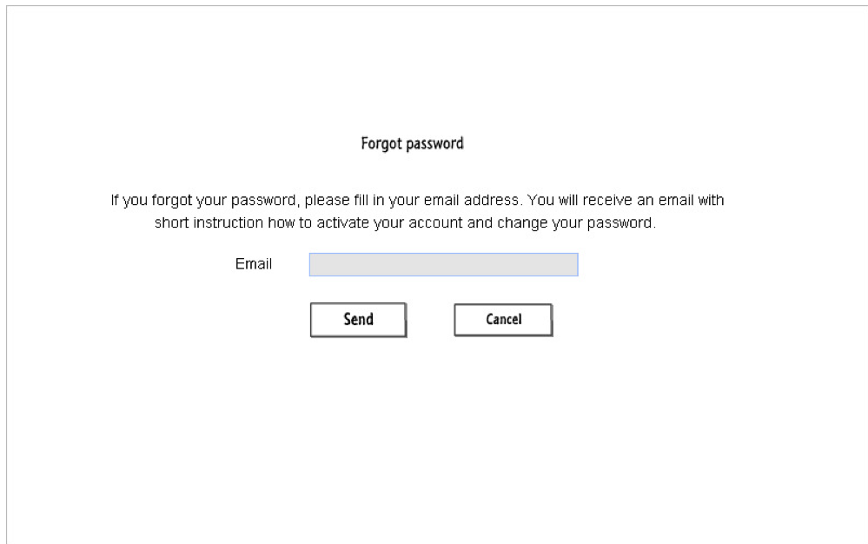

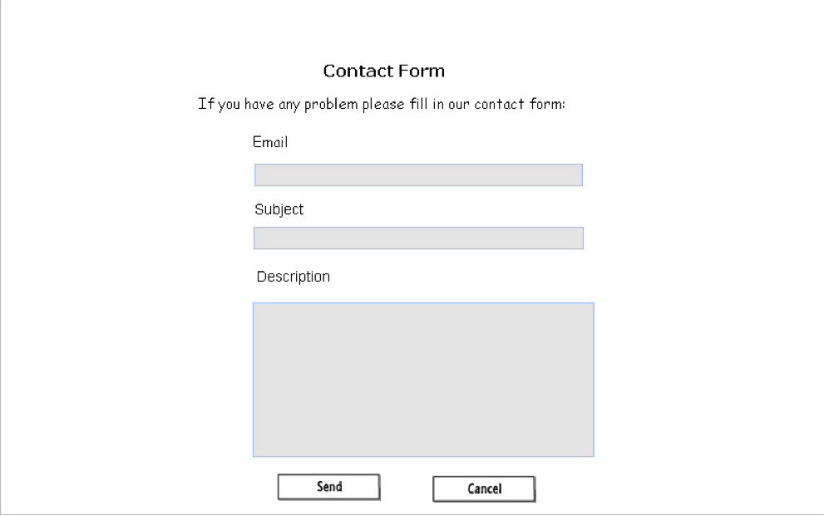

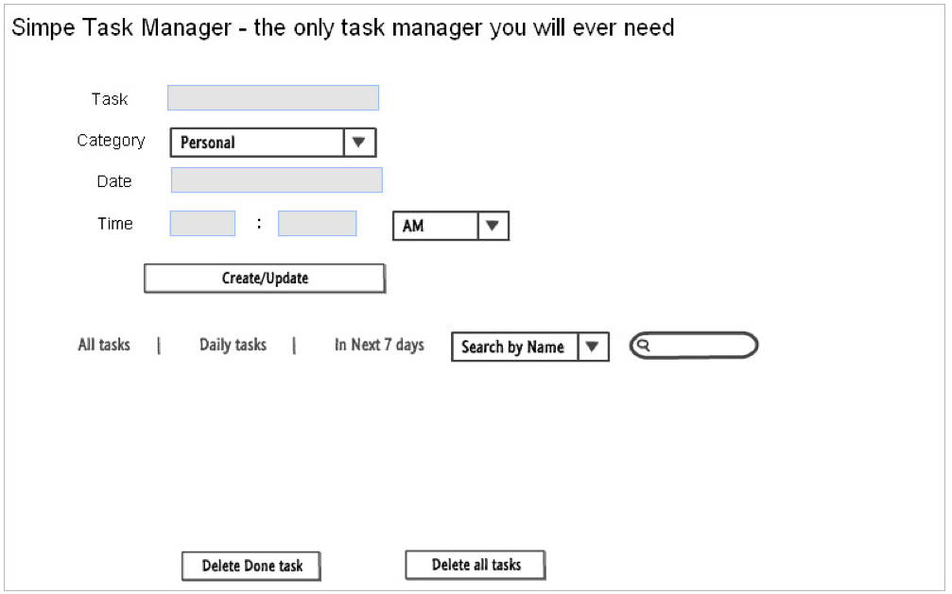
tasks
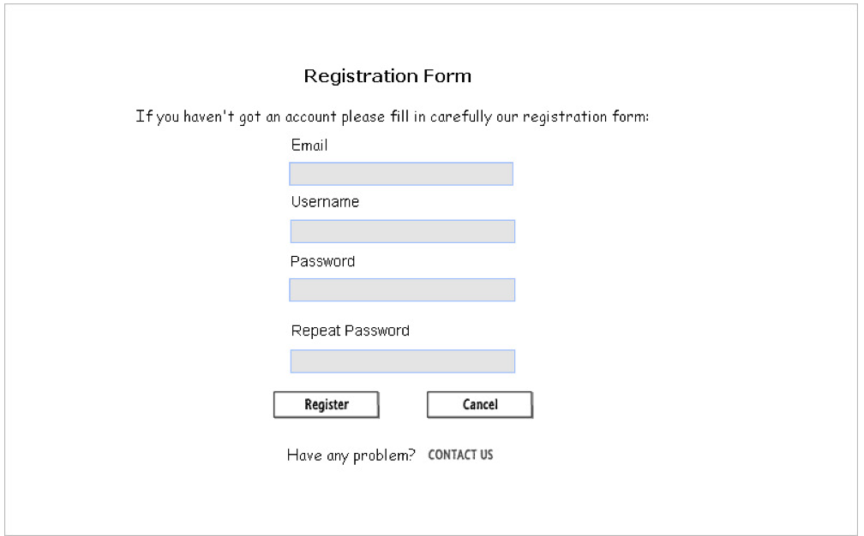
registration form in register_page.php

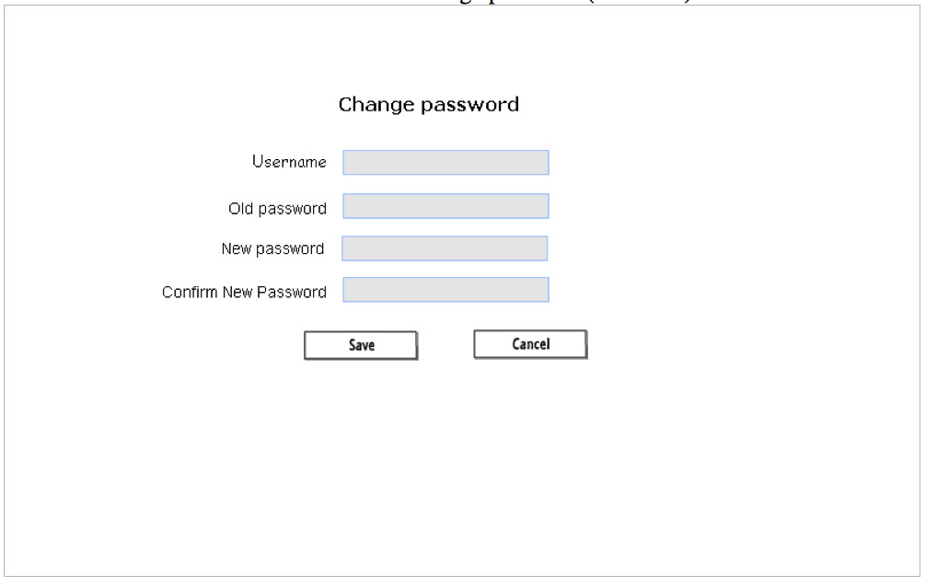
change password

