**ARTIFICIAL INTELLIGENCE**

**CREATE A CHATBOT USING PYTHON**

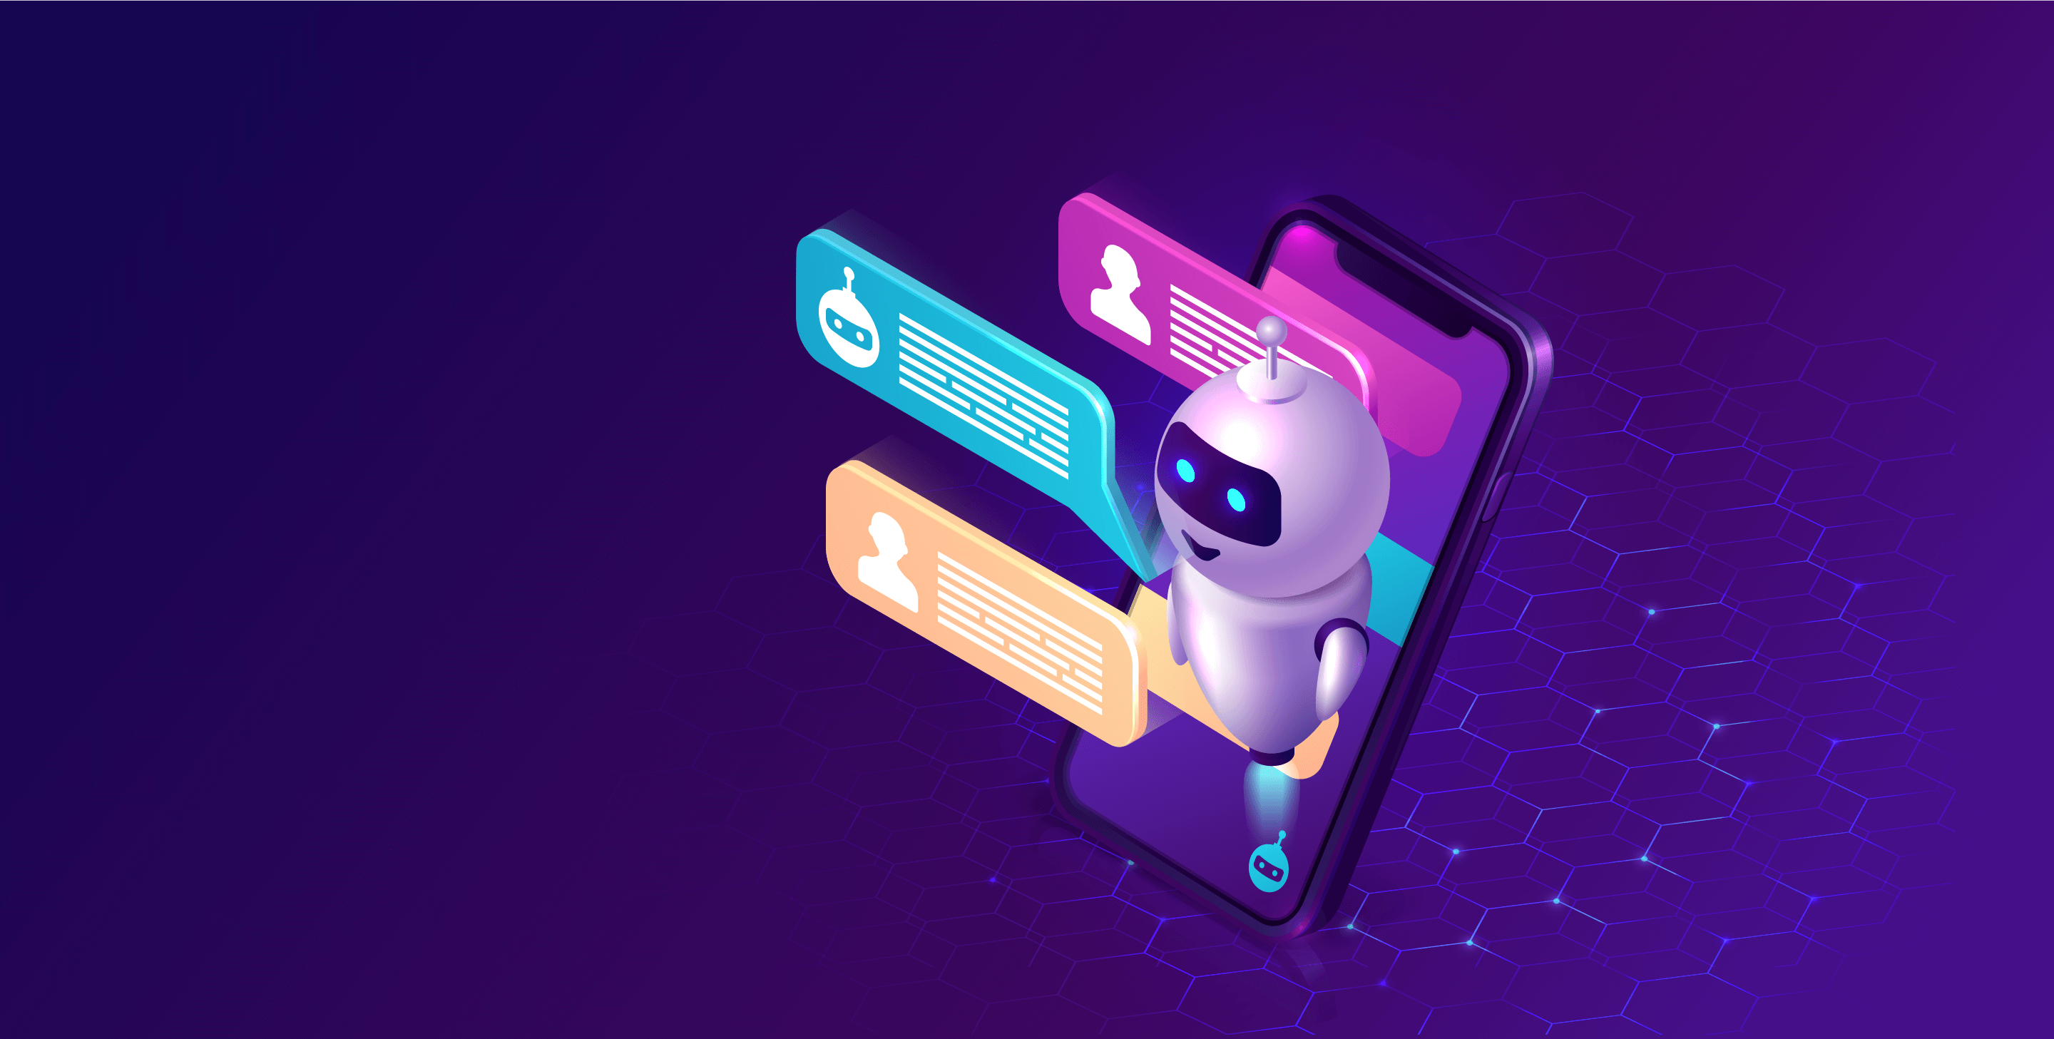

Name: Kalavathy K

Reg. No: 513521104019

Department: CSE

Year: III

NM ID: au513521104019

E-Mail: [kaviyakalavathy@gmail.co](mailto:karpagapriya062003@gmail.com)m

Phase 4 (Development Part-2)

**INTRODUCTION:**

"Welcome to the world of Chatbot development with Python! In this project, we embark on a journey to create an intelligent and interactive chatbot powered by Python's Natural Language Processing (NLP) capabilities. Our goal is to design a chatbot that can engage in meaningful conversations, answer questions, and provide assistance across a range of domains. Through data acquisition, model training, and iterative improvement, we aim to craft a chatbot that not only understands user queries but also offers contextually relevant responses. Join us as we explore the fascinating realm of conversational AI and create a chatbot that's ready to assist and engage with users."

In the continuation of the previous documentation AI_Phase2, we will be looking forward on the development part of the project. In this phase, we will start building the model by loading the dataset and processing the data. The following steps are followed in this development part 2.

**1.PROTOTYPE:**

In the context of chatbot development, creating a prototype allows you to design and test the chatbot's user interface, conversation flows, and functionality before fully implementing it. Prototyping helps you gather feedback, make improvements, and ensure that the chatbot meets user needs.

**TRAIN MODEL:**

Training a chatbot model is a crucial step in chatbot development, especially when your chatbot uses natural language processing (NLP) techniques.

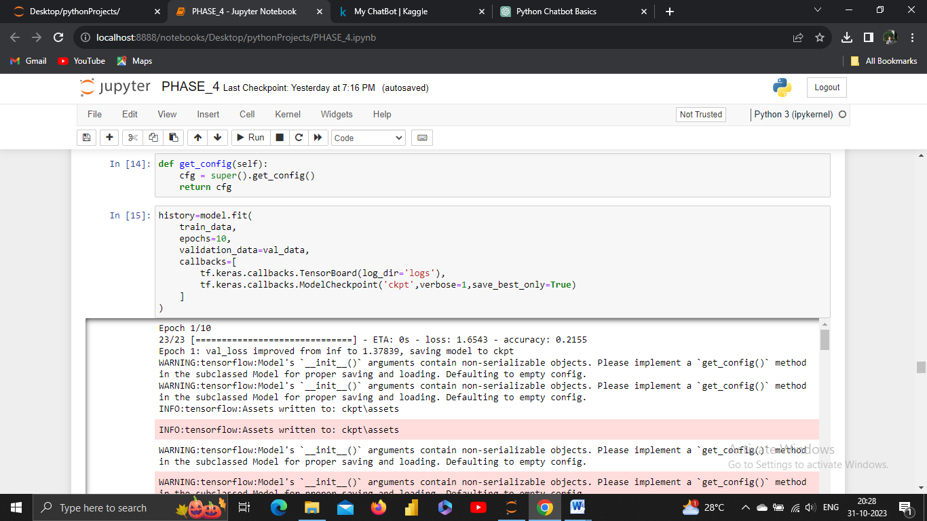

O/P:

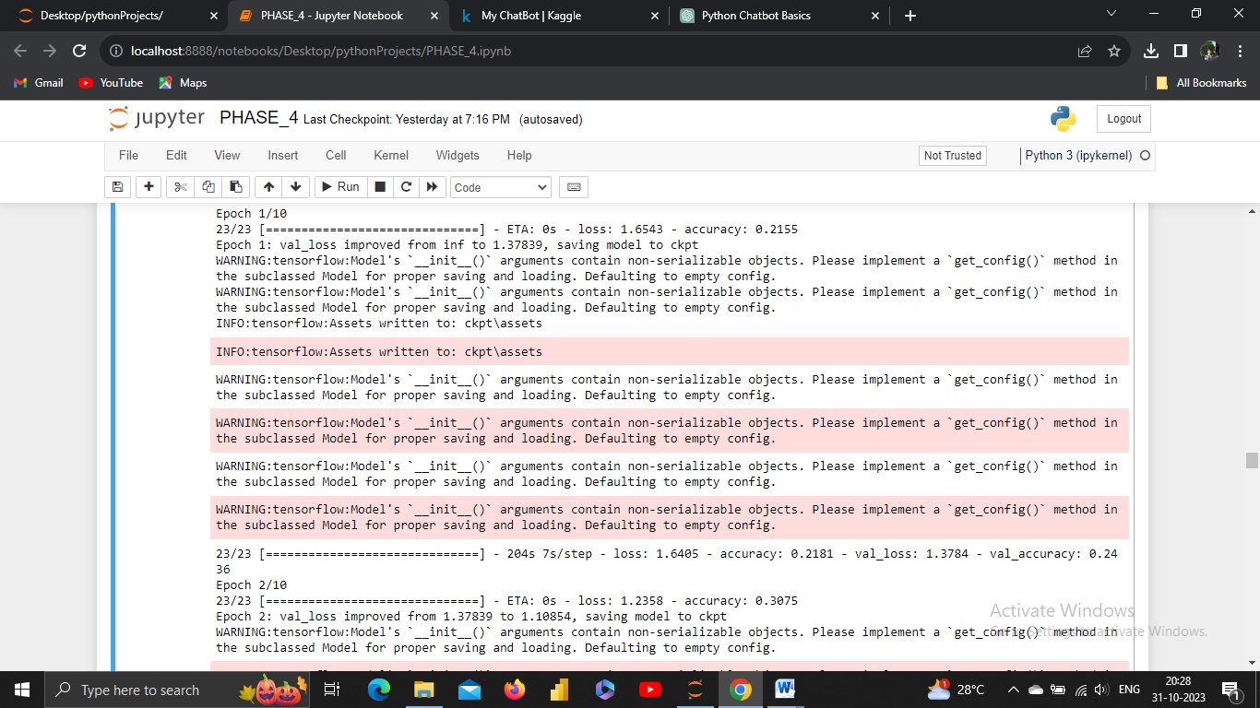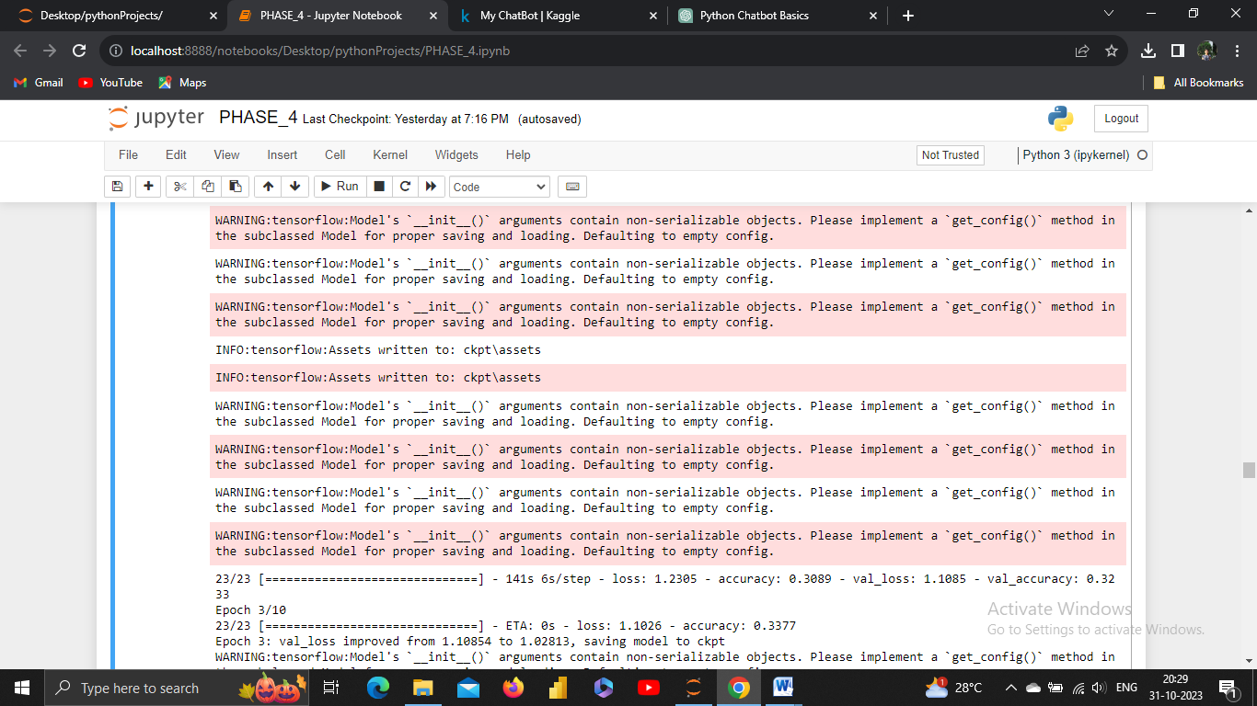

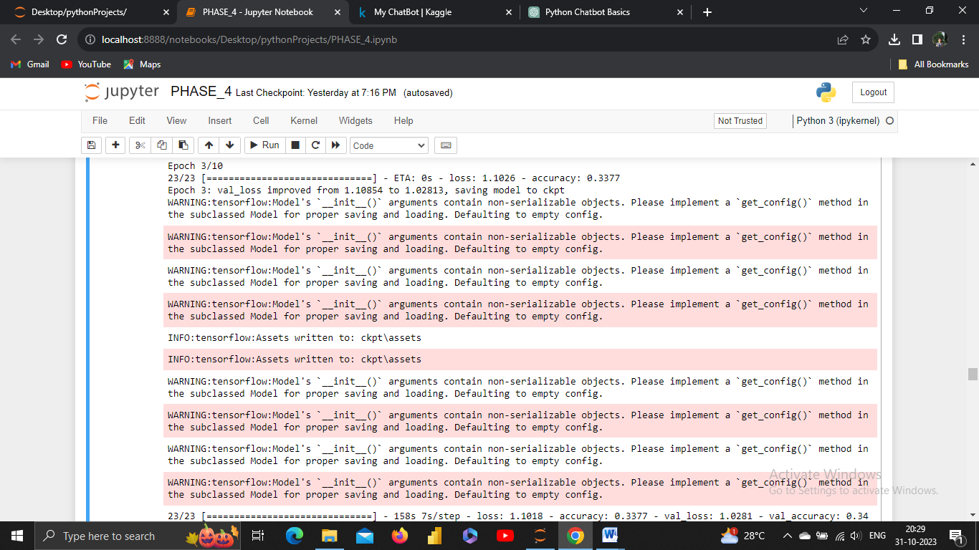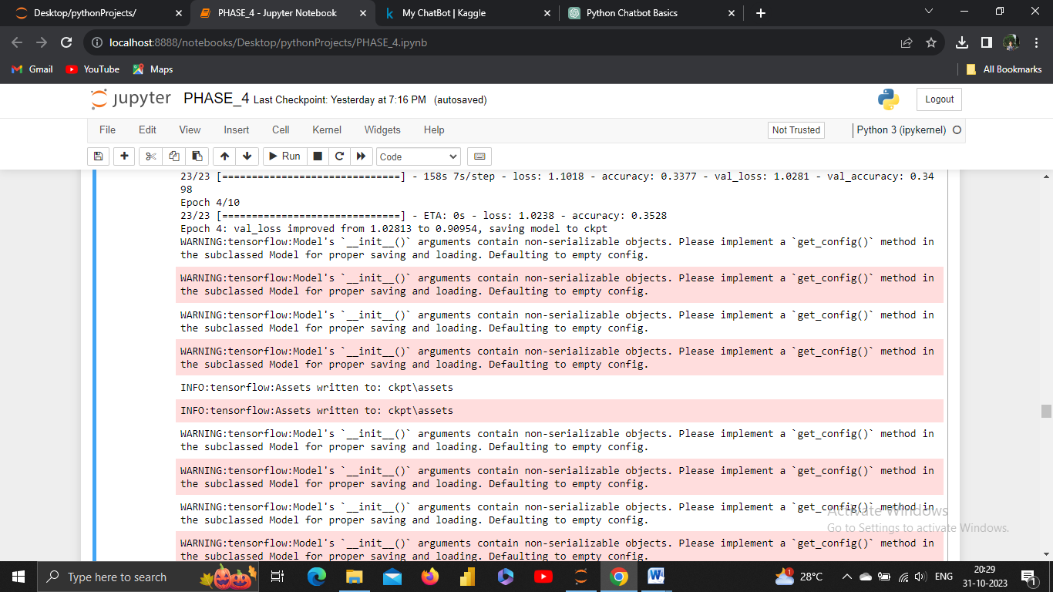

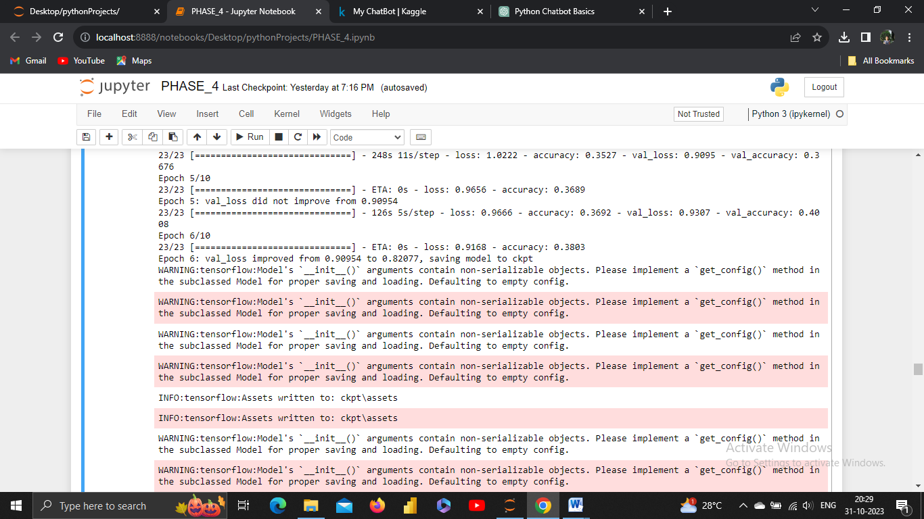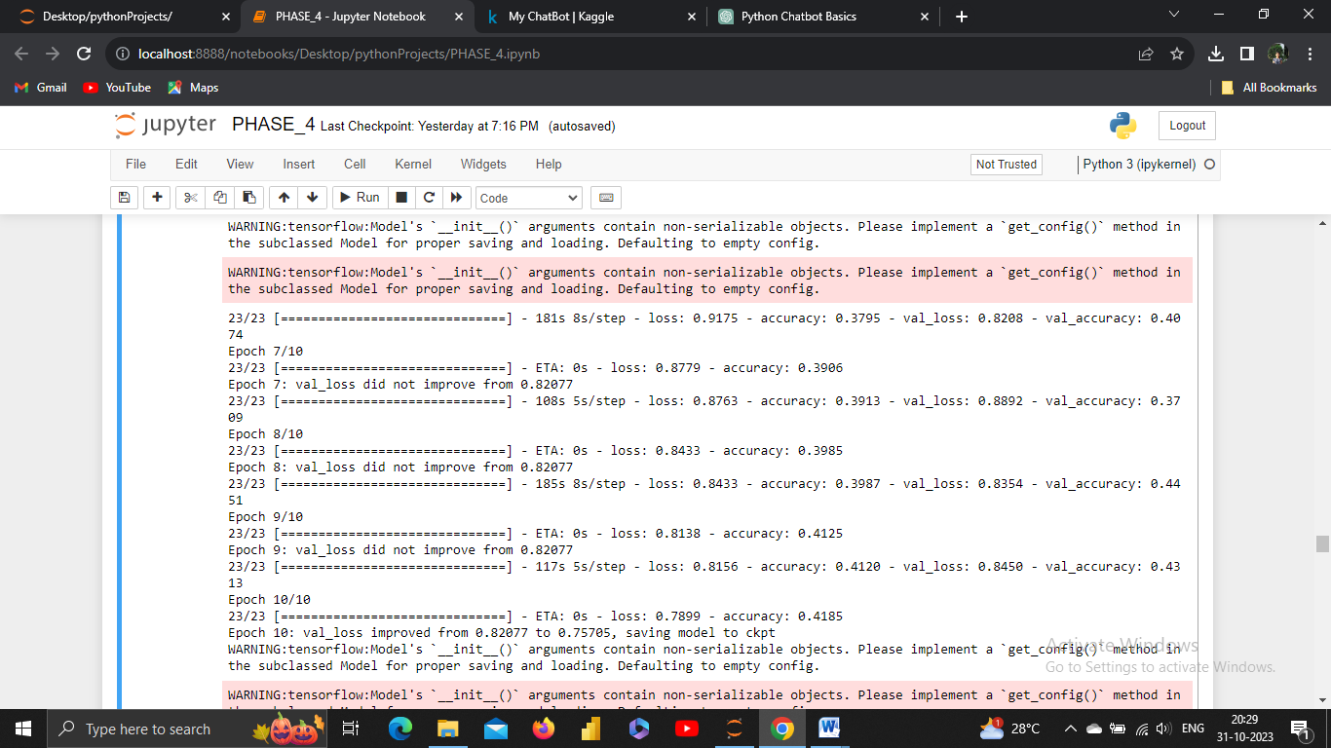

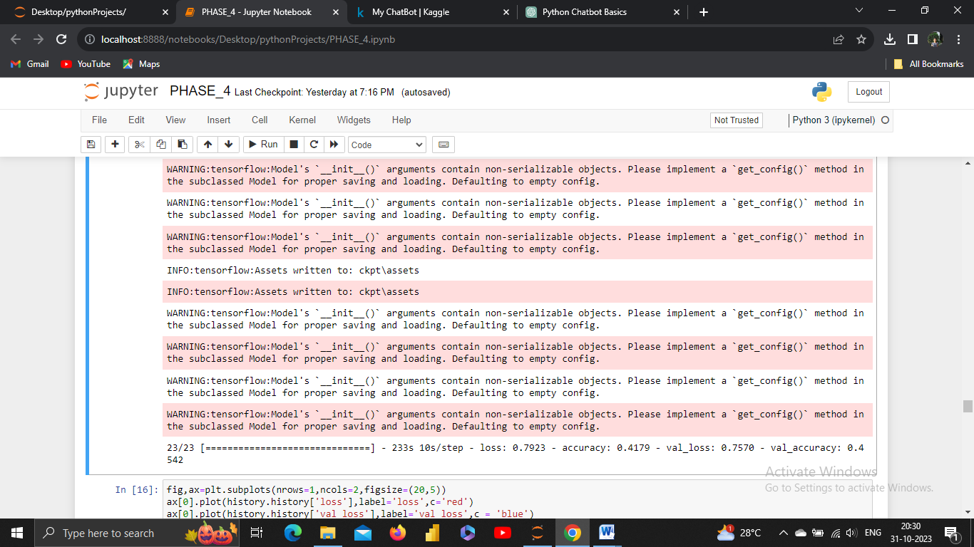

**2.TEST:**

**VISUALIZE METRICS:**

Visualizing metrics is a powerful way to gain insights into the performance of your chatbot or any machine learning model. It allows you to understand how well your model is performing and identify areas for improvement.

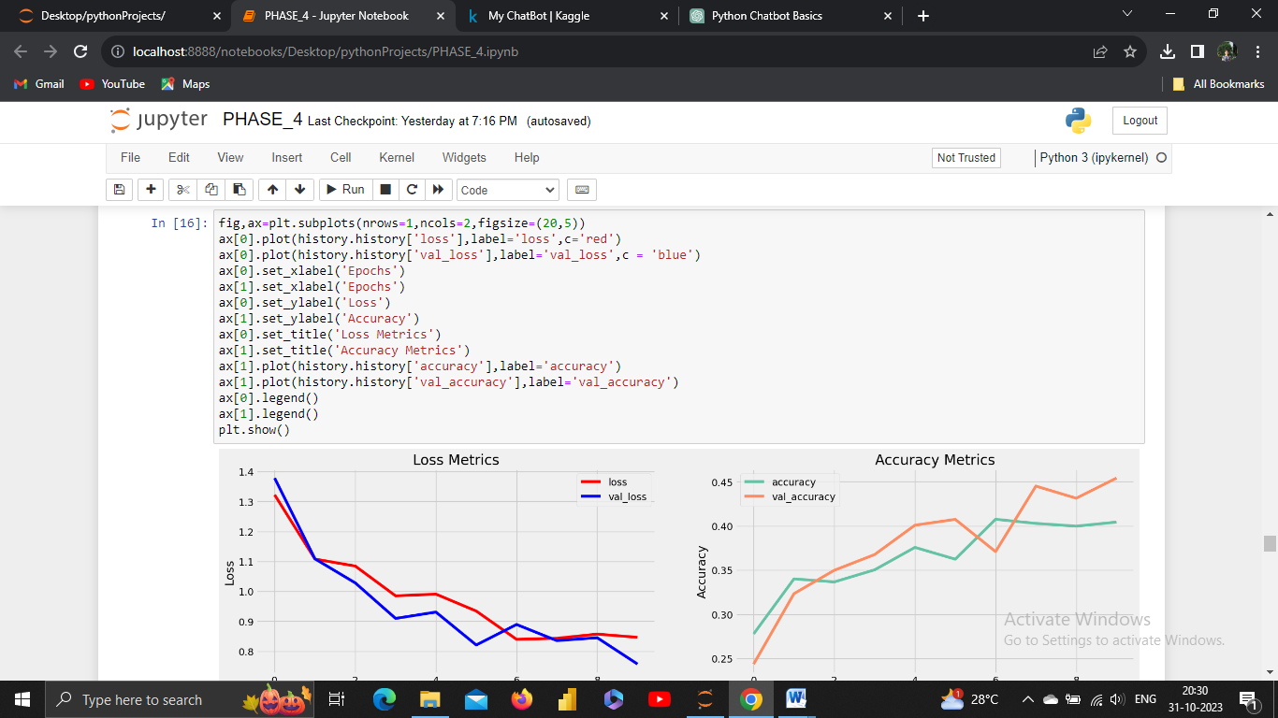

O/P:

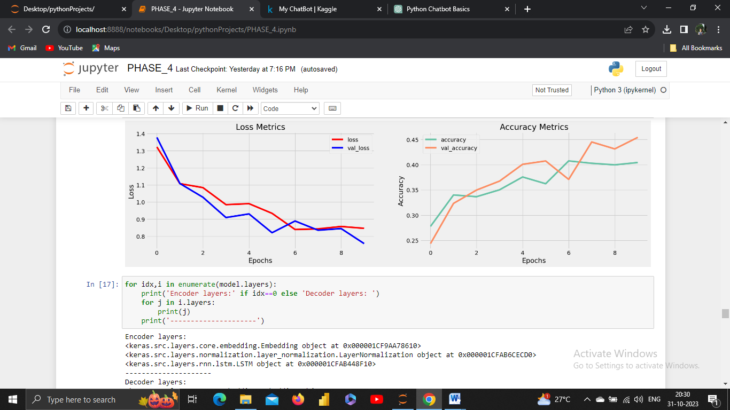

**3.SAVE MODEL:**

Saving a machine learning or chatbot model is essential to preserve the trained model for future use or deployment. In Python, you can save models using libraries like TensorFlow, PyTorch, scikit-learn, or any other machine learning framework.

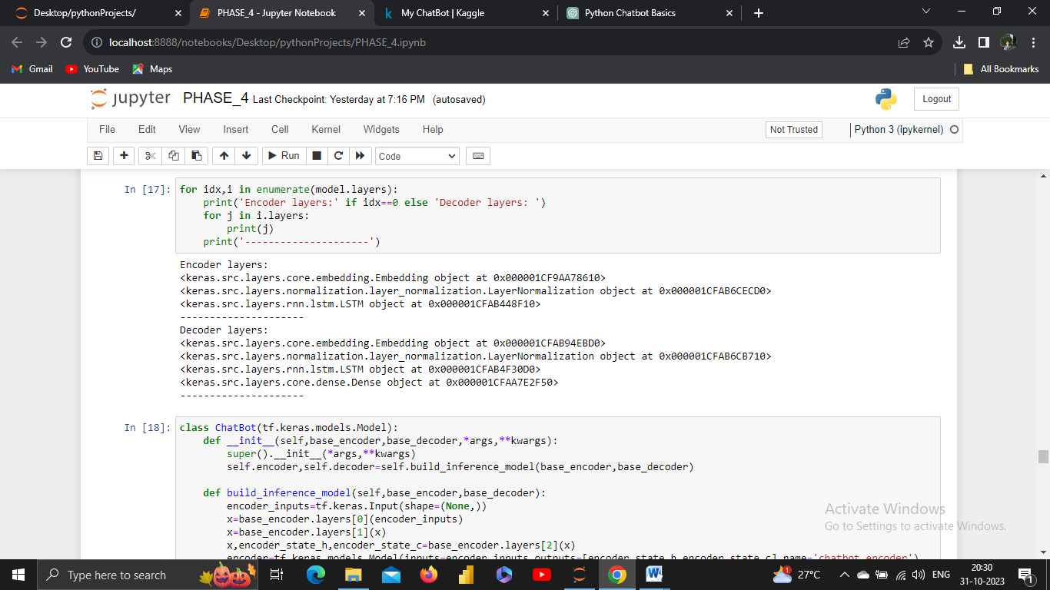

**4.IMPLEMENT:**

To implement a chatbot, you can follow a step-by-step approach, using popular frameworks and libraries for natural language processing (NLP) and machine learning.

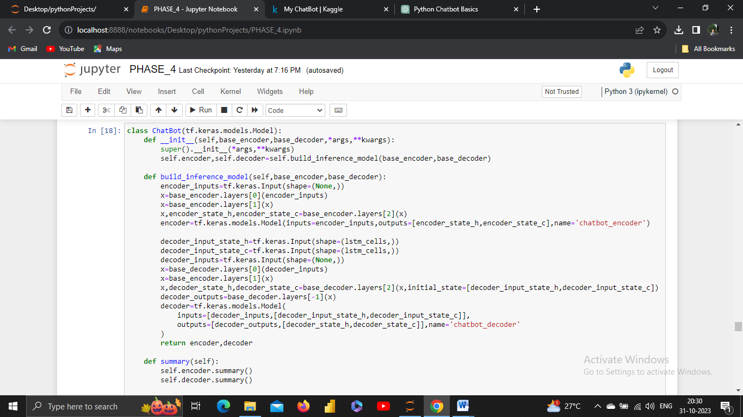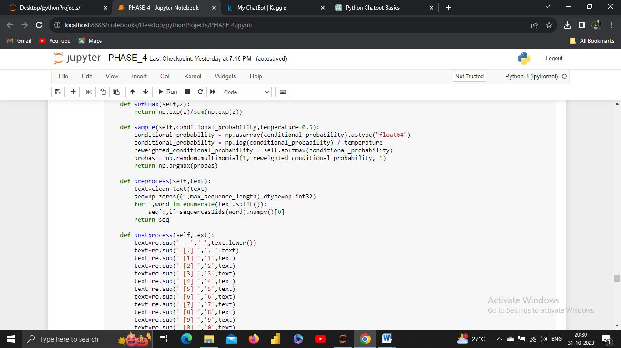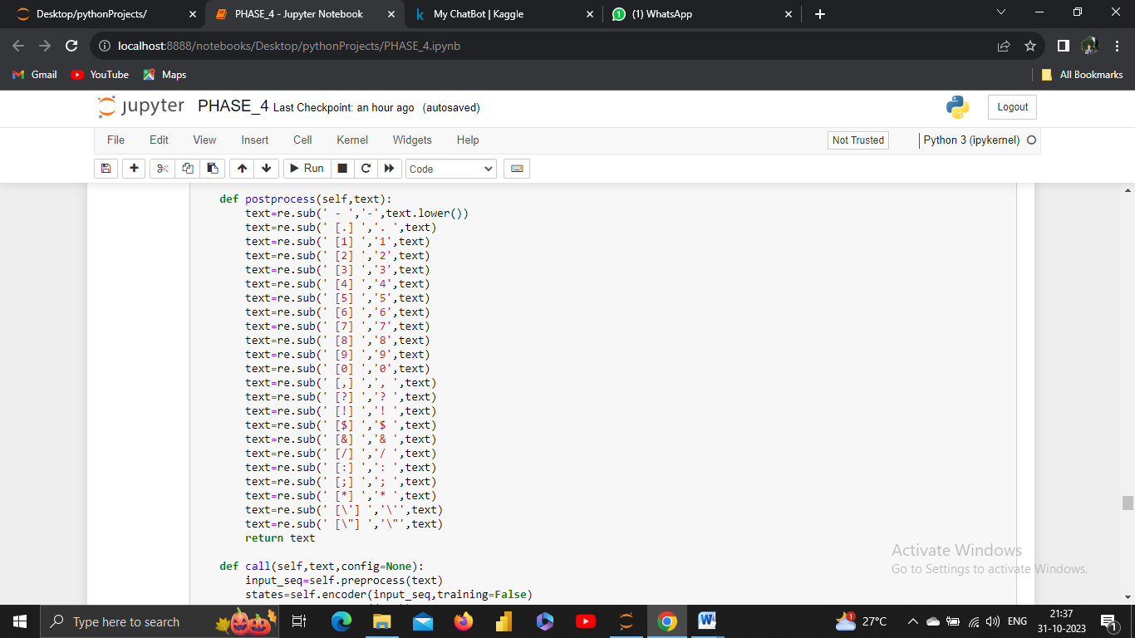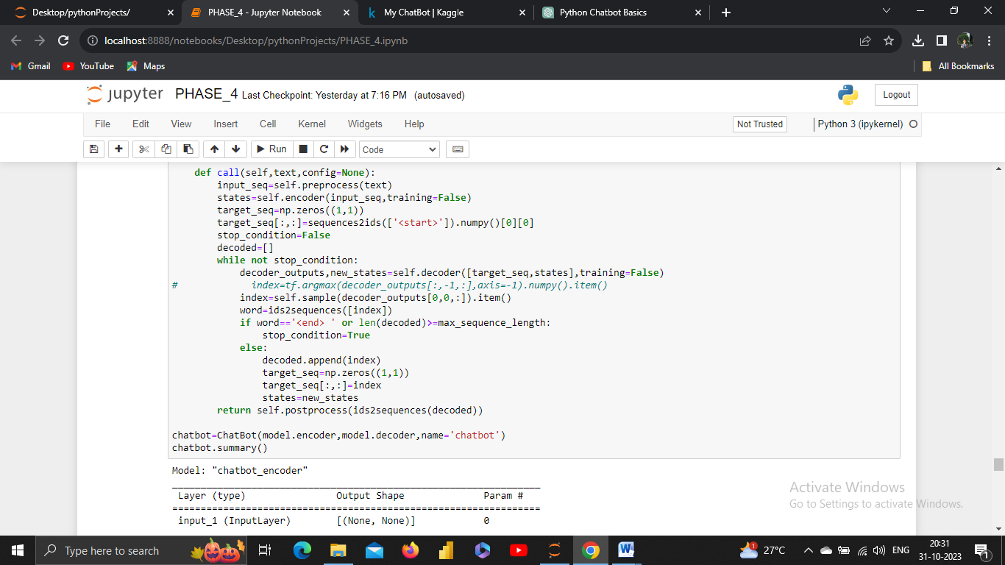

O/P:

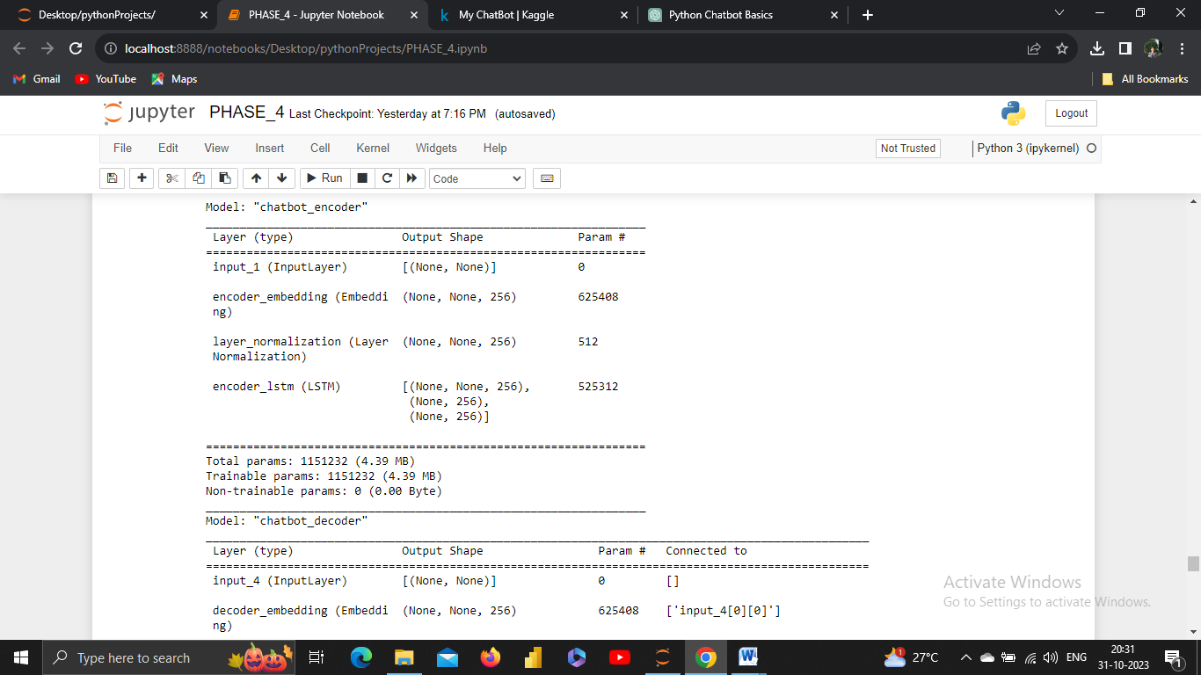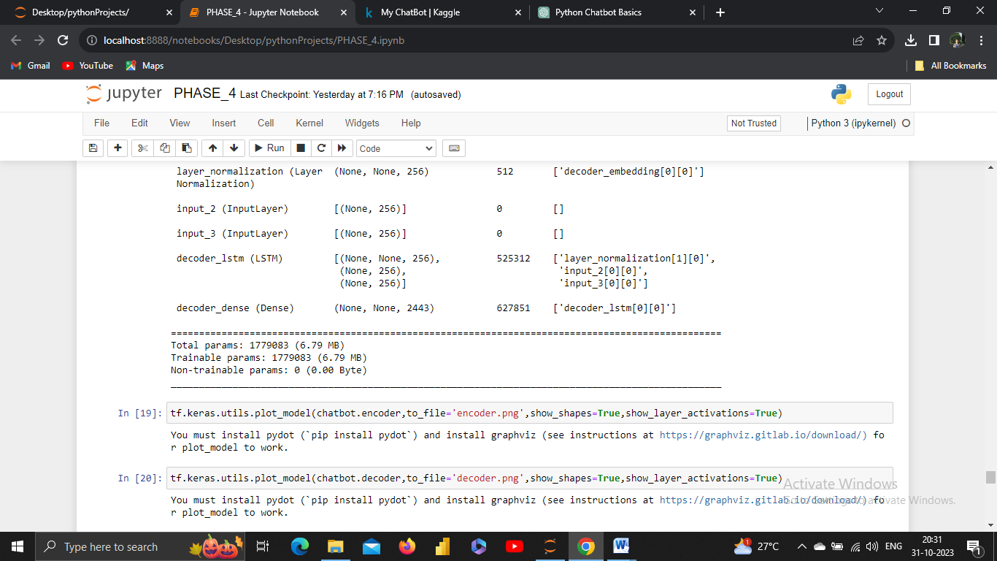

**5.DEPLOY:**

**EVALUATION:**

Deploying a chatbot involves making it accessible to users on a specific platform or through a particular channel. The deployment process can vary depending on your chatbot's design and use case.

**TIME TO CHAT:**

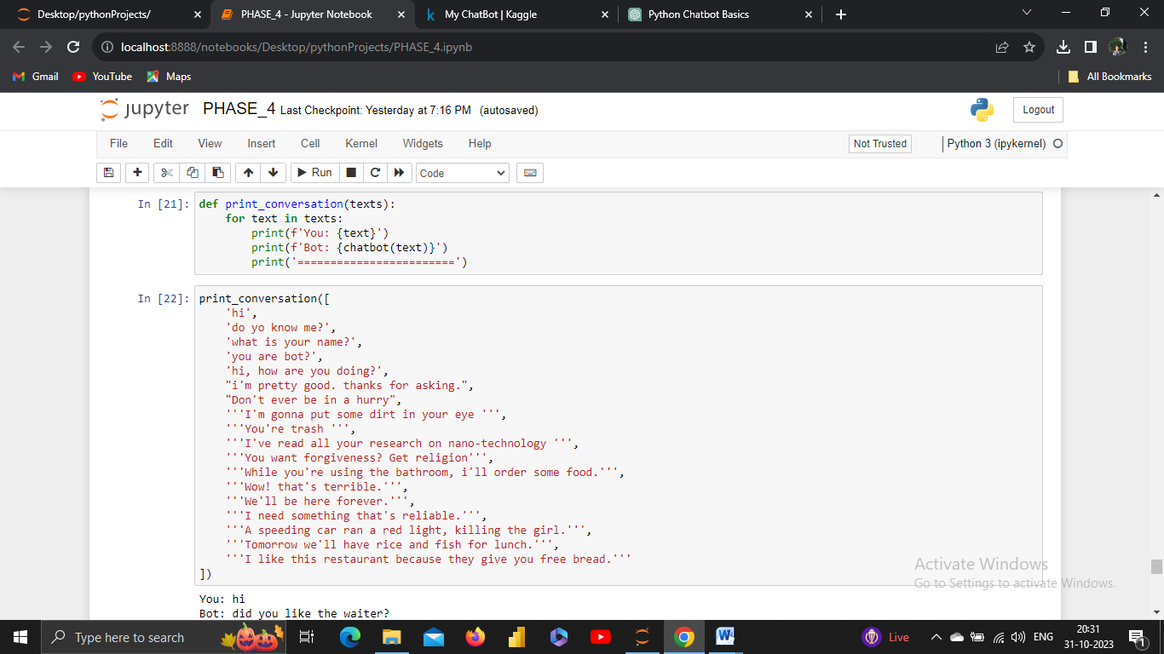

**O/P:**

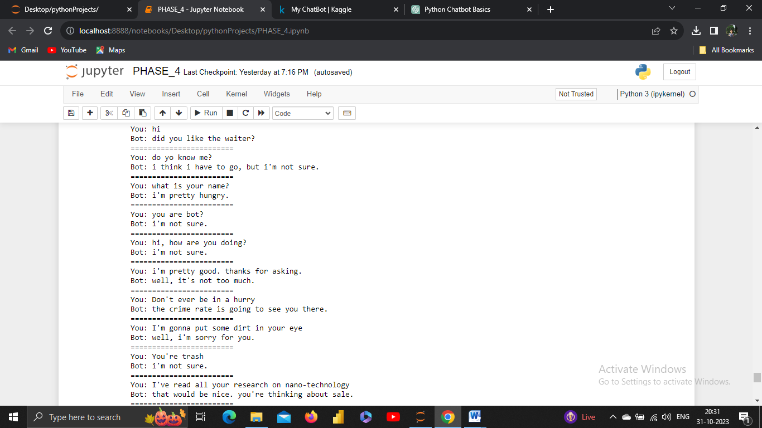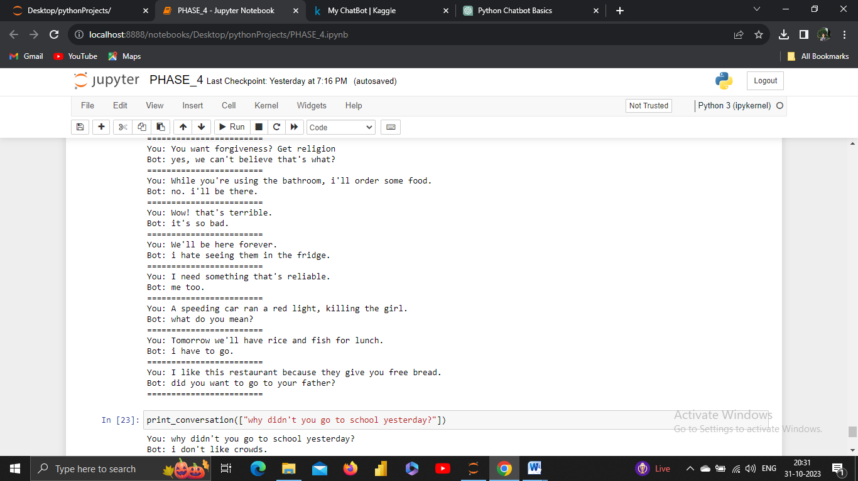

**CONCLUSION:**

In conclusion, chatbot development is a multifaceted process that involves several stages, from design thinking and empathizing with users to deployment and ongoing improvement. It's crucial to follow a structured approach, considering user needs, defining the problem, and applying the principles of design thinking to create a chatbot that delivers real value.