Weak prompts Improving
a) Explain regression

This is not quietly wrong. I have many short prompts like that but, I trained and personalize my chatbot. You must be more specific about that. For example;
“Explain regression's effect on countries”
.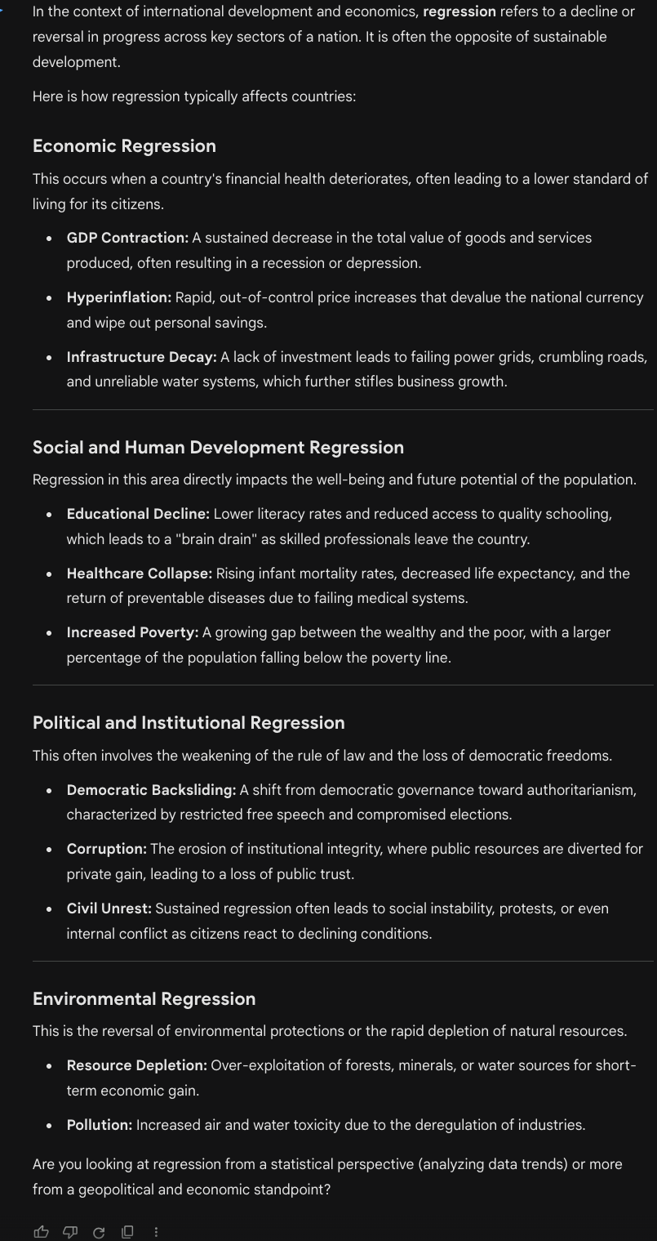
b) Help me understand SQL
“I’m a Data Science student and I try to Learn SQL in these days. Can you give me quick summary about SQL?”
You must personalize the data while takin with AI. This helps to create a more related answer with you.

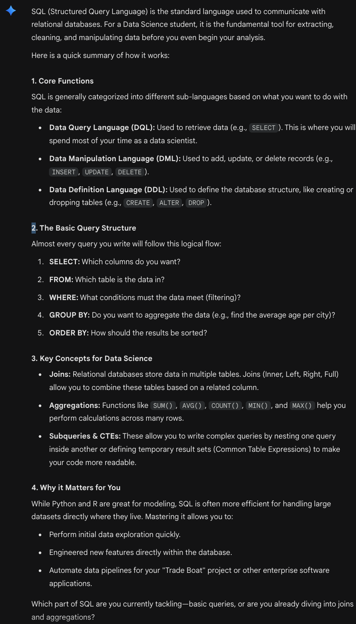
c) Create a dataset
“Create a dataset about Superbowl Champions. It has to be compatible with Excel ”
if you write without additional information, it possibly asked you a topic, or something related with dataset. Because AI is a tool not a decision maker.

