WISDOM REPORT

1. **We have achieved**
2. **Detection keypoint landmark:**

After studying and exploring more methods, we have found a typical detection and tracking method. The extremely lightweight module can support the foundation skin. This method is based on the MediaPipe google open source library. Here we combine blazepose and blazehand to create a link between the arm we need to analyze.

1. **Tracking**

The tracking process is also easier as we follow the combination of the headmap and the standard keypoint. Follow the flow char below.

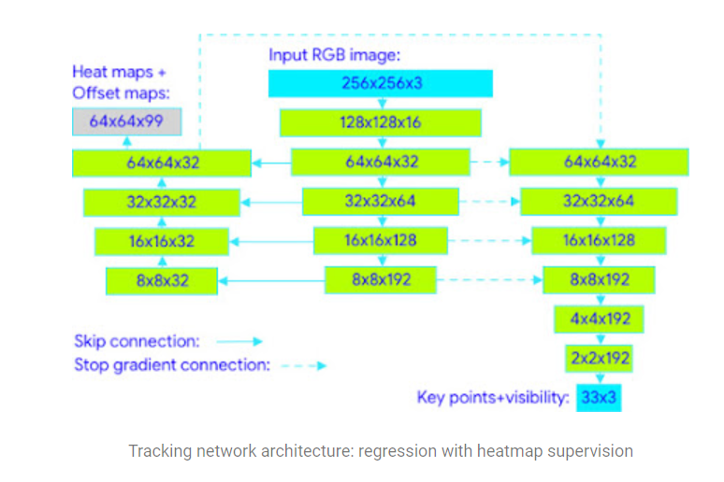

1. **Analysis of movements M1, M2 in MODAPTS**

Next we analyze the basic set of motion.

**Example**

**M1**: M1 is the movement of pressing with index finger, so the first thing determines the coordinates of index finger oil, thereby forming a characteristic thought expressing the movement of “pressing”. Here we distinguish by the finger lower lower knuckle is able to analyze the pressing movement.

**M2**: the rotation is similar, we grasp the characteristics of rotation and analysis as above

**Limitations:** we are only analyzing on the right hand, and need more stable analysis of movements

.

1. **Plan for the next task**

* Further analysis of the missing moves.
* We need to consult more carefully with your side requirements