GARUDA SoC
AHB-Lite Interconnect — Block 6
IP Block Design Specification

Field | Value
Document ID | GARUDA-AHB-SPEC-001
Revision | 2.0
Date | 2026-08-10
Status | Draft — RTL-ready (aligned to frozen core boundary)
Owner | Team AeroSoC
Target process | 28 nm CMOS
Bus domain | AHB-Lite (ARM IHI 0033A/B), 200 MHz hclk
Classification | Internal Use Only

Revision History
Version | Date | Author | Description
1.0 | — | Team AeroSoC | Initial architecture (bus described inline in TRM).
2.0 | 2026-08-10 | Team AeroSoC | Interconnect as a standalone block, aligned to the frozen CPU-core and DMA boundaries: exact i_/d_ master port names, HPROT[3:0] carried as pass-through (DMA default 0x3), hreset_n_i active-low synchronous de-assert, explicit arbiter micro-FSM and per-master hold rule, default slave with mandatory two-cycle ERROR. Cross-checked against GARUDA-CORE-SPEC-001 §2.1/§4.2–4.4/§16/§17.

1. Scope and Purpose

1.1 Block identification
Attribute | Value
Block name | AHB-Lite Interconnect
Block number | 6 of 24 (the core spec refers to it as SoC Block VI, §4.4)
Category | On-chip interconnect (shared bus fabric)
Clock domain | hclk_i = 200 MHz system clock (same net as core clk_i, DMA hclk)
Reset | hreset_n_i — active-low, synchronous de-assert (same net as core rst_n_i)
Protocol | AMBA 3 AHB-Lite, ARM IHI 0033A/B
Masters | 3 — CPU I-Port (M0), CPU D-Port (M1), DMA (M2)
Slaves | 4 — Instruction SRAM, Boot ROM, Data SRAM, AHB-to-APB Bridge
Clock domains | One (200 MHz). No CDC in this block — all 200/100 MHz crossing is in the bridge (core §2.1)
Programmable registers | None — fixed-function; the memory map is hardwired

1.2 Functional role in GARUDA
The CPU core exposes two AHB-Lite master ports and performs no arbitration. The Core Design Specification is explicit on this in two places: §16.1 delegates “multiplexing the I-port, D-port and DMA onto the shared slaves, and generating per-slave HSEL and the read-data mux” to a separate block, and §4.4 (“What Does Not Exist at the Core Boundary”) states “No bus arbitration. Inter-master arbitration is the interconnect’s responsibility (SoC Block VI).” This document specifies that block. Every instruction fetch, every load/store and every DMA beat reaches memory or the peripheral bridge through it.
The masters above and the slaves below are already boundary-frozen in sibling specifications. The interconnect has no latitude over port names or the address map; its only design content is how it decodes, arbitrates and steers.

1.3 Design goals
Goal | How it is met
Deterministic latency | Purely combinational decode + mux; a granted transfer completes in the slave’s own cycle count with zero interconnect wait-states.
1 transfer / cycle throughput | Address phase of transfer N+1 overlaps data phase of transfer N; no bubble inserted between back-to-back transfers to the same master.
No CPU starvation | DMA holds the bus for exactly one SINGLE beat then releases, so the arbiter re-evaluates every beat boundary even under continuous DMA demand.
Fault containment | Unmapped addresses answered by a default slave with a compliant two-cycle ERROR; a stray address raises a precise access-fault instead of hanging the bus.
Minimal area | Single shared layer, not a crossbar — justified by <0.3% measured bus utilisation (§13.1).
Forward compatibility | HPROT[3:0] carried end-to-end though unused today, so a future MPU/cache needs no re-plumbing (§7.5, §13.5).

1.4 Compliance (Normative)
AMBA 3 AHB-Lite (ARM IHI 0033A/B). The interconnect is protocol-transparent: it presents a standard AHB-Lite slave view to each master and drives a standard AHB-Lite master view to each slave. One protocol obligation is load-bearing and is called out wherever it applies: every slave — including the default slave and the AHB-to-APB bridge — MUST issue the two-cycle ERROR response (HREADY=0 then HREADY=1, HRESP=ERROR in both cycles). The DMA master’s beat engine (dma_ahb_master.v) relies on the first cycle to cancel an already-pipelined write address; a single-cycle ERROR would let a spurious write commit.

2. Feature Summary
Feature | Specification
Topology | Single shared AHB-Lite layer (3×4): master arbiter + address decoder + master mux + read-data mux
Data / address width | 32-bit / 32-bit
Masters | M0 CPU I-Port, M1 CPU D-Port, M2 DMA
Arbitration | Fixed priority DMA > D-Port > I-Port; grant sampled at beat boundaries only
Address decode | HADDR[31:28] → 4 regions + default slave
Bursts | I-Port may issue INCR (undefined-length prefetch); D-Port and DMA issue SINGLE only
HPROT | Carried pass-through from the granted master; DMA has none, interconnect drives 0x3 (data, privileged)
Wait-states inserted by interconnect | Zero (slaves own their wait-states via HREADY)
Error handling | Two-cycle HRESP=ERROR; unmapped region → default slave
Clock domains / CDC | One (200 MHz); no CDC here
Registers / interrupts | None / none
Sustained throughput | 1 transfer / hclk cycle per active master

3. Block Diagram

3.1 Internal sub-blocks
Sub-block | Type | Function
Address Decoder | comb. | HADDR[31:28] → one-hot HSEL; asserts default-slave select for unmapped regions
Master Arbiter | seq. | Fixed-priority selection over the masters’ HTRANS≠IDLE requests; latches the winner for the beat (micro-FSM, §7.2)
Master Mux | comb. | Steers the granted master’s HADDR/HTRANS/HWRITE/HSIZE/HBURST/HPROT/HWDATA onto the shared slave-side bus
Data-Phase Slave-Select Reg | seq. | Registers address-phase HSEL by one cycle so the return muxes select the correct slave in the data phase
Read-Data Mux | comb. | Selects HRDATA from the data-phase slave back to the owning master
HREADY / HRESP Mux | comb. | Returns the data-phase slave’s HREADY and HRESP; gates ungranted masters (§7.3)
Default Slave | seq. | Answers unmapped addresses with the mandatory two-cycle ERROR

3.2 Structure
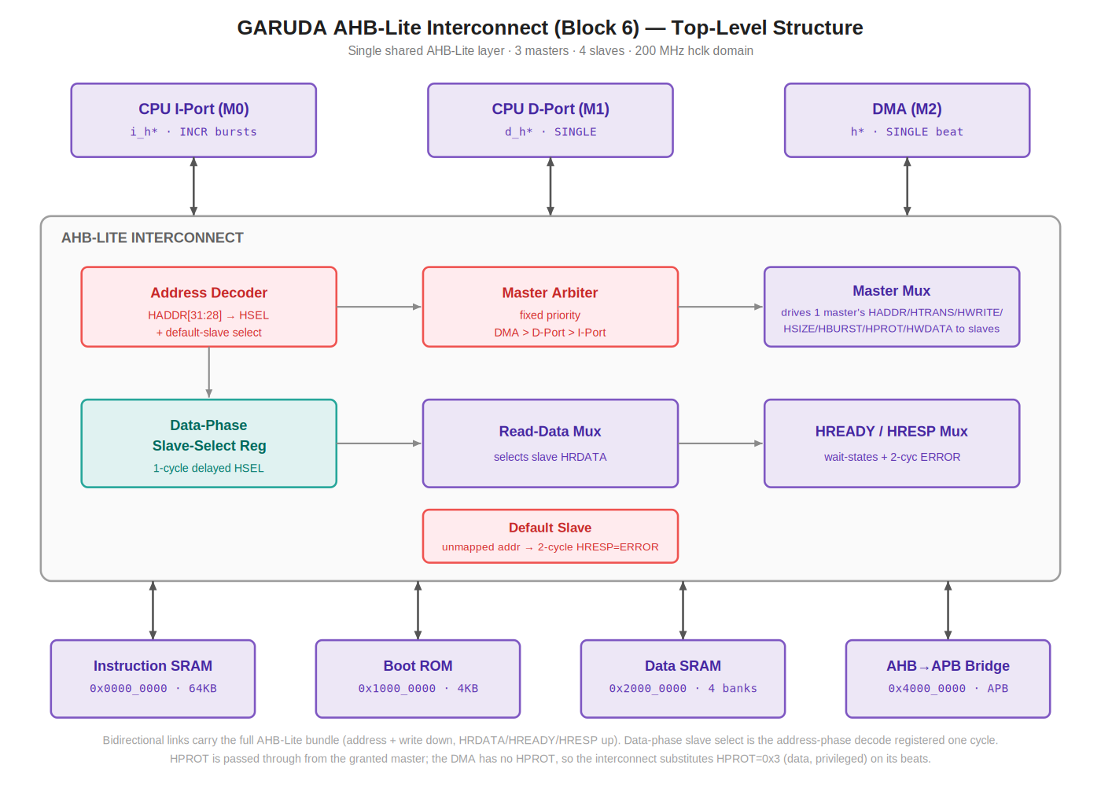
Figure 1 — Top-level AHB-Lite interconnect. Purple = AHB port entities and datapath muxes; coral = control (decode, arbitration, error); teal = the one registered element (data-phase slave select). Editable source: GARUDA_AHB_Bus_BlockDiagram.svg.

3.3 Suggested RTL module hierarchy
Module | Role
ahb_interconnect.v | Block boundary; instantiates and wires the sub-blocks below
ahb_decoder.v | Combinational address decode → HSEL + default select
ahb_arbiter.v | Fixed-priority master arbiter with beat-boundary grant latch
ahb_master_mux.v | 3:1 address/control/HPROT/write-data mux to the slave side
ahb_slave_mux.v | Read-data / HREADY / HRESP return mux with registered data-phase select
ahb_default_slave.v | Two-cycle ERROR responder for unmapped addresses

4. External Connectivity Map
Authoritative for top-level integration. The interconnect terminates every AHB-Lite link in the SoC. It generates no interrupts and has no sideband.
Peer block | Direction | Interface | Notes
CPU I-Port (Block 1) | Master → IC | i_h* | Instruction fetch; may issue INCR bursts; drives HPROT
CPU D-Port (Block 1) | Master → IC | d_h* | Load/store; SINGLE only; drives HPROT
DMA (Block 9) | Master → IC | h* | One SINGLE beat per grant; no HPROT (default 0x3 applied)
Instruction SRAM (Block 3) | IC → Slave | 0x0000_0000 | 64 KB, read-mostly
Boot ROM (Block 5) | IC → Slave | 0x1000_0000 | 4 KB, read-only; reset vector
Data SRAM (Block 4) | IC → Slave | 0x2000_0000 | 64 KB / 4 banks; bank arbitration internal to Block 4
AHB-to-APB Bridge (Block 8) | IC → Slave | 0x4000_0000 | All peripherals; must honour two-cycle ERROR; owns 200/100 CDC
Clock Divider (Block 22) | → IC | hclk_i | 200 MHz
Reset Controller (Block 23) | → IC | hreset_n_i | Async assert / sync de-assert
Routing is by address only: any master may reach any slave. The “port” column in the core memory map (§17) records typical usage (I-port → ISRAM/ROM, D-port → DSRAM/peripherals) and is not a restriction enforced here.

5. Signal Interface

5.0 Naming convention
Signals use the GARUDA house style: lower-case, _n = active-low. Master-side ports carry the connected master’s prefix exactly as that master’s frozen boundary names them — i_ for the CPU I-Port, d_ for the CPU D-Port, and no prefix for the DMA (whose boundary drops the suffix, per the DMA spec §5.7). Direction in every table is relative to this interconnect. Widths match the core Pin Contract (core §4.1) and the DMA top boundary.

5.1 Clock and reset
Signal | Dir | Width | Description
hclk_i | in | 1 | 200 MHz AHB system clock (= core clk_i / DMA hclk net)
hreset_n_i | in | 1 | Active-low reset, synchronous de-assert (= core rst_n_i net)

5.2 Master-side ports (interconnect as AHB-Lite slave)
Instances: M0 prefix i_ (CPU I-Port), M1 prefix d_ (CPU D-Port), M2 no prefix (DMA). The DMA does not drive HPROT; see §7.5.
Signal (per master) | Dir | Width | Description
<m>haddr | in | 32 | Address phase: transfer address
<m>htrans | in | 2 | IDLE / NONSEQ / SEQ transfer type
<m>hwrite | in | 1 | 1 = write, 0 = read
<m>hsize | in | 3 | Byte / half / word
<m>hburst | in | 3 | SINGLE, or INCR from the I-Port
<m>hprot | in | 4 | Protection/attribute hint (I- and D-Port only; not on DMA)
<m>hwdata | in | 32 | Data phase: write data
<m>hrdata | out | 32 | Read data returned to this master
<m>hready | out | 1 | Transfer-complete / wait / hold to this master
<m>hresp | out | 1 | OKAY / ERROR to this master

5.3 Slave-side ports (interconnect as AHB-Lite master)
Instances: S0 = ISRAM, S1 = ROM, S2 = DSRAM, S3 = Bridge. Standard AHB-Lite slave signalling with per-slave HSEL and a shared HREADY.
Signal (per slave) | Dir | Width | Description
hsel_<s>_o | out | 1 | Slave select from address decode
haddr_o | out | 32 | Shared address to all slaves
htrans_o | out | 2 | Shared transfer type
hwrite_o | out | 1 | Shared write/read
hsize_o | out | 3 | Shared transfer size
hburst_o | out | 3 | Shared burst type
hprot_o | out | 4 | Shared protection/attribute (granted master’s, or 0x3 for DMA)
hwdata_o | out | 32 | Shared write data
hready_o | out | 1 | Global HREADY to slaves (data-phase gating)
hrdata_<s>_i | in | 32 | Read data from slave
hreadyout_<s>_i | in | 1 | Slave ready-out (drives HREADY mux)
hresp_<s>_i | in | 1 | Slave response OKAY / ERROR

5.4 Signal count summary
Interface | Named ports (buses counted once)
Clock / reset | 2
Master-side: I (10) + D (10) + DMA (9) | 29
Slave-side: shared bundle (9) + per-slave hsel/hrdata/hreadyout/hresp (4×4) | 25
TOTAL | ≈56

6. Address Decode & Memory Map
The interconnect has no software-visible registers; its “register map” is the fixed address decode. Regions are distinguished by HADDR[31:28] (only [30:28] actually differ; decoding the top nibble is simpler and leaves headroom). The map matches core §17 exactly.
Region | Base | HADDR[31:28] | Size | Slave
Instruction SRAM | 0x0000_0000 | 0000 | 64 KB | S0
Boot ROM | 0x1000_0000 | 0001 | 4 KB | S1
Data SRAM | 0x2000_0000 | 0010 | 64 KB | S2
Peripherals (APB) | 0x4000_0000 | 0100 | via bridge | S3
Unmapped | all others | — | — | Default slave
Decode is one-hot and mutually exclusive. The reset vector is 0x1000_0000 (Boot ROM); the first live access after reset is the I-Port fetching there. Addresses inside a region but beyond a slave’s physical size are the slave’s responsibility to flag; the interconnect only routes by region.

7. Arbitration & Sequencing

7.1 Priority
Master | Priority | Rationale
M2 DMA | Highest | A stalled DMA can overflow a peripheral RX FIFO and lose sensor data; DMA takes only one beat before releasing, so “highest” cannot starve the CPU.
M1 CPU D-Port | Middle | A load/store stall freezes the pipeline directly, so data beats outrank fetches.
M0 CPU I-Port | Lowest | The prefetch buffer (core §6.3) hides fetch latency; a delayed or split fetch is harmless.

7.2 Arbiter micro-FSM and grant granularity (Normative)
The priority selection is combinational, but the grant is committed by a two-state micro-FSM so a winner cannot change mid-transfer:
State | Meaning | Transition
ARB_FREE | Bus idle; no beat in flight | On any HTRANS≠IDLE request, sample priority, latch grant_r = winner index, go ARB_HELD
ARB_HELD | grant_r owns the bus for this beat | Stay until the beat’s address phase is accepted (HREADY high). Then, if any master still requests, re-sample and re-latch; else return to ARB_FREE
State: one grant_r register (2 bits) plus a busy flag. Sampling only at HREADY-high boundaries is the whole point — it is the same discipline the DMA uses internally (dma_top.v: beat_start = grant & bus_idle). Without it, a higher-priority request raised mid-beat would swing HADDR/HSIZE under a live transaction, and read data from one master would land at another’s slave — two transfers corrupted with no error flagged anywhere.

7.3 Per-master ready / hold rule (Normative)
The three masters are plain AHB-Lite masters; there is no HBUSREQ/HGRANT handshake. The interconnect therefore gates the ungranted masters through their own HREADY: a master that is not currently granted sees its <m>hready driven 0. By AHB-Lite rules a master holds HADDR and all control stable while its HREADY is low, so an ungranted master automatically freezes its pending request until the arbiter selects it. The granted master sees <m>hready driven from the addressed slave’s HREADYOUT (so real wait-states still pass through). Exactly one master is un-gated at a time.

7.4 Address / data phase pipeline
AHB-Lite is two-phase: the address phase of transfer N+1 overlaps the data phase of transfer N. The interconnect tracks two selects at once — the address-phase select (combinational, from the current HADDR) drives HSEL and the master mux; the data-phase select (that same decode, registered one cycle) drives the return muxes.
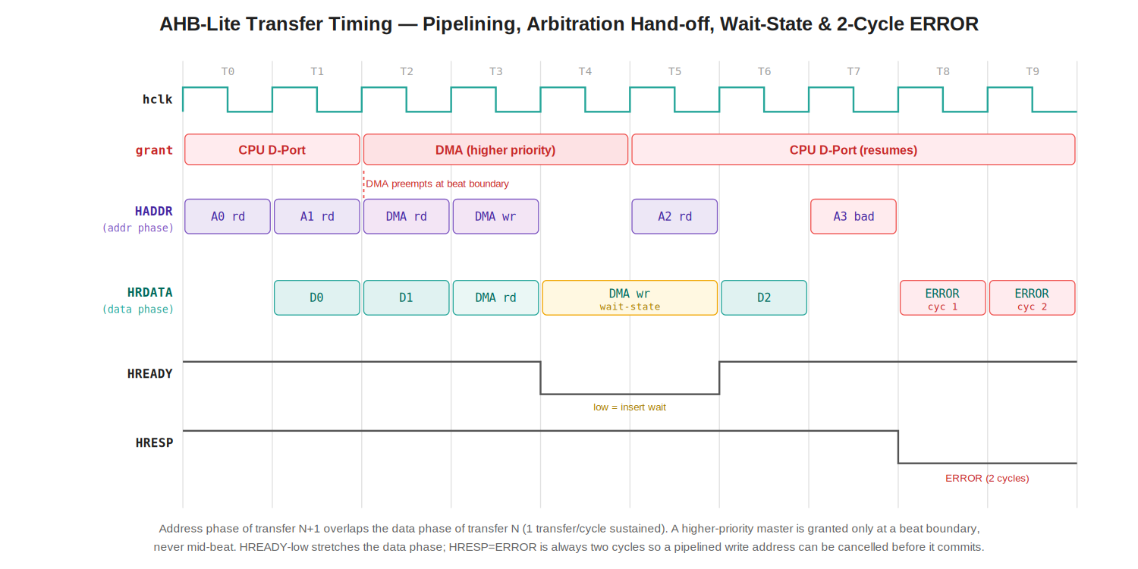
Figure 2 — Two consecutive CPU fetches, a higher-priority DMA beat preempting at the beat boundary, a slave wait-state, and a two-cycle ERROR. Editable source: GARUDA_AHB_Bus_Timing.svg.

7.5 Data-phase slave-select register (Normative)
A single registered copy of the one-hot HSEL, updated whenever HREADY is high (an address phase is accepted). During the following data phase the read-data, HREADY and HRESP muxes all select on this registered value, so late read data is always taken from the slave that was addressed the previous cycle — never from whatever the current address phase points at.

7.6 HPROT handling (pass-through) (Normative)
HPROT[3:0] is an access-attribute hint: bit0 opcode/data, bit1 user/privileged, bit2 bufferable, bit3 cacheable. GARUDA is M-mode only with no MPU and no caches, so no slave consumes it today; it is carried purely for forward compatibility. The master mux selects the granted master’s HPROT onto hprot_o. The DMA has no HPROT port, so when the DMA is granted the interconnect drives the AMBA default for a privileged non-cacheable non-bufferable data access, hprot_o = 4’b0011 (0x3). No decode or enforcement is performed (see §13.5).

8. Functional Description

8.1 Address decode
Combinational. HADDR[31:28] selects one of four regions or, if none match, the default slave. HSEL is one-hot. Decode is valid in the address phase and feeds both the master mux (this cycle) and the data-phase register (for next cycle).

8.2 Read-data return
A 4:1 32-bit mux selects HRDATA from the slave named by the data-phase select register, and it is driven only to the master that owned that transfer (tracked alongside the data-phase select). The other masters see their own gated/idle response.

8.3 Wait-states
The interconnect inserts none of its own. It forwards the addressed slave’s HREADYOUT as the granted master’s HREADY. While HREADY is low the master holds address and control stable and the arbiter does not advance, so a slow slave transparently stretches only the transfer that touches it.

8.4 Default slave & error response
Any address that decodes to no region selects the default slave, which returns the mandatory two-cycle ERROR: cycle 1 HREADY=0/HRESP=ERROR, cycle 2 HREADY=1/HRESP=ERROR. The owning master takes the AMBA error and raises a precise fault (instruction fault for M0, load/store fault for M1, bus_error for the DMA). The bus never hangs on a bad address.

8.5 Burst handling
The I-Port may present undefined-length INCR bursts for sequential prefetch. On a shared layer a burst is not locked: if the DMA or D-Port requests while an INCR is in flight, the higher-priority master is granted at the next beat boundary and the I-Port’s burst is split — it resumes later with a fresh NONSEQ. This is safe because the prefetch buffer discards surplus fetches on any branch; a split burst costs at most one re-issued address phase. D-Port and DMA issue SINGLE only and are never split.

8.6 Life of a contended transfer
The D-Port is mid-way through a load (address accepted, data phase pending) when the DMA raises a request for an IMU beat. Because the DMA is higher priority the arbiter marks it as next — but does not disturb the in-flight load. On the next HREADY-high boundary the DMA is granted; it drives its source read address, and one cycle later (overlapped) its destination write address, completing a single beat, then drops its request. The arbiter re-evaluates and the D-Port, still asking, is granted again. Net cost to the CPU: the DMA’s beat cycles — exactly the “DMA wins, CPU stalls” behaviour promised in the memory and DMA specs.

9. Performance and Timing

9.1 Latency
Path | Cycles | Notes
Uncontended transfer (SRAM/ROM) | slave’s own | Interconnect adds 0 wait-states; ISRAM read ≈ 1 cycle
Interconnect combinational overhead | 0 | Decode + mux delay folded into the same hclk cycle
Grant latency under contention | ≤ 1 beat | Loser waits at most the current beat, then is granted
Peripheral access (via bridge) | ~3–4 core | Dominated by AHB→APB CDC (Block 8), not the interconnect
Error response | 2 | Fixed two-cycle AMBA ERROR

9.2 Bandwidth & utilisation
At 200 MHz a 32-bit shared layer offers ~800 MB/s of single-beat bandwidth. The flight pipeline consumes ~18,200 of the 200,000 cycles available per 1 ms loop; DMA sensor traffic measures <0.3% of AHB capacity (DMA spec §11.2). The bus is idle ~99% of the time, which is the justification for a shared layer over a crossbar (§13).

10. Reset Behaviour
hreset_n_i is active-low with synchronous de-assert (same net as core rst_n_i; sequencing owned by Block 23). On assertion the data-phase select register, grant_r and default-slave state clear, and the interconnect drives HTRANS=IDLE and HSEL=0 to every slave. De-assert is synchronous. Out of reset the combinational decode/arbiter are immediately valid; the first live transfer is the I-Port fetch from the reset vector 0x1000_0000 (Boot ROM) once i_hready is high. No programming is required before use. There is no clock-domain crossing in this block — the 200/100 MHz crossing is entirely in the AHB-to-APB bridge (core §2.1, §4.3).

11. What This Block Does Not Contain
Mirroring core §4.4, the following are explicitly out of scope and must not be added without revising this specification:
Absent | Why
Software-visible registers | Fixed-function; the memory map is hardwired
Clock-domain crossing | Single 200 MHz domain; all CDC is in the bridge
HMASTLOCK / HBUSREQ / HGRANT | Masters are plain AHB-Lite; ungranted masters are gated via HREADY (§7.3)
HPROT decode / enforcement | M-mode only, no MPU/cache; HPROT is carried but not acted on
Crossbar / concurrent bank access | Shared single layer; see §13.1 and the open item §13.4
Clock division / PLL | Provided by Block 22

12. Verification Plan
Area | Checks
Protocol compliance | Bind an AHB-Lite protocol checker to every master and slave port: HTRANS/HREADY handshake, address-phase stability under HREADY-low, control constant during a burst.
Decode coverage | One transfer to each region + boundary addresses (base, base+size−1) of every slave; confirm one-hot HSEL and no aliasing.
Default slave | Access each unmapped hole; assert exactly two ERROR cycles and correct fault back to the owning master.
Arbitration & FSM | All 2- and 3-master request combinations; assert priority DMA>D>I, grant_r stable through a beat, no mid-beat swing, no starvation under continuous DMA.
Per-master hold | With one master granted, drive the other two active; confirm their HREADY is held 0 and their HADDR/control stay frozen until granted.
Data-phase select | Back-to-back transfers to different slaves; confirm read data always sourced from the previous cycle’s addressed slave.
Wait-states | Slave HREADYOUT held low 1..N cycles; master must hold address/control and see the stretch transparently.
Two-cycle ERROR / cancel | Slave returns ERROR mid-beat during a DMA read; confirm the pipelined DMA write address is retracted (no spurious write).
HPROT pass-through | Confirm the granted master’s HPROT reaches hprot_o unchanged; when the DMA is granted, confirm hprot_o = 0x3.
Burst split | I-Port INCR interrupted by a DMA grant; confirm clean split + NONSEQ resume, no lost/duplicated beat.

13. Design Decisions & Rationale

13.1 Shared single layer, not a crossbar
A crossbar would let all three masters reach different slaves concurrently. It is not built because there is no bandwidth pressure: utilisation is under 0.3% and the flight loop leaves ~91% of every 1 ms idle. A crossbar would multiply mux/arbiter area for throughput never demanded. Shared layer is the pragmatic choice.

13.2 Fixed priority, not round-robin
Fixed DMA>D>I encodes the real-time requirement (don’t drop sensor data; don’t stall the pipeline for a fetch) in ~30 gates and cannot starve anyone because every DMA beat releases the bus. Round-robin would smooth a fairness the block does not need.

13.3 Default slave is mandatory
Without it an unmapped address leaves HREADY never asserted and the master hangs forever — the classic bring-up bug that looks like a dead CPU. The two-cycle-ERROR default slave converts that into a precise, debuggable access fault.

13.4 Open item — Data SRAM bank concurrency
Block 4 and the DMA spec state that CPU and DMA reach different banks “simultaneously with zero stall.” On this shared single layer that is not literally true: the two masters serialise on the one bus. In practice the claim holds statistically — the bus is idle ~99% of the time, so a bank conflict almost never coincides with a bus conflict — but the mechanism is time-multiplexing, not physical dual-path. If true concurrent bank access is ever required, promote the four banks to four decoded AHB regions and add a partial crossbar. FLAGGED for reconciliation when the Memory Subsystem spec (Blocks 3/4/5) is written.

13.5 HPROT pass-through, not decode
HPROT is carried end-to-end but not acted on. Decoding it would only matter with multiple privilege modes or a protection unit, neither of which exists (M-mode only). Passing it through costs four wires and keeps the wire present so a future MPU/cache upgrade needs no re-plumbing; dropping it would leave the core driving a dead-end signal. Pass-through is the zero-cost, forward-compatible choice.

14. Appendix

14.1 Acronyms
Term | Meaning
AHB / AHB-Lite | Advanced High-performance Bus (Lite = single-master AMBA 3 variant)
APB | Advanced Peripheral Bus
HSEL | Slave select (per-slave, from address decode)
HREADY / HREADYOUT | Bus ready (in to slave) / slave ready-out
HRESP | Bus response, OKAY or ERROR
HPROT | Protection/attribute hint (opcode/data, priv, bufferable, cacheable)
HMASTLOCK / HBUSREQ / HGRANT | Full-AHB arbitration signals — absent here (see §11)
NONSEQ / SEQ / IDLE | HTRANS transfer types
INCR / SINGLE | HBURST types
CDC | Clock-domain crossing (none in this block)
IC | Interconnect (this block)

14.2 Cross-references
Block / doc | Relationship
Core spec §16.1, §4.4 | Defers muxing/arbitration to this block (“SoC Block VI”)
Core spec §2.1, §4.3 | Single 200 MHz domain; CDC is in the bridge, not here
Core spec §17 | Memory map (matched in §6)
1 — RV32IM Core | M0/M1 masters (i_/d_ ports)
3 / 4 / 5 — Memories | Slaves S0/S2/S1; DSRAM bank arbiter internal (see §13.4)
8 — AHB-to-APB Bridge | Slave S3; must honour two-cycle ERROR; owns 200/100 CDC
9 — DMA Controller | M2 master; relies on two-cycle ERROR for write-address cancel
22 / 23 — Clock / Reset | Provide hclk_i and hreset_n_i
— End of AHB-Lite Interconnect Design Specification —

