GARUDA SoC
Clock & Reset Generation Specification
CRG architecture, Clock Divider (Block 22) and Reset Controller (Block 23)
Document ID | GARUDA-CRG-SPEC-001
Revision | 2.0
Date | 2026-09-16
Blocks covered | 22 (Clock Divider), 23 (Reset Controller)
Status | Released for RTL. Fallback mode frozen (§4.4); reset-cause reporting scoped out (§8.5)
Owner | Team AeroSoC
Target process | 28 nm CMOS
Classification | Internal Use Only

Revision History
Version | Date | Author | Description
1.0 | — | Team AeroSoC | Clock divider and reset controller described inline in the TRM as Blocks 22 and 23.
2.0 | 2026-09-16 | Team AeroSoC | Combined specification. Structured as one architecture part plus two independent block parts so each block can be implemented from its own part alone. Written to satisfy the clock and reset requirements already committed to by released sibling specifications — the ÷2 generated-clock relationship (Bridge §13.4, CLIC §5.1.1), coordinated reset assertion (Bridge §10.1), and asynchronous-assert / synchronous-de-assert (Memory §10.1, Core §3). Adds the clock/reset bootstrap resolution (§3.3), glitch-free fallback switching, and two flagged items requiring an architecture decision (§4.4 fallback frequency plan, §8.5 reset-source qualification).

Part I — CRG Architecture
This part defines only how the two blocks relate to each other and to the rest of the SoC. It is deliberately short. Part II specifies the Clock Divider and Part III the Reset Controller; each is self-contained, and an engineer implementing one block should not need to read the other.

1. Scope

1.1 What this document covers
Attribute | Value
Blocks covered | 22 — Clock Divider; 23 — Reset Controller
Document structure | Part I architecture (shared), Part II Block 22, Part III Block 23. The two block parts share no requirements text — only the interface contract in §3.
Why one document | The two blocks have exactly one hard coupling (§3.1) and a combined startup sequence that belongs in neither block alone. That relationship needs one authoritative home. They do NOT share a bus interface, a register model or a timing contract, so they are not merged into one specification body (§1.2).
RTL modules | Two, independent: clock_divider.v and reset_controller.v. One document does not mean one module.
Programmable registers | None in either block. The divider's fallback mode is a static strap input sampled at reset, not a software-writable register (§4.4).

1.2 Why these are not merged the way the memories were
The Memory Subsystem specification folds three blocks into one because they genuinely share an interface: three AHB-Lite slaves, one slave bundle, one timing contract, one error model. Merging removed real duplication.
Clock and reset share almost nothing structurally. One is a divider flop plus a distribution tree; the other is source qualification plus a synchroniser chain. They have no common bus interface, no common register model, and no common access semantics. Writing them as one continuous specification would invent shared requirements that do not exist — the failure mode this document is explicitly structured to avoid. What they do have is a startup dependency and a shared consumer list, and that is what Part I is for.

2. Clock and Reset Architecture
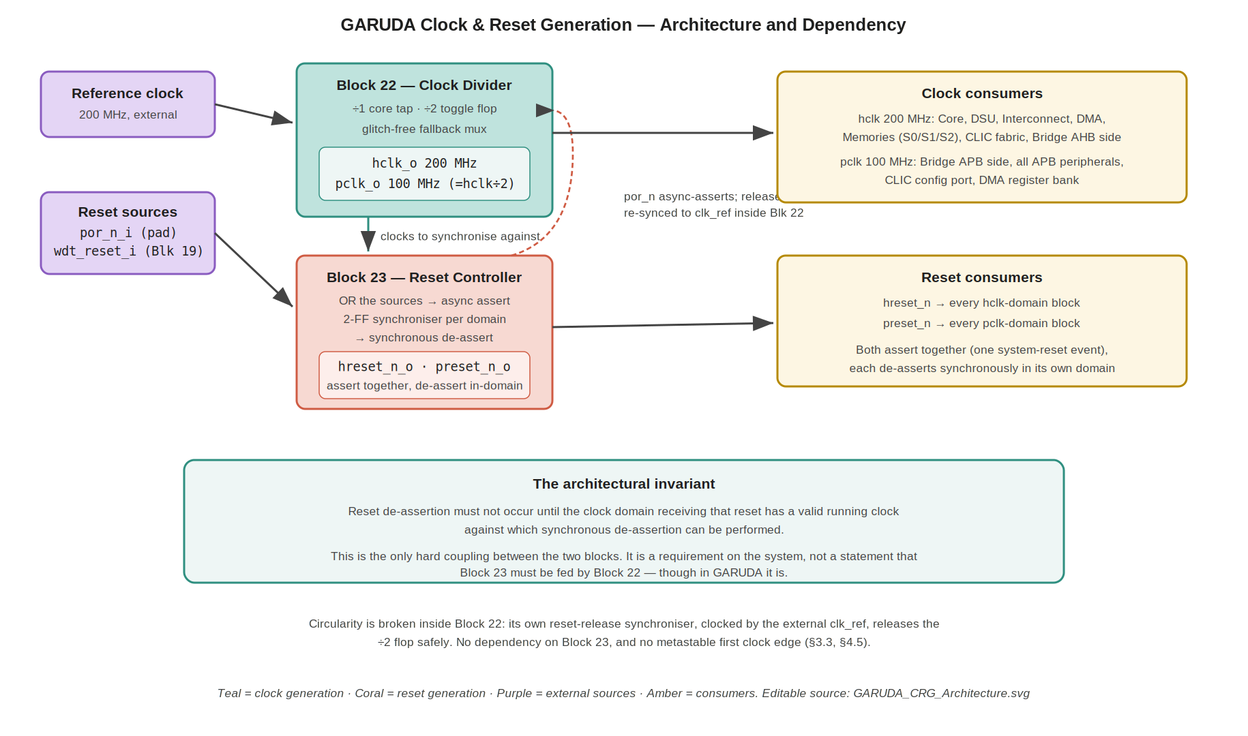
Figure 1 — CRG architecture. Teal = clock generation, coral = reset generation, purple = external sources, amber = consumers. The dashed coral path shows por_n asserting the divider asynchronously, with its release re-synchronised to clk_ref inside Block 22 — which is what breaks the circular dependency (§3.3, §4.5). Editable source: GARUDA_CRG_Architecture.svg.

2.1 Clocks in the SoC
Clock | Frequency | Source | Consumers
hclk | 200 MHz | Block 22, ÷1 tap of clk_ref_i | Core, DSU, AHB interconnect, DMA, memories S0/S1/S2, CLIC interrupt fabric, Bridge AHB side
pclk | 100 MHz | Block 22, ÷2 of hclk from the same source | Bridge APB side, all APB peripherals, CLIC configuration port, DMA register bank
There are exactly two clocks and one clock generator. No PLL is used: the 200 MHz reference arrives from outside the block and the only division is a single toggle flop (§4.2).

2.2 Resets in the SoC
Reset | Domain | Source | Consumers
hreset_n | hclk | Block 23, synchronised to hclk | Every hclk-domain block
preset_n | pclk | Block 23, synchronised to pclk | Every pclk-domain block
Both are active-low, asynchronously asserted and synchronously de-asserted, and both derive from the same set of reset sources so they assert as one event (§3.2).

3. The Interface Between the Two Blocks

3.1 The architectural invariant (Normative)
Reset de-assertion must not occur until the clock domain receiving that reset has a valid running clock against which synchronous de-assertion can be performed.
This is the whole of the coupling between Blocks 22 and 23, and it is stated as a property of the system rather than as a wiring requirement. It does not say that the reset controller must be clocked by the clock divider — a reset controller could legitimately run from an always-on reference. It says only that whatever clock a domain's reset is synchronised against must be running before that reset is released into the domain.
In GARUDA the invariant is satisfied by the obvious implementation: Block 22 drives hclk and pclk, and Block 23 uses those same two clocks for its two synchronisers. That is an implementation fact recorded here, not a law derived from the invariant.

3.2 Reset coordination (Normative)
Released sibling specifications depend on a specific coordination property, so it is restated here as a requirement on Block 23:
- Assertion is simultaneous. hreset_n and preset_n assert together, asynchronously, the instant any reset source fires. Both are driven from the same qualified source term (§8.2). The Bridge relies on this: its reset-during-transfer behaviour (Bridge §10.3) is only correct because both of its domains reset as one event.
- De-assertion is per-domain and therefore skewed. Each reset is released through a synchroniser clocked by its own domain, so preset_n can de-assert up to one pclk cycle after hreset_n. This skew is unavoidable if de-assertion is to be synchronous in each domain, and it is safe (§9.3).

3.3 Breaking the clock/reset bootstrap (Normative)
There is an obvious circularity in the invariant: the reset controller needs a running clock to release reset, while the clock divider contains a flip-flop that needs a reset to start in a known state. If the divider's flop waited for a synchronously de-asserted reset, neither block could ever start.
Resolution: the Clock Divider carries its own local reset-release synchroniser, clocked by clk_ref_i, and does not use a reset from Block 23. por_n_i asynchronously asserts that synchroniser; its output — a reset that is released synchronously with respect to clk_ref_i — is what clears the ÷2 flop. clk_ref_i is supplied externally and is already running, so the divider depends on nothing that depends on the divider. The circularity is broken without Block 23 being involved at all (§4.5).
It is worth being explicit about why the ÷2 flop must NOT simply take raw por_n_i on its asynchronous clear. That flop is the clock generator. If its reset release violates recovery/removal against clk_ref_i, the flop can go metastable and emit a runt or indeterminate transition on the very first cycle of pclk_o. A metastable clock is far more damaging than a metastable data signal: a runt pulse can violate the minimum pulse width of every flop in the pclk domain, and different flops may observe different numbers of edges. Crucially, the usual reassurance — that the metastability resolves before anything consumes it — does not apply here, because the first thing to consume pclk_o is Block 23's pclk reset synchroniser, whose entire job is to time the release of preset_n_o against that same clock. There is no downstream margin to absorb it. Hence the local synchroniser.
Cost is negligible: two flops and a few reference-clock cycles of extra startup delay, which is irrelevant during power-on. No other flop in either block may take a raw asynchronous reset release. Block 23's own synchroniser flops use the qualified source on their asynchronous reset input (which is what makes assertion asynchronous) but release synchronously, as specified in §7.3.

3.4 Startup sequence
Step | Event
1 | Power ramps; por_n_i is low. All flops in the SoC are held in reset asynchronously.
2 | clk_ref_i becomes valid and stable at 200 MHz.
3 | por_n_i releases. The divider's local reset synchroniser (§4.5) counts two clk_ref_i edges and releases the ÷2 flop synchronously; the flop begins toggling cleanly — hclk and pclk are now both running and edge-aligned, with no runt first pulse.
4 | Block 23 sees por_n_i released; each domain's two-flop synchroniser counts two edges of its own clock.
5 | hreset_n de-asserts on an hclk edge; preset_n de-asserts on a pclk edge (up to one pclk cycle later).
6 | The core's PC loads the reset vector 0x1000_0000 and the I-Port issues its first fetch to the Boot ROM (Core §3, Memory §10.2).

Part II — Block 22: Clock Divider
Self-contained specification of the Clock Divider. The only external dependency is the interface contract in §3.

4. Clock Divider — Functional Specification

4.1 Purpose and structure
The Clock Divider takes the external 200 MHz reference and produces the SoC's two clocks. It contains no PLL, no DLL and no analogue content: the 100 MHz APB clock is generated by a single flip-flop toggling on every rising edge of the 200 MHz clock, which produces an exact 50% duty cycle with zero added jitter and a fixed phase relationship to the source.
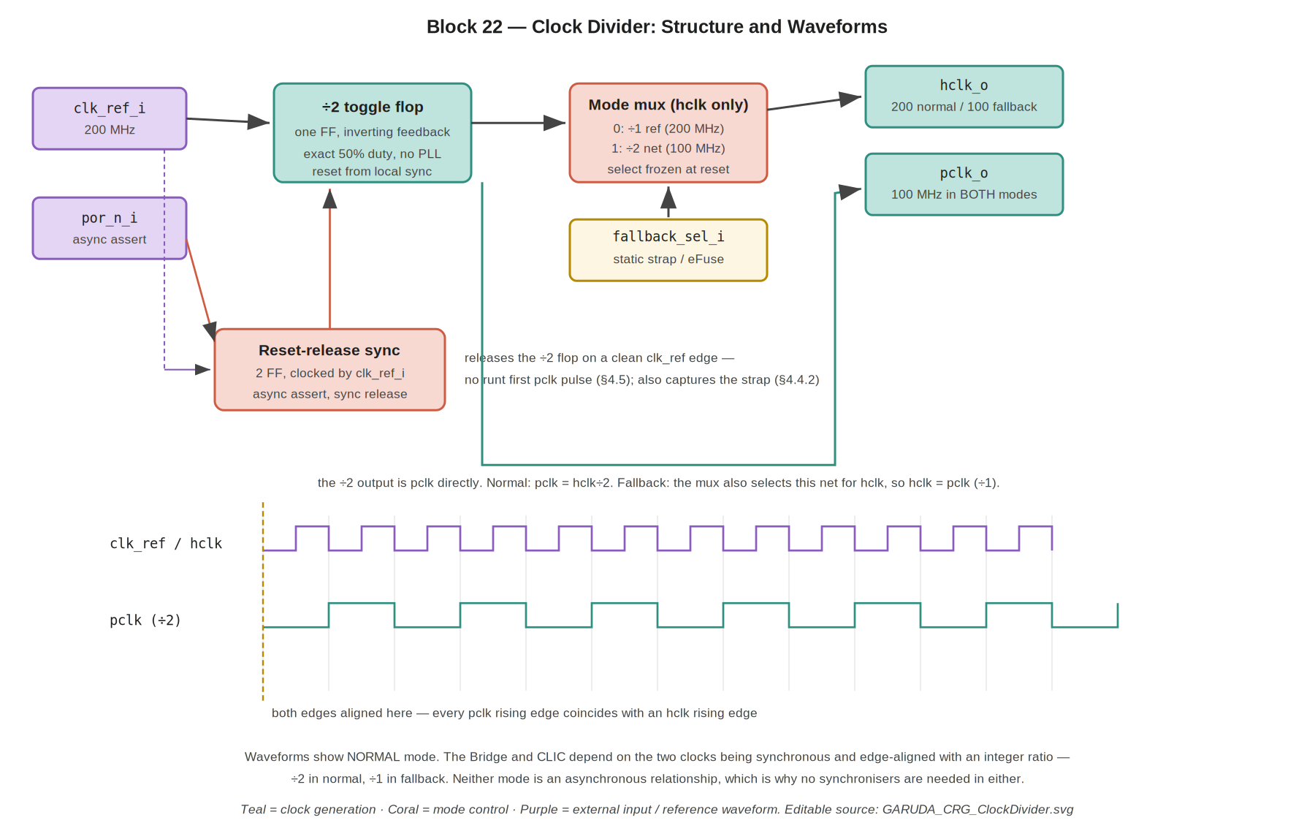
Figure 2 — Clock Divider structure and output waveforms, shown in normal mode (hclk 200 MHz, pclk 100 MHz). The local reset-release synchroniser (§4.5) releases the ÷2 flop on a clean clk_ref edge, so the first pclk pulse is full width. Every pclk rising edge coincides with an hclk rising edge. In fallback the mux selects the ÷2 net for hclk_o too, so both outputs become the same 100 MHz clock and the relationship is ÷1 rather than ÷2 (§4.2, §4.4.1); the waveforms below apply to normal mode. Editable source: GARUDA_CRG_ClockDivider.svg.

4.2 The clock relationship is a frozen contract (Normative)
Two released specifications have built their clock-domain-crossing arguments on the precise nature of the relationship between hclk_o and pclk_o, so it is a requirement on this block rather than an implementation choice. Because the relationship differs between normal and fallback operation, the contract is stated per mode:
- Bridge §13.4 / §13.4.1 treats pclk as a synchronous, integer-related generated clock of hclk and requires STA to model it with create_generated_clock and the correct source relationship, explicitly forbidding an asynchronous clock-group declaration.
- CLIC §5.1.1 goes further and instantiates no CDC synchronisers at all on its configuration path, on the strength of pclk being a ÷2 of clk_i from the same source.
Therefore, Normative — and the requirement is mode-aware: in BOTH modes hclk_o and pclk_o MUST be synchronous, edge-aligned, and derived from a single common source, with an integer frequency ratio. What differs between the modes is only the value of that ratio. Neither clock may ever be generated from a separate source, a separate PLL output, or a counter that could introduce an arbitrary phase. Any change that makes the two clocks asynchronous to each other breaks the CLIC’s no-synchroniser configuration path silently — that is, it would not fail in simulation, only in silicon.
Mode | hclk_o | pclk_o | Relationship | Edge alignment
Normal | 200 MHz (÷1 reference) | 100 MHz (÷2 net) | pclk_o is the ÷2 generated clock of hclk_o | Every pclk_o rising edge is coincident with an hclk_o rising edge
Fallback | 100 MHz (÷2 net) | 100 MHz (÷2 net) | ÷1 — the two outputs are the same 100 MHz clock net, not a divided pair | Trivially aligned: every pclk_o edge IS an hclk_o edge
Do not state or constrain a ÷2 relationship between hclk_o and pclk_o in fallback. There is no divider between them in that mode — they originate from one net (§4.4.1). Describing it as divide-by-2 would be simply wrong, and constraining it that way would have STA analysing a division that does not exist.
The property the Bridge and CLIC actually depend on is not “÷2” as such; it is that the two clocks are synchronous and edge-aligned with a known integer ratio, so that no metastability is possible on a path between the domains. That property holds in both modes. ÷1 is the degenerate case of the same contract, which is why fallback needs no special-casing in either consumer (Bridge §13.8, CLIC §5.1.1).

4.3 Signal interface
Signal | Dir | Width | Description
clk_ref_i | in | 1 | 200 MHz reference clock from the pad / external source
por_n_i | in | 1 | Raw asynchronous power-on reset. Asynchronously asserts the divider's local reset synchroniser; it does NOT directly clear the ÷2 flop (§3.3, §4.5).
fallback_sel_i | in | 1 | Static mode strap: 0 = normal (200/100), 1 = fallback (100/100). Driven from a pad strap or eFuse, NOT software. Sampled once during reset and frozen thereafter (§4.4).
hclk_o | out | 1 | Core-domain clock: 200 MHz normal (÷1 reference), 100 MHz fallback (the ÷2 net)
pclk_o | out | 1 | Peripheral clock: always the ÷2-of-clk_ref_i net, 100 MHz in both modes. Its ratio to hclk_o is ÷2 in normal and ÷1 in fallback (§4.2)
Names are proposed; adopt in RTL. Clock-tree buffering and balancing are a physical-design activity, not RTL: this block emits hclk_o and pclk_o as single nets and clock-tree synthesis distributes them (§6.2).

4.4 Fallback mode (Normative — frozen)
GARUDA supports a whole-chip fallback in which the core runs at half speed. Its purpose is to rescue the design if the 200 MHz core path fails to close timing in silicon. The frequency plan is frozen as follows:
Mode | hclk | pclk | Selected by
Normal | 200 MHz | 100 MHz | fallback_sel_i = 0 (default)
Fallback | 100 MHz | 100 MHz | fallback_sel_i = 1
The defining consequence: pclk remains 100 MHz in BOTH modes. Fallback reduces only the core clock. There is no second ÷2 in the peripheral path, and the peripheral clock frequency never changes.
This resolves an ambiguity in the TRM, which describes fallback as inserting “another div-2 in the core clock path”. Read literally, and with pclk continuing to be derived as ÷2 of the core tap, that would make pclk 50 MHz. That reading is rejected for two reasons, the second of which is decisive:
- It contradicts the Bridge specification, whose §13.8 already states that fallback is a single 100 MHz domain.
- It would silently break every peripheral. Peripheral timing configuration is computed against a 100 MHz pclk throughout the design — UART baud-rate divisors, SPI clock dividers, PWM period counts, the system timer’s 1 µs prescaler. Halving pclk would halve every one of those rates without any indication that it had happened. A fallback intended to rescue a core timing-closure problem must not also invalidate the configuration of every peripheral. Fallback changes only the thing that failed.
The TRM wording should be corrected to match this section.

4.4.1 Implementation (Normative)
pclk_o is always taken from the ÷2 output. hclk_o is taken from a mux that selects either the undivided reference (normal) or the same ÷2 output (fallback). In fallback the two outputs therefore originate from one net, which makes the ÷2 contract of §4.2 degenerate to ÷1 — an integer ratio from the same source, so the Bridge and CLIC assumptions hold in both modes without special-casing.
Clock-tree synthesis still builds separate balanced trees for hclk and pclk, since their load sets differ. In fallback those two trees are driven from the same source and CTS must balance them against each other so the edge alignment of §4.2 survives at the leaves.

4.4.2 Mode select is a static strap, sampled at reset (Normative)
fallback_sel_i is a static input driven from a pad strap, an eFuse, or an equivalent boot-time configuration source. It is NOT a software-writable register, and in particular there is no APB-accessible configuration register inside this block. Placing one here would put the register behind a bus whose own clock this block generates, and would mean the write that changes the clock is itself carried on the clock about to change — both avoidable problems, avoided by not doing it.
The select is sampled once and frozen. fallback_sel_i is captured into a flop clocked by clk_ref_i while the divider is still held in its local reset (§4.5), and the mux is driven from that captured value. Because clk_ref_i is running before the ÷2 flop is released, the capture completes before either output clock is live, and the mux select is thereafter constant for the entire operating life of the chip.
This matters more than it may appear. It converts “the select is static, so a simple mux is safe” from a promise about how the input will be driven into a property guaranteed by the block itself. A noisy strap, a slowly-settling eFuse read, or a future integrator who wires the input to something less static cannot produce a mid-operation clock switch, because the block stops listening to the input once reset releases.

4.5 Local reset-release synchroniser (Normative)
The divider contains a two-flop reset-release synchroniser clocked by clk_ref_i. Its structure is the conventional one: a constant 1 is shifted through two flops whose asynchronous clear is por_n_i, and the second flop's output is the internal reset that clears the ÷2 flop.
Behaviour: por_n_i low clears both synchroniser flops and therefore holds the ÷2 flop cleared, asynchronously and with no clock required. When por_n_i releases, the synchroniser output rises two clk_ref_i edges later, on a clean edge, so the ÷2 flop's reset release meets recovery and removal by construction. The ÷2 flop therefore never samples an asynchronously released reset — which is the property being bought here. Metastability is never literally impossible in silicon; the point is that the unresolved event is confined to the synchroniser's first flop, where a full clk_ref_i period is available to settle it, rather than occurring on the clock generator itself (§3.3).
The same reset window is used to capture the fallback strap (§4.4.2): fallback_sel_i is sampled by a clk_ref_i-clocked flop while the ÷2 flop is still held, so the mode select is frozen before either output clock goes live.
This synchroniser must be inside Block 22 and clocked by clk_ref_i. It must not be replaced by a reset from Block 23, which would reintroduce the circular dependency, and it must not be omitted on the grounds that the ÷2 flop is “just a toggle” — the whole point is that this particular toggle is the clock source.

4.6 Mode mux and the runtime-switching guard (Normative)
Because the mux select is captured at reset and cannot change while the clocks are live (§4.4.2), the core-tap mux MAY be a simple combinational mux. No glitch-free clock-switching structure is required, and none should be implemented: it would be dead logic guarding a transition that cannot occur.
Conditional guard, retained deliberately. If any future revision makes the mode select changeable while the clocks are running — from software, from a debug interface, or from anything else — then a glitch-free clock mux becomes mandatory at that moment. Switching between two live clocks with a plain combinational mux can emit a runt pulse that violates the minimum pulse width of every flop downstream and corrupts state across the whole SoC. The required structure is the standard one: each clock input gated by a flop synchronised into its own domain, with one path’s enable removed and allowed to settle before the other is enabled, so the output is held static through the changeover. A stretched cycle at the switch point is acceptable; a short pulse is not.
This paragraph is kept in the specification precisely so that the requirement is not rediscovered the hard way. Runtime switching is out of scope today; if it is ever added, it must not be added without this.

5. Clock Divider — Reset and Verification

5.1 Reset behaviour
por_n_i asserted asynchronously clears both the local reset synchroniser and, through it, the ÷2 flop — no clock is required for assertion. On release, the synchroniser holds the ÷2 flop cleared for two further clk_ref_i edges and then releases it synchronously (§4.5), so the flop begins toggling on a clean edge with no possibility of a runt first pulse. This also gives a deterministic startup phase: pclk_o always begins its first high period on a known hclk_o edge, so the edge alignment the Bridge and CLIC depend on is established from the very first cycle rather than being a property that settles later.
This block has no other state. It does not need, and must not be given, a synchronously de-asserted reset.

5.2 Verification
Area | Checks
Frequency and duty | Measure hclk_o = 200 MHz and pclk_o = 100 MHz; confirm pclk_o duty cycle is exactly 50% (it must be, being a toggle flop — assert it anyway to catch a counter-based implementation slipping in).
Edge alignment (normal) | With fallback_sel_i = 0, assert that every pclk_o rising edge coincides with an hclk_o rising edge and that the ratio is exactly 2. This is the property §4.2 makes normative for normal mode and the one that silently breaks the CLIC if lost.
Startup phase | Release por_n_i at several different points relative to clk_ref_i and confirm the first pclk_o period is identical every time — deterministic starting phase (§5.1).
Reset assertion | Assert por_n_i mid-operation with clk_ref_i running and also with it stopped; confirm the ÷2 flop clears in both cases and that pclk_o shows no short pulse during or after assertion.
Reset release (recovery/removal) | Release por_n_i at a fine sweep of phases relative to clk_ref_i, including deliberately inside the recovery/removal window of the synchroniser's first flop. Confirm pclk_o's first pulse is always full-width and the startup phase is identical every time. This is the test that would have caught the raw-POR release removed in §3.3; it must be run at gate level with timing, not RTL only.
Fallback frequencies | Strap fallback_sel_i = 1 and confirm hclk_o = 100 MHz and pclk_o = 100 MHz. Strap = 0 and confirm 200/100. In BOTH modes confirm pclk_o is 100 MHz — the property §4.4 exists to guarantee (a regression here silently breaks every peripheral's timing configuration).
Strap capture and freeze | Confirm fallback_sel_i is sampled during reset and that changing it AFTER reset release has no effect on either output clock. Toggle it repeatedly post-reset and assert both clocks are undisturbed — this verifies the freeze in §4.4.2 and is what makes the simple mux safe.
Edge alignment (fallback) | With fallback_sel_i = 1, confirm hclk_o and pclk_o are the same 100 MHz clock — ratio exactly 1, every edge coincident. Assert that the testbench does NOT expect a ÷2 ratio in this mode; a check written for normal mode will incorrectly fail here (§4.2).
STA note — constraints are mode-aware. Each mode must be constrained and analysed as its own timing scenario; a single set of constraints cannot describe both, because the relationship between the two outputs differs.
- Normal mode: declare pclk_o as a generated clock derived from the hclk_o source with divide_by 2. Cross-domain paths are then analysed against the real ÷2 relationship.
- Fallback mode: hclk_o and pclk_o are the same 100 MHz net. Constrain them as one clock — or, if the implementation keeps them as separately named nets for tree-balancing purposes, declare pclk_o as a generated clock of that net with divide_by 1 and require CTS to balance the two trees against each other (§4.4.1). Do NOT declare divide_by 2 here.
In neither mode may hclk_o and pclk_o be declared asynchronous clock groups. Two blocks have explicitly chosen not to instantiate synchronisers on the strength of the synchronous relationship (Bridge §13.4.1, CLIC §5.1.1); declaring the clocks unrelated, or failing to declare the relationship at all, leaves real setup paths in those blocks unchecked.

Part III — Block 23: Reset Controller
Self-contained specification of the Reset Controller. The only external dependency is the interface contract in §3.

6. Reset Controller — Functional Specification

6.1 Purpose
The Reset Controller collects every reset source in the SoC, qualifies them into a single system-reset event, and distributes that event to the two clock domains as hreset_n and preset_n. Its entire reason for existing is the asymmetry between how a reset must be applied and how it must be removed: asserted immediately and asynchronously so the chip reaches a known state even if the clock is dead, but removed synchronously so that every flop in a domain leaves reset on the same clock edge.
Without synchronous de-assertion, flops near the reset driver would leave reset an edge earlier than flops far from it, so part of the chip would begin executing while the rest was still held — producing corrupted state on the first cycle with nothing to indicate why.

6.2 Reset sources
Source | Type | Origin | Notes
por_n_i | Asynchronous, active-low | External reset pad / power-on reset | The primary reset. Asserted during power ramp and by an external reset assertion.
wdt_reset_i | Synchronous pulse, active-high | Watchdog Timer (Block 19) | Fires when the watchdog counter reaches zero because firmware failed to feed it — a deliberate whole-chip recovery from a hung system (TRM Block 19).
Both sources produce the same outcome: a full system reset of both domains. There is no partial or per-block reset in GARUDA, and no reset source is maskable.

6.3 Signal interface
Signal | Dir | Width | Description
por_n_i | in | 1 | Raw asynchronous power-on / external reset, active-low
wdt_reset_i | in | 1 | Watchdog reset request, active-high, hclk domain (Block 19)
hclk_i | in | 1 | 200 MHz clock, used to synchronise hreset_n_o de-assertion
pclk_i | in | 1 | 100 MHz clock, used to synchronise preset_n_o de-assertion
hreset_n_o | out | 1 | hclk-domain reset, active-low, async assert / sync de-assert
preset_n_o | out | 1 | pclk-domain reset, active-low, async assert / sync de-assert
Names are proposed; adopt in RTL. Reset-tree buffering and balancing are a physical-design activity; this block emits one net per domain.

7. Reset Controller — Behaviour

7.1 Source qualification
The two sources are combined into one internal active-low term, rst_n_qual, which is low when por_n_i is low OR wdt_reset_i is high. That term drives the asynchronous reset input of both domain synchronisers, which is what makes assertion simultaneous across the chip (§3.2).

7.2 Assertion (Normative)
When rst_n_qual goes low, hreset_n_o and preset_n_o go low immediately and asynchronously, with no dependence on either clock. This is what guarantees the chip reaches a known state even if a clock has stopped — which is precisely the condition a watchdog reset may be recovering from.

7.3 De-assertion (Normative)
When rst_n_qual returns high, each domain releases its reset through an independent two-flop synchroniser clocked by that domain's clock. The synchroniser shifts a constant 1 through two flops whose asynchronous clear is rst_n_qual; its output is the domain reset. The effect is that the reset is released two clock edges after the source releases, on a clean clock edge, simultaneously for every flop in that domain.
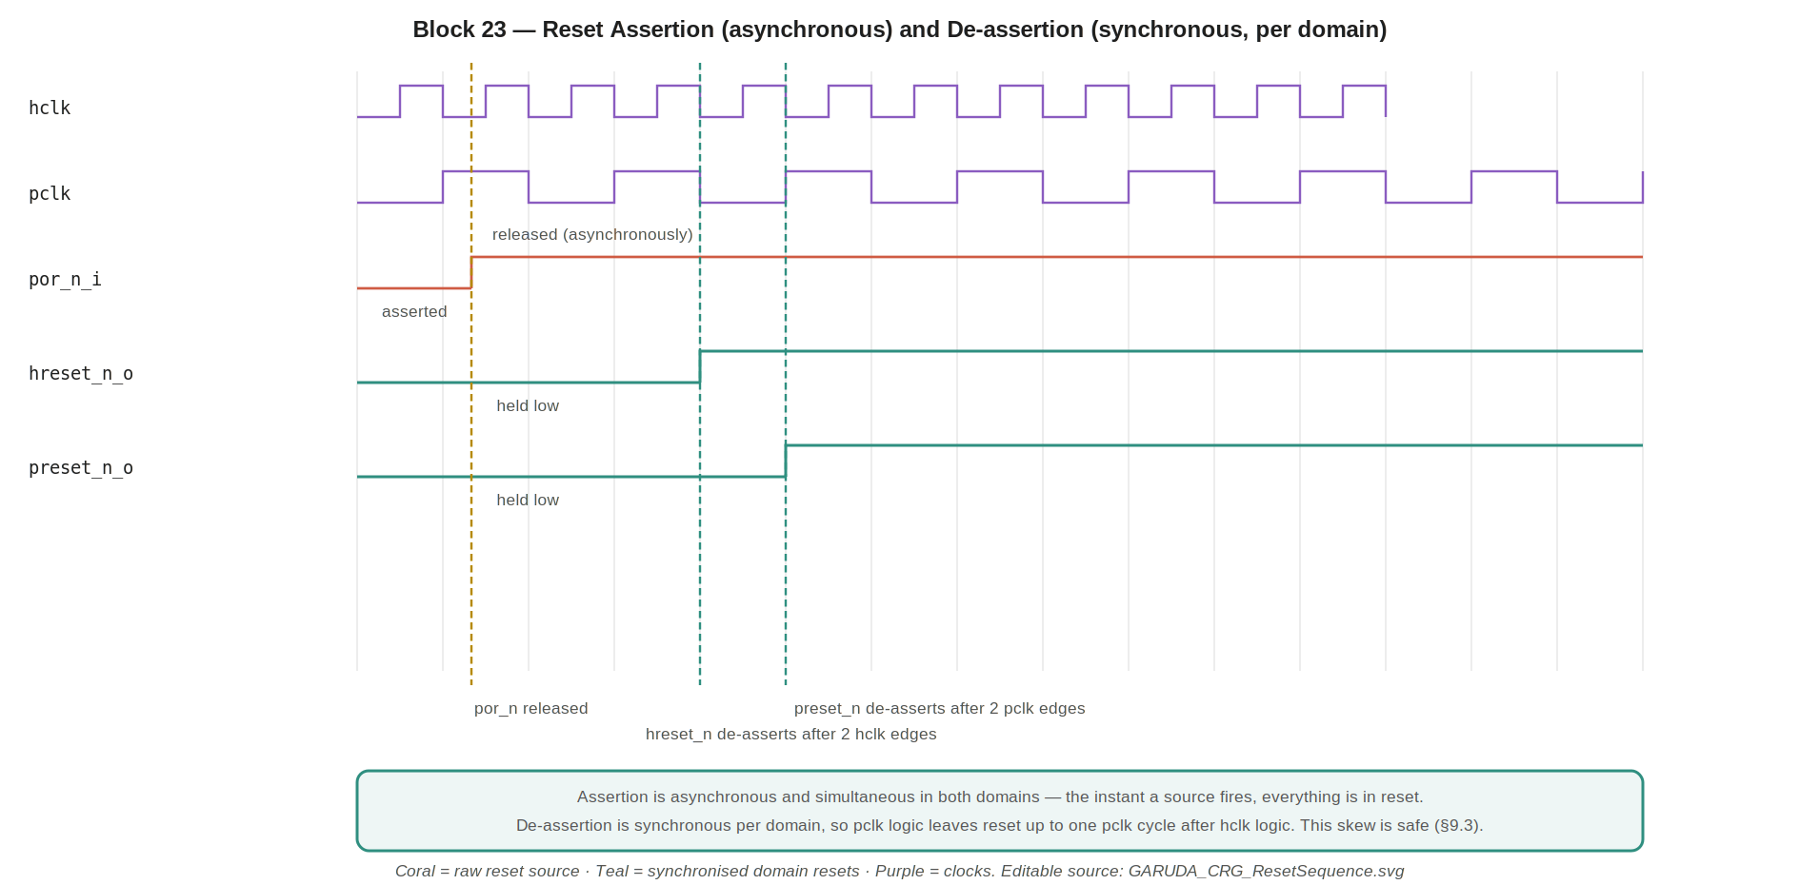
Figure 3 — Reset assertion is asynchronous and simultaneous in both domains; de-assertion is synchronous per domain, so preset_n_o can release up to one pclk cycle after hreset_n_o. Editable source: GARUDA_CRG_ResetSequence.svg.

7.4 Why two flops
The source release is asynchronous to both clocks, so the first flop may go metastable when it samples the release. The second flop gives it a full clock period to resolve before the value is used. Two stages is the baseline synchroniser depth for this design. Depth cannot be justified from clock frequency alone: the final depth shall be confirmed against the 28 nm library's metastability parameters at sign-off, taking the source event rate and the required MTBF into account, in the same way as the Bridge's CDC synchronisers. If that analysis calls for three stages, adding one is a trivial change here and should be made rather than argued against.

8. Reset Controller — Analysis and Open Items

8.1 De-assertion skew between domains
Because each domain synchronises against its own clock, hreset_n_o releases after two hclk edges and preset_n_o after two pclk edges. Since pclk runs at half the rate, preset_n_o can release up to one pclk period (10 ns) after hreset_n_o, so hclk-domain logic begins running while pclk-domain logic is still held.
This is safe, and the argument is a system-level one. The two domains interact only through the AHB-to-APB bridge. During the skew window the bridge's pclk side is still held in reset, so no APB transfer can be initiated or completed in that interval — the peripheral bus is simply inert. How the bridge handles an AHB access that arrives before its pclk side is ready is defined by the bridge's own reset specification (Bridge §10), not by this document; this specification asserts only that the window exists, is bounded at one pclk period, and leaves the APB side incapable of completing a transfer.
In practice the window is not exercised at all. After reset release the core fetches the reset vector from the Boot ROM, which is an hclk-domain slave (Memory §10.2), and the first peripheral access does not occur until the bootloader initialises the SPI controller many cycles later. The skew is therefore closed long before any master targets the APB region.

8.2 Watchdog reset and the reset loop
A watchdog reset must clear the watchdog's own counter, or the chip would immediately re-reset and never boot. The watchdog counter is therefore reset by hreset_n like any other hclk-domain flop, which breaks the loop: the reset event clears the counter, the counter reloads to its timeout value on release, and firmware has a full timeout period to feed it before the next expiry (TRM Block 19).
It is worth noting explicitly that this makes the watchdog reset self-clearing and non-latching. There is no status bit in this block recording that the last reset came from the watchdog. If firmware needs to distinguish a watchdog reset from a power-on reset — which a flight controller plausibly does, in order to log the event or enter a degraded mode — that requires a reset-cause register that survives the reset it is recording, which this block does not have. See §8.5.

8.3 Reset and the memories
Reset clears flop state, not memory arrays. The SRAM contents are undefined after power-up and are not initialised by reset (Memory §10.1); the Boot ROM's contents are fixed in metal and are valid immediately. This is why the reset vector points into ROM: it is the only memory guaranteed to hold valid data at the instant reset releases.

8.4 Verification
Area | Checks
Asynchronous assertion | Assert por_n_i with hclk and pclk both stopped; confirm hreset_n_o and preset_n_o go low regardless. This is the property that cannot be verified with a running clock only.
Simultaneous assertion | Confirm hreset_n_o and preset_n_o assert in the same instant for every source (§3.2) — the Bridge depends on this.
Synchronous de-assertion | Release por_n_i at many different phases relative to both clocks; confirm each output de-asserts only on an edge of its own clock, always two edges after release, never asynchronously.
Inter-domain skew | Measure the hreset_n_o to preset_n_o de-assertion gap; confirm it never exceeds one pclk period and that no bus activity occurs in the window (§8.1).
Watchdog path | Drive wdt_reset_i; confirm a full system reset and that the watchdog counter is itself cleared so the chip boots rather than looping (§8.2).
Reset during operation | Assert each source mid-transaction on the AHB and APB buses; confirm all blocks return to their reset state and the first post-reset access is clean (joint test with the Bridge and memories).
Metastability | Formal or gate-level check that no path bypasses the two-flop synchroniser on the de-assert path, and that the asynchronous assert path reaches every output without a clocked element in the way.

8.5 Reset-cause reporting — scoped out
Recommended position: out of scope for the first tapeout. As specified, firmware cannot tell why the chip reset. That is a real capability gap — a watchdog reset in flight is a serious event that arguably should be logged or trigger a degraded mode, whereas a power-on reset is routine — but it is a new requirement rather than a defect in this block.
Implementing it is not a wording change. A reset-cause register must survive the reset it records, so it would need either a separate always-on reset domain or a flop set by wdt_reset_i and cleared only by por_n_i, and it raises the question of whether GARUDA has an always-on domain at all. Speculative infrastructure for an undecided requirement is exactly what should not go into a block this small.
Therefore, unless the system architect states otherwise before RTL: reset-cause reporting is out of scope for the first tapeout, Block 23 contains no status register, and firmware will not attempt to distinguish a watchdog reset from a power-on reset. If the distinction is later required it becomes its own small design addition with its own reset-domain specification.

9. What These Blocks Do Not Contain
Absent | Why
PLL / DLL / clock multiplication | The 200 MHz reference arrives from outside; only division is performed, by one flop (§4.1).
Clock gating for power management | No low-power modes are specified for the first tapeout. Any future gating must preserve the §4.2 edge relationship.
Partial, per-block or soft reset | Every reset is a full system reset of both domains (§6.2).
Maskable reset sources | Neither source can be disabled; a maskable watchdog reset would defeat its purpose.
Reset-cause register | Not present — flagged as an open decision (§8.5).
Clock and reset tree buffering | Physical-design activity; these blocks emit one net each (§4.3, §6.3).
Any bus interface | Neither block is a bus slave. The divider's mode select is a signal input, not a register in this block (§4.4).
A reset input from Block 23 on the divider | Deliberately absent — the divider resets itself from por_n_i via its own synchroniser, which is what prevents the bootstrap circularity (§3.3, §4.5).
Runtime clock switching | The fallback select is frozen at reset, so no glitch-free switching structure is implemented. The requirement that would apply if this changed is retained in §4.6.
A second ÷2 in the peripheral path | pclk is 100 MHz in both modes; fallback halves only the core clock (§4.4).

10. Appendix

10.1 Acronyms
Term | Meaning
CRG | Clock and Reset Generation — the collective name for Blocks 22 and 23
POR | Power-On Reset
Async assert / sync de-assert | Reset applied immediately without a clock, removed on a clock edge
Generated clock | A clock derived from another by division, with a known fixed integer relationship. In GARUDA the ratio is ÷2 in normal mode and ÷1 in fallback (§4.2)
Glitch-free mux | A clock multiplexer that cannot produce a runt pulse when switching (§4.6)
MTBF | Mean time between failures — the correct metric for synchroniser reliability (§7.4)

10.2 Cross-references
Block / doc | Relationship
8 — AHB-to-APB Bridge §13.4, §13.4.1, §13.8, §10.1 | Depends on the ÷2 generated-clock relationship and on coordinated reset assertion. Bridge §13.8's single-100 MHz-domain fallback assumption is now confirmed by the frozen §4.4 plan
16 — CLIC §5.1.1 | Instantiates no CDC synchronisers on its configuration path on the strength of §4.2 — the most safety-critical consumer of this contract
3/4/5 — Memory Subsystem §10 | Async-assert / sync-de-assert resets; arrays not cleared by reset; reset vector in ROM
1 — RV32IM Core §3 | PC loads 0x1000_0000 out of reset; first fetch follows reset de-assertion
19 — Watchdog Timer | Drives wdt_reset_i; its counter is cleared by the resulting reset (§8.2)
6 — AHB-Lite Interconnect | hclk-domain consumer; its hready gating is what absorbs the de-assertion skew (§8.1)
— End of Clock & Reset Generation Design Specification —

