GARUDA SoC
CLIC Design Specification
Core-Local Interrupt Controller — RISC-V CLIC-mode, 8 encoded levels, preemptive nesting
Document ID | GARUDA-CLIC-SPEC-001
Revision | 2.0
Date | 2026-09-14
Status | Draft — RTL-ready (aligned to frozen core interrupt boundary & DMA interrupt contract)
Owner | Team AeroSoC
Target process | 28 nm CMOS
Bus domain | APB v3 slave (config, 100 MHz); combinational/registered interrupt fabric to the core (200 MHz)
Classification | Internal Use Only

Revision History
Version | Date | Author | Description
1.0 | — | Team AeroSoC | CLIC described inline in the TRM (architecture: IP/IE/priority/threshold registers, nesting, vectored/non-vectored).
2.0 | 2026-09-14 | Team AeroSoC | CLIC as a standalone block, aligned to the frozen core interrupt interface (core §4.1 CLIC interface, §14.3 take condition and acknowledge handshake) and the DMA interrupt contract (12 level-sensitive lines, W1C at the source; DMA §10). Full source map, register map with bit-fields, max-priority arbiter, strictly-greater preemption rule, selective hardware vectoring (shv), and the level-sensitive re-fire semantics. Cross-checked against GARUDA-CORE-SPEC-001 §4.1/§14 and GARUDA-DMA-SPEC-001 §5.5/§10.

1. Scope and Purpose

1.1 Block identification
Attribute | Value
Block name | CLIC — Core-Local Interrupt Controller
Block number | 16 of 24
Category | Interrupt controller (RISC-V CLIC-mode)
What it is | The one external interrupt controller in GARUDA. It collects every peripheral interrupt line, applies enable/priority/threshold policy, and presents the single highest-priority pending source to the CPU core over the frozen CLIC interface.
What it is not | Not the core's trap CSRs. The core's mstatus/mie/mip/mtvec/mcause/mepc logic (core §13) lives inside Block 1 and every RISC-V hart has it; that is the core's privileged trap plumbing, not a second CLIC. This block is the external controller that drives clic_irq_i into that plumbing.
Config interface | APB v3 slave (behind the AHB-to-APB bridge, Block 8), pclk 100 MHz
Core interface | Dedicated sideband to the core: clic_irq / _id / _lvl / _shv out; ack / id_ack / mintthresh in (core §4.1). Not a bus.
Interrupt levels | 8 (3-bit), 0–7; level 0 never interrupts
Nesting | Preemptive. 8 encoded levels (0–7), but level 0 never interrupts, so at most 7 handlers can be stacked (§7.4, core §14.3)
Reset | preset_n_i (config domain); interrupt fabric follows the core clock/reset. Active-low, synchronous de-assert, Block 23.

1.2 Functional role in GARUDA
When a peripheral needs the CPU's attention — the DMA finished a sensor transfer, a UART received a byte, the system timer ticked — it raises an interrupt line. Dozens of such lines exist across the SoC. The CLIC is the block that turns that thicket of lines into a single, prioritised, maskable request the CPU can act on deterministically.
Concretely it does four things: it collects all interrupt source lines; it filters them by a software-programmed enable and by a per-source priority level; it finds the single highest-priority source that is pending and enabled; and it presents that source's id and level to the core, asserting the request only if the level clears the core's current threshold. When the core takes the interrupt it pulses an acknowledge back, which the CLIC uses to clear that source's pending state.
The DMA→CPU path this project cares about is one instance of the general mechanism: the DMA raises dma_irq[n] (transfer complete) or dma_err[n] (bus error); the CLIC treats each as a source; if enabled and high-enough priority it presents that source to the core; the core vectors to the ISR, which clears the DMA's SR flag (W1C) so the level-sensitive line drops. That worked example runs throughout this document (§8.5, §10.4).

1.3 Design goals
Goal | How it is met
Deterministic latency | Priority resolution is a combinational reduction tree registered once; from a source going pending to clic_irq asserted is a fixed, small cycle count independent of which source or how many are pending (§9).
Correct RISC-V CLIC-mode behaviour | Implements the take condition, acknowledge handshake, selective hardware vectoring (shv) and strictly-greater-than level preemption exactly as the core spec defines them (core §14.3), so hardware and the M-mode software model agree.
No priority inversion / no starvation of urgent sources | A strictly higher level always wins and can preempt a running lower-level handler; the flight-critical sources (IMU-via-DMA, system timer) sit at the top levels (§7.4).
Glitch-free request to the core | The presented id/level and the request line are registered, so the core never samples a mid-resolution transient (§7.3).
Level-sensitive by default, edge where needed | Matches how GARUDA peripherals signal: the DMA and most peripherals hold a level until firmware clears the source (DMA §10.2); per-source attribute allows edge for pulse sources (§6.4).
Small | One pending/enable/priority register set per source plus one reduction tree; no CAM, no per-source microcode (§16).

1.4 Compliance (Normative)
RISC-V CLIC specification (draft), M-mode only, as referenced by the core spec (core §1, §14.3). Two obligations are load-bearing:
- Take condition (Normative). The core takes the presented interrupt only when clic_irq_i is high, mstatus.MIE is set, clic_irq_lvl_i is strictly greater than mintthresh, and strictly greater than the active handler's level. Both comparisons are strictly-greater-than. The CLIC's job is to present the correct highest source and level; the core evaluates the condition. The CLIC must never present a level-0 source or an id that does not correspond to the level on clic_irq_lvl_i (core §14.3).
- Acknowledge handshake (Normative). clic_irq_ack_i / clic_irq_id_ack_i are a one-cycle pulse from the core naming the taken id. The CLIC MUST use them to clear the pending/edge state of exactly that source, and MUST NOT clear any other source. For a level-sensitive source whose line is still asserted, pending re-asserts on the next cycle — this is intended (§8.4).

2. Feature Summary
Feature | Specification
Interrupt sources | Up to 32 (parameter CLIC_N). GARUDA populates 12 from the DMA (dma_irq[5:0], dma_err[5:0]) plus peripheral and timer lines (§4)
Interrupt id width | 12 bits on the core interface (clic_irq_id), matching core §4.1; only CLIC_N ids are used
Levels | 8 (3-bit priority per source), 0–7; level 0 = never interrupts
Trigger types | Per-source: level-sensitive (default) or edge (rising), via clicintattr.trig (§6.4)
Arbitration | Max over {level, id-tiebreak}: highest level wins; lowest id breaks a level tie; single-cycle combinational reduction tree, registered output (§7)
Preemption / nesting | Preemptive; a strictly-higher level interrupts an active handler. Maximum nesting depth is 7 active handlers — 8 encoded levels minus level 0, which never interrupts (§7.4)
Vectoring | Both supported: non-vectored (all traps to mtvec.base) and selective hardware vectoring (shv per source, via mtvt) (§8.6)
Threshold | Core presents mintthresh; CLIC/core mask any source at or below it (strictly-greater to interrupt)
Config interface | APB v3 slave, pclk 100 MHz, behind the bridge (Block 8)
Core interface | clic_irq/_id/_lvl/_shv out; clic_irq_ack/_id_ack/mintthresh in (core §4.1). Sideband, not a bus.
Clearing | Acknowledge clears pending; level sources re-fire until the peripheral source is cleared (e.g. DMA SR W1C) (§8.4, DMA §10.2)

3. Block Diagram

3.1 Internal sub-blocks
Sub-block | Type | Function
APB Slave I/F | comb.+seq. | Config port (pclk). Decodes register reads/writes: per-source ip/ie/attr/priority. Threshold is presented by the core, not stored here (§6).
Per-Source Conditioning | seq. | For each source: edge-detect (if attr.trig=edge) or level-pass; drive the pending bit clicintip[i] (§8.1).
Pending / Enable / Priority registers | seq. | clicintip[i], clicintie[i], and a 3-bit level per source. The programmable policy state.
Max-Priority Arbiter | comb. | For each source, form active = ip & ie and a sort key {level, ~id}; a reduction tree selects the maximum → winner id, level, shv (§7.2).
Winner register | seq. | Registers winner id/level/shv so the core sees a glitch-free, stable presentation (§7.3).
Take-Condition / Vectoring | comb. | Compares winner level to mintthresh, drives clic_irq and presents id/level/shv; the final take decision is the core's (§8.6).
Acknowledge capture | seq. | On clic_irq_ack_i, clears the pending/edge state of clic_irq_id_ack_i (§8.4).
Core Interface | — | The frozen sideband to Block 1 (§5.2).

3.2 Structure
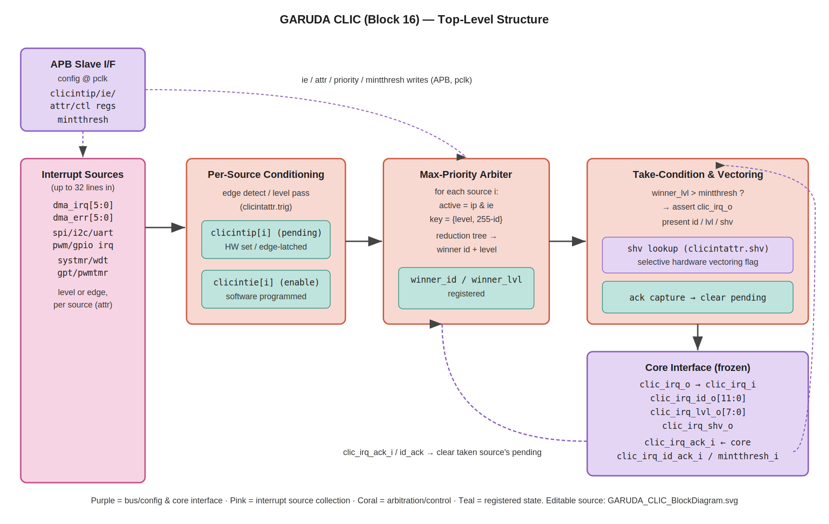
Figure 1 — Top-level CLIC. Pink = interrupt source collection; teal = registered state (pending/enable/winner); coral = conditioning and arbitration/control; purple = config (APB) and the frozen core interface. Editable source: GARUDA_CLIC_BlockDiagram.svg.

3.3 Suggested RTL module hierarchy
Module | Role
clic_top.v | Block boundary; instantiates the sub-blocks; holds parameters CLIC_N, level width
clic_apb_regs.v | APB slave: ip/ie/attr/priority register file (pclk)
clic_source_cond.v | Per-source edge/level conditioning → pending
clic_arbiter.v | active = ip & ie; key = {level,~id}; reduction tree → winner
clic_present.v | Winner register + take-condition compare + shv presentation
clic_ack.v | Acknowledge capture and pending clear
Naming note: register-block and internal signal names follow the RISC-V CLIC draft (clicintip/ie/attr) and are proposed; adopt in RTL. The core-facing signal names (clic_irq*, mintthresh) are frozen by the core boundary and are matched exactly (§5.2).

4. External Connectivity Map
Authoritative for top-level integration. The CLIC has three edges: a config port (APB, from the bridge), a fan-in of interrupt source lines (from every interrupting peripheral), and the dedicated core interface.
Peer block | Direction | Interface | Notes
RV32IM Core (Block 1) | CLIC ↔ Core | clic_* sideband | Frozen interface (core §4.1); request out, acknowledge in (§5.2)
AHB-to-APB Bridge (Block 8) | Bridge → CLIC | APB slave | Config-register access (ie/attr/priority); one 4 KB window
DMA Controller (Block 9) | DMA → CLIC | dma_irq[5:0], dma_err[5:0] | 12 level-sensitive sources; W1C at the DMA clears the line (DMA §10)
SPI/I²C/UART/PWM/GPIO (10–15) | → CLIC | one line each (or more) | Peripheral RX/TX/done/error interrupts; GPIO edge interrupts
System Timer (Block 18) | → CLIC | tick line | 1 ms tick at the top level (TRM Block 18 places it at level 7)
Watchdog / PWM / GP timers (19–21) | → CLIC | one line each | Timer expiry / capture interrupts
Clock Divider (Block 22) | → CLIC | clk, pclk | Core-domain clock for the fabric; pclk for the APB config port
Reset Controller (Block 23) | → CLIC | reset_n / preset_n | Active-low, synchronous de-assert
The RISC-V per-hart software interrupts (MSIP) and the machine timer interrupt (from mtime/mtimecmp) are handled by the core's own CSR logic (core §13, §4.1 memory-mapped timer) and do not pass through this CLIC; this block handles the external/peripheral sources. The PLIC (Block 17) is a minimal platform-level counterpart for Option-2 compliance and, in this single-core SoC, all external interrupts route through the CLIC (TRM Block 17).

5. Signal Interface

5.0 Naming convention
House style: lower-case, _i/_o for direction, _n active-low. The core-facing names below are stated from the CLIC's point of view (so the CLIC's request output clic_irq_o connects to the core's input clic_irq_i). The mapping to the core's frozen names (core §4.1) is given explicitly in §5.2. APB and source names are proposed for adoption in RTL.

5.1 Clock and reset
Signal | Dir | Width | Description
clk_i | in | 1 | Core-domain clock, 200 MHz — the interrupt fabric and all core-facing presentation run here
reset_n_i | in | 1 | Fabric reset, active-low, asynchronous assert / synchronous de-assert
pclk_i | in | 1 | APB config clock, 100 MHz. Generated by Block 22 as a ÷2 of clk_i from the same source — a synchronous, integer-related generated clock, not an independent asynchronous clock (§5.1.1)
preset_n_i | in | 1 | APB-side reset, active-low, asynchronous assert / synchronous de-assert; coordinated with reset_n_i (Block 23)

5.1.1 Clock relationship and the configuration boundary (Normative)
The CLIC spans two clocks: the APB configuration port runs on pclk_i (100 MHz) and the interrupt fabric — conditioning, arbiter, winner register and all core-facing presentation — runs on clk_i (200 MHz). The programmed state (clicintip/ie/attr/ctl) is written in the pclk_i domain and read every cycle by the arbiter in the clk_i domain, so that boundary must be defined rather than assumed.
The architectural decision is that these clocks are treated as synchronous and related, and no CDC synchronisers are instantiated on the configuration path. Block 22 derives pclk_i by dividing clk_i by two with a single flip-flop from the same source, so the two are edge-aligned with a fixed integer ratio. Every clk_i edge is therefore in a known phase relationship to every pclk_i edge, there is no possibility of metastability on a path between them, and the configuration registers can be read combinationally by the arbiter as ordinary synchronous timing paths.
Two consequences follow and both are requirements, not observations:
- STA must model the relationship. pclk_i is constrained as a generated ÷2 clock of clk_i with the correct source relationship. The pclk_i-launched configuration registers to clk_i-capturing arbiter logic form real, analysable synchronous paths (effectively a two-cycle launch into a one-cycle capture) and must be timed as such. They must NOT be declared false paths or asynchronous clock groups — doing so would leave a genuine setup path unchecked.
- Update atomicity is per-register and benign. All bits of a given configuration register launch on the same pclk_i edge, so a clk_i sample sees either the complete old value or the complete new value, never a mixture. The arbiter re-evaluates every cycle, so a configuration change that lands between two clk_i edges simply takes effect on the next evaluation — one clk_i cycle of skew between “firmware wrote the enable” and “the arbiter honours it”, which is architecturally invisible because an interrupt presented one cycle later is indistinguishable from one that became pending one cycle later.
If the clock relationship ever changes — for example if a future configuration drives pclk_i from an independent source rather than a ÷2 of clk_i — this assumption is void and the configuration path would require proper CDC: a two-flop synchroniser per crossing bit is adequate here because each configuration bit is independently meaningful (there is no multi-bit value whose bits must change atomically across the boundary, since a partially-updated LEVEL field only ever mis-prioritises for one cycle and cannot corrupt state). That is a specification change, not an RTL decision.

5.2 Core interface (frozen — maps to core §4.1)
These connect one-to-one to the core's CLIC interface. The core-side name is the frozen name; the CLIC-side name is this block's port.
CLIC port | Dir | Width | Core-side (frozen) | Description
clic_irq_o | out | 1 | clic_irq_i | Interrupt request pending (level): a source is active, enabled, and above the presented threshold
clic_irq_id_o | out | 12 | clic_irq_id_i | Id of the highest-pending source
clic_irq_lvl_o | out | 8 | clic_irq_lvl_i | Level of that source (3-bit level zero-extended to 8)
clic_irq_shv_o | out | 1 | clic_irq_shv_i | 1 = selective hardware vectoring for this source (via mtvt)
clic_irq_ack_i | in | 1 | clic_irq_ack_o | Core took the interrupt (1-cycle pulse)
clic_irq_id_ack_i | in | 12 | clic_irq_id_ack_o | Id being acknowledged
mintthresh_i | in | 8 | clic_mintthresh_o | Current interrupt-level threshold from the core CSR

5.3 APB config port (proposed; adopt in RTL)
Signal | Dir | Width | Description
psel_i | in | 1 | APB select for the CLIC window
penable_i | in | 1 | APB enable (ACCESS phase)
paddr_i | in | 12 | Register offset within the CLIC window
pwrite_i | in | 1 | 1 = write, 0 = read
pwdata_i | in | 32 | Write data
prdata_o | out | 32 | Read data
pready_o | out | 1 | APB ready (single-cycle access; tie high after ACCESS)
pslverr_o | out | 1 | Error on access to an undefined register offset

5.4 Interrupt source inputs
Signal | Dir | Width | Description
irq_src_i | in | CLIC_N | Flat vector of source lines. GARUDA mapping: [5:0]=dma_irq, [11:6]=dma_err, then peripheral/timer lines. Fixed at integration (§6.2).

5.5 Signal count summary
Interface | Named ports (buses counted once)
Clock / reset | 4
Core interface | 7
APB config port | 8
Source vector | 1 (CLIC_N wide)
TOTAL | 20 (plus the CLIC_N source vector)

6. Register Map

6.1 Overview
The CLIC is programmed over APB. The register model follows the RISC-V CLIC draft: one small register per source holding its pending, enable, attribute and priority state. The threshold is NOT a CLIC register — it is the core CSR mintthresh, presented on mintthresh_i (core §4.1, §14.3). Base address is the CLIC's 4 KB APB window (assigned in the top-level memory map; proposed until fixed there). Offsets below are per-source, indexed by source id i.
Offset (per source i) | Register | Access | Reset | Function
0x000 + i | clicintip[i] | R/W1C | 0 | Pending. Hardware sets (level high, or edge latched). Firmware may read; W1C clears an edge-latched pending. A level source re-sets while its line is high.
0x400 + i | clicintie[i] | R/W | 0 | Enable. 1 = source may interrupt.
0x800 + i | clicintattr[i] | R/W | 0 | Attribute: trigger type (bit0: 0=level,1=edge) and shv (bit1: 1=hardware-vectored).
0xC00 + i | clicintctl[i] | R/W | 0 | Priority/level: the 3-bit level in the high bits (level 0–7). Level 0 = never interrupts.
Byte-wide per-source registers are the CLIC-draft layout; GARUDA implements only CLIC_N of each. Reads of unimplemented ids return 0; writes are ignored (or PSLVERR if strict decode is enabled).

6.2 Source id assignment (GARUDA)
Ids are fixed at integration and must match the top-level interrupt map. The DMA occupies the first twelve to keep its complete/error pairs contiguous and easy to reason about.
Id | Source | Trigger | Suggested level
0–5 | dma_irq[0..5] (channel complete: SPI/IMU, I²C, UART0/1/2, GPIO) | level | per channel; IMU/CH0 high
6–11 | dma_err[0..5] (channel bus error) | level | ≥ its complete line
12+ | SPI/I²C/UART/PWM/GPIO peripheral interrupts | level (GPIO edge) | mid
… | System Timer tick | level | 7 (highest, TRM Block 18)
… | Watchdog / GP / PWM timers | level | mid–high
Levels are software policy, set in clicintctl at boot; the table gives the intended assignment, not a hardware constraint. The arbiter treats any legal 0–7 level.

6.3 clicintip — Pending (per source)
Bits | Field | Reset | Access | Description
[0] | IP | 0 | R/W1C | Pending. For a level source, mirrors (line AND not-yet-serviced) and is cleared by the acknowledge for this id; re-asserts while the line stays high. For an edge source, set on a rising edge and held until acknowledge or W1C.
[7:1] | Reserved | 0 | RO | Read as 0.

6.4 clicintattr — Attribute (per source)
Bits | Field | Reset | Access | Description
[0] | TRIG | 0 | R/W | Trigger type. 0 = level-sensitive (default; DMA and most peripherals). 1 = rising-edge (pulse sources, e.g. some GPIO).
[1] | SHV | 0 | R/W | Selective hardware vectoring. 1 = on take, the core vectors through the mtvt table entry for this id; 0 = jumps to mtvec.base (software dispatch).
[7:2] | Reserved | 0 | RO | Read as 0.

6.5 clicintctl — Priority / Level (per source)
Bits | Field | Reset | Access | Description
[7:5] | LEVEL | 000 | R/W | 3-bit interrupt level, 0–7. 7 = highest. 0 = the source can never interrupt (masked regardless of enable). Placed in the high bits so the CLIC-draft's “more implemented bits = finer priority” convention holds.
[4:0] | Reserved | 0 | RO | Read as 0 (GARUDA implements 3 level bits only).
clicintie is a single R/W enable bit [0] per source; its table is omitted for brevity (identical shape). Threshold lives in the core (mintthresh), not here.

7. Arbitration & Presentation
The CLIC has no multi-state transaction FSM in the bus sense; its behaviour is a per-cycle priority resolution plus an acknowledge-driven pending update. This section specifies that resolution; §8 covers the surrounding behaviour.

7.1 Priority model
Each source has a 3-bit level (0–7) and a fixed id. The winner is the active source with the highest level; ties within a level are broken by lowest id. Level 0 is special: a level-0 source is never a candidate, matching the RISC-V convention that level 0 means “no interrupt”. This is a pure priority scheme — there is no round-robin — because interrupt urgency in a flight controller is a fixed property of the source, not something to be shared fairly (§13.2).

7.2 Max-priority arbiter (Normative)
For every source i in parallel:
active[i] = clicintip[i] & clicintie[i] & (level[i] != 0);
key[i] = active[i] ? {level[i], ~id[i]} : {LOWEST};
// reduction tree: winner = argmax over all key[i]
winner_id = id of max key
winner_lvl = level of max key
winner_shv = clicintattr[winner_id].SHV
Embedding ~id in the low bits of the sort key makes “highest level, then lowest id” a single unsigned-max comparison, so the whole resolution is one combinational reduction tree — O(log N) depth, a handful of gate levels for N≤32 (§9, §16). No priority encoder chain, no iteration.
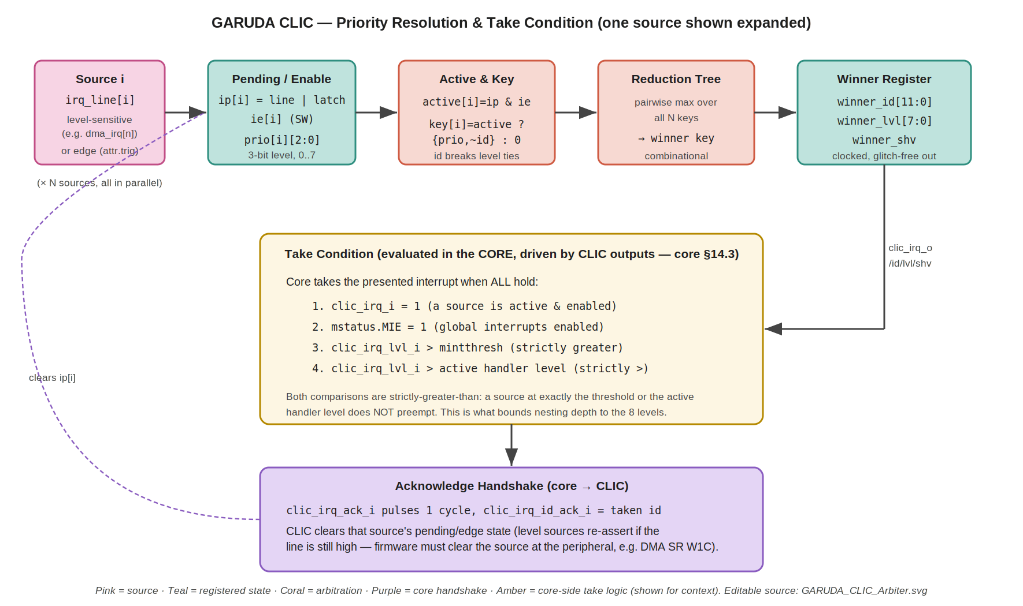
Figure 2 — Priority resolution and take condition. One source is shown expanded; all N resolve in parallel into the reduction tree. The amber box is the core-side take logic (core §14.3), shown for context — the CLIC drives its inputs. Editable source: GARUDA_CLIC_Arbiter.svg.

7.3 Registered presentation (Normative)
The arbiter result — winner_id, winner_lvl and winner_shv — is registered before leaving the block, so the core never samples a combinational transient while the reduction tree is settling after a source changes. clic_irq_id_o, clic_irq_lvl_o and clic_irq_shv_o are therefore registered outputs.
clic_irq_o is NOT registered. It is combinational from the registered winner level and the core-supplied mintthresh_i: clic_irq_o = (a winner exists) & (winner_lvl > mintthresh_i). This is stated explicitly because the two constructions are easy to conflate and they behave differently.
Combinational is the correct choice here for two reasons. First, mintthresh_i is a core CSR that firmware can change at any time; registering the comparison would delay every threshold change by a cycle, so a firmware write that unmasks a level would not take effect until the cycle after the CSR updated, which the core's take-condition model (core §14.3) does not expect. Second, it is what makes the one-cycle latency in §9.1 true: a source going pending reaches clic_irq_o through the combinational arbiter, one registration stage, and one combinational comparator — a single clk_i cycle. Registering the request as well would make it two.
The output is glitch-free despite being combinational, because both of its inputs are stable registered values: winner_lvl comes from the winner register and mintthresh_i comes from a core CSR flop. The comparator settles once per cycle and the core samples it synchronously. Only the request line is combinational; every value that accompanies it (id, level, shv) is registered, so the core never sees a request qualified by a level that has not yet settled.

7.4 Preemption and nesting (Normative)
The CLIC always presents the current highest active source, even while a handler is running. Whether that preempts is decided by the core using strictly-greater-than comparisons (core §14.3): a newly-pending source preempts the running handler only if its level is strictly greater than the active handler's level (and strictly greater than mintthresh). A source at exactly the active level does not preempt — it waits. This strict-greater rule is what bounds the nesting depth. Because two handlers can never share a level, at most one handler may be stacked per level that is capable of interrupting. GARUDA encodes 8 levels (0–7), but level 0 is defined as “never interrupts” (§6.5) and therefore can never own a handler, so the levels that can be active are 1–7. The maximum nesting depth is consequently 7 concurrently active handlers, not 8. This is the figure the stack budget is sized against (§13.4).

8. Functional Description

8.1 Becoming pending
A level source sets clicintip while its line is high. An edge source (attr.TRIG=1) sets clicintip on a detected rising edge and holds it. Pending is gated by enable and non-zero level to form active; only active sources enter the arbiter.

8.2 Presentation to the core
The registered winner drives clic_irq_id_o/_lvl_o/_shv_o continuously. clic_irq_o is the combinational comparison of that registered winner level against mintthresh_i, asserting when a winner exists whose level is strictly greater than the threshold (§7.3 fixes this as combinational, not registered). The core additionally checks MIE and the active-handler level before actually taking it (§8.3). If a higher source becomes active, the presented id/level update on the next clk_i edge and clic_irq_o follows combinationally within that same cycle; the core will preempt if its rule allows.

8.3 Being taken
The core takes the interrupt when all four take-condition clauses hold (§1.4, core §14.3). On taking it, the core pulses clic_irq_ack_i with clic_irq_id_ack_i = the taken id, writes mepc/mcause, updates its active level, and vectors (§8.6).

8.4 Clearing and re-fire (Normative)
On the acknowledge pulse the CLIC clears the pending/edge state of the acknowledged id. For an edge source that ends the event. For a level source, if the underlying line is still high the pending bit re-asserts on the next cycle — the source will be presented again as soon as the handler's level drops. This is by design and is why every level source must be cleared at the peripheral: the DMA ISR writes 1 to the SR flag (W1C), which drops dma_irq[n]; only then does the CLIC source stop re-firing (DMA §10.2). A handler that returns without clearing its source will immediately re-enter — the classic level-interrupt infinite loop.

8.5 Worked example — DMA completion
DMA channel 0 finishes an IMU transfer and sets SR.COMPLETE; because CR.IE=1, dma_irq[0] goes high (DMA §10). That line is CLIC source id 0. If clicintie[0]=1 and its level (say 6) is non-zero, source 0 becomes active and, being the only one, wins. The CLIC registers winner {id=0, lvl=6} and, since 6 > mintthresh, asserts clic_irq_o. The core (MIE=1, no higher handler active) takes it, pulses ack with id=0; the CLIC clears pending. The ISR reads the DMA SR, processes the samples, writes 1 to SR.COMPLETE (W1C) — dma_irq[0] drops — and returns with mret. Because the line is now low, the CLIC does not re-fire. Had the ISR forgotten the W1C, dma_irq[0] would still be high, pending would re-assert, and the interrupt would immediately recur.
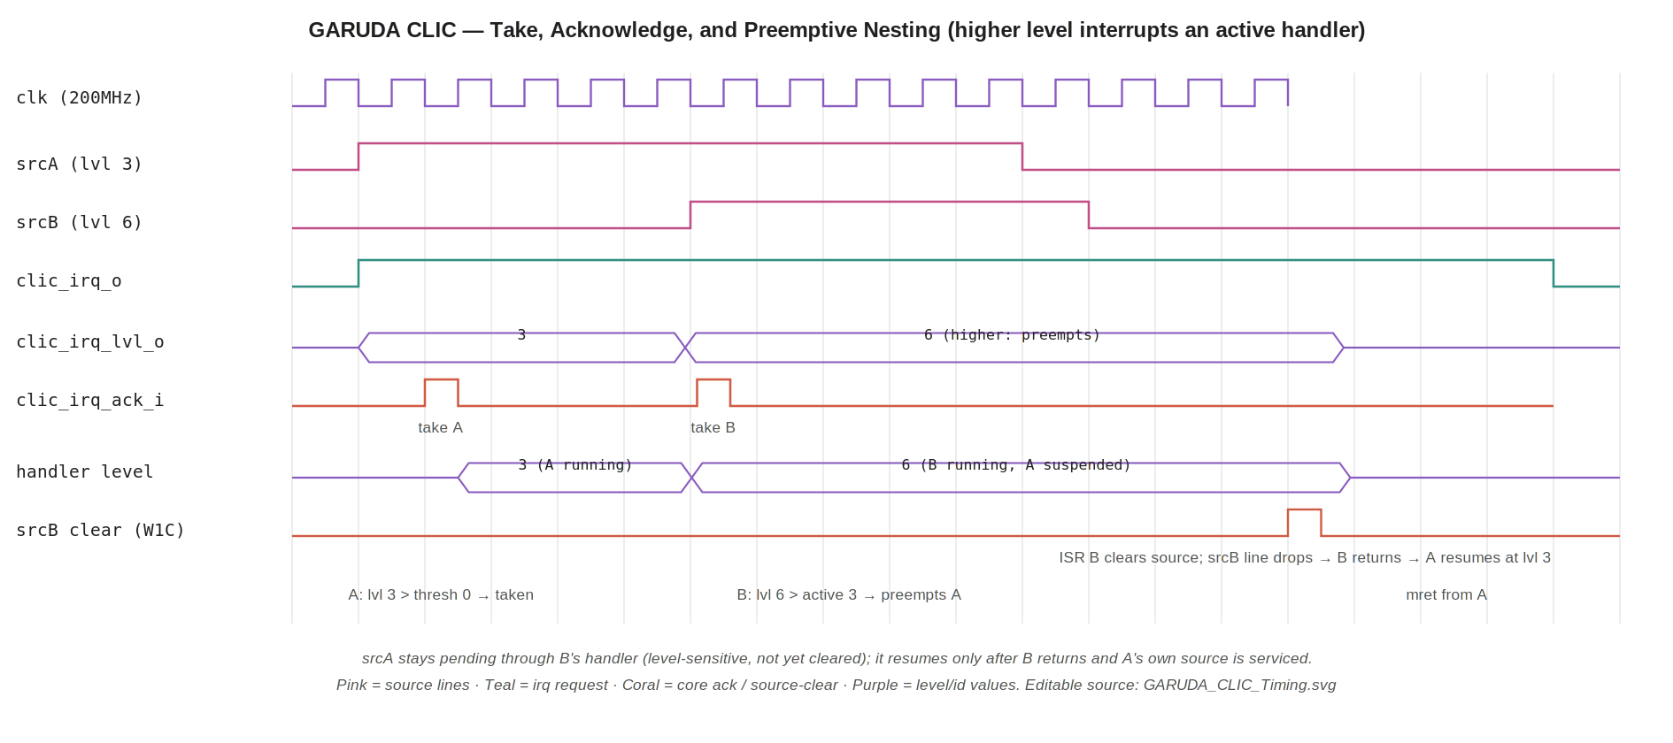
Figure 3 — Take, acknowledge, and preemptive nesting. Source A (level 3) is taken; source B (level 6) then preempts it because 6 is strictly greater than the active level 3; A stays pending (level-sensitive) and resumes only after B's ISR clears its source and returns. Editable source: GARUDA_CLIC_Timing.svg.

8.6 Vectoring
Two modes, selected per source by clicintattr.SHV and honoured by the core (core §14.3):
- Non-vectored (shv=0): the core jumps to mtvec.base; software reads mcause and dispatches to the right ISR. Simple, ~10–20 cycles of dispatch overhead (TRM Block 16).
- Selective hardware vectoring (shv=1): the core indexes the mtvt table by id and jumps directly to that ISR, removing the software dispatch. Use for the most latency-sensitive sources (IMU-via-DMA, system timer).
The CLIC's only role in vectoring is to present the correct shv bit for the winning source; the table lookup and jump are in the core.

9. Performance and Timing

9.1 Latency
Path | Cycles | Notes
Source pending → clic_irq_o asserted | 1 clk (5 ns) | Combinational arbiter → one registration stage (winner id/lvl/shv) → combinational threshold comparator. Exactly one registration stage, hence one cycle (§7.3)
clic_irq_o → core takes (ISR entry) | ~10–20 clk | Core-side: pipeline drain + vector; depends on MIE/threshold/pipeline state (DMA §11.1, TRM Block 16)
Acknowledge → pending cleared | 1 clk | Single-cycle clear on the ack pulse (§8.4)
Preemption decision | 0 extra in CLIC | CLIC always presents the top source; the core decides to preempt combinationally against its active level (§7.4)
The CLIC contributes a single deterministic cycle to interrupt latency; the dominant term is the core's ISR-entry sequence, which the CLIC does not control. Selective hardware vectoring (§8.6) removes the software-dispatch portion of that term for chosen sources.

9.2 Throughput
The arbiter re-resolves every cycle, so there is no limit on how quickly successive interrupts can be presented — back-to-back sources on consecutive cycles are each presented the cycle after they go active. In the flight workload the aggregate interrupt rate is low (a few kHz of DMA completions plus the 1 kHz timer), a negligible fraction of the 200 MHz fabric.

10. Interrupt Generation Detail
This section consolidates the interrupt-specific behaviour for the reader who cares only about the interrupt path (e.g. the DMA/firmware integrator).

10.1 The three distinct priority systems (do not conflate)
GARUDA has three priority mechanisms that must never be confused (established in the DMA spec and reiterated here):
- DMA arbiter — decides which DMA channel gets the AHB bus. Internal to Block 9.
- DMA IRQ aggregator — a passive collector that ORs channel flags into the dma_irq/dma_err lines. No prioritisation (DMA §10).
- CLIC — this block: decides which interrupt source the CPU services, by level. The dma_irq/dma_err lines are just twelve of its inputs.

10.2 Level vs edge
All DMA sources and most peripherals are level-sensitive (§8.4). Edge mode (attr.TRIG=1) exists for genuine pulse sources. The default (reset) is level, which is the safe choice: a level source cannot be missed if the CPU is briefly masked, whereas an un-latched edge could be.

10.3 Threshold and masking
Firmware sets mintthresh (a core CSR) to raise the floor: only sources strictly above it can interrupt. Setting mintthresh=7 masks everything except a level-7 source; mintthresh=0 admits any non-zero-level source. Per-source masking is clicintie.

10.4 Firmware contract
For every level source the ISR MUST clear the source at its origin before mret (DMA: W1C the SR flag; UART: read the data register; etc.). Clearing only the CLIC pending bit is insufficient — the line re-sets pending immediately. This is the single most common interrupt bug and is called out in both this spec and the DMA spec (§8.4, DMA §10.2).

11. Reset Behaviour
On reset all clicintip, clicintie, clicintattr and clicintctl clear to 0. With every enable low and every level 0, no source is active, clic_irq_o is deasserted, and the winner register presents id 0 / level 0. The core therefore sees no interrupt until firmware programmes enables and levels — which is the correct boot posture: the bootloader runs with interrupts effectively masked and opts sources in as it initialises each peripheral.
The APB config port resets on preset_n_i; the interrupt fabric resets on reset_n_i. Both are active-low, asynchronous assert / synchronous de-assert, and are coordinated by Block 23 so the two domains enter and leave reset as one event.

11.1 Clock-domain boundaries inside the CLIC (Normative)
There are exactly two places where the CLIC touches more than one clock, and neither is an asynchronous crossing:
- Configuration state (pclk_i → clk_i). Handled by the synchronous-related-clock contract in §5.1.1: pclk_i is a ÷2 generated clock of clk_i from the same source, so the arbiter reads the configuration registers over ordinary synchronous timing paths with no synchronisers. Note that the AHB-to-APB bridge does NOT solve this: the bridge synchronises the transfer across its own 200/100 boundary and delivers the write into the pclk_i domain — it delivers nothing into clk_i. The pclk_i-to-clk_i boundary is internal to this block and is this block's responsibility.
- Interrupt source lines (→ clk_i). All source lines are sampled directly in clk_i. Sources driven by logic in the pclk_i domain need no synchroniser for the same reason as above — the clocks are related. A source that is genuinely asynchronous to clk_i, however, does: see the flagged item below.
FLAGGED (open item): the §5.1.1 contract covers sources generated in either on-chip clock domain, because both are related. It does not cover a source that is genuinely asynchronous to clk_i — the clearest candidate being a GPIO interrupt driven from an external pad, whose edge bears no relationship to any internal clock. Such a source MUST be passed through a two-flop synchroniser before the CLIC samples it (a level line is safe to synchronise directly; an edge-triggered pad input additionally needs the edge detected after the synchroniser, never before). Confirm per peripheral when each peripheral spec is written, and state explicitly in the GPIO specification whether the pad interrupt is synchronised inside the GPIO block or is expected to arrive raw here. The default assumption in this document is that every source arriving at the CLIC is already clean and clk_i-relatable.

12. Verification Plan
Area | Checks
Register access | APB read/write every clicintip/ie/attr/ctl; reset values; W1C on pending; RO reserved bits read 0; PSLVERR on undefined offset.
Priority resolution | Drive all combinations of 2–3 simultaneous sources at various levels; confirm highest level wins and lowest id breaks a level tie; confirm level-0 sources never win.
Take condition | Vary mintthresh and active level; confirm clic_irq only when winner level > threshold; confirm strictly-greater (a source at exactly threshold does NOT interrupt).
Acknowledge / clear | Pulse clic_irq_ack with each id; confirm only that source's pending clears; confirm no other source is disturbed.
Level re-fire | Level source held high; acknowledge; confirm pending re-asserts next cycle; then clear the source line; confirm pending stays low. Directed on dma_irq[n] with a DMA SR W1C model.
Edge sources | attr.TRIG=1; single pulse sets pending once; confirm no re-fire after acknowledge without a new edge.
Preemption / nesting | Take a low-level source; raise a strictly-higher source; confirm the higher preempts and the lower resumes after; raise an equal-level source and confirm it does NOT preempt. Nest to the maximum depth of 7 (one handler each at levels 1–7) and confirm no overflow; confirm a level-0 source never interrupts and so can never add an eighth frame.
Vectoring | shv=0 → present shv low (software dispatch); shv=1 → present shv high; joint test with the core mtvt path.
Latency | Measure source-pending → clic_irq assertion = 1 cycle; regression against §9.
Output registration | Confirm clic_irq_id_o/_lvl_o/_shv_o change only on a clk_i edge (registered) while clic_irq_o responds combinationally within the same cycle to a mintthresh_i change: write mintthresh to mask, then unmask, and confirm clic_irq_o deasserts/asserts in that cycle rather than one cycle later (§7.3).
Config/clock boundary | With pclk_i as a ÷2 of clk_i, write clicintie/ctl on every pclk phase and confirm the arbiter honours the new value within one clk_i cycle and never reads a partially-updated register. STA: confirm the pclk_i→clk_i configuration paths are timed as synchronous related paths, not declared false or asynchronous (§5.1.1).
Reset | Assert reset with sources active; confirm all pending/enable clear and clic_irq drops.
Bind an assertion set to the core interface: clic_irq_lvl_o must always correspond to clic_irq_id_o; clic_irq_o must never be high with a level-0 winner; on an ack pulse the id_ack must equal a currently-presentable id. Sim stack: Verilator 5.008 + Spike for co-sim of the take/ack handshake against the M-mode model; Cadence Xcelium for signoff. Directed tests should run the §8.5 DMA-completion narrative first.

13. Design Decisions & Rationale

13.1 One external CLIC, distinct from the core CSRs
The interrupt controller is a separate block from the core's trap CSRs on purpose. The core owns the architectural trap state (mstatus/mcause/mepc/mtvec) because that is privileged CPU state defined by the ISA; the CLIC owns the policy (which sources, what priority, what threshold) because that is SoC integration state that changes as peripherals are added. Splitting them keeps the core boundary frozen (core §4.1) while letting the interrupt map grow. Calling the core's CSR block “a CLIC” is a category error the naming in this section is careful to avoid (§1.1).

13.2 Fixed level priority, not round-robin
Interrupt urgency in a flight controller is intrinsic to the source: the IMU/timer must be serviced ahead of a UART byte, always. Fixed level priority encodes that directly and cannot invert. Round-robin would trade the guarantee for a fairness no interrupt source wants. Id-tiebreak within a level keeps resolution deterministic without a second policy knob.

13.3 Reduction-tree arbiter, not a priority-encoder chain
Packing {level, ~id} into one sort key turns the whole resolution into a single unsigned-max reduction — O(log N) depth, trivially meeting timing at N≤32 (§9). A ripple priority-encoder would be simpler to write but longer in the critical path and harder to extend. The tree is the pragmatic choice for a block that must present a winner every cycle.

13.4 Level-sensitive default, strict-greater preemption
Level default matches how GARUDA peripherals actually signal (hold until serviced) and cannot drop an interrupt during a masked window. Strictly-greater-than preemption (rather than greater-or-equal) is the RISC-V CLIC rule and has the useful property of bounding the nesting depth: a same-level source can never stack. With 8 encoded levels of which level 0 never interrupts, the interrupting levels are 1–7, so the worst-case handler stack is exactly 7 frames deep. At roughly 140 bytes of context per frame that is about 980 bytes of stack — which is precisely the TRM Block 16 budget, whose arithmetic (7 × 140) is also based on 7 nesting levels, not 8.

13.5 Selective hardware vectoring only where it pays
shv is per-source, not global, so the latency-critical sources (IMU-via-DMA, system timer) get direct hardware vectoring while the rest use cheaper software dispatch through a single mtvec entry. This avoids paying for a full vector table on sources that don't need the microseconds.

14. Appendix

14.1 Acronyms
Term | Meaning
CLIC | Core-Local Interrupt Controller (RISC-V)
PLIC | Platform-Level Interrupt Controller (Block 17; minimal here)
IP / IE | Interrupt Pending / Interrupt Enable (per source)
Level | 3-bit interrupt priority, 0–7 (0 = never interrupts)
Threshold (mintthresh) | Core CSR; only sources strictly above it may interrupt
shv | Selective Hardware Vectoring (per-source, via mtvt)
mtvec / mtvt | Trap-vector base / CLIC trap-vector table (core CSRs)
mcause / mepc | Trap cause / exception PC (core CSRs)
W1C | Write-1-to-clear
Preemption / nesting | A higher-level interrupt suspends an active lower-level handler

14.2 Cross-references
Block / doc | Relationship
Core spec §4.1 | Frozen CLIC interface (clic_irq/_id/_lvl/_shv/_ack/_id_ack/mintthresh) matched exactly in §5.2
Core spec §14.3 | Take condition, acknowledge handshake, strict-greater preemption, shv vectoring — the normative core-side contract
Core spec §13 | The core's own trap CSRs (mstatus/mie/mip/mtvec/mcause) — distinct from this block (§1.1)
8 — AHB-to-APB Bridge | Carries CLIC config writes (APB); synchronises them from the CPU domain
9 — DMA Controller §10 | 12 level-sensitive sources dma_irq[5:0]/dma_err[5:0]; W1C-at-source clearing contract (§8.4)
10–15, 18–21 — Peripherals/Timers | Additional interrupt sources; system timer at level 7 (§6.2)
17 — PLIC | Minimal platform-level counterpart; all external interrupts route through this CLIC in the single-core SoC
22 / 23 — Clock / Reset | Provide clk/pclk and reset_n/preset_n
— End of CLIC Design Specification —

