GARUDA SoC
DMA Controller Design Specification
6-Channel, AHB-Lite Master / APB Slave
Parameter | Value
Document ID | GARUDA-DMA-SPEC-001
Revision | 2.0
Date | June 2026
Status | Released for Review
Owner | Team AeroSoC
Process | 28 nm CMOS
Bus domain | AHB-Lite (200 MHz) + APB (100 MHz)
Classification | Internal Use Only
Abstract
This document specifies the GARUDA SoC DMA controller: a six-channel, AHB-Lite master / APB slave block that offloads periodic sensor-data movement from the RV32IM CPU. It defines the complete register map, signal interface, channel and bus state machines, arbitration scheme, interrupt model, timing, reset behavior, software programming model, verification plan, synthesis estimates, and design rationale. The content is sufficient to implement the block in HDL and to integrate it into the GARUDA SoC.

Revision history
Rev | Date | Author | Changes
1.0 | May 2026 | Team AeroSoC | Initial draft
2.0 | June 2026 | Team AeroSoC | Corrected FSM state names per Deep Technical Reference. Moved PRI into CR. Added SR.REMAINING field. Corrected arbiter to per-beat re-evaluation.

1. Scope and purpose

1.1 Block identification
Field | Value
Block name | DMA Controller
Block number | 9 of 24
Base address | 0x4000_5000 (APB slave, config port)
Bus interfaces | AHB-Lite master (data, 200 MHz) + APB slave (config, 100 MHz)
Gate count estimate | 14,000 - 18,000 equivalent gates
Area estimate (28 nm) | 0.02 - 0.03 mm²

1.2 Functional role in GARUDA
The DMA controller moves data between peripheral FIFOs and DSRAM without CPU involvement. The CPU configures transfer parameters (source address, destination address, transfer count, direction, priority) into the DMA's register bank via the APB bus. Once enabled, the DMA autonomously reads from the source and writes to the destination using its AHB-Lite master port, freeing the CPU to run EKF, PID, and APF algorithms.
Six independent channels are hardwired to six peripheral subsystems. An 8-level fixed-priority arbiter ensures that time-critical sensor data (IMU via SPI, priority 7) always wins bus access over lower-priority transfers (GPS via UART, priority 2).

1.3 Design goals
1. Offload all periodic sensor data transfers from the CPU pipeline.
2. Guarantee worst-case IMU data latency under 1 microsecond.
3. Support continuous circular transfers for 1 kHz sensor fusion without per-iteration CPU reconfiguration.
4. Provide 12 interrupt lines (6 transfer-complete + 6 error) to the CLIC for deterministic ISR dispatch.

1.4 Compliance
AHB-Lite master interface compliant with ARM AMBA 3 AHB-Lite Protocol Specification (IHI 0033A). APB slave interface compliant with ARM AMBA 3 APB Protocol Specification (IHI 0024B).

2. Feature summary
Feature | Specification
Channels | 6, independently programmable
Bus master | AHB-Lite, 200 MHz, 32-bit address/data
Config interface | APB slave, 100 MHz, base 0x4000_5000
Transfer directions | Peripheral-to-Memory, Memory-to-Peripheral, Memory-to-Memory
Transfer sizes | 8-bit (byte), 16-bit (halfword), 32-bit (word)
Max transfer count | 65,535 beats per descriptor (16-bit TCR)
Address modes | Fixed (FIFO) or auto-increment per beat
Circular mode | Auto-reload SAR/DAR/TCR on completion, re-arm without CPU
Priority | 8 levels (0-7), 3-bit field in CR. Highest wins. Index tiebreak.
Arbiter granularity | Re-evaluates after every single beat (one read + one write)
Interrupts | 12 lines: dma_irq[5:0] (complete) + dma_err[5:0] (error)
Interrupt type | Level-sensitive. Stays asserted until firmware clears SR flag (W1C).
Peripheral handshake | dma_req[5:0] (in, level) + dma_ack[5:0] (out, 1-cycle pulse)
Clock domains | hclk (200 MHz): FSMs, arbiter, AHB master. pclk (100 MHz): APB slave, register bank.
Reset | Asynchronous assert, synchronous deassert. All channels to IDLE, all SR to 0, all CR.EN to 0.
Gate count | ~14k-18k equivalent gates
Area (28 nm) | ~0.02-0.03 mm² (<2% of 1.45 mm² die)

3. Block diagram

3.1 Internal sub-blocks
# | Sub-block | Function | Clock domain
1 | APB Slave Interface | Decodes CPU config reads/writes at base 0x4000_5000. Routes address to register bank. pready tied high (zero wait states). pslverr tied low. | pclk (100 MHz)
2 | Register Bank | 30 registers (5 per channel x 6 channels). SAR, DAR, TCR, CR, SR. Implemented as flip-flops. Written by CPU via APB, read by channel FSMs. | pclk (100 MHz)
3 | Channel FSMs (x6) | Six independent 5-state machines: IDLE, CONFIGURED, WAITING_FOR_REQUEST, TRANSFERRING, COMPLETE. Each has private xfer_cnt, src_addr, dst_addr working registers. | hclk (200 MHz)
4 | Priority Arbiter | Combinational priority encoder. 6 inputs (ch_req + priority from CR). Outputs grant + ch_sel[2:0]. Re-evaluates every cycle. | hclk (200 MHz)
5 | AHB-Lite Master | Drives HADDR, HTRANS, HWRITE, HSIZE, HBURST, HWDATA. Captures HRDATA. All transfers are SINGLE (one beat per address phase). | hclk (200 MHz)
6 | Data Buffer | Single 32-bit register. Temporarily holds data between read-from-source and write-to-destination AHB transactions. | hclk (200 MHz)
7 | IRQ Aggregator | 12 AND gates. dma_irq[n] = SR.COMPLETE[n] AND CR.IE[n]. dma_err[n] = SR.ERROR[n] AND CR.EIE[n]. Outputs go to CLIC. | hclk (200 MHz)

3.2 Internal block diagram
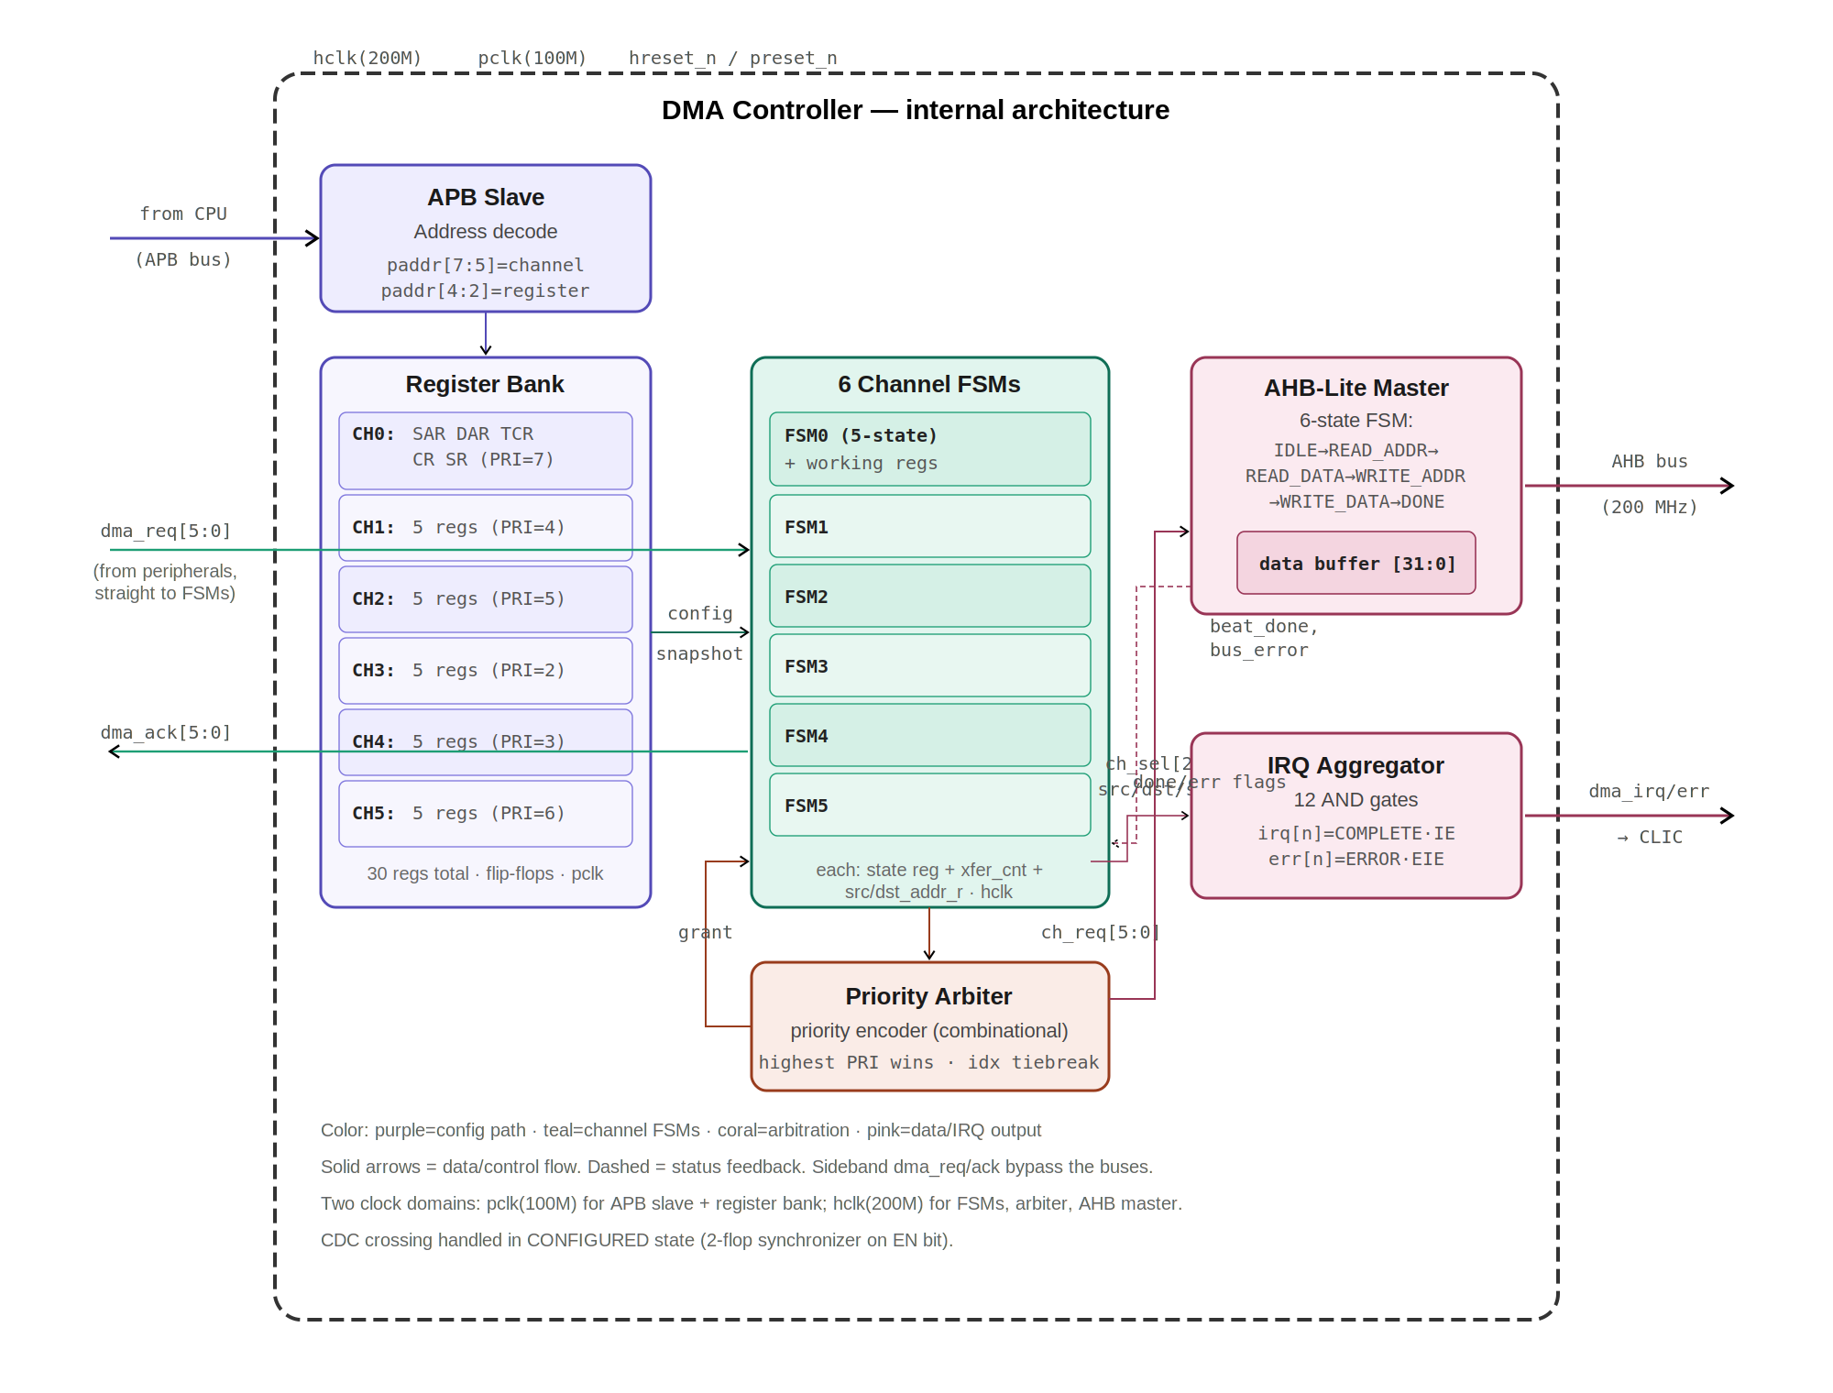
Figure 3.1 - DMA internal architecture. All seven sub-blocks, internal signals, and both clock domains. Sideband dma_req/dma_ack connect directly to the channel FSMs, bypassing the buses.

3.3 RTL module hierarchy
Suggested Verilog module decomposition for implementation. Each sub-block maps to one module. The top module wires them together and exposes the block-level ports.
Module | Instances | Parent | Responsibility
dma_top.v | 1 | (top) | Block boundary. Wires all sub-modules. Exposes APB, AHB, dma_req/ack, dma_irq/err ports.
dma_apb_slave.v | 1 | dma_top | APB protocol + address decode. Generates per-register write strobes, MUXes read data.
dma_reg_bank.v | 1 | dma_top | 30 registers (5 x 6). Holds config (pclk domain). Exposes per-channel config buses to FSMs.
dma_channel_fsm.v | 6 | dma_top | 5-state transfer controller. Contains working registers (xfer_cnt, src/dst_addr_r). One instance per channel.
dma_arbiter.v | 1 | dma_top | Combinational priority encoder. ch_req + priorities in, grant + ch_sel out.
dma_ahb_master.v | 1 | dma_top | 6-state bus protocol FSM + data buffer + address/control MUX. Serves the granted channel.
dma_irq_agg.v | 1 | dma_top | 12 AND gates. Combines SR flags with CR.IE/EIE to drive dma_irq/dma_err.
dma_cdc_sync.v | 1+ | dma_channel_fsm | 2-flop synchronizer for the EN bit crossing pclk to hclk.

4. External connectivity map
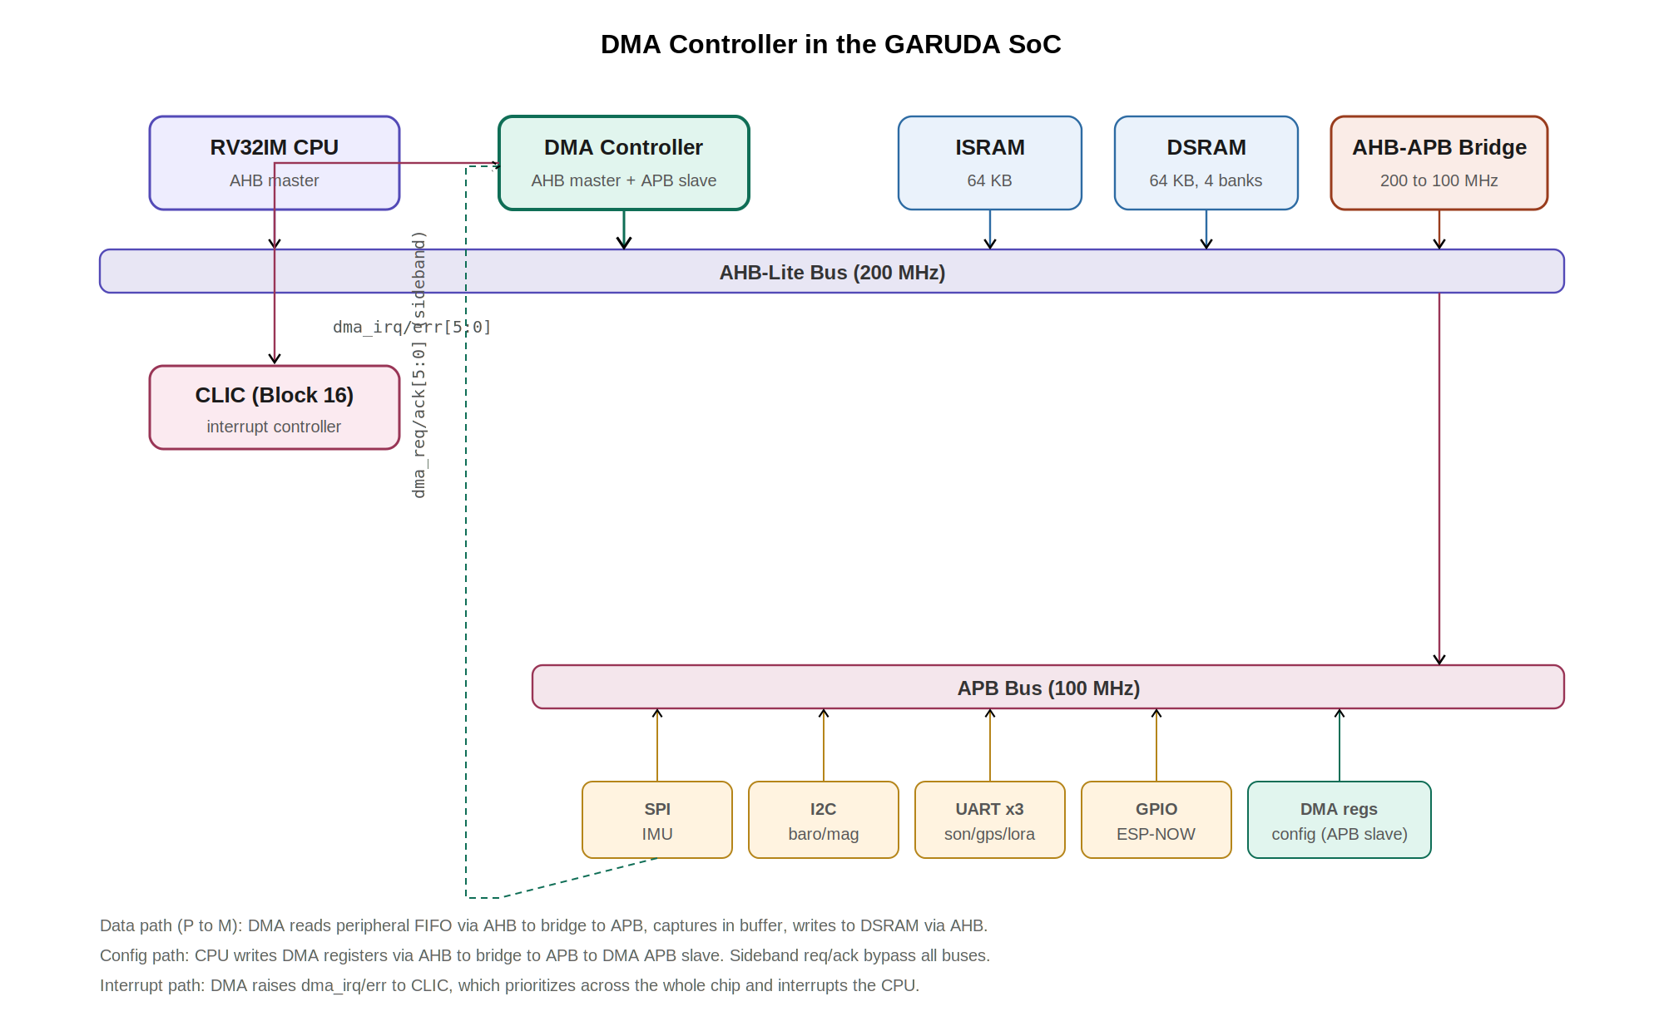
Figure 4.1 - DMA in the GARUDA SoC. AHB-Lite master port (data) and APB slave port (config), sideband req/ack to peripherals, and 12 interrupt lines to the CLIC.
Connected block | Direction | Protocol / Wires | Purpose
CPU (via APB bridge) | CPU → DMA | APB slave (psel, penable, pwrite, paddr[7:0], pwdata[31:0], prdata[31:0], pready, pslverr) | CPU writes config registers (SAR, DAR, TCR, CR). CPU reads status (SR).
AHB-Lite Bus | DMA → Bus | AHB master (haddr[31:0], htrans[1:0], hwrite, hsize[2:0], hburst[2:0], hwdata[31:0], hrdata[31:0], hready, hresp) | DMA reads from source address (peripheral FIFO via bridge, or SRAM). DMA writes to destination address (SRAM, or peripheral FIFO via bridge).
SPI Master (IMU) | Sideband | dma_req[0] (in), dma_ack[0] (out) | CH0: IMU sensor data. Highest priority (7).
I²C Controller (Baro/Mag) | Sideband | dma_req[1] (in), dma_ack[1] (out) | CH1: Barometer/magnetometer data. Priority 4.
UART0 (Sonar) | Sideband | dma_req[2] (in), dma_ack[2] (out) | CH2: TFMini sonar 9-byte packets. Priority 5.
UART1 (GPS) | Sideband | dma_req[3] (in), dma_ack[3] (out) | CH3: NEO-M8N NMEA sentences. Priority 2 (lowest).
UART2 (LoRa) | Sideband | dma_req[4] (in), dma_ack[4] (out) | CH4: SX1276 base station comms. Priority 3.
GPIO/SPI2 (ESP-NOW) | Sideband | dma_req[5] (in), dma_ack[5] (out) | CH5: ESP-NOW inter-drone mesh. Priority 6.
CLIC | DMA → CLIC | dma_irq[5:0] (out), dma_err[5:0] (out) | 12 level-sensitive interrupt lines. Cleared by firmware writing 1 to SR flags.

5. Top-level signal interface

5.1 Clock and reset
Signal | Width | Dir | Description
hclk | 1 | In | AHB domain clock, 200 MHz. Drives channel FSMs, arbiter, AHB master, data buffer, IRQ aggregator.
pclk | 1 | In | APB domain clock, 100 MHz. Drives APB slave interface and register bank.
hreset_n | 1 | In | Active-low reset, AHB domain. Asynchronous assert, synchronous deassert.
preset_n | 1 | In | Active-low reset, APB domain. Asynchronous assert, synchronous deassert.

5.2 APB slave interface (config port, 100 MHz)
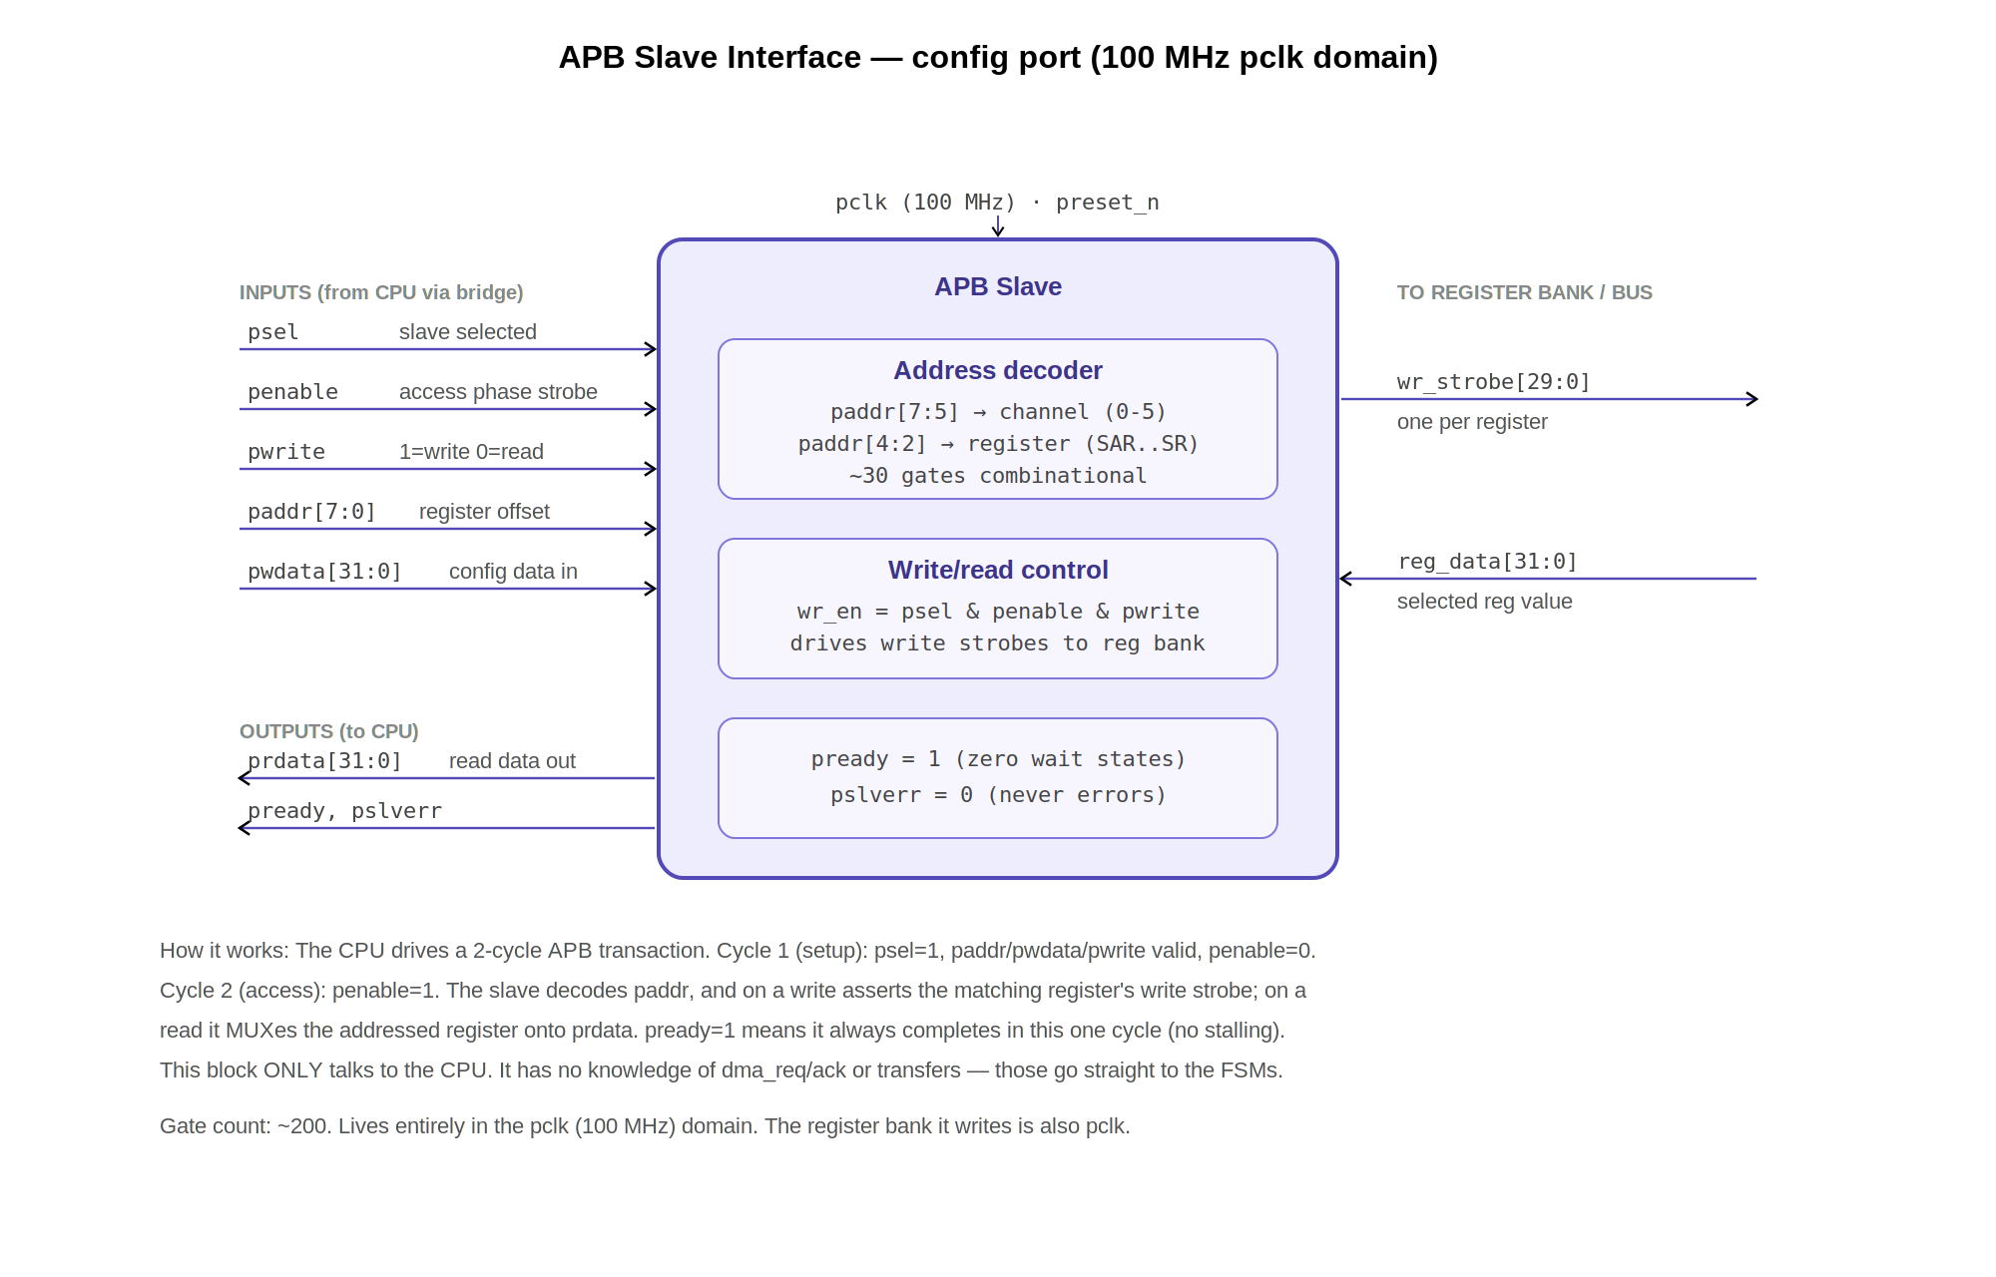
Figure 5.1 - APB slave interface. 2-cycle APB protocol, address decode, write strobes to register bank, read MUX. pready tied high, pslverr tied low.
Signal | Width | Dir | Description
psel | 1 | In | Slave select. High when CPU addresses DMA register range (0x4000_5000 - 0x4000_50BF).
penable | 1 | In | Access phase strobe. High on the 2nd APB cycle (data transfer happens here).
pwrite | 1 | In | Direction: 1 = CPU writing to DMA registers, 0 = CPU reading from DMA registers.
paddr | 8 | In | Register byte offset. Bits [7:5] = channel select (0-5). Bits [4:2] = register select. Bits [1:0] = 00 (word-aligned).
pwdata | 32 | In | Write data from CPU (config values for SAR, DAR, TCR, CR, or W1C bits for SR).
prdata | 32 | Out | Read data to CPU (returns current value of addressed register).
pready | 1 | Out | Transfer complete. Directly tied to logic 1 (zero wait states, all accesses complete in one APB cycle).
pslverr | 1 | Out | Slave error. Directly tied to logic 0 (DMA never signals an APB error). Per APB3 specification.

5.3 AHB-Lite master interface (data port, 200 MHz)
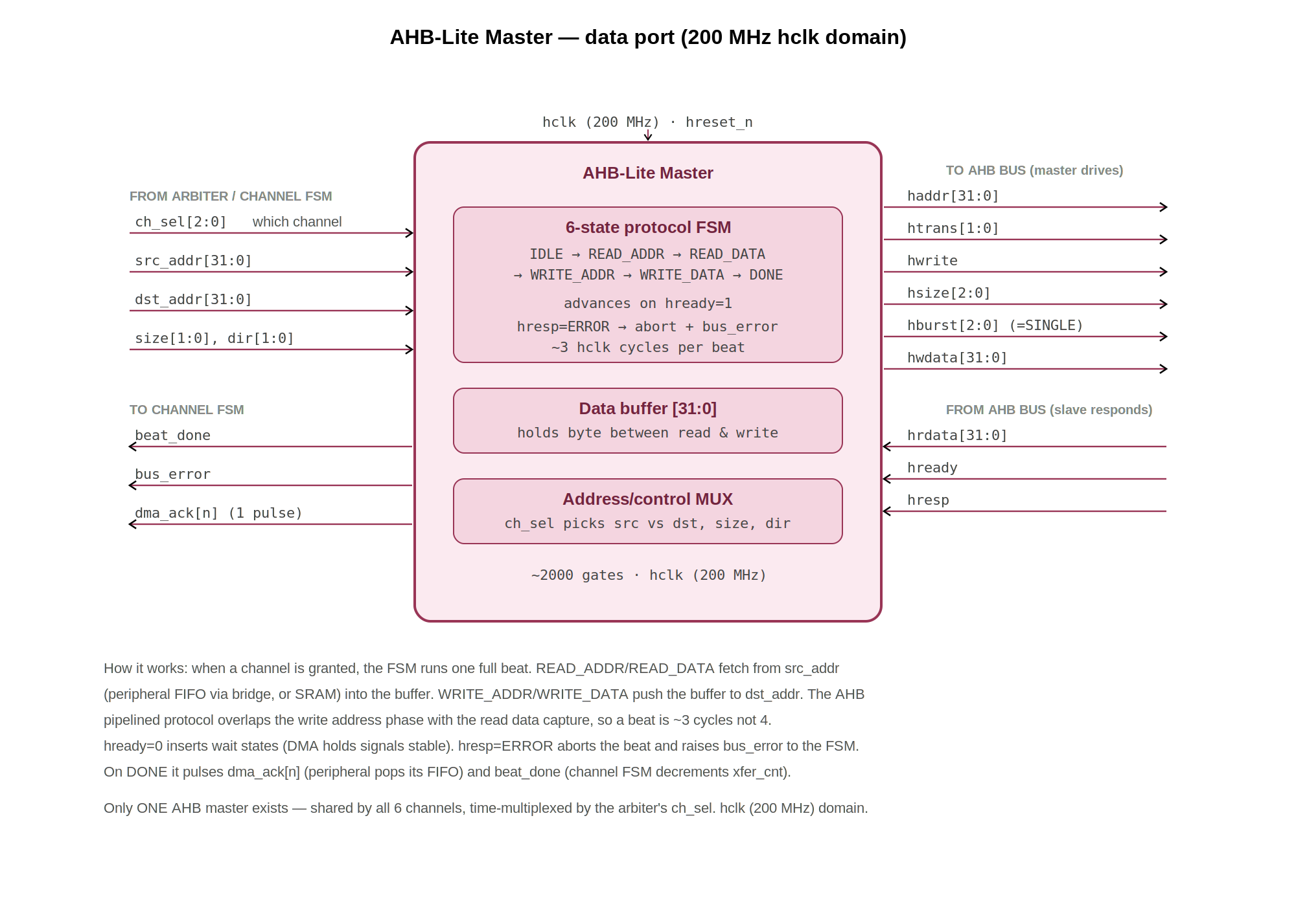
Figure 5.2 - AHB-Lite master interface. 6-state protocol FSM, data buffer, address/control MUX. Drives haddr/htrans/hwrite/hsize/hburst/hwdata; samples hrdata/hready/hresp.
Signal | Width | Dir | Description
haddr | 32 | Out | Address bus. Points to source address (during read phase) or destination address (during write phase). Source of address: channel FSM's working src_addr_r or dst_addr_r register.
htrans | 2 | Out | Transfer type. 2'b00 = IDLE (no transfer). 2'b10 = NONSEQ (first/only beat of a transfer). 2'b01 and 2'b11 (BUSY, SEQ) are not used (all transfers are SINGLE).
hwrite | 1 | Out | Direction: 0 = read from source, 1 = write to destination.
hsize | 3 | Out | Beat size: 3'b000 = byte (8-bit), 3'b001 = halfword (16-bit), 3'b010 = word (32-bit). Driven from CR.SIZE field of the active channel.
hburst | 3 | Out | Burst type. Always 3'b000 (SINGLE). One beat per address phase. Burst modes (INCR4, INCR8) not implemented in baseline design.
hwdata | 32 | Out | Write data. Driven from the internal data buffer. Valid 1 hclk cycle after the address phase (AHB pipelined protocol). For byte/halfword transfers, data is lane-aligned per AMBA spec.
hrdata | 32 | In | Read data from addressed slave (peripheral FIFO via bridge, or SRAM). Captured into the internal data buffer on hready=1.
hready | 1 | In | Slave ready. 1 = beat accepted. 0 = slave inserts wait state (DMA holds address/data stable until hready=1).
hresp | 1 | In | Slave response. 0 = OKAY. 1 = ERROR. If ERROR, active channel sets SR.ERROR flag and transitions to COMPLETE.

5.4 Peripheral handshake (sideband, bypasses bus)
Signal | Width | Dir | Description
dma_req | 6 | In | Per-channel transfer request from peripheral hardware. Active-high, level-sensitive. [0]=SPI/IMU, [1]=I²C/Baro, [2]=UART0/Sonar, [3]=UART1/GPS, [4]=UART2/LoRa, [5]=GPIO/ESP-NOW. Asserted when peripheral FIFO has data (P→M) or space (M→P). Deasserted when FIFO empty/full. Connected directly to channel FSMs, NOT to APB slave.
dma_ack | 6 | Out | Per-channel acknowledge. Pulsed high for exactly 1 hclk cycle (5 ns at 200 MHz) after the DMA completes one beat for that channel. The peripheral uses the rising edge of dma_ack to pop its RX FIFO (P→M) or advance its TX FIFO (M→P).

5.5 Interrupt outputs
Signal | Width | Dir | Description
dma_irq | 6 | Out | Transfer-complete interrupt, one per channel. dma_irq[n] = SR.COMPLETE[n] AND CR.IE[n]. Level-sensitive: stays asserted until firmware writes 1 to SR.COMPLETE to clear it (W1C). Routes to CLIC.
dma_err | 6 | Out | Error interrupt, one per channel. dma_err[n] = SR.ERROR[n] AND CR.EIE[n]. Level-sensitive: stays asserted until firmware writes 1 to SR.ERROR to clear it (W1C). Routes to CLIC.

5.6 Signal count summary
Group | Input wires | Output wires | Total
Clock / Reset | 4 | 0 | 4
APB Slave | 43 | 34 | 77
AHB-Lite Master | 34 | 71 | 105
Peripheral Handshake | 6 | 6 | 12
Interrupts | 0 | 12 | 12
TOTAL | 87 | 123 | 210

5.7 Verilog top-level module declaration
The block boundary as a synthesizable module port list. This is the exact interface dma_top.v must expose.
module dma_top (
// Clocks and resets
input wire hclk, // 200 MHz AHB domain
input wire pclk, // 100 MHz APB domain
input wire hreset_n, // active-low, AHB domain
input wire preset_n, // active-low, APB domain
// APB slave (config port)
input wire psel,
input wire penable,
input wire pwrite,
input wire [7:0] paddr,
input wire [31:0] pwdata,
output wire [31:0] prdata,
output wire pready,
output wire pslverr,
// AHB-Lite master (data port)
output wire [31:0] haddr,
output wire [1:0] htrans,
output wire hwrite,
output wire [2:0] hsize,
output wire [2:0] hburst,
output wire [31:0] hwdata,
input wire [31:0] hrdata,
input wire hready,
input wire hresp,
// Peripheral handshake (sideband)
input wire [5:0] dma_req,
output wire [5:0] dma_ack,
// Interrupts to CLIC
output wire [5:0] dma_irq,
output wire [5:0] dma_err
);

6. Programming model / register map
Base address: 0x4000_5000. Each channel occupies a 32-byte (0x20) address window. Total register space: 6 channels x 32 bytes = 192 bytes (0x4000_5000 to 0x4000_50BF). Addresses are word-aligned (bits [1:0] = 00).

6.1 Address map
Register | Offset | CH0 | CH1 | CH2 | CH3 | CH4 | CH5 | Width | Access
SAR | +0x00 | 0x5000 | 0x5020 | 0x5040 | 0x5060 | 0x5080 | 0x50A0 | 32 | R/W
DAR | +0x04 | 0x5004 | 0x5024 | 0x5044 | 0x5064 | 0x5084 | 0x50A4 | 32 | R/W
TCR | +0x08 | 0x5008 | 0x5028 | 0x5048 | 0x5068 | 0x5088 | 0x50A8 | 16 | R/W
CR | +0x0C | 0x500C | 0x502C | 0x504C | 0x506C | 0x508C | 0x50AC | 32 | R/W
SR | +0x10 | 0x5010 | 0x5030 | 0x5050 | 0x5070 | 0x5090 | 0x50B0 | 32 | R/W1C

6.2 APB address decode
The APB slave decodes the 8-bit paddr to route accesses to the correct register. The address field is partitioned as follows:
paddr bits | Field | Function
[7:5] | Channel select | Selects channel 0-5 (binary 000-101). Values 110 and 111 are unused/reserved.
[4:2] | Register select | 000=SAR, 001=DAR, 010=TCR, 011=CR, 100=SR. Values 101-111 reserved.
[1:0] | Byte offset | Always 00 (word-aligned access). All registers are word-addressed.
Decode example: a CPU write to 0x4000_502C. The offset from base is 0x2C = binary 0010_1100. Bits [7:5] = 001 = channel 1. Bits [4:2] = 011 = CR register. The APB slave routes pwdata into channel 1's CR flip-flops. This is pure combinational address decode (approximately 30-40 gates): a 3-to-6 channel decoder plus a 3-to-5 register decoder generating write-enable strobes for each register.
// APB slave decode (RTL sketch)
wire [2:0] ch_sel = paddr[7:5]; // channel 0-5
wire [2:0] reg_sel = paddr[4:2]; // register within channel
wire wr_en = psel & penable & pwrite;
// write strobe: e.g. CH1 CR = (ch_sel==1) & (reg_sel==3) & wr_en

6.3 SAR - Source Address Register (32-bit, R/W)
Holds the byte address the DMA reads from. For P→M transfers: the peripheral FIFO register address (e.g., 0x4000_1004 for SPI RX FIFO). For M→M: a memory source address. All 32 bits are writable. The value is latched into the FSM's working register (src_addr_r) when the channel enters CONFIGURED. If CR.SINC=1, the working copy increments by 1/2/4 bytes (per CR.SIZE) after each beat. The register bank copy is never modified by hardware.
Bits | Field | Reset | Description
[31:0] | ADDR | Undefined | Source byte address. Must be aligned to CR.SIZE (byte=any, halfword=even, word=4-aligned).

6.4 DAR - Destination Address Register (32-bit, R/W)
Holds the byte address the DMA writes to. For P→M: a DSRAM buffer address (e.g., 0x2000_0100). For M→P: the peripheral TX FIFO address. Same latching and increment behavior as SAR but controlled by CR.DINC.
Bits | Field | Reset | Description
[31:0] | ADDR | Undefined | Destination byte address. Must be aligned to CR.SIZE.

6.5 TCR - Transfer Count Register (16-bit, R/W)
Number of beats to transfer. One beat = one data unit of CR.SIZE width. Latched into the FSM's xfer_cnt working register in CONFIGURED state. The working copy decrements by 1 per beat. When xfer_cnt reaches 0, the channel enters COMPLETE. The register bank copy is preserved for CIRC mode reload. Maximum value: 65,535 (0xFFFF). Bits [31:16] are reserved and read as 0.
Bits | Field | Reset | Description
[15:0] | COUNT | Undefined | Number of beats. 0 = no transfer (channel enters COMPLETE immediately on enable).
[31:16] | Reserved | 0 | Read as 0. Write ignored.

6.6 CR - Control Register (32-bit, R/W)
The channel's instruction register. Contains all transfer configuration including priority. The EN bit must be written LAST, after all other fields and SAR/DAR/TCR are set. Hardware clears EN when the channel enters COMPLETE (single-shot mode).
Bits | Field | Reset | Description
[0] | EN | 0 | Channel enable. 1 = armed/active. Hardware clears to 0 on COMPLETE (if CIRC=0). Set this bit LAST after configuring all other registers. Writing 0 while active is undefined behavior.
[2:1] | DIR | 00 | Transfer direction. 00 = Peripheral-to-Memory (read from SAR, write to DAR). 01 = Memory-to-Peripheral. 10 = Memory-to-Memory. 11 = Reserved.
[4:3] | SIZE | 00 | Transfer size per beat. 00 = 8-bit (1 byte). 01 = 16-bit (2 bytes). 10 = 32-bit (4 bytes). 11 = Reserved. Controls HSIZE on AHB and address increment step.
[5] | SINC | 0 | Source address increment. 1 = auto-increment src_addr_r by SIZE after each beat. 0 = fixed (read from same address every beat). Use 0 for peripheral FIFOs (data always at same register address). Use 1 for memory sources.
[6] | DINC | 0 | Destination address increment. 1 = auto-increment dst_addr_r by SIZE after each beat. 0 = fixed. Use 1 for memory buffers. Use 0 for peripheral TX FIFOs.
[7] | CIRC | 0 | Circular mode. 1 = on COMPLETE, reload SAR/DAR/TCR from register bank, return to CONFIGURED, restart transfer automatically. 0 = single-shot, clear EN on COMPLETE, return to IDLE.
[8] | IE | 0 | Transfer-complete interrupt enable. 1 = assert dma_irq[n] when SR.COMPLETE is set. 0 = no interrupt on completion (firmware must poll SR).
[9] | EIE | 0 | Error interrupt enable. 1 = assert dma_err[n] when SR.ERROR is set. 0 = no interrupt on error.
[12:10] | PRI | 000 | Channel priority. 3-bit unsigned, range 0-7. 7 = highest priority. When multiple channels request the bus simultaneously, the arbiter grants to the highest PRI. Equal PRI: lowest channel index wins.
[31:13] | Reserved | 0 | Read as 0. Write ignored.

6.7 SR - Status Register (32-bit, R/W1C + RO)
Hardware-written status. Bits [1:0] are write-1-to-clear (W1C): firmware writes 1 to a bit to clear it; writing 0 has no effect. Bits [31:16] are read-only live readback of the internal transfer counter. Clearing COMPLETE or ERROR deasserts the corresponding interrupt line.
Bits | Field | Reset | Access | Description
[0] | COMPLETE | 0 | R/W1C | Transfer complete. Hardware sets to 1 when xfer_cnt reaches 0 (normal completion). Firmware writes 1 to clear. If CR.IE=1 and COMPLETE=1, dma_irq[n] is asserted.
[1] | ERROR | 0 | R/W1C | Bus error. Hardware sets to 1 when hresp=ERROR during TRANSFERRING. Firmware writes 1 to clear. If CR.EIE=1 and ERROR=1, dma_err[n] is asserted.
[15:2] | Reserved | 0 | RO | Read as 0.
[31:16] | REMAINING | 0 | RO | Live readback of the internal xfer_cnt working register. Shows how many beats are left in the current transfer. Reads 0 when channel is IDLE or transfer is complete.

7. Channel state machine
Each of the 6 channels contains an identical, independent 5-state FSM clocked by hclk (200 MHz). State names per the GARUDA Deep Technical Reference Block 9.

7.1 State definitions
State | Encoding | Entry condition | Actions | Exit condition
IDLE | 3'b000 | Reset; or COMPLETE with CIRC=0 | No bus activity. All working registers idle. Channel waits for CR.EN=1. | CR.EN = 1 (CPU enables channel)
CONFIGURED | 3'b001 | IDLE when EN set to 1; or COMPLETE with CIRC=1 | Latches SAR, DAR, TCR, CR fields into working registers (src_addr_r, dst_addr_r, xfer_cnt, direction_r, size_r, sinc_r, dinc_r, circ_r). Single-cycle state (1 hclk = 5 ns). | Always transitions to WAITING_FOR_REQUEST after 1 cycle.
WAITING_FOR_REQUEST | 3'b010 | CONFIGURED; or TRANSFERRING after 1 beat; or TRANSFERRING when dma_req deasserts | Channel asserts ch_req[n] to arbiter. Waits for BOTH: dma_req[n]=1 (peripheral has data/space) AND arbiter grant=1. | dma_req[n]=1 AND grant=1
TRANSFERRING | 3'b011 | WAITING_FOR_REQUEST when both conditions met | AHB master reads 1 beat from src_addr_r, captures in data buffer. AHB master writes 1 beat to dst_addr_r from buffer. Pulses dma_ack[n]. Decrements xfer_cnt. Updates src_addr_r/dst_addr_r if SINC/DINC=1. | Beat complete: 3 possible exits (see 7.2)
COMPLETE | 3'b100 | TRANSFERRING when xfer_cnt=0; or TRANSFERRING on hresp=ERROR | Sets SR.COMPLETE=1 (or SR.ERROR=1). Fires interrupt if IE/EIE enabled. Checks CIRC bit. | CIRC=0: clear EN, go IDLE. CIRC=1: go CONFIGURED (reload).

7.2 TRANSFERRING exit conditions
After each beat completes in TRANSFERRING, the FSM evaluates three conditions in priority order:
Priority | Condition | Next state | Rationale
1 (highest) | hresp = ERROR | COMPLETE (with SR.ERROR=1) | Bus error detected. Abort transfer immediately.
2 | xfer_cnt = 0 | COMPLETE (with SR.COMPLETE=1) | All beats transferred successfully.
3 | xfer_cnt > 0 AND dma_req[n] = 0 | WAITING_FOR_REQUEST | Peripheral FIFO ran empty mid-transfer. Park and wait for more data.
4 (default) | xfer_cnt > 0 AND dma_req[n] = 1 | WAITING_FOR_REQUEST | Beat done, more to go. Release bus for arbiter re-evaluation. Re-request immediately.

7.4 AHB master internal state machine
The AHB-Lite master sub-block contains its own 6-state FSM, separate from the channel FSMs. When a channel FSM enters TRANSFERRING, it hands off the beat parameters (src_addr, dst_addr, size, direction) to the AHB master FSM, which executes the actual bus protocol. The AHB master serves one channel at a time, selected by the arbiter's ch_sel output.
State | Drives | Description
IDLE | htrans=IDLE | No bus activity. Waiting for a granted channel to enter TRANSFERRING.
READ_ADDR | haddr=src_addr, htrans=NONSEQ, hwrite=0, hsize=size | Read address phase. Presents source address to the bus.
READ_DATA | (address of next phase) | Wait for hready=1. Capture hrdata into the data buffer. Check hresp for error.
WRITE_ADDR | haddr=dst_addr, htrans=NONSEQ, hwrite=1, hsize=size | Write address phase. Presents destination address.
WRITE_DATA | hwdata=buffer | Wait for hready=1. Data written to destination. Check hresp for error.
DONE | htrans=IDLE | Pulse dma_ack[n]. Signal the channel FSM that the beat is complete. Return to IDLE.
Note on AHB pipelining: READ_DATA and WRITE_ADDR overlap by one cycle (the write address phase is issued while read data is being captured), per the AHB-Lite pipelined protocol. A complete beat (read + write) takes approximately 3 hclk cycles when both slaves respond with zero wait states. APB-mapped sources (peripheral FIFOs accessed via the bridge) add bridge wait states.

7.5 Internal signals (between sub-blocks)
These signals are internal to the DMA module (not exposed at the block boundary). They connect the sub-blocks together.
Signal | From | To | Description
ch_req[5:0] | Channel FSMs | Arbiter | Each FSM asserts its bit when in WAITING_FOR_REQUEST and dma_req[n]=1.
ch_pri[5:0][2:0] | Register bank (CR.PRI) | Arbiter | Each channel's 3-bit priority value.
grant | Arbiter | Channel FSMs | Asserted when a channel wins arbitration.
ch_sel[2:0] | Arbiter | AHB master | Binary index of the winning channel. Selects which channel's working registers drive the AHB master.
beat_done | AHB master | Channel FSMs | Pulsed when the AHB master completes one beat (read+write). Triggers xfer_cnt decrement.
bus_error | AHB master | Channel FSMs | Asserted on hresp=ERROR. Triggers transition to COMPLETE with SR.ERROR.
src_addr/dst_addr/size/dir | Active channel FSM working regs | AHB master | Beat parameters for the current transfer, MUXed by ch_sel.
data_buffer[31:0] | AHB master | AHB master | Holds read data between READ_DATA and WRITE_DATA phases.
done_flag[5:0]/err_flag[5:0] | Channel FSMs (SR) | IRQ aggregator | Completion and error status, gated with CR.IE/CR.EIE to form interrupts.

7.6 State diagram placeholder
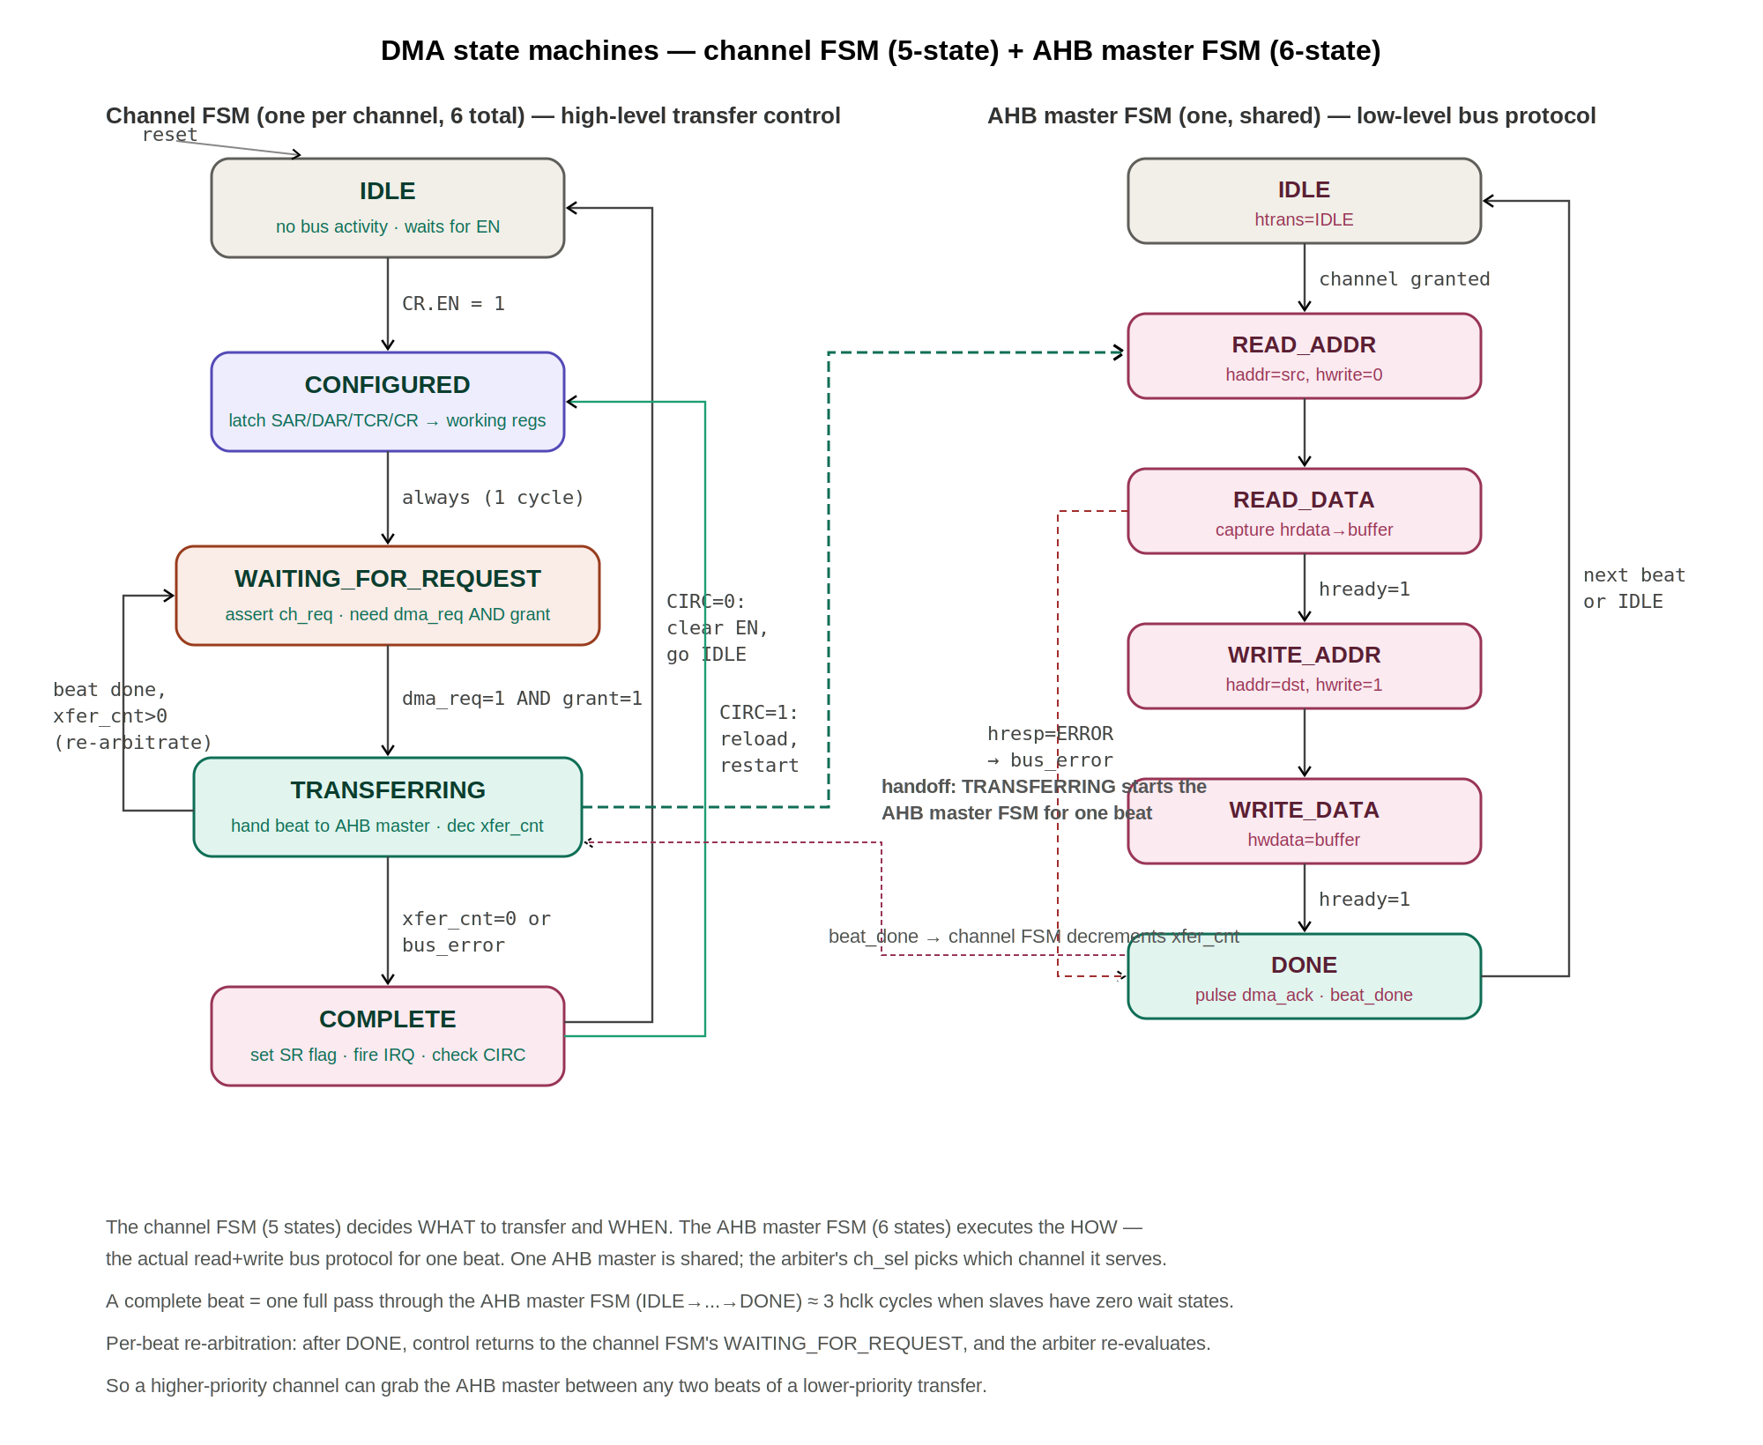
Figure 7.1 - Channel FSM (5-state, left) and AHB master FSM (6-state, right). Dashed arrows show the handoff (TRANSFERRING starts the AHB master) and feedback (beat_done decrements xfer_cnt).

8. Arbitration

8.1 Arbiter architecture
The arbiter is a purely combinational priority encoder. It evaluates all 6 channel request lines and their associated priority values every hclk cycle and produces a one-hot grant signal plus a 3-bit channel select.
Inputs: ch_req[5:0] (one per FSM, asserted when in WAITING_FOR_REQUEST and dma_req[n]=1), ch_pri[5:0] (3 bits each, from CR.PRI of each channel).
Outputs: grant (1-bit, 1 = a channel wins), ch_sel[2:0] (binary index of winning channel).

8.2 Priority algorithm
Scan channels 0 through 5. Track the highest priority seen so far. If a requesting channel's priority exceeds the current winner, it becomes the new winner. If equal, the earlier channel (lower index) wins because the scan started there. This produces deterministic, fixed-priority behavior.

8.3 Re-evaluation granularity
Per the Deep Technical Reference: the winner gets bus for one transfer pair (one read + one write = one data beat moved), then the arbiter re-evaluates. This ensures a higher-priority channel can preempt a lower-priority transfer between any two beats. No channel holds the bus for more than ~15 ns (3 hclk cycles per beat).

8.4 Channel priority assignments
Channel | Peripheral | CR.PRI | Rationale
CH0 | SPI Master (IMU) | 7 (highest) | IMU feeds 9-state EKF at 1 kHz. Late data causes attitude estimate drift.
CH1 | I²C (Baro/Mag) | 4 | Barometer/magnetometer at ~50 Hz. Moderate urgency.
CH2 | UART0 (Sonar) | 5 | TFMini at 100 Hz. Distance data for altitude hold.
CH3 | UART1 (GPS) | 2 (lowest) | NEO-M8N at 10 Hz. Position data is not time-critical within 1 ms.
CH4 | UART2 (LoRa) | 3 | Base station commands. Moderate urgency.
CH5 | GPIO/SPI2 (ESP-NOW) | 6 | Inter-drone mesh. High urgency for swarm coordination.

8.5 DMA-CPU bus sharing
CPU is the default AHB master. When the DMA needs the bus: the CPU's current AHB transfer completes first (bus is never yanked mid-transaction), then the DMA gets one beat (one read + one write), then the CPU resumes. With DSRAM banking (4 banks), different-bank accesses proceed in parallel. Same-bank worst case: CPU stalls 1 cycle. Occurs less than 5% of cycles in practice.

9. Operating modes
Mode | CR.DIR | CR.SINC | CR.DINC | Description
Peripheral-to-Memory | 00 | 0 | 1 | Read from fixed peripheral FIFO address, write to incrementing memory buffer. Standard sensor data ingestion.
Memory-to-Peripheral | 01 | 1 | 0 | Read from incrementing memory buffer, write to fixed peripheral TX FIFO address. Sending commands to peripherals.
Memory-to-Memory | 10 | 1 | 1 | Read from incrementing source in SRAM, write to incrementing destination in SRAM. Block copy. No peripheral handshake needed (dma_req ignored, channel proceeds on grant alone).
Single-shot | -- | -- | -- | CR.CIRC=0. Transfer runs once. Channel returns to IDLE on COMPLETE. CPU must reconfigure and re-enable for next transfer.
Circular | -- | -- | -- | CR.CIRC=1. On COMPLETE, SAR/DAR/TCR are reloaded from register bank, channel returns to CONFIGURED and restarts. CPU configures once at boot; DMA runs indefinitely.

10. Interrupt generation

10.1 Interrupt lines
Signal | Source | Condition | Routing
dma_irq[0] | CH0 (SPI/IMU) | SR.COMPLETE AND CR.IE | CLIC, configurable priority
dma_irq[1] | CH1 (I²C) | SR.COMPLETE AND CR.IE | CLIC
dma_irq[2] | CH2 (UART0) | SR.COMPLETE AND CR.IE | CLIC
dma_irq[3] | CH3 (UART1) | SR.COMPLETE AND CR.IE | CLIC
dma_irq[4] | CH4 (UART2) | SR.COMPLETE AND CR.IE | CLIC
dma_irq[5] | CH5 (GPIO) | SR.COMPLETE AND CR.IE | CLIC
dma_err[0] | CH0 (SPI/IMU) | SR.ERROR AND CR.EIE | CLIC
dma_err[1-5] | CH1-CH5 | SR.ERROR AND CR.EIE | CLIC

10.2 Clearing semantics
All interrupt lines are level-sensitive. They remain asserted as long as the generating condition is true (SR flag=1 AND enable bit=1). Firmware must clear the SR flag by writing 1 to the corresponding bit (W1C). If the firmware fails to clear the flag, the interrupt re-fires immediately after the ISR returns (mret), creating an infinite loop. Recommended ISR pattern: read SR, process, write 1 to flag bit(s), then return.

11. Performance and timing
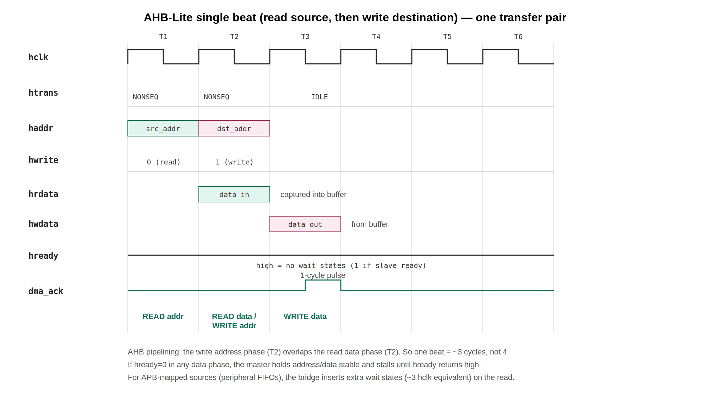
Figure 11.1 - One transfer pair on AHB-Lite. Read address phase, then write address phase overlapping read data capture (pipelined), then write data. dma_ack pulses on completion.

11.1 Latency table
Event | Latency | Notes
Single beat (P→M): read source + write destination | ~3 hclk cycles (15 ns) | 1 cycle read address phase, 1 cycle data capture + write address phase (pipelined), 1 cycle write data. Add bridge latency (~3 pclk cycles) for APB-mapped sources.
Arbiter grant latency | 1 hclk cycle (5 ns) | Combinational logic resolves in same cycle as request.
14-byte IMU transfer (CH0) | ~42 hclk cycles + bridge latency (~210 ns total) | 14 beats x 3 cycles/beat. Actual time longer due to bridge wait states on APB reads.
Worst-case preemption latency | 1 beat = ~15 ns | A higher-priority channel must wait at most 1 beat for a lower-priority channel to finish its current read-write pair.
ISR entry latency (from dma_irq assertion) | ~10-20 hclk cycles | Depends on CLIC priority/threshold and CPU pipeline state.
Config write latency (CPU → DMA register) | ~6 pclk cycles (60 ns) | AHB-to-APB bridge crossing + APB 2-cycle protocol.

11.2 Bandwidth budget
AHB-Lite theoretical peak: 200 MHz x 32 bits = 800 MB/s. DMA utilization per control loop (1 ms): approximately 200-400 bus cycles out of 200,000 available. Bus utilization by DMA: <0.2%. Combined with CPU: <4% bus utilization. The bus is overwhelmingly idle.

12. Reset behaviour
On assertion of hreset_n (active-low): all 6 channel FSMs forced to IDLE state. All SR registers cleared to 0 (no flags set). All CR registers cleared to 0 (all channels disabled, EN=0). SAR, DAR, TCR values are undefined (do not care, will be written before use). Arbiter outputs deasserted (grant=0). AHB master drives HTRANS=IDLE (no bus activity). All dma_irq and dma_err lines deasserted (low). All dma_ack lines deasserted (low).
On deassertion of hreset_n: synchronized to hclk via 2-flop synchronizer. All flip-flops exit reset on the same hclk rising edge. DMA enters quiescent state. No transfers occur until firmware explicitly configures and enables a channel.

13. Software programming sequence

13.1 Register definitions (C header)
#define DMA_BASE 0x40005000
#define DMA_CH_OFF 0x20
#define DMA_SAR(ch) (*(volatile uint32_t*)(DMA_BASE + (ch)*DMA_CH_OFF + 0x00))
#define DMA_DAR(ch) (*(volatile uint32_t*)(DMA_BASE + (ch)*DMA_CH_OFF + 0x04))
#define DMA_TCR(ch) (*(volatile uint16_t*)(DMA_BASE + (ch)*DMA_CH_OFF + 0x08))
#define DMA_CR(ch) (*(volatile uint32_t*)(DMA_BASE + (ch)*DMA_CH_OFF + 0x0C))
#define DMA_SR(ch) (*(volatile uint32_t*)(DMA_BASE + (ch)*DMA_CH_OFF + 0x10))

// CR bit positions
#define CR_EN (1 << 0)
#define CR_DIR_P2M (0 << 1)
#define CR_DIR_M2P (1 << 1)
#define CR_DIR_M2M (2 << 1)
#define CR_SZ_BYTE (0 << 3)
#define CR_SZ_HALF (1 << 3)
#define CR_SZ_WORD (2 << 3)
#define CR_SINC (1 << 5)
#define CR_DINC (1 << 6)
#define CR_CIRC (1 << 7)
#define CR_IE (1 << 8)
#define CR_EIE (1 << 9)
#define CR_PRI(n) ((n & 0x7) << 10)

// SR bit positions
#define SR_COMPLETE (1 << 0)
#define SR_ERROR (1 << 1)
#define SR_REMAINING_MASK 0xFFFF0000
#define SR_REMAINING_SHIFT 16

13.2 Channel initialization (P→M, circular, IMU example)
#define SPI_RX_FIFO 0x40001004

void dma_init_ch0_imu(uint8_t *dest_buf) {
DMA_SAR(0) = SPI_RX_FIFO; // Source: SPI FIFO (fixed)
DMA_DAR(0) = (uint32_t)dest_buf; // Dest: DSRAM buffer
DMA_TCR(0) = 14; // 14 bytes per IMU read
DMA_CR(0) = CR_DIR_P2M // Peripheral to Memory
| CR_SZ_BYTE // 1 byte per beat
| CR_DINC // Dest increments
| CR_CIRC // Continuous (auto-reload)
| CR_IE // Interrupt on complete
| CR_EIE // Interrupt on error
| CR_PRI(7) // Highest priority
| CR_EN; // ENABLE - set LAST
}

13.3 Interrupt service routine
void DMA_CH0_IRQHandler(void) {
uint32_t sr = DMA_SR(0);
if (sr & SR_COMPLETE) {
DMA_SR(0) = SR_COMPLETE; // Clear flag (W1C)
// Signal EKF task: fresh IMU data in buffer
xSemaphoreGiveFromISR(imu_data_ready, NULL);
}
if (sr & SR_ERROR) {
DMA_SR(0) = SR_ERROR; // Clear flag
error_count++;
}
}

13.4 Polling transfer progress
uint16_t dma_get_remaining(uint8_t ch) {
return (DMA_SR(ch) & SR_REMAINING_MASK) >> SR_REMAINING_SHIFT;
}

14. Verification plan
Test category | Test case | Pass criteria
Unit - Register access | Write/read all 30 registers via APB | Read-back matches written value for SAR/DAR/TCR/CR. SR.REMAINING reads 0 when idle.
Unit - Single channel P→M | Configure CH0 for 14-byte P→M, assert dma_req, check DSRAM | All 14 bytes arrive at DAR in correct order. SR.COMPLETE set. dma_irq[0] asserts.
Unit - Circular mode | Configure CH0 CIRC=1, run 3 full transfers | Channel auto-reloads and completes 3 transfers without CPU intervention.
Unit - FIFO deassert | Deassert dma_req mid-transfer (after 3 of 14 bytes) | Channel parks in WAITING_FOR_REQUEST. Reassert dma_req, transfer resumes. All 14 bytes complete.
Unit - Error handling | Inject hresp=ERROR during TRANSFERRING | Channel enters COMPLETE with SR.ERROR=1. dma_err[n] asserts. Transfer aborts.
Unit - W1C semantics | Write 1 to SR.COMPLETE, read back | Bit clears to 0. Writing 0 has no effect.
Multi-ch - Arbitration | CH0 (PRI 7) and CH3 (PRI 2) both active | CH0 completes all beats before CH3 gets any bus access.
Multi-ch - Tiebreak | Two channels with same PRI value | Lower channel index wins.
Multi-ch - Preemption | CH3 transferring, CH0 asserts mid-transfer | CH0 gets bus on next beat boundary. CH3 resumes after CH0 completes.
System - CPU contention | CPU and DMA access same DSRAM bank simultaneously | CPU stalls for 1 cycle. DMA completes beat. No data corruption.
System - Full sensor suite | All 6 channels active with real peripheral models | All transfers complete correctly. No starvation. IMU latency <1 us.
Coverage | FSM state coverage | All 5 states visited per channel. All transitions exercised.
Coverage | Register coverage | All bits of all 30 registers written and read.
Coverage | Toggle coverage | >95% toggle on all DMA signals.

15. Implementation and synthesis notes

15.1 Area estimate
Sub-block | Estimated gates | Notes
APB Slave + address decode | ~200 | Simple FSM + MUX
Register Bank (30 regs x 32 bits) | ~3,000 | 960 flip-flops + write enable logic
Channel FSMs (6 x 5-state) | ~2,400 | 400 gates per FSM (state reg + combinational next-state logic + working registers)
Priority Arbiter | ~300 | 6-way priority comparator chain
AHB Master + data buffer | ~2,000 | Address/data MUX, state machine, 32-bit buffer register
IRQ Aggregator | ~100 | 12 AND gates + output registers
Control logic, MUXes, misc | ~6,000 | Channel-select MUXes, CDC synchronizers, glue logic
TOTAL | ~14,000 - 18,000 | 0.02 - 0.03 mm² at 28 nm CMOS

15.2 Critical path
The longest combinational path is the arbiter priority comparison chain: 6-way comparison of 3-bit values followed by MUX select to AHB master inputs. At 28 nm, this chain has approximately 8-10 gate delays (~0.8-1.0 ns), well within the 5 ns hclk period. Comfortable timing margin.

15.3 Clock domain crossing
One CDC boundary exists inside the DMA: register bank (pclk, 100 MHz) to channel FSMs (hclk, 200 MHz). The EN bit in CR is synchronized via a 2-flop synchronizer (two hclk-domain flip-flops in series). All other register values (SAR, DAR, TCR, CR fields) are guaranteed stable by software protocol: the CPU writes all config before setting EN=1. The CONFIGURED state provides a 1-cycle sampling window on the hclk domain after the synchronized EN edge is detected.

15.4 Power considerations
Clock gating: when a channel FSM is in IDLE, its working registers and associated AHB master logic can be clock-gated to reduce dynamic power. The arbiter is combinational and consumes negligible power when no requests are active. Estimated dynamic power at 200 MHz: <1 mW (negligible fraction of the SoC's total power budget).

16. Design decisions and rationale
This section documents the key architectural choices and their justifications, for design review and mentor discussion.

16.1 APB slave for config, AHB master for data
Decision: the DMA exposes a config interface as an APB slave and a data interface as an AHB master, rather than a single AHB connection. Rationale: a master port can only initiate transactions; it cannot receive them. The CPU must write the DMA's registers, which requires the DMA to be a slave on some bus. Placing this slave port on APB (rather than adding a second AHB slave port) keeps the high-speed AHB interconnect lean: every AHB slave widens the central read-data multiplexer and adds delay on the 200 MHz critical path. Config accesses are infrequent (once at boot in circular mode), so APB's lower bandwidth is more than sufficient. This matches standard AMBA practice where control/status registers reside on APB.

16.2 Fixed priority instead of round-robin
Decision: an 8-level fixed-priority arbiter with lowest-index tiebreak. Rationale: GARUDA is a hard real-time flight controller. IMU data feeds the EKF at 1 kHz; any delay degrades the attitude estimate. Fixed priority guarantees the IMU channel (priority 7) always wins bus access. Round-robin would allow a low-priority GPS transfer to delay the IMU by several channel slots. Starvation of low-priority channels is not a practical concern: each transfer is small (tens of beats) and the bus is under 4% utilized, so low-priority channels always eventually win.

16.3 Per-beat arbitration
Decision: the arbiter re-evaluates after every transfer pair (one beat), not after a burst. Rationale: this bounds the worst-case preemption latency for a high-priority channel to a single beat (~15 ns). A higher-priority request can interrupt a lower-priority transfer between any two beats. The cost is ~3 cycles of re-arbitration overhead per beat, which is negligible given the idle bus. This is the behavior specified in the GARUDA Deep Technical Reference.

16.4 SINGLE transfers only (no bursts)
Decision: hburst is always SINGLE; INCR4/INCR8 burst modes are not implemented in the baseline. Rationale: all GARUDA DMA transfers are small (max 14 bytes for IMU, fewer for other sensors). Burst mode would save only ~20-30 cycles per transfer against a 200,000-cycle control-loop budget with 91% idle headroom. Omitting bursts removes the burst counter, bus-locking logic, and burst-boundary arbitration, simplifying the RTL and verification. Bursts can be added as a future extension if a high-bandwidth source (e.g. camera) is introduced.

16.5 Priority field inside CR
Decision: the 3-bit priority lives in CR[12:10] rather than a standalone PRI register. Rationale: priority is set once at initialization and never changed mid-flight. A separate register would add six more APB-decoded addresses with no functional benefit. Embedding it in CR keeps the register map at exactly five registers per channel.

16.6 16-bit transfer count
Decision: TCR is 16 bits (max 65,535 beats). Rationale: the largest single GARUDA transfer is well under 256 bytes. 65,535 beats at word width is 256 KB, four times the entire DSRAM. A 16-bit counter saves register area versus 32-bit. Transfers larger than 65,535 beats (not expected) would be chained in software.

16.7 SR.REMAINING readback
Decision: expose the live transfer counter in SR[31:16]. Rationale: allows firmware to poll transfer progress for debugging or adaptive scheduling without consuming an additional register address. Read-only; costs only routing from the existing xfer_cnt working register.

17. Integration guidelines

17.1 Instantiation
Instantiate dma_top as an AHB-Lite master on the system AHB interconnect and as an APB slave behind the AHB-to-APB bridge at base address 0x4000_5000. Connect hclk to the 200 MHz core clock and pclk to the 100 MHz peripheral clock generated by the clock divider.

17.2 Peripheral connections
Wire each peripheral's DMA request output to the corresponding dma_req[n] input and the dma_ack[n] output back to the peripheral's FIFO pop/push enable. The mapping is fixed: SPI=0, I2C=1, UART0=2, UART1=3, UART2=4, GPIO/SPI2=5. These are point-to-point sideband wires and must not be routed through any bus.

17.3 Interrupt connections
Connect dma_irq[5:0] and dma_err[5:0] to twelve CLIC interrupt source inputs. Assign CLIC priorities consistent with the channel priorities (IMU completion highest). Firmware ISRs must clear the corresponding SR flag (W1C) before returning, or the level-sensitive interrupt will immediately re-fire.

17.4 Address map requirements
The AHB address decoder must route 0x4000_5000-0x4000_50BF to the DMA's APB slave (via the bridge). The DMA's AHB master will issue transactions to peripheral FIFO addresses (0x4000_xxxx range, routed through the bridge) and DSRAM addresses (0x2000_xxxx range, direct on AHB). Ensure these targets are reachable from the DMA master port.

17.5 Reset sequencing
hreset_n and preset_n should be released by the reset controller using asynchronous-assert, synchronous-deassert. The DMA comes up inert (all channels disabled). No DMA activity occurs until firmware configures and enables a channel. Ensure both clocks are stable before reset deassertion.

17.6 Software bring-up checklist
1. Confirm APB register read/write (write SAR, read back). 2. Configure one channel single-shot, trigger a known transfer, verify destination data and SR.COMPLETE. 3. Verify interrupt reaches the ISR and clears correctly. 4. Enable circular mode and confirm continuous operation. 5. Bring up remaining channels. 6. Run full sensor suite and confirm no starvation and IMU latency under 1 microsecond.

18. Appendix

18.1 Acronym table
Acronym | Expansion
AHB | Advanced High-performance Bus (ARM AMBA)
APB | Advanced Peripheral Bus (ARM AMBA)
CLIC | Core-Local Interrupt Controller
CR | Control Register
DAR | Destination Address Register
DMA | Direct Memory Access
DSRAM | Data Static Random Access Memory
EKF | Extended Kalman Filter
FIFO | First In, First Out (queue buffer)
FSM | Finite State Machine
IMU | Inertial Measurement Unit
ISR | Interrupt Service Routine
PID | Proportional-Integral-Derivative (controller)
SAR | Source Address Register
SR | Status Register
TCR | Transfer Count Register
W1C | Write-1-to-Clear

18.2 Cross-references to related GARUDA blocks
Block # | Block name | Relationship to DMA
1 | RV32IM Processor Core | Programs DMA registers via APB. Handles DMA interrupts via ISR.
6 | AHB-Lite Bus | DMA is an AHB master. Shares bus with CPU.
7 | APB Bus | DMA config registers are APB slaves.
8 | AHB-to-APB Bridge | All DMA register accesses and peripheral FIFO reads/writes cross this bridge.
4 | Data SRAM (4 banks) | DMA writes sensor data here. Bank arbiter resolves DMA-CPU conflicts.
10 | SPI Master | CH0 source. dma_req[0]/dma_ack[0]. IMU sensor interface.
12 | I²C Controller | CH1 source. dma_req[1]/dma_ack[1]. Barometer/magnetometer.
13 | UART (x3) | CH2/CH3/CH4 sources. Sonar, GPS, LoRa.
15 | GPIO Controller | CH5 source. dma_req[5]/dma_ack[5]. ESP-NOW mesh radio.
16 | CLIC | Receives 12 DMA interrupt lines. Routes to CPU with priority management.

