GARUDA SoC
Memory Subsystem Design Specification
Instruction SRAM, Data SRAM (4 banks) and Boot ROM — AHB-Lite slaves S0/S1/S2
Document ID | GARUDA-MEM-SPEC-001
Revision | 2.0
Date | 2026-09-16
Blocks covered | 3 (Instruction SRAM), 4 (Data SRAM), 5 (Boot ROM)
Status | Draft — RTL-ready (aligned to frozen interconnect, core and DMA boundaries)
Owner | Team AeroSoC
Target process | 28 nm CMOS
Bus domain | AHB-Lite (ARM IHI 0033A/B), 200 MHz, single clock domain
Classification | Internal Use Only

Revision History
Version | Date | Author | Description
1.0 | — | Team AeroSoC | Memories described inline in the TRM as three separate blocks (3, 4, 5) with array-level narrative only.
2.0 | 2026-09-16 | Team AeroSoC | Unified specification for the three on-chip memories as a single subsystem. Rationale: all three are AHB-Lite slaves on the same interconnect (S0/S1/S2), share one slave interface pattern, one clock domain, and one memory map; specifying them together removes three near-identical interface chapters and makes the shared zero-wait-state contract explicit in one place. Aligned to the frozen interconnect slave bundle (AHB §5.3, §6), the core's reset vector and misalignment contract (Core §6, §12), and the DMA bank-conflict contract (DMA §16). Adds bank decode, arbiter specification, and the boot copy sequence.

1. Scope and Purpose

1.1 Blocks identified
Attribute | Value
Blocks covered | 3 — Instruction SRAM (64 KB); 4 — Data SRAM (64 KB, 4 banks); 5 — Boot ROM (4 KB)
Category | On-chip memory; AHB-Lite slaves
Slave indices | S0 = Instruction SRAM, S1 = Boot ROM, S2 = Data SRAM (frozen, interconnect §5.3)
Clock domain | One — hclk 200 MHz. No CDC anywhere in this subsystem.
Reset | hreset_n_i, active-low, asynchronous assert / synchronous de-assert (Block 23)
Programmable registers | None. All three are fixed-function memory; there is no control register anywhere in this subsystem.
Wait-states | Zero. All three memories answer in the slave's own cycle and never assert a wait-state (§8.4)
Error responses | None. All three tie hresp to OKAY; unmapped addresses never reach a memory (the interconnect's default slave handles them) (§8.6)

1.2 Why one document
These three blocks are separate entries in the TRM block list, but they are one design problem. Each is an AHB-Lite slave hanging off the same interconnect, in the same clock domain, answering in the same number of cycles, with the same (empty) register model and the same (absent) error model. Ninety per cent of what a separate ISRAM specification would say is identical to what a separate Boot ROM specification would say. Writing them together lets the shared slave contract be stated once and precisely, and leaves each block's genuinely distinct content — the ISRAM array organisation, the DSRAM banking and arbiter, the ROM's boot payload — in its own section without repetition.
What is genuinely different between them is small and is called out explicitly: the Data SRAM is the only one with internal banking and an arbiter (§7); the Boot ROM is the only one that is read-only in silicon and the only one that holds the reset vector (§6.3, §10.2); the Instruction SRAM is the only one that is written by another block during boot rather than by firmware at run time (§10.3).

1.3 Functional role in GARUDA
Every instruction the CPU executes comes from one of two places: the Boot ROM immediately after reset, or the Instruction SRAM once the bootloader has copied firmware into it. Every piece of data the flight-control loop touches — raw sensor samples landing from the DMA, EKF state matrices, the FreeRTOS stacks — lives in the Data SRAM. The memory subsystem is therefore on the critical path of essentially every cycle the SoC executes, which is why its single most important property is that it answers in one cycle with no wait-states.
The Data SRAM is the memory both the CPU and the DMA use, but they do not contend for it inside this block. The AHB-Lite interconnect grants exactly one master at a time (AHB §7.3), so the Data SRAM sees one transaction per cycle and has no visibility of which master issued it. CPU/DMA contention is resolved upstream in the Block 6 arbiter, where the DMA holds the highest priority. This specification therefore contains no memory-side arbitration; §7 explains what the banking does and does not buy, and §13.3 records the architectural decision behind that.

1.4 Design goals
Goal | How it is met
Single-cycle access at 200 MHz | The array read path (address decode → wordline → bit lines → sense amps → output register) is budgeted at ≈2.8 ns, inside the 5 ns cycle with margin (§9.1). hreadyout is tied high; the slave never inserts a wait-state.
Deterministic access time | Every access completes in the slave's own cycle with no wait-states and no memory-side arbitration, so the memory contributes a constant, analysable term to every master's timing (§9).
Low area | Single-port 6T cells throughout. Dual-port (8T) would eliminate bank conflicts but costs 40–60% more area per bit, which is not affordable on a 1.45 mm die (§13.2).
Low access energy | Only the addressed 16 KB bank is activated per access rather than a full 64 KB array, cutting dynamic read/write energy and shortening bit lines (§7.1, §13.2).
Protocol simplicity | No registers, no error path, no bursts to handle beyond beat-by-beat service. The slave logic around each array is a thin AHB wrapper (§5.2).
Safe boot | The reset vector points into mask ROM whose contents are fixed at tapeout and cannot be corrupted, so the chip always starts from a known-good image (§10.2).

2. Feature Summary
Feature | Specification
Instruction SRAM | 64 KB, 16,384 × 32 bits, single-port 6T, 14-bit row decode, 32 sense amplifiers. Slave S0 at 0x0000_0000.
Data SRAM | 64 KB as 4 × 16 KB independent banks (4096 × 32 each), single-port 6T per bank, each with its own decoder and sense amps. Slave S2 at 0x2000_0000.
Boot ROM | 4 KB, 1024 × 32, mask/metal-programmed, read-only. Slave S1 at 0x1000_0000. Holds the reset vector.
Bus interface | AHB-Lite slave × 3, using the frozen per-slave bundle: hsel_<s>, shared address/control/wdata, hrdata_<s>, hreadyout_<s>, hresp_<s> (§5.2)
Access width | Word, half-word and byte, all naturally aligned. Misaligned accesses are trapped by the core before the bus transaction commits, so no memory ever sees one (§8.3).
Depth checking | Each memory range-checks the address bits above its implemented depth and treats out-of-depth accesses as unimplemented: reads return zero, writes are discarded. No aliasing (§6.4).
Wait-states | Zero on all three memories under all conditions; hreadyout is tied high (§8.4).
Bank decode | HADDR[15:14] selects the DSRAM bank; HADDR[13:2] indexes the word within it. Banking is a physical organisation (access energy, bit-line length), not a concurrency mechanism (§7.1).
Arbitration | None inside this subsystem. The interconnect grants one master per beat (AHB §7.3), so each memory sees one transaction at a time; CPU/DMA priority is a Block 6 property (§7.3, §13.3).
Error responses | None generated. hresp tied OKAY on all three slaves (§8.6).
Registers / interrupts | None / none
Writeability | ISRAM: written at boot by the bootloader, read-mostly thereafter. DSRAM: freely read/write. ROM: read-only in silicon.

3. Block Diagram

3.1 Subsystem structure
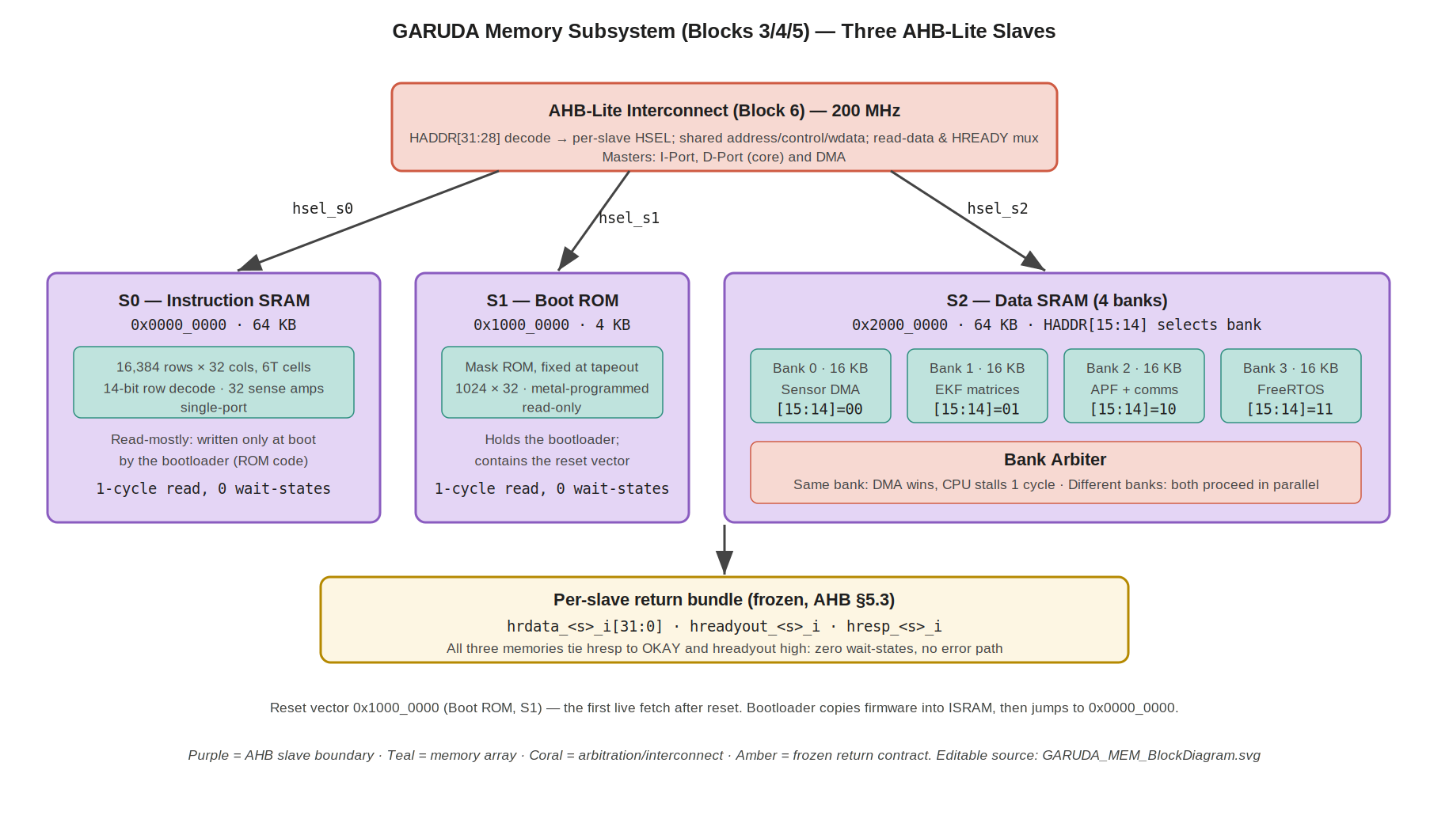
Figure 1 — The three memory slaves on the AHB-Lite interconnect. Purple = AHB slave boundary; teal = memory array; coral = interconnect and arbitration; amber = the frozen per-slave return contract. Editable source: GARUDA_MEM_BlockDiagram.svg.

3.2 Internal sub-blocks
Sub-block | Block | Type | Function
AHB slave wrapper | 3, 4, 5 | comb.+seq. | Terminates the AHB-Lite slave port: qualifies the address phase, registers address/control, drives hrdata/hreadyout/hresp. One instance per memory.
Row decoder | 3, 4, 5 | comb. | Decodes the word address to one wordline. 14-bit for ISRAM, 12-bit per DSRAM bank, 10-bit for ROM.
Memory array | 3, 4, 5 | — | 6T SRAM cells (ISRAM, DSRAM) or metal-programmed ROM cells (Boot ROM).
Sense amplifiers | 3, 4 | analog | 32 per array (per bank in the DSRAM); detect and amplify the bit-line differential.
Output register | 3, 4, 5 | seq. | Captures the sensed word so hrdata is driven cleanly in the data phase.
Byte-lane write logic | 3, 4 | comb. | Per-byte write enables derived from HSIZE and HADDR[1:0] (§8.3). Absent in the ROM.
Bank decoder | 4 | comb. | HADDR[15:14] → one-of-four bank select; only the selected bank is activated (§6.2, §7.1).
Depth range check | 3, 4, 5 | comb. | Compares the address bits above the implemented depth against zero; out-of-depth accesses are flagged as unimplemented (§6.4).
Read mux | 4 | comb. | Selects the addressed bank's output word onto hrdata_s2 (§7.4).

3.3 Suggested RTL module hierarchy
Module | Role
isram_top.v | Block 3 boundary: AHB slave wrapper + 64 KB array instance
dsram_top.v | Block 4 boundary: AHB slave wrapper + bank decode + 4 bank instances + read mux
dsram_bank.v | One 16 KB single-port bank (4096 × 32)
bootrom_top.v | Block 5 boundary: AHB slave wrapper + ROM array
ahb_mem_slave_if.v | Shared AHB-Lite slave wrapper, parameterised by depth and writeability; includes the depth range check of §6.4 — instantiated by all three
Sharing one parameterised slave wrapper across all three memories is strongly recommended: the AHB behaviour is identical and the only differences are depth, address width, and whether writes are accepted. Names are proposed; adopt in RTL. The memory array instances themselves will be replaced by foundry compiler macros once the PDK is available (§13.6).

4. External Connectivity Map
Authoritative for top-level integration. All three memories connect only to the interconnect and to clock/reset; they have no sideband, no interrupts, and no direct connection to any other block.
Peer block | Direction | Interface | Notes
AHB-Lite Interconnect (Block 6) | IC ↔ memories | AHB-Lite slave × 3 | S0 = ISRAM, S1 = ROM, S2 = DSRAM. Frozen bundle and addresses (AHB §5.3, §6).
RV32IM Core (Block 1), I-Port | via interconnect | — | Word-aligned instruction fetches; targets ROM after reset, then ISRAM. Never targets peripherals (Core §6.4).
RV32IM Core (Block 1), D-Port | via interconnect | — | Loads/stores; targets DSRAM (and peripherals). Misalignment trapped before the bus (Core §12).
DMA Controller (Block 9) | via interconnect | — | Reads and writes DSRAM as an AHB master; the other party in every bank conflict (§7.3).
Clock Divider (Block 22) | → memories | hclk | 200 MHz; the whole subsystem is single-domain.
Reset Controller (Block 23) | → memories | hreset_n | Active-low, synchronous de-assert. Resets slave-wrapper state only, not array contents (§10.1).
Routing is by address only: the interconnect permits any master to reach any slave, so the port associations above describe typical usage rather than an enforced restriction (AHB §4). In particular the DMA is architecturally able to read the ISRAM or ROM even though the flight firmware has no reason to.

5. Signal Interface

5.0 Naming convention
House style: lower-case, _i / _o for direction, _n for active-low. The slave-side names are frozen by the interconnect specification (AHB §5.3), where <s> is the slave index — s0 for ISRAM, s1 for Boot ROM, s2 for DSRAM. Direction in the tables below is relative to the memory block.

5.1 Clock and reset
Signal | Dir | Width | Description
hclk_i | in | 1 | 200 MHz system clock; the only clock in this subsystem
hreset_n_i | in | 1 | Active-low reset, asynchronous assert / synchronous de-assert (Block 23)

5.2 AHB-Lite slave port (frozen — one instance per memory)
The interconnect drives a shared address/control/write-data bundle to all slaves and a per-slave select; each slave returns its own read data, ready-out and response. This is exactly the bundle in AHB §5.3 and is not renegotiable here.
Signal | Dir | Width | Shared / per-slave | Description
hsel_i | in | 1 | per-slave | Slave select from the interconnect address decode (hsel_s0/s1/s2_o on the interconnect side)
haddr_i | in | 32 | shared | Transfer address (address phase)
htrans_i | in | 2 | shared | Transfer type; the memory acts on htrans_i[1] (NONSEQ/SEQ)
hwrite_i | in | 1 | shared | 1 = write, 0 = read
hsize_i | in | 3 | shared | Transfer size: byte / half-word / word → byte-lane write enables (§8.3)
hburst_i | in | 3 | shared | Burst type. Accepted and serviced beat-by-beat; no special handling (§8.5)
hprot_i | in | 4 | shared | Protection/attribute hint. Not consumed — GARUDA is M-mode with no MPU.
hwdata_i | in | 32 | shared | Write data (data phase). Ignored by the Boot ROM (§8.6).
hready_i | in | 1 | shared | Global HREADY: the address-phase qualifier. A transfer is accepted when hsel_i & htrans_i[1] & hready_i.
hrdata_o | out | 32 | per-slave | Read data returned to the interconnect's read mux
hreadyout_o | out | 1 | per-slave | Slave ready-out. Tied high except during a DSRAM bank conflict (§7.3).
hresp_o | out | 1 | per-slave | Response. Tied to OKAY on all three memories (§8.6).

5.3 Signal count summary
Interface | Named ports (buses counted once)
Clock / reset | 2
AHB-Lite slave port (per memory) | 12
TOTAL per memory block | 14
TOTAL subsystem (3 slaves, shared bundle counted once) | ≈20

6. Memory Map and Address Decode

6.1 Region map (frozen)
The interconnect decodes HADDR[31:28] into regions and asserts one slave select; the memories do not re-decode the region. These bases are frozen by AHB §6.
Region | Base | HADDR[31:28] | Size | Slave | Block
Instruction SRAM | 0x0000_0000 | 0000 | 64 KB | S0 | 3
Boot ROM | 0x1000_0000 | 0001 | 4 KB | S1 | 5
Data SRAM | 0x2000_0000 | 0010 | 64 KB | S2 | 4
Peripherals (APB) | 0x4000_0000 | 0100 | — | S3 (bridge) | 8
Unmapped | all others | — | — | default slave | 6
An access to an unmapped address never reaches a memory: the interconnect's default slave answers it with the mandatory two-cycle ERROR. The memories therefore need no decode-fault logic of their own (§8.6).

6.2 Data SRAM bank decode (Normative)
Within the DSRAM region the address splits as follows:
Bits | Field | Role
HADDR[31:28] | Region | 0010 — selects S2; consumed by the interconnect, not re-decoded here
HADDR[15:14] | Bank select | One of four 16 KB banks (§7.2)
HADDR[13:2] | Word index | 4096 words within the selected bank
HADDR[1:0] | Byte lane | Selects byte/half-word lanes within the word (§8.3)
Bank assignment is by function, chosen so that the two contending masters normally touch different banks:
Bank | HADDR[15:14] | Address range | Intended contents | Primary user
Bank 0 | 00 | 0x2000_0000 – 0x2000_3FFF | Sensor DMA landing buffers | DMA
Bank 1 | 01 | 0x2000_4000 – 0x2000_7FFF | EKF state and matrices | CPU
Bank 2 | 10 | 0x2000_8000 – 0x2000_BFFF | APF working set and comms buffers | CPU / DMA
Bank 3 | 11 | 0x2000_C000 – 0x2000_FFFF | FreeRTOS stacks and heap | CPU
This assignment is a firmware convention enforced by the linker script, not by hardware — the hardware will service any address in any bank. Note that it is a locality and organisation convention, not a contention-avoidance mechanism: because the interconnect serialises masters before they reach the memory, placing the DMA and CPU working sets in different banks does not let their accesses overlap (§7.1, §7.3). It remains worth doing for clarity of ownership and for reasoning about which data lives where.

6.3 Boot ROM and Instruction SRAM addressing
The Boot ROM occupies 4 KB at 0x1000_0000 and is addressed by HADDR[11:2] (1024 words). The reset vector is 0x1000_0000 itself: the core's program counter loads that address out of reset and the first live fetch targets this block (Core §3). The Instruction SRAM occupies 64 KB at 0x0000_0000, addressed by HADDR[15:2] (16,384 words). Firmware is linked to run from 0x0000_0000, which is where the bootloader jumps once the copy is complete (§10.3).
Neither block aliases — but that is a property the memories must actively enforce, not something the interconnect provides. See §6.4.

6.4 Depth range checking (Normative)
The interconnect decodes only HADDR[31:28] (AHB §6). It therefore selects a memory for the whole 256 MB region implied by that nibble, not for the memory’s actual implemented size. If a memory then used only its low address bits, every region address would fold onto the implemented depth. For example HADDR[15:2] is identical for 0x0000_0000 and 0x0001_0000, so both would read ISRAM word 0; likewise 0x2000_0000 and 0x2001_0000 would both hit DSRAM bank 0 word 0. That aliasing is a real consequence of region-granular decode and is not acceptable.
Each memory wrapper therefore performs a local range check on the address bits between the region nibble and its own addressing range, and treats anything outside its implemented depth as unimplemented:
Memory | Implemented depth | Local range check | Address bits used
Instruction SRAM (S0) | 64 KB | HADDR[27:16] == 0 | HADDR[15:2] → word
Data SRAM (S2) | 64 KB | HADDR[27:16] == 0 | HADDR[15:14] bank, HADDR[13:2] word
Boot ROM (S1) | 4 KB | HADDR[27:12] == 0 | HADDR[11:2] → word
An access that fails its range check is an in-region but out-of-depth access. It is completed normally on the bus — hreadyout_o high, hresp_o OKAY — but reads return zero and writes are discarded; no array location is selected. This preserves the no-error-response policy of §8.6 while guaranteeing that a stray address reads zero rather than silently returning a valid-looking word from an aliased location, which is what makes a runaway pointer or fetch obvious in simulation. RTL must assert on any out-of-depth access so the condition is caught rather than tolerated.
Alternative considered: the interconnect could perform exact-size decode and route out-of-depth addresses to its default slave, which would turn these into two-cycle ERRORs and remove the check from the memories entirely. That is arguably cleaner, but it changes the frozen Block 6 decode (AHB §6) and is therefore recorded here as a system-level option rather than adopted unilaterally (§13.7).

7. Banking (Data SRAM)
This section applies to Block 4 only. The Instruction SRAM and Boot ROM are single unbanked arrays.

7.1 What banking does and does not buy (Normative)
The Data SRAM is built as four independent 16 KB arrays rather than one 64 KB array. It is important to be precise about why, because the TRM narrative and an earlier draft of this specification both overstated it.
Banking does NOT provide concurrent CPU and DMA access. The AHB-Lite interconnect arbitrates on the master side and un-gates exactly one master at a time (AHB §7.3); the granted master’s transaction is the only one presented to slave S2. The Data SRAM therefore sees one transaction per cycle, through one shared address/control bundle, and has no signal identifying which master issued it. Two accesses cannot arrive in the same cycle, so there is nothing for a memory-side arbiter to arbitrate and none is implemented (§13.3).
Banking does provide lower access energy and shorter array delay. Only the addressed bank is activated on any access, so one read charges the bit lines of a 4096-word array rather than a 16,384-word one. That cuts dynamic energy roughly fourfold per access and shortens the bit lines, which is what keeps the array read inside the 5 ns cycle with margin (§9.1). For a battery-powered flight controller running a 1 kHz control loop this is the substantive benefit.
A secondary benefit is physical: four 16 KB macros give the floorplanner more freedom than one 64 KB macro, and each has a friendlier aspect ratio.

7.2 Bank structure
Property | Value
Banks | 4
Capacity per bank | 16 KB = 4096 words × 32 bits
Cell type | Single-port 6T
Per-bank logic | 12-bit row decoder, 32 sense amplifiers, output register, byte-lane write enables
Selection | HADDR[15:14], one-of-four (§6.2)
Banks activated per access | Exactly one; the other three remain idle
Simultaneous access | Not possible — one AHB transaction reaches S2 per cycle (§7.1)
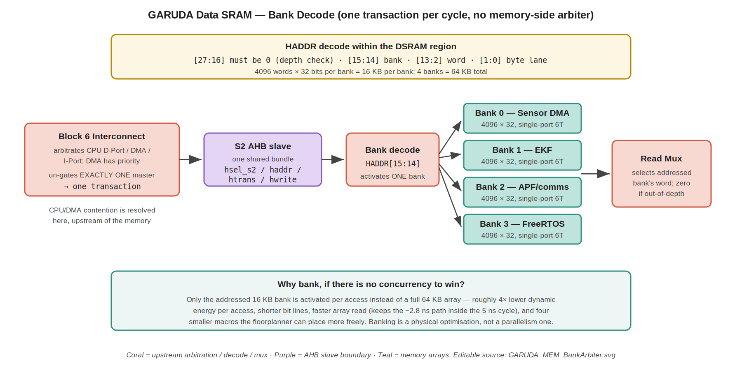
Figure 2 — Data SRAM bank decode. One AHB transaction reaches the slave per cycle; the bank decoder activates exactly one of the four arrays and the read mux returns its word. There is no memory-side arbiter — CPU/DMA priority is resolved upstream in the Block 6 interconnect. Editable source: GARUDA_MEM_BankArbiter.svg.

7.3 Where CPU/DMA contention is actually resolved (Normative)
Both the CPU D-Port and the DMA use the Data SRAM, and they do contend — but for the bus, not for the memory. The Block 6 arbiter ranks the masters DMA (highest), CPU D-Port, CPU I-Port (lowest), and commits a grant for the duration of one beat before re-evaluating (AHB §7.1, §7.2). An ungranted master has its HREADY driven low and holds its address stable until it is selected.
So the system-level behaviour the TRM describes — the DMA taking priority and the CPU waiting a cycle — is real, and the reasoning behind it (a stalled DMA can overflow a peripheral FIFO and lose sensor data irrecoverably, while a stalled CPU loses a cycle of compute) is sound. It simply lives in Block 6, not here. The Data SRAM contributes no part of it and must not re-implement it.
FLAGGED (cross-block): the TRM Block 4 narrative and the DMA specification both state that different-bank CPU and DMA accesses “proceed in parallel” with only a same-bank conflict costing a cycle. Under the frozen Block 6 architecture that is not achievable: the interconnect serialises the masters before either reaches the memory, so accesses to different banks are just as serialised as accesses to the same bank. This specification follows Block 6, which is released. The TRM wording and DMA §16 should be reconciled to match. If genuine CPU/DMA concurrency into the Data SRAM is actually wanted, it requires a system-level change — a second slave port on the Data SRAM fed by a dedicated DMA path that bypasses the shared bundle, with the bank arbiter then living here — which would alter both Block 4’s interface and Block 6’s topology. That is a decision for the architecture owner, not something to be implied by memory-side wording.

7.4 Read mux
The outputs of the four banks feed a 4:1 mux selected by the registered bank index of the access currently in its data phase. The mux output drives hrdata_o. Because the bank index is registered along with the rest of the address-phase information, the mux selection is stable throughout the data phase and hrdata_o is glitch-free. An out-of-depth access (§6.4) selects no bank and forces the mux output to zero.

8. Functional Description

8.1 Read access
A read is accepted when hsel_i & htrans_i[1] & hready_i are all high in the address phase. The memory registers the word address (and, for the DSRAM, the bank index), and the array read begins immediately: the row decoder activates one wordline, the addressed cells drive their bit lines, the sense amplifiers detect and amplify the differential, and the result is captured into the output register. In the following cycle — the data phase — hrdata_o presents the word and hreadyout_o is high, completing the transfer. The whole array path is budgeted at ≈2.8 ns and fits inside one 5 ns cycle (§9.1).

8.2 Write access
Writes follow the same two-phase structure: address and control in cycle N, hwdata_i in cycle N+1. The memory captures the address in the address phase and the write data in the data phase, then commits the addressed byte lanes to the array. The Boot ROM accepts no writes (§8.6). The Instruction SRAM accepts writes, but in normal operation only the bootloader performs them (§10.3).

8.3 Transfer size and byte lanes (Normative)
hsize_i and haddr_i[1:0] together determine which byte lanes participate:
HSIZE | Access | Lanes written | Notes
000 | Byte | 1, selected by HADDR[1:0] | Byte write enable asserted for that lane only
001 | Half-word | 2, selected by HADDR[1] | HADDR[0] must be 0 (alignment)
010 | Word | All 4 | HADDR[1:0] must be 00
Reads always return the full 32-bit word regardless of HSIZE; the requesting master extracts and sign- or zero-extends the addressed lanes (the core does this in its MEM stage). The memory performs no read-side extraction.
Alignment is guaranteed upstream. The core checks for misalignment in late EX / early MEM and traps before the D-Port address phase commits, raising a load or store address-misaligned exception (Core §12). A misaligned access therefore never appears on the bus and no memory needs to detect or reject one. RTL should nevertheless assert that HADDR is naturally aligned for the given HSIZE, so that a future master violating this contract is caught in simulation rather than corrupting a word silently.

8.4 Wait-states
No memory in this subsystem ever inserts a wait-state. hreadyout_o is tied high on all three slaves, including the Data SRAM: because the interconnect delivers one transaction at a time and every bank answers in one cycle, there is no condition under which a memory needs to stall the bus. An out-of-depth access (§6.4) also completes in one cycle, returning zero. A master waiting for the Data SRAM is waiting for the Block 6 arbiter to grant it the bus (§7.3), never for the memory itself.
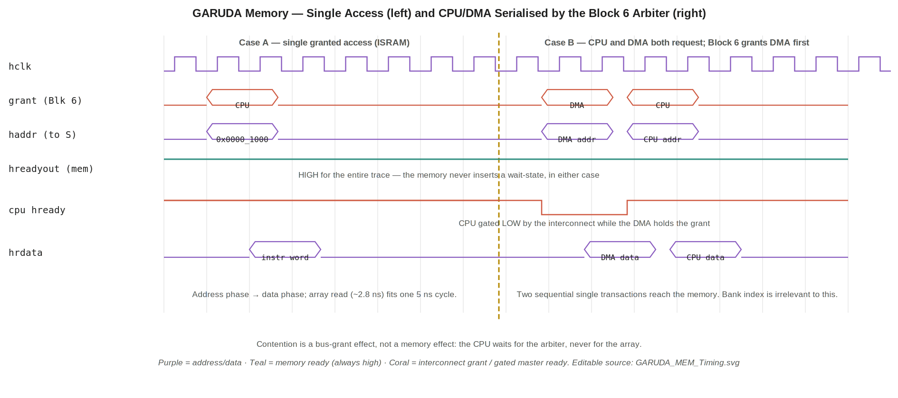
Figure 3 — Left: a read completes in the slave's own cycle with hreadyout high throughout. Right: the CPU and DMA both want the bus; the Block 6 arbiter grants the DMA first and gates the CPU's HREADY, so the two accesses are serialised before either reaches the memory. The memory itself never stalls. Editable source: GARUDA_MEM_Timing.svg.

8.5 Bursts
The interconnect passes hburst_i through, and the core's I-Port issues sequential fetches that may be marked SEQ. The memories require no special burst handling: each beat carries its own address and is serviced independently in one cycle, so a burst is simply a run of consecutive single-cycle accesses. There is no burst-length counter, no wrap logic, and no prefetching inside the memory — the core's prefetch buffer (Core §6.3) already handles fetch-ahead, and duplicating it here would be wasted area.

8.6 Error responses and the read-only ROM (Normative)
None of the three memories generates an error. hresp_o is tied to OKAY in all cases, for two reasons: an unmapped region never reaches a memory (the interconnect's default slave answers it with the two-cycle ERROR), and a misaligned access never reaches a memory (the core traps it first). Within each memory's implemented address range, every naturally aligned address is legal. Aligned accesses that fall inside the selected region but outside the implemented depth are treated as unimplemented within that slave (§6.4): they return zero and discard writes, and still complete without generating an error.
The Boot ROM is read-only in silicon — its contents are fixed by the metal mask at tapeout. A write targeting the ROM region is accepted on the bus and silently discarded: hreadyout_o goes high and hresp_o stays OKAY, but no state changes. It deliberately does not return an error, because doing so would require an error path in a block that otherwise has none, to catch a condition that correct firmware never produces. RTL should assert on a write to the ROM region so the condition is caught in simulation.

8.7 Life of one instruction fetch
The core's I-Port drives a word read of 0x0000_1000 with htrans NONSEQ and hsize 010. The interconnect decodes HADDR[31:28]=0000, asserts hsel_s0, and forwards the shared address/control bundle. The ISRAM accepts the address phase (hsel & htrans[1] & hready all high), registers word address 0x400, and starts the array read: 14-bit row decode selects one of 16,384 wordlines, the 32 cells on that line drive their bit lines, the sense amplifiers resolve, and the word lands in the output register — about 2.8 ns end to end. On the next rising edge the ISRAM presents the instruction word on hrdata_s0 with hreadyout_s0 high; the interconnect muxes it back to the I-Port, which pushes it into the prefetch buffer. Total cost: one cycle, no stall.

9. Performance and Timing

9.1 Access timing
Path | Budget | Notes
Address decode → wordline | ≈ 0.6 ns | Row decoder; 14-bit for ISRAM, 12-bit per DSRAM bank
Wordline → bit-line differential | ≈ 1.2 ns | Cell drive; the dominant term and the one most sensitive to array aspect ratio
Sense amplify → output register | ≈ 1.0 ns | 32 sense amplifiers in parallel
Total array read | ≈ 2.8 ns | Fits the 5 ns cycle at 200 MHz with roughly 2 ns of margin
AHB wrapper overhead | < 0.3 ns | Address qualification and output muxing; thin combinational logic
DSRAM read mux | ≈ 0.2 ns | 4:1 word mux after the banks (§7.4)
These are pre-PDK budgets. The array numbers derive from the 28 nm targets in the TRM and are analytic estimates, not compiler output. Once the foundry memory compiler is available the real macro timing replaces them wholesale, and the margin above is what gives confidence that 200 MHz single-cycle access remains achievable when it does (§13.6).

9.2 Throughput and contention cost
Scenario | Cost
Any single access, master already granted | 1 cycle in the memory; zero wait-states
CPU and DMA both requesting | Serialised by the Block 6 arbiter, DMA first (AHB §7.1). Each access still costs 1 memory cycle; the waiting master is gated by its HREADY, not by the memory.
Same bank vs different banks | No difference. The bank index does not affect timing or arbitration because only one transaction reaches the memory per cycle (§7.1).
Out-of-depth access (§6.4) | 1 cycle; returns zero, no error, no array activation
Instruction fetch (ISRAM or ROM) | 1 cycle; the DMA has no reason to target these regions, so in practice uncontended
The bank-conflict probability figures that appear in the TRM and the DMA specification do not apply to this design as built, because bank index has no bearing on arbitration (§7.3). What does affect the CPU is losing an arbitration turn to the DMA, which costs one beat. Since the DMA moves only a handful of words per sensor sample and releases the bus after each beat (AHB §7.2), the realised CPU stall rate stays low and, more importantly, the worst case is bounded at one beat per arbitration — which is what the control loop's deterministic timing budget needs. The bank assignment in §6.2 remains useful for locality and for reasoning about which data is where, but it is no longer a contention-avoidance mechanism.

10. Reset and Boot

10.1 Reset behaviour
hreset_n_i resets the AHB slave wrapper state in each memory: the registered address, bank index, control flags and output register clear, and hreadyout_o is driven high so the block is immediately ready to accept a transfer when reset de-asserts. Reset does not clear the memory arrays. SRAM contents after power-up are undefined — there is no hardware initialisation of the ISRAM or DSRAM, and firmware must not read a location before writing it. The Boot ROM's contents are fixed in metal and are valid immediately, which is precisely why the reset vector points there.

10.2 Reset vector and first fetch (Normative)
Out of reset the core's program counter loads 0x1000_0000 — the base of the Boot ROM (Core §3). Both AHB masters drive HTRANS = IDLE initially; the I-Port begins fetching from the reset vector once hreset_n de-asserts and the interconnect's hready is high. The first live bus transaction in the SoC's life is therefore an instruction fetch from S1, this subsystem. Because ROM contents are mask-programmed, that first fetch is guaranteed to return valid code regardless of the state of every other memory in the chip.

10.3 Boot copy sequence
The bootloader executing from ROM performs, in order: initialise the stack pointer; configure the clock divider; initialise the SPI controller; read the firmware image from external flash over SPI; write it into the Instruction SRAM; verify a checksum over the copied image; and jump to 0x0000_0000 to begin executing it (TRM Block 5). The Instruction SRAM is thus written exactly once per boot, by the CPU executing ROM code, over the ordinary AHB write path — there is no special load port or back-door into the array. After the jump, the ISRAM is read-mostly: nothing in the flight firmware writes to it, though the hardware does not prevent it.
This is why the ISRAM must be writable at all despite holding instructions, and it is worth stating plainly for the RTL engineer: the ISRAM is a normal read/write SRAM whose write traffic happens to be confined to the boot window by software convention, not a ROM-like structure with a special programming mode.

11. What This Subsystem Does Not Contain
Explicitly out of scope; must not be added without revising this specification.
Absent | Why
Caches, tags, or replacement logic | GARUDA has no cache. The core's prefetch buffer is a FIFO, not a cache (Core §6.3); all memory is single-cycle on-chip SRAM, so a cache would add area and non-determinism for no latency gain.
ECC or parity | Not in scope for the first tapeout. A flight-critical successor may warrant it; adding it would change the access timing budget (§9.1) and must be a specification change, not an RTL decision.
Memory-mapped control registers | All three blocks are fixed-function; there is nothing to configure.
Dual-port arrays | Single-port 6T throughout. A second port would only help if two masters could reach the memory at once, which the interconnect prevents (§7.1).
Memory-side arbitration | No arbiter of any kind. One transaction reaches each slave per cycle; CPU/DMA priority is a Block 6 function (§7.3, §13.3).
A second Data SRAM slave port | Would be required for genuine CPU/DMA concurrency; flagged as a system-level option, not implemented (§7.3).
Address aliasing / wrapping | Prevented by the local depth range check; out-of-depth addresses return zero rather than folding onto an implemented location (§6.4).
Error generation | hresp tied OKAY; unmapped and misaligned accesses are handled upstream (§8.6).
Write buffering or posted writes | Writes commit in their data phase; no buffering anywhere.
Self-test (BIST) | Not specified here. If a memory BIST wrapper is required for production test it will be added around these macros at the physical-design stage and specified separately.
Clock gating / retention modes | No low-power modes are specified for the first tapeout.

12. Verification Plan
Area | Checks
Protocol compliance | Bind an AHB-Lite slave protocol checker to each of the three slave ports. Confirm acceptance only on hsel & htrans[1] & hready; address/control stability; correct data-phase alignment of hwdata and hrdata.
Read / write, all sizes | Word, half-word and byte writes at every alignment to ISRAM and each DSRAM bank; read back and confirm only the addressed lanes changed. Confirm reads return the full word.
Full-depth addressing | Walk every address in each memory (or a randomised subset plus all boundaries: base, base+4, top-4, top) and confirm data integrity and no aliasing between banks.
Depth range check / aliasing | Write a known pattern at base+0, then read base + implemented_size (e.g. 0x0001_0000 for ISRAM, 0x2001_0000 for DSRAM, 0x1000_1000 for ROM) and confirm it returns ZERO, not the pattern — this is the direct aliasing test. Confirm out-of-depth writes do not disturb any implemented location, that hresp stays OKAY and hreadyout high, and that the RTL out-of-depth assertion fires (§6.4).
Bank decode | Confirm HADDR[15:14] selects the intended bank across all four; confirm a write to one bank never disturbs another (write-all-banks-then-read-all pattern).
No memory-side arbitration | Assert that hreadyout is never driven low by any memory under any traffic pattern, including CPU and DMA alternating on the same bank. Confirm the memory behaves identically for same-bank and different-bank access sequences — bank index must have no timing effect (§7.1).
Master serialisation (system level) | With the interconnect in the testbench, request CPU and DMA in the same cycle and confirm Block 6 grants the DMA first and gates the CPU's HREADY, and that the memory sees two sequential single transactions. This is a Block 6 behaviour verified here only to confirm the memory makes no assumption about it (§7.3).
Zero wait-states | Assert that hreadyout is never low for any of the three memories under any traffic pattern whatsoever.
ROM read-only | Attempt writes across the ROM region; confirm contents unchanged, hresp stays OKAY, and the simulation assertion fires.
Reset | Assert reset mid-transfer on each slave; confirm the wrapper returns to a ready state, no spurious hreadyout/hrdata, and the next transfer is clean. Confirm array contents are not required to be reset.
Boot sequence | Directed test: fetch from the reset vector, run a ROM stub that writes a known pattern into ISRAM, jump to 0x0000_0000, and confirm execution continues from the copied image (joint test with the core).
Alignment assertion | Drive a deliberately misaligned access directly at the slave (bypassing the core's trap) and confirm the RTL assertion fires — this protects the §8.3 contract against a future master.
Sim stack: Verilator 5.008 + Spike for fast RTL, Cadence Xcelium for signoff. Memory-array behavioural models stand in until the PDK compiler macros are available; the testbench should be written against the AHB interface so that swapping the behavioural array for a compiler macro requires no testbench change (§13.6).

13. Design Decisions & Rationale

13.1 One specification for three blocks
Covered in §1.2. The short form: the three memories differ in depth, writeability and banking, and are identical in everything else that a specification must pin down. Three documents would have triplicated the AHB slave contract and invited the three copies to drift apart — exactly the failure mode that produces integration bugs. The TRM block numbering (3, 4, 5) is preserved throughout so the traceability to the block list is not lost.

13.2 Banking for energy and delay, single-port cells
Four 16 KB banks rather than one 64 KB array means only a quarter of the storage is activated per access: shorter bit lines, lower dynamic energy, and a faster array read that comfortably fits the 5 ns cycle (§9.1). Those are the real reasons to bank here. Dual-port (8T) cells were not considered seriously: they cost 40–60% more area per bit on a 1.45 mm die where the instruction SRAM alone already takes around 17% of the area, and — decisively — a second array port would buy nothing, because the interconnect never presents two transactions to the memory in the same cycle (§7.1).

13.3 No memory-side arbitration
An earlier draft of this specification placed a bank arbiter inside the Data SRAM that granted the DMA priority over the CPU on a same-bank conflict. That was wrong and has been removed. The interconnect un-gates exactly one master at a time (AHB §7.3) and presents a single transaction to the slave through one shared address/control bundle; the memory cannot see two requests, and there is no signal on its interface identifying the requesting master, so such an arbiter is not merely redundant but unimplementable. The behaviour it was trying to describe is genuine, but it belongs to the Block 6 arbiter, where the DMA already holds highest priority for exactly the stated reason (§7.3). Duplicating a policy into a block that cannot enforce it is how two specifications come to disagree in silicon.

13.4 Bank assignment is locality, not contention avoidance
The functional bank map in §6.2 — DMA buffers in Bank 0, EKF in Bank 1, FreeRTOS in Bank 3 — is retained because it makes ownership legible and keeps related data together. It is no longer claimed to reduce contention, because it cannot: accesses are serialised upstream regardless of which banks they target (§7.1). Keeping the map while correcting the claim is deliberate — the convention is useful, the justification previously given for it was not.

13.5 No error path
Tying hresp to OKAY on all three slaves is a deliberate simplification justified by two upstream guarantees: the interconnect's default slave catches unmapped regions, and the core's misalignment trap catches unaligned accesses (§8.6). Adding an error path would mean writing, verifying and maintaining a two-cycle ERROR responder in three places to catch conditions that structurally cannot arrive. The one case that can arrive — an in-region, out-of-depth address — is handled by returning zero rather than erroring (§6.4), which keeps the policy uniform; the RTL assertions in §6.4, §8.3 and §8.6 catch it in simulation instead.

13.7 Depth checking in the memory, not the interconnect
Out-of-depth addresses could be handled in either of two places. The interconnect could decode exact sizes (64 KB, 4 KB, 64 KB) rather than 256 MB regions and route anything beyond them to its default slave, which would produce a proper two-cycle ERROR and leave the memories with no range check at all. That is arguably the cleaner system architecture and it is what a larger SoC would do.
It is not adopted here for one reason: Block 6 is released and its region decode on HADDR[31:28] is frozen (AHB §6). Changing it to exact-size decode widens every comparator in the address decoder and alters the default-slave behaviour of a block that other specifications already depend on. Putting a small equality check in the shared memory wrapper achieves the necessary correctness — no aliasing — at a cost of a dozen gates per memory and no change to any frozen interface. If the interconnect is ever revised for another reason, moving the check upstream should be reconsidered at that point, and this specification would then drop §6.4 in favour of an ERROR response.

13.6 Array implementation deferred to the PDK
FLAGGED. The array organisations and timing budgets in this document (§2, §9.1) are analytic, derived from the 28 nm targets in the TRM. The actual arrays will be instantiated from the foundry's memory compiler once the PDK is available, and the compiler's real macro timing, area and aspect ratio supersede the estimates here. Three things must be revisited at that point: the single-cycle access assumption at 200 MHz (if the compiler macro cannot meet it, either the memories gain a wait-state — which changes the core's timing model — or the array is split further); the per-bank aspect ratio, which may favour a different bank count; and whether the compiler offers a byte-write-enable port natively or whether the byte-lane logic in §8.3 must be built around a word-write macro. Until the PDK lands, RTL should use behavioural array models behind the interfaces specified here so that only the array instantiation changes later.

14. Appendix

14.1 Acronyms
Term | Meaning
ISRAM / DSRAM | Instruction SRAM (Block 3) / Data SRAM (Block 4)
6T / 8T cell | Six-transistor single-port / eight-transistor dual-port SRAM bit cell
Bank | One of four independent 16 KB arrays comprising the Data SRAM
Sense amplifier | Analog circuit that detects and amplifies the small bit-line differential during a read
Wordline | The row line activated by the address decoder, enabling one row of cells
S0 / S1 / S2 | Interconnect slave indices: ISRAM / Boot ROM / DSRAM (AHB §5.3)
Reset vector | 0x1000_0000 — the address the PC loads out of reset (Boot ROM)
BIST | Built-In Self-Test (not implemented; §11)
PDK | Process Design Kit — the foundry's cell libraries and memory compiler (§13.6)

14.2 Cross-references
Block / doc | Relationship
1 — RV32IM Core §3, §6, §12 | Reset vector; I-Port fetch behaviour and prefetch buffer; misalignment trapped before the bus, which is why the memories need no alignment check
6 — AHB-Lite Interconnect §5.3, §6, §7 | Frozen slave bundle and slave indices S0/S1/S2; region-granular decode (why §6.4 range checking is needed); single-master grant (why no arbitration exists here, §7.3)
8 — AHB-to-APB Bridge | The fourth slave (S3) on the same interconnect; not part of this subsystem but shares the slave contract
9 — DMA Controller §16 | The other master using the Data SRAM. Contention with it is resolved by the Block 6 arbiter, not here; DMA §16’s “different banks proceed in parallel” wording needs reconciling (§7.3 flagged item)
5 — Boot ROM / TRM Block 5 | Boot sequence executed from this subsystem's S1 (§10.3)
22 / 23 — Clock / Reset | Provide hclk and hreset_n
— End of Memory Subsystem Design Specification —

