**CGG ASSIGNMENT 5**

Name: Kedar Kale

Roll No: 129

Block B1

Topic: 2D Transformation

Code:

#include <GL/glut.h>

#include <GL/gl.h>

#include <math.h>

#include <stdio.h>

int c;

float xinc,yinc,x1,x2,y12,steps,x,y,t;

float dx,y11,dy;

void line(float x1, float y11, float x2, float y12, float r, float g, float b)

{

glBegin(GL_LINES);

glColor3f(r,g,b);

glVertex2d(x1+320,y11+320);

glVertex2d(x2+320,y12+320);

glEnd();

}

void display(void)

{

glClear(GL_COLOR_BUFFER_BIT);

line(x1, y11, x2, y11, 1.0, 0.0, 0.0);

line(x2, y11, x2, y12, 1.0, 0.0, 0.0);

line(x2, y12, x1, y12, 1.0, 0.0, 0.0);

line(x1, y12, x1, y11, 1.0, 0.0, 0.0);

if(c==1)

{

line(t+x1,t+y11,t+x2,t+y11, 0.0, 1.0, 0.0);

line(t+x2,t+y11,t+x2,t+y12, 0.0, 1.0, 0.0);

line(t+x2,t+y12,t+x1,t+y12, 0.0, 1.0, 0.0);

line(t+x1,t+y12,t+x1,t+y11, 0.0, 1.0, 0.0);

}

else if(c==2)

{

line(t*x1,t*y11,t*x2,t*y11, 1.0, 0.0, 1.0);

line(t*x2,t*y11,t*x2,t*y12, 1.0, 0.0, 1.0);

line(t*x2,t*y12,t*x1,t*y12, 1.0, 0.0, 1.0);

line(t*x1,t*y12,t*x1,t*y11, 1.0, 0.0, 1.0);

}

else if(c==3)

{

line(x1*cos(t)-y11*sin(t),y11*cos(t)+x1*sin(t),x2*cos(t)-y11*sin(t),y11*cos(t)+x2*sin(t), 0.0, 1.0, 1.0);

line(x2*cos(t)-y11*sin(t),y11*cos(t)+x2*sin(t),x2*cos(t)-y12*sin(t),y12*cos(t)+x2*sin(t), 0.0, 1.0, 1.0);

line(x2*cos(t)-y12*sin(t),y12*cos(t)+x2*sin(t),x1*cos(t)-y12*sin(t),y12*cos(t)+x1*sin(t), 0.0, 1.0, 1.0);

line(x1*cos(t)-y12*sin(t),y12*cos(t)+x1*sin(t),x1*cos(t)-y11*sin(t),y11*cos(t)+x1*sin(t), 0.0, 1.0, 1.0);

}

glFlush();

}

void init(void)

{

glClearColor(1.0,1.0,1.0,1.0);

gluOrtho2D(0,640,0,640);

}

int main(int argc, char **argv)

{

printf("Enter diagonal points of the quardilateral:\n");

printf("Enter points space sepratedly i.e x0 y0 x1 y1: \n");

scanf("%f""%f""%f""%f",&x1,&y11,&x2,&y12);

printf("1.Translation \n");

printf("2.Scaling \n");

printf("3.Rotation \n");

printf("Enter your choice\n");

scanf("%d",&c);

if (c==1)

{

printf("Enter the translating factor i.e t: \n");

scanf("%f",&t);

}

else if (c==2)

{

printf("Enter the scaling factor i.e s: \n");

scanf("%f",&t);

}

else if (c==3)

{

printf("Enter the angle of rotation i.e theta: \n");

scanf("%f",&t);

t = (t*M_PI)/180;

}

glutInit(&argc,argv);

glutInitDisplayMode(GLUT_SINGLE | GLUT_RGB);

glutInitWindowPosition(0,0);

glutInitWindowSize(500,500);

glutCreateWindow("TRANSLATION, SCALING, & ROTATION");

init();

glutDisplayFunc(display);

glutMainLoop();

return 0;

}

Output:

1) Translation:

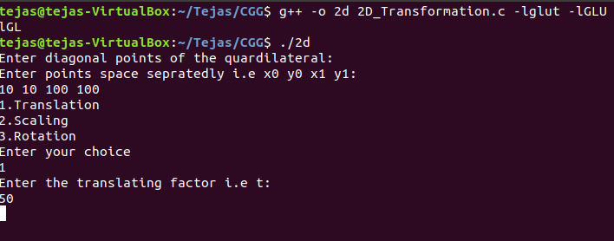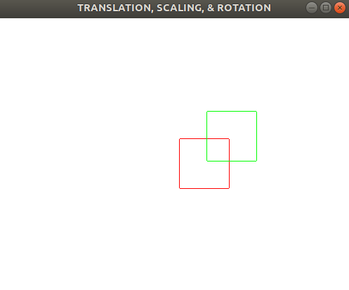

2) Scaling:

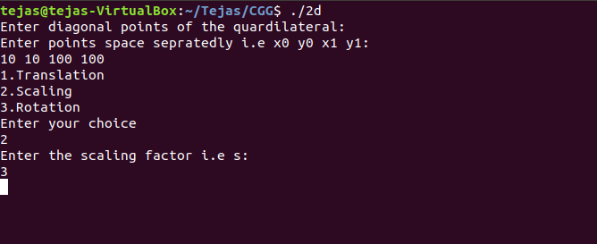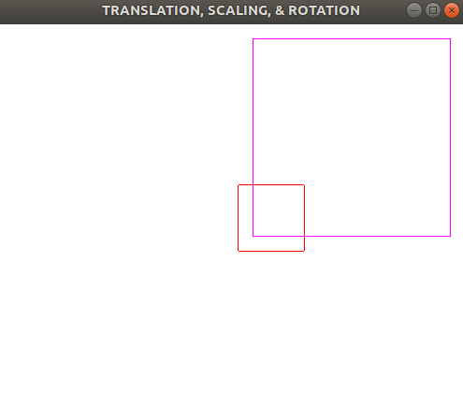

3) Rotation:

