**CGG ASSIGNMENT 8**

Name: Kedar Kale

Roll No: 129

Block B1

Topic: Clock with pendulum animation

Code:

#include<math.h>

#include<iostream>

#include<GL/glut.h>

using namespace std;

float inc=1.0;

float angle=135;

float drawCircle(float segments,float radius,float sx,float sy)

{

glBegin(GL_LINE_LOOP);

for(int i=0;i<segments;i++)

{

float theta=2.0*3.142*float(i)/float(segments); //get the current angle

float x=radius*cos(theta);

float y=radius*sin(theta);

glVertex2f(x+sx,y+sy);

}

glEnd();

}

void draw(float x1,float y1,float angle)

{

float segments=100;

float radius=6.0;

//Drawing Clock main Circle

glLineWidth(4);

glColor3f(1,0,0);

drawCircle(segments,radius,x1,y1);

//Drawing Minute Line

glColor3f(1,1,0);

glLineWidth(2);

glBegin(GL_LINES);

glVertex2f(x1,y1);

glVertex2f(x1,(radius/3.0)*2.0);

glEnd();

//Drawing Hour Line

glColor3f(1,0,0);

glLineWidth(2);

glBegin(GL_LINES);

glVertex2f(x1,y1);

glVertex2f(radius/3.0,radius/3.0);

glEnd();

//Drawing Pendulum Circle

double radians=angle*3.142/180;

float x2=(radius*3.4)*cos(radians);

float y2=(radius*3.4)*sin(radians);

float radius2=radius/3.0;

glColor3f(0,0,1);

//glLineWidth(2);

drawCircle(segments,radius2,x2,y2);

glBegin(GL_LINES);

glVertex2f(x1,-1*(radius)+0.2);

glVertex2f(x2,y2);

glEnd();

}

void display()

{

glClearColor(0,0,0,1);

glClear(GL_COLOR_BUFFER_BIT);

glLoadIdentity();

glTranslatef(-10,10,-30);

glColor3f(1,1,1);

if(angle>315)

{

angle=315;

inc=-inc;

}

if(angle<225)

{

angle=225;

inc=-inc;

}

angle += inc;

draw(0,0,angle);

glutSwapBuffers();

}

void reshape(int w,int h)

{

glMatrixMode (GL_PROJECTION); //maps camera to screen

glLoadIdentity ();

gluPerspective (100, (GLfloat)w / (GLfloat)h, 0.5, 100.0);

glMatrixMode (GL_MODELVIEW);

}

int main(int argc, char** argv)

{

glutInit(&argc,argv);

glutInitDisplayMode(GLUT_DOUBLE);

glutInitWindowSize(800,600);

glutInitWindowPosition(0,0);

glutCreateWindow("Pendulum");

glutDisplayFunc(display);

glutIdleFunc(display);

glutReshapeFunc(reshape);

glutMainLoop();

return 0;

}

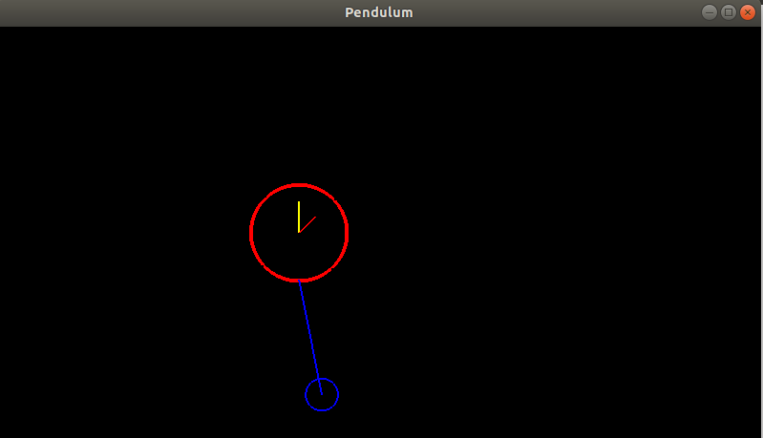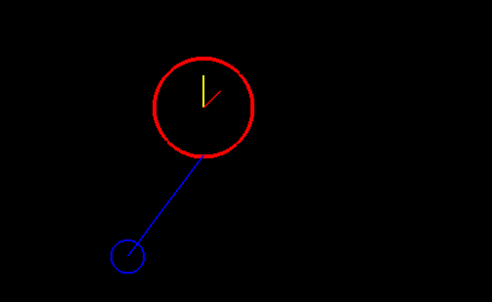Output: