Devin White

CS 5610

Interactive Computer Graphics

Project 6-EnvironmentMapping

* **What was implemented:**
  + Implemented the environment mapping
* **What you could not implement.**
  + Reflections as of the first submission are not implemented
* **Additional functionalities beyond project requirements.**
  + No additional functionalities at this time
* **How to use your implementation.**
  + Right click and drag to zoom in and out (the teapot)
  + Left click and drag to rotate. Left and right rotates left and right, up and down rotates up and down(the environment)
  + P switches between orthogonal and normal transforms
  + F6 recompiles the shaders.
  + ESC exits the window
  + CTRL and left click slightly moves the lighting
  + Alt + Left click rotates the teapot
* **What operating system and compiler you used**
  + Operating system: Windows 11
  + Programmed in Visual studio: used VS internal compiler(gl????)
* **External libraries and additional requirements to compile your project.**
  + Same as previous projects:
  + Required libraries:
    - FreeGlut
    - Glew
    - CyCodeBase
    - LodePNG

In addition, FreeGlut.dll and Glew.dll were required to be put in System 32. Libraries were put in folders next to the project along with the associated headers. Both LodePNG.h and LodePNG.cpp need to be included in the headers as well.   
A header file with the functions in the program is also included. Main.h  
In addition, I used:

#include <string.h>

#define _USE_MATH_DEFINES

#include <math.h>

//I had to put this to make it work...for some reason  
#pragma comment(lib, "glew32.lib")

There were really no other changes from the things required for previous projects. Everything should be run using the exe in the zipped folder in either debug or release

**Figure 1: Background**

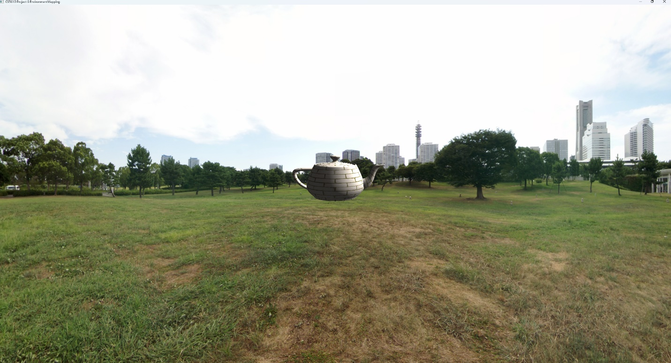

**Figure 2: Rotated background**

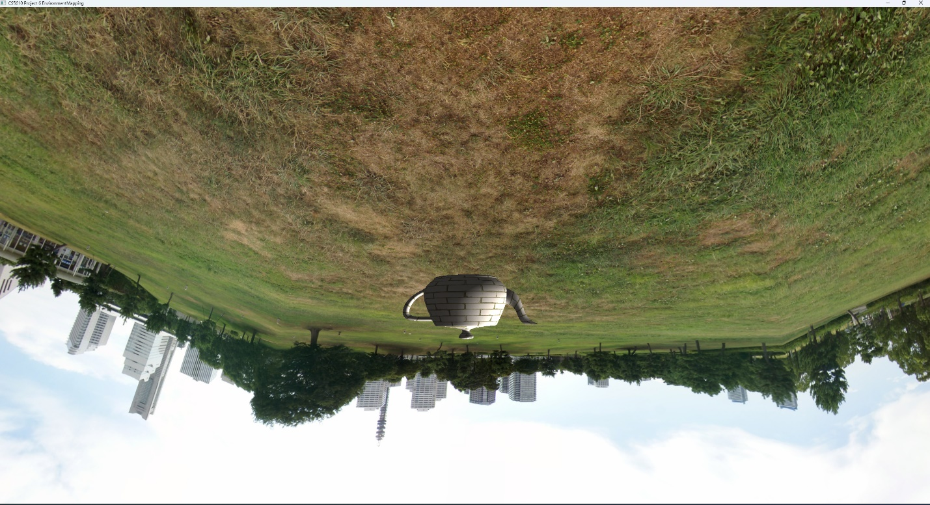

**Figure 3:Rotated background and teapot**

