Devin White

CS 5610

Interactive Computer Graphics

Project 3-Shading

* What was implemented:
  + The triangular mesh appears to be drawn properly
  + The normals appear to have been calculated correctly, as shown by the colors
  + Lighting/shading was started
* What you could not implement.
  + I couldn’t figure out entirely how to get the lighting to work correctly. The light is there but it is neither at the correct angle /doesn’t look right, and it certainly doesn’t work as I’d expect with the blinn-phong equation.
* Additional functionalities beyond project requirements.
  + N/A I need to still finish the lighting.
* How to use your implementation.
  + Right click and scroll to zoom in and out
  + Left click and scroll to rotate. Left and right rotates left and right, up and down rotates up and down
  + P switches between orthogonal and normal transforms
  + F6 recompiles the shaders….I think(hard to test)
  + ESC exits the window
* What operating system and compiler you used
  + Operating system: Windows 11
  + Programmed in Visual studio: used VS internal compiler(gl????)
* External libraries and additional requirements to compile your project.
  + Same as previous projects:
  + Required libraries:
    - FreeGlut
    - Glew
    - CyCodeBase

In addition, FreeGlut.dll and Glew.dll were required to be put in System 32. Libraries were put in folders next to the project along with the associated headers.  
In addition, I used:

#include <string.h>

#define _USE_MATH_DEFINES

#include <math.h>

//I had to put this to make it work...for some reason  
#pragma comment(lib, "glew32.lib")  
  
Here are some screenshots of the implementation:

Figure 1: Triangular meshes drawn

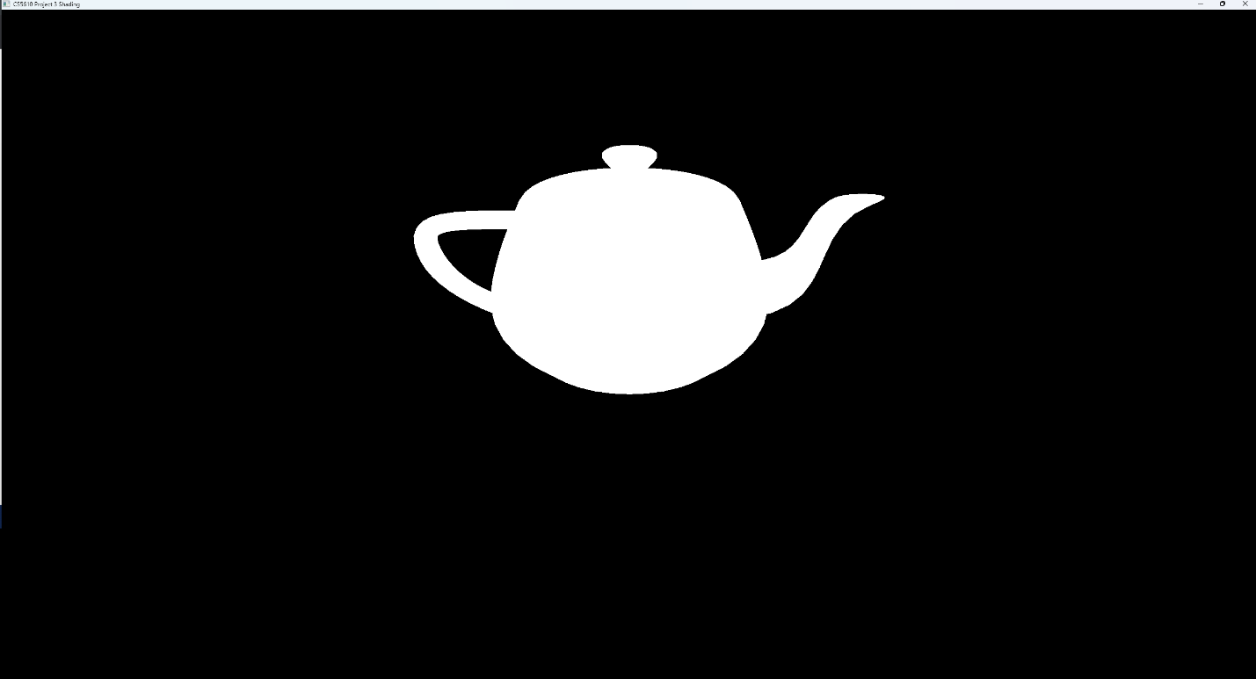

Figure 2: Normals shown  
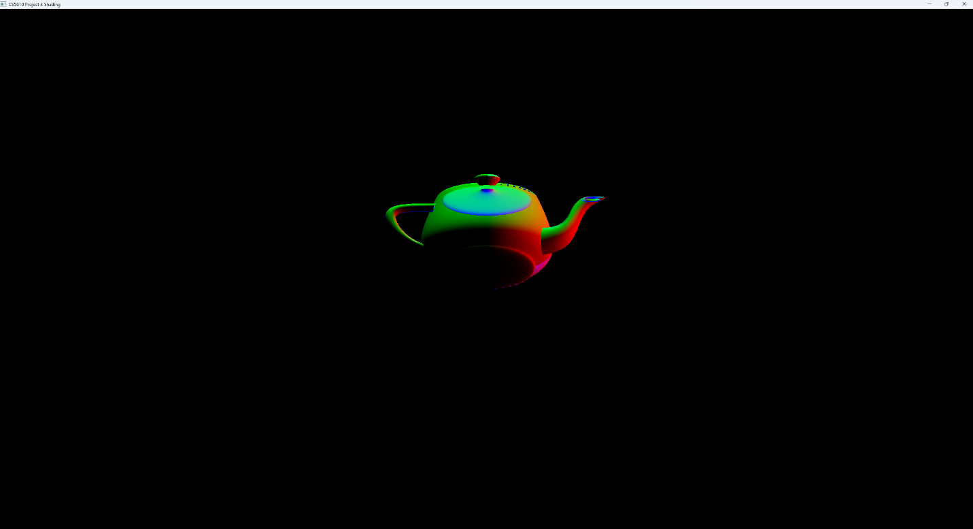

Figure 3: Lighting started(unfinished)  
