Devin White

CS 5610

Interactive Computer Graphics

Project 4-Textures

* **What was implemented:**
  + Textures are loading on the teapot
  + Load both specular and Diffuse textures

**Second Submission:**

* + Lighting/normal issue Fixed
  + Code slightly refactored
  + Window made green because green is cooler
* **What you could not implement.**
  + ~~The color of the texture isn’t correct~~
  + ~~The lighting needs to be reworked, something with the textures somewhat borked it up~~
  + ~~Several bugs need to be fixed~~

**Second Submission:**

* + Everything is implemented and working correctly.(To the best of my knowledge anyway.)
* **Additional functionalities beyond project requirements.**
  + Added Specular AND Diffuse materials as a non-grad student. No other additional functionalities.
* **How to use your implementation.**
  + Right click and scroll to zoom in and out
  + Left click and scroll to rotate. Left and right rotates left and right, up and down rotates up and down
  + P switches between orthogonal and normal transforms
  + F6 recompiles the shaders….I think(hard to test)
  + ESC exits the window
  + CTRL and left click slightly moves the lighting
* **What operating system and compiler you used**
  + Operating system: Windows 11
  + Programmed in Visual studio: used VS internal compiler(gl????)
* **External libraries and additional requirements to compile your project.**
  + Same as previous projects:
  + Required libraries:
    - FreeGlut
    - Glew
    - CyCodeBase
    - LodePNG

In addition, FreeGlut.dll and Glew.dll were required to be put in System 32. Libraries were put in folders next to the project along with the associated headers. Both LodePNG.h and LodePNG.cpp need to be included in the headers as well.  
In addition, I used:

#include <string.h>

#define _USE_MATH_DEFINES

#include <math.h>

//I had to put this to make it work...for some reason  
#pragma comment(lib, "glew32.lib")

**Second Submission screenshots**

**Figure 1: Teapot with texture**

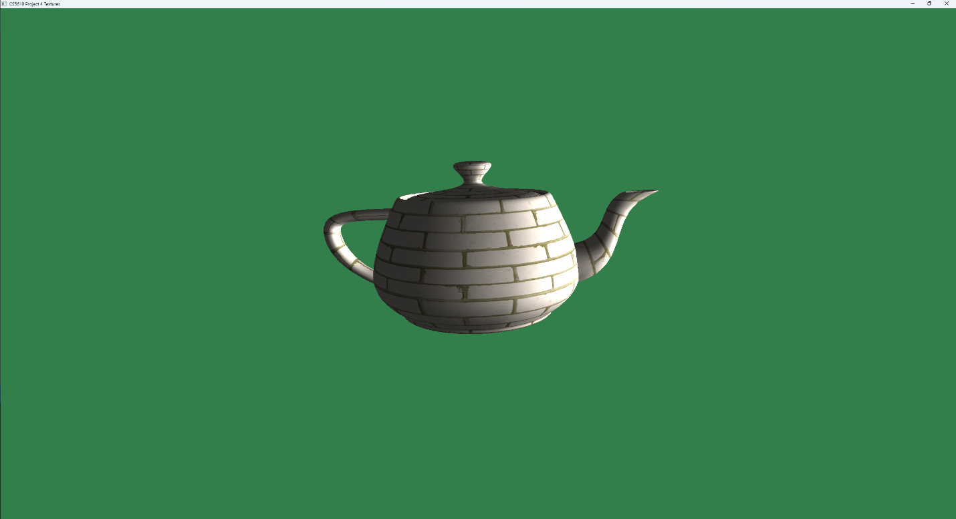

**Figure 2: Teapot with texture on black background(to see lighting better)**

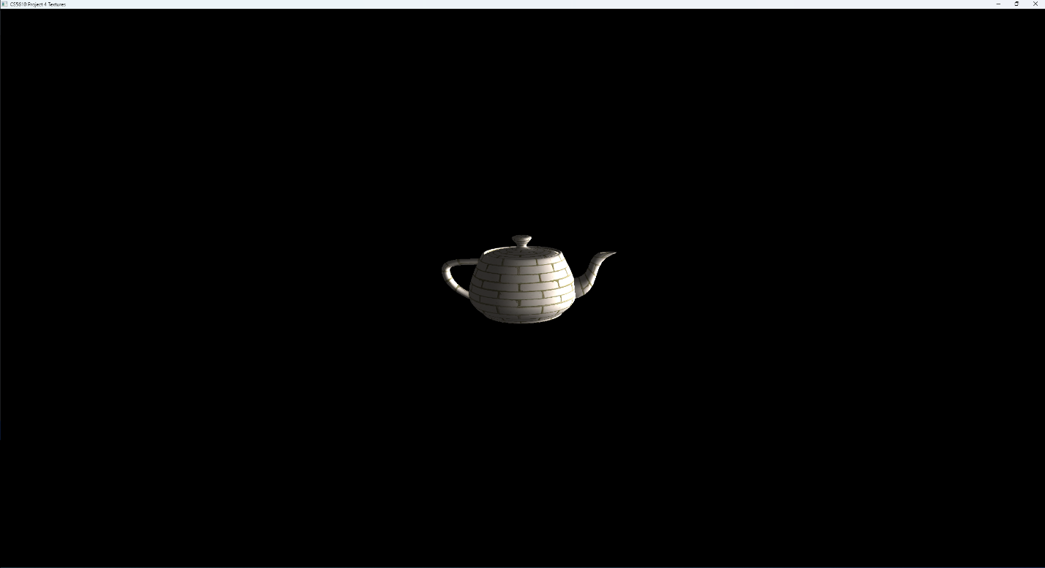

**OLD(original) SUBMISSION**

**Figures showing textures**

