**ADFGVX Cipher HW 10**

**By: Kaleb Alstott**

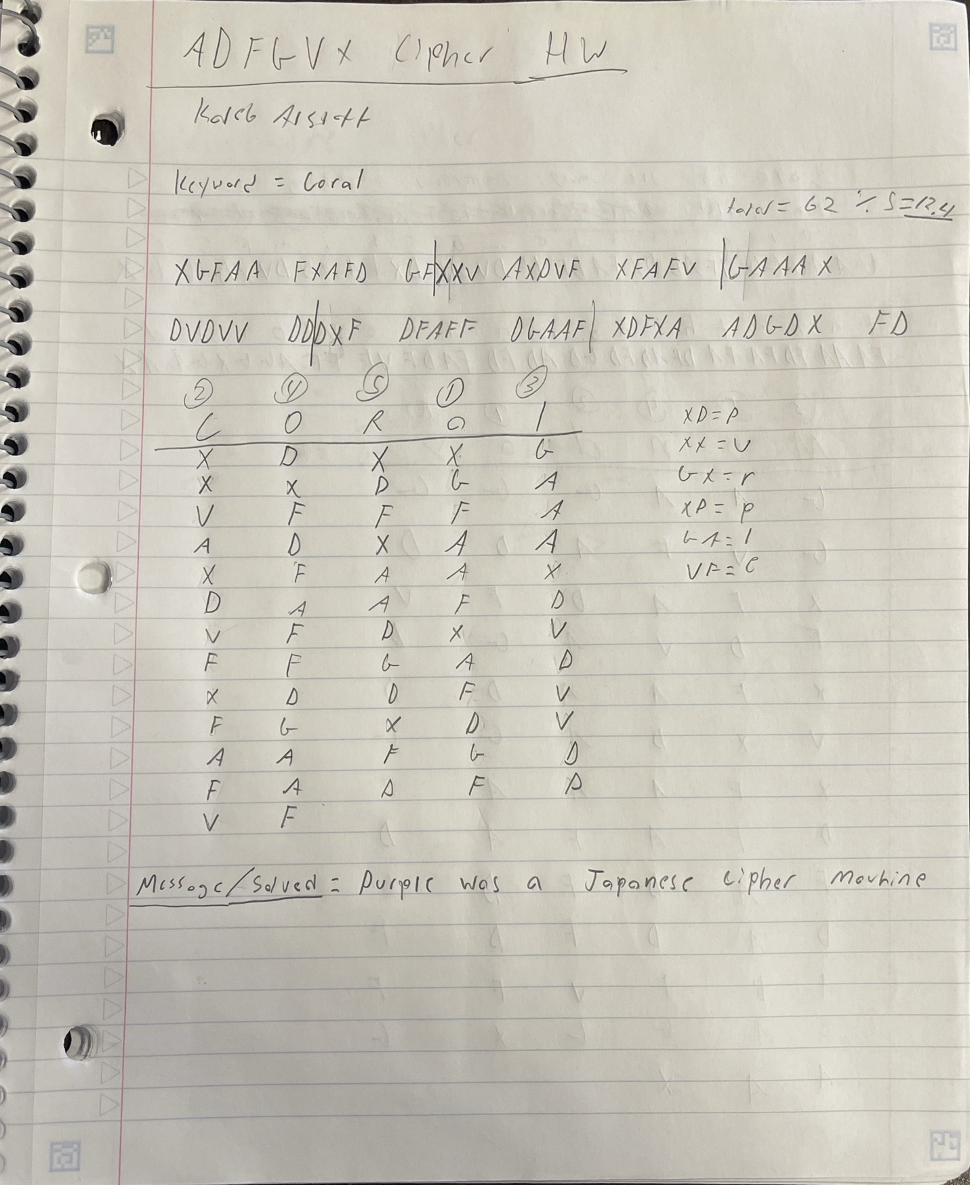

**Solved: Purple was a Japanese cipher machine**. I was able to solve this cipher by first figuring out the total number of letters divided by the keyword to figure out that each column would have 12 letters. The two extra letters would be applied to the columns of 2 and 4 so those columns will have 13 letters to appropriately fit all the letters into our box. Once we separated out the correct number of letters per column, we simply rearrange the letters to suit the order of the column alphabetically. In our case the A column would be first then the C, followed by L,O, and R. Once we rearranged the letters back to normal, we use our ADFGVX key square to decipher the message.