**Known PT Attack on LSFR**

**By: Kaleb Alstott**

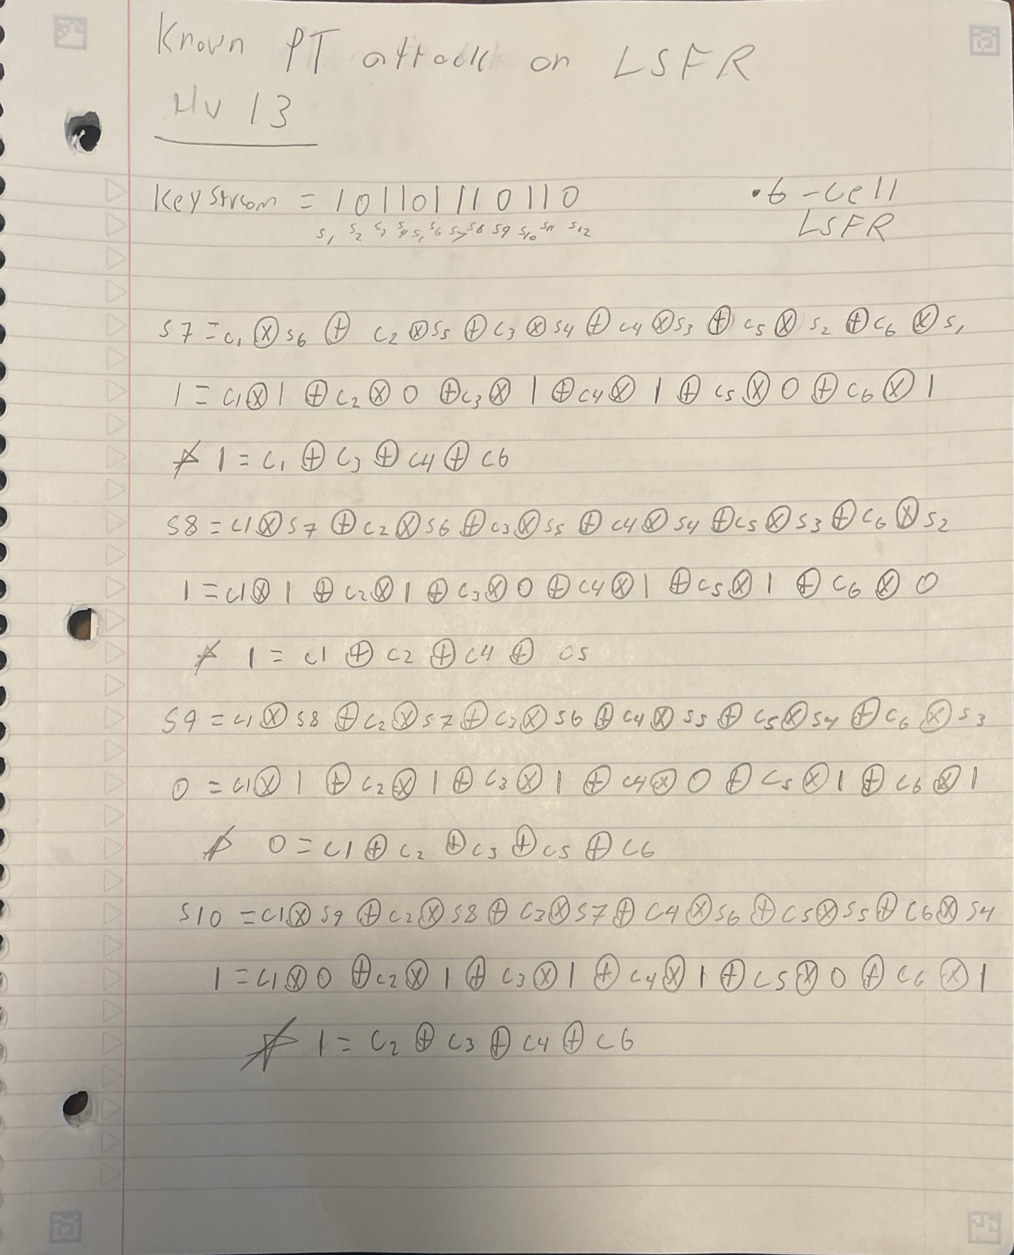

**Taps = c5 and c6**