**Stream Cipher HW 11**

**Kaleb Alstott**

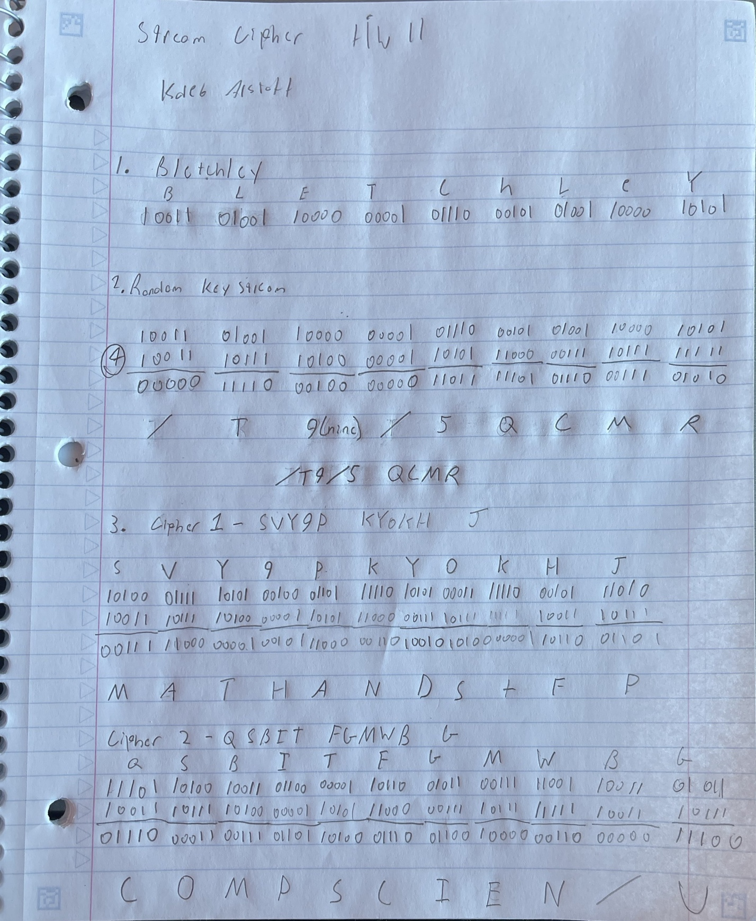

SOLVED: I was able to solve the stream cipher by taking the bits and XOR them with the random key stream in order to encipher the text. I was able to decipher by taking the binary digits of the cipher and XOR them to the keystream to solve the messages.