## **3) Lab5-3: Scripting (30-points)**

Lab **Submission**

Please make sure to do all the exercises.

**Exercise 1 – Perform Search**

**Task 1 - Use the Find Command**

#### **Perform the Step 1 - Step 20 Use the Find Command and copy and paste the screenshots here. Remember to provide a title to each screenshot. Screenshots without title will not be graded.**

**Using Find Command**

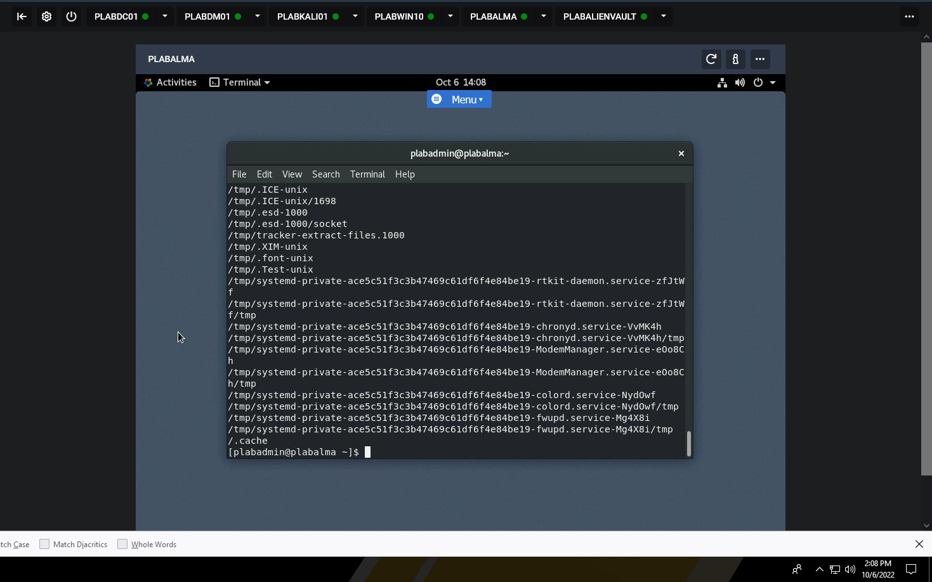

**Task 2 - Find Files and Commands on a Linux System**

#### **Perform the Step 1 - Step 16 Find Files and Commands on a Linux System and copy and paste the screenshots here. Remember to provide a title to each screenshot. Screenshots without title will not be graded.**

**Finding files and commands on LS**

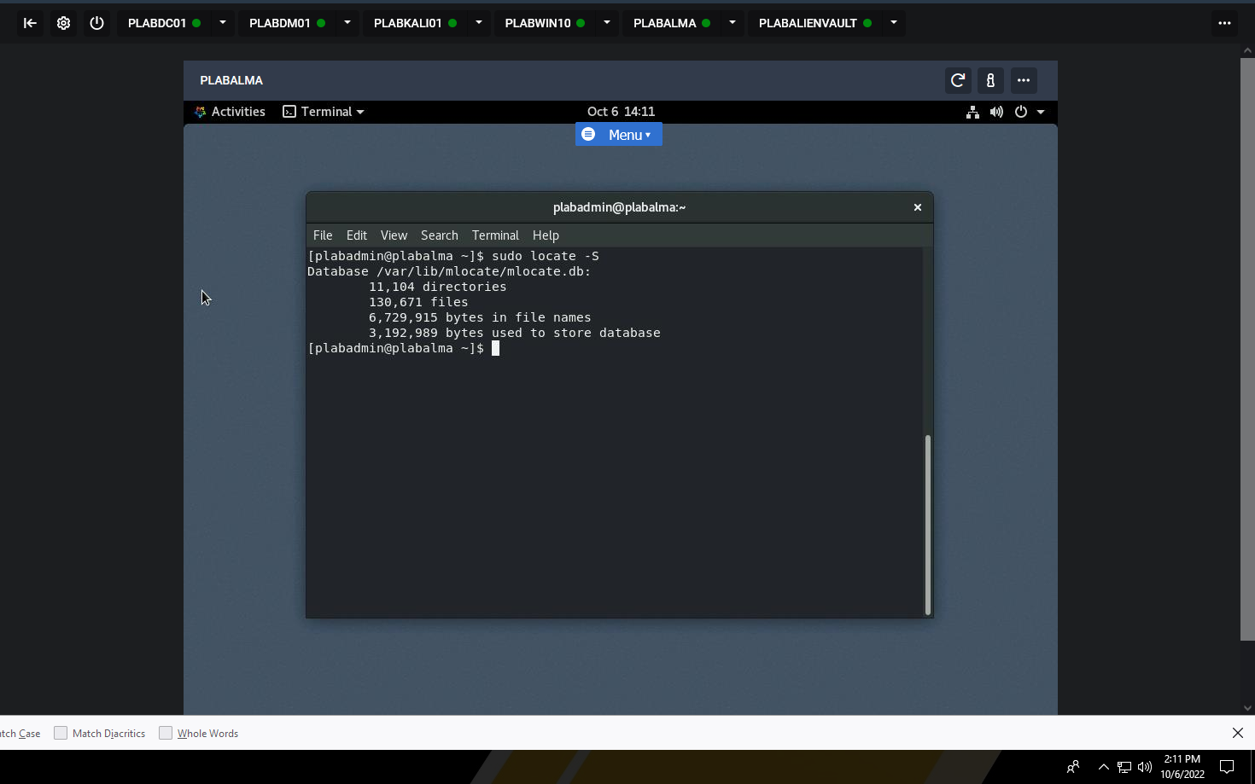

**Task 3 - Search for a Specific Text in a File**

#### **Perform the Step 1 - Step 10 Search for a Specific Text in a File and copy and paste the screenshots here. Remember to provide a title to each screenshot. Screenshots without title will not be graded.**

**Search for specific text in a file**

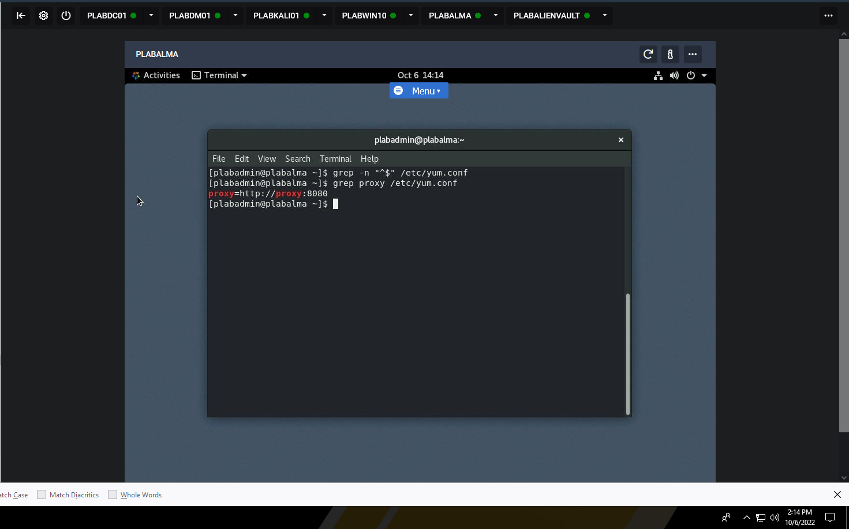

**Task 4 - Search for Specific Criteria Through a File Content or a Filesystem**

#### **Perform the Step 1 - Step 12 Search for Specific Criteria Through a File Content or a Filesystem and copy and paste the screenshots here. Remember to provide a title to each screenshot. Screenshots without title will not be graded.**

**Searching for Specific Criteria Through a File Content or a Filesystem**

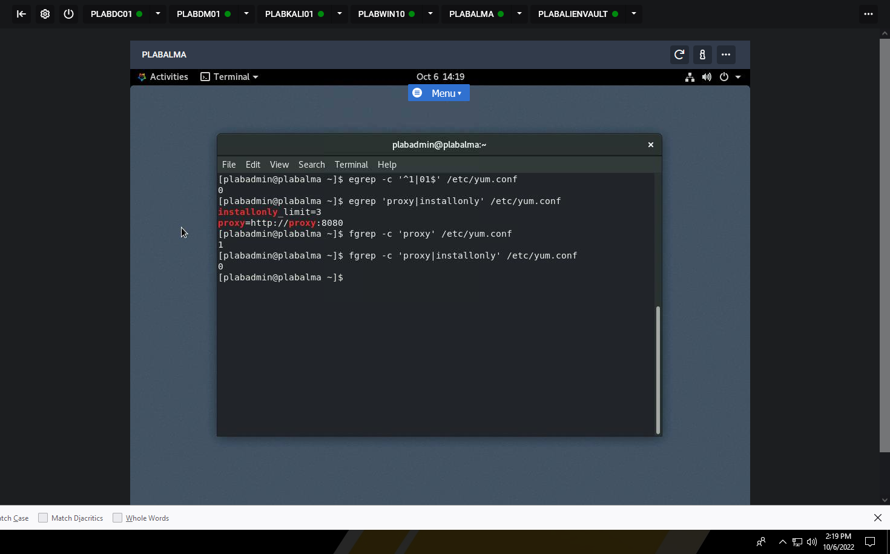

**Exercise 2 – Scripting**

**Task 1 - Write a Simple Bash Script**

#### **Perform the Step 1 - Step 19 Write a Simple Bash Script and copy and paste the screenshots here. Remember to provide a title to each screenshot. Screenshots without title will not be graded.**

**Simple bash shell script**

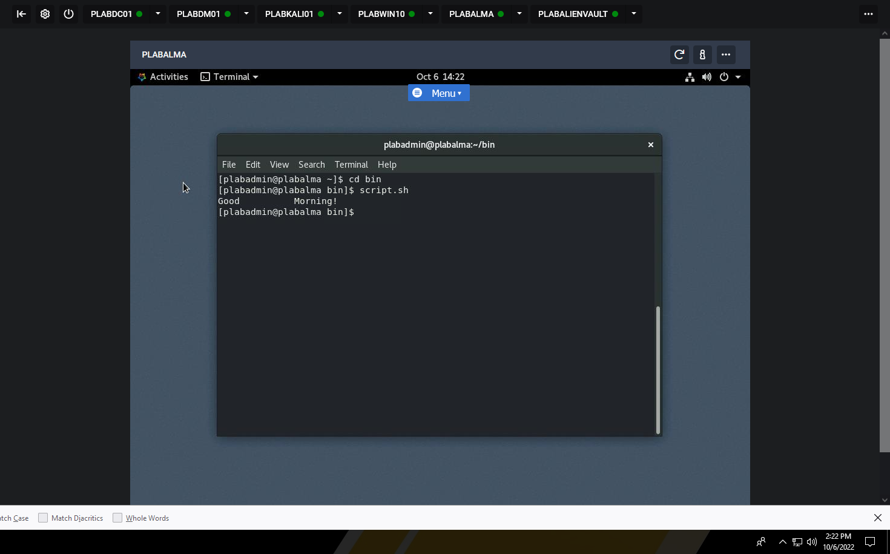

**Task 2 - Use Commenting**

#### **Perform the Step 1 - Step 6 Use Commenting and copy and paste the screenshots here. Remember to provide a title to each screenshot. Screenshots without title will not be graded.**

**Using Commenting**

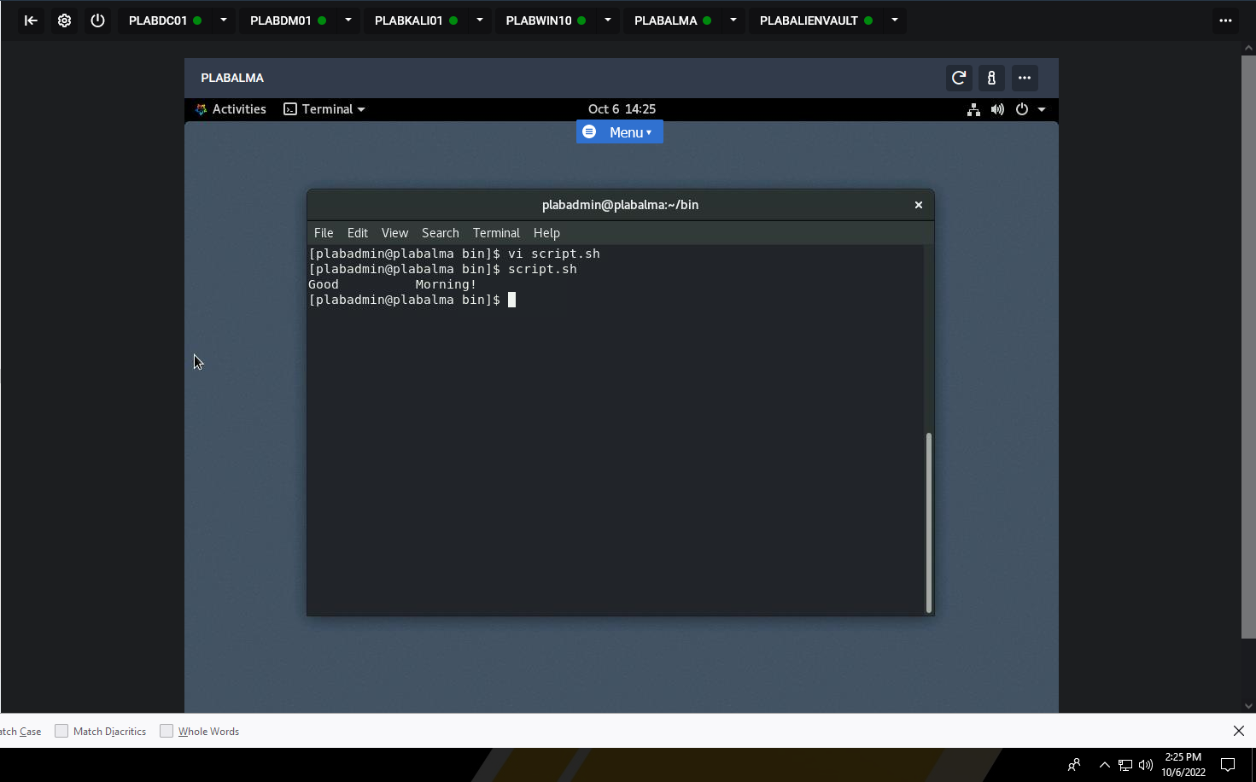

**Task 3 - Use Parameters**

#### **Perform the Step 1 - Step 11 Use Parameters and copy and paste the screenshots here. Remember to provide a title to each screenshot. Screenshots without title will not be graded.**

**Using Parameters**

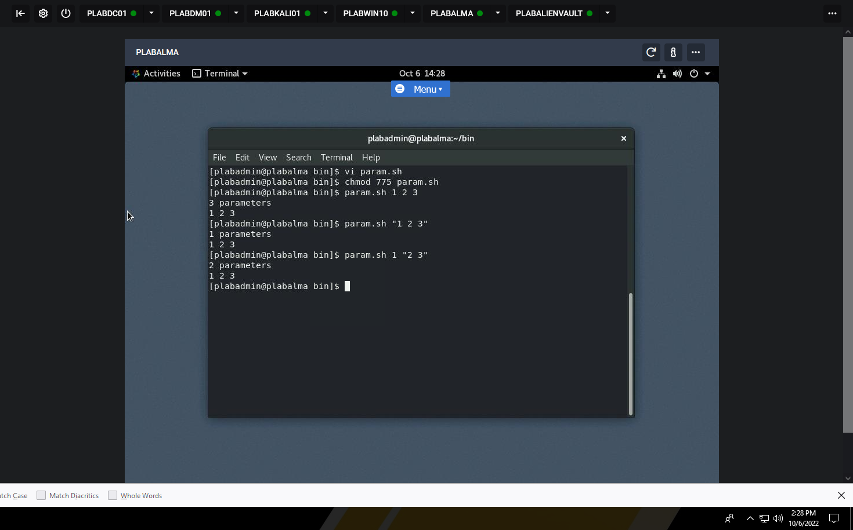

**Task 4 - Capture User Inputs in Scripts**

#### **Perform the Step 1 - Step 13 Capture User Inputs in Scripts and copy and paste the screenshots here. Remember to provide a title to each screenshot. Screenshots without title will not be graded.**

**Capturing user inputs in Scripts**

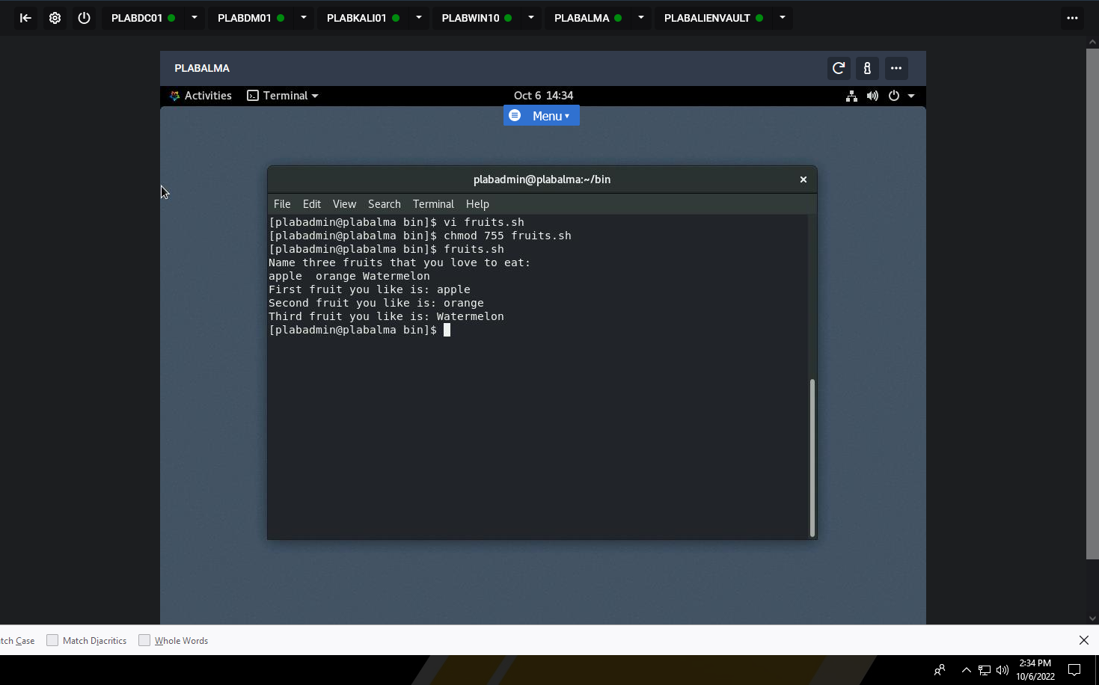

**Exercise 3 - Piping**

**Task 1 - Pipe the Output of one Command to the Input of another Command**

#### **Perform the Step 1 - Step 3 Pipe the Output of one Command to the Input of another Command and copy and paste the screenshots here. Remember to provide a title to each screenshot. Screenshots without title will not be graded.**

**Pipe the Output of one Command to the Input of another Command**

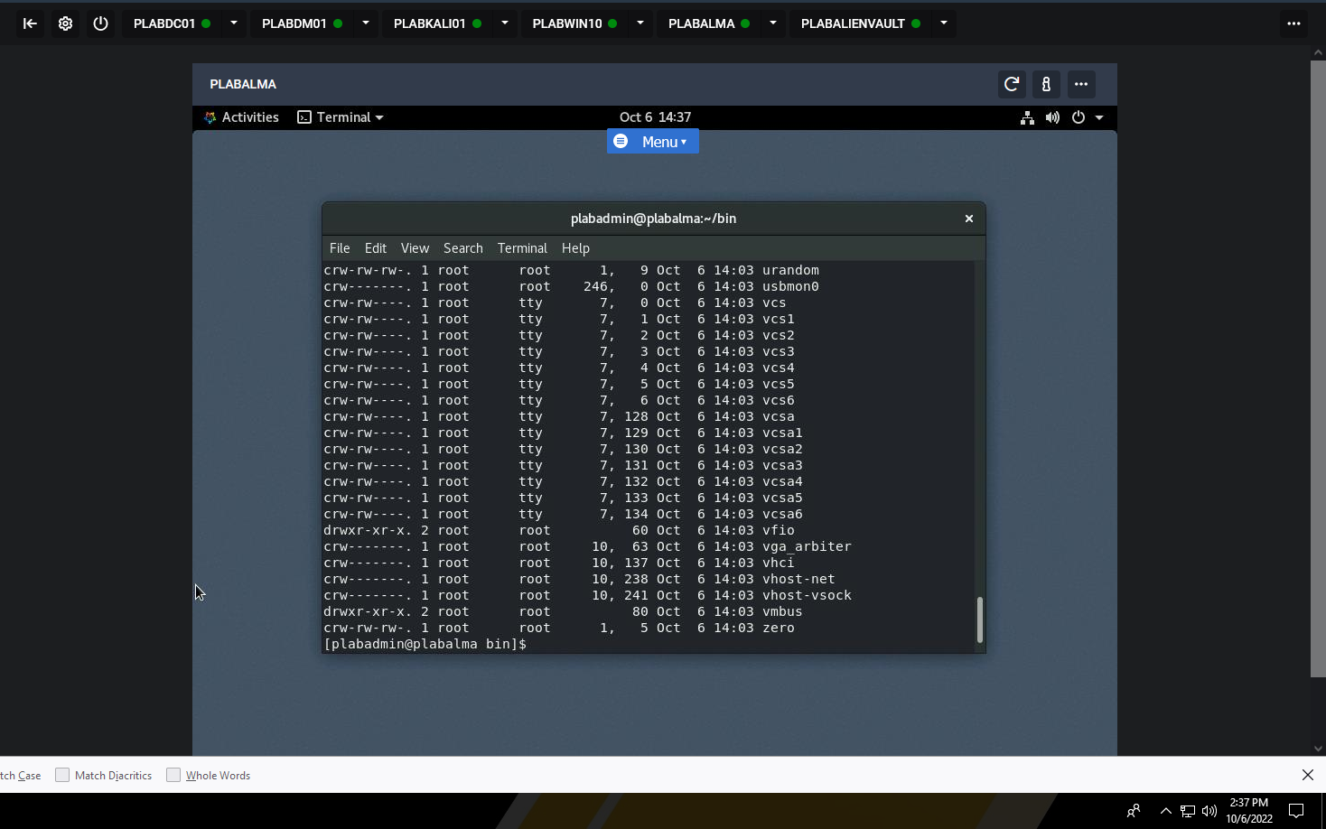

**Task 2 - Use the Output of One Command as Argument to another Command**

#### **Perform the Step 1 - Step 6 Use the Output of One Command as Argument to another Command and copy and paste the screenshots here. Remember to provide a title to each screenshot. Screenshots without title will not be graded.**

**Use the Output of One Command as Argument to another Command**

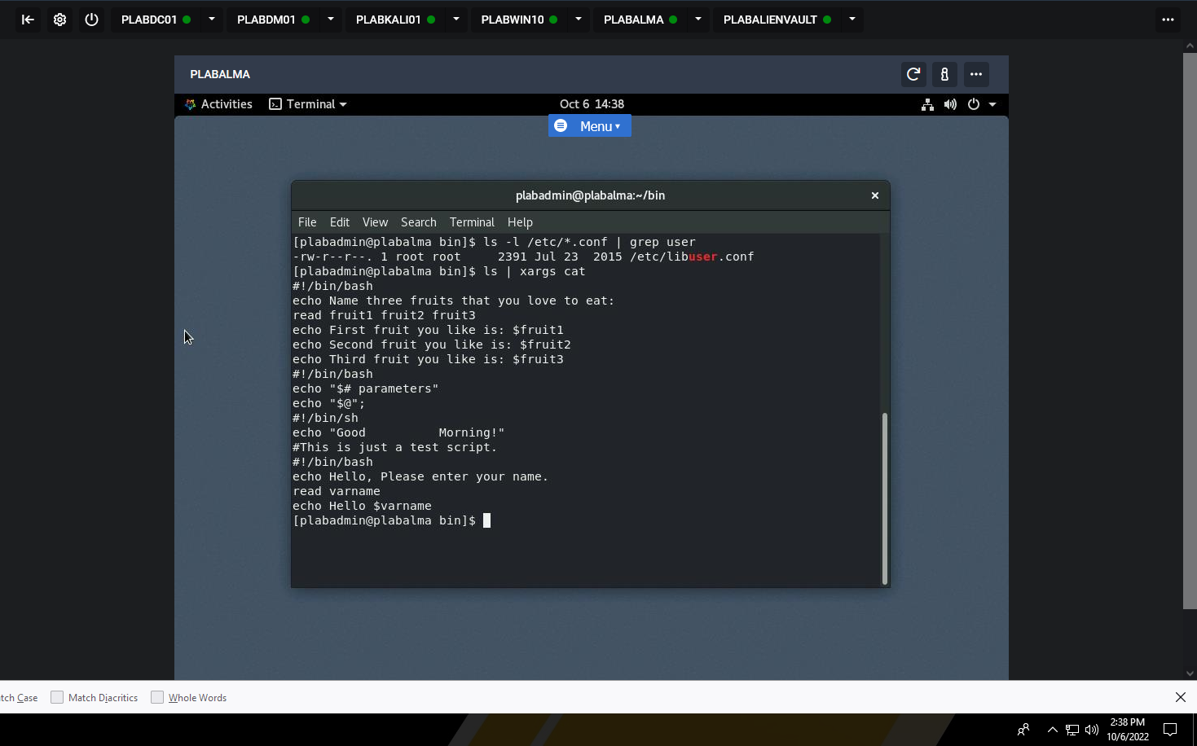

**Task 3 - Send Output to Both Stdout and a File**

#### **Perform the Step 1 - Step 6 Send Output to Both Stdout and a File and copy and paste the screenshots here. Remember to provide a title to each screenshot. Screenshots without title will not be graded.**

**Send Output to Both Stdout and a File**

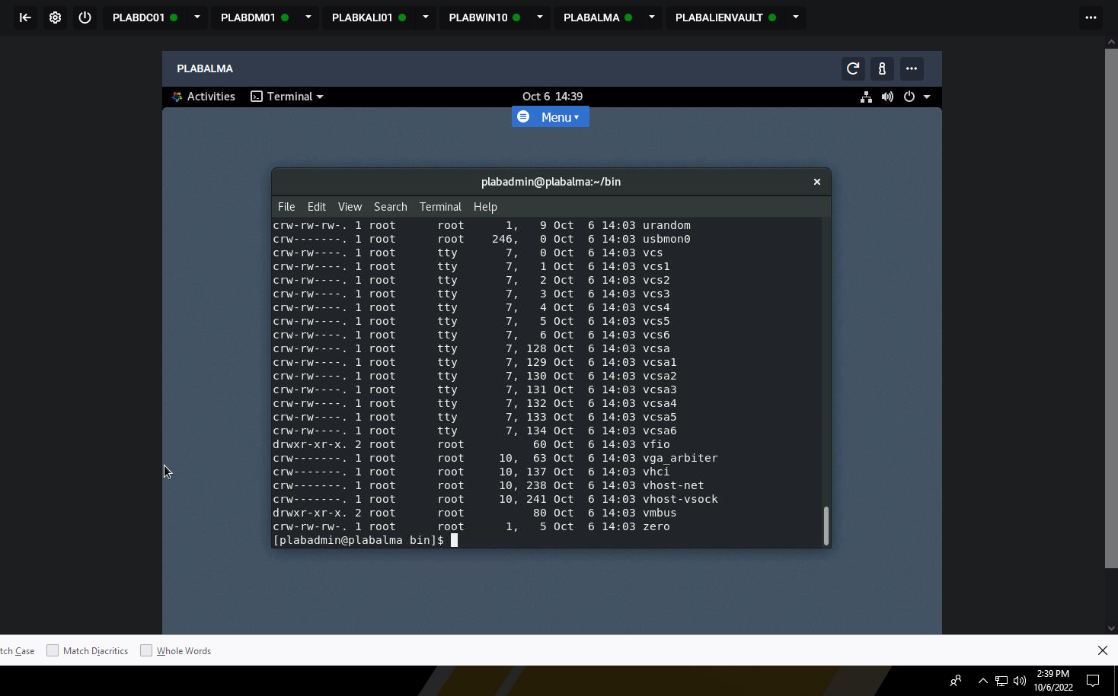

· Save the report as a docx file (first name and last name: ex. Awad_Mussa3.docx)

· Keep this file as you will upload it when you take the lab4’s quiz.