## **2) Lab6-2: Host Related Incident Compromise Indicators (30-points)**

Lab **Submission**

Please make sure to do all the exercises.

**Exercise 2 - Prevent Unauthorized Software from Running**

**Task 1 - Create a Sample Batch File**

#### **Perform the Step 1 - Step 14 Create a Sample Batch File and copy and paste the screenshots here. Remember to provide a title to each screenshot. Screenshots without title will not be graded.**

**Sample Batch File**

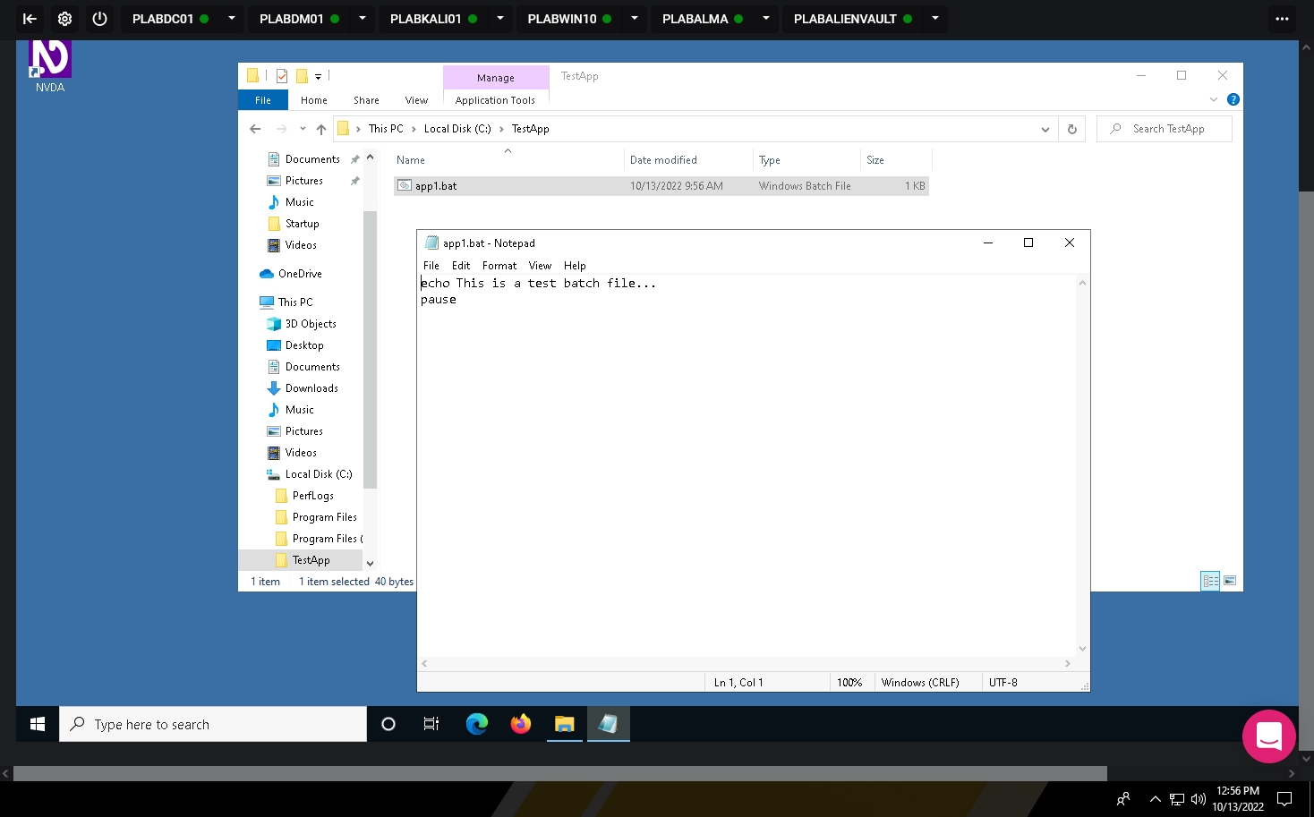

**Task 2 - Create a Local Software Restriction Policy**

Perform the Step 1 - Step 23Create a Local Software Restriction Policy and copy and paste the screenshots here. Remember to provide a title to each screenshot. Screenshots without title will not be graded.

**Local Software Restriction Policy**

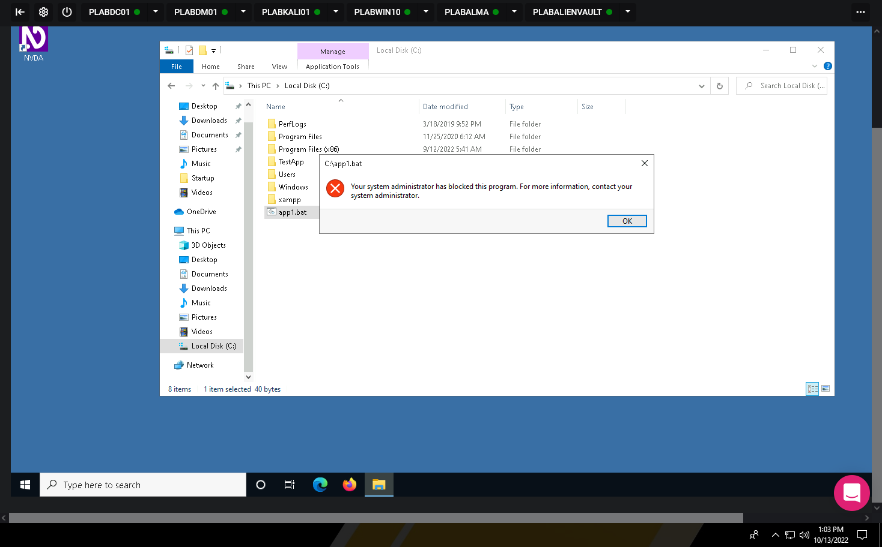

· Save the report as a docx file (first name and last name: ex. Awad_Mussa2.docx)

· Keep this file as you will upload it when you take the lab4’s quiz.

· d it when you take the lab4’s quiz.