**2) Lab4-2: Improving Network Security (35-points)**

**LAB SUBMISSION**

Please make sure to do all the exercises.

**Exercise 2 - Update Antimalware Signatures**

**Task 1 - Update Windows Defender**

Perform the Step 1 - Step 7 Update Windows Defender and copy and paste the screenshots here. Remember to provide a title to each screenshot. Screenshots without title will not be graded.

**Updating Windows Defender**

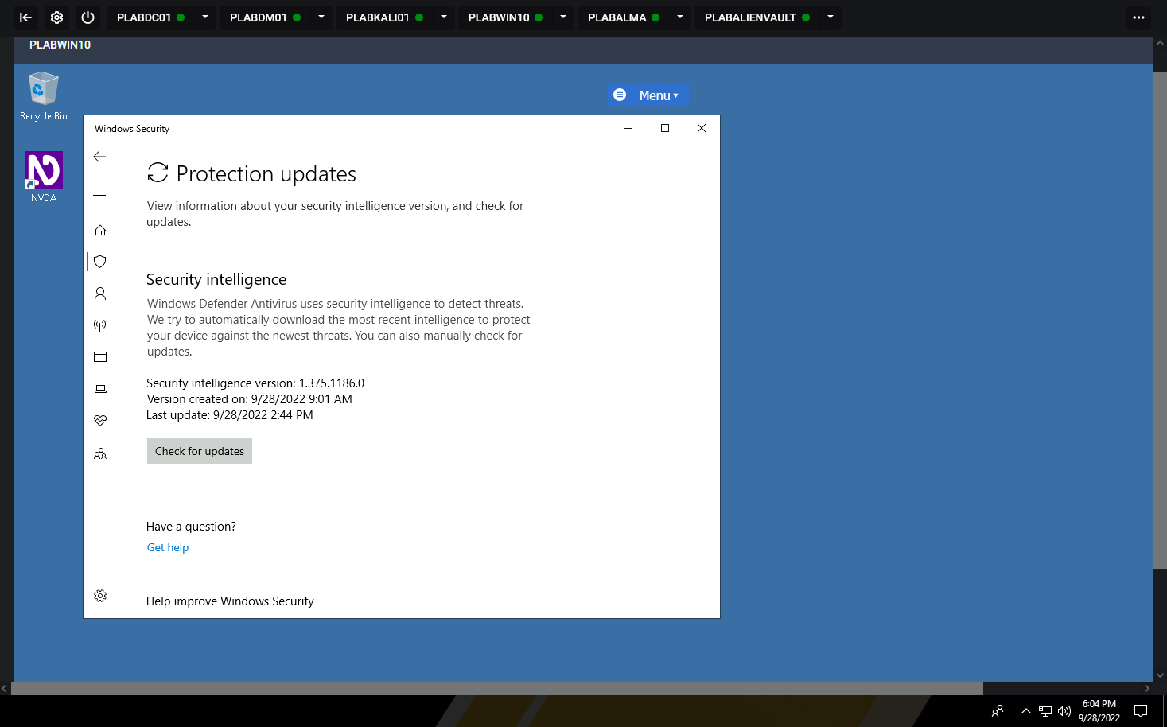

**Exercise 3 – Work with Snort**

**Task 1 – Installing Snort**

Perform the Step 1 - Step 9 Installing Snort and copy and paste the screenshots here. Remember to provide a title to each screenshot. Screenshots without title will not be graded.

**Installing Snort**

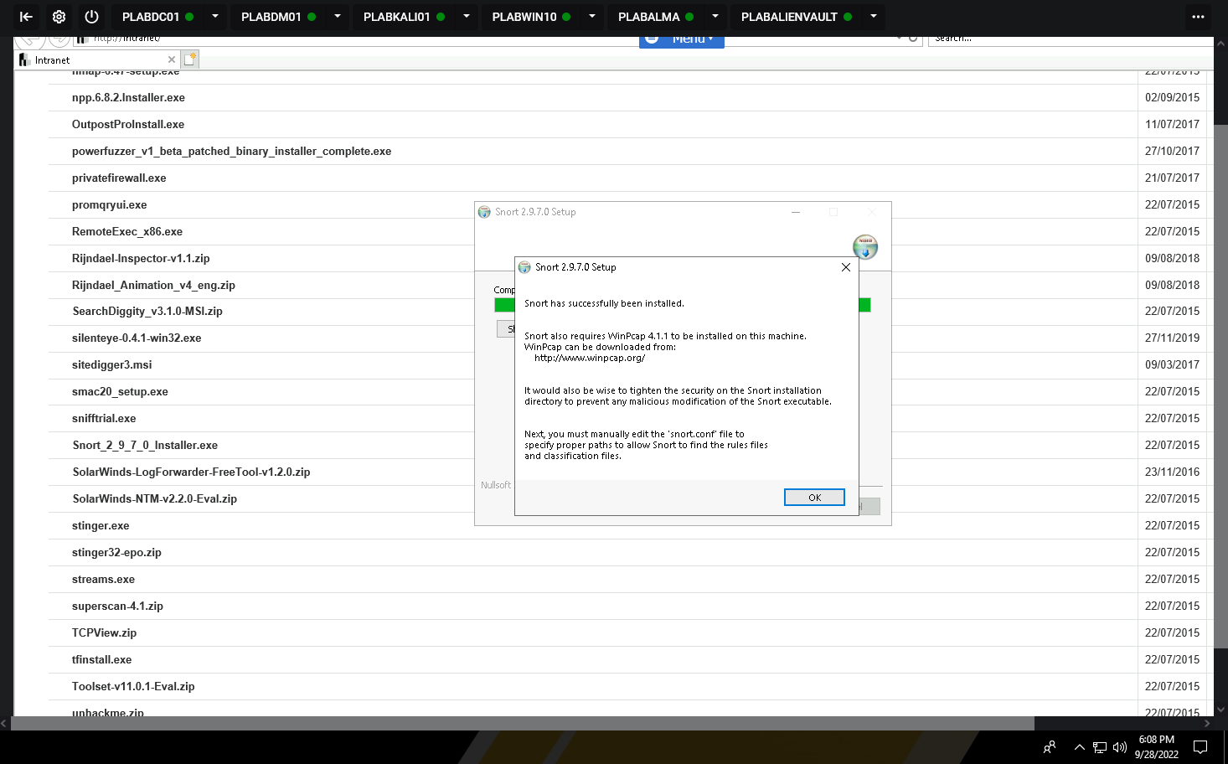

**Task 2 – Download Snort Rules**

Perform the Step 1 - Step 7 Download Snort Rules and copy and paste the screenshots here. Remember to provide a title to each screenshot. Screenshots without title will not be graded.

**Downloaded Snort Rules**

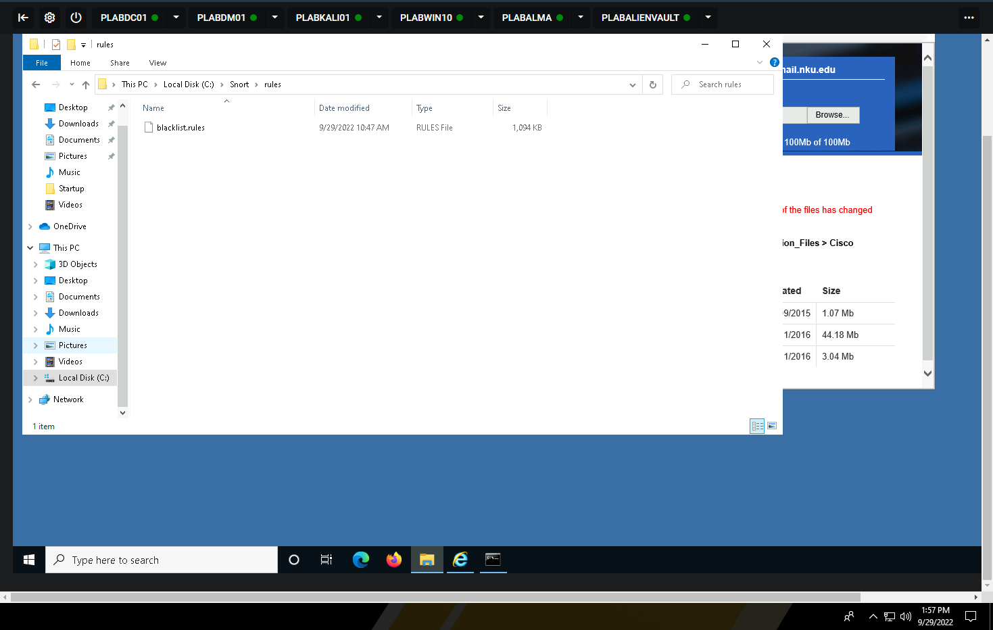

**Task 3 – Running Snort Tool**

Perform the Step 1 - Step 13 Running Snort Rules and copy and paste the screenshots here. Remember to provide a title to each screenshot. Screenshots without title will not be graded.

**Running Snort Tool**

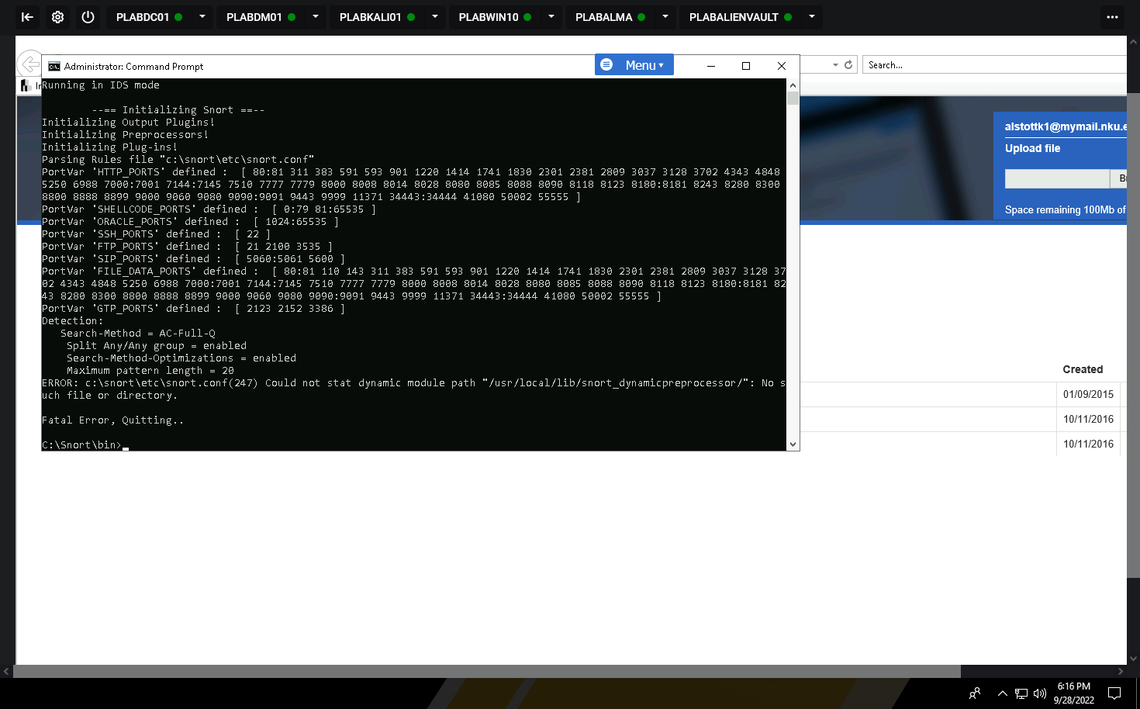

**Task 4 – Create a Folder and the Rules File in the Snort Folder**

Perform the Step 1 - Step 16 Create a Folder and the Rules File in the Snort Folder and copy and paste the screenshots here. Remember to provide a title to each screenshot. Screenshots without title will not be graded.

**Creating a folder and place rules file in the snort folder**

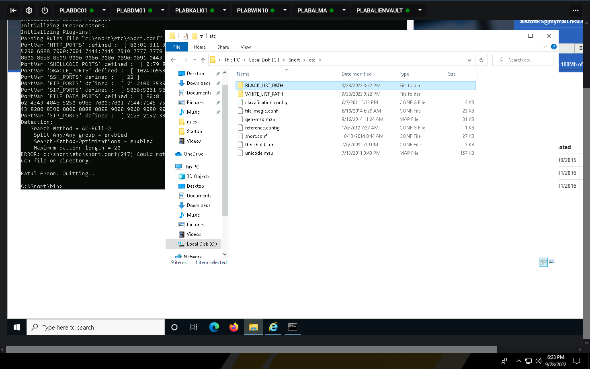

**Task 5 – Modify the Snort Configuration File**

Perform the Step 1 - Step 26 Modify the Snort Configuration File and copy and paste the screenshots here. Remember to provide a title to each screenshot. Screenshots without title will not be graded.

**Modifying the Snort conf file**

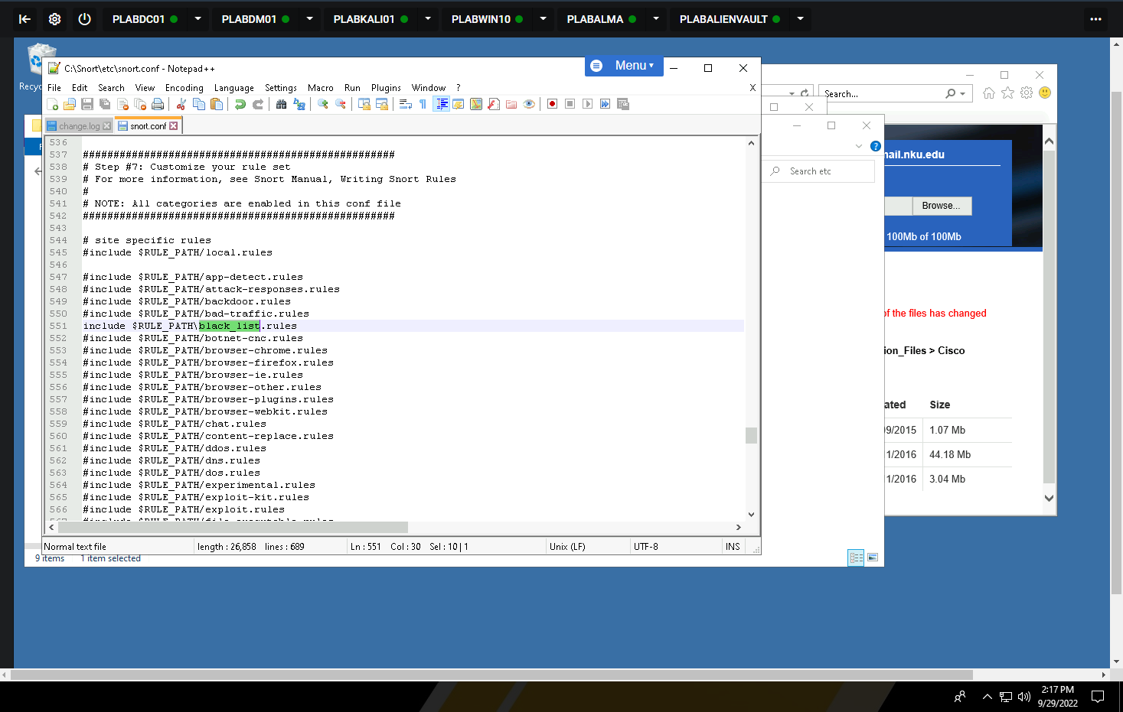

**Task 6 – Re-run Snort IDS tool**

Perform the Step 1 - Step 5 Re-run Snort IDS tool and copy and paste the screenshots here. Remember to provide a title to each screenshot. Screenshots without title will not be graded.

**Re run Snort**

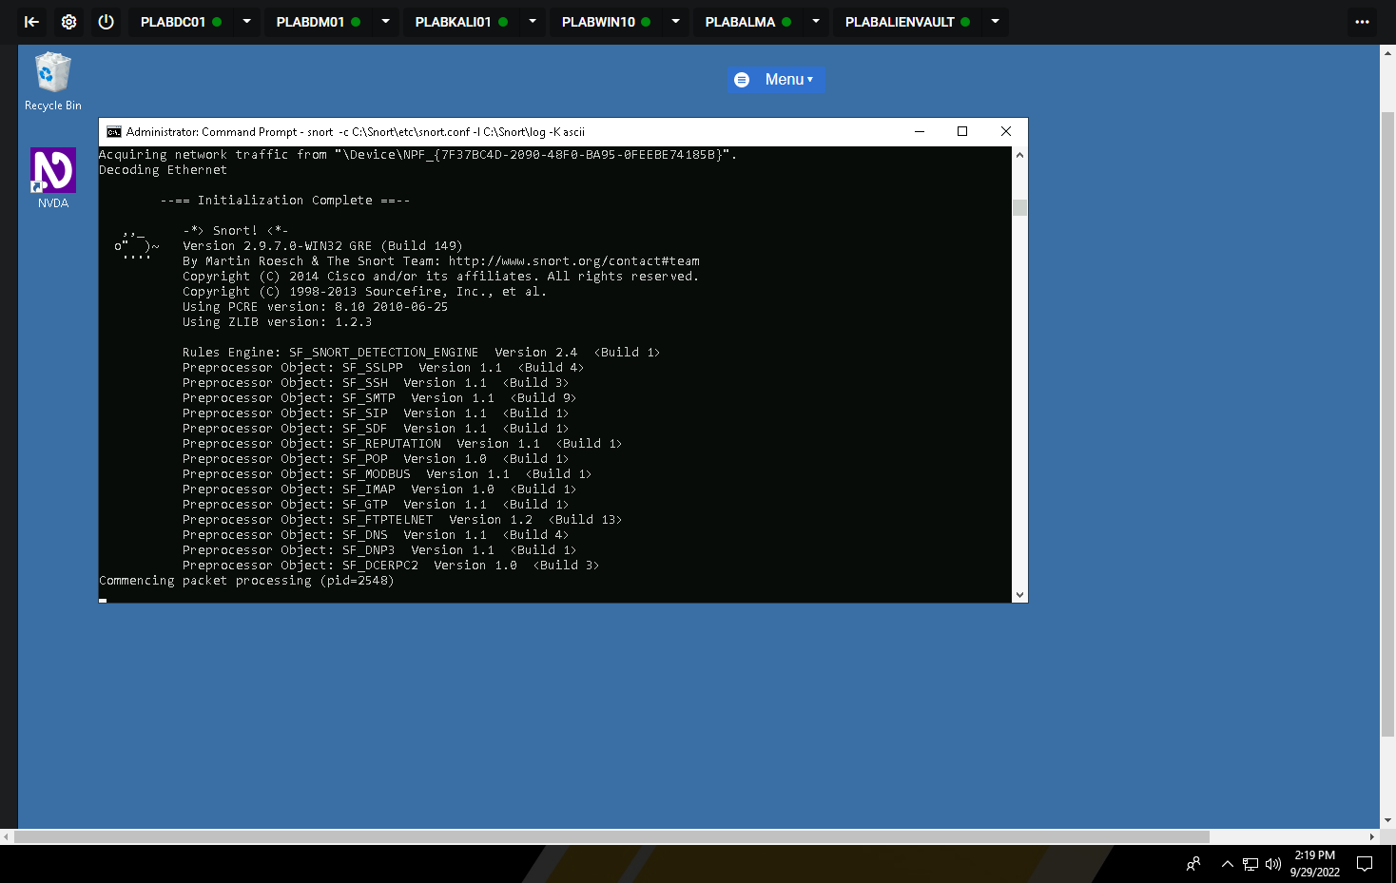

• Save the report as a docx file (first name and last name: ex. Awad_Mussa2.docx)

• Keep this file as you will upload it when you take the lab4’s quiz.