**3) Lab4-3: Infrastructure Security (30-points)**

**LAB SUBMISSION**

Please make sure to do all the exercises.

**Exercise 1 - Set up a Honeypot with Pentbox**

**Task 1 - Download and Install Pentbox**

Perform the Step 1 - Step 14 Download and Install Pentbox and copy and paste the screenshots here. Remember to provide a title to each screenshot. Screenshots without title will not be graded.

**Installed Pentbox**

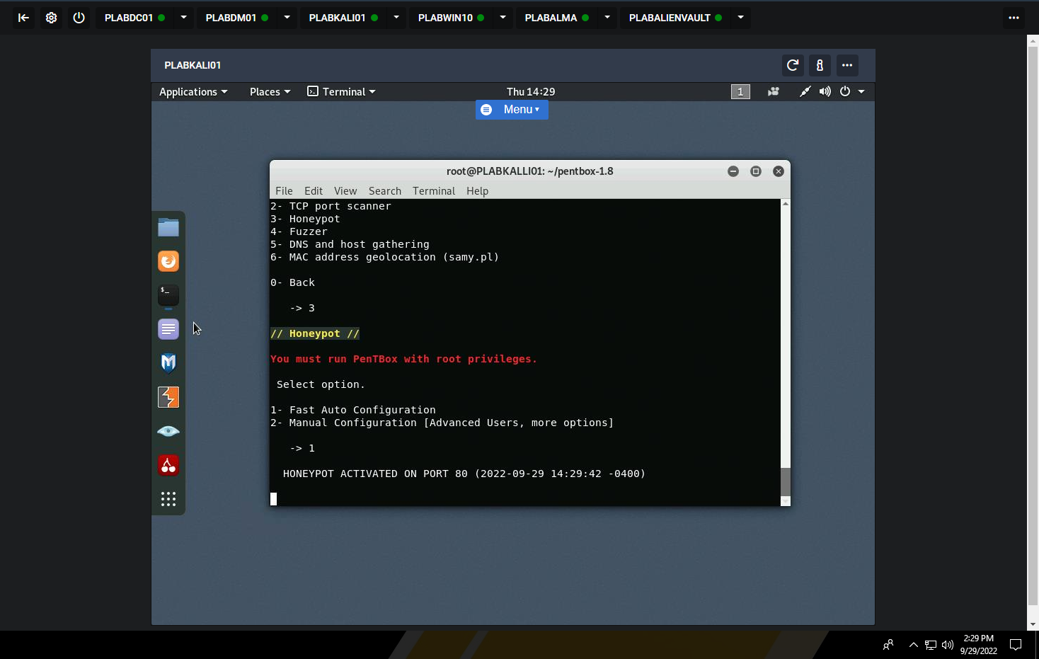

**Task 2 - Modify Proxy Server Exceptions in PLABWIN10**

Perform the Step 1 - Step 7 Modify Proxy Server Exceptions in PLABWIN10 and copy and paste the screenshots here. Remember to provide a title to each screenshot. Screenshots without title will not be graded.

**Modifying the Proxy server**

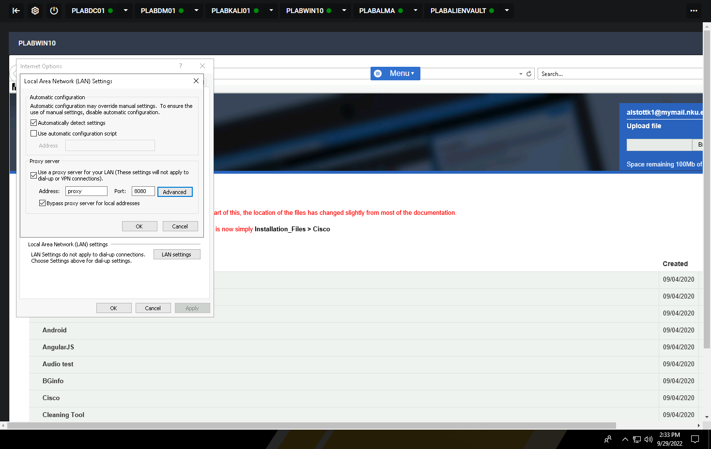

**Task 3 - Test Honeypot Functionality**

Perform the Step 1 - Step 3 Test Honeypot Functionality and copy and paste the screenshots here. Remember to provide a title to each screenshot. Screenshots without title will not be graded.

**Testing honeypot**

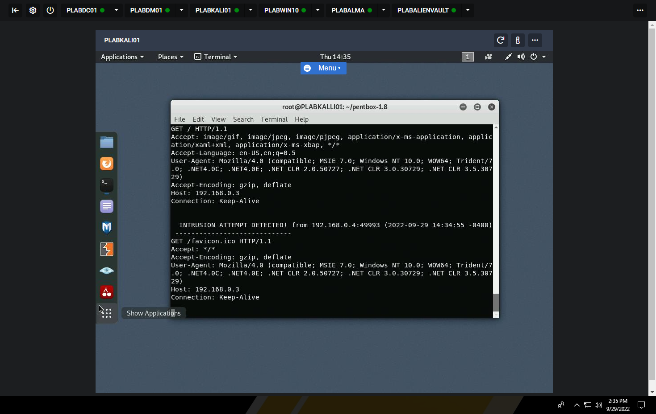

• Save the report as a docx file (first name and last name: ex. Awad_Mussa3.docx)

• Keep this file as you will upload it when you take the lab4’s quiz.