**Lab Submission**

**Exercise 1 – Automation Concepts**

**Task 1 - Scripting**

Perform the Step 1 - Step 11 Scriptingand copy and paste the screenshots here. Remember to provide a title to each screenshot. Screenshots without title will not be graded.

**Scripting**

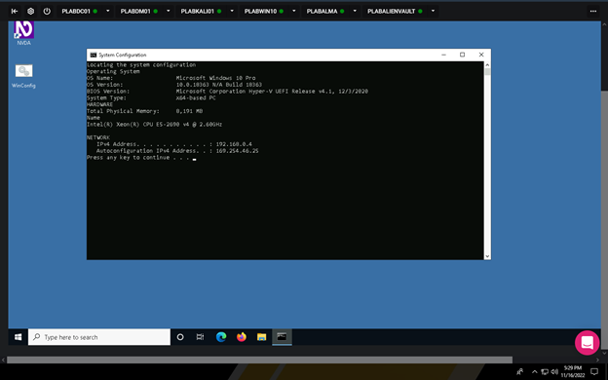

**Then back to the home screen when any button is pressed**

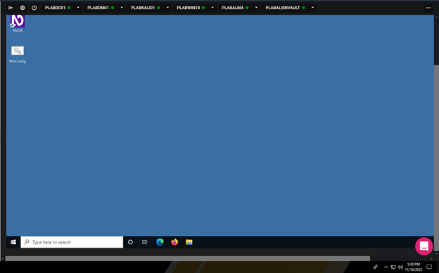

· **Save the report as a docx file (first name and last name: ex. Awad_Mussa2.docx)**

· **Keep this file as you will upload it when you take the lab10’s quiz.**