**Install express rate limit**

“npm i express-rate-limit”. Rate limit would limit an IP address request to the server, like logging in would cap login request to 15 minutes for a specific IP for Security such as DDOS attacks.



**How to import**

import { rateLimit } from 'express-rate-limit'

**Use**

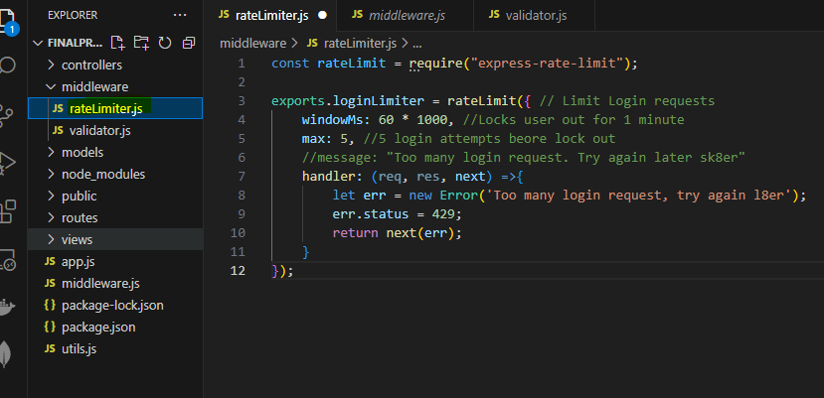

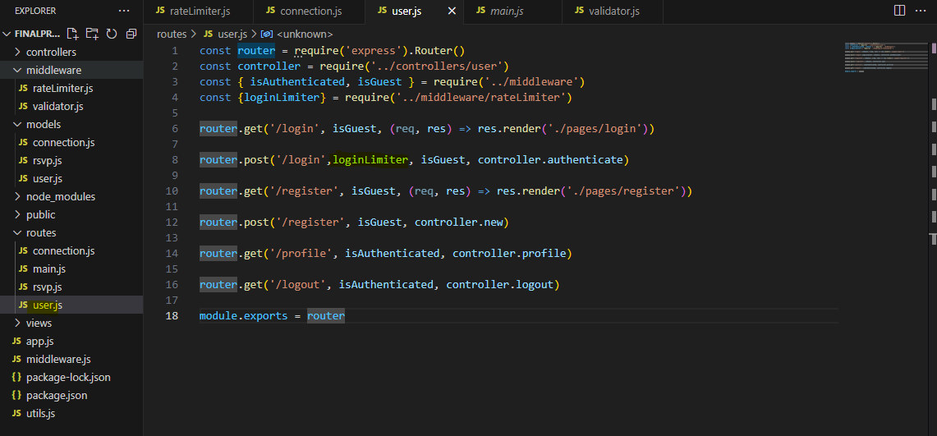

Install express validator

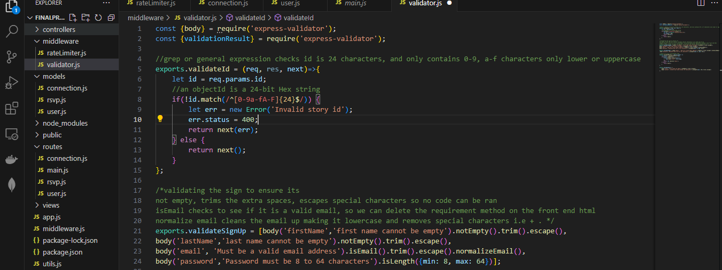

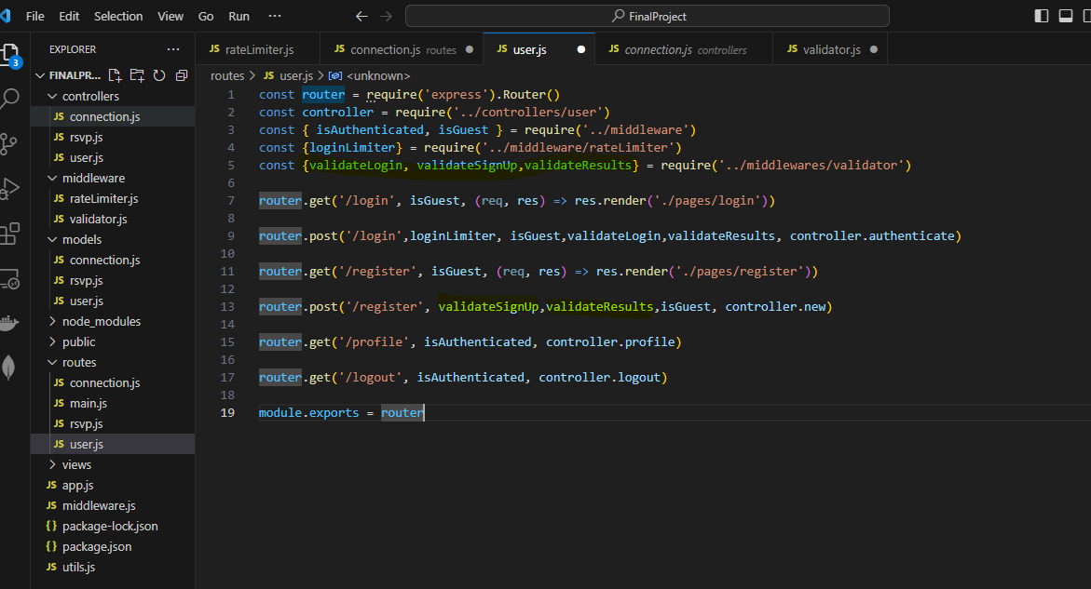

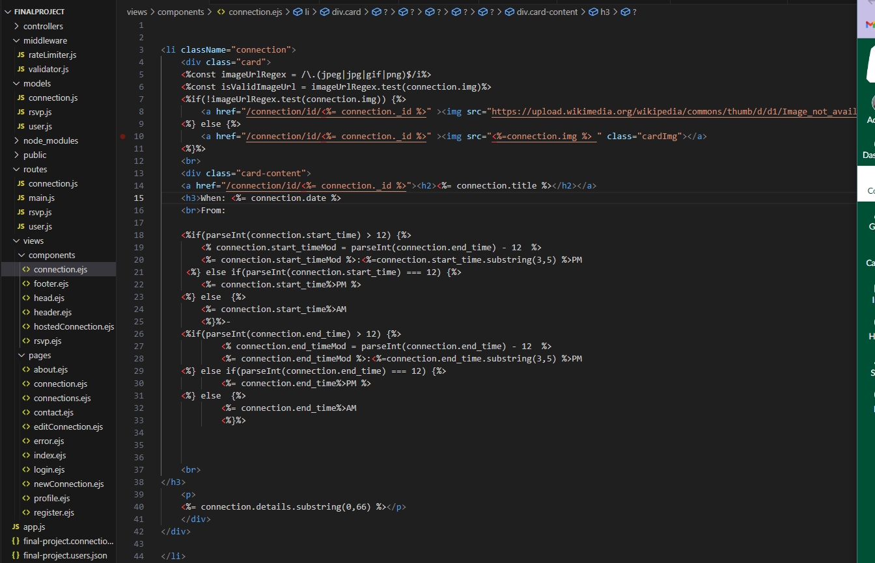

Image validator, and if statements to check the time and print out the appropriate time, and card class for the connections

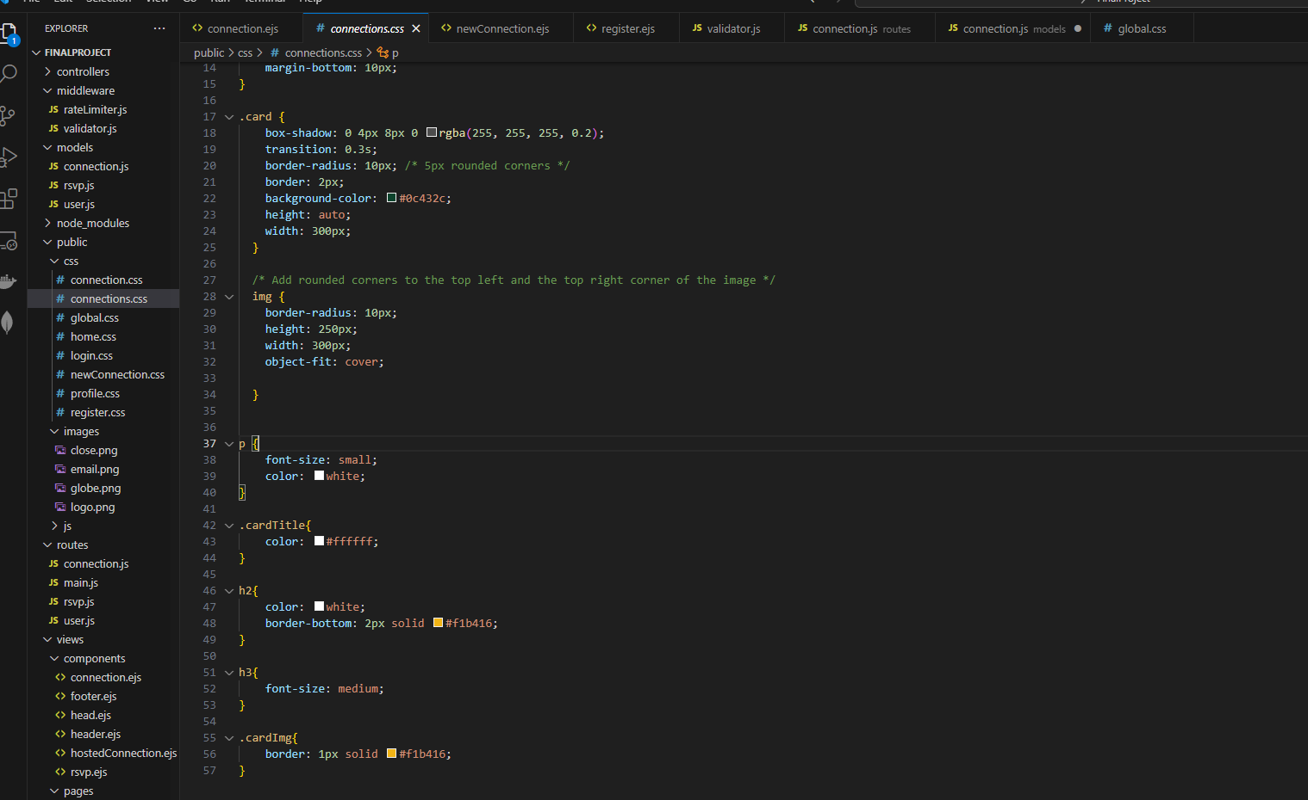

Css for the card in the connections.css