TABLE 1:
- Go to Access Company Information on DIFC Public Register | DIFC
- Scrape all entries under “Public Register” (multiple pages available)
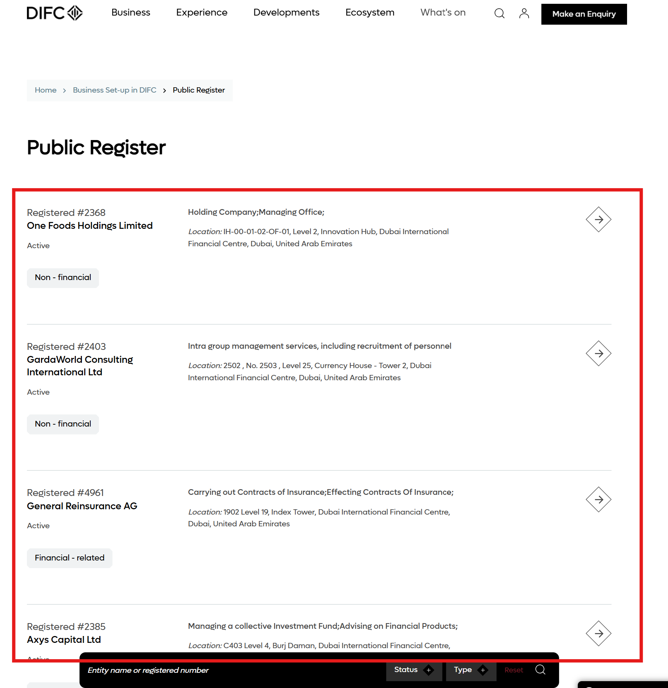

Note: There’s an underlying API which contains all data points -
https://www.difc.com/api/handleRequest
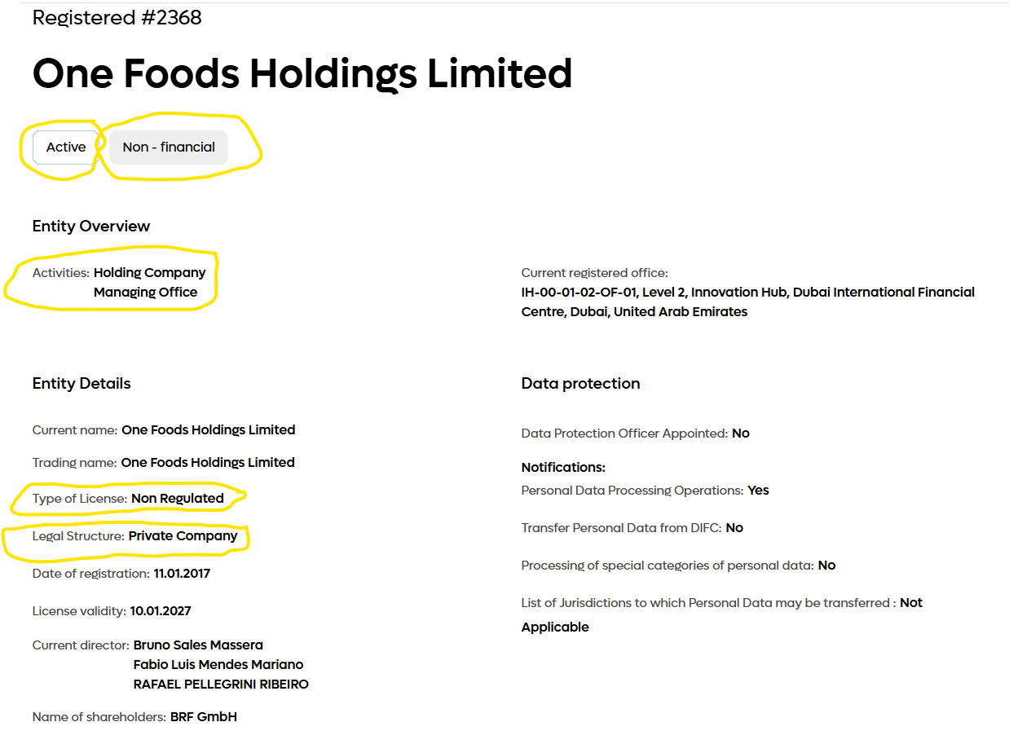

File naming: PUBLIC_REGISTER_{yyyymmdd}_{HHMMSS}

