Final Project Hive Code
Question NO:1
Highest Avg PM value
select avg(PM25) as pm, city from pm25_table group by city;
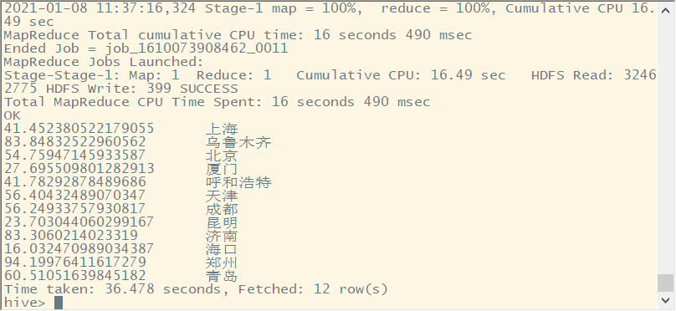
2 Question No: 2
Air Quality Distribution (Part1)
create table level(level int, day_of_month int,city string);
insert overwrite table level
select case
when(avgaqi>=0 and avgaqi<=50) then 1
when(avgaqi>50 and avgaqi<=100) then 2
when(avgaqi>100 and avgaqi<200) then 3
when(avgaqi>=200 and avgaqi<300) then 4
when(avgaqi>=300 and avgaqi<=350) then 5
else 6 end, date_pm,city from
(select avg(AQI) as avgaqi,date_pm,city from pm25_table
where city in ('成都','上海','北京') and month = 2 and year = 2019
group by city,date_pm) level;
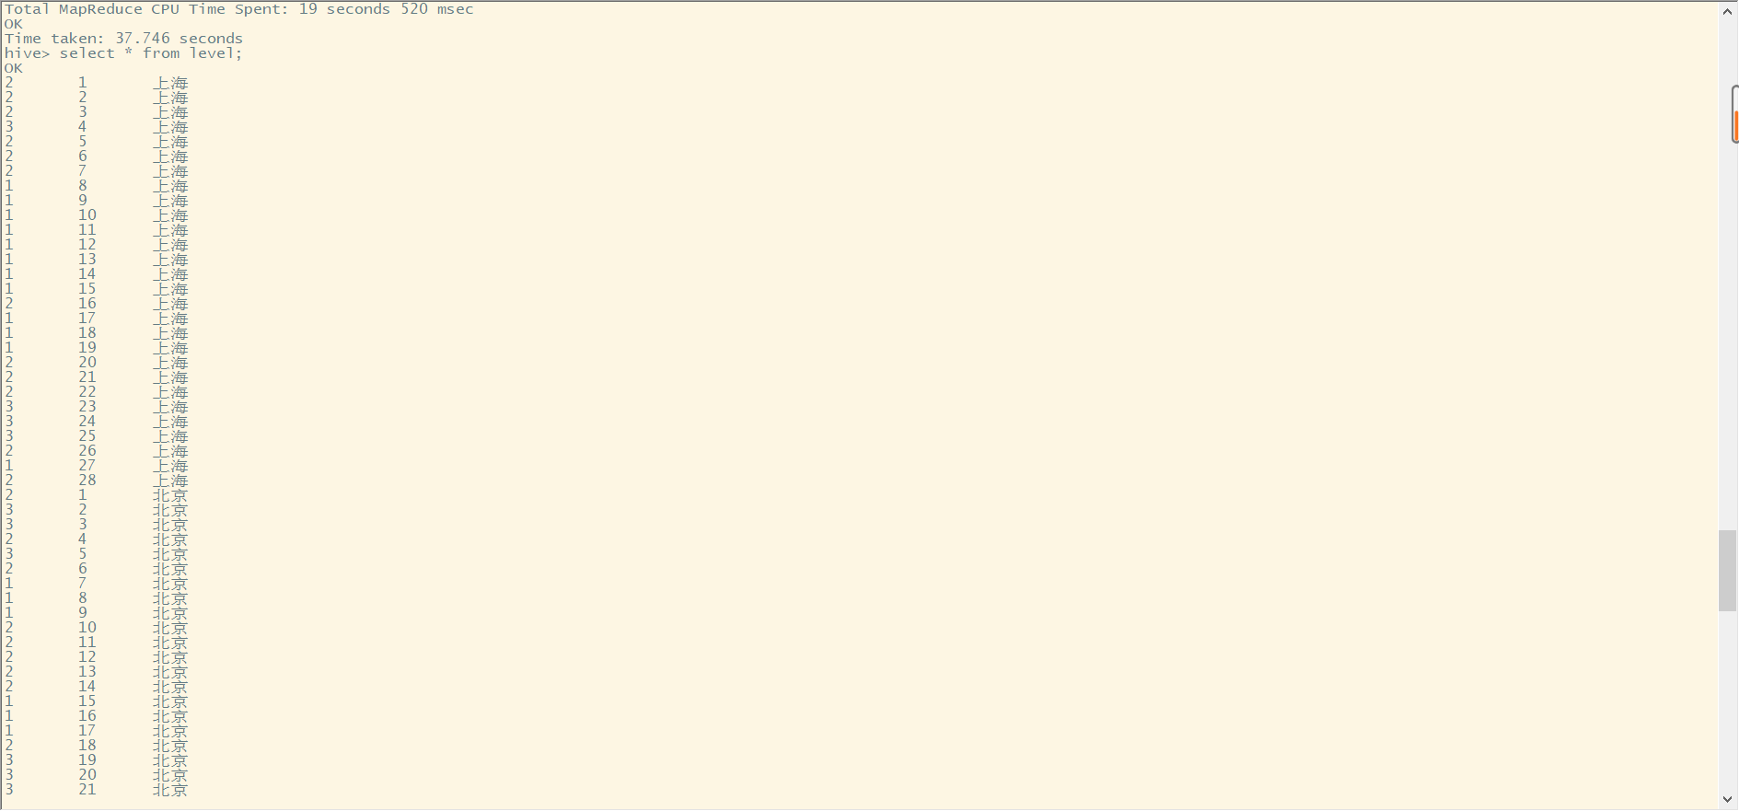

Question No: 2
Air Quality Distribution (Part2)

select city,level,count(*) from level group by level,city;
